**“*Disgusting* isn’t it? This sinful form of mine…please, don’t panic. At least…until you hear what I have to say. I’ve been your foster father for years now, haven’t I? And I never did ask much in return, but just this once, I *want* something from you…excise me from this world. You know the rites don’t you? Please, I…w-wait…what did you just say?”**



***Adrian*** had heard the tale of the Priest’s plight many times over. A household favorite that had come into relevancy quite recently in comparison to many other old legends and fairy tales for its relative shortness and polarizing subject matter. Telling the story of a righteous man of the cloth pushed to the brink of despair, his village, soon to be pillaged by an infamous band of nomadic bandits. Its inhabitants, suffering fates no living being should ever be subject to. And in his darkest hour, unanswered pleas to empower him had been answered, not by his Lord in heaven but rather, the unholy alliance working in the shadows to undo God's work.

Imbued with the power of Hell itself, the wayward priest had laid waste to the bandits. Saving his village and fellow man before vanishing without a word shortly after the deed was done. Never to be seen again…to many who had first heard of the tale, they had all assumed it to be the work of madmen with too much time on their hands. Heretical authors looking to inject doubt against the Church by painting the image of demons being heroes. But when word of the very real Insulai Raiders being found dead outside a remote village, their corpses laid to rest in haphazardly marked graves. The Priest's Plight had suddenly skyrocketed in popularity. Where there were people, the tale had touched them all. Rousing heated debate and speculation as to where this 'cursed priest' had gone. Linking many similar cases like the Insulai's 'punishment' to the demon's hands. And until tonight, Adrian had been among the skeptics wondering when he would hear the last of that impossible tale when wandering the streets. His doubts put to rest by a sudden confrontation with the famed priest himself…or perhaps the term demoness would've been far more preferable to describe the azure skinned woman clad in a perverse mockery of a nun's attire. Hovering slightly off the ground through the use of adorably small bat-like wings extending out from both sides of a shapely behind, landing with a soft clack of heels once her wings fold away and vanish. Exposing the flexible length of a leathery, spade tipped tail that licks the air like a cautious serpent with a mind of its own.

He would've clutched at his crucifix with haste. Uttering a prayer to his Lord right then and there without hesitation…had she not materialized from the flesh of his adoptive father. Claiming to be the very same priest spoken of in the tale, trapped in the body of a vivacious young woman forged from the flames of damnation for all eternity. Boasting the strength of a thousand men, youth to last the ages…and a hunger for human blood on a scale far worse than anything she had ever felt before in her time as an ordinary human. A hunger she could no longer hold back after years of strenuous peace raising Adrian as if he were her own child after discovering him as an orphan on the side of a muddied road…and it all made sense then. The vague glimpses of a woman in his early years he had mistaken to be the mother who had abandoned him. Why ***Father Rickard***, a devout priest who had thought him all he knew, never seemed to carry a cross on his person and why he didn't look a day older than the first time Adrian remembered laying eyes on him. An understandable situation when the image she remembered herself by had become a mere illusion to mask her ‘true’, feminine self from the world at large lest she be chased out of villages and towns by people who wouldn’t give the likes of a demon the chance to speak without butchering her first..a harsh truth she had experienced herself when her fellow man greeted her with fearful eyes and curses shortly after decimating their would-be murderers…just like all the other people toyed and suppressed by others she had tried to bring joy to in her own way.

With Adrian now a young man sporting a notable reputation as a man of the Church who had notched plenty of exorcisms to call his own. Rickard had finally found the strength to confess the truth to her ‘son’ in an effort to get him to end her suffering. Her village was safe, but without her humanity, no one in their right mind would ever welcome her back into the fold with open arms. A fate she did not want to live through for another second longer. But what if she didn’t need to? What if there was a way for things to end on a happier note besides condemning oneself to the void? And that was exactly what Adrian had said in response to Rickard’s absurd request. Challenging her views by asking what even was the point of raising him up to be the man he was today if she wasn’t even intending to see her effort’s through. Bashing her selfishness with a voice and tone neither of them had heard before like an angry father reprimanding their child. Arguing the fact that if she really did want to ‘end it all’...then any old priest or nun would have given her a swifter sendoff than he ever could. Because who in their right mind could so easily kill a loved one just because they asked? Rickard was all he had left. His mentor, and revealing her true self as the fabled demon he had always fantasized the possibility of collaborating with in an effort to better understand them only to claim the desire for death was just absurd.

Instead of wishing for Adrian to bring a swift end to her. They could’ve been out there beyond the city walls, wandering the vast expanse of the greater world. Enjoying unseen sights and sounds…and saving those in need just like she once used to before running away from it all after she had felt like no one ever appreciated her efforts. A critical mistake when her biggest devotee was standing before her right then and there. Unable to believe the Night Hero spoken of in hushed, excited voices along the street was the very same coward blushing like a lovestruck girl…

**“I…I thought you might’ve hated me for who I really was…the thought of being raised by hellspawn would’ve been enough for even a devout trainee to strike me down if I told them as such…Aiden…do you truly understand what you ask of me? My hunger…sooner or later, it will…wait, you propose your *own* lifeblood to satisfy *me*? Preposterous…but…like you said, I’ve held on for this long…and if I can keep going for a little while longer…alright, I’ll…*hold off* on the idea of departure…for now at least. And if your blood proves ill-suited to staunch my hunger…promise me you won’t hold back, alright? H-Hey! What’s with that look? I’m being serious here! Are you listening to me?! I’m still your father!!!”**

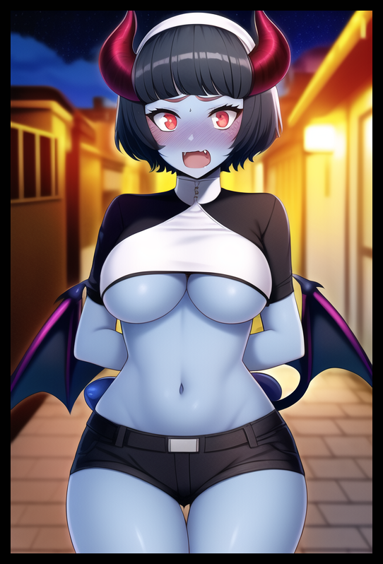

Laughing off the tension between them before turning his back on a flustered Rickard, left fidgeting awkwardly in the middle of the alley as Adrian stalks back toward their quiet abode, ready to hit the hay and call it a night. Especially after that mind boggling series of reveals he had been hit in the face with without prior notice at the tail end of yet another tiring day running errands for the local Church’s inhabitants alongside delivering the weekly shipment of ingredients for the kindly folks over at the slums. What they would do from here on out could be settled tomorrow after a good night’s rest, shooing away the dirty thoughts flitting about inside his head from the prolonged glimpse he had of Rickard’s true self as a buxom demoness…even though they weren’t related by blood, his stringent faith would prevail. Soothing the ache in his pants just as his aching body numbs, a tired mind drifting off into the peaceful realm of wholesome rest.

High up above however, Rickard would be left conflicted with her own beating heart. Racing as new emotions and unexpected thoughts began to flow through the crevices of her brain. Spurring thoughts of how a life on the road together might go; traveling with her adopted child in a bid to help those who needed aid while exploring the world beyond stale city walls…and how that life might develop in the future if she would agree to Adrian’s proposal. Pondering the possibility of a future where people would welcome demons from all over, not just herself, with open arms…or maybe even a cure for her ailment as the moon rises high above, refracting scarlet irises glimmering with a renewed hope for the future…

THE END

Images generated by Novel AI