KITAKAMIZATION
COMMISSION STORY
BY CHALDEACHANGE
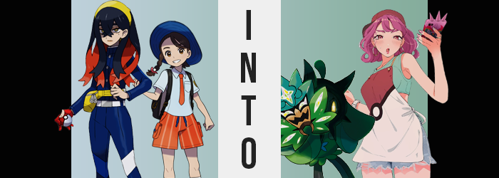

All of Juliana’s nights in Kitakami had been late ones.

But that was okay, right? She did have schoolwork to do, but part of the reason for the school trip had been so that the students of Uva Academy could explore a different region and have some fun while doing it. Kitakami’s Mask Festival was a big local event that happened at night and it ran over an extended period of time. It was enticing and so she had spent most nights visiting since it had begun, especially now that the locals were being receptive to Ogerpon’s presence.

Yet the girl was filled with a little sadness. For as fun and exciting as the trip had been (and it had certainly had its ups and downs), in only two more sleeps it was going to have to come to an end and she would be returning to the Paldea region to resume her duties as one of the current Champions. “I hope Carmine remembered the time… It’s getting pretty late.”

Having taken to walking upon reaching the entrance to Mossui Town, Juliana stared down the main road towards the Community Center. Because the trip was coming to a close she had wanted to spend some more time with Carmine. Kieran too, but for some reason he wasn’t returning any attempts on her part to communicate. She’d reached out to Carmine by phone after leaving the festival grounds and the pair had agreed to meet at the Community Center under the night sky.

“I wish I didn’t have to leave though. I’d stay here forever if I could…” The girl didn’t entirely mean that. She had friends back in Paldea that she would miss terribly if she stayed in Kitakami, but the sentiment was true at its core. It wasn’t like that wish could be granted anyways! Or at least that was what she thought, short of a Jirachi suddenly flying over her head at that exact moment.

And that didn’t happen. But this also didn’t mean that there weren’t any wish-granting venues available. Unbeknownst to the Paldea Champion, something in her bag had begun to glow. It was Ogerpon’s usual mask. The green accessory had accidentally been left at the festival by her Pokémon companion, but Juliana would return it to her in the morning. Ogerpon had simply run off to her cave to sleep for the night before returning to Paldea with her in a couple of days.

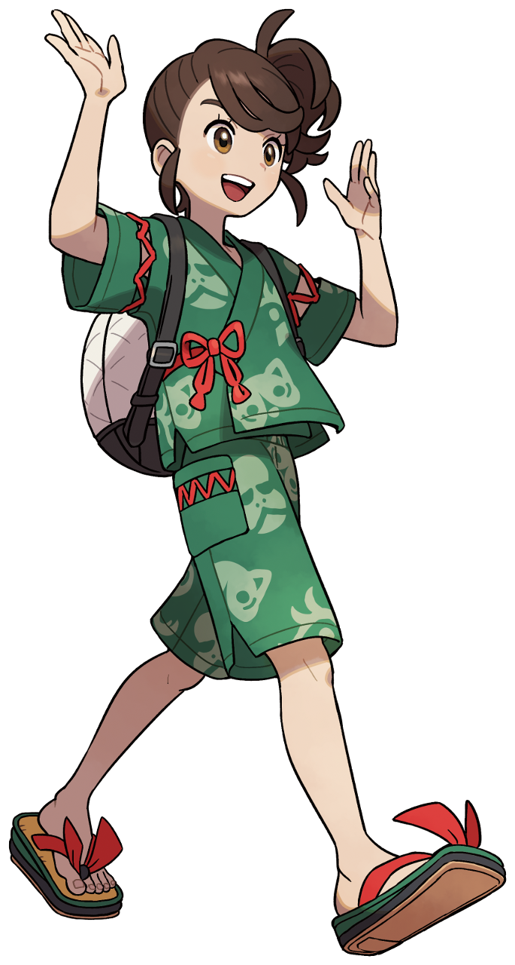
Reaching the Community Center hadn’t taken all that long and, once she was standing directly outside, having taken a look around, Juliana came to the conclusion that something felt off about her surroundings. “Huh? Where’s the nurse?” Maybe it was a little odd to expect the lady who ran the portable Pokémon Center outside of the building to always be there, but the pink-haired woman had been there every other night she had come back this late. Maybe she was just taking a break?

But that wasn’t it. The singular, wish-granting stone that had been embedded in the Ogerpon mask in her bag was to blame. The nurse lady had been removed because it was necessary for what this wish-granting device had in store for Juliana. The girl herself just hadn’t been directly affected by it yet. That would quickly change. As would she. “Good thing none of my Pokémon are injured I guess… Not that I don’t know how to use the machine.”

Huh? Did Juliana know how to use the machine? She couldn’t recall having ever learned, and she was short enough that she couldn’t usually see over the device to understand just what the nurse was doing whenever she healed her partners. Yet she had said that she knew how? And she felt like it was somehow child’s play to her with absolutely no experience to back that up.

The girl shook her head. Maybe she just needed to get some sleep? Though while shaking her head her hair itself seemed to suggest that whatever was happening couldn’t possibly be the side effect of some kind of fatigue. That is, unless your hair color and style alike could change when you were tired?

Maybe someone existed with that strange of a condition out there. Juliana was not one of them, and so her brown hair coming alight with the odd strand of dark pink was very unusual. “Hm?” The girl couldn’t clearly see this, but she did remove her hat to rub at her head a moment because of a related feeling. Her scalp had gotten really itchy all of a sudden? It was because her pinkening hair was growing longer and wavier, eventually cascading farther past her shoulders before stylistically curling upwards.

“Um…?” The girl could eventually feel its length but couldn’t comprehend it. Was it the effect of a Pokémon? Even her side ponytail had unraveled from the growth, and pulling down some bangs to see… That color was definitely familiar, wasn’t it? Of course, because it was the exact same color that the missing nurse always had her hair colored in. Still, Juliana didn’t connect those dots. Because just as quickly as she noticed her hair bore a different color, she came to accept it as ‘normal’.

That would be a running trend throughout. The wish-granting nature of the stone would be exposed if the ones under its effects were able to cause a stir or outcry, so even the Pokémon Champion’s potential reactions were blocked by a sensation of familiarity. ‘Is this wrong? No. It’s always been that way’. This was the line of thinking that kept her subdued even as the girl’s face restructured – not that she would easily notice that anyways.

“Like, maybe I really do need more sleep…” Juliana had somehow begun to sound far vapider, like a casual gal that might have grown up surrounded by spoiled, trendy friends. Her words came across as a little slurred mind you, for her lips appeared to be much fuller than they had been moments before. Much too full for a girl of her age, but that was a sentiment communicated by her face as a whole. Her face looked older and older, with eyes narrowing and cheeks thinning. That face was a little longer and her brows, now pink like her hair, grew bushier. On the other hand her brown eyes ignited with a bright red. Not only did she look older, but she didn’t look much like Juliana.

She looked more like the nurse, piercing holes in the cartilage of her ears and all.

But she almost looked funny. Like an adult woman’s head had been slapped onto a young teenager’s body. Fortunately for the uncanniness of it all this wasn’t a prolonged aesthetic. Her body soon began to grow – and the green festival jinbei she was wearing was definitely not equipped for the amount of growth. “Weird, what am I even wearing?” The fact that she was growing taller as the seconds ticked on didn’t even end up being what she was fixated on. “I haven’t gone to the Mask Festival in years. Like… what?”

As Juliana grew taller a gap between her jinbei’s top and bottom formed. More and more of her tummy and ultimately her bellybutton were revealed, while lengthening arms and legs eventually turned the shorts into microshorts and her shoulders broadened so much that the short sleeves tore right off. “I really gotta wear stuff that fits. What if someone sees me dressed like this?”

Before long she had sprung up to 5’4”, a pretty stark departure from her previous 4’10” height. And it wasn’t like she had just grown upwards either as torn sleeves revealed. Her body was wider and thicker, with her tummy just the slightest bit soft in its broadness. Her hips flared out even farther however, to the point that tears began to form in the sides. “Ngh…” It definitely wasn’t comfortable, and that discomfort wasn’t immediately treated. It got worse first.

Because while she looked tall enough to be the adult woman of around 24 that her face suggested, she’d still had the scrawnier build of a child. So in tandem with each other both her ass cheeks and her breasts soon swelled, inflating mass wreaking additional havoc upon the fit of the green jinbei. The cloth of the shorts was pulled into the crack between the cheeks of her shapelier rump, and the base of those shorts gripped burgeoning thighs tightly. There was no way her panties hadn’t snapped yet beneath their girth, for her lower half almost entirely tore through the shorts in the end.

On the other hand the shirt portion of the jinbei had already been struggling to properly contain her broader chest and it certainly didn’t help that her small bosom had begun to swell soon after. The pushed forward under restraining cloth, but eventually their mass forced the neckline of the green garment to tear directly down the center so that her C-cups tits could breathe a little. “Huh.” She tugged a little at the crevice with one hand, the fact that her lengthened fingers had fake acrylic nails not really bothering her at all.

In the end the torn garments didn’t really matter, because with one final flash of light not only did Juliana’s bag seem to disappear, but the woman she had become found herself properly dressed in a green crop top, torn blue jean shorts, trendy running shoes, a Pokéball apron, hoop earrings, and a sideways facing, red baseball cap. Even the Rotom phone in the pocket of her shorts was different now.

“Hm? I missed a text or somethin’? Is that what was botherin’ me? I probably shouldn’t hang out over here too long either, don’t wanna lose my job…” It was after midnight now and the trendy Nurse Joy that worked the Pokemon Center stall found herself skipping back behind the outdoor counter while perfectly manicured nails scrolled the feed on her Rotom Phone at the same time. She didn’t notice that she was leaving behind an elaborate, green mask that had fallen onto the ground.
Instead she slid behind her counter without thinking much of anything. But ultimately Juliana’s wish had been granted, right? The beautiful yet lazy woman she had become didn’t need to leave the Land of Kitakami. As far as she was concerned now she was a native. She had spent her whole life on this land and, while her job was a little boring? The pay was good and it was fulfilling in a weird way. Plus she could just stand around and scroll through social media for most of the day.

Still, she groaned. “The night shift kinda sucks though. Sis has it way easier workin’ the day.” While the Kitakami Joys were a little different, they still operated in the same way as Joys from other regions. She had an identical sister that handled things when she off and vice versa. And this one could not wait until she was relieved at 6am! She had a date with a real cutie in the afternoon!

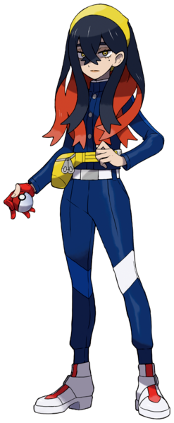
“And here I thought I was late. Where is she?” Not long after the nurse had run back to her booth, Carmine had arrived outside of the Community Center as she’d promised. She’d gotten tied up with her grandparents when trying to leave and had assumed that she’d be making Juliana wait. And honestly? Carmine was a little excited. She harbored a little crush for Juliana, and hanging out so late? Didn’t that mean there was a chance they might have a sleepover?

But her friend was nowhere to be found and she definitely should have arrived already. “I hope she didn’t run into any… trouble? Huh? Isn’t this Ogerpon’s?” It was around that point that she noticed it. A glimmering, green mask laying on the ground directly in front of one of the Community Center windows. “Juliana wouldn’t misplace something this important on purpose… Doesn’t this mean she was here though!?”

Carmine knew how important Ogerpon’s masks were to her. “I wish I could return this to her…”, she mused after picking the mask up. An innocent and well-intentioned wish. One that would be granted in the most backwards way possible of course, just like what had happened to her missing friend. “H-Huh!?” Unlike Juliana though, Carmine bore witness to the stone glowing with her own two eyes first.

A weird feeling spread throughout her body from the stone’s light and she ultimately dropped the mask – but not on purpose. It had slipped out of her fingertips, which had begun to feel oddly numb? “What’s— AAAAH!?” It was a miracle that Nurse Joy hadn’t heard her scream, but in the end the nurse had actually slipped into the Community Center to use the bathroom quickly. But Carmine had been given plenty of reason to scream in horror.

Her hands were nubs! The fingers on both of them had disappeared, and her balled up first were beginning to look green while a leafy scent filled the air. The coloration travelled up her arms, and the stubbed hands that remained out of her sleeves all of a sudden felt hollow. That hollowed feeling traveled up her arms with the green coloring, and what she couldn’t see was that the undersides of those arms had been hollowed out. Almost like her arms were the open sleeves of a cloak with nothing inside of them.

“S-Somepon is wrong, isn’t pon!?” For a change that should have been so blatantly unsettling it seemed Carmine was struggling to show concern. Were her arms really wrong? Should she have hands? Wouldn’t that mean she was a human? Was she? Well she was wearing clothing like a human did, or…?

She wasn’t. Her Blueberry Academy uniform had disappeared instantaneously, headband and all, and so Carmine was standing out in the cool night air with her strange cloak-arms on full display. Without the sleeves to bind them now they had unraveled and hung down to her bellybutton. With the arms entirely exposed it was clear that the leafy greens of this cloak weren’t consistent and almost had a patchwork pattern with various shades of green, but at the same time? It had grown to replace her shoulders and wrapped all of the way around her back.

The teen’s mind felt strangely groggy. It was getting harder and harder for her to think critically about anything, much less the situation she currently faced. “I’m… Pon? But I pon to…” A Pokemon’s cries were peppered throughout her human speech more and more, indicative of the fact that it was very much her humanity that was at stake. Not that she could do anything to prevent what had already begun to unfold.

Looking at her womanly figure, and mammalian traits were evening away. Her nipples faded and her breasts eventually flattened into naut, whereas her ass cheeks and thighs shrunk away as well. In the end her body were left without even widened hips, giving her an oddly stick shape beneath the cloak that was very much a part of her body. “Pon?” And was the world not… getting bigger? The fact that Carmine rationalized it that way without questioning actually spoke to her drop in intelligence, because to a thinking, functional human it would have been obvious that what was changing size was actually herself.

The girl had shrunk all of the way down to a meager 3’11”, and in the process her legs had grown stranger in form to boot. Their skin had not only turned black, but her feet had thickened into blockier shapes upon which weeds grew out between the two toes on either foot – as all the digits had merged so she only had two. Knees weren’t visible on either leg, and the inner legs were completely flat.

Carmine kicked a leg out and stared down at it? “Foot… pon?” No, nothing was wrong with her feet, was it? It was no more unfamiliar to her than her torso, which had suddenly puffed out with a mossy green gown with flowers sprouting from it. This, much like the ‘sleeves’ of her cloak, was not actually clothing. It was her own body.

With eyes jumping around energetically, the whitening and expansion of her pupils into star shapes within golden irises suggested that her face, the only thing that retained her humanity thus far, had begun to change in kind. Her face was painted over with an orange fuzz, while her neck shortened so that a rounding chin merged into the ‘collar’ of her green ‘gown’. The cloak that made up her arms and shoulders then appeared to grow further, stretching over her hair and head so that locks were turned into a trio of leaves that framed her forehead. “Pon!”

She felt very comfortable once the final changes set in. Little fangs poked up from her mouth, human lips no longer present to skew their reveal. Carmine wore a little smile, now dancing back and forth on her two-toed feet while black, thorny vines wrapped around the Pokémon’s face to bind the cloak to the rest of her oddly shaped flesh. Four black dots appeared in the corners of her face, and a green stem shot out from atop her head and, in the end…

No human stood where Carmine once had.

“Pon!? Pon!?” Dancing around on her big feet (at least compared to the rest of her body), Ogerpon scooped up her dropped mask and put it on to hide her very confused expression. The Legendary oni Pokémon could tell that something had just happened and her instincts had responded in kind. But that said? The child-sized monster wasn’t really sure what had happened. Her intellect was about as keen as a small child itself and so thinking too critically was hard. But it was also late at night! Shouldn’t she have been in her cave resting?
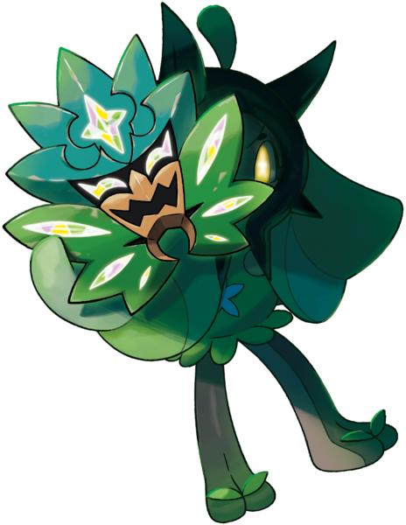
With that in mind, Ogerpon barreled off from the Community Center, slipping behind the nurse at the Pokémon Center with only a soft “Pon!” uttered in the process. She no longer had any reason to fear the humans of Mossui, but after such a long time in solitude her social skills when it came to them still wasn’t the best. Her anxiety was getting the better of her! She needed to get home and sleep… as an uncaught Pokémon.

“Huh? Was that a Pokémon?” Ogerpon hadn’t escaped without any notice though. She had been looking at cute girls on her phone while walking out of the Community Center, but the Nurse Joy had heard its cry as it had slipped away into the town. She’d looked up far too late to see it, but what she did see was something glimmering by the Community Center window. “A gemstone? Wonder if this belongs to one of the kids that were visitin’…” Against the evil voice in her ear that wanted to pocket it, she brought it in to the front desk to be returned to its owner.

And that was how the wish-granting stone from Ogerpon’s mask would find its way back to Paldea even without Juliana attached.

