MEMBER NO. 8
ZOMBIES DON’T NEED NURSES SAGA
JULY 2021 REQUEST STORY
BY CHALDEACHANGE
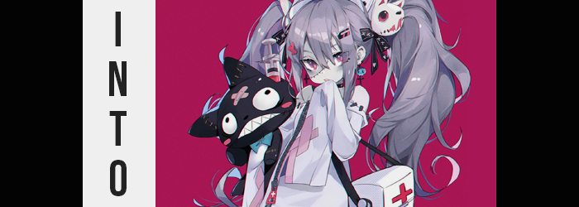

“This has to be a dream or something, right? I sure remember falling asleep in my bed.” It was a perplexing situation to find yourself in, waking up in a place where you had not fallen asleep the night before. But perhaps ‘waking up’ wasn’t the right choice of words in the end, for the only plausible explanation for such a thing was that I was, in fact, still asleep.

After all, I immediately recognize the setting I was sitting in, and not because I’d been here before. I had ‘come to’ in a fold out, metal chair in the middle of what was most certainly the basement of a large building. Cell bars lined the walls behind me, and in from there was a chalk board with something written in Japanese etched into it. The most I could make out was an ‘8’ at the end.

“Yeah, gotta be a dream. This is 100% the house from Zombie Land Saga.” An anime that I had binged the second season of recently. It was about a girl that was killed after getting hit by a truck, who one day woke up to find that she was a zombie and was expected to perform in an idol unit called ‘Franchouchou’ along with six other zombie girls. It was cute, wholesome, and funny, but had it really occupied so much of my attention that I might dream about the setting?

It just had to be a dream. After all, this house was in the Saga Prefecture in Japan, and I lived in the United States. Unless I’d had the world’s longest nap when someone stowed me away on a plane, it just wasn’t plausible at all. Then it occurred to me, hadn’t I gone to bed after something odd happened? I’d been watching an episode, and then Kotaro, the manager of Franchouchou had pointed at the screen and yelled “WE WANT YOU!” and then… and then…?

I hadn’t fallen asleep at all? I hadn’t gone to bed! I’d just suddenly appeared here? How did my memory get so jarred? So this wasn’t a dream? No! Appealing as it sounded to be in one of my favorite shows, it was just impossible. I must have dreamed the Kotaro part too, that’s all! I remember doubting my impossible circumstances, but I didn’t realize just how possible they were, nor just how much my life would change for the better as a result.

If I was dreaming, then I might as well look around the basement, right? That was the thought I’d had initially, but I was given pause by a dizziness that left me wobbling on my feet. “I’m not getting sick in a dream, am I? That’d kind of suck.” Being whisked away to something from a popular anime and being unable to look around? That’d be strangely cruel of a dream as lucid as this one appeared to be.

But it was strange. I was wobbling more because controlling my body felt strange – like my reach and inner balance didn’t match up at all with what my brain was processing it to be. Was it too far, or too short? Making sense of it was difficult, at least until I felt it. My t-shirt beginning to slide with imbalance towards my right shoulder. “Huh?”

Now, I was a bigger guy. Tall and full figured, so naturally I wore big clothing. Never would I expect a t-shirt to feel too big, much less one that I was already wearing, but that was exactly what was happening here. “Am I getting… smaller?” Because I was unfamiliar with the scale of everything in the room around me it hadn’t struck me, but the things around me looked larger. It wasn’t limited to my clothes.

It was my height, my width, and my weight collapsing in on itself all at once. The front of my shirt not only flattened but hung loose, prompting a hand to press it against my tummy. All of that fat that should have been there was slipping away, and I could even feel it flattening more under the touch of my fingers!

Although on the subject of my digits, they fared similarly. The length of each finger regressed, but on the other hand the nails that rested on the tips did not. Instead my fingernails grew longer and were robbed of the frayed qualities they’d taken from enduring a bad nail-biting habit. My hands looked downright feminine as a result, but considering I was more fixated on patting my shrinking body I didn’t really pay them too much attention.

Because I’d been taken directly from my home, I wasn’t wearing shoes. But I was wearing socks. Socks that were quick to become a hazard once the feet within became smaller, increasing my chance of slipping on balled up fabric. “I should fix that…” Should I have been panicking more as I leaned forward and struggled to yank socks from petite feet as the legs of my pants obscured my feet otherwise? Probably, but there was no small part of me that was interested in this. Almost elated, actually. Like I was being given something I’d wanted for a long time. Was I under the influence of the transformation mentally? No.

Before long, my immense height had been crunched down to roughly 4’6”. The change was dramatic and could be felt all throughout my body, the clothing malfunction fittingly dramatic as a result. “Uh…?” I was given little choice but to step out of the pants that had fallen to my ankles along with my boxers, but I was thankful my shirt was so big that it fell down to my thighs.

“Is this really…? Ee!? My voice!?” It sounded soft and feminine, but at the same time not at all mature. This revealed something to me I hadn’t noticed without a mirror, but considering my height I probably should have noticed. Tiny hands immediately sprung to my face. My cheeks felt squishy, my lips were small with a little definition. Was this a child’s face?

Yes, but it was also a girl’s face. During my descent, my facial features had noticeably softened as they’d grown younger, leaving me with a natural pout, a tiny nose, and bigger eyes. Yet, on closer examination of my optics? Something else was easy noted. I was Caucasian – I should have been – but my eyes now had the more rigid shapes of a Japanese girl. In fact, ever since my shrinkage had completed, I’d been speaking in fluent Japanese. I could read the words on the board too, but that didn’t really occur to me.

“This… can’t be, can it?” I wondered not because I was shocked, but because I was scared of being wrong. This made me a little happy. I fidgeted nervously in place, moving my body around to try and adjust to my new height – but in the meantime my short hair took on life of its own and began to extend with vigor. Dark locks fell rapidly behind me like a waterfall, their natural straightness now teased with a subtle perm that made them weave about messily. In the front, my bangs fell between my eyes and framed my face to my shoulders.

With every passing second I looked more and more like a girl. I suddenly had to adjust my fidgeting posture because my hips parted wider despite the fact that my shoulders remained so tiny, but it appeared to be done in good nature to accommodate a thickness that soon saw my thighs and butt plump beneath my shirt. At best I looked thirteen, and so I held it in as the unwieldly sensation of my junk being sucked into my body, leaving what I assumed to be a girl’s counterpart. “…Oh.”

It certainly felt surprising, but not as surprising as two tiny bumps pushing up against the inside of my shirt from my chest. Considering my age, they likely weren’t very big – and in fact were probably more indicative of what might come in the future if I was allowed to grow. But because I was fixated on my changing sex, I wasn’t thinking about much else. Like things that might prevent me from ever growing.

“Should I touch them? It’s my body… right?” What to do with myself was certainly a debacle, but as I pondered this something strange was distorting my body’s colors and quality. My dark hair had been lightening to silver, the strands fraying at the tips and looking quite worn overall. While my skin? It lost its pink and looked almost dried out, veins visible in place as the beating of my heart slowed in speed.

The very moment I worked up the courage to touch my chest through my shirt, the very second my fingers pressed into their flesh? My heartbeat stopped, and I fell limply, dead, to the floor. Did I die from the shock of touching my own chest!? For a moment I remained still as death settled in further, my skin turning slightly blue from its earlier gray while stitches etched their way diagonally across my face. Bandages also appeared from nowhere as gouges and nicks formed in my skin, wounds from an accident I had never experienced covered by this white cloth.

Until, finally, my eyes fluttered open again. This time, they glowed an eerie red. “Did I just… die?” Dying because you fondled your own chest would certainly be an embarrassing way to go, but that seemed like it. I pulled myself up to my feet nonetheless, my body feeling stiff and worn. But there was no soreness, which struck me as odd. At least until I saw my blue fingers. “W-Wait… Am I… am I a zombie?” My bright eyes blinked, and without realizing I turned my neck so sharply that it should have cracked, but instead it spun around 180 degrees as if it wasn’t properly attached to my body. “W-Wait a sec…”

“ARE YOU AWAKE NOW, YOU STUPID ZOMBIE!?”

“W-WAH!?” While I’d been busy examining myself, a man had appeared behind me and had yelled into my ear with no shortage of enthusiasm, sending my undead body to spill forward and faceplant on the stone floor. That voice could only belong to one person, but how did I know what he was saying? He was speaking Japanese. It finally occurred to me though: I was thinking in Japanese, and so I must have become Japanese over the course of my transformation.

I managed to turn myself over while still on the floor, arms and legs getting mixed up in my oversized t-shirt. By the time I ended up on my back, one Kotaro Tatsumi in the flesh had his face only inches away from my face. “I CAN’T HEAR YOU, NUMBER 8!” I recoiled back again from the volume, replaying his words in my head. Had he just called me ‘Number 8’? Like the words on the chalkboard? It was true that I’d become both a girl and a zombie, but was it actually to become a member of Franchouchou?

“U-Um… I’m awake… clearly…” My voice was soft, and I was stuttering with my usual anxiety. It just came across as a lot cuter with the voice and face of a young girl – not that I minded at all. In fact, there was a part of me that had always wanted a life like this. Being small, and cute like this. Even if I was undead, it was a small price to pay, right? “But how is this possible? Who am I supposed to be…?” Because I certainly couldn’t use my real name anymore.

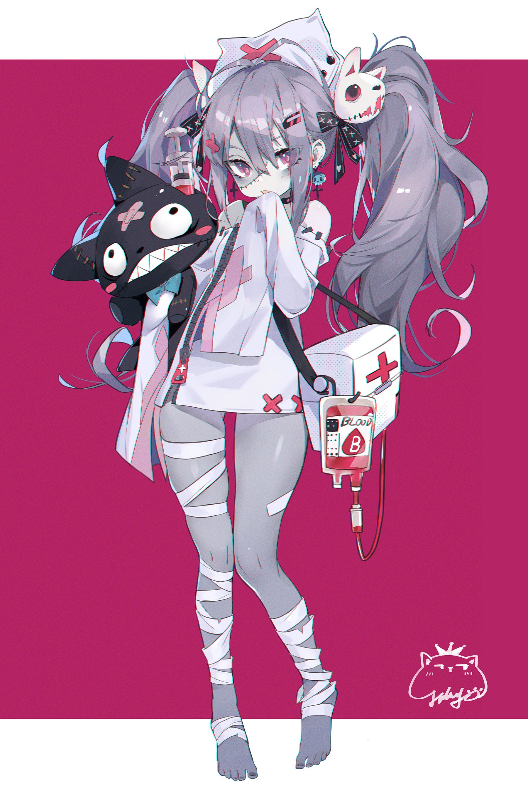
At the question, the man in the sunglasses beamed and stood upright, before pointing back down at me. “You’re Franchouchou’s Number 8, THE LEGENDARY NURSE, SATO KIYOKO!” Nurse? I had to make sure I wasn’t hearing things. Yet, the moment he’d said as much, something clicked. An influx of nursing knowledge, things I could not have possibly known before. My lip quivered as I attempted to sort it all out, but Kotaro didn’t afford me much time to adjust.

“SAKURA! TAE! Get Kiyoko dressed for her debut show!” The man backed away and two remarkably familiar zombies stepped forward. I knew them from the anime, the main character Sakura and the feral Tae. Sakura was making an apologetic gesture with her hands while Tae, holding what looked like a nurse’s gown, growled, and rapidly JUMPED ON ME!

“H-Hey! S-Stop it! That tiiiickles!” My girlish cries were unleashed while the zombie tore my clothes off and shoved me into an elaborate nurse’s gown before I was pulled up and onto my feet by Sakura. The gown was so short that I could feel the cool air teasing the pasts of my legs that weren’t wrapped in bandages, while the sleeves were so long that they hung well past my hands, swinging around childishly as Sakura applied clips and bows to my long hair, which was tied up into twintails.

It was only now, with Sakura right in front of me, that I realized just how small I was. It prompted me to ask a question. “Um… I know we’re zombies, but how do I look? Am I cute?” There was no small part of me that yearned to hear a ‘yes’. A lifetime spent yearning to be seen that way, but not being given the life where that might ever be possible. Being a zombie was a small price to pay in order to be a cute idol!

And so, at Sakura’s words, I couldn’t help but tear up. “Yup! You’re super cute, Kiyoko-chan!”

