BUNS FOR BRAINS
JANUARY 2022 REQUEST STORY
BY CHALDEACHANGE
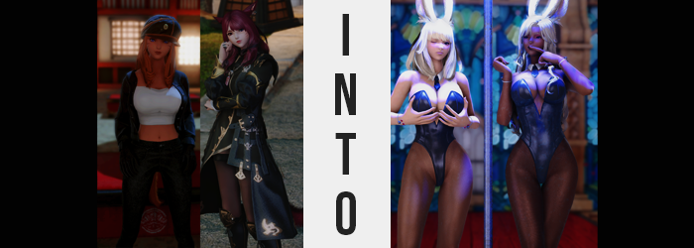

It had been a stroke of luck, really. Or at least that was how it had felt.

Silvia Kuroi had found something of interest among the most recent batch of relics she had scavenged from a vendor in Ul’Dah. Nestled within gemstones and decrepit offerings from civilizations past had been a ticket. A special, all-expenses paid ticket for the Gold Saucer that included a fancy hotel room and unlimited participation in the establishment’s games, all for two guests. And the best part? It wasn’t even expired!

The Miqo’te hadn’t been sure if she’d received it in error (and she probably had), but it had been someone else’s mistake in the end if so. Why would she squander a free trip revolving around rest and relaxation? She certainly needed it, and she knew of another Miqo’te that probably needed it as well. “So? Pretty nice trip, right?” The eyes of the red-headed woman in question flickered between the friend she had invited and a pair of fake, white bunny ears that they had received after cashing their tickets in.

Supposedly they had to wear those ears if they wanted to take advantage of the free entry, free food, and free lodging – and while they’d only had to flash them to the innkeeper to gain access to the shared room they had now, they had been told they would have to be worn to access the other benefits.

“Aside from the stupid ears, you mean?” S’aiya, the professional thief with whom Silvia had brought, was glaring at the accessory in her hand. With a no nonsense type of personality, she loathed the idea of having to wear something so embarrassing even if the benefits included a bunch of free stuff. The hustle and bustle of an establishment like the Gold Saucer was a little much for her considering her background, too. “I don’t know. This place isn’t really my style. I’ve run a bunch of cons here before, so I’m still worried someone is going to remember my face.”
She had been saying things like this since she was invited, and Silv was tired of hearing it. And so, after putting her own fake ears on, she slid over to her companion and guided her hands so that the ears rested upon S’aiya’s head too. “Come on, don’t be like that! No one is going to recognize you. Especially with those cute bunny ears!”

On that note, it was a little surprising. Would Viera not be offended by these ornaments?

“That’s it. I’m not wearing these after all.” Utterly unamused by Silvia’s ribbing, S’aiya went to pull the ears from atop her head. “Ow!?” But there was an issue. “Why won’t these come off!? They feel like they’re… attached?” Not just attached, as in bound to her skull, but they were also softer. At first they’d looked like cheap polyester, but as fingers grazed them now the blonde fur that decorated them felt soft and authentic. They had also begun to convulse as if a part of her body, something that the observant Silvia soon noted.

What the scholar hadn’t realized was that she was suffering the very same change. Too in awe of what was happening to her friend, she didn’t even think to check if she, too, was a victim. But she very much was. “Not only do they look like they’re attached, but they look like real Viera ears. And your Miqo ears are…” Hidden behind the bunny ones, both of their cat ears had begun to shrink, ultimately slipping into obscurity midst their scalps. No hearing was lost in the end, but only because it was deferred to their new ears.

“You’re joking, ri— No, Silvia? It happened to you, too! And your hair…” Streaks of a bright blonde, the very same color as the fur in her new ears, could be seen whipping through the locks of the redhead. It didn’t take long for them to be wholly consumed, the look of her hair much thinner – especially as far as her bangs, now swept to the right, were concerned.

S’aiya’s eyes eventually drifted upwards as she pointed Silv’s hair out to her, unamused to see that the fact that they were both succumbing to the same shift had continued on her behalf. She could see more of her bangs than she was accustomed to, and they were an even brighter blonde than her friend’s hair had become. Almost bordering white with the lighting in their inn room, its overall style was largely the same albeit a few inches longer than normal.

“Oh, I’m like totally going to complain to the front desk! Those ears are doing something super-duper weird to us!” Silvia hadn’t even realized what she had said until S’aiya began to giggle with amusement at her. But the thief herself was acting out of character by giggling in the first place.

“Listen to yourself! You’re totally talking like a big old dumb-dumb!”

“……….”

The two stood in stunned silence, their conditions worsening even as they did so. The remaining indicators of their Miqo’te heritage were dwindling away in the process, but they felt far too perplexed by the states of their minds. Where had these vapid sounding words come from? Why hadn’t they spoken with the intelli… intel… interli… smart words that they had meant to!?

When it came to their Miqo’te tails, neither of their furs had been dyed in the blondes that their hair had been. This was by design because it would have been unnecessary, for both tails seemed to be severed from the bases of their spine before falling to the floor behind either of them with a THUD. They did not disappear, but instead hardened into a furless rubber – pink for S’aiya, purple for Silv – so that they looked like a pair of brand new dildos.

There was very little sign of their past racial status in their faces to boot. Markings that typically pinched in across their cheeks to almost mirror whiskers faded, and the architecture of their maws was delicately reconfigured. Not so that they were identical, but so that their general features were similar. Noses became more upturned with flattened tips, very typical of the Viera race, and while their faces grew longer there was a greater roundness to S’aiya’s cheeks that made gave her a more youthful appeal than Silvia, who gave the impression of a more mature woman with her eyes slightly smaller.

“Why is my head so, like… fuzzy? Ehehe! It feels kinda nice…” Speaking with no shortage of carefree ignorance in her voice, Silvia’s movements seemed erratic, almost like she was idly dancing in place. Through bloated lips she spoke, struggling with sounding her words before she had eventually gotten that question and giggle out, and her companion fared no better in that regard. Their minds had become little more than a stew that inhibited their perception of the events transpiring.

While Silv was typically the lighter-skinned of the two, that balance soon found itself in flux. S’aiya’s skin grew lighter, taking on a proper alabaster, while Silvia’s skin found a natural bronze that darkened even her nipples. Through her own thickened lips, dribbles of drool soon fell from the former’s mouth. “Reaaaaally nice! Like I’m fucking on a cloud~! …Huh? Fucking?” It certainly wasn’t like her to fixate on sexual things like that.

The idea, however, had become much more appealing to the pair of them. Rocking their tall, ample bodies against another man or woman, feeling the pleasures that only interlocking flesh could bring. Mind you, with the two women of decreased intellect lost in these new fantasies, it hardly struck them that the bodies they imagined did not match up with the ones they possessed in terms of height and figure. But then again this inconsistency was but a temporary one.

Standing their with their heads in the clouds, it became increasingly apparent that their heads were literally reaching towards those clouds. They were both growing taller, stretching out their outfits in ways that were quite different thanks to the different preferences in clothes they (had once) held in the first place.

S’aiya wore a simple white shirt underneath a jacket and a pair of jeans, and so the increase in height – taking her to just above six feet – increased the amount of exposed torso that it had already produced. Her jeans rose higher on her hips, which meant that her ankles and shins were fully exposed. As the growth wasn’t just vertical, widened shoulders and slightly better pronounced hips caused further tightness around her shoulders and, with a POP, shot the button off the front of her pants.

“Ooooo~!” A sensual cry bellowed from the fair-skinned Viera’s O-shaped lips, for she found the tightness of her outfit somewhat arousing – speaking to the fact that she had earned something of an understanding and preference for masochistic pleasure. Of course, it certainly helped that her curves had begun to swell. Beginning with her breasts, the white tee that she wore beneath her jacket struggled to wrap around them fully, fabric pulled to its limits and yanking her shirt’s bottom so that everything below those tits were fully exposed. A pair of F-cups were what decorated her chest, tender and yearning for touch; and touch she soon did.

As for her pants, widened hips swung even more so, forcing the sides of her legwear to rip without an invitation. Ample weight was then fed into her ass and thighs, bringing with them a thickness that no doubt would be envied by any woman that sought to be seen as ‘sexy’. With S’aiya’s rounded cheeks and bigger eyes, she certainly presented herself with a more youthful sexuality than Silvia.

“Mmmm~!” Not to undersell Silvia’s appeal, though. Dressed in an ornate, long-sleeved, black tunic over a pair of black tights, the height boost certainly left much of her pelvis region exposed. Said tights had been yanked down past her tanned ass, and with the tunic pulled up so that even her hips were exposed thanks to her 6’2” sizing you could make out the roundness of her rear blowing up.

With every little smidge of mass that found her ass it jiggled like a balloon filling with water. Her undergarments were increasingly consumed by the breadth of the canyon left between swelling ass cheeks, filling with such life that her hips were stretched wider until they surpassed even S’aiya’s. But such was the trend – her figure would be the superior one in the end.

Plusher thighs initially rubbed together, only to struggle some thanks to the newfound breadth of her hips. Full cheeks found goosebumps in the chilly inn room air, and the front of her undergarments were plucked in between the lips of her pussy to reveal stray blonde hairs just above them. Silvia so badly wanted to smack her own ass, but at the same time? It would be better if someone else did it for her. Someone to ravage her entire body including her bosom.

And her bosom certainly seemed to be ripe for a ravaging. The space within her hoisted tunic was becoming rather scarce, swollen nipples pushing up against its underside with all of their might. Of course their efforts were bolstered by the fatty tissue beneath, honkers big, round, and perky enough to put even S’aiya’s to shame. But that was fine! Both women had their own appeal. The pale skinned Shine was the bright, baby bunny, and tan skinned Starlet was the more mature, more experienced bunny – even though they were the same age, technically.

Wait, were those their names? Since when? Since they’d started working at the Gold Saucer?

New memories graced their glazed-over minds, crafting a new reality for them that saw the pair of Viera as a couple of guides that had come under employment here. And to those ends? A change in costume was necessary. Both women gasped as their old ensembles were dissipated from their flesh, leaving them butt naked within their inn rooms. Both stared blankly at one another’s sexy forms for just a moment, sensing that something was wrong with that picture.

But that sense wasn’t enough, and no sooner than they were painted over with dark tights, black heels, and open-topped bunny girl leotards with little collars and ties did everything suddenly click and make sense to them – both sets of eyes glossing over with a pastel pink. Their bodies, strangely, also seemed to ache some, as were their bodies covered in the slightest traces of sweat.

Indicators that they had already worked a full day.

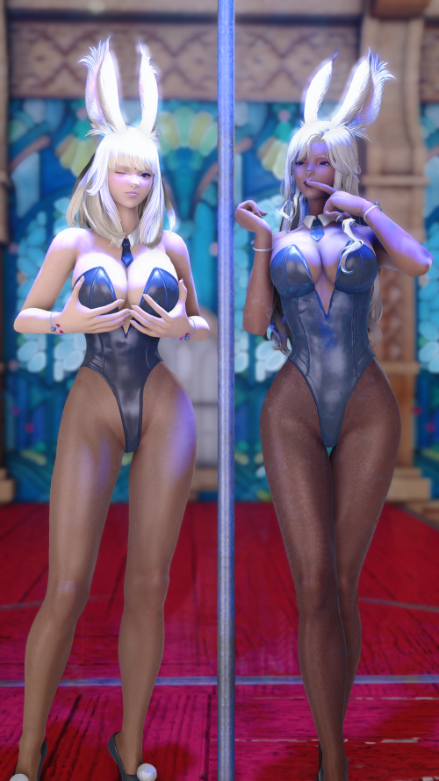
“Wooow! I totally feel great! Like I’m on top of the world? But how could I not with a bod like this!? What about you, bae!?” The tanned Viera bimbo that had once been Starlet wasted no time in throwing herself at her lightly-skinned compatriot, a transformed Shine. Despite the once-thief’s normally prickly disposition, as she was now she wasted no time in clinging back to her sexy partner, their huge breasts both docked as they reached down to grope each other’s asses.

Even Shine was cooing, on a sensual high from her transformation and at the mercy of the new, airheaded, entertaining bimbo personality that had been enforced upon her. “Heehee! Soooo amazing! And we have, like, the best jobs! Entertainers at the Gold Saucer?” She somehow sounded even more vapid than Starlet, but with a sexual appeal that was more girlish compared to Starlet’s more mature look, perhaps it all made some semblance of sense.

She’d also become the much needier member of the two, and despite the tanned bun being the one to initiate contact, the pale bun was the first to lean in for a kiss. A kiss that was readily shared with twisting tongue, hands exploring one another’s body with the intention of eventually stripping the bunny girl costumes from each other’s bodies.

For as they could remember, their shift for the day had just ended! The Gold Saucer was very short staffed these days and the two of them had recently been hired due to their ample… personalities. It was no surprise that they easily drew in visitors, guiding them about as an inseparable pair a lot of the time. When they weren’t working, the two empty-headed busty babes could either be found sleeping about or with each other. It was a happy life.

Ideal in its simplicity.

“HEEHEEHEEHEE!”

