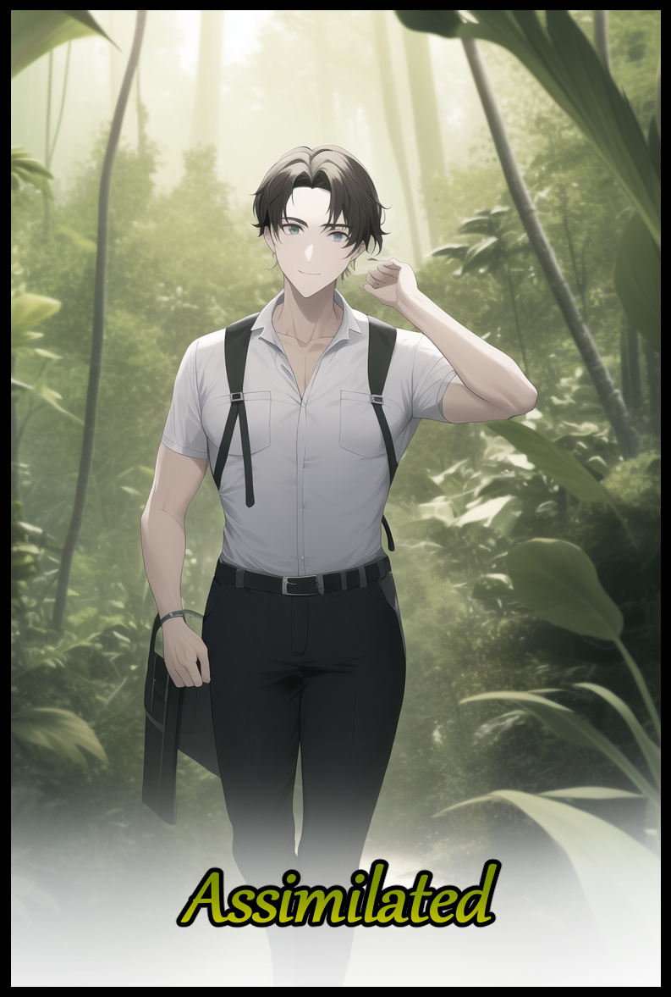

*‘Was it all just a dream?’* A question echoing repeatedly within the head of a young lady basking near the waters of a river lapping against the stone and soil she sits upon. Ochre skin glistening under the sweltering rays of an afternoon sun while ruby red eyes trace the ripples in the surface left by speedy fish swimming by, only to be speared by an excellently aimed throw from the lackadaisical woman. Sighing as she rises despondently from her post to toss the newly caught fish into a straw bucket, doing her best to stay focused despite the chatter she could hear from somewhere behind her.



Boys from the village no doubt, spying on her with lecherous eyes instead of training again…strangely enough, she would've taken comfort in that fact if only to placate her worries that her past was just as she remembered it to be; a simple girl born to parents who cherished her like a gem, doing her best to keep her people well fed and safe once she had grown able enough to wield a spear, joining the men on hunts while the rest of her sisters held back, tending to matters of maintenance while others taught the next generation important skills they would need to carry on their mantle without concern.

But the dreams and visions she'd been having as of late were starting to affect her performance. Missing out on prey hiding just out of sight, missing the mark on her throws. The list of problems was an ever growing one, all because she couldn't get a good night's rest ever since she'd hit puberty a few weeks ago and the sudden developments it brought with it, both physically and mentally. A precarious point in a woman's life if she hoped to attract a mate to be with for the rest of her life…something Asmola was already struggling with thanks to her boyish habits in stark contrast to her curvaceous appearance, earning the ire of her parents as they struggled to set her on the proper path.

The dreams in question weren't malignant at all…confusing might've been a better word for it. For she found herself strangely drawn into them whenever they would strike her while she slept, experiencing what looked to the life of a pale man sailing in from off the shores of the island she called home in perfect detail. Everything, from the smell of salt wafting in his nose to the excitement he felt while speaking a language that was both alien and familiar to her all at once was so realistic that it made Asmola easily fall into his role, believing herself to be that man as he anchors his boat the shore before making his way toward the edges of the jungle. Pushing through dense foliage and almost slipping on a twisted root or two until finally arriving at the outskirts of the village where he would be welcomed by who Asmola could recognise as the Chief and the Shaman, spying her mother and father by the corner of the man's vision as he was shown around by the strangely welcoming locals, feeling his confusion and wondering just as he did; why were they so easygoing? This was so risky, allowing an outsider so readily into their heart…if she were in charge, she'd personally task the hunters with keeping him under lock and key until they could decide what to do with him.

Despite her personal protests, the dream would go on and she would soon grow quiet, watching this outsider observe their daily life and customs, recording his findings in a strange little thing made of wood and lined with fine layers of smooth rectangles upon which he scribes letters with a sharp implement far removed from their use of fingers dipped in paste to mark stone and wood with easy to understand symbols derived from her people's spoken tongue much like the ones currently adorning her body, whose purpose was to draw the eyes of men looking for suitable wives to take under their wing by highlighting her more appealing features, doing little thanks to her gruff attitude and unsuitable behavior in their eyes…and definitely not because she tended to outperform the men when it came to the securing of kills and other material vital to the village's continued upkeep.

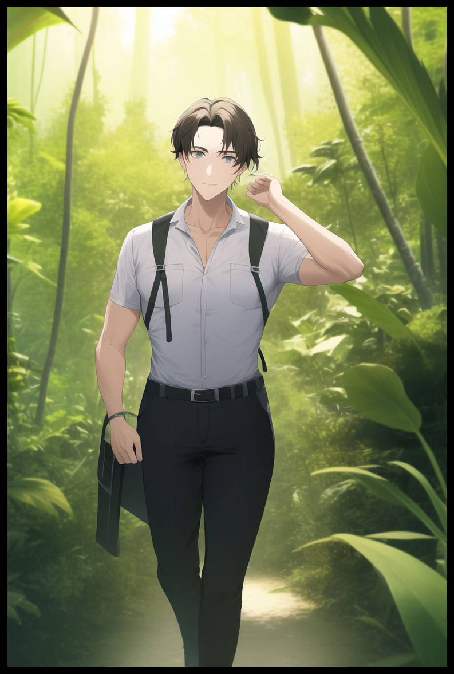

Something strange would begin to happen to the man as the days flew by and the memories grew hazier. Watching from his perspective as his appearance begins to *change*, gaining a tan that would grow to become a natural khaki alongside a notable increase in both musculature and soft fat across his formerly boney physique. Making the smartly dressed foreigner indistinguishable from another of their number over the days of his stay as he abandons his clothes…then his notes…until eventually he joins them in their activities, never batting an eye to his belongings or the boat he'd left at the shores as his planned stay of a month soon turns into years, changing so much to the point where she couldn't even recognize him once he had begun to grow…breasts…he was becoming one of their women.

But that wasn't the strangest bit…the part that scared her was when her parents seemed to start caring for him as if Steven was their own son when he eventually stopped partaking in hunting and gathering, staying locked down inside their hut in the very same room she lived in currently. All while he continued to lose himself like those curious insects she'd seen in the trees. Starting life as pulsating worms until they wound themselves up in soft shells, emerging a long time later as winged creatures that dazzled her with their beautiful wing patterns…a similar sequence of events that afflicted Steven as his breasts continued to grow while his musculature fades for pronounced curves, soon losing his wrinkled member for a hairless slit with its purity intact…all features that would've made her an excellent woman to take up for a wife.

She thought it weird how accepting he seemed to be towards the alterations to both his body and mind. So accepting in fact that she had to guess someone or something was influencing him, maybe her parents? There was no doubt about it for Asmola could feel it; how external hands probed his mind, making him slowly begin to forget his purpose for coming to their island, going from studying to participating, foreign to native…until he had lost completely, replacing what made him Steven, a man from another land far across the ocean, with the traits and qualities of a local bred girl until nothing unique remained, blacking out from the dream at that exact point every time he…or rather she, would wake up on a particularly arid evening before washing up at the pail outside…looking into the unmistakable reflection of her younger self, perfectly mirroring a sequence of events she herself had remembered in even clearer detail; from the careless way she'd scratched her loins as they itched from the irritation of constantly cinching against the cloth of her dress to the amazing chill of the water as she splashes it against her face…it left her panting in a fit of cold sweat everytime, sending a chill down her spine upon the realization of yet another surreal out of body experience playing out in her mind, muttering the name of the man whose besmirched memory she seemed doomed to relive forever under her breath with a furrowed brow, deciding to call it a day with her catch as she heads for the village with her bucket full of fish in hand and her spear in the other.

But before she could deliver her catch, a shrill voice calls out to her from the side of the path, scaring the onlookers away as Asmola turns to meet the piercing gaze of the Shaman herself. Hunched over in her heavy robes, crooked staff in hand, forcing the woman to take a knee in the usual gesture of goodwill everyone offered in the wake of either the Chief or the Shaman, arguably the two positions responsible for the ongoing safety and security of their humble little settlement far from the prying eyes of foreign powers, so it was natural for Asmola to kneel before such capable individuals who had kept her people safe so she could be there to grace their presence.

Beckoning for her to rise with a powerful thump from her cane, the Shaman directs Asmola to follow after her, grunting a command to a man she was familiar with, nodding in thanks as he carries her haul and weapon back toward the village, keeping their gazes locked with each other before they part ways. Unlike the other hunters, Fermut was kind, understanding and oh so lovely to be with. Ever since she began to have these dreams, he was the only one in the village she was able to confide in comfortably. Not even her parents counted in that number when faced with what she'd seen in Steven's memories (if they were even real and not some figment her over imaginative mind had dreamt up) and the implications behind it.

And the fact that he was with her…had he told the Shaman of what was ailing her hoping to find a cure? Amazingly brash if so, very few could simply walk up to an elder and demand a favor, much less so the Shaman herself…either this was a major problem Fermut had managed to goad the undaunting into believing…or the Shaman knew something they didn't…and that irked Asmola the wrong way as she follows after the elder, eyes widening upon the realization of where she was being led to as they strode further and further away from the village proper towards a small alcove carved into the underside of a muddy wall, forming a natural passageway leading down into the depths of the earth.

'But there's no way the Shaman would trick me…she's a legendary figure after all…maybe she'll just help sort my mind out' was more or less Asmola's train of thought as she enters the hallowed halls of the village underground, supposedly the place where their deities bestowed great power to keep them protected alongside the wisdom of the ages gathered from the minds of influential members of the tribe from its inception till the current day. Instilling enough positivity in the troubled woman's heart to wholeheartedly trust in the Shaman as she begins her descent underground.

That would be the last time anyone in the village saw friction with Asmola after whatever the Shaman had done to her down beneath the earth. All they knew was that she had become a changed woman overnight, losing most of her gruff personality and warming up with most of the menfolk despite their earlier transgressions against each other.

More importantly however, Asmola had been able to reconnect with her parents after she had made the decision to put down her spear in exchange for more maternal duties like preparing a new home in tandem with her chosen mate Fermut. Building the foundations of what would soon be a bustling home for the adults and their children. Commemorating the first night of their lives as husband and wife with slow, loving copulation that ended with a guarantee that Asmola's belly would soon be heavy with her first child in a few month's time…

As for her dreams? They never plagued her again…nor would she ever recall a name like Steven after the healing ritual the Shaman had performed on her, plucking the remaining vestiges of the foreign man that had arrived in their domain on the nick of time to solve a mild crisis that would usually rear its head every once in awhile; infertility amongst the women…and in this case, only one family seemed burdened by that seemingly incurable ailment. Something the Shaman had almost given up hope on fixing until she sensed the arrival of Steven. Surely a gift from the heavens themselves as she and in turn the village, welcomed him with open arms.

He had claimed he wanted to learn more about their customs, to make known their presence in the greater world…but behind his claims, the Shaman could sense personal gain to be had; being the one who discovered their village as if they were a relic to be exploited…

And so she would work to keep that from happening, faking acceptance while her magic slowly worked to assimilate the foreign thorn in their side, keeping the disabled couple's wishes in mind as she molds the unwanted guest into a lovely maiden by taking heavily after the infertile mother's side of the family and interfacing it with Steven, overwriting him like a scribe would a miswritten piece of scripture, painting over until nothing remained of him…at least, that was what she thought until Fermut, the meek yet honest boy, had brought news of the newly reborn Asmola being plagued by dreams of 'living another man's life, a strange man from outside their village no one but herself could remember…a problem that needed immediate rectifying if she hoped to avoid instability amongst her people.



But in an act of respect for the former man's hardiness and drive to live on despite being changed so much, the Shaman had collected Steven's memories and experiences, his essence in a nutshell, to be archived in the village's collective consciousness…ensuring he would be remembered for the sacrifice of his manhood even if he didn't quite know it in the new form he'd been given, rutting like a canine in heat with Fermut as they exchanged soft spoken words of affection with each other under a moonlit night, sweaty bodies radiating heat from their efforts as Asmola slowly drifts off to sleep with her husband close at hand, his pecker lodged deep inside her throbbing loins to ensure the majority of his seed remained sloshing around inside her womb…

Her work however, was not done by a mile. Steven's arrival on the island was already a worrying sign, indicating the magic that kept them concealed was beginning to be overtaken by whatever modern civilizations existed beyond the endless blue horizons…they couldn't risk anymore random arrivals, but if they came in small enough numbers like Steven had…maybe more like Asmola could follow suit…after all, fresh blood was always welcome in their right knit community, and the Shaman could see no better way to do that than to draw from unwitting outsiders…especially those who would think her people easy pickings for their own selfish ambitions…

THE END