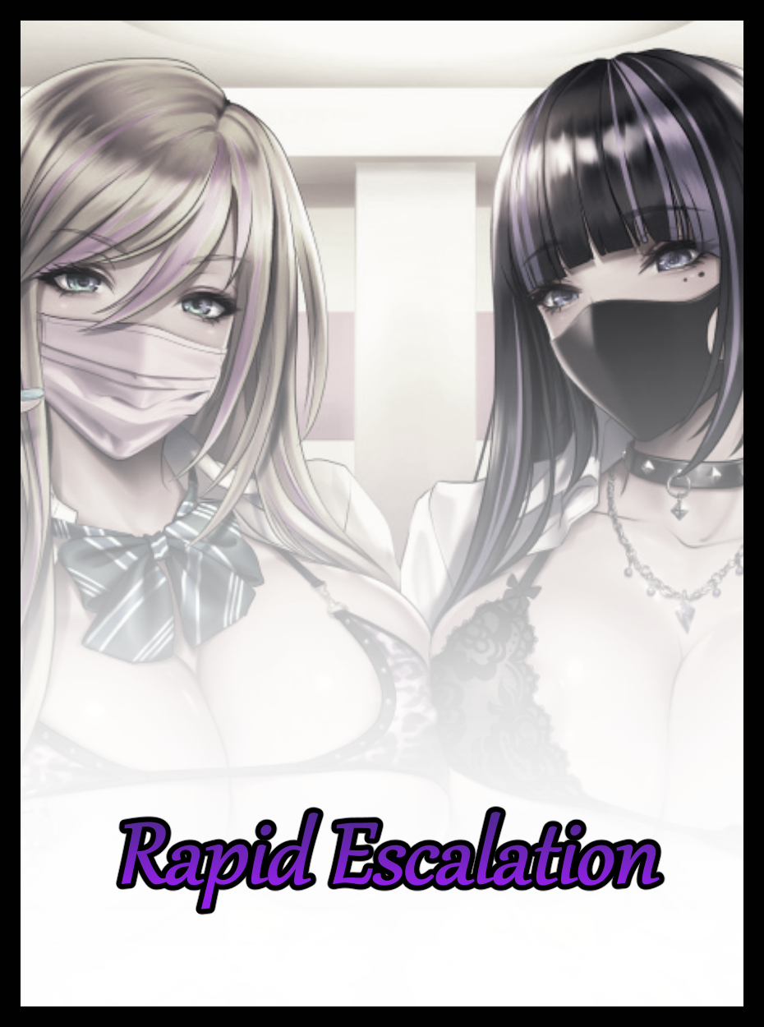

Within dimly lit halls and empty classrooms bathed in the warm citrus hues of a midday sun, two distinct voices of women could be heard echoing throughout. Seemingly in argument with each other if the anger apparent in their voices was enough evidence to go by. The subject of their 'discussion' barely discernible to the average listener when all they would be able to hear was just muffled yells and only the occasional vulgarity being vocalized with added emphasis and extra emotion.

But at a point so late into the grungy campus' operating hours, there was nary a soul around to bother the two feuding women nipping at each other’s throats within an empty lecture hall. Their bags packed away, ready to head home and call it a day were it not for this petty argument keeping them rooted to the spot as scathing words were exchanged with fervent energy. Insulting everything from looks to taste while wide eyes saw nothing but blinding rage toward their respective nemesis. Their shrill vocalizations and crude gestures providing a brief glimpse at the underlying rot beneath the women’s alluring exterior. With choice insults like; “An emo bitch? If it weren’t for you goin’ around with those saggy basketballs bouncin’ around, you’d never have hit it big with Andrew!” , “With how mud you’ve got on that face of yours, it’s a wonder you haven’t like, gone blind yet!” and the ever so mundane yet universally understood classic “You are such a bitch!”...but even an argument as heated as this would eventually have to come to an end, and with an abrupt departure, the pissy platinum becomes the first to vacate the hall. Leaving her gloomily dressed ‘sparring’ partner alone to utter a few more words under her breath before doing the same, making a hasty retreat with a scowl on her face after slamming the doors shut. The echoes of stomping feet left to fill the silent halls with sound now that the spewing of venomous vitriol had come to an end.

Unbeknownst to the rivals however, an unseen set of eyes had been forced to watch (and listen in) their spiteful display. Scowling at the vulgar words being thrown around after realizing this wasn't some serious argument between two friends having a falling out moment, but rather, a contest between two familiar, adolescent skanks who each thought themselves better than the other. Yelling on and on about how one's choice of dressing was inferior and how the other was way better at 'hooking the boys'...and when taken in tandem with such nasally voices that had yet to cross over fully into ripened adulthood, made for a strenuous exercise in patience when it came to bearing with such a raucous that made the unseen entity tremble in rage, hoping the two would leave so it could resume it's late afternoon slumber.

But after what felt like hours had passed with no end in sight to the girls' argument, the being had taken it upon himself to end it right then and there. Coaxing forth primordial essences the likes of which had not been seen on the face of the Earth in many a millenia just so it could bring an end to all the whining, for this hadn't been the first time something like this had occurred between the rivals the long lived, college dwelling being had come to know very well even if he didn't quite like what he saw. Such was his nature as a spirit who had come to call the old college grounds home years ago, and like any other spirit of his ilk, had settled in nicely to the point where the campus itself had become an extension of his existence. Allowing him to glean all the information he needed to know about the two scandalous women in order to concoct the most fitting punishment that would rid him and the campus of their obnoxious presence forevermore…

The first one up on the chopping block was Natalia, the vivacious lady with a head of lustrous ashen who had been the first to call it quits. With the faintest hint of a southern belle accent to a sonorous voice oozing the sensual flair of an immature bimbo, the first year college grad had easily hooked most of the campus' male population, bringing them under her sway as the institute's de facto queen bee. A position she begrudgingly had to share with Tristina, the brooding lady styling herself after a goth punk with sensual flair that more than made up for her lack of raw titillating quality demonstrated in full by Natalia. Who was none too pleased to know that such a drab 'emo' had cut into her own slice of the pie right out from under her nose, an intruder vying for her own cut of the vainglorious ‘empire’ the ditz was fashioning for herself out of the muck that was this cheap, run-off-the-mill college for highschool dropouts and delinquents with nowhere else to go. A dark reality painted over by colorful advertisement and false marketing to push for new admissions and a fitting den for the two like-minded women who had no idea of the major similarities they shared even if they would deny it to the bitter end. Showing only the faintest signs of camaraderie between them in a testament to that innate bond whenever the coals that fueled the flame of competition were faint and cold. But when the embers were stoked and raring for an outlet to emerge from…all negotiations were off, and ear piercing screams alongside a cacophony of the most unladylike noises imaginable were quick to follow…

But that very same thread had been one thing the entity would see fit to capitalize on as the catalyst behind his brewing revenge plan, firing off a pulse that resonated with Natalia and Tristina just before they had left to go their separate ways. Imbuing them with a payload of magic that would steadily begin to strengthen as time went by…and when it would hit its eventual peak? Well, safe to say that the girls' incessant noise making days at the college would finally be over…not like the spirit was going to harm them or anything, for as furious as he was, Malevolent was a trait he did not embody. No, punishments and ‘acts of karma’ were the words best suited to this temperamental being, who could see no one better than the two mindless ditzes meandering their way through life to work his magic on.

And besides, once their college years were up. Where exactly were they going to end up? Manning a convenience store counter maybe. Or perhaps finding a sugar daddy to support them seemed more likely. Either way, all he was doing was speeding the process up a little with some minor adjustments here and there…a rapid escalation of the situation, one might say.

With his meddlesome part in all this concluded, the welcome silence and cooling winds of a fast approaching evening ushers lethargy back into ethereal limbs. Coaxing the spirit back to his peaceful slumber once more, sparing not a thought for the miscreants that would soon cease to be a part of his life altogether. Moved far, far away to a place where their debauched passions could truly shine and where honest folk like himself would remain free of their nauseating vices and seeming absence of social etiquette. A subtle process that would take hold of Natalia’s oblivious self just as a lanky foot steps out from the front gates of the college. More concerned with huffing to herself about the insults Tristina had flung her way than the lengthening locks of hair cascading down her back in a swirling mass. Losing the artificial layer of gaudy grays that had coated every last inch of her hair, unveiling natural raven for the briefest of moments before a new, even more pronounced coat of color splashes itself over a windswept mane that had finalized itself at a length long enough to tickle at a protruding rump whose girth had begun to show itself through the hem of a shrinking skirt. Sporadic changes that quickly begin to accentuate Natalia’s risque manner of dressing in accordance with a not-so-subtle increase of mass and height all around. As if the twenty year old was experiencing a ravaging passage of time as months quickly become years, transforming the bratty bimbo into a true seductress who knew best how to get the horny menfolk staring her way wherever she went; a hypnotic sway to pendulous hips with gratuitous steps that serve to flip and pinch at a pleated miniskirt, unveiling panties that shrink away. Taking on a consistency and make more akin to a racy thong than the cotton wraps they once were, giving the fattened lips of a juicy vulva a good tickle as snaking straps sling themselves around the length of fertile hips flanking a toned tummy ripe with muscle earned from something that definitely wasn’t exercise. Interrupting her frustrated musings with an involuntary groan that comes out just a few octaves deeper and with the sensual air of an adulterous woman who had seen real experience far beyond the likes of rookie foreplay and childish groping, drilling her undulating body with all the muscle memory gleaned from phantom hands and other unmentionable body parts. Imparted by weeks…no, years of sexual depravity the Natalia of today had yet to experience for herself.

But as dull eyes of ivory green dilute and warp with smoky trails of cyan blue, mental images and foggy recreations of said events begin to fill an addled mind. Steadily convincing the young bimbo that the woman she could see throwing herself into many scenarios involving a naked man to be herself, one and the same. Reflecting the sexcapades in minute changes within her aging form and across its unrecognizable exterior, looking more like a carefree adult than the wannabe college queen she once was only a few minutes ago. Drawing the attention of weary businessmen on their way home from a tiresome day, welcoming the sight of what they could only perceive to be a scantily dressed prostitute advertising her ‘goods’ just as a baggy cardigan and the blouse beneath it finish their fusion into a revealing top secured not by buttons, but with a makeshift knot done up right beneath a bosom that had since experienced its own growth spurt. Leaving two milky tits bouncing freely around inside a matching bra that does little to secure their gelatinous mass, not like there was even an ounce of modesty left inside of Natalia’s mind to care of course. Because to her, the more skin she showed only meant that more men would be interested in the lascivious services she could provide with the luscious boobs, pliable ass and tight lil pussy that came packaged with her…and when they began to mouth off about some spanking hot lay they had ran into out there in the streets? It would only draw in more potential clients who would happily throw their hard earned dough her way, just like all the others who had felt her for themselves, returning with renewed vigor to feel the sting of her manicured fingers digging into their backs every time they did her raw. Gasping as a faint pop from between curvaceous legs causes her brain to white out for a moment. Erasing a faint sense of irritation that quickly makes itself void now that the reason to sustain it had, just like many other things, been drained straight out of the vapid bimbo’s already decimated mind. Clearing the haze of clashing memories and conflicting thoughts just as the last of her childish facial features are overwritten; gaining a foxy slant to formerly wide eyes while the broad nose between them flattens and shrinks into a sharp, vindictive point. Accentuating a striking come-hither gaze while lean lips beneath them bloat into lipstick lathered cocksuckers perfect for latching onto a true man’s phallic girth. Giggling in a voice oozing with hypersexualized aftertones as the length of her throat tingles in response to the lewd thought, licking luscious lips while sharp, side swept bangs descend to frame the perfected visage of a woman who knew no boundaries, no shame and certainly not a single thing about some college she never even attended after the memory of dropping out of highschool seeds itself within vulnerable synapses that could no longer differentiate fabricated fiction from waning reality. Trading the persona of a vapid lass for the real deal…

No more worrying about what the future held for her, no more strife with a familiar face that now held a different position in her mind while the lingering remnants of gnawing anger against pesky parents who didn't understand a lick about her no longer mattered, none of it did. She was living life to the fullest, enjoying every single day to the best of her ability with the only person in life she ever needed to rely on…all she would ever need from here on out.

By the time long socks had wrapped themselves firmly around shapely calves after emerging from polished heels that had subsumed plain sneakers, Natalia’s hairdo had taken on strawberry pink highlights to their metallic length while formerly unimpressive eyes had forever shifted over to a sparkly sea blue glimmer. Contrasting nicely against the drab beige of a knotted top to draw the eye of an onlooker to the naughtier bits of her banging bod. Like for instance; a skirt that did scant little to hide the full scale of a bubble butt and the pink undies slung tight between immense cheeks and a runny vag even when standing, or how the vast navel curtain showing off her pinched in waistline served as a warning to the uninitiated that she wasn’t just some cheap escort as hinted at by the presence of expensive studs embedded within her cute little belly button. Coupled with her lavish yet slutty appearance and the overwhelming fragrance of strawberry wafting off every last inch of her perverse form, and any man could immediately tell she’d be worth whatever price she would ask in exchange for a slice of heaven. Cementing Natalia’s renewed identity as one of the town’s most sought after escorts who almost always had a line waiting for her outside the nightclub she frequently associated whenever she wasn’t busy stuffing her mouth full of cock beneath some rich daddy’s table out there in the business district where many a client wouldn’t mind having some street wench relieve them while on the job. A privilege most often reserved for managers and CEOs, offering ridiculous sums just to get Natalia to follow them inside whatever building they happened to be working at if they had the time, or if they were rushing for a business meeting soon after lunch; shoving her into the nearest nook for a quickie. Leaving with their stress relieved, and the blonde skank with a belly full of piping hot semen…and speaking of… “Heya mister~ Noticed you’ve been eyein’ me up for quite some time now! Don’t act all scared, I know you’re interested…or else ya wouldn't've followed me all the way out there…so? How about it? I’m in a good mood today so I’ll give you a discount! Haven’t seen your face around here before so…first time’s free…just do me a favor and make it enjoyable yeah? I’m totally chargin’ full price if you’re some limp dick quick shot!”
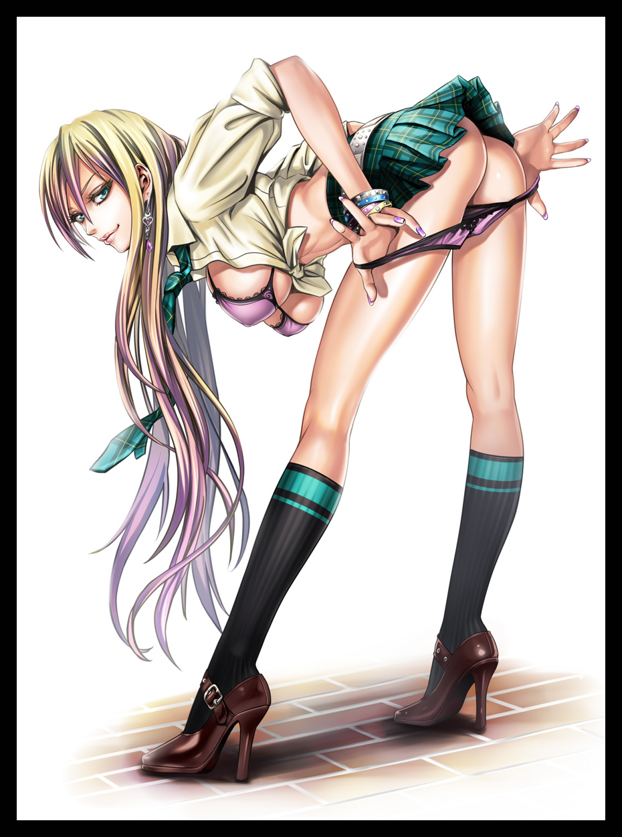
Brushing off the idea that she might’ve been missing out on something important in favor of bagging the nervous gentleman who had thought himself sneaky enough to tail her of all people, the reborn Natalia crosses half of the distance between them with those killer legs of hers before leaning over into a sideways facing posture, leaning down with a provocative arch to a flexible spine that leaves milk-laden boobs hanging like pendulous weights. A lewd pose that roots her target to the spot with his jaw hanging slack at the preposterous show being put on before stupefied eyes, a weakness that allows his own mind to become clouded by a lighter form of the haze that had ‘nurtured’ the shameless wench within Natalia, making it so that the act of pulling her panties down in front of a man came as second nature to her. Doing so without the slightest hint of hesitation to be seen in her fluid motions or the suave expression plastered over her beautiful face. Deriving enough joy from the debased deed to wet herself on the spot just as the fabric lifts away from her eager snatch, trailing a thin bridge of dangling lubricant between her lower lips and the wrinkled stretch of underwear left half disheveled and stretched taut between fine pillars that would serve her well in the strenuous act to come as it had done so many times before…

As for her partner, he too could no longer remember the original intent for trailing the blonde airhead into the depths of such a rank alleyway. Succumbing to Natalia’s feminine wiles as trembling hands brush aside the unkempt skirt that was barely doing it’s job in the first place to get at the warm meat beneath, giving her right cheek a hard squeeze that sends a titillating sound straight into insensate eardrums, twitching in the throes of estrus’ feverish grip as his number two rises to full mast, causing a strain unlike anything he had ever felt before in his life, amplified by the unbelievable feel of a woman’s soft fingers sliding over it’s restrained length as if she knew how to handle ‘him’; where to jab, which vein to prick with the tip of her raking claws and how he loved the application of force to the head of his member. Grunting in tune with the streetwalker’s mischievous giggles, evidently satisfied with his size from the way her dumptruck of a bum had begun to jab into his crotch like an impatient dog nudging at it’s owner for a treat instead of just leaving the man where he stood as with her usual routine when it came to dealing with ‘unsatisfactory’ clientele. “Y’know? I actually thought you were like, gonna be a real limp dick or something. But you boys can pop a real big one when a girl gets your gears going huh? But we’re only just gettin’ started, so c’mon babe. Show me what you can do~”

Stretching her neck around like a serpent, Natalia would land a careless kiss straight onto the man’s waiting lips, filling the air with the raunchy prelude to their bodily union while kicking the formerly curious and frightened man into full gear, filled with the courage and unimpeded arousal needed to plow the babe offering herself to him free of charge. Forgetting the startling sight of some unimpressive college dropout flowering into the stunning number he was currently pistoning in and out of with gusto, too enamored by the tightness of her insides to care about whatever had influenced her change from just another uneducated bimbo into the bona fide slut whose powerful legs and vigorous reciprocatory thrusts painted her as a mistress skilled in the carnal arts of lovemaking to question it, thinking of Natalia as a simple sex worker who had caught his attention, nothing more, nothing less. Falling with her into an abyss of lust that sapped the two of any thought besides enjoying what the other had to offer; Natalia with the fiery rod banging against the puckered entrance to her uterus, the sweaty businessman whose name she had failed to ask ravishing every last inch of the sultry woman whose name he too was clueless of…adoring her pleasure twisted features with nary a hint of the clueless brat she once was left in the face of a buxom minx who looked to be approaching her thirties instead.

While Natalia would engage in the profound pleasures of the flesh offered by her ‘enhanced’ physique however, Tristina would be left as the last to change on her own, taking on a more severe and violent reaction to the magic’s activation within her being in comparison to the relatively unnoticeable process that had left her nemesis irrevocably altered, a change she was yet to become privy to as a swift diversion en route to her home in a high rise flat takes her into a dimly lit public restroom at a nearby park. Carrying herself with a noticeable limp to her gait thanks to disproportionate limbs that seemed to grow at differing rates separate from one another, an alarming affliction kept numbed to a feverish mind starting with thighs that plump and bloat to tremendous proportions far removed from their formerly stick thin appearance as heaps of baby smooth fat and toned flesh manifest out of the blue to insert themselves into vacant pockets. Leaving the goth with portly legs that looked cartoonishly off when contrasted against the rest of her unafflicted body. A discrepancy that would not remain uncontested for much longer as a loud crack from popped straps and a strained “Urgh!” fills the air amidst the subtle crackle of strained fabrics and bubbling flesh. Barely catching herself against the polished rim of the basin she would end up using as a support for most of the ordeal as a pillowy core surges outward after freeing itself from the suffocating embrace of a lengthy skirt criss crossed by studded belts and skull decor that could no longer fit around hips that had abandoned their gaunt outline for a handlebar girth comparable to that of a gravure model’s.

“W-What the hell’s…h-happening to me?! C-Can’t move my arms…my skin…why’s it doin’ that?” Grimacing at the sight of crawling hide squirming with unseen activity going on beneath, Tristina’s attention falters enough for the mental rewiring that would leave her unable to do anything but accept to begin in earnest. Starting as a pinprick shock at the back of her mind that would force an involuntary gasp of air to leak out before stiffened shoulders twitch in a last, futile sign of resistance before loosening up altogether just as ruffled locks of midnight smoothen out, losing the gel keeping it all together until they fell down her sides and back in much the same way her rival had hers done; loose and free falling in an ever lengthening trail of mystical raven interspersed with occasional trails of neon magenta to match the otherwise mundane veil with the gradual emergence of said color palette across the majority of Tristina’s stabilizing form as it all falls apart. Following in the path Natalia had unknowingly been led across as the rest of her shrimpy form underwent the same process that had left her legs measuring in nearly half the length of her original height. A number quickly surpassed once lengthened bones and accompanying layers of entwined flesh add up to form a voluptuous silhouette not even Tristina could recognize as her own, that is of course, if her sense of self were still intact that is.

Because with every white hot spark that zips across each neuron to stimulate the synapses in her brain, vast portions of the goth girl’s being would be lost to the inky depths. Making Tristina question herself with every gap that manifests before answering said doubts with new pieces remodeled to fit her ever changing form like computer software being formatted to fit the upgraded hardware it had been forced to run on. And like any other essential update, the information being uploaded into the stunned woman’s mind would prove pivotal in overturning Tristina’s understanding of goth fashion, removing the need to drape herself heavily in it’s semblance in favor of light sprinkles of the subculture’s signature traits like the major use of dark, moody colors and dramatic flair when it came to the positioning of accessories and the application of makeup. Leaving the imperiled student looking rather normal by the time a flat chest had ballooned to incredible proportions, stretching reformed material to the limit as the straps of a lace bra colored gun metal gray to match her glimmering hair squeal in protest to the immense baggage they were tasked with holding up without prior notice. Finding reprieve in the form of a salacious cutout that allows for swollen nipples to protrude from as they harden into erect nubs, stimulated by the arid air of the restroom. Attesting to their sensitivity as the insertion of cool metal piercings cause Tristina to lurch forward with a guttural, drawn out moan. Wet tongue lolling in the air just as another stud pierces its frolicking length while childish eyes shrink and contort into a far more promising fit that leaves the girl one step closer to attaining the true form embodied by her rotten ideals; a beauty styling herself lightly after goth tones. Conveying the misunderstood style with the level of attention it deserved, highlighted by the grace and allure expected of a mature, level headed woman like herself…

And just like that, the fragmented memories of a troubled college student were completely scoured from synapses that refused to believe in them anymore. Leaving all the room in the world for a fabricated lineup to take their rightful place in a body that no longer belonged to the Tristina of old. Retaining only a shadow of the closet prude she once was in the form of the tact and faux skills that had enabled her to compete on someone who relied wholly on sex appeal to win the favor of men like Natalia, except said skills were no longer just there for face value boasting but rather practiced and put into effect many times over by seedy experiences of a similar vein to the new woman busying herself on the other side of town right as the last figments of Tristina’s new self are allowed to settle down. Not fretting one bit about the expensive rocker jacket adorned with edgy stickers and badges the magic warping her had reduced to non-existent rags somewhere along the way, leaving just a plain white undershirt that had been adjusted to fit her adult frame; a tight, lithe figure that had aged nicely under the effects of rapid time acceleration. Producing a woman with the looks and maturity to easily pass for her former self’s big sister if anyone in the world could even remember a lick of Tristina’s younger, more naive self.
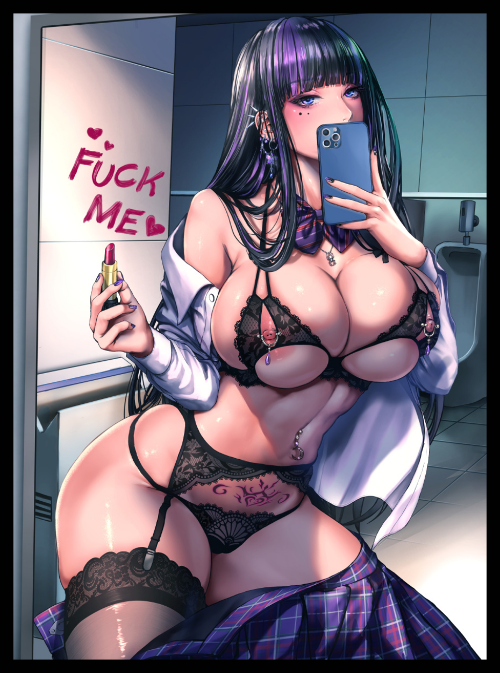
And if the snarky grin painted over her face was anything to go by, clearly Tristina couldn’t remember either. Ogling the half naked reflection cast back at her in the basin mirror with apparent glee burning within abyssal blue irises that had since subsumed muddy grays. Marking the adolescent goth’s successful transition like a butterfly having emerged from its chrysalis…a lewd butterfly whose body was built for one thing and only one thing. Demarking that purpose as an ominous tattoo etches itself into the warm flesh of her navel, right where her womb laid ready and waiting for a special delivery she would receive plenty of in her new line of work far removed from that of a simple failure who couldn’t make it past college. Receiving her ‘first’ catch of the day if recent memory served to inform her correctly, unable to recall the nauseating sensation of magic eating away at her in face of a new one filling the scantily dressed woman in on an agreed meet with a special someone of hers in a popular joint downtown frequented by the both of them. A meeting her mind would instantly decide on holding off on at the sight of the burly stud wandering into the toilet before jumping at the sight of her bare ass squeezed tight by the adulterous lingerie she wore around at all times as a result of a little wardrobe malfunction, and certainly not because her expanding body had momentarily snapped the ill-fitting garments sheathing a body that paled in comparison to the likes of her own.

All she saw was her own grown self framed by the flapping clothes of the highschool uniform getup she liked to parade herself in whether or not she was on the job. And at times such as these, said outfit would serve to mute any potential peepers who might involve themselves in a not-so accidental encounter in the toilet. She had chosen to redo her makeup in the men’s room on purpose after all, and just like the many other times she could remember doing so, the immediate response elicited in her target would spur Tristina to doll out the finishing touch in the form of words written backward using scarlet lip gloss, words whose meaning was temporarily lost to the mildly confused and aroused man who would realize what the flirtatious minx was telling him after pulling her phone out from between her immense bosom, turning the camera view around on the perfectly readable screen so the vulgar message was clear for the stunned stranger to take in clearly accepting of Tristina’s invitation to a one-time fling right smack in the middle of the toilet before common sense would drive her partner to shove themselves into a cubicle before slamming the door shut. Leaving behind the message painted over the mirror and a forgotten pin adorned with the symbol of a cartoonish skull lying on the dirt encrusted floor before that too disintegrates into dust, leaving the toilet as it was save for the occasional rattle of a body thumping against the rickety door alongside terribly hushed vocalizations coming from the occupied stall. Marking an end to Tristina’s metamorphosis into the ultimate goth skank she had always envisioned herself as alongside a drastic reduction to the noise pollution back at a quiet college campus neither girl would ever remember going forward…

Putting aside their visual overhaul, perhaps the biggest change would’ve been the worldly edits done to Natalia and Tristina’s perception of each other to make them the best of friends who would rarely if ever break out into an argument with one another instead of the vitriolic frenemies they once were, recalling precious moments spent with each other spanning all the way back to a radically altered time in highschool that would serve as the kicker to their long lasting relationship in tandem with the ultimate career the two like-minded skanks could ever hope for.

No longer were they immature children bickering amongst themselves over who had the right to rule over what had basically been a playground for them to escape from their own individual woes. Whether it had been Natalia's grudges and insecurities stemming from a troubled family life involving siblings whom fickle minded parents had immediately latched onto when it became clear prospects for her future were dark hence the immediate send off to a dead end college shortly after a pathetic highschool graduation or Tristina’s similar predicament, originating not from a neglected life at home but rather a tormented one fueled by her religious parent’s hatred for what they saw as the ‘devil’s influence’ over their daughter. A vehement distaste so strong it had been enough for them to saddle her apathetic uncle with the burden of raising her. All of it; nothing more than water under the bridge now after what the spirit’s magic had done its work.

Instead of wallowing in their own troubles, Natalia and Tristina had met a few years earlier. Enough for them to meet on even grounds without too much of a condescending view over the other that had led to their alternate future’s endless squabbles. And while their dark hearts were lightened somewhat, nothing could be done when it came to their shared adoration for men. A desire that, without the need to hide wounded hearts, had been allowed to flower into a depraved fruit. Giving rise to the vivacious duo who had agreed to elope in each other's arms come graduation. Abandoning everything with a renewed confidence in taking on all the world had to throw at them with just their significant other close at hand.
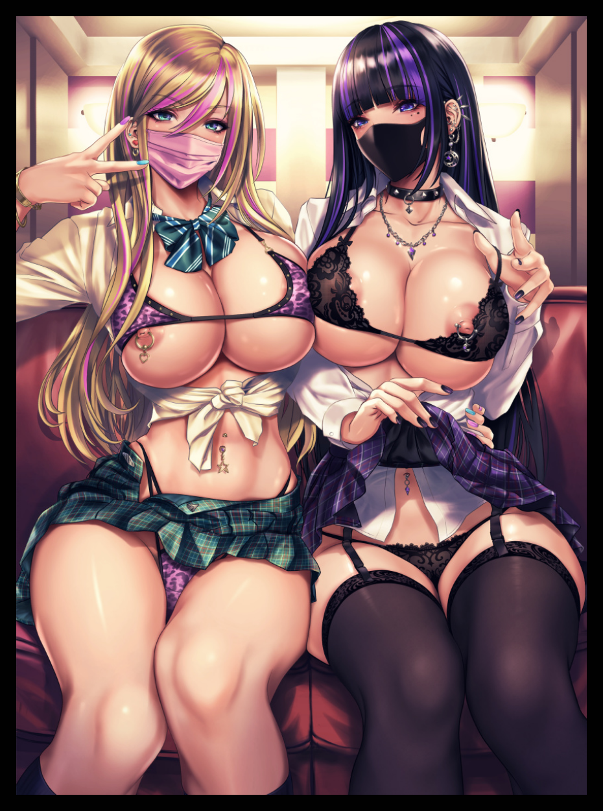
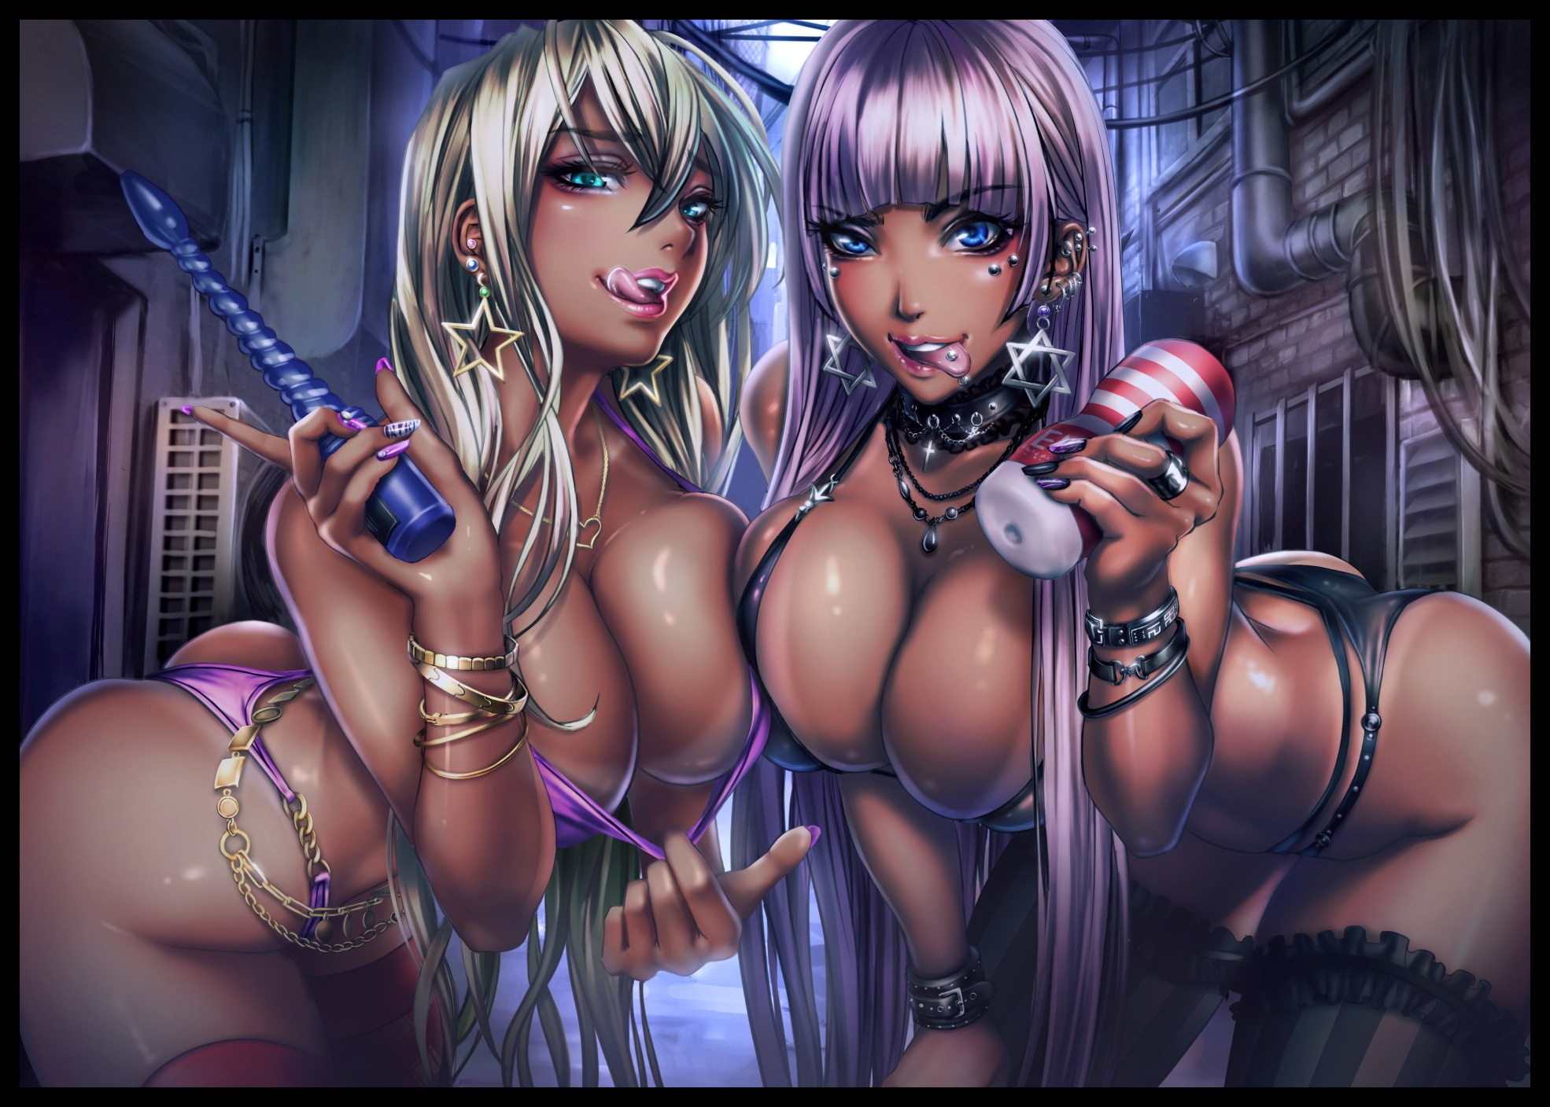
And in a couple of years on a bone chilling Friday night in the present? There, in the midst of a busy crowd meandering through the brightly lit interiors of a gilded nightclub, stood two of the city’s most talented women when it came to matters of the sheets. Chiding each other for arriving late ‘stinking like fish’ with joyous looks on their faces. For as perverse and wanton as they were, the fact of the matter was that the two were kindred spirits brought together like peas in a pod. Sharing an appreciation for sex alongside an innate understanding for what the other had been through, coming out the other side more like sisters than mere ‘best friends’. Decked out in matching jewelry and other glimmering accessories in a show of how deep the bond between them was, adopting a strange fusion between the two styles their former selves once ranted about to no end; with Natalia retaining most of her ditzy blonde bimbo persona while Tristina would remain under heavy goth influence while taking a page from her gal pal’s book just like how she had when it came to styling her hair and doing makeup. An equivalent exchange that left them with the looks of a bona fide pair, encouraging only the bravest amongst the many patrons roaming about to ask the girls if ‘they were free’...and as long as the one asking had the money in his wallet to afford their combined services, they were more than ready to leap into action…

Years later however, the increasingly infamous college would soon be closed down and demolished for good. Leaving the entity that had triggered the girls’ transformation without a home to live in, forcing a lengthy migration to far off lands in the hopes of securing another suitable abode. All while Natalia and Tristina, as depraved as ever, would continue to relish in the delights of their sex-crazed lives. Continuously gaining in notoriety as their skills at making men bend the knee to their advances continued to improve, sporting yet more heavy alterations to their physique in the form of an ebonshade tan and surgical enhancements to equalize their front and back ends.

What had supposed to be a slap on the wrist had become a godsend, and even if they would never find out about it. The two loyal hookers were content with the way things were, especially if it meant getting to live day by day doing what they did best in the presence of one another, sharing in everything without ever missing a beat…

THE END
Pre-TF forms based on art by S3ikora : https://www.deviantart.com/s3ikora/art/Untitled-923879236

Images by Sadakage : https://www.pixiv.net/en/users/821219

