STEALTH +10
APRIL 2021 REQUEST STORY
BY CHALDEACHANGE
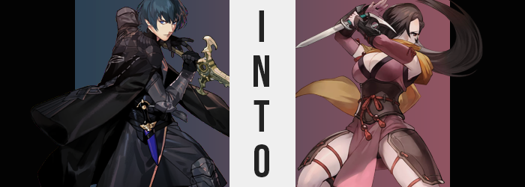

The mission seemed to be simple enough. An investigation into the estate of a man whose goals apparently ran opposite to those of the Church. Archbishop Rhea had deemed him a threat as a result, but before anything could truly be done about him, they needed enough information to justify what would be tantamount to the man’s murder.

To those ends, Rhea had commissioned Shamir to go investigate from the shadows. She didn’t mind at all, and in fact Shamir preferred jobs that weren’t exactly forward. But, considering the size of the manor that she was meant to snoop around, she had asked Rhea for something: help. This wouldn’t be a job she could successfully complete on her own, at least not efficiently. She required the aid of another that was familiar with the shadows.

And Rhea had was happy to oblige.

After all, she had two Byleths at present, and she was making much better progress with one than the other.

“Why was I called all of the way out here?” The brother of the two Byleths had a big question on his mind as he closed a barn door behind him. Rhea had requested his presence at this exact location, a small farm area on the outskirts of the monastery, without any rhyme or reason. Admittedly, he had assumed it was for a mission that was so secret that it couldn’t even be discussed in front of the others. It wasn’t that unusual, and Rhea always made sure they were more or less alone when they discussed things… barring Seteth.

But once he’d stepped into the barn, he was made keenly aware of the fact that no one else was really around. Just dust and the scent of hay and manure, slightly aged. Come to think of it, it had been quite some time since he’d last seen this building used. “Hello?”, he called out to no response. In fact, he called several times, each answered with silence alone. Was he the first to arrive?

That was when he ended up noticing it. An object glistening under the light filtering in through the cracks between the boards that made the barn’s walls. It looked to be a dagger of sorts, with an ornate, green handle. Unlike everything else in this building, which was dusty, it seemed completely clean. Was it related to why he was called here?

The moment he picked it up following this train of thought, he felt unbelievably strange.

From the tips of the fingers that held the blade, straight through to the core of his body, it was as if a strange energy had just washed through him. It provoked him to immediately drop it back where he had found it, because while he’d felt this once before – the first time he’d picked up the Sword of the Creator – there was something off about this. Difficult to describe, he could only best liken the feeling to something static-y.

The object was either blessed or cursed, and he couldn’t be sure of which. Or, at the very least, until his gloves began to unfurl, the threads and leather that bound them, leaving hands bare while the phenomenon continued up his sleeves. Before all was said and done, he was left standing completely bare in the barn, as if he were the livestock being featured there. Had this been a different kind of story, that might have been the case.

Fortunately for him, it wasn’t. Though he certainly wouldn’t find what was to come to be any less shocking, not as his tummy let out a pained gargle. “What is happening!?” While he now stood bare, the fact that his body likewise still felt incredibly warm could not be ignored. Even so, as he leaned forward one of his hands reached down to press against his stomach, for the pain there had become unbearable.

Accompanying that pain was a shift. Almost as if it were starving itself, it began to sink inwards. Becoming flatter in the front, and curving inwards on the sides, the firm muscle he’d accumulated upon his belly seemed to thin until it was barely recognizable while any scars and blemishes upon his skin softened away. It all gave him a very girlish waistline by contrast, one amplified even more as his hips seemed to establish themselves at a widened gait that forced his already fragile posture to arch and knees to bend.

“I’m… transforming!?” Difficult as it was to believe, Byleth could not deny the events transpiring before his very eyes. Even as he stared at his belly, he could notice the changes spread across his fingers as well. Nails grew long, the fingers themselves more petite as they slid across his soft belly without choice due to the shrinkage. Callouses remained, yet they spread out slightly and became thinner – indicative of a different combat style to be sure.

The professor’s options were limited. His form was shifting at an alarming rate, and this barn was so far from the village, must less the monastery, that getting back to find help before it was too late might as well have been completely fruitless. Not to mention that his motions felt labored at the moment, as flesh and bone were rewritten in shape and size to match that which was dictated by the curse placed upon them.

He took a step and almost rolled his ankle, for example, because his feet had gone the same way as his hands. Toes cracked and popped as they diminished in size as if they were being squeezed, while their nails grew about an inch longer and heels became both soft and round – barring the natural wear from prolonged time standing, walking, and running. It had spread into his ankles as well, and with much of his bulk still present in his torso, this weight distribution almost caused some problems.

Meanwhile, Byleth was still trying to rationalize the cause. The dagger was obviously it, but why had it been here? “Rhea summoned me here… Those were official summons, so was this her doing?” He’d certainly questioned her motives in the past, particularly as she’d had eyes for his twin sister and seemed to want her to be the one to wield the Sword of the Creator even though she hadn’t wanted to. Had this been little more than a plot to get rid of him?

Discomfort grew, and the young man let out a groan as shoulder were forced in towards his neck one by one, sending ripples through a torso that was becoming lighter by design with each passing moment. There was an inherent femininity about how his frame was shaping up, so much that he couldn’t even be surprised at the sight of his dick shriveling up and inside her until it was no more. “Really? A woman!? My voice as well…” Evidently, her vocal chords had been replaced within the same breath as her dick, and her tone was now soft and womanly.

For the past minute or two she’d felt like her body had being crunched together. She’d become much fairer in shape and height, creating the workings of an undeveloped woman that stood a few inches shorter than Byleth’s original height. Her facial features had even been reworked, giving her lips that were almost excessively round and pouty, with a fair nose and eyes that had narrowed to a point where she looked to belong of another race, their almond shapes and brown coloration likely unfamiliar to those of Fodlan. On the whole, cheekbones were longer, and her face had a much sleeker appeal.

But while everything had taken the initiative to collapse, it was now time for things to flourish. Much of it happened at the same time, though there had been a noticeable shift in the color of Byleth’s hair long before anything else. The blue that she and her sister shared lightened and lost its ocean-like luster, this blue washed away for a dark brown that was far more typical of a commoner in this day and age.

It then grew, and substantially at that. Like slithering snakes it crept towards her naked shoulders and down her back, strands remaining straight without weaving in and amongst one another. They stopped just below the threshold of her ass, and the style of her bangs found a curved rightward sweep that left most of her right eye covered, while stray hairs hooked beneath the left.

Byleth, who didn’t like having her hair long, should have been bothered by this styling. But she didn’t seem to have a problem. Rather, her heaving posture seemed to be adjusting, and her comfort with the situation was growing. “Just get it over with.” This more or less seemed to be her philosophy on the exterior, yet on the interior she couldn’t even quite remember why she’d resisted these changes in the first place.

Much less her old name.

Her hands placed on her hips; the woman was forced to adjust her grip once key aspects of her body began to swell. Down there it was her ass and thighs, which both ballooned with a gratuity that she’d never seen in a woman that wasn’t Rhea before. Each thigh became soft and supple, so much so that if you were to prod a finger into it, it would certainly retain that shape. Their bulk was sensual in nature, but these legs had grown extraordinarily strong too.

Additionally, her ass? It certainly wasn’t anything to scoff at. The cheeks of her rump jiggled as they heaved with new mass, skin tightening around them while they not only doubled, but tripled in size until they bore a heft comparable to her thighs. Were she to walk now, these cheeks would undoubtedly bounce from side to side, something that would be very noticeable in tighter clothing.

Yet even then, they were hardly comparable to what became of her chest at the same time. The woman’s nipples had sprung to life first, their density greater and their sizing plumper – but not merely from the erection they’d experienced in response to the sensuality of her entire transformation. Their growth was merely the precursor for what came next, and fat was quickly conjured to see a bare chest bloat up into a set of springy A-cup tits. If this had been their destined size then perhaps her ass would have won out in terms of size, but that wasn’t the case. They merely grew.

And grew.

And grew.

Cup size after cup size, they bounced forward with new purpose. They eventually settled in the realm of a hearty pair of Gs, each breast larger than her own head, but despite their mass they were exceptionally perky. Of course they sagged ever so slightly due to their wholly natural weight, and each breath saw the fat within them ripple and bounce, but at no point did they feel like a hindrance. Largely because the muscles in her back had been strengthened to properly support them. But then again, while her muscles looked lesser, she was still actually extraordinarily strong. It was just that this strength was geared more towards agility.

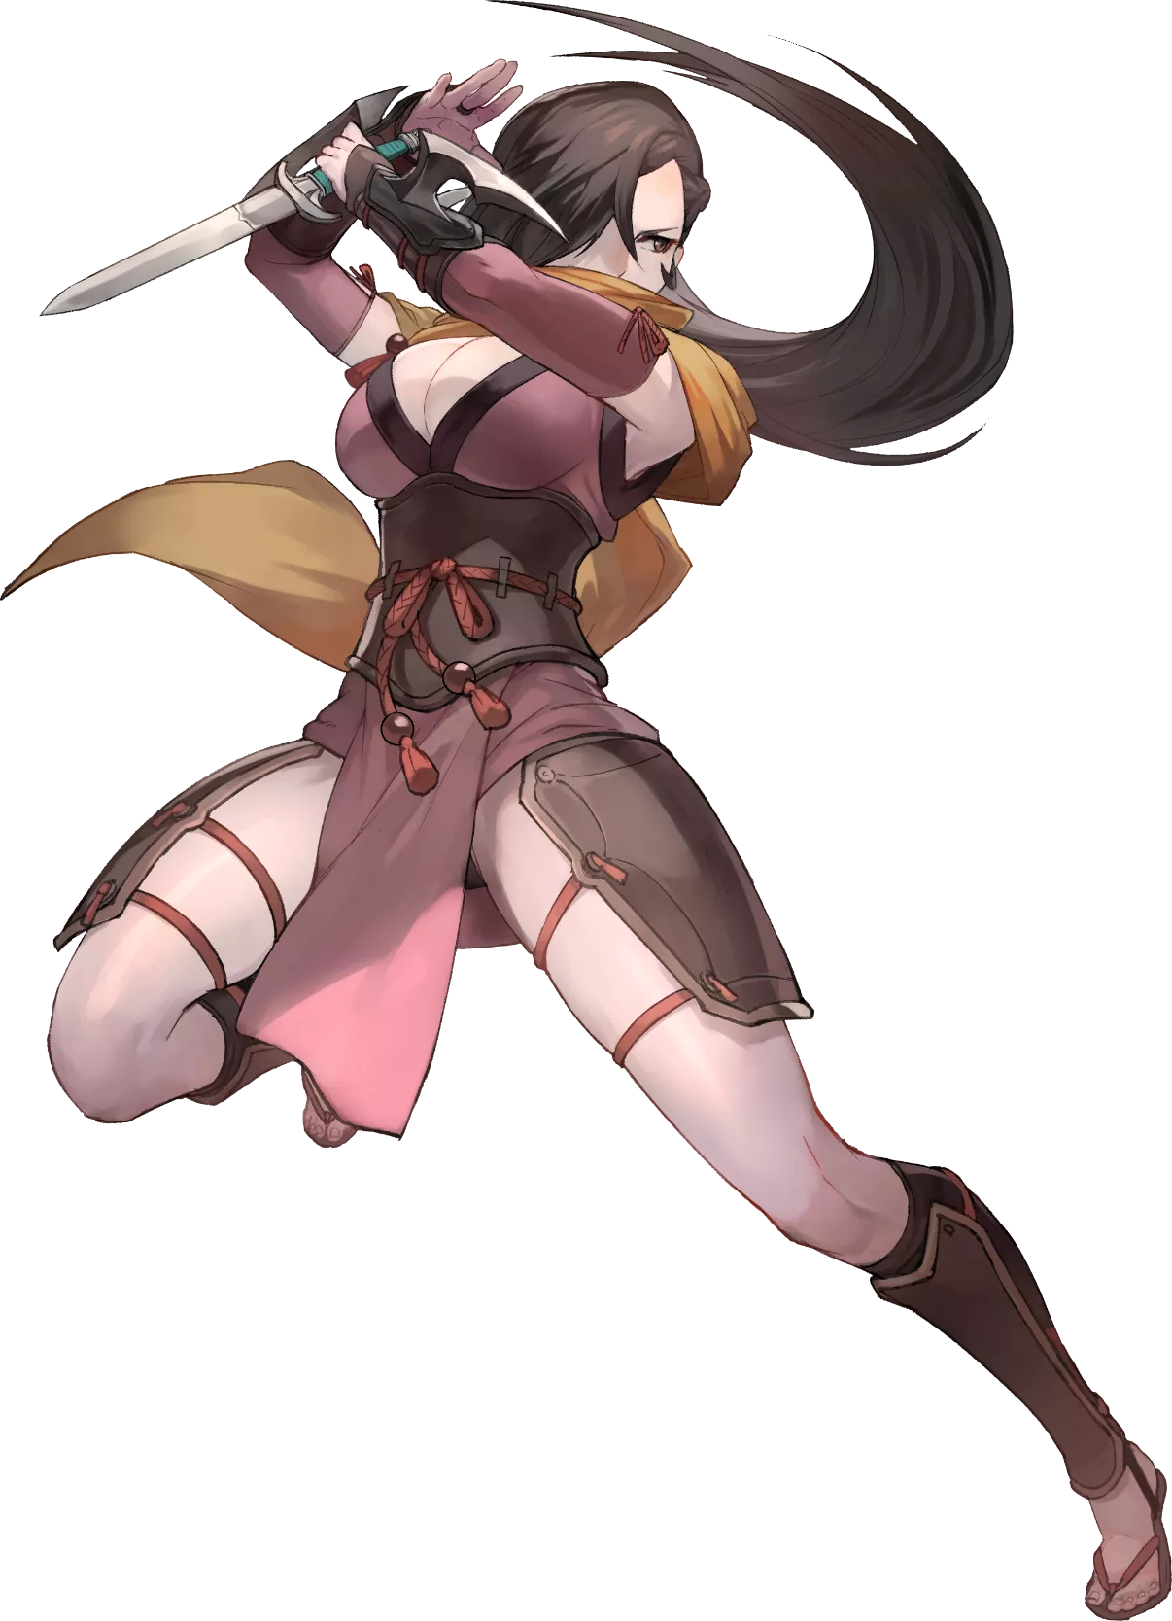
Kagero (as she now remembered herself to be) stood dazed, her body completely bare within an unfamiliar location. No… it familiar. She’d come her with intent, but the reasoning behind that intention was more or less lost on her. Regardless, there was no excuse for her to be standing in her birthday suit. “Ahem!”

A cough from nearby put the ninja on high alert, and as she spun around her heaving chest couldn’t help but bounce. Blade brandished, she stabilized it with her empty hand before her eyes locked with the one who’d coughed. A familiar face… she was fairly sure. The name ‘Shamir’ came to mind immediately, yet Kagero could not quite place why she knew it. “Can I help you!?” Cheeks practically bleeding crimson, she cast her hands to cover her more sensitive spaces. If only because she could tell Shamir was ogling her.

Shamir simply coughed. “Yes, well… When Rhea told me she was giving me a partner for this mission and told me to meet her here while giving me these…”, she held out a pile of clothes. “I didn’t expect to find a beautiful woman, naked in a barn.” It wasn’t suave, but the ninja felt flattered at least.

The other’s words triggered a recollection in Kagero however. Her distant past remained a mystery, but was she not in the service of the Church of Seiros? Not officially, but as hired help of sorts. This was where she knew Shamir from, surely. Sighing, she snatched the clothing out of the other’s hand and turned around, showing off her ass unintentionally.

“At least stop staring while I get changed.”

