SHORT-COMINGS
MAY 2022 REQUEST STORY
BY CHALDEACHANGE
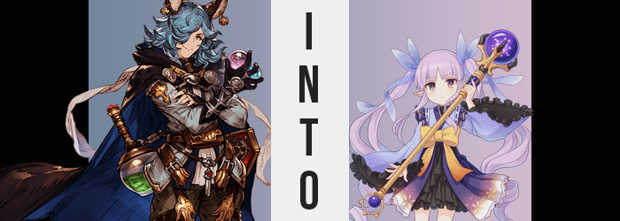

It had been several weeks since the disappearance of the Grandcypher’s captain, and naturally the crew were all in crisis mode.

The last they knew, the captain in question had been investigating the mysterious disappearance of the Gourmet Edifice members that counted themselves among the crew from time to time. And other than his disappearance there had been the strange appearance of a young girl named Mimi who claimed to come from another guild, Little Lyrical, from the same lands as Pecorine and the others. But no one knew how she had gotten to the ship.

Had she been a stowaway? That certainly felt like the most likely scenario to most. She was such a young child that she hardly seemed like a threat, but at the same time, considering the circumstances? It was hard for some of them not to be suspicious that she was related to Gran’s disappearance as well. They just weren’t able to draw the line between their suspicion and the truth.

The truth being that Mimi was Gran. Or at least had been.

But not all of the suspicious crew members were content with inaction. If she was related, and Mimi wouldn’t volunteer any information, then the bunny-eared girl needed to be tracked. That was why the mercenary, Drang, had opted to tail her for a day in the ship and see where she went. Regardless of their past relationships, Sturm and himself owed the captain some favors. Figuring out how he had gone missing could most definitely be considered a favor repaid.

That said, the Erune’s full day of what essentially amounted to stalking didn’t quite turn up the lead he was expecting. The child had woken up early and run around the ship most of the day without any obvious goals that he could see. Considering she was roughly the age of ten, it wasn’t hard to see why that might be the case, but she did claim to be the leader of Little Lyrical. Didn’t she have some manner of responsibilities to take care of, or was it all just playing?

He had also wanted a moment to question her himself, but there were always others around. Drang was willing to look like the bad guy, but if another crew member got the idea in their head that he was harassing a child and reported him to Sturm, then well… He’d be stabbed with the tip of her blade a million times, surely.

Finally it seemed like he would get his chance to do just that, though. Late in the evening as it was, the recreation room quickly emptied as everyone set off to get dinner. Everyone except Mimi, who had been content simply drawing at one of the tables for the past hour or so. When the coast was finally clear, the Erune man slipped out from behind the corner had concealed himself behind and approached her. “Yo! Mimi, right? I was just wondering if I could ask you some questions real quick?”

The child had heard him, but her response didn’t come immediately. She was scribbling with intention on her paper with a violet crayon, and it seemed like she didn’t want to break her own focus until it was done. Curious, Drang peered over her shoulder to see. It was a picture of a girl? Albeit one crudely drawn like most kids did. From what he could make out, she had pointed ears and long, purple hair. “Oh, who’s that you’re drawing?” Perhaps if he could feign curiosity she would be more open to speaking with him?

“Oh! It’s you!” Had it finally registered that he had been speaking to her? Mimi had picked up the paper and spun around, holding it out for him to take. Which he did, rather confused about it. Had she meant to say it was for him? Did that mean she had known that he had been following her? Well, even if she did she was just some kid. If it was for him, what did it mean?

Before Drang could ask, the girl sped off and out the door. “Hey!” His attempt to stop her had fallen on deaf ears, though. He was left standing in the rec room alone with a child’s drawing in his hand. The man hadn’t planned on revisiting the picture in question, since it was basically just junk in his eyes, but his eyes did eventually wander back down to them. Not because he was curious our had any interest in it, but because of something rather bizarre.

The image of the girl on the paper was glowing.

“Erm… Is this some sort of magic?” Drang arched an eyebrow at the sight, naturally. It felt a little warm, but he couldn’t imagine that he had anything to worry about. Maybe Cagliostro had given the girl some strange crayons or something? But he had actually misinterpreted Mimi’s words. The drawing wasn’t for him. The drawing was of him. He just didn’t resemble it yet.

While Drang could be an outlandish gentleman, he still had enough common sense to drop the picture and step away from it. The longer he had held it, the more he could feel his body tingling after all – and that left him more than a little wary. “Did that kid play a prank on me? How lame.” Probably something stupid like a tingling spell, or something of that nature. Of course it was much more profound than that, and no matter of distance could undo what had already been set in motion when it came to the man’s body.

Unbeknownst to him, the magic he had been exposed to had already begun to get to work. It was just in a place that was difficult to recognize without a mirror, because much of it was focused on his own head. His golden eyes, for example, dulled slightly so that their golds were more subdued. But more than that? With lengthier lashes and corners that appeared fuller, they almost appeared to be downright feminine.

And such was the trend when it came to his face, ultimately. Those girlish eyes only amounted to part of it, and features that he would have considered to be ‘rugged’ were quick to soften along with his face’s overall shape growing shorter. Before long, if you were to look at Drang’s face alone, you might have rightfully wondered if he was a woman. And, well, in a few moments that wouldn’t be too far from the truth. The rest of his body just needed a little bit of time to catch up.

“Huh? What the hell’s going on?” While he hadn’t noticed the changes to his face, a sudden dip in height certainly didn’t go without him catching on. He had dipped about four inches all at once, after all, and not only was that clearly notable from the drop alone, but his outfit also ultimately fit less comfortably as a result. “Did I just shrink?”

It was a little more than that, not that Drang himself had the tools to understand. Bigger clothes meant baggier clothes, so he couldn’t really see how the contours of his body were reshaping. The sides of his tummy, for example? They pulled inwards slightly, gifting him a rounded gait that spread into hips that somehow looked just a little but wider… because they were. They had swung so that they were just a little more pronounced, and that had led to a number of related alterations in the same, general area.

For example? Drang’s legs were usually muscular without any excess fat on them to speak of, but his thighs in particular had suddenly exploded with a tender meat that gave them a rounded appeal. There was also the matter of his rear end, which had swollen up into a peach shape, making good use of the extra space that now existed in his pants.

Or her pants? “Woah!? What was that?” In an octave that sounded a few points higher, not even Drang could avoid noting the sensation of something tugging on her groin. A hand immediately reached down to investigate, and what it found was, well… “Huh!? Where’d my dick go!?” She was definitely supposed to have one! …Wasn’t she? She should have been much more panicked, but she was strangely calm about it past that initial outburst. “No… Haven’t I always been a woman?” Had she? The more she thought about, the more correct it sounded.

Being a woman would certainly explain why the front of her jacket had gotten tighter. Because she had been missing one key part of a woman’s biology up until that point in time, and it eventually found its way into reality. Her chest had swollen several sizes, up to a notable C-cup. Erune weren’t exactly known for their huge busts. Compared to Draphs they were typically much more honest considering their penchants for backless outfits.

“A… woman…” She said it one more time, because it felt strange still. Not because of her sex, mind you, but a strange thought soon crossed her mind. I wish I could grow up and be a woman… Despite the fact that she was very much a grown up, and that was clear as day to anyone who gazed upon her. But deep down she really didn’t feel like that was correct. Her thoughts were simplifying, with complex ideas and concepts quickly slipping from her mind. It didn’t take long, but she had begun to not only think like a child, but she truly believed herself to be one.

So she didn’t react much when her height fell once more, but this time much more dramatically. Over only twenty seconds, Drang’s height had fallen all of the way down to a meager 3’10”, her body practically swallowed whole by the outfit she was wearing. The pile of clothes that had consumed her wriggled about as she tried to fish her way out of them, ultimately emerging with only a black undershirt hanging off of her like a very long dress. “…Phew.”, she squeaked.

The face that poked up out of the shirt’s neck hole was very different from the one that had been swallowed, though. Better resembling that of a child for one, there was hardly anything left to it that resembled Drang. Her eyes were big, her cheeks fair, and her lips thin. But then again, very little of her old self remained physically. Only her hair and ears, really, because the breasts and hips she’d possessed as an adult had all naturally melted away into nothing other than a promise of what they could one day be.

“Uu… That was distressing.” Not only was her voice higher, but she was speaking in a deadpan matter, too. She wasn’t sure how she’d just been swallowed up by clothing, and she didn’t really seem to notice how her ears were slowly sliding down to the sides of her head. Well, that and they were balding. All of the Erune hair that was so typical of them was peeling off and falling into the pile of clothing beneath her, exposing that her ears had shrunk and, once they were fastened on the sides of her head, looked more like a Draph or Harvin’s.

Or an elf’s.

Drang exhaled slowly, trying to find her balance so that she could step out of the pile. While doing so, a violet danced upon her curly locks, and that violet also saw them straighten and lengthen. Before long they fell to her ankles and were curled at the ends, while her bangs were soft and parted in the center.

For all of the effort it had been to step out of the clothing pile, the child quickly forgot about it. “Oh…” Because after what felt like a breeze had teased her, she looked down to find herself in an outfit that looked and felt familiar. A dress that had a black, ruffled skirt and a top that resembled a more Japanese dress, as well as long, blue bows that kept her violet hair pulled into twintails. It was a very cute ensemble that suited her more than an oversized t-shirt. But then again, she couldn’t even remember that. The pile of clothing she had been stuck within was even gone!

“This is… the ship Mimi called me to? I think…” The girl had been struggling to express herself for most of her transformation, but now her words sounded more or less entirely emotionless. It was hard for the eight year old to show even a frown upon her features, much less a smile. Even then, the only thing she felt was confused. She couldn’t remember making the trip to board this ship, nor was she sure why her guild leader had called her out to this place in the first place.

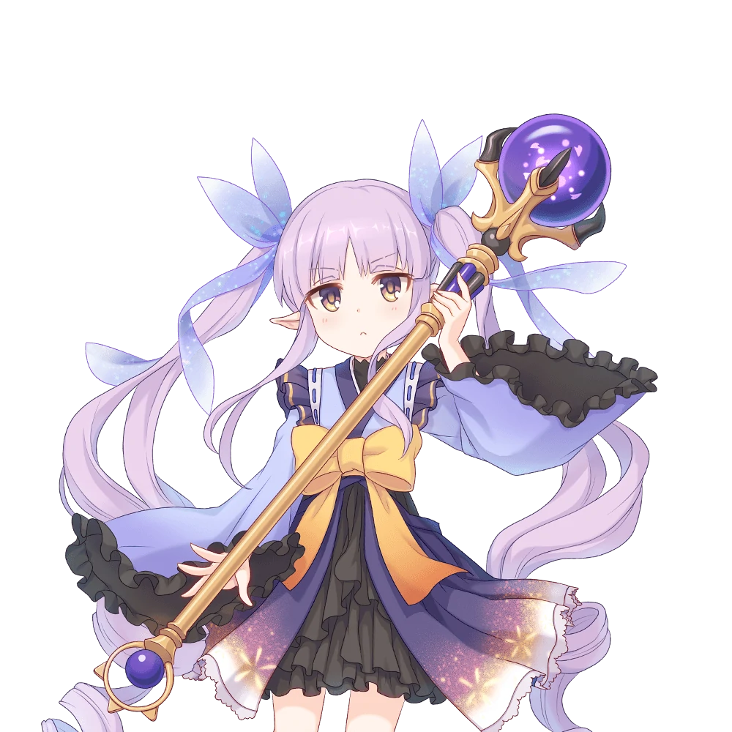
In fact if it had been her call, Kyouka would have avoided visiting this ship altogether. Evidently Gourmet Edifice had gotten caught up in something strange when they had traveled to these distant lands, and now they were missing. It didn’t take a genius to realize that perhaps the ship they had been traveling on had been related to that disappearance? But then again Mimi wasn’t a genius. Kyouka couldn’t rightfully claim to be one either, though.

After all, she was eight.

The elf’s confusion just melted away once a familiar face bounded through the door of the rec room, though. “Kyouka! Kyouka! You came!” Speaking of their unintelligent guild leader, it was Mimi who had practically hopped in like a bunny, immediately glomping the younger elf with all of her might. While Kyouka didn’t smile, the pink upon her cheeks was enough to show that she was happy, if not a little embarrassed. They may have not always seen eye to eye, but they were still close friends at the end of the day.

“I am… But uuu… I have no idea how I ended up here. Did you do something, Mimi…?” The rabbit was practically rubbing her cheek up against the elf’s own, forcing her golden eyes to look off to the side. Her confusion was gone, but she still wanted an answer.

Mimi did finally withdraw, but she reached down to pick up the drawing that had been dropped as Kyouka had transformed. She held it out to Kyouka with her chest full of pride. “I summoned you! I have these really neato crayons! If I draw a member of our guild, I can bring them here!” That sounded… completely unbelievable. Like a child’s fantasy, which it very much might have been. But being a child herself? Kyouka ate it up, even if it made sense.

“Um… If you say so…?” If it was true, then it sounded amazing. Did that mean that they could summon the others too? But how did they get home? She still had questions. “Can you show me? Can you summon someone else?”

“Oh, sure! But we gotta give the picture to someone! So let’s find a person!”

