LIFETIME MAINING
COMMISSION STORY
BY CHALDEACHANGE
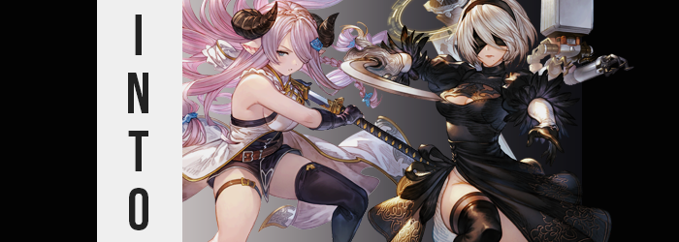

“Sometimes I wonder why we even bother, it isn’t like I’m getting any better.”

“I get what you’re saying, but that isn’t the type of mentality we should probably have if we actually do want to improve.” Joseph gave a little chuckle over the headset as he continued to set up his game console. It wasn’t often that he got to practice fighting games live with a friend, but Axel, who was on the other end of the headset he was wearing, had recently gotten into one of the many fighting games that he was playing.

Granblue Fantasy Versus Rising. With all of the fighting game behemoths that had come out in the last couple of years it was likely hardly a blip on the maps of most seasoned fighting game players. But for Joseph? It fit a special niche for him as a player who was also a big Granblue Fantasy game. There were those that would write the game off as ‘too easy’ because of the simplified special attack inputs, but the game was surprisingly deep despite that.

Deep enough that it was hard enough to learn, especially when the players weren’t exactly professionals. Axel was a casual player himself so his concerns about improvement were understandable. But Joseph also had enough experience to recognize a mentality that would lead him to making absolutely zero improvement. “I get what you mean though.” He followed up as the two selected their characters on screen.

“Sometimes I feel like I’d need to literally become Narmaya herself to stop mashing under pressure.”

The game had loaded, but then everything had frozen from Joseph’s perspective. Not just the game but his own body and breathing. It had been as if everything had become perfectly still – leading to the sensation of being pulled into darkness. But seconds later his surroundings were illuminated once more and he was standing. Standing in what looked to be a gate that led out into a colosseum!? “…Huh?”

He was naturally confused. Was this a dream? Had he just been teleported? The fresh air smelled so clear and real, the colosseum gate – which he presumed led into the arena – seemed so real. And in the first place wasn’t that gate familiar somehow? “This isn’t the Colosseum stage from Rising, is it!?” He couldn’t see beyond the gate, but the red banners flying above him were definitely familiar. Not to mention that it was the very same stage that had been selected for their battle.

None of it made any sense. Did that mean he was in the video game? But why? Or was it more that he’d been sent into the world of Granblue Fantasy itself? Assuming this wasn’t a dream— Well, no. He could only really assume it was one, right? But it really didn’t feel like one either. In terms of how things felt though, they began to feel quite unusual. This sensation manifested in many ways over the minutes that followed, but its very first manifestation truly set the stage for what was to come.

“Ouch! What the—?” A sharp pain had rung out from both sides of the man’s head, seeing to it with certainty that both of his hands would reach up to try and massage the cause. But more than pain alone? His head had felt confusingly heavy. Like something was on top of it that hadn’t been there before. He’d wanted to dismiss the possibility entirely and might have if not for what exploring hands had grabbed onto. “H-Horns!? Do I have horns!?”

Two solid objects were curling out and forward atop his head. Grasping and pulling them confirmed his worst suspicions, that they were grafted to his skull and wouldn’t budge. If a mirror or reflective surface had been present he might have immediately recognized their designs, but with only his touch and the unpleasant realization when he had lowered his hands that, in the meantime, his ears had grown long and pointed, he could only really draw a more general conclusion. “Am I turning into a Draph?”

Draphs were the only race in all of the skies that had horns and pointed ears. But was that even possible? Joseph supposed that if there was a force capable of transporting him into the Skydom itself then it must have been a power capable of transforming his body, right? But why? What was his plan of action here? Would things begin to get worse? In a way that he had yet to notice? It had already begun to worsen, in fact.

He wasn’t exactly a bigger guy but he wasn’t the thinnest nor the fittest either. Or at least that was supposed to be his reality, and yet beneath his clothing that was exactly what had been shifting. Any excess weight beneath his olive-colored skin had thinner away and, in its place? Fit muscle had toned his physique. It wasn’t excessive, but simultaneously he had become a lot stronger than it even appeared somehow. Once those muscles were in place, the olive tone of his skin lightened until it was a soft pink instead.

“Okay, so let’s say that I’m hypothetically becoming a DRAPH!?” An attempt to verbally work through what was happening only fueled the confusion and distress he felt, because his voice kept chirping up to a significantly higher and effeminate octave as he spoke. His face expressed this alarm clearly, and it became increasingly obvious since the features of his face were shifting in a way that made them easier to read. At the cost of him looking at all like himself, however.

Joseph had lost weight, but a touch of it had returned to make reddened cheeks a tinge rounder in their shapes. Although weight pooled within plumper, poutier lips too, there was a glossy femininity to them that was only exacerbated by a nose that shrunk into a button shape. Everything about this new face of his was dainty yet beautiful, and when his eyes thinned, lashed lengthened, and irises shifted to a purple color that was more or less cemented. The fact that he looked increasingly like a woman.

“But in that case… Ah!? Why is my voice like this? It’s stuck now!? It almost sounds like…” Like the character he had chosen on the character select screen? But that couldn’t— “Wah!?” Almost as if the process itself was trying to tell him ‘Yes, it could’, he felt like he was falling out of nowhere. That was impossible because his feet were still rooted firmly on the ground, but with clothing swallowing him whole another reality came to mind. “I-I’m shrinking!?”

It wasn’t even just a little bit, either. While standing up straight Joseph should have measured just under the 6’ mark, but he had plunged down to 4’5” so quickly that it had felt like he was falling. Arms and legs were swallowed by his sleeves and pant legs, and his shirt ended up fitting him more like a dress at a height that was a touch more childish. But the pieces were coming together. He wasn’t becoming a ‘child’. His face still retained his maturity after all. If he was still becoming a Draph like he had originally wondered, then…

A strong wind blew through the area all of a sudden, seemingly setting his short hair loose? No, it was more like the wind was playing with it, pulling strands longer as they fluttered out behind him in a lightened coloration. Shrunken, delicate fingers of his hands eventually caught them, examining their color in earnest. “Lilac purple, much like my hair… E-Eh? My hair? I mean I guess it’s my hair now, but I meant my hair!” Rather than be able to speak the name of the character he was thinking of? Instead he referred to himself every time.

So he was right. This validation didn’t make things any less confusing, especially not as a tug between her legs signaled the final end of her masculinity, but Joseph at least found some peace in knowing what was happening. “Did my loins just…? No, that’s not right? I’ve always been a woman.” Wait, what? Why had she said that? It wasn’t what she was thinking deep down at all! She’d just blurted it out!

The advent of her changed sex triggered several extreme changes in her figure in quick succession, and since she was clearly becoming a Draph woman now? She was certainly in for a time. The inflation of her once flat chest led the charge her, shifting her balance forward and pushing Joseph to let out a cute, surprised squeak as the ample space within her oversized top was made good use of. The staggeringly large I-cup tits that jiggled rightfully above her tummy flopped about for a moment before settling, their weight evidently already accounted for in her mind.

Just as the heft that saw her thighs and ass swell seemed to not bring her eyes to bat either. This was all entirely natural from her perspective. Just as natural as the backless, leather dress and kimono-like raiment that clad her torso now felt above a pair of panties and leather boots. Some of her hair was bound and braided by blue ribbons, while length bangs were swept across her left eye. The same side of her body where a long katana now rested, sheathed.

My tits are huge and my clothes changed, but…!

She couldn’t speak on any of that. She kept talking about other things unprompted.

The Draph woman steadied her breathing. “Oh dear, how could I let myself get so worked up before a battle?” That wasn’t what she had wanted to say. At least deep down. She very much looked and acted the part of Narmaya, but at her core? She was still very much Joseph as well. The issue was that she was essentially acting on autopilot, her body acting out the motions of her new life in a way that made it so that she could not question nor fight against it. Joseph was able to cling onto her old identity for the time being… but what would happen if this wore on for too long?

Before long the gate opened and Narmaya stepped outside. Her opponent wasn’t ready yet? “Well, I suppose this is as good a time as any to meditate!” And so she allowed her short and bouncy body to fall limply, crossing her legs and closing her eyes as she allowed herself to slip into a meditative stance and mindset. Something that didn’t help Joseph. That feeling of calm was making it difficult for her to cling onto her old sense of self.

Whatever I do, I mustn’t fall asleep!

But hey! At least she wouldn’t mash under pressure now?

Around the same time, Axel had found himself in a very similar situation. He was behind the gate on the dead opposite side of the Colosseum map – a conclusion that he had come to on his own just like Joseph had. “This isn’t possible. I wasn’t sucked into a game! This had gotta be…” A dream? He wanted to label it as such, but it was hard when it felt so real. The man had experienced numerous lucid dreams in the past and they did not feel like this.

Understanding the cause was just as important. “Joseph made a joke about needing to become Narmaya and then everything froze when the game loaded. Is he here too? Is the game trying to like, give him Narmaya’s training?” That was essentially true in a sense, but maybe not quite as literally as he had been thinking. “Actually, I chose 2B as my character. Is she around here somewhere?”

To be fair, it would have been cool to meet a character who had become such a big gaming icon. Not that Axel understood at all how meeting her had even become something remotely possible. But in the end? He was going to get to know her a touch more intimately than that much like Joseph had ‘gotten to know’ Narmaya. While a change to a fantasy race wasn’t quite in order for him, however? That didn’t mean he would remain human either.

But it wasn’t even something he’d notice. Instead he immediately became far more fixated on his weight of all things. He was by no means a light man, but the feeling of his skin pulling tighter all over his body – but most noticeably around his stomach – wasn’t realistically simple to ignore. “Eh?” For some reason his first instinct was to pat his hand into his stomach. And that revealed something that was met with an odd calm. “I’m getting thinner…”

That was a realization that probably should have elicited more of an outcry, right? But for some reason he couldn’t muster the energy even as he felt his hand sink closer and closer towards an absence of excess weight altogether. Just like that his excess weight had evaporated, leaving everything about his figure thinner than it had ever been. And yet…

He wasn’t lighter.

The weight his body carried as a bigger man was gone, but there was a new weight to him courtesy of a change he could not see. A shift in his internal biology that had transitioned him away from, well, being biological. His bones had hardened into steel, his blood had transitioned into a coolant, and all of his flesh, skin, and hair? It shone now with a synthetic glow. Even his heart and brain were mere artificial counterparts, all composing a body that was not fundamentally human… but of an android.

That was why he felt so calm despite everything. The brain through which he thought and felt had already been transformed and while his sense of self had yet to be stifled, it had already repressed his emotions somewhat. As his eyes began to shine blue with an artificial light this somehow seemed even clearer. “Something is happening to my body…” Something that obviously wanted his voice to sound feminine yet deep at the same time, as it was slowly shifting to that tone.

With his body so much thinner, Axel’s clothing was having a hard time stay fixed to his body. Pants and boxers had slid right off, but his top hung lopsidedly off one of his shoulders like a gown – just barely covering his crotch. This disguised just how odd the weight loss had been. If he had merely been getting thinner then why had his waistline pinched in so dramatically? And were his hips wider? These weren’t questions that he had thought to ask in the moment.

Instead, blue eyes were cautiously surveying his surroundings. Had he noticed it? The reality that his eye level was decreasing? “I’m shrinking.” Spoken through lips that were fuller and sultrier now, it seemed that he had. But he could deny that his new height felt accurate once he bottomed out at 5’3”. Well that wasn’t quite true. Something deep down was urging him to find three inch heels. “Where are my boots? Wait, no… I don’t wear boots, much less heels. But…?” He was having a hard time acknowledging what was or wasn’t true. Largely because he was murmuring some things unintentionally.

The shape of his face changed in ways that did more than simple gift him fuller lips. His thinned jawline and sharper nose made it all appear smaller, while blue eyes fluttered until they were bigger and rounder beneath thinned brows. This was the face of a stunningly beautiful woman now, accentuated by a head of white hair that grew out into a full bob cut. The resemblance was uncanny to the character he had selected, and that white hair was what finally tipped him off.

“Ah. Am I becoming 2B? That feels… correct.” He could only really accept it. His changing personality wouldn’t really let him do much else. He could feel his already ample weight growing heftier, but only because his form was obtaining additional ‘padding’. Some of this was around his chest, with a pair of C-cup breasts jiggling to attention beneath his shirt. But they didn’t seem to really shock him. Or, well, her.

Her genitalia had folded like Joseph’s, but seeing as she was an android it did beg the question why she needed a pussy in the first place. Then again? That question probably also extended to her tits, or to all of the weight that saw her thighs and ass swell to even greater heights. Upper legs jiggled as fat filled them almost like a hose was pumping weight into them, skin stretching firm around thighs that usurped her waistline in width individually.

And if her thighs were already that impressive? Well, you could imagine the blessings that her ass received. It was fortunate that she wasn’t wearing her men’s boxers anymore, for cheeks nearly quadrupled in mass as the depths of her crack became a canyon in comparison. The slightest movement would see these cheeks jiggle, and when she walked? It would certainly be an arousing sight.

While unrelated, the three inches she was missing because she lacked her heels were suddenly restored. “…Oh.” Because her entire outfit had changed into what it needed to be. A white half-leotard underneath a black, YoRHa-issued dress with leather gloves and thigh high boots. A headband shrouded a line of white hair, and her vision had been hidden by a black blindfold that actually functioned as a visor. She could see right through it. And even if she couldn’t? The Pod that now floated behind her could help.

And the two swords floating behind her were probably a help too.

“I see. A dangerous opponent exists beyond this gate.” In the end, Yorha No 2. Type-B or 2B for short was in a very similar situation to Narmaya. From her body to the was she carried herself and spoke she was unmistakable from the real article. She was 2B through and through, yet buried beneath this mask was a clinging fragment of Axel’s ego. She was able to tell that this was wrong, and that she didn’t want to act this way. It was true that she was a stranger in this lands but she wasn’t supposed to be thinking that from the perspective of a YoRHa unit!

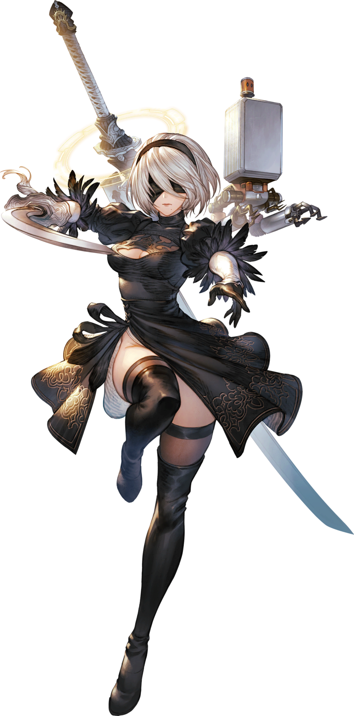
Try as she might, however? She was utterly powerless to say what she wanted to say or do what she wanted to do. And the longer things remained this way she would have less and less influence until finally, she feared, she would entirely be absorbed into this new identity of hers. The android could make no efforts to fight against this and, from the way she acted, would make no attempts to do so.

The gate opened and 2B stepped through it into the Colosseum. On the ground before her was a short, horned woman meditating. Or was she sleeping? Joseph Narmaya? Axel could see the truth, but she continued to act with the unfamiliarity with this world of 2B. “Target location marked on map. Proposal: proceed to target location.” Or so came the chiming of the Pod that floated behind 2B. But she dismissed it. There was something more important sitting in front of her and drew her sword.

“After dealing with the enemy.”

The noise that 2B and her Pod made seemed to stir Narmaya from her stillness, and she opened her eyes. Axel 2B? A similar familiarity registered in the back of the Draph’s mind, but she was nonetheless powerless to resist Narmaya’s own impulses, almost like they were programmed into her. Sleepy eyes fluttered open. “Huh… What was that? Oh!” Those eyes narrowed into a serious expression as she realized a powerful opponent stood before her. She rose and grabbed the hilt of her blade. “That posture… You’re no ordinary swordswoman. I won’t take this duel lightly.”

BELIEVE IN VICTORY!

BATTLE 1

ENGAGE!

