*From Mentor to Something More*

**"Be gentler Akari…you're being too rough!"**

**"I can't help it Mizuki! Y-Your boobs are just too good!"**

In the darkness of an unlit office space, two women; one stripped bare with her plump, mature body on display for all to see and the other dressed in casual attire with the exception of a popped collar to let her fine bosom soak in the air, sat together at the back near a shrouded window, letting loose gentle sighs and excited yelps with their heated bodies pressed tightly together as the younger of the two; Akari, suckled on the fattened teats of the platinum haired Mizuki, greedily drawing milk from the blushing mothers nipples whose hesitant face suggested she was torn up by the situation she found herself in.

But it wasn't the seditious act itself that tickled her conscience but rather the fact that she was even partaking in such a thing at the back of her office; reminiscing on the events that had landed her here in the first place. During a time when she wasn't some ordinary Japanese MILF in her late forties but an experienced wizard from a time long before the steam engine was introduced to the world, honing his skills and technique instead of being ogled at while she taught geography to a class of lecherous boys and envious girls, feeling dozens of eyes strip her naked in their mind while reveling shamelessly in it all.

Raphael had been a renowned magic practitioner. Famed for his alchemical formulae and contributions to the community, the man made little foes and plenty of connections in an effort to impress the man that had made his career possible. His mentor and a grandmaster of magic; Faroe. Carrying on the mantle of a magic teacher after the man had passed away, leaving Raphael with both his knowledge and a reliquary of magic items, most of which had never seen the light of day, remaining unappraised within the dusty old halls and then in the study of Raphael’s home.

Unlike Faroe however, Raphael had been too hasty in his search for an apprentice, putting little thought into the security and safety of his home which would serve as the lodgings for the lucky soul chosen as his understudy, much like he had done when Faroe had seen the potential in him all those years ago. It was an age old custom and one Raphael had every intent to respect when welcoming Fitzgerald into his abode. By the end of the first day, his overeager protege had seen fit to attempt to open a mysterious box brimming with unknown magics and power, probably to impress him. Before Raphael could lift a finger to put a stop to the dangerous affair however, a faint click was heard before the world went white around them, swallowed whole by the box leaving not a soul left inside Raphael’s home…

The experience of being zapped through time and space into an alternate world set thousands of years in the future was dizzying to say the least. WIth invisible hands picking and pulling at their very essence as they hurtled through void at a dizzying speed, it was impossible for the two to put up any sort of resistance as their bodies and minds were pried apart before being reassembled into new shapes alongside the insertion of new memories and thought patterns. By the time the dust had settled and the two were free to explore their drastically altered bodies, it was fair to say that furious was an understatement to describe Raphael’s emotions when he realized the box had transfigured him from a respectable 7 foot tall man in his late thirties into a bodacious wench barely reaching the 4 foot 5 mark with a platinum head of hair done up into a cute bun, beneath which sits her new oriental visage beginning to sport wrinkles and a sag to her cheeks, staring dumbfounded at the naked form of a motherly maiden that was nothing like her old one; dark hide stripped away for pristine, hairless skin that seemed wet. Muscles reduced to pudgy lines of baby fat and softening flesh. A proud member vanished into the moist folds of a thick, well used snatch. Powerful pectorals pulled outwards into twin melons tipped with swollen areolae that sagged down over a pudgy belly and strong legs warped into flabby pillars that lined up well with broad hips that had experienced many childbirths. Every part of her ached when she moved in the alien room she found herself in, and when the doors to her room swung open without warning, she knew then that the panicked young woman that looked much like she did was Fitzgerald…or whatever was left of him after the box had chewed him up and spat him out as a Japanese lady in her early twenties.

With their minds altered to match their new place in this pocket dimension within the box, Raphael had been forced to adopt the role of Mizuki Tsubome, a teacher at the local university while Fitzgerald had been aged up (and sexed up) into Akari Shirase, Mizuki’s favorite student whose lessons extended far beyond Geography and into the realm of how to snag herself a man. Instead of immense knowledge in the arcane, Mizuki now had to deal with the fact that she knew way too much about the carnal arts of sex and everything associated with it, realizing why she had appeared butt naked in what she now knew to be her office and why Akari had emerged from her break room on their first day in this twisted world. Much like how the Raphael of old was supposed to teach Fitzgerald, now Mizuki had daily appointments set up between her and Akari in an effort to both satiate her lesbian urges and impart her knowledge on what made men tick to allow the innocent girl an easy win when the time came to lose her virginity to Itsuki, the boy Fitzgerald’s new self fancied in this reality.

By the time the fifth ‘lesson’ had come and gone, Raphael knew that this place was having an effect on their minds. For one, she could no longer refer to her former student by her appropriate name and it seemed like Akari had already forgotten that she wasn’t supposed to be here. No longer able to remember the pipsqueak she once was as her Japanese soon became fluent and natural, speaking much like the hawty young adult she now was instead of a naive little kid.

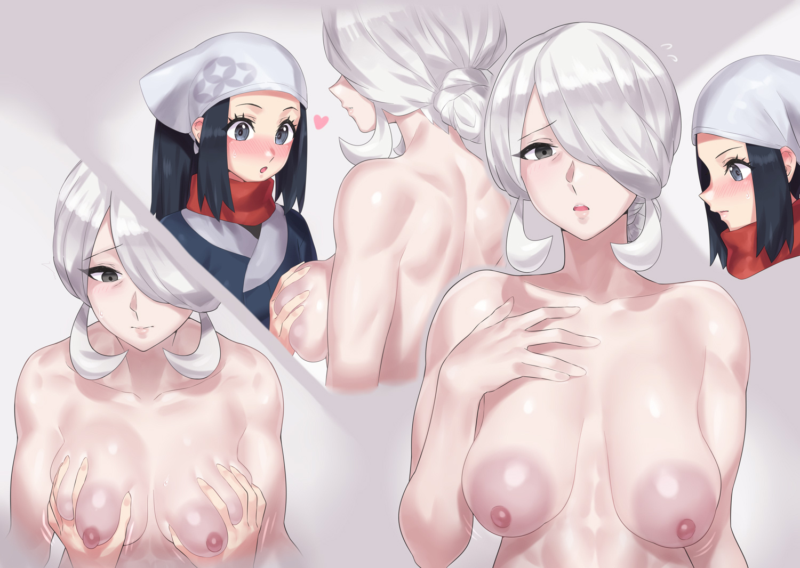

And the same would soon be said for Raphael. With most of her original language slipping from her mind, the loss of Fitzgerald who had been assimilated into the world and an inability to host mana in this new, aging form of hers, her quest to find a way out of the cursed relic was ended and her days outside of university were spent as the doting housewife of the Tsubome household. Tending to her five young children in the day before tending to her man by night. Even with Mizuki’s memories, Raphael had found her first time to be an electrifying experience and how much of an error it was to refuse her rabid dog of a husband; pushed down into bed before being stripped naked and screwed silly. And between her naughty lessons with Akari and her now nightly rutting sessions with her husband, the parts of her that remained Raphael were fading rapidly with each passing day.

Very soon, she would forget why she even seemed to worry so much whenever she taught Akari dirty tricks like how to use her breasts when pleasuring a man or why she hated the feeling of her man’s pecker deep inside her aching pussy. And as she sits in her office staring blankly at the mirror while her student continues to suckle away at her leaking mammaries, that moment would soon be fast approaching as Mizuki begins to contemplate what to cook for dinner tonight alongside what outfit to dress for when her hubby returned home from work. It was a busy night and she hated seeing a frown on anyone’s face, if a lil bit of salacious lingerie was enough to turn that frown on its heels, then she would gladly do it even if the straps chafed against her jiggly body and sensitive skin.

**“Mizuki? Are you alright?”**

**“Mmm? It’s nothing Akari…just wondering what to make for dinner tonight when Fugo returns…”**

**“That must be nice…having a hubby to think about when you go back home…and how is he in bed hmm? He must be quite the stud if he’s got you acting up enough to come to me~”**

**“Gosh, Where did you even learn to speak like that Akari? You musn’t pry so easily into others lives…I don’t think Itsuki’s the type to be like my Fugo so you’d better watch that mouth if you want him!”**

**“Fine fine~ Speaking of, can you teach me how to do that trick with your tongue? I’ve got this toy we could use to practice?”**