Chemical Kinetics:
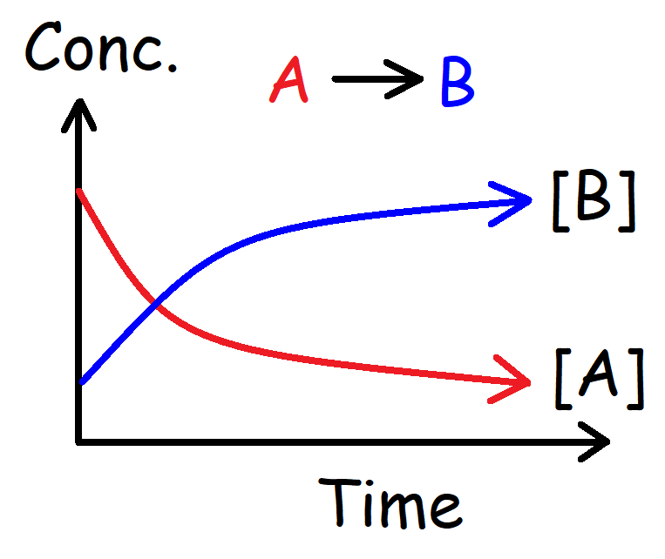  Instantaneous Rate of Appearance:  $$Rate= +\frac{d[B]}{dt}$$ | Average Rate of Appearance: $A→B$  $$Rate= +\frac{∆[B]}{∆t}= \frac{{[B]}_{F}-{[B]}_{0}}{t_{F}-t_{0}}$$  Average Rate of Disappearance:  $$Rate= -\frac{∆[A]}{∆t}$$  Rate of a Chemical Reaction:  $$2A+3B→4C+5D$$  $$Rate= -\frac{1}{2}\frac{∆\left[A\right]}{∆t}=-\frac{1}{3}\frac{∆\left[B\right]}{∆t}=+\frac{1}{4}\frac{∆\left[C\right]}{∆t}=+\frac{1}{5}\frac{∆[D]}{∆t}$$
Method of Initial Rates:  Trial [A] [B] [C] I. Rate  1 0.10 M 0.10 M 0.10 M 0.20 M/s  2 0.20 M 0.10 M 0.10 M 0.40 M/s  3 0.10 M 0.20 M 0.10 M 0.80 M/s  4 0.10 M 0.10 M 0.20 M 0.20 M/s  Rate Constant k:  $$k=\frac{Rate}{{[A]}^{x}{[B]}^{y}{[C]}^{z}}$$  Units of k: $M^{1-n} t^{-1} or {(mol)}^{1-n}{(L)}^{n-1}t^{-1}$  Note: $M=mol*L^{-1} and t→s, min, hr, days$ | Differential Rate Law Expression:  $$Rate=k{[A]}^{x}{[B]}^{y}{[C]}^{z}$$  Finding The Order of a Reactant:  $$x=\frac{\log\left(\frac{Rate 2}{Rate 1}\right)}{\log\left(\frac{{[A]}_{2}}{{[A]}_{1}}\right)} y=\frac{\log\left(\frac{Rate 3}{Rate 1}\right)}{\log\left(\frac{{[B]}_{3}}{{[B]}_{1}}\right)}$$  Overall order of the reaction:  $$Order=x+y+z$$
Unimolecular:  $$A→B Rate=k[A]$$  Bimolecular:  $$A+A→B Rate=k{[A]}^{2}$$  $$A+B→C Rate=k\left[A\right][B]$$  Termolecular:  $$A+B+C→D Rate=k\left[A\right]\left[B\right][C]$$  $$2A+B→C Rate=k{[A]}^{2}[B]$$  $$3A→B Rate=k{[A]}^{3}$$ | Factors Affecting the Rate of a Reaction:  - Temperature  - Concentration  - Catalyst  - Surface Area  - The Nature of the Reactants  Reaction Mechanisms:  $$A+B→C+D Rate= k_{1}\left[A\right][B]$$  $$D+E→F+B Rate= k_{2}\left[D\right][E]$$  Note: $Catalyst→B Intermediate→D$

Reaction Order: | Zero Order: | 1st Order: | 2nd Order: | Nth Order: $(n≠1)$
Differential Rate Law Expression: | $$Rate=k$$ | $$Rate=k{[A]}^{1}$$ | $$Rate=k{[A]}^{2}$$ | $$Rate=k{[A]}^{n}$$
Units of k: $(M={mol}^{1}L^{-1})$  $$t→time (s, min, hr, days)$$ | $$M^{1}t^{-1}$$ | $$t^{-1}$$ | $$M^{-1}t^{-1}$$ | $$M^{1-n}t^{-1}$$
Half-Life: | $$t_{1/2}=\frac{{[A]}_{0}}{2k}$$ | $$t_{1/2}=\frac{\ln{2}}{k}$$ | $$t_{1/2}=\frac{1}{k{[A]}_{0}}$$ | $$t_{1/2}=\frac{1}{k(n-1)}∙\frac{2^{n-1}-1}{{{[A]}_{0}}^{n-1}}$$
Integrated Rate Law: | $${[A]}_{F}=-kt+{[A]}_{0}$$ | $${\ln{[A]}}_{F}=-kt+{\ln{[A]}}_{0}$$ | $$\frac{1}{{[A]}_{F}}=+kt+\frac{1}{{[A]}_{0}}$$ | $$\frac{1}{{{[A]}_{F}}^{n-1}}=kt\left(n-1\right)+\frac{1}{{{[A]}_{0}}^{n-1}}$$
Slope: | $$m=-k$$ | $$m=-k$$ | $$m= +k$$ | $$m=k(n-1)$$
Straight-line Plot: | $$\left[A\right] vs t$$ | $$\ln\left[A\right] vs t$$ | $$\frac{1}{[A]} vs t$$ | $$\frac{1}{{[A]}^{n-1}} vs t$$
Graph: | 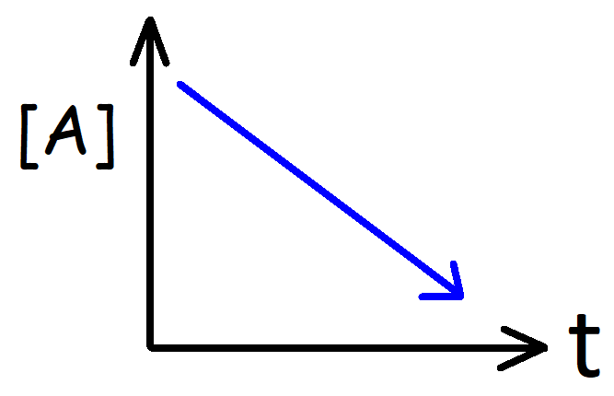 | 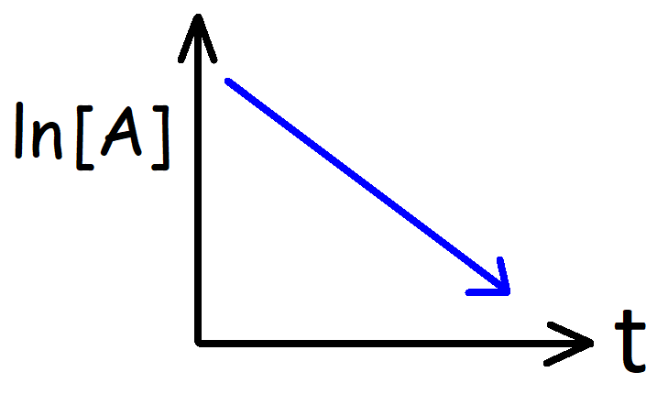  IRL Formula Variation:  $${[A]}_{F}={[A]}_{0}e^{-kt}$$  $$\ln\left(\frac{{[A]}_{F}}{{[A]}_{0}}\right)= -kt$$ | 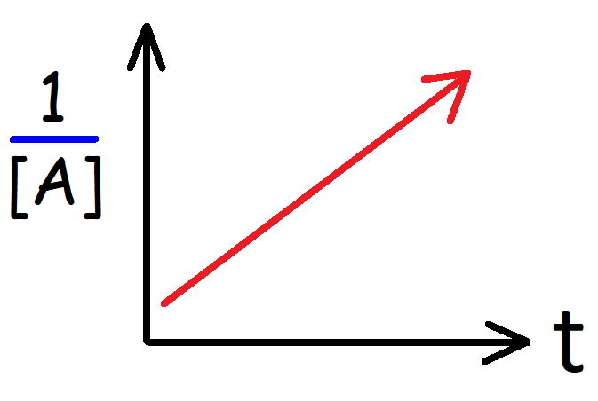 | 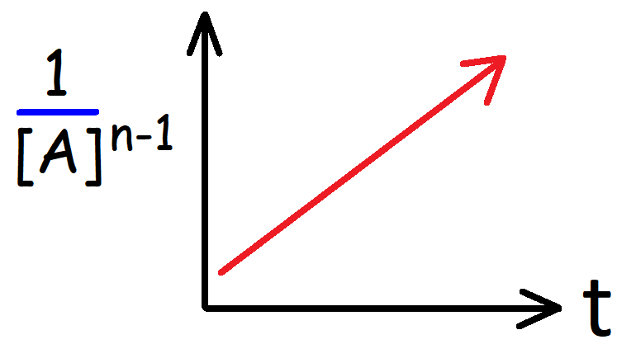  Note: $n ≥2$

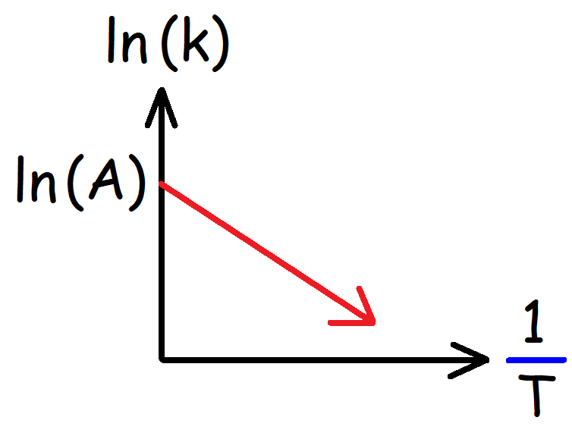 | Arrhenius Equation – Slope Intercept Form:  $$\ln\left(k\right)= -\frac{E_{a}}{R}\left(\frac{1}{T}\right)+ln⁡(A)$$  $$y=mx+b$$  Slope (m) and Y-Intercept (b):  $$m=-\frac{E_{a}}{R} b=\ln{(A)}$$
The Activation Energy: (J/mol)  $$E_{a}=-\left[\frac{R\ln\left(\frac{k_{2}}{k_{1}}\right)}{\left[\frac{1}{T_{2}}-\frac{1}{T_{1}}\right]}\right] E_{a}=-R∙Slope$$ | Arrhenius Equation – Standard Form:  $$\ln\left[\frac{k_{2}}{k_{1}}\right]= -\frac{E_{a}}{R} \left[\frac{1}{T_{2}}-\frac{1}{T_{1}}\right]$$  $$R=8.3145 J/{(mol*K)}$$
Temperature – Arrhenius Equation:  $$T_{2}= {\left[\frac{1}{T_{1}}-\frac{R\ln\left(\frac{k_{2}}{k_{1}}\right)}{E_{a}}\right]}^{-1}$$ | Arrhenius Equation – The Rate Constant k:  $$k_{2}=k_{1} e^{- \frac{E_{a}}{R} \left[\frac{1}{T_{2}} - \frac{1}{T_{1}}\right]}$$
Notes:  $$A→Frequency Factor$$  $$z→Collision Frequency$$  $$p→Collision Orientiation (Steric Factor)$$  $$e^{-{E_{a}}/{RT}}→Collsion Energy$$  $$b→Y-intercept$$ | The Rate Constant k:  $$k=Ae^{-{E_{a}}/{RT}}$$  Frequency Factor (A):  $$A=zp A=e^{b} 0<p<1$$
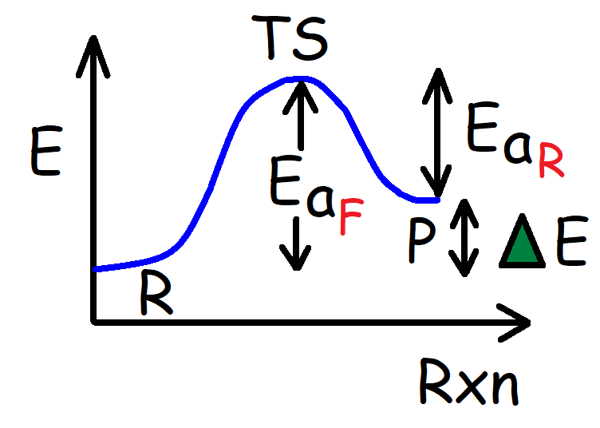  $$∆E={Ea}_{F}-{Ea}_{R}$$ | Rate Constant (k) and Activation Energy (Ea):  $$k_{2}=k_{1}e^{-{\left({Ea}_{2}-{Ea}_{1}\right)}/{RT}}$$  $${Ea}_{2}={Ea}_{1}-RT\ln\left(\frac{k_{2}}{k_{1}}\right)$$  Rate Constant (k) vs Time (t):  $$\frac{k_{2}}{k_{1}}=\frac{t_{1}}{t_{2}}$$

