**The Insider**

**Introduction**

*This story is based on the idea of an alien parasite which arrives on Earth with the intent to enjoy a hedonistic lifestyle by taking human host as vessels. Thanks to this ability to take control of any human body and his innate resistance to most common human weapons, this alien is really difficult to track and take down. The story takes place on an city inspired by Miami, and the background recall to the Sci-Fi horror atmosphere of the 80’s movies, with particular reference to the one called “The Hidden” from 1987 and its sequel “The Hidden II” from 1993, where an alien take control of a humans and goes rampant on the city. The comic itself is inspired from this but other than a thriller-horror background it contains also more erotic contents-*

**Chapter 1**

**(In the adaptation of the story the events will be narrated by the point view of the alien)**

The story open with a view of Earth, then an unknown object from the outer space enters the atmosphere. The view moves on a coast during night time, where a young redhead ponytail woman is running on an isolated spot, but suddenly her attention is taken by a light which briefly illuminate the sky before falling close to her location.

As she makes her way to the crash site, she finds the burning remains of some sort of craft scattered throughout the area. Surprised by the scene she takes a closer look around when she suddenly hears a noise coming from behind a bush, which piques her curiosity.

As she comes close to the bush suddenly two tentacles attach to her neck, causing the woman to get scared and as she tries in vain to escape, she hear a hissing noise and looking toward the bush her expression change to horrified one and the scene turn black with just the suffocated scream of the woman.

The scene moves on a hidden street, where a tough muscular woman is enjoying a beer leaned on her bike. Suddenly her attention is cough by a staggering woman down the street which noticing her moves in her direction. As she approaches it is reveal that the woman is the same redhead one from the first scene and as getting closer while sensually licking her lips, the tough one reacts aggressively demanding if she just have a death wish but without caring to her manners and threats she start to sensually caress her.

Surprised but not particularly annoyed by her behavior, as it is the first time for her that another woman has a crush for her, the redhead woman smiles and suddenly starts kissing her. The muscular woman makes a smug face, clearly enjoying herself, but after some hot moments of hugs and sensual poses her gaze switches to a horrified expression as she notices something from the girl's mouth entering inside hers. Trying to break free, her movements are blocked by the inhuman force of the redhead woman which grabs her head making her efforts futile. After some moments of struggle the muscular woman start to have convulsions through all of her body while her eyes roll back as we see a mass moving inside her body, expanding her throat and then her belly while making hissing noises.

* **NOTE: the kissing possession scene will be based on this scene from the second movie:** [**https://www.youtube.com/watch?v=IdNGPHmSoQI**](https://www.youtube.com/watch?v=IdNGPHmSoQI)

As the alien continues its way inside, her belly expands making her look like she is pregnant and when tentacles finally leave the previous host they move inside her mouth. Now taking place inside the woman, the slug movements inside her belly causes intense pleasure to her body which culminates with an intense orgasm before hearing some last noises within her belly returns to its original form and size.

With the other woman dropping to the ground we can see the tip of the tentacles still sticking out of the muscular girl's mouth and her throat bulging out before they reunites with the main body. After some moments the woman still standing up re-take consciousness, but her behavior is completely changed: her gaze is more cold and “alien” and after watching her hands she start to looks and touch her body, taking interest in the most curvaceous and erogenous zone. Feeling something restraining her, she zip off her leather suit (to the level of her navel) causing her generous breast to forcefully bounce out, and taking interest on this zone she start to massage and palpating her tits discovering the pleasure derived from those.

* Reference image down here for the scene she start to massage her breast, **but with a gaze based on this video from the first movie From minute 0.50 onward**: <https://www.youtube.com/watch?v=50ceJcD3DOE>

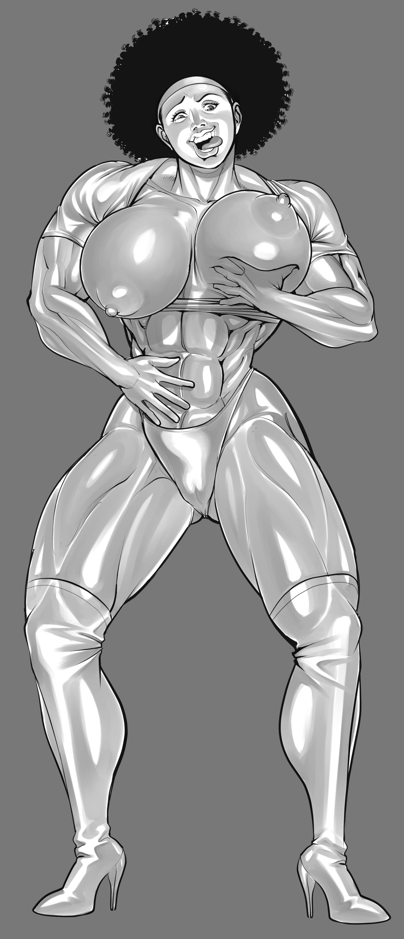

Moving her right hand down to her suit she notice that a portion of her suit is wet at the level of her groin, and the more she discovers of her body the more her behavior become sensually one smiling lightly while touching herself, before pulling out her hand covered in that strange liquid produce by her body. After looking at it her gaze become serious and sensually walking toward her bike, she get on and rides off to the center of the city. The scene close with the muscular woman exiting the alleyway with an evil expression as she licks her lips in the same way the redhead did, and in a smaller panel we have a close-up of the muscular girl's mouth showing a little tail tentacle going inside her mouth.

**Image references**

The main protagonist should be a muscular afro woman:

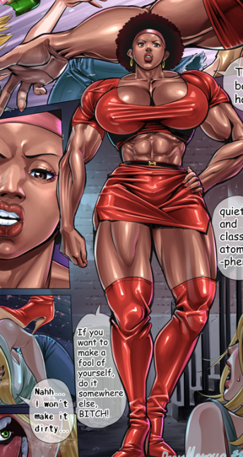

Her hair will be in this hairstyle:

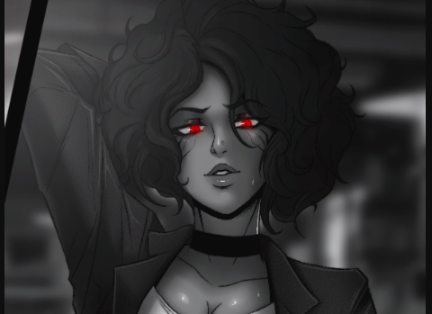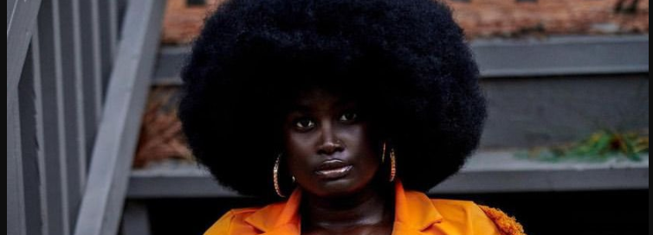

**Her muscular body and outfit will be this video (click the icon to see it); this is also a reference for the scene where she sensually walks to the bike after being possessed with the same way of walking).**



**Image reference for the basis for the appearance of the alien parasite**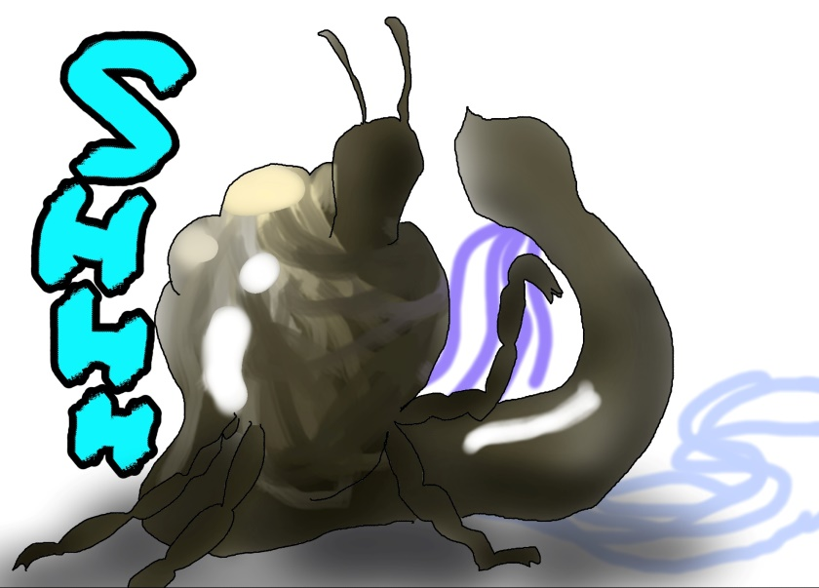

After the possession the host will have a cold behaviour (**video refernce from the movies**):

<https://www.youtube.com/watch?v=lHVuXZp-qoA>

https://www.youtube.com/watch?v=g8yurma6ToA

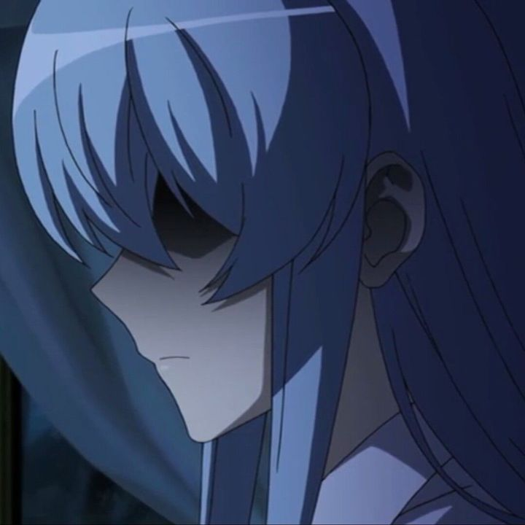

**SPECIAL DETAIL**

During the scene of the masturbation a detail could be seeing an effect like where some tentacles moves under the skin as the woman is reaching the climax (maybe based on the idea of this this images).

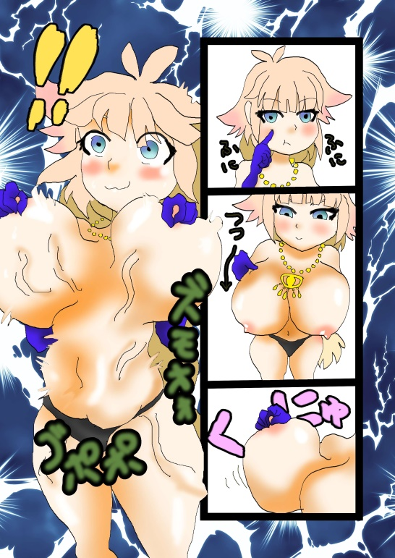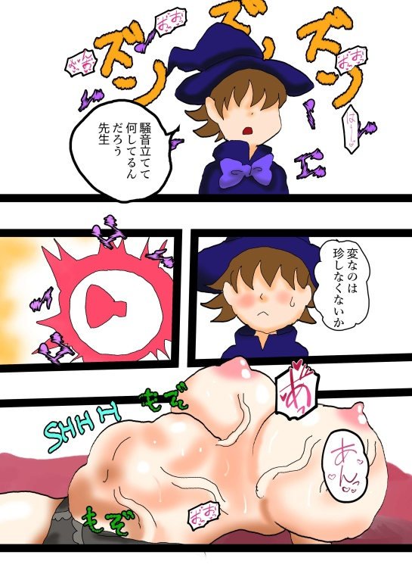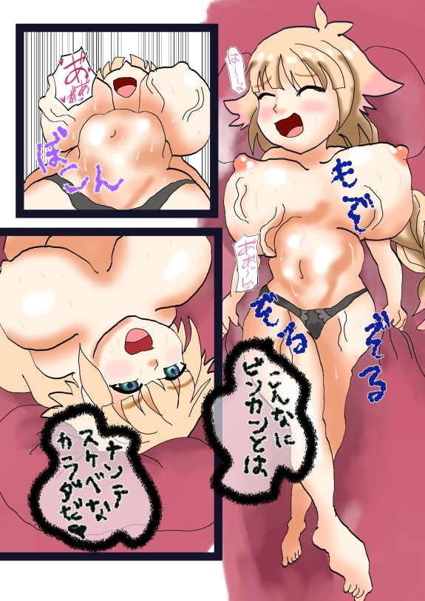

Chapter 2

As the woman rides her motorbike she arrives in the red light district of the city, a place where there can be found the most notorious and frequented strip clubs. Seeing a long row of people in front of one of this clubs, taken by the curiosity she parks nearby. As she gets off she is approached by a young man who upon seeing her figure and outfit, he starts to harass her hoping to engage in a sexual encounter. At first the woman looks at the guy with her cold emotionless gaze but as soon the man touches her, she grabs him with just her right hand and throws him away against the wall knocking him down.

Walking toward to the entrance, she carelessly passes the row of people and as she is about to enter through the VIP entrance, she is blocked by the bouncer who warns her to get back in line; however after the man notices the exposed bust of the woman, stammering to her that the entrance for the dancers is on the back, he lets the woman enter inside the club wondering if she is a new dancer of the boss while admiring her back figure.

Inside the club, the woman takes a look at the people enjoying themselves, from the people interested in getting drunk to the ones watching the erotic dance of the strippers. Wanting to enjoy those too, first she orders a bottle of beer (the alternative could be a bottle of a strong alcohol) which she quaffs in one hit, causing some of the drink to drip onto her exposed torso and ending with a loud belch.

After this she takes interest in the men attracted by the erotic dance of the strippers which shows their bodies with their sensual movements. Watching with a closer look and then palpating her own exposed breasts, making a little smile of enjoyment, she gets on the stage and starts to move in a sensual and energetic way, taking the spotlight from the other dancers (angering them) while exciting the crowd of people with her savage attitude. As the crowd becomes more and more enthusiastic, the alien enjoys even more her moment which reaches the climax when she exposes her breasts completely, causing the crowd yell out for the performance.

As some of the bouncers try to get the woman off from the stage, a group of men intervene protesting and wanting another dance from her. With the crowd becoming troubling to contain by the bouncers, the alien throws one of guards against the group, starting a riot which involve all the people inside the club, much to the enjoyment of the alien who smiles as it spreads more chaos.

Some minutes later the police intervene to sedate the riot and arrest the people which took part in the brawl, meanwhile the woman comes out from the back exit of the club wanting to continue to enjoy her human body. But then she is stopped by a muscular blonde police woman, who points her gun warning her to freeze as she is going to be taken to the police station for interrogation.

The alien, taking interest in the authority and the body of the agent, making her at first submits to the policewoman but as soon she comes close to handcuff her, she grabs her face and pushes her against the wall making her drop her gun.

Here there two option for the scene:

1. As the agent warns her to not resist, the woman smiles and opens her mouth from which the parasite emerges and much to the terror of the officer, enters inside her body. As the alien goes down the officer’s throat, its tentacles follow the main body inside the new human host, leaving the body of the afro woman which faint on the ground followed by the officer. While unconscious the belly of the officer expands as the alien takes place inside her, causing her body to undergo an orgasm which causes the unconscious woman to cum.
2. As the agent warns her to not resist, the woman knock her violently against the wall making her loose for a brief moments her senses. The alien decides to enter inside her this time trying to pass through her lower orifice (her erogenous zone), and as she opens her mouth the parasite emerges and move inside the officer forcing its way. Entering in this way causes the officer’s body violent spasm with a huge amount of liquids juicing out due to the derived stimulation on this zone. With tentacles following the main body inside the new host, the afro woman which faint on the ground but while unconscious the belly of the officer expands as the alien takes place inside her, causing her body to undergo an orgasm which causes the unconscious woman to cum.

After the belly returns to its normal size, the officer regains consciousness and as she lifts her face she makes a malicious smile as the parasite has taken control of her body. After admiring her new appearance and touching her muscular new body, she looks at the unconscious woman expressing enjoyment.

After grabbing the gun, an agent comes to look what happened after hearing a scream and as the new “officer” walks toward him with a light sensual smile, she passes him without a word, ending with her walking away as she goes to enjoy her new authority. The chapter close with a view of the crash site of the first chapter where a group of individual commanded by a human in penumbra approach to examine the remains in a serious behaviour.

**Special Detail**

A possible idea interesting to see could be an x-ray vision of the woman where her body is obscured but we can see the parasite attached to the host’s limbs and brain with his tentacle .

The alien parasite should be based on this video, also this scene could be used as a reference for the possession scene which saw the afro woman being possessed.

<https://www.youtube.com/watch?v=4TAwRf4wMec>

Reference for the belly expanding (but in the comic her belly expands in a minor size)

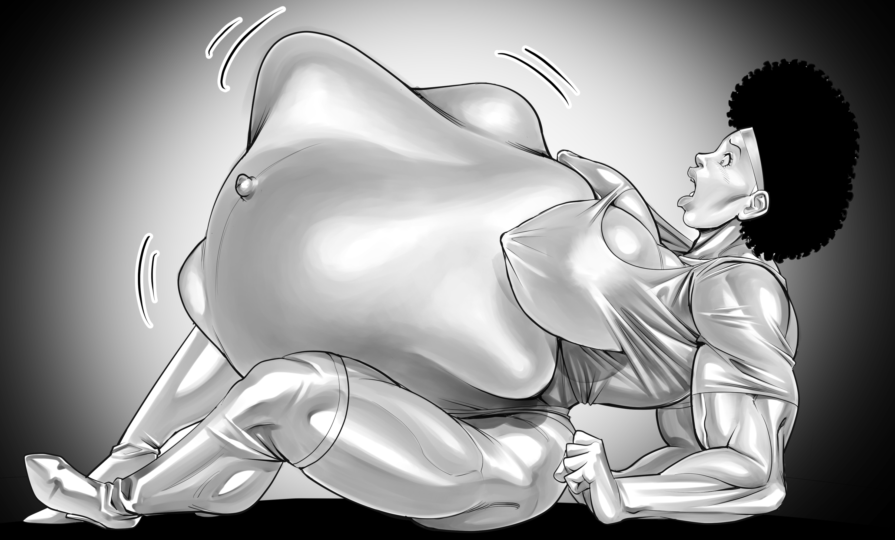

The woman expression is emotionless except for moments where she enjoys her body or spread chaos (like this woman from the movie “the Hidden” 1987 or like in the movie Terminator)

<https://www.youtube.com/watch?v=PfHoY4G94CU>

The policewoman which appears at the end of the chapter 2, in the appearance should be based on the Lieutenant Debbie Callahan from the movie series Police Academy. She is blonde and muscular wearing her uniform with a skirt.

