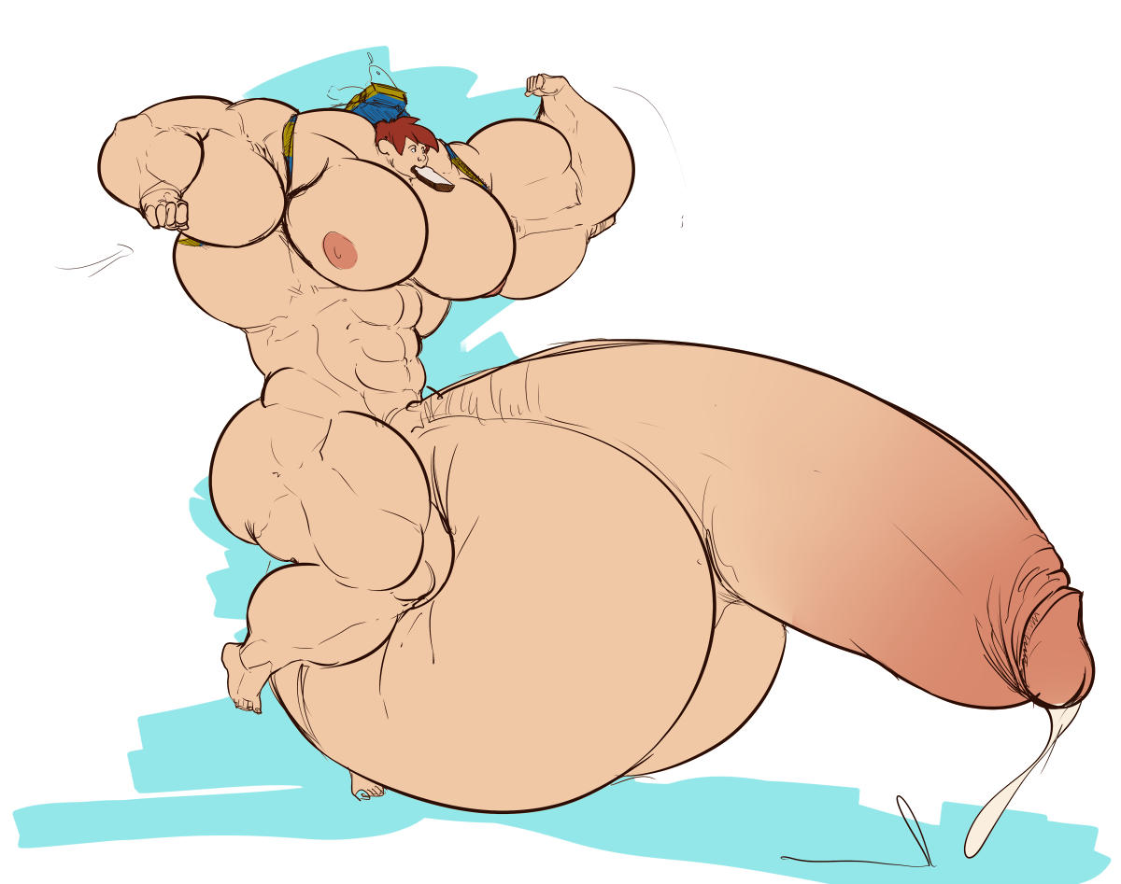**Above Average**

**By Ziel**

Story © 2016 Ziel

Cover art © Whatinsomnia (All rights reserved)

Above Average

Part 25

By Ziel.

**Above Average**

**Part 25**

Alan did the one thing he had never done before – he hung around after class, and he wasn’t even trying to make a scene or draw attention to himself. He was as discrete as he could be considering his cock along took up nearly half the auditorium, and his muscles filled up a large percentage of what was left. Some of his fellow classmates hung around for a while too, but once it became clear that Alan wasn’t just biding his time to pull one of his signature stunts, the throngs of admirers steadily thinned until the only person left in the Auditorium was Alan himself.

Once the last other student left Alan leapt into action – figuratively anyway. With his sheer girth it was hard for him to do anything particularly speedy. Even with immense muscles it still took a lot of effort to maneuver his massive cock around, and his enormous muscles tended to be a problem in their own right since they were so thick they impeded his range of motion. Even without his massive cock factored into the problem Alan was in for a tight fight. His burly body was so broad and brawny that he didn’t even fit down the center aisle that went from the back of the auditorium down to the front podium. This pathway was wide enough for three or more students to walk down side by side, but Alan’s massive, meaty quads bulged out so far that the chairs groaned in protest as he squeezed between them, and his balls were even worse off. His enormous sack spilled over into the adjacent rows of chairs as he made the trek. It was almost as if his nuts were sliding down the slope of the auditorium with the rest of him along for the ride as opposed to him laboriously moving his package along. About the only part of his massive body that wasn’t having trouble navigating the auditorium was his enormous cock which was thankfully in a semi-chubbed state so that it didn’t even touch the rows of chairs in front of him. Instead his massive semi lolled back and forth in front of him as he walked. Had there still been any students seated they surely would have had a huge, drooping dick swinging back and forth right above their heads that was so close they could reach up and poke it without even needing to strain to raise their hand.

It took a while, but Alan eventually managed to make his way down towards the front lecture stage, but then the real difficulty began. The professor’s office was tucked away in the side of the room, and he had nearly twenty feet of fat cock sticking out in front of him. His dick was touching the wall and he had barely even begun the trek from the center aisle towards the corner. Alan found himself having to scoot sideways along the front pathway between the chairs and the stage. His big, bare, beefy butt brushed against the wooden stage and his enormous cock jutted out in front of him over top of the student desks. The tip of his massive dick brushed against the folded up seat cushions of the chairs in the fifth row, and his enormous balls engulfed the chairs in the first row of seats as he sidled his way towards the corner.

By the time Alan made it in range of the door to knock and get the professor’s attention, the hot, hunky lecturer was already out of his office and admiring Alan’s attempts at navigating a classroom that was far, far too tiny for his massive bod to navigate. Alan’s heavy footfalls were hard to ignore, and sound of chairs and folding desks groaning in protest as his colossal balls slid over them was even noisier. To put it lightly, Alan’s approach was obvious long before he actually got close to the professor’s office.

“Ah. To what do I owe the pleasure?” The professor asked.

“Uh… right… Mr.….” Alan murmured awkwardly as he glanced around for something to refresh his memory of the professor’s name. Luckily he managed to spot the nameplate on the wall beside the professor’s door before things got too awkward. “Mr. Simpson.” Alan finished.

Alan was suddenly struck by a new memory that made him wonder how he had ever forgotten the guy’s name at all. The professor was a certified stud. Even well into his fifties he had a body that would make men half his age weep out of jealousy. The professor’s big, barrel chest was bulging out of his button-up shirt. The buttons could barely contain his thick, muscular pecs, and his khaki slacks weren’t faring much better against his tree-trunk thick quads, and then there was that bulge of his thick cock. The monster looked ready to burst out from behind the zipper of his fly at any second. All this coupled with the professors flowing, grey-flecked mane had garnered him the nickname of “Mr. Samson.”

Alan balked at the sudden realization. He had to remind himself that that was a brand new memory. He had to force the image of Mr. Simpson as a hunched over, wizened old fogey into his mind. The Professor Simpson that Alan knew was more akin to Mr. Burns than Brock Samson, but that was a different reality. In the current reality his professor was the beefcake that stood before him now. The question was, when did the professor become such a stud?

“Hey so… did something happen this morning?” Alan asked awkwardly.

“Excuse me?” the professor replied.

“Oh. I mean. You just seem more… robust than usual. I was wondering what your secret was.” Akan said. It was partially the truth and it seemed to alleviate the professor’s confusion. In fact, Mr. Samson went from baffled to bawdy on a dime.

Mr. Samson let out a hearty guffaw and puffed up his chest which caused the top button to fly off. “Noticed that didya?” He boasted with no small amount of pride. “I usually start the day off with a glass of six raw eggs, but recently I’ve been trying eight instead. Takes a lot of protein to fuel a body like this, but I suppose I don’t have to tell *you* that, do I?” He said and let out another hearty guffaw.

“No. I know all about that.” Alan replied with a smirk. He took a moment to puff up his own chest and even went so far as to flex his biceps as well. He never could pass up a chance to flaunt his muscles, but as much as he really wanted to put on a show, he knew he needed to get some info from the professor, and the sooner he did it the better. There was no telling how much the old man would remember, and the longer Alan waited to jog his memory the less the chances became that Alan would be able to get any useful info out of the guy. It may already be too late. Whatever chance encounter the professor had had with someone carrying the magic box and relic may not even have happened in the current version of reality.

“So… you didn’t happen to meet with another student today, did you?” Alan asked as casually as he could, but he didn’t really succeed. He sounded like he was up to something, and Alan could tell from the sudden change in the professor’s disposition that the older guy didn’t trust where this line of questioning was leading.

“I can’t share any information like that. Teacher student confidentiality and all that.” The professor explained.

“Oh. No I didn’t mean anything class related.” Alan quickly explained, but his explanation just made matters worse.

“What are you implying…?” The professor asked suspiciously. He narrowed his gaze at Alan and silently peered at the beefy student as if appraising Alan’s intentions.

Alan knew he was on thin ice so to speak. He was just trying to coax some information out of the older guy, but that would require not just subtlety but also knowing the right questions to ask – both subjects that Alan was sorely unprepared for.

Alan fortunately had one trump card he could play. It was no surprise that the older guy was as virile as ever – if not more so thanks to the effects of the relic, and being in such close proximity to the huge, hyper-hung, beefcake of a student was having a pronounced effect on the man’s cock. Alan could see the snake stirring to life in the man’s trousers. Mr. Samson’s cock seemed even larger than Alan remembered, and Alan wasn’t convinced that that was purely because the professor was more of a grower than a shower. It was almost as if the older guy had had another mild growth spurt.

As if to confirm Alan’s suspicions, the seams around the shoulders of the older guy’s shirt started to pop and fray. The professor was struggling against his own supercharged libido, and this was causing his to hover in a semi-boned state. The slight vacillations between slightly hard and slightly soft were enough to add a few millimeters to his final cock size every few seconds, and that was really adding up in a hurry. His already massive muscles were threatening to burst free from his clothes at any second, and Alan had a mind to help matters along.

“Well, it’s just that I couldn’t help but notice how hot you look lately. I was wondering if anyone else had tapped that yet today.” Alan said impishly. He reached down and ran a brawny hand across the bulge in the older man’s slacks. It was a ballsy move – even for someone whose testes were the size of clown cars, but Alan had reason to believe that the professor’s supercharged sex drive would make him agreeable to what he had in mind.

“Y-you really shouldn’t do that…” The professor murmured, but he didn’t sound particularly opposed to the idea. Whatever defense he was putting up was paltry at best. He made no effort to shy away from Alan’s touch nor did he try to push Alan’s hand away.

“Oh… That’s nice…” The professor murmured softly as Alan stroked the older man’s cock through the fabric of his khaki pants. With each passing second the older guy’s cock grew harder and harder. It strained against the fabric of his slacks so hard that it threatened to tear free of his pants at any second. The huge tent of his fully boned cock was far larger than the slacks had room to accommodate causing the fabric to groan audibly in protest. It was only a matter of time until something gave out, and Alan was eager to see what would give first.

Alan’s eyes traced a path up and down the older guy’s body as he stroked the professor’s rigid cock through the guy’s slacks. Even within the confines of his slacks it was obvious the dude had well over a solid foot of schlong, and it would probably be even larger than that once it was free to show its true size.

Alan grinned from ear to ear as he listened to the older guy’s breathing steadily get heavier and raspier. He chuckled as he watched the man who had a body that made bodybuilders weep quiver like Jell-O against his touch. Someone with so much brawn and power and yet was so easily brought to his knees – both literally and figuratively. It didn’t take long for Alan’s touch to have its intended effect. Alan wasn’t interested in dragging this out so he kept the pressure on even as the older man’s legs began to wobble beneath him. He continued to stroke the guy’s cock even as he felt it buck and lurch in his hands. Even as he felt the warm, slick pre seep through the khaki fabric, Alan continued to stroke and pump the man’s dick. It was soon apparent to both of them that Mr. Samson wasn’t getting out of this situation without making some form of a mess.

The professor suddenly jumped into action, but he didn’t try to stop Alan’s groping. Instead he fumbled awkwardly with the button at the top of his fly – a button which was now clasping far too tight causing the waistband of the slacks to dig into the defined muscles of his abs and Adonis belt, but try as he might Mr. Samson had neither the time nor the manual dexterity available to him to undo the clasp and drop his drawers. He let out a soft moan as he lost the fight against his own need to cum. His cock lurched hard in the tight confines of his slacks, and thick cum oozed through the fabric and started to drip down his front. He was so overcome with ecstasy that he nearly collapsed flat onto his ass – in fact, he would have had Alan not been on hand to catch him.

“Easy, old timer. We wouldn’t want you to fall and break a hip now, would we?” Alan teased playfully as he helped to older man lean back against the wall.

“Oh… you know how it is when you get to be my age. Old grey mare ain’t what she used to be.” The professor mumbled in reply.

Both Alan and Mr. Simpson realized what he had said at the same time. The both did something akin to a double-take and quickly looked at one another. There was a brief flash of mutual understanding.

“You remember something.” Alan said firmly.

“I was… I was weak…” The professor murmured.

That was putting it mildly. The professor that Alan knew was so scrawny and scraggly that he looked like he could be blown away by a gust of wind. It was a wonder he was able to get around without a cane. The former Mr. Simpson was a stark contrast to the current massive, muscular Mr. Samson that now sat beside Alan.

“But I’ve always been strong… ever since I was a boy…” The professor murmured.

“It’s alright. Your memories are a little jumbled right now. It happens.” Alan explained.

Alan tried to be reassuring – he really did, but it was not his expertise nor could he really focus too much on the professor’s mental state – not when the professor was steadily swelling before his very eyes. The older man was beefing up by the second. The latest climax had caused him to once again have a growth spurt, and the pounds of muscle steadily stacked on. He was bulking up so fast that even with reality warping around them trying to play catch up his clothes just could not keep up. The already suffering seems on his shirt popped and frayed. The fabric of his slacks creaked and groaned in protest as the fibers were pulled tighter and tauter with each passing second. The teeth of his zipper popped and snapped as his already massive semi grew and swelled beneath. Soon the professor’s fat chubby fell out from behind the broken zipper, but it did little to alleviate the strain on the fabric. Now his balls were massive enough to be a bulge and a half unto themselves and his muscles were even more massive than ever.

The professor was breathing heavily due to an odd mix of impending panic and overpowering afterglow. He felt amazing and his swelling muscles felt fantastic, but the knowledge of his past self was more than he could handle right now.

“I can’t go back.” He pleaded.

Alan was taken aback. He hadn’t even thought about that. He still didn’t know a whole lot about the relic, but it did seem clear from his last visit with the God King that it wasn’t meant to be shared like this. What would happen if Alan claimed the full power for himself? Would bulky Mr. Samson once again be weak Mr. Simpson? Would the titanic quarterback, John, once again be the fairly average quarterback?

Alan didn’t have the time nor the mental fortitude to think too hard on all that right now. The professor was still under the effects of the relic which means that whoever had exposed him hadn’t shut the box yet. There was no telling how much longer Alan would have to talk with the older man before he was cut off from the magic, and once that happened it would be much harder to get him in this semi-lucid state where the various realities converged in his mind.

“It’s ok. I won’t let you go back. You’re huge, like me, right? We gotta stick together, right?” Alan tried to console the older man, but the words felt strangely hollow. There was a pang of guilt gnawing at his gut. Could he really claim everything was ok? And that “big guys gotta stick together” bullshit was too much. Alan hadn’t intended to share, but surely he could spare a little size for Mr. Simpson, right?

Alan awkwardly patted the older man’s shoulder in a half-hearted attempt to seem sympathetic. Alan’s palm made contact with a large swath of exposed, muscular upper arm. Mr. Samson had grown so massive that his sleeved had pulled completely away from the rest of his shirt. It looked more like he was wearing an undersized vest and some tatters on his arms as opposed to a button-up shirt.

“Yes… of course…” the professor said shakily. The fabric of his khaki slacks shredded audibly as his quads and calves grew too large for the fabric to even cope with.

“I need you to tell me about the person you spoke with earlier. Did someone show you a black box? Do you remember a dick shaped rock?” Alan asked.

“Yes. I remember something about that. A young man about your age came to see me… It’s strange… it was just this morning, but it’s so hazy… but that can’t be right… I didn’t have office hours this morning. I skipped it to go for a jog.” The professor murmured.

Alan glanced at the older man’s body. He could tell that his muscles had more or less stabilized. Even the professor’s huge, flaccid cock had steadied out for size. The fat, floppy cock dangled now down almost to the older man’s knees, but it didn’t seem to be getting bigger. Alan knew he was losing his window of opportunity. Soon reality would finish adjusting itself, and if he didn’t get the original memories locked into Mr. Samson’s mind before things stabilized then it would be nearly impossible to dredge up the memories from the original reality.

Alan did the only thing he could think of. He reached down and took the professor’s drooping cock in the palm of his hand. Even soft the thick schlong was so fat that Alan couldn’t fully get his fingers to wrap all the way around it. The dude’s cock was thicker than his wrist by a good margin. Mr. Samson’s soft cock was now thicker than Mr. Simpson’s whole arm had been just this morning, and the behemoth was almost as long to boot.

“Wha-? Oh. Ohhh…” the professor cooed softly in response. His confusion gave way to bliss as his cock once again stirred to life. His muscles once again began to swell beneath his overstuffed clothing. The next button on his shirt popped off causing his big, beefy chest to spill out completely from behind the fabric of his button-up shirt. Mr. Samson was breathing so heavily as Alan toyed with his steadily hardening cock that each time he inhaled his chest heaved which caused another button to fly free and another. It seemed with each orgasmic gasp his muscles surged outward. His slacks split. His shirt buttons popped off completely so that his shirt looked more like Aladdin’s vest than it did a long-sleeve shirt.

It wasn’t long at all before Mr. Samson’s cock was rock hard in Alan’s hand. The tool was enormous by anyone’s standard. The thick cock was easily as wide as 3-liter coke bottle and stood all the way up to the older man’s swelling pecs.

Alan slowed his strokes. This time his goal was not to make the man cream. This time he needed to bide his time.

“Professor… Hey! Professor!” Alan cried out to get the older man’s attention.

“What?” the professor asked. His mind was adrift in a sea of bliss and swirling memories. He could barely focus on anything other than how great he felt.

“I need you to remember what happened this morning. You met with someone – someone with a magic box. Who was it?” Alan asked sternly.

“I… don’t remember his name. I see so many students for so many years… they all blur together…” the older man murmured.

Mr. Samson suddenly gasped. His cock gave a hard lurch in Alan’s hand. His pants shredded even more. His vest began to split straight down the back as the massive muscles in his chest grew simply too vast for the piddly garment to even try to cover.

Alan slowed his stroking and waited for the shuddering to stop. As much fun as it would have been to watch Mr. Samson blow another thick load, Alan needed information, and that meant keeping him in a state of steady growth.

Once Mr. Samson’s breathing stabilized and his cock stopped shuddering, Alan continued his steady stroking. He took a moment to let Mr. Samson savor the feeling before he started his interrogation.

“Surely you can give me some info. What did he look like? What was he wearing? Anything that would give him away?” Alan asked.

“He was… He was strong… Not like us. Not like me, but he was definitely built. I remember him sitting there. I could not take my eyes off of him. His tight shirt gripping his firm body…” the professor murmured softly.

This caused Alan to cock an eyebrow. The last memory was obviously from the original reality. The professor had been checking out the mystery man even before he had been given access to the vitality that the relic granted. Alan tried to search his memories to see if he could remember anything about Mr. Simpson from the original reality. He tried to recall if anyone knew that Mr. Simpson was gay, but Alan just could not recall, but this time it was not the reality altering magics messing with Alan’s memories. Alan had just never even cared to remember the older guy’s name let alone his orientation back in the original reality. However, Alan did not think it was a simple coincidence that the professor was given access to the relic.

Just thinking about how hot the mystery man was seemed to send Mr. Simpson over the edge. He gasped once more. His cock shuddered again, but this time a small spurt of cum shot out before Alan could back off.

“Small” spurt was a relative term. For any normal person the solid rope of jizz that shot out of Mr. Sampson’s cock would have been more than seven loads worth, but the older guy had all that and a lot more tucked away in his nuts. Even after firing off a rope of cum that would fill a Big Gulp the dude’s dick was still rock hard and ready for more – much to Alan’s relief.

“I need more info.” Alan said calmly as he continued to gently stroke the older man’s cock.

Mr. Sampson was hit with another growth spurt. This one caused the waistband of his slacks to snap like a rubber band. His Adonis belt and abs had growth simply too thick for the waistband to handle, and that was saying nothing of his thick, meaty ass. For all intents and purposes he was completely nude save for a few tatters of clothing which still clung to his massive body. Mr. Samson was now so huge and hulking that his broad shoulders would have trouble fitting through a double door. His barrel chest was wider than the podium he stood at to teach class. His cock was now even longer than his arm and as thick as a milk jug. His nuts were now the size of ripe grapefruits. Each enormous orb would more than fill one hand. Alan would have had to cup both hands together just to hold even one massive stone.

“He had… brown hair… Wavy brown hair. And glasses.” Mr. Samson murmured groggily.

“Great. I can use that, but I need more. Anything else I can use. How thick were his glasses? How tall was he?” Alan pressed.

“What? I didn’t meet with anyone this morning. I don’t have office hours in the morning since I always take a jog before classes.” The professor mumbled.

“Come on. I need you to remember. I need to know about the relic.” Alan insisted.

“I don’t know what you’re talking about.” The professor said uncertainly.

Alan stroked the older man’s cock even faster hoping to trigger another growth spurt and force another semi-lucid state, but the professor didn’t seem to be in any condition to talk nor remember. He just moaned and writhed in ecstasy as Alan pumped his huge cock with both hands. It didn’t take long for Mr. Samson to blow his thick load all over his chiseled abs and thick pecs. The guy came and came again, and all the while Alan kept a grip on the guy’s fat cock and kept pumping in hopes to drain every last ounce of spunk and spur yet another growth spurt, but even when Mr. Samson ran out of spunk to shoot and his huge cock softened and drooped, his muscles stayed the same.

Alan stood up and took a step back. He glanced over at his side to see Mr. Samson enjoying a pleasant afterglow. His huge cock now drooped well past his knees, but that seemed to be as big as it was going to get. Somehow he had stopped growing. Somehow he had been cut off from the source of the power.

“Hey. What’s that noise?” John asked Kyle as the smaller, slimmer guy trotter over to the table that John was sitting at.

“Oh. Something’s been rattling around in here all day, but I haven’t had time to dump everything out and look at it.” Kyle replied.

“Give it here. That’s gonna annoy me the whole time if I don’t fix it.” John replied and rolled his eyes.

Kyle held out his book bag which John quickly took and began to rifle through. It wasn’t long before John let out an “ah ha!” and pulled forth a couple of objects; a familiar solid black box and an equally familiar cock shaped stone. John didn’t say anything nor did he waste any time. He put the relic back into its compartment and began to shut the lid.

“I swear that thing does not want to stay closed.” Kyle replied.