NURSE SHORTAGE
JANUARY 2022 FIRST PERSON STORY
BY CHALDEACHANGE
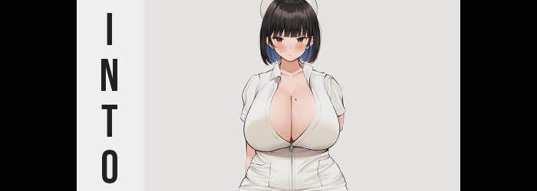

Sometimes you just wanted to try something new, right? If transformation was real, life itself was the perfect embodiment of that. The world was always changing, and within it? Your role. No individual was destined to do the same thing forever, and once in a while you would seek new thrills, new experiences. Whether it was an adventure or a new career, there would always be moments where you would feel that way.

I can attest to that because it had happened to me. One day I just began to wonder ‘what would life be like if I’d chosen a different career?’. One thing ultimately led to another, and before long? I had found myself on numerous job posting sites, looking for something that might stand out to me. It was a tunnel-visioned state of mind that consumed me for an entire afternoon and well into the evening.

But in the end? I didn’t find much of anything that interested me. Thinking it would be best to finally take a break, I ultimately retired to fetch a coffee and dinner. Maybe if I perked myself up, I would feel a little more inspired? If not, maybe it was just a fool’s errand after all? No! Thinking so negatively never benefitted anyone.

Trying to maintain that mentality, I eventually did return with some sustenance. A coffee, as planned, and a roast beef sandwich that I had tossed together on a whim from what was sitting in my refrigerator. It wasn’t the most balanced of meals, but hey! You gotta do what you gotta do.

I had a habit of eating at my computer desk. Living alone meant that I didn’t exactly need to sit alone at my kitchen table, and it was always nice to pick a video to enjoy while snacking. And yet before I could even bring up a video? Disaster struck. I had clumsily knocked over my coffee mug, and hot liquid spilled all over my mouse and keyboard. With the job application site still up, something much more miraculous occurred as a result.

“Hey!” While I hadn’t verbally reacted to the spill itself (because it wasn’t the first time I had spilled something on electronics, sadly), I certainly reacted to what popped up on my screen. “Your job application has been… I didn’t submit any applications!” Had the spill caused my keyboard and mouse to glitch, sending an application without my intent? Where had it even sent one? Well, a little additional reading would answer that question. “To be a nurse!?”

I certainly didn’t have the qualifications for a job like that. In fact I had no medical experience whatsoever. My resume was just going to get laughed at by whoever who had to read it… or at least I’d thought. But what I didn’t know was that the application that had been sent? Not only did it include the relevant qualifications, but it had spoken to a completely different name and background.

And soon? All of it would become true.

It was a process that had already begun, in fact. I just wasn’t trained to notice the internal warning signs. It was like a mysterious force had begun to nibble away at my knowledge, replacing what I knew about my current career and replacing it with a very specific know-how. Regarding how to function as staff within a hospital.

“There’s no way that I could be a— Huh…?” Rather than focus on trying to clean up the mess I had just made, instead I was fretting over the issue of the unintentionally sent application. Wasn’t anxiety a bitch? But it was a focus I had to abandon, because out of nowhere the fit of my clothes felt… strange? Maybe ‘strange’ wasn’t the correct term, but not only did it feel too tight, but it felt breezy in places as well.

Looking down, it actually was pretty obvious as to why. Most of my shock stemmed from the fact that what I was looking at was basically impossible. “Where did these clothes come from? When did I put them on…?” I was dressed in what looked like your stereotypical nurse’s uniform – and a woman nurse at that. With a skirt and a zipped up dress. Unfortunately, because I had a gut it was being tightly compressed by the cloth, and the breeze I felt was from both wearing white thigh highs and what I perceived to be a woman’s panties around my crotch. “What the hell!?”

That settled it! This had to be some sort of dream, or so I had thought! Clothes just didn’t randomly change, and not into… the occupation… that was on my computer screen? Were the two things related? They had to be, didn’t they? “Woah!? Now what!?”

Just as I was on the verge of accepting that maybe, perhaps, quite possible, this was all somehow real, something altered my sense of balance and I felt as if I had begun to fall. I immediately corrected my assumption because my feet were still firmly planted on the floor of my room, but the cause I identified in its stead was just as unbelievable as my sudden costume change.

“Wait, I’m shrinking…?” I didn’t yell this time, but I also wasn’t any less shocked by the idea. My desk looked closer to my eyes than it had before, and as a tall man that had always wondered what it was like to be short, I could definitely notice my height dipping down from six feet to around five foot two inches. It also helped with a problem I hadn’t even known that I had. At my old height, the skirt had been lifted so high that you could see my underwear and my dick stuffed within. Now, at least, the base of the skirt seemed to cover it for the most part. “Did… Did I really just get shorter?”

I was much too stunned to say more than that for a time. Looking down at myself, and then around at the room, there really was no other explanation. As if it was seizing upon the fact that I was looking elsewhere, the gut that I had previously been so worried about? It soon flattened along with all of the excess fat in my body. This left by tummy trim and the nurse’s costume fitting on me much more comfortably, not that I was planning on continuing to wear it (at this point).

Before I could redirect my attention back down at myself proper, fingers reached to stroke my own cheek for a moment. My skin there had felt a little tingly, and I was worried that it was related to everything else that was happening. “Smooth…? I must have shaved recently, right?” Why was my skin so smooth? And I absolutely hadn’t shaved that day, but in the back of my mind there was a question that stood to contradict the first one.

Since when did I have to shave my face?

Truthfully my face had become softer. Far too much so. There was no sign left of any stubble, none that would even suggest it had ever grown there. My cheeks had actually become thinner, but then again so had the rest of my head, which had shrunk alongside my body. I exhaled through lips that were much, much plumper, breathed in through a nose that was much smaller, and saw through eyes that were much larger. All in all, my face was better suited to match that of an attractive young woman. One with eyes of brown.

And hair of black. My natural color wasn’t exactly lightly colored, but it darkened towards a raven black while growing out some. Incredibly straight, it reached around my neck in the back like a dome before stopping just above it, while in the front? My bangs hung long but were cut right above my eyes like curtains. “I… What was I doing? This mess… I did it, right?”

My voice was soft yet melodious now, having lost the masculine undertones that once had rendered it so deep. I looked quite androgynous with the state of my head and my manner of dress, but there were also signs that an inescapable femininity would alleviate any doubt as to the nature of my sex. Even now, my hands were shrinking with fingernails growing – and the same could be said about feet that were fitting much more snugly into the sock portion of my thigh highs.

Why was I having such a hard time focusing? I had to… I had work to do, didn’t I? Paperwork? Room visits? Was that right? What was my job, exactly? Why did that not feel right? “Mmn!” I was already having enough problems focusing, and so why now of all times did I suddenly feel strangely aroused? I was already much too caught up in my transformation to realize, but it was because my dick and balls had folded into my loins, leaving a woman’s pussy in its place and the front of my white panties flat short of the slight pushback from the black bush beneath.

By all definitions, I had become a woman. Even if my body had yet to properly embody that, it was certainly what seemed to be the case. Just as things had been progressing thus far, mind you, the lack of an appropriate figure was only a briefly entertained dilemma. But my uniform wasn’t exactly prepared for just how ‘appropriate’ my body’s figure would become by the time all was said and done.

Beginning in the areas closest to my new, moist pussy, the phenomenon of growth began to work itself, contrasting all of the loss I had suffered thus far. My exposed thighs looked to grow shinier as the flesh beneath them pushed the skin to tighten around what was undoubtedly an unnatural amount of fatty tissue. I’d no doubt seen plenty of women with thick thighs in my lifetime, but even when comparing my own thighs to them (had I been in the right state of mind to do so) it would have been pretty clear that this was absolutely ridiculous.

Their mass, as well as the mass of a swelling ass behind them, gave my hips little choice but to part much wider than they were normally designed to part. Inch after inch stretched them, and yet despite how they grew to surpass my shoulders in width by a substantial margin, my thighs were just so dense that they still met between my legs. Even if you’d had three of my arms side-by-side, a single thigh would have been thicker. It was absurd! But I was used to people ogling them. …Right? My huge ass was in a similar position, and not only had my panties been wedged right into my cheeks, but the nurse’s dress had been lifted by it all to show those panties again. Not even my thigh highs could contain their mass.

And this was only the lower half. What occurred when it came to my chest was not only just as chaotic as what had happened to make me so bottom heavy, but it was arguably even more unbelievable. And it began with little more than an itchy feeling that saw the shapes of my nipples protruding up against the inside of the zipped-up dress. Had I not put a bra on? …Since when did I wear bras?

Since when were my nipples that big, actually? They seemed to be larger than quarters, foreshadowing the sizing difficulties I’d have not long after. Because I wasn’t wearing a bra because I’d forgotten. It was just very hard to get them in my size. A building pressure saw those nipples pushing farther and farther forward, with the zipper of my dress sliding down gradually along with it. There couldn’t be any culprit other than my chest itself, which had surged forth with a sudden jiggle that added two cup sizes to where no breasts had existed in the first place.

And that was the rhythm it maintained. “Oh!?” I moaned every few seconds as the fat saw these breasts grow bigger and bigger, with the zipper of my dress yanking itself down farther and farther as a direct result. It didn’t take long to reveal a mole on my inner left breast – a mole that part of me couldn’t seem to remember possessing before. But they continued to swell, and to avoid a situation where I might fall flat on my face, the muscles in my back strengthened to support them.

And they’d have to be pretty damn strong all things considered. With the zipper halfway open, my cleavage might have better been described as a canyon. Each tit was one and a half times the size of my head, unbelievably huge and yet completely naturally. My teats were so immense that if I hadn’t been dressed you would have been able to see the veins flowing inward from my equally huge nipples. Some girls were thick, but me? I had definitely been called a freak of nature by my fellow women in the past.

“Owwie!? What the heck!?” Pain and the scent of coffee alike snapped me out of my stupor. The cause? Hot coffee had splashed against this cleavage, which was strange. Had I been holding a cup? Oh no! It was all over the mouse and keyboard too! But… no? Hadn’t I done that earlier? Before I had… Before my body had…?

“Wh… at? Did that really just happen?” For but a brief moment it seemed like I was on the verge of acknowledging the transformation I had lost track of a short while ago. But for what it was worth? I wasn’t. I wasn’t at all. “I can’t believe my tits knocked my coffee over! All of my files… I’m going to get in so much trouble!” With H-cup honkers, it made working any job difficult. But using a computer with other items around? Sometimes it was basically impossible.

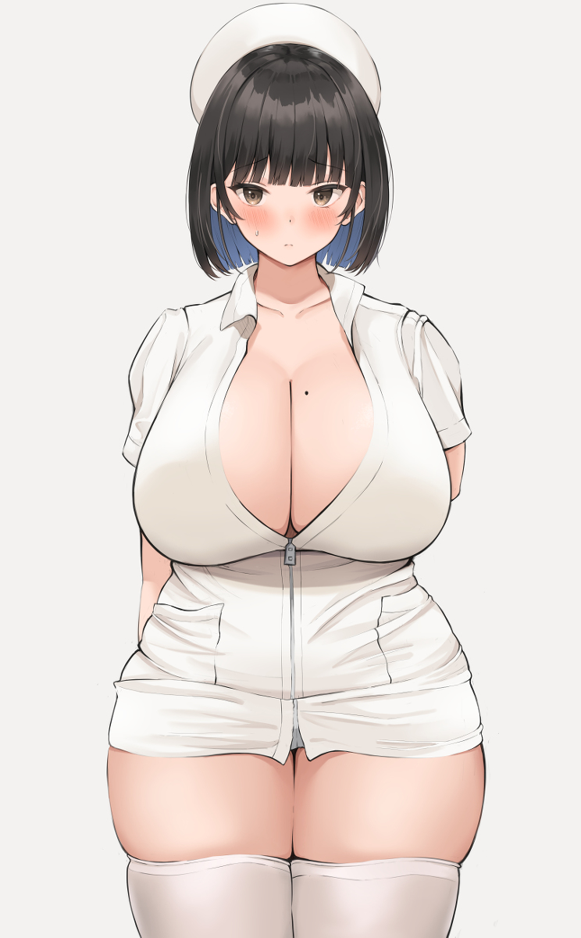
As for my concerns about this job, I’d hardly noticed that my surroundings had changed. I wasn’t in my room anymore – and in fact what I considered to be ‘my room’ wasn’t even in the house I was familiar with anymore. I was in a different city. A different state. Living an entirely different life, completely unaware of the fact that anything had changed at all.

In fact the date was even different. One month in the future, to be exact. This hospital had hired me after receiving my application, and I was having a hard time adjusting to the rhythm of this facility. I was still fairly green as a nurse, only just having graduated from college with middle of the road grades, but my body’s design made it even more difficult! My huge breasts and ass made it so none of the uniforms fit properly, and I was always bumping into things because of how thick I was.

The only silver lining was that some of the patients requested me personally. But as I was now, I was much too oblivious to realize it was only because they enjoyed staring at my body. Or maybe I did realize, and I kind of liked it? I’d certainly never admit to that! Not in a million years! “Oh, phew! Looks like the last backup was an hour ago. I just need to replace the mouse and keyboard then…” As well as cleaning out the coffee that had splashed into my cleavage during the spill. I, Amy, had to clean it up!

But just how clumsy could I be?

