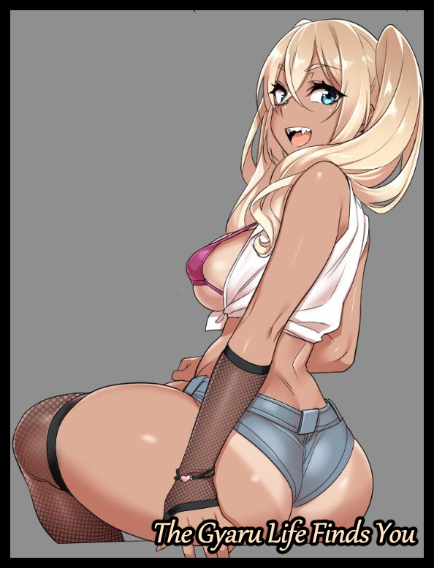

**"C'mon girl, you've totes got to bring out that smile o'yours! What're you like, so scared of anyways? You've done this a buncha times now, *remember?*"**

**"I…I know…it's just-*mnf!*-not in front of so many peeps before! A-And…w-what was I gonna…I've totes forgot what I was even gonna-*ugh!*"**

**"Then shut yo mouth and use it for sumthin else hm? These folks aren't even in front of us! Hey, eyes up! Cams rolling! Say hi to all the boys out there!”**

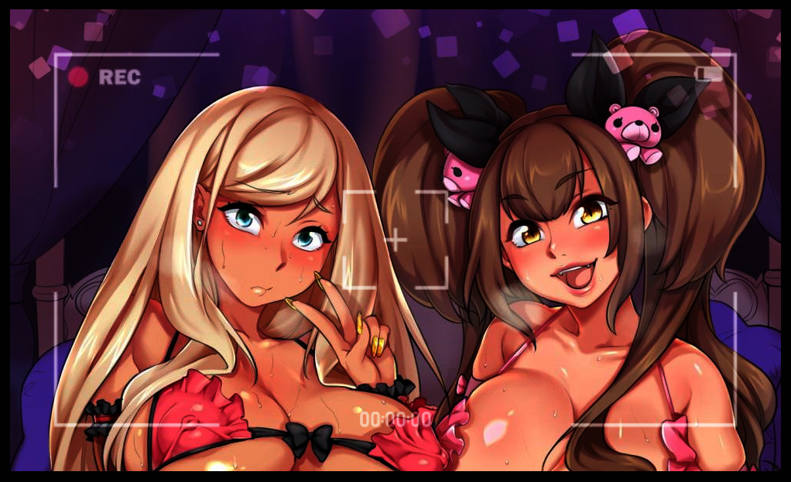

Gaudy neon colors, oversaturated lights, trashy music and a whole array of tools reserved for more depraved acts. The cramped interior of the room looked like the set of a sketchy adult movie, complete with the two main actresses lying coddled together in the middle of a heart shaped, canopy bed. Oily, tanned skin shimmering in the nauseating lightshow as they both strike a pose for the expensive camera aimed at them from the foot of the bed, connected to a laptop streaming the decadent scene of the two borderline naked gals in bed with each other to the world.

On the left sits a voluptuous girl with dirty blonde hair flowing down around her hesitant face heated into a severe blush from embarrassment and a smidge of pleasure. Clad in nothing but a frilly bikini top that was way too small to cover anything besides her swollen nips and a matching set of semi transparent stockings and shoulder length gloves, the brave girl tries to keep her face straight despite the awe inspiring sight of two massive dildos being forced into her puckered asshole and sputtering vag, soaked in juices emanating from periodic bursts of slick lubricant from between the loose folds of her aching snatch. And judging from the way her high heel clad feet shivers in uncontrollable ecstasy, the willpower she must've had to control herself was immense, a strength her partner seemed eager to test and push to the limits as a playful giggle escapes her twisted smile upon glimpsing the faintest roll of the eye and an erotic whimper after giving the toy lodged in her friends other hole a hard slap.

Not to be outdone by her more mature yet reserved appearance, Blondie's partner was a brunette with an even more banging body sporting breasts larger than melons and perkier than balloons. It was her one trump card she could hold proudly over her friend's athletic build, boasting a rosy navel, thin arms and portly legs against a toned belly, slender branches and curvy mobile pillars. But the biggest difference would have to be their contrasting personalities. While Blondie was submissive and demure, the Brunette was daring and unafraid to get down and dirty whenever the need arose, masking it behind a shield of cutesy accessories, bright clothing and playing innocent until her claws had sunken deep, not letting go of whoever she was after at the time. Though the meekness of her friend was something she hoped to turn around by the end of the school year, she was feeling confident that moment would be approaching far sooner than that as her analytical eyes scan over Blondie's faltering face. She could try all she wanted to deny it, but she already knew the cracks in her psyche were too far gone to repair. Just another push, and she'd be going around sleeping with whoever she fancied while engaging fully in the latest fashion trends and fads.

But at the end of the day, it didn't change the fact that the two of them were the school's current queen bees and very popular for all the wrong reasons, even amongst their clique of like minded gyaru gals.

Things weren't always this way however. Because at one point in time, Blondie wasn't a blonde at all, and neither was she some shameless slut who would open her legs for anyone with the dough to pay…

It all began a few months ago, back when Blondie had been a straight A student from another city altogether. Going by the name of Bart Flemmington, the boy she once was had been a straight laced individual with an unbroken streak of perfect test scores and pristine exam results. Originally set to finish his final year without incident, the major sequence of events that would lead to his inevitable transition into Blondie would begin the moment his father and mother, strict corporate overlords were given promotions that necessitated a move in locale to someplace closer to their new assigned branch.

Left with no choice when faced with his parents ambitions, Bart had to drop everything he had planned, say rushed goodbyes to friends and pack his meager belongings in preparation for the move which was set to happen on the same day of their bosses decree in the evening. Speeding off across the country and into their new company sponsored bungalow near the edge of the unfamiliar cityscape that was to be Bart's home for the foreseeable future until the next job or shift in manpower had his parents rushing off once more in a bid to climb the ever growing ladder of the corporate world.

With the change in scenery, his final year of education would have to be set back by a tad bit until his parents found a suitable place for him to finish up his highschool education and move on to the next stage in life. While he hadn't really objected and sought to do as his parents bidding on the pretense of not wanting to disappoint them, in Bart's heart of hearts, he had plentiful stacks of regret and empty hatred. Highschool was a moment in one's life where many amazing things could be experienced alongside an opportunity to make the best friends one could ask for. But because of his studious nature and his parents iron grip over him, all he had ever done was bury his head in books and waste away his weekends and holidays in front of no nonsense tutors. And it didn't help that his only source of reprieve from it all was…more books…

In essence, he'd spent 3 years as a bore. And it looked like his last one wouldn't be any different, he didn't know who to blame so he had simply stopped thinking about it in an effort to preserve his sanity…in a way, the ultimate fate that awaited Bart at the end of the year would be a blessing in disguise for him…but for his controlling parents however, not so much.

At the end of the day however, they only had themselves to blame for looking the other way when it came to the ethical statutes the shady company's eggheads were willing to breach alongside the higher ups who would simply cover it all up without batting an eye for the losses incurred by those affected by their actions.

After a few days spent brushing up on what he would inevitably miss from his absence at school, Bart would eventually receive news from his mother that they had found him a school to attend nearby. But from the way she spoke, it clearly wasn't one they were happy to send him to. And after hearing the name alone, he knew why she seemed miffed.

It was a private school with a less than stellar reputation in regards to the student body, being composed mostly of troublemakers with no interest in their studies, equally hopeless delinquents and debauched harlots. The rest that kept their wits about them managed just fine however, that is if they could last through the bullying, a particularly rampant problem in this school considering the sheer volume of bad seeds compared to the insignificant faculty.

Without a personal chauffeur or the time to fetch Bart to and from other more reputable choices, this hellhole was the only alternative left for the poor highschooler to attend. At least a silver lining existed in that he only needed to spend about a year there before he was done with it all and ready to move on to greater ventures. And in usual fashion, he only had a few hours from hearing the news to brace himself for what was to come the following morning as he drifted off to bed staring at the new set of uniform hanging on his door.

For an educational institution that demanded its students follow a strict uniform dress code, the place was as chaotic as Bart had imagined it to be in his dreams even before he stepped foot within the premises. A fight right outside the gates, a clique of scantily clad seniors hanging around the near the corner leading to a private area beside the school's outer perimeter, sullen faces plastered over all the other regular kids left to fend for themselves. Even the teachers seemed stressed out to hell and back!

It was like a small fragment of the world had been quarantined to stop the spread of total anarchy that ruled the school. A maelstrom of vice that Bart now found himself right smack in the middle of as he navigates hall after hall of rowdy juniors who didn't dare start up a conversation on account of him possibly being one of the bullies, not like he blamed them. From now until homeroom began, Bart would take a cue from their book, staying silent in an empty seat near the back of the class, hoping to be ignored by a growing number of students pouring into the classroom, none of which looked like the type to socialize with him of all people. Ironic considering the fact that the delinquents outnumbered the more civilized students that were there to learn by a large margin…in fact, besides himself, everyone in the room seemed to be-

**"Oi, you there! Haven't seen you before! The fuck you doin' in my seat? Think you're some hotshot?"**

The sensation of the lump in his throat rocketing down towards his belly as the chair he was on suddenly flies backward would be one Bart would never forget for the rest of his very short time as himself. Coming face to face with a brute of a delinquent decked out in piercings, a baggy jacket and shorts in defiance of the dress code. His mind was racing, thinking up an excuse for accidentally intruding upon the personal space of someone he'd never seen before fists started flying. But before he could say anything else, Bart notices the aggressor's eyes widen at the sight of something behind him, backing off with the rest of his lackeys in uneasy steps, eager to get away from the bigger fish no doubt creeping up behind the frozen newbie to the schools vicious ecosystem as he turns to face…a bodacious young woman dressed heavily in the Japanese gyaru fashion culture who couldn't have been any older than he was approaching with a smile on her bubbly face.

Twintails of lustrous brown bob with each step to the tune of her amazing chest barely contained in an altered rendition of the school uniform that left her shapely arms and midriff exposed alongside a criminally short skirt that left little to the image. It left Bart stumped, wondering what the thugs saw in her that warranted a swift retreat. Though he had a feeling he wouldn't have to ponder much longer as the apparent Queen Bee of the class towers over him with a sudden hush falling over the hub, queasy glances and nervous whispers from the boys and eager eyes from the girls sent their way until the she whips her head around, clearly annoyed by the special attention she was getting.

**"Could y'all stop starin' and get back to whatever y’all were doin? Totally ruining the mood here, hello?"**

With that brief outburst, the room slowly returns to its former laid-back atmosphere with one or two students slipping out beneath her notice, leaving Bart in suspense for what would come next as her amber eyes finally come to rest on him.

**"Heya! Soz about earlier…Isaac and his boys can be so rough when I'm not around to set their asses straight~ They didn't like, punch ya or anything did they?"**

**"No…not really…you turned up right before things got hairy. T-Thanks for the help…oh, the name's Bart by the way…and you are?"**

There was an audible gasp from the girls and chill from the remaining boys after hearing Bart ask for the stranger's name alongside an outstretched hand in greeting as if it was taboo. As much as he disliked her revealing getup and highly perverse body, the very least he could do was thank the girl who saved him right? Even though he couldn't tell what was there to be so afraid of, at least from what he could see, did she carry around some sort of weapon? Or was she secretly a judo master…the anxiety of not knowing what made her so feared was beginning to wear on Bart's mind as beads of sweat roll down his forehead while the girl simply gapes at his outstretched arm…

…Before taking it in her own cushioned palm before giving it a firm shake, complete with a bright smile on her face.

**"Aww shucks, no prob no prob! Just doin' what any ol' gal worth her looks should…but I'm afraid there's still a lil somethin' we gotta get done 'fore I go around droppin' m'name…soz Barty boy, but yet still a newbie round here."**

**"T-Then how do I…not be one? Like what? A couple of days pass and I'm not new anymore?"**

**"Hoh? This mean ya interested? In not being a completely helpless bitch? I'm not around all the time so Isaac and the rest? Sooner or later they'll probs try to get at ya again. Trust me, those sissies will totes try ta pull some shit…only a matter of time…so? Ya in?"**

That had Bart thinking, if he went with this eccentric gal and she kept her promises…that would mean he'd be a part of the clique or something? Immunity from bullying? For the rest of his one year stay here…no matter how insignificant it sounded, the idea sounded good to him. After all, better safe than sorry.

And if she tried anything…well, Bart was a little more confident in his self defense skills against a girl his age whose only form of offense seemed to be the massive jugs on her chest. And so with his heart swelled and mind set in stone, Bart gives their still clenched hands another shake and a nod of his head.

**"Y-Yeah…I'm in!"**

**"Ehhh~ C'mon now! Give it s'more spirit!"**

**"I'm in!"**

**"Atta boy! Now get off y'butt and follow these sweet cheeks a'mine!"**

**"But what about home-"**

**"Hah! Ya really think a place like this has got homeroom?! Lessons don't start till an hour later so we still got time to get ya up to speed~ Say, why don't cha tell me bout yerself? It'd totes make the rest of the walk a lil less borin' y'know?"**

Walking sheepishly behind her as the pair make a swift exit from the classroom, Bart struggles to relate his life to the lax gal who seemed to have her ears pricked and listening with arms bound around her head. Everything, from his boring home life to the way he bounced around from place to place wherever his parents went, he told it to her without missing a beat. It was probably the first time in his short life that he'd had a conversation that wasn't about mathematics or science with anyone.

By the time he was done however, the look on the girls face was one of indifference, as if she'd heard that story time and again as she turns to face Bart, cocking her head to the side while stepping up the stairs leading to the second floor.

**"No wonder you were such a pushover…come from a cushy place huh? Do everything your mama and papa tell you to? Damn…don’t matter much tho, know that yer here, ya made the right choice comin’ along. I’ll totes whip ya into shape better than a PT coach! C’mon, just a lil further now~”**

Moving on past rows of classrooms while ignoring the rowdy bunch populating the halls, the pair finally reach the empty chemistry lab, pushing open the door to a rank smelling interior that looked like it hadn’t been used to serve its intended purpose in quite a long time. Tables bereft of equipment, sealed canisters, locked cabinets. The place looked like a spacious room now instead of the lab it must’ve been once back in a time long forgotten. But that still left the question of why the gal had decided to bring Bart here unanswered. Frowning in uncertainty as he watches his escort continue onward, tugging on a locker door before pulling out plastic wrapped package and a full sized body mirror with a triumphant huff, lugging the items over to the back and leaning them up against the wall and turning to Bart with a mischievous grin on her face that sends a small tingle down the young man’s spine. The sensation every vulnerable animal felt when faced with a threat, something he couldn’t quite believe he was feeling just from looking at the seemingly innocuous girl before him.

**“What’cha doin’ all the way back there? Come on~ I totes won’t bite~ Just wanna show you somethin’!”**

**“B-But what’s a mirror got to do with-”**

**“I said; I just wanna show you somethin’, so be a dear and get your ass over here asap…*please*.”**

He wouldn’t have listened and stood his ground, demanding to know why she had brought him here. But after hearing that last, venom laced word. Something at the back of Bart’s mind clicks, shutting off control of his legs as they begin to move on their own volition, ignoring the panic in his chest and the resistance in his brain, obeying the leering gal’s words and carrying Bart over towards the mirror before staying rooted, not allowing Bart to move even as his sudden captor runs her hands over his face, tracing the contours of his chin and the slight stubble growing in without a hint of concern about violating one's personal space.

**“W-What did you do? Why can’t I move?!”**

**"What? Never heard a voice as sweet as mine? Now do us both a favor and talk only when I need you to alright? Do what I say, and by the end, you'll totes be wondering why you didn't come find me sooner! *Trust me.*"**

And just like before, her words force Bart into submission as the fear, regret and uneasiness vanish altogether, leaving him feeling uncomfortably empty as his posture relaxes and his breathing stabilises, finding no reason to resist her grip as her manicured hands move down his neck before coming to rest on his shoulders. It was a nauseating feeling that had Bart just about ready to hurl as he stood there before the mirror, helpless to fight back against his captor's strange spell while she moves to unwrap the package, revealing a full set of the school's girls uniform, with one major difference being the pink colored top and an seditious alteration to the length of the pleated skirt in an effort to make sure whoever ended up wearing it would need to be extra careful lest they give every man within range a good show…something the gyaru seemed.to be aware of as a lithe tongue slides across her posh lips in anticipation, walking forward to stand beside the mirror with her arms held out in front of it, casting a mock illusion of Bart adorning those embarrassing clothes…

**"Tut tut! Eyes forward~ Now, strip."**

*'Damn it! I can't…stop! How the hell is she doing this?!'*

Once again moving against his will, Bart obeys the girls' every word, unbuttoning his neatly ironed shirt before moving on to his pants, unzipping the front and unabashedly dropping it to his feet. While his face remained blank and emotionless, Bart was screaming in anger and embarrassment with his inner voice, locked away and silenced within his own mind to watch as his hands move to unwind his boxers, letting them slide down his legs to join the pile. Leaving him stripped bare and baked before a gleeful girl who seemed more delighted to take in the sight of his naked body, scoffing at the meager wiener between his legs.

**"Now that that's over with…tell me Bart, no lies, what sorta person do ya think wears clothes like these?**

*'A degenerate of course, no girl in their right mind would even think of wearing something that revealing!'*

**"Dayumn, mighty strong words there bucko! But…I totes agree with cha~ But what you told me earlier…your boring old life being mommy and daddy's yes boy…something tells me you want more than that. It gets boring doesn't it? You just can't say no cuz you're too much of a pussy to walk your own way…but what about these 'degenerates' hm? Can you say the same for them?"**

*'N-No…their too carefree…too dumb to-'*

**"But they have the final say, don't they? They do whatever they want…say whatever they want…what does that make them hm?"**

*'D-Dumb bimbos with no thought about their future…'*

**"Half right there…but c'mon~ Can you really say they don't think about the 'morrow? Here, lemme show ya~"**

Sidling over to Bart, the snide girl begins to dress him in the ill fitting clothes, forcing the soft sleeves down over his arms before buttoning the thing around his boney torso, lifting one leg over the other so she could shift the skirt up till it chaffed hard against his hips followed up by matching socks and sneakers.

And with the finishing touches in the form of heavy earrings piercing his earlobes, the girl steps aside, letting Bart stare at the awful sight before him in the mirror, if anyone were to come in right now, his social life would be ruined forever! Strangely enough however, a part of him felt…excited. Thrilled even, that the girly getup seemed to fit him surprisingly well despite the pecker hanging down just barely hidden by the skirt. Was he…actually enjoying this?

But Bart wouldn't have much time to ponder his fears as a cackle rings out to his side, grabbing his attention once more as lax eyes turn to focus on his all powerful captor who held total seat over him with her words. How was crossdressing supposed to uplift him from being a 'newbie'?

**"Hey! What did I say earlier? Eyes forward….now then, since you're all dolled up now, how's it feel?"**

*'It…feels wrong…but it's also a little..e-exciting.'*

**"Right~? I knew the moment I saw your face in class! You've totes got what it takes to walk the walk while lookin' like a bitchin broad! But…all this, what you are now, don't you agree it's a little…lacking?"**

*'Huh?'*

**"Don't you wish you'd just fit those clothes better? Just think about it; long slender arms so you'll get plenty'ah air flowing in there, a waistline so thin any man could wrap their hands around you like the lil toy you are, hips wide and filled enough so anyone havin' ya won't just slip while doin the deed, a gorgeous face to doll up with eyeliner and a lil bit of lipstick…you see it…you want it…don't lie to yourself~"**

As she gave the bare minimum to describe the fictional individual she saw in Bart, the boys mind was quick to latch on to them, giving it shape by overlaying it on a mental image of himself, replacing bony hands and scrawny legs with slender arms and curvaceous legs composed of plump thighs and toned calves. Blinking away a gaunt torso in favor for one with an arched spine that accentuates a bubble butt behind a delectable tummy and a healthy set of breasts that were just as perky and filled as a porn star's sculpted fakes. And instead of his own familiar visage, he saw…

**"Slant eyes framed by silky lashes, big fat lips that are so glossy even I'd wanna fuck em with my fingers, baby round cheeks…oh, and not to forget ya hair! Long, blonde and oh so soft and sturdy~ I can see it already…can you? *I know you can~*"**

He didn't want to admit it, but with her spell over his mind and body, Bart was forced to nod, staring with half lidded eyes not at himself, but the girl the gyaru had described. Wearing her clothes so perfectly without issue, styling her luxurious mane of brilliant blonde in adorable twintails. A perfectly innocent facade to hide the vivacious slut she was…and yet she looked perfectly at home in those clothes, and with matching cocoa hued skin shining in the light, she looked a fitting match for the girl beside her…*unlike him*.

**“Would you like it? To be her? To see how life’s like on the other side? To be a bimbo, free to do what she wants, say what she wants…be who she wants to be? Hah! I don’t even need to ask do I?”**

Indeed she didn’t, for all the bravado Bart liked to put on about being a principally correct individual, he was, at his core, dissatisfied with his lot in life. He wanted something more, away from his parents who he knew didn’t give a rats ass about him. Maybe they did, or maybe they saw him as an obligation to be raised after an accidental fun time in bed resulted in him, too afraid to do the immoral and instead choosing to bear with him until he came of age and went his own way. But enough was enough, if he was going to be let go of, then…

*‘Why wait any longer?’*

He didn’t know if this was the girl’s mental sway talking or his own true feelings, but it didn’t matter much to Bart anymore. Although this wasn’t what he had been expecting of a private school chock full of delinquents, this certainly had been an interesting turn of affairs.

**“Nice choice…now, hold that image of yourself in the mirror…don’t blink until I say so at the count of three, and loosen up a lil alright? Listen to every word from here on out…ah crap, almost forgot! Whaddya think a girl like her’s called hm?”**

*‘...Betty…Betty sounds like a nice name for her…’*

**“Mmm…cute…not what I would’ve picked but if thats the way ya swing, i’m totes on board! Now then…*\*ahem\**!”**

One

*Betty’s a young lil bimbo, best gal pals with lil ol’ me; Tristy! In fact, she’s Tristy’s roommate! Born and raised off the streets makin’ a name for herself before her one and only friend takes her under her wing an’ all that other sappy stuff…*

Two

*Betty’s a feisty gal who loves hangin’ with the gurls just as much as she loves hookin it up with anyone a dick between their legs…as long as they’ve got the dough of course…or if her eyes like what they see~*

Three

*When you blink your eyes, you’ll become Betty and you’ll never have believed otherwise…until your bod’s ready to go though…but no worries, your best friend’ll be there the whole way through…now blink!*

On command, Bart blinks for the last time, blinded by a searing pain that lasts for only a moment before the world around him…***her***, comes back into focus. Standing on uneasy feet while slowly taking in the sight of the empty chem lab around her before a sudden pat on the shoulder alerts her to Tristy’s presence as a bright smile spreads across her vapid face upon the sight of her best friend, instantly pushing aside her brief musing about the strange alien wave of energy that had washed over her, molding her very being in an instant wherever it touched as she bawks in a voice that was startling different from the nervous, nasally one of an adolescent man, sounding like that of a natural born, peppy gal befitting her newly transfigured bubbly appearance as she hops on a leg to give her friend a hug.

**“What’s up Tris…why’re we here in the chem lab?”**

**“Oh Betty girl~ You were gonna show me that new scrunchy you got the other day, *remember?*”**

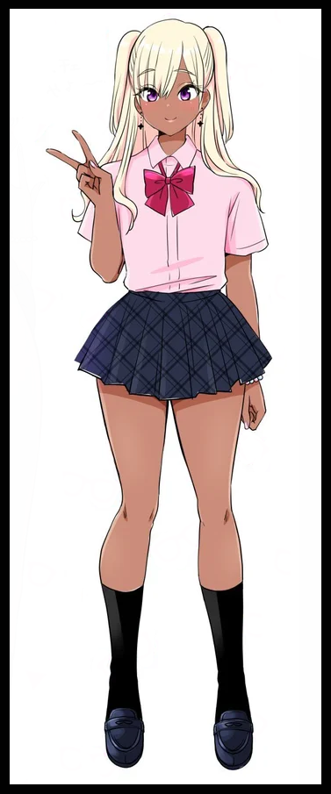

Purple eyes widen, alongside an ecstatic gasp as the ditzy gyaru that had subsumed the boney nerd who stood in her place only seconds prior directs her drastically lowered IQ to fishing for the matching set of accessories she now remembered were hidden away in the back pocket of her skirt, fluttering the extremely short hem to reveal a curious sight still dangling between her succulent thighs, looking slightly smaller than they were before with a visible seam beginning to form between the smooth sac hanging below the humiliated sausage.

**“Ah right! I got these sweet babies the other day while I was at the mall hookin’ up with Isaac~”**

**“Isaac hm? My, I never thought that prick’d be good for anything else besides puffing himself up…”**

**“Aww don’t say that~ Sure, he’s like, a total musclebrain, but he can be such a sweetheart! Anyway, how do I look?”**

Reducing her twintails in length while letting an extension of her mane drape itself over her shoulders, Betty shoots a beaming smile towards her friend with a peace sign held up so naturally it was almost hard to believe she was once a reserved, studious boy who wouldn’t think to ever do such a thing. Not like Tristy was complaining as she eyes up her buddy with a smile.

**“Lookin’ good gurl! Though if it were up to me, I’d ditch the tails…”**

**“Oh? Are you jealous Tris~ Ahaha! You totes are aren’t you?”**

**“Hahah funny~ Now help me pack this up and we can get goin…I’ll let you choose this time though~”**

**“Really? Sweet! Let’s hook up with the girls at the mall then! There’s this new dress I think would totes go along with your bod Tris!”**

**“Aww, for me? Hehe~ You shouldn’t have!”**

**“Anything for a sister!”**

As they get to work quickly stowing the mirror back inside the locker before making a swift exit. The two young women make their way back downstairs, fetching their bags from the classroom with more than a few nervous glances cast Betty's way before they exit the school proper right as the bells ring for lessons to begin with the second newly reformed gal being none the wiser to her bag slowly shifting under her armpit into one more suitable for a girl like her as textbooks and writing material morph into an array of sex toys and other such things more befitting of a prostitute than a highschool girl.

With Bart's acceptance of his fate, Tristy's mastery over the fabric of reality easily eliminates what little footprints her new friend's former self had left in the world, including any memory of ever having had a son in the first place, though that didn't seem to bother them that much. They were still corporate slaves thinking they had power at the end of the day, cogs in a grander machine whose work occasionally produced unintended results. Failures like a certain infamous senior year student at the only highschool in this wretched city.

After her father had used her as a test subject involving a mysterious element, her life would be forever changed. He'd seen her as a good for nothing harlot, despising the way she lived her life dressing like a streetside hooker with failing grades and a lack of interest in improving. So utilizing her newfound powers of control over others and the fabric of reality through her voice, she had cut ties with the power hungry oaf while ensuring she left no trail. From there, she would live out the remainder of her highschool days through the use of mental suggestions and if the need arose, physical alterations to those who thought themselves smart enough to cross her. Faculty, classmates, it didn't matter, she kept them all under a watchful eye, adding unruly folk to her own little clique of like minded girls who all bore her carefree mentality and lax view of sex and all the carnal arts it entailed. Admittedly she wasn't so smart herself, as true a bimbo as one could be, but it was something she was proud of. By ensuring the school's faculty never really caught on to the fact that she was a student who simply shouldn't have existed in the roster, she planned to finish her years as a highschooler before moving on to greener pastures elsewhere. With her powers, she never needed to worry about going hungry or finding a cozy roof to sleep under. And if she needed someone to talk to, she could always just make a pretty little face out of a scumbag….

Until she came upon Bart and heard his tale. She had initially planned to just add him to her clique of gals, but his story was one she could empathize with more than she would've liked to admit, masking it behind a lack of interest while changing her objective.

She wouldn't make a doll out of him, she would give him a better life, one with purpose and freedom the only way she knew how to…Sure, she might've had to resort to lies, but from the way his inner voice spoke to her near the end of it, she could tell he wanted it just as much as she did.

Now here she was, walking hand in hand with her new sister; Betty. They might not have been related by blood, but from the crafted memories she had implanted in both their minds, they were close enough to disregard that fact.

*'Sucks tho…I don't think Betty's got her brain all screwed up right, I guess that saying about big stuff falling harder really is true after all…cept in her case she went from Dexter to clueless gal…my cute little clueless gal~'*

She had made a vow that day, that she would watch over Betty from here on out, nurturing her until she became a woman all her own unlike both of their former families. True, she wasn't the sappy type to groan about family and bonds but now that she had gone ahead with the deed, the following days spent with Betty only served to deepen Tristy's resolve to stick with her, especially since she somehow still had a pecker between her legs. While she personally found the thing to be adorable, she knew Betty would instantly be called out for some hermaphroditic freak if she ever got found out. If she had to guess, it must've been the result of her holding back on the changes. Limiting its effects on Bart unlike her other 'victims' to ensure she didn't end up as a mindless bimbo.

While there was a quick and easy solution that involved sex. That was something she had to slowly put Betty through while they went about their lives going on dates with men, hanging with Tristy's clique or just spending time together at the mall. The longer she spent living as the gyaru she now was, the more her body would further acclimate, gaining a noticeable bosom while her already impressive form continues to nature, gaining a sultry allure to her visage while porcelain smooth skin takes on a natural oily sheen akin to her own, all while Bart's former manhood continues to recede, with Tristy monitoring the progress through occasional perks under the guise of 'roughplay' where the two indulged their lesbian urges unbeknownst to Betty who remained unaware of the flaccid thing between her legs.

One month after Betty's birth, and her ball sacks were replaced by smooth, hairless labia. Another, and her penis had already shrunk into an inert nub that was hypersensitive to the slightest touch. Two more, and her snatch had become fully functional enough for periods to begin occurring naturally.

By the time seven months had passed, Betty had changed dramatically. Gaining subtle musculature to her curvaceous, hourglass figure, a fully functional set of D cup breasts tipped with swollen pink nipples and a juicy vagina her body still had to get used to after so many times unwittingly having anal sex thanks to Betty's masking voice. She wasn't sure if it was ready to take a dick until she saw how far her baby sister could squirt after a particularly heated night in bed doing a livestream together. Putting a smile on both their faces then as they fell asleep in each other's embrace afterward.

By the time a year had passed, the two had done almost everything together. Blind dates, toying with nerds, wasting the entire jock squad in the lockers, hooking up with rich folk and getting paid up the wahzoo for it. If one could name it, the girls had done it. And by then, Betty had grown from bubbly ditz to demure maiden and now, much like her sister, a bold bitch who knew her way around the fickle hearts of men and the naive, trouble clouded minds of the fairer sex. Even her habit of riling Tristy up by tying her hair up into twintails had grown more extravagant, finding all sorts of ways to prod her about it, even as the two loitered on the school’s rooftop on graduation day…a pretty lackluster one when it mostly boiled down to a mad dash for certificates and a less than rousing speech by the principal who simply wanted the oldest batch of good for nothing’s gone from her school.

**“C’mon sis~ Lemme start sportin’ the tails. That stream the other day was totes in my favor y’know~ Besides…the boys haven't seen you with your hair down in…forever actually!”**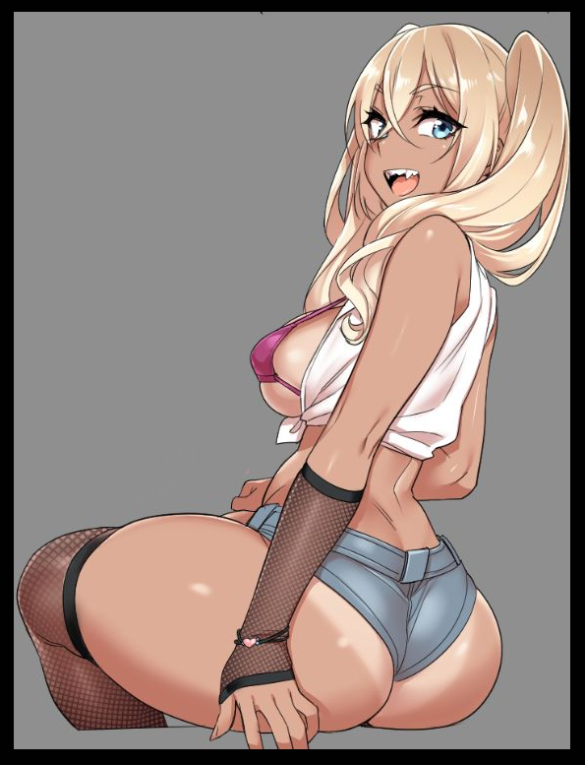

**“Yeah yeah I get it…we could set one up for tonight I think…grad day and everything y’know? And…come to think of it…today’s your birthday ain’t it?”**

**“Tee hee! Happy ta hear ya remembered sis!”**

**“Sheesh, whaddya think I am? C’mere baby gurl…so, we hittin’ the mall later?”**

**“Heh, totally! Promised Isaac I’d meet ‘im there later anyway.”**

**“Seriously? You’re still seeing that wimp? Last time I saw him he literally crapped his pants..”**

**“Hey, that’s cuz you threatened him with that magic of yours! He’s a changed man sis! You’ll see!”**

**“Hoo~ A man now huh? Sure you don’t want a pet dog? Or maybe a loyal sub girl? I could do either one~”**

**“Tris! I swear if you lay a finger on Saac!”**

**“Feisty now arentcha~ Cheer up there gurl! I was only teasing ya…whatever ya wanna do…I’ll be there to help!”**

**“Uuuu…you’d better be!”**

**“You bet your sweet ass I will…well then, what’re we waitin’ for?”**

Giggling, Tristy holds the door open for her sister as a smug Betty leaps down from the air ventilation unit without breaking stride, taking her sister’s spare hand before they go to collect their certificates together. Uncaring of the past her sister had helped her to lay aside, ready to live life as a free woman with the weight of the world off her shoulders…

*THE END*