*Guardians of The Treasure*

***The Treasury of Domus***; a fabled subterranean chamber filled with the riches of an ancient king; Domus, long dead and forgotten after an unfortunate last stand against an unknown adversary, only ever remembered for the horde of coin, jewels and miscellaneous trinkets he had left behind after his passing…supposedly anyway.

Because by modern times, his castle had already crumbled to dust, with any remaining ruins washed away permanently by unnatural disasters that seemed to rock the area until a mighty volcano had seen fit to spawn right where Domus' majestic home once stood. But still the rumors of his surviving treasure would persist; the amazing treasury whose contents could assure a dozen lifetimes of comfort.

As one might imagine, many souls stemming from a bevy of backgrounds ranging from opportunistic bastards to hopeful adventurers were drawn in to seek the treasure. Most would be lost to the fiery ravages of mother nature's interference while others would return empty handed. But if wasn't all for nothing; for within the sweltering hellscape of the volcanic mass, traces of ancient castle walls of no known make were found within the labyrinthine tunnel systems underground, spurring efforts to find the treasury even further, with an outpost even being established near the volcano to aid in their efforts, all while more and more people continued to turn up missing. Whether they were lost to the hazards, fierce Wyverns or plain lost down in the tunnels, no one knew for sure.

Unbeknownst to the people up top however, a few of these individuals had come across the lost king's treasury either entirely on coincidence or after months of searching. Now, normally anyone in their right mind would wait, maybe call for reinforcements before proceeding to enter much less loot the place dry. But when presented with the mountains of gold and shimmering relics ripe for the taking? Any thought of letting even one coin slip free was gone, entering by their lonesome, heedless of the potential dangers that awaited them in the almost well preserved chamber save for founts of magma having risen up from the floor. Except if one were to take a closer look, they would realize the igneous rock baths that held the still but angry pools of magna weren't natural formations at all; webbing out in dark organic chunks of flesh that blended incredibly well with the actual volcanic rock that had broken through the cobblestone flooring.

One of these unfortunate individuals was Nisha; a thief and pathfinder operating out of a nearby settlement located not far from the volcanic outpost. The woman was a master at the arts of stealth and deception, perceptive enough to pinpoint a rat scurrying in the dark and eagle eyes to land a killing blow with a well placed shot from one of her many custom made throwing knives. And with a trusty sword spirited from the armory of a noble, the thief was also a capable swordswoman, evident in her callused glove laden hands and the faded scars that criss crossed her muscular, yet lithe body. Clad in form fitting rugged leggings and a simple red top that only hid her ample assets while revealing plentiful amounts of skin. It was both a way to distract her usual fare of human opponents while allowing her to maintain her superhuman agility and flexibility.

With a hooded cloak that trailed off into twin wicked flaps reminiscent of flames, Nisha was as beautiful as she was deadly…except in a few minutes time, she would no longer remain so, just like all the other fools that had strolled in before her; wide eyes entranced by the gold all around them while remaining oblivious to the otherworldly forces watching their every step…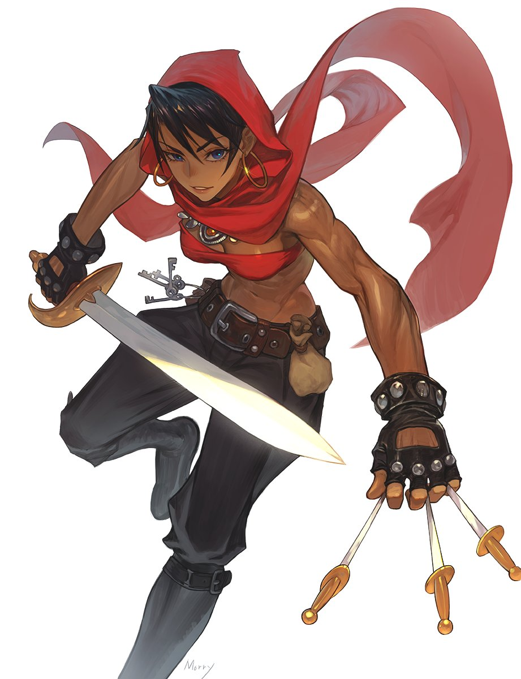

The thoughts running through her mind upon discovering the hallway leading to the treasury were of mild excitement and tempered expectations. But once she had turned the corner, the sword she'd held in her hand had instantly returned to its sheathe, racing with swift, light steps towards the open door of the treasury, marveling at the physical manifestation of the tales spoken about Domus' Treasure; riches plentiful enough for a dozen lifetime's worth of leisure and financial assurance.

Nisha's keen senses told her there was nothing around guarding the treasure, no traps to ward off the unwanted and not a living soul to take what she saw as hers. For as beautiful and cunning as she was, it didn't change the fact that Nisha was, at her core; a black hearted thief who saw no qualms with murder and other heinous acts if it meant coin filled her pouch on a regular basis.

Taking extra care to avoid the pools of magma, the opportunistic woman begins hauling bags of gold and other precious oddities out of the room, unaware of the magical beings eyeing her from within the lava itself until it was too late. When an eager hand reaching for an ornate box draws too close to one such pool, the tenant within springs its trap, blinding Nisha with a gob of warm goop to the face and a white hot hand far larger than a human's grabbing ahold of the thief's outstretched arms before she could retract them in pain and shock.

Blinded and with one arm immobilized, the panicking Nisha, unsure of what she was even up against, draws her sword with her free hand before stabbing downward where she could feel the entity lurking, grinning in confidence that she had done damage at the sound of wet flesh parting in the wake of her blade…before a giggle that sounded like it was coming from a drowned woman's throat fills her ears.

By the time she realized her sword hand had likewise been trapped in the same sticky goop that held her other limb hostage, the thief was well and truly helpless as a human shaped figure rises from the magma, slowly gaining definition and curvature as the molten slime hardens in certain places to mimic clothing, armor and skin especially prominent around the facial regions where a mix of viscous rock and plump jelly came together to form the visage of a beautiful maiden with ashen silver hair draping down her face and around her buxom body. But with a body made out of glowing lava with claw-like hands and digitigrade legs, any seasoned adventurer would realize what she was.

***Lava Golems***; a high tier monster usually taking on more draconic shapes that were almost impossible to fight due to the intense heat they radiated. But this one had taken on a humanoid appearance, and her magma hadn't incinerated the bound Nisha, instead, something curious was beginning to happen to the struggling human; Her body was beginning to take on the same consistency and texture of the goop binding her, losing muscle definition and color to her skin as it all begins to sag and droop, splashing against the floor in pale orange pools, forcing a muffled scream of panic from Nisha, assuming she was being devoured. Her niche lay with humans, so it was no surprise she had little to no knowledge on monster abilities.

Assimilation, a rare skill some monster species had and the only way they could procreate and spread. And in this case, it seemed the golem had deemed Nisha a suitable host, implanting cells within her that rapidly began converting her flesh and blood into living magma. By the time Nisha's arms had been completely dissolved however, her captors leans forward with a vapid smile, eager to take a personal hand in the molding of her first sister as a long serpentine tongue jams itself down the struggling thief's open mouth, disrupting her ferocious screams, devolving into gagged protests until dwindling away into dizzied moans, feeling the rest of her strength fade away as her tormentor begins pouring more of herself down her throat, filling her innards with boiling spunk while her toned tummy begins to lose firmness and muscle, boiling and bubbling until a rotund belly glowing a bright yellow remains, incinerating her clothes from the uncontrolled burst of heat beginning to emanate from the core floating within Nisha's gelatinous mass, feeling the uncomfortable heat pass for a pleasant warmth that assaults her mind, coaxing it into submission as her jerking neck relaxes in tune to the Lava Golems erotic kiss. A sign that she was no longer human, as evidenced by the way her legs fold in to be absorbed by her sagging lower half that by now had been stripped of most of its cocoa brown skin and toned muscle, replaced by a steadily growing pool of magma being cupped and embraced by the organic stone that caked the floor, forming her very own tub to idle in.

There was nothing left of Nisha by now. Clothes and pouches incinerated, weapons dissolved, flesh, blood and bone traded for glimmering orange slime. The only thing that remained of the former arrogant thief was her head but even that was beginning to lose all sense of uniqueness, bulging cheeks taking on the same black iron texture of the golem’s face, a gruff commanding voice giving way to the same sweet bubbly voice her lover had, twitching eyeballs burning into black coals with a eerie orange sphere for irises and pale ashen silver subsuming her raven black head of hair, losing its rough hewn texture as a freshly grown mane of silicate crystals mimicking hair flutters down around her changed torso, sporting the same plump firmness and massive boobs her sister had atop her chest, giving in fully to her advances and new animalistic urge to satiate the literal burning lust she now felt throughout her very being.

Nisha could no longer remember her harsh upbringing in that arid village of hers, nor could she recall the eat-or-be-eaten life she lived as a child that had led to her becoming such a talented thief and apathetic assassin, honing her skills over each act of theft, each chase that oftentimes resulted in clashes with the guards. Even her purpose for coming down here was forgotten, leaving the newborn Lava Golem bereft of memory and knowledge. Pretty soon, the worry and anger would leave her entirely, uncaring about the loss of her name while moaning to her sister's tune as their like minded tongues entwine in coital bliss once more, pooling bubbling saliva atop twin peaks as they made idle love to pass the time.

Unknown to all, the tale of Domus’ treasury held a far darker secret that explained why his castle and riches had been wiped and buried overnight. Pagan rituals with beings from the netherworld. The king desired immortality, and in his pursuit of it, had made many an enchanted item, spell and deal with many powerful Daemons. And it was the treasury that held all his creations before a force led by the gods themselves had seen fit to wipe his heresy from the face of the earth…but years after, it seemed their handiwork had not been enough to bury the heretic king’s wretched storehouse from prying eyes. And while most of the chambers contents were simple trinkets and inert items, some were very much alive, and after decades, maybe even millennia of hibernation, the flood of newcomers were enough to awaken some of these experiments; like the bodacious Lava Golem playing with her freshly converted twin in the middle of the room, who now seemed more concerned with having her searing teats fondled and squeezed than the treasure that, not too long ago, was all she could think about.

Made to guard the treasury, Domus’ Lava Golems were infused with Succubi blood, meaning they all took after her in appearance and habits; sexually active, essence of men for their dietary needs, flirtatious and beautiful etcetera etcetera…but one golem wasn’t enough for him. That was where the Assimilation ability came in, allowing for that one specimen to endlessly spawn clones of herself as long as there were a fresh supply of hosts to draw mass from…like the unfortunate Nisha who now completely resembled her assailant in form and mind, no longer the self thinking thief but rather, a sex starved Daemonic Lava Golem serving the will of a non-existent master…

And with the footsteps of yet another approaching intruder, the older golem retreats to give her younger sister some first hand experience, leaving her on the brink of orgasm, a look of need and frustration on her face, clicking her wet tongue before picking up on the scent of a man, triggering her Succubi instincts as the last shreds of Nisha’s greedy essence burns away in her gelatinous core, fingering herself one last time before stepping out of the pool of magma, ready to greet the armored knight who had already taken notice of her as her own bodily fluids harden to form toughened skin and an unbreakable carapace. All she needed was to make contact, and he would be hers to milk for his semen. Unlike women who she could simply convert, men needed to be sucked dry before doing so, it would be a waste after all! But if they proved extremely resilient and eager? Maybe they could be kept as milk studs to be shared amongst her growing family. And judging from the massive tent nudging against his loincloth, the salacious Lava Golem was more than confident that he would be more than fitting to fill that spot.



And so Domus’ Treasury would remain undiscovered alongside the many lives lost in the endless attempts to discover its riches…but rumors and sightings of women composed of lava and stone would begin to make the rounds, all of them bearing the same appearance and an equal voracious appetite for the flesh of a man, not to fill their bellies with but to lie with as partners in bed, but this same mercy wasn’t extended to females with reports of vanished women being assimilated and transformed into more of these phantom lava babes dismissed as hallucinations caused by the intense heat.

But like the Treasury, these tales would prove themselves true soon enough…for the once spacious chamber was no longer enough to house the enormous gathering of daemonic women, and with their former master’s hold over their minds beginning to weaken after being spread so thin, it was only a matter of time till their eyes looked up and beyond…

*THE END*