POLL WINNER- JUNE 2021 -

APPREHENDED BY DORA MILAJE TUMBO NYEUSI

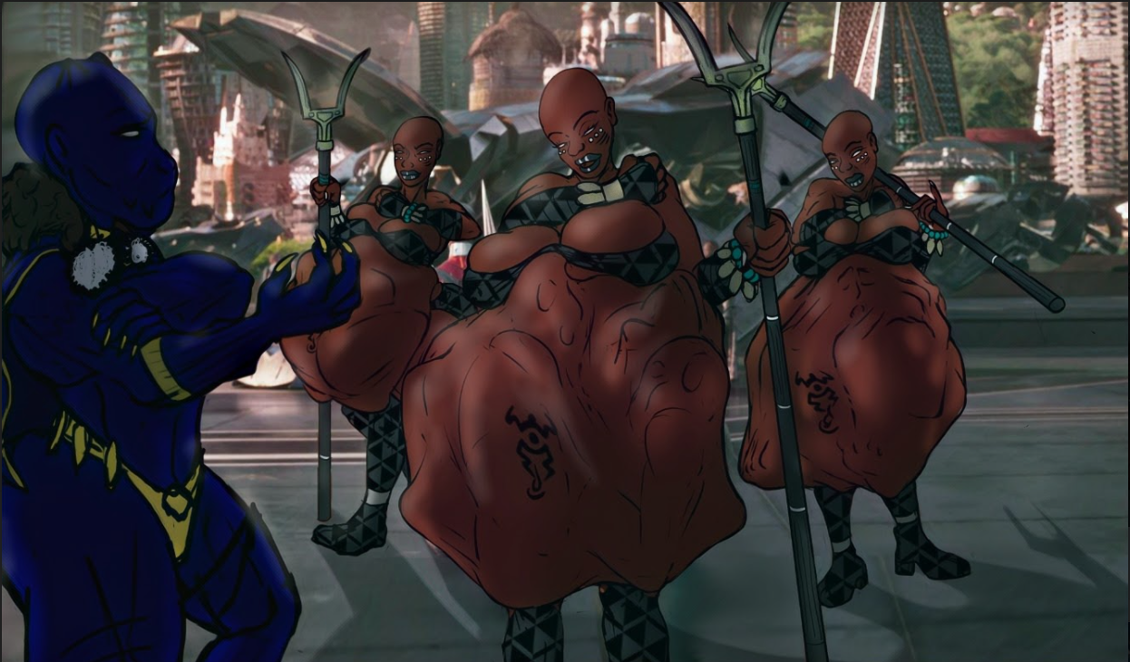

“Welcome back!” Bahiya heard the call from across the landing platform where she and her elite team of 2 other Dora Milaje had just landed and disembarked their customized Wakandan Royal Talon Fighter.

Upon turning and seeing the Princess Shuri, in her full regal Black Panther ensemble, Bihiya, Adina and Kamili turned and saluted their regent, striking their special spears on the platform , crossing one arm over their breasts and tilting their heads down in an differential nod. At that moment Bahiya’s stomach lurched, it’s massive girth shifting and bulging as the two occupants inside of it decided to re-initiate their useless struggles. Though the struggles did little more than jostle her already compromised center of gravity a bit, she was glad that deep bowing was not something they did here in Wakanda.

“I take it the ‘hunt’ was successful.” the Panther Princess stated, her hand gesturing towards the incongruous bulges and muffled sounds coming from Bahiya’s stomach.

“Yes My Lady.” She replied, giving her report of the activity of the night before; her role as the leader of this Dora Milaje special forces group. “Using the intelligence provided to us by yourself and the queen, we successfully located the group of would-be terrorists in A'maia, a busy fishing village near the border of Niganda. Without alerting the residents of the village Kamili, Adina and I located the four identified threats *‘apprehended’* them.”

At the word *‘apprehended’* Bahiya moved her hand from her chest and firmly yet playfully patted a particular bulge protruding from her stomach. Beneath her hand, the bulge pressed hard against her stomach’s already stretched, briefly revealing the outline of the face of one of her meals. Beneath her stretched ebony skin of her stomach Bahiya’s ***Kuliwa Mfungwa*** let out a muffled cry for mercy and help. With an expression of pure pleasure Bahiya smacked the bulging face, causing it to recede, her meal cowering back beneath the belly’s surface in a visible fetal ball beside the other.

“And have you been able to glean any other information from these *‘apprehended’* would-be terrorists?” Shuri asked, her voice bringing Bahiya back to the conversation at hand.

“Yes, my Princess. Once we returned to the Mchungaji, the name of our Talon ship, we were able to interrogate each other's apprehended prisoners using special gastrointestinal interrogation techniques which my team and I have developed specifically for *Kuliwa Mfungwa*. Using them we learned the location of various planted bombs from Kamili’s Kuliwa *Mfungwa*. We sent that information to the Wakandan guard with Dora Milaje high priority codex. From both of my *Kuliwa Wafungwa* I was able to get names of names of a few who had funded this group. From Adina’s Kuliwa *Mfungwa* we were able to locate a cache of weapons, plans and communication intel. Though through further interrogations this evening we do believe that more information will be coming. “

“Well done!” Shuri proclaimed. “It looks as if the *Tumbo Nyeusi* of the Dora Milaje has lived up to its name. Now go and rest and continue your interrogations.” She reached out and placed her ebon-gloved hand atop Bahiya’s gut which continued to squirm and gurgle with the movements of her Kuliwa *Wafungwa* beneath her fingers. “I may come by a bit later to help you with these interrogations, if you wouldn't mind.”

“Thank you my princess. Your assistance would be more than welcome” Bahiya replied, with a repressed shudder of pleasure at the princess's touch and a slight smile.

*----------------------*

*Vore vocab:*

*eaten prisoners - kuliwa wafungwa*

*eaten prisoner - kuliwa mfungwa*

*black belly - tumbo nyeusi*