YOGA CAN’TS
BIWEEKLY STORY #114
BY CHALDEACHANGE
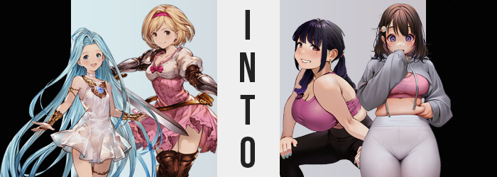

It was a trend that had been sweeping the Grandcyper by storm as of late.

Yoga. It was a rather novel way to stay in shape, to finds some peace for a short moment in one’s day. Because the Grandcypher crew was always busy with this and that, it turned out that it was the perfect tool for some of them to work out stress while also getting in the exercise they might not have gotten otherwise. It was Cupitan of all people that had started the trend, though it was undeniable that some of the boys had gotten into it just because of her due to… reasons.

As yoga fever spread across the ship, there were more and more orders for related items. Exercise balls, yoga mats, but perhaps more importantly? Clothing that was associated with the craft. Yoga pants had become exceptionally popular, with some of the crew tasked with fulfilling orders for them whenever they docked at a new port.

“Oh! My order is finally ready!” One of the women who had been waiting a few weeks now for her own yoga pants had been Lyria. The Girl in Blue was difficult to buy clothes for, or at least clothing that wasn’t meant for children. As yoga pants were typically marketed to older women, and Lyria was so skinny… It was difficult to get any yoga pants that were her size! But she’d woken up that morning to find a small box outside of her door.

And after bringing it inside? She opened it to find a pair of black yoga pants. Finally! She knew Djeeta had been waiting for some too. Hopefully she’d gotten her order as well? But Lyria’s enthusiasm was short lived, because once she took the black pants out of the box? “Oh… There are still way too big!” While they were made of spandex and were meant to stretch, she could tell that they were designed for a taller and broader woman than herself, but—

“E-Eh!?” For a brief moment she had felt the fingers holding the pants tingling, and the next thing Lyria knew? She wasn’t in her assigned room aboard the Grandcypher. She was in what looked like a living room? There was a couch, a display screen, two yoga mats laid out on the floor… And based on the view from a nearby window she wasn’t docked on an airship but was in the middle of a town? “Wh-Where am I!?”

It wasn’t like this was the first time she had been teleported, but she hadn’t felt any magic or anything! Looking to take a step forward though, she immediately felt something amiss beneath her skirt. “Huh? Why am I wearing these!?” The yoga pants she had been holding were now on her body, held up only by a tight waistband while they were bunched up around her knees since they were too long. It was difficult to walk in them.

…For now.

“Why was I warped though…? I didn’t sense any strange powers.” Lyria really didn’t understand the rhyme nor reason behind her displacement, which wholly made sense considering the circumstances. And while this was perhaps a more pressing thing to worry about than why she was wearing oversized yoga pants, she was promptly forced to worry about something else. Was the couch near her lower to the ground than it had been a moment ago? It felt like that was the case with everything within the space.

Lyria gave a tilt of her head. She had been on the cusp of accepting that as what was actually happening up until she felt it. The feeling of the yoga pants tightening around her knees. “Um…?” Looking directly down, the Girl in Blue was practically smacked in the face with the answer. It wasn’t that everything in the room had gotten smaller, but— “I grew taller!?”

The slack around her knees when it came to the yoga pants had lessened because she was now the correct height to wear them, having sprung up to about 5’5” compared to her previous height. The skirt of her dress had been lifted up as a side effect, but of course she wouldn’t have noticed that with the pants between her skin to dull the friction. Arms were longer too, and so the golden bangles she wore didn’t cover as much of these limbs as they had before.

“What’s… happening to me?” Lyria was concerned but not panicked, despite the fact that it was clear she had grown broader on top of taller to make sure she didn’t come across as bizarrely lanky in stature. Her hips had grown probably five or six inches stronger, and the stretchy material of the yoga pants accommodated them perfectly. On the other hand? Wider shoulders prompted her belly to stretch as well, and this had the unpleasant side effect of tearing the stitching on the sides of her dress.

The girl was taller and wider, but what she had yet to realize was that a ‘girl’ wasn’t really what she was any longer. Her face made that more than clear upon a head that naturally had to grow to better match her taller body. But everything about her complexion oozed maturity, from swollen lips to enlarged eyes. Lyria hadn’t become a young adult though, Crow’s feet and a slight looseness to her skin gave off the impression of a woman that might have been in her late thirties or early forties.

“Ara ara! EEP!?” A sound escaped her swollen lips that the woman hadn’t intended on making, yet it had escaped so naturally! Had she taken the time to examine the fingers that were covering swollen lips in that moment she might have noticed how her nails were now colored in a sky blue, or how the skin upon her fingers was tighter and drier – giving them an older albeit bonier appearance. “Wh-Whai…u?”

“なぜ私はその音を立てたのでしょうか？” Oddly, she was hung up on her pronunciation, ultimately shifting to speaking in a completely different one altogether without taking notice of it. She’d asked why she had made that noise, but in the meantime her body had begun to change to racially match the language she was speaking. It could be seen in a darkening of her hair towards black with a purplish undertone – and that hair’s length quickly unraveled until it hung just past her shoulders while pink ties bound them into twin tails.

Her already matured face changed shape subtly by contrast. Eyes narrowed until they were decidedly Asian in shape, blue irises taking on a plainer brown between lengthened lashes. Her face was ultimately rounder on the whole both in terms of shape and weight, cheeks full to they point that they could almost be called chubby as her nose soon flattened as well. A single beauty mark appeared beneath her left eye, not that she needed to look any less like her old self.

Lyria’s brown gaze fell downward, responding to a gurgling in her stomach. “Oh dear, now what?” She was still speaking in fluent Japanese as she watched her otherwise trim tummy gargle and bloat, a soft tummy bump pushing out against her dress. “But that’s exactly why I’m doing yoga, right?” Was it? To get rid of that? Even though she had just seen it bulge?

Then again, her view of her slight gut was soon disturbed by the emergence of dark pink beneath her dress. This entire time a pink sports bra had been concealed beneath Lyria’s usual clothes, but it was only visible now because the contents of that bra had begun to grow. Both quickly and significantly. “Woah!?” She had no choice but to correct her posture as breasts promptly surpassed D-cups within her bra, eventually tearing through what remained of her child-sized dress before white tatters seemingly disappeared entirely into the void.

But this made it so that her tits could grow even bigger, the size of the sports bra adjusting to ultimately accommodate her hefty G-cups.

She giggled to herself. “Geez, I’d definitely have an easier time exercising if not for these things!” She grabbed her own tits and gave them a playful shake as if they had always been that size. But from the woman’s new perspective they had always been that size. They’d been even bigger when she’d been pregnant! Her breasts weren’t even the only part of her body that had swollen, but her ass and thighs hadn’t grown nearly as significantly. They were also much more toned than the rest of her body when all was said and done.

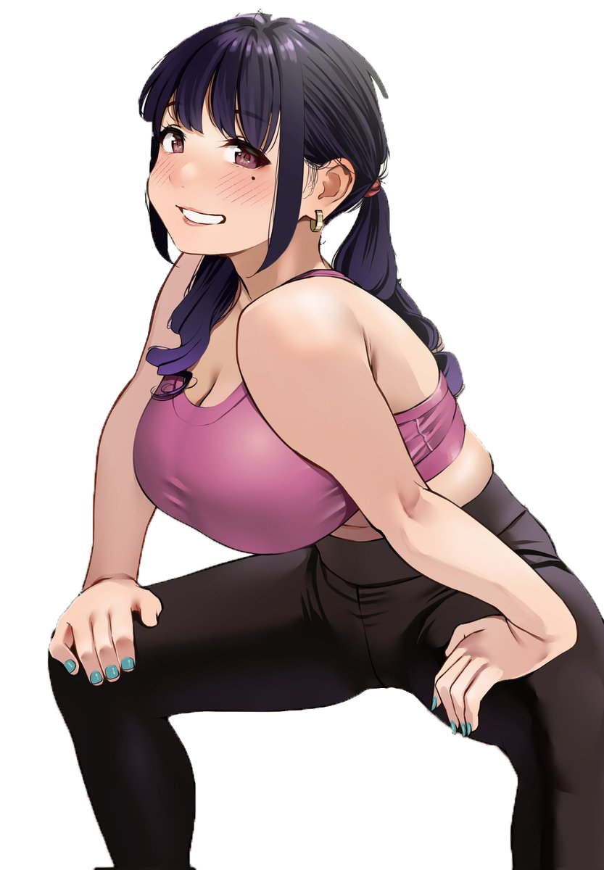
“My, my. Is she still not ready yet? I bet she’s off being too self-conscious again… But that’s exactly why I asked her to join me!” No longer weighed down by the burden of a ‘transformation’ nor a ‘past life’, Kato Riisa cast a glance towards the small hallway where she knew the stairs to be. Riisa had gotten really into yoga as of late, largely because she was a single mother who finally had an interest in finding a new partner. She had big tits and a nice ass, but she was definitely a little chubby in areas where she didn’t want to be thanks to poor eating habits.

Poor eating habits that had rubbed off on her teenaged daughter. She had been getting chubbier and wanted to get thinner too, so Riisa had invited her to participate in her daily yoga sessions. But the girl was late. Whether it was intentional or she had slept in again was unknown, but she was pretty sure she’d heard her use the upstairs bathroom! Giving herself one more stretch, the thirty-six year old woman walked into the hall.

“Sweetie!? You coming down!?”

“…?” Djeeta blinked, confused about her present circumstances. After waking up that morning she had gotten dressed and opened her door to head out, only to find a package containing the yoga pants she had ordered waiting for her at her door. Upon opening the box she’d found that the gray pants were a little bit too big for her, but the moment she’d touched them not only had those pants been put on beneath the skirt of her dress, but she had found herself in a different place entirely.

It was a bedroom. A very pink bedroom with a bed covered in stuffed animals, a small terminal, and an assortment of matching furniture covered in cute stickers. “What’s going on here?” As the Singularity she was used to being displaced without warning, but this somehow felt different. Djeeta became even more confused when a voice called out to her from seemingly somewhere else in the house.

“Sweetie!? You coming down!?”

“Just a minute, kaa-san!”

The response, one she hadn’t intended on making at all, lingered there for a moment before it finally dawned on Djeeta. “H-Huh!? What did I just shout!?” She hadn’t even understood what the woman’s voice calling to her had said, but she had fluently responded as if she did! The woman’s eyes being so wide with shock made it clear to see that her brown eyes had come alight with a different color. A rich purple that she had inherited from her father.

“I’m in a stranger’s home! I need to… leave…? Nani?” Was that right? Wasn’t this room hers? No, but she had just teleported there! But teleportation isn’t real, right!? But it definitely was back in the world that she…? The captain’s head was spinning albeit not physically else it would have been difficult to see all of the changes that were affecting her from the neck up. Take her eyes for example. They’d already changed colors, but now their shapes were shifting. They grew bigger and brighter, certainly making them more expressive, but their shapes promptly came to resemble those of the woman who had called up to her from downstairs.

She was already thinking more and more in the Japanese language, and so her words were gradually communicated in this language as well. The woman soon found herself more competently reading the words scattered across the bedroom on various things like books and posters, but she ultimately didn’t find herself questioning it. It made sense though. Her face was rounder, lips better defined, nostrils fuller… She definitely resembled Riisa, a Japanese woman.

But she also looked a lot younger. Younger than even Djeeta was supposed to be, that is. The room she had found herself in looked like it belonged to a girl in her early-to-mid teens, and that age was clearly reflected in her rounded face. “I… I… I was going to do something, wasn’t I? These pants…? Kaa-san wanted to…? But!?” Was that actually correct? It was clear as day that she was struggling immensely with her changing reality.

Not that the changing let up because of it. The captain’s height took a sudden dip, a few inches shaved off so that she was only 5’1”. Oddly this didn’t disrupt the fit of her gray yoga pants too harshly, but the reason for that made itself readily apparent. All of the girl’s muscles had softened into naught. But more than that? She was becoming chubbier. A single look at the front of her dress made this clear as soft flab began to pool in her gut. While you couldn’t see it, it lipped over the tight waistband of her yoga pants before stopping – a bit of chub, but it didn’t give her a bulging gut or anything.

Rather, much of the weight gathered elsewhere. The cups of her dress soon felt rather restrictive as her breasts swelled several cup sizes larger. Perhaps one was due to her new genetics, but the other was the result of her being an out-of-shape snacker; you could see it making her arms a little jiggly in the process. Once everything above her waist had fattened up? Her dress seemed to disappear, leaving a pink sports bra to hug her enlarged, chubby bosom while a cut hoodie wrapped around her arms and neck but little else.

A defeated sigh escaped the Japanese girl’s lips. “I really need to work on this, don’t I…?” Djeeta stared down at her softened upper half, evidently paying little mind to what was happening to her lower body. There was a reason that those yoga pants had felt so loose: because they were meant to be wrapped around a lot. The gray material stretched around thighs that thickened both with natural girth and the weight of inactivity. They forced hips wider, material pulled skin tight ultimately as those thighs met in the middle to completely close her thigh gap. Her ass bulged out behind her, ultimately pulling the yoga pants so tight that you could easily make out the lace, white panties she was wearing beneath. Sure, she was chubby up top but…

A lot of the weight had gone to her ass and thighs.

Not that some of her classmates minded it all that much.
“If I take any longer kaa-san is going to get mad, but…” The small, twitching fingers of Kato Daishi grasped at the roll of fat that peeked out over her tight yoga pants from her tummy. Her first name meant ‘large beauty’, but she definitely didn’t want that to be taken literally! It was just… her mom had been buying a lot of snacks lately, and being only fifteen she didn’t have a lot of self-control! It was so easy to snack when the food was there, but…

She knew she was just making excuses.

Daishi let go of the flab and watched it jiggle back into its usual shape, prompting a sigh. She didn’t want to show this to her mom, but she also knew Riisa wouldn’t make fun of her for it. Her peers, on the other hand… Changing for gym class had been getting way too embarrassing! “Okay! I… I’m gonna do it!” After picking the wedgie her yoga pants had forced with how tight they were, the teen balled up her fists as if to display her determination before heading into the hall and down the stairs.

“I’m ready, kaa-san!”

“Yay! Yoga is really fun, Daishi-chan! You’ll see!”

