Helmet Head
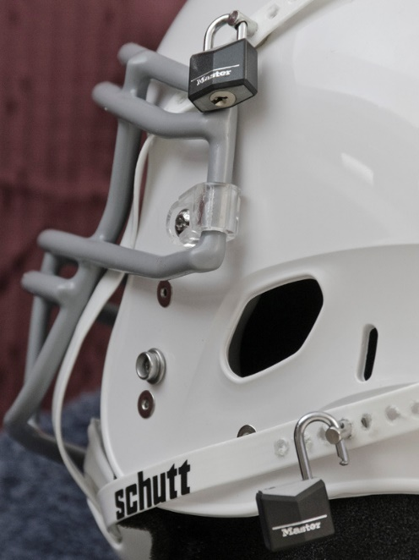
“PLEASE!” I shrieked as my coach walked towards me with The Helmet. “Please don’t do this to my! Last time I woke up 6 months later!” I tugged against the steel vice of my teammates. I stared into their eyes, silently pleading for them to let me go. None showed an ounce of remorse or regret about what I was about to endure.
“It’s not too bad.” The older man said as he passed the helmet from one hand to the other. “Didn’t you say that you would do anything to be the best on the team?” He asked with a cocked eyebrow. My own words. Anything. At any cost. I remembered saying those exact things to him when I joined the football team. That I would do anything to be the best.
“Not at the expense of my freedom!” I shouted back. I tensed my arms and pulled free from the linebacker’s hands and lunged for the door as fast as my body could move. But my teammates were faster. Hands snaked out for me and grabbed onto my shoulders. Before I could react, I was thrown back into the chair and Coach hovered closer to me with The Helmet. The soft clicks of the locks, as he unlocked the sides caused sweat to erupt along my back.
“It’s not too bad. Why would you ever be anything but one of us?” He asked as he lifted an arm and flexed his rounded bicep.
“I take it back. I take it back!” I shouted as he lifted the helmet over my head. I thrashed my head back and forth. But my attempts at survival did nothing. The helmet was squeezed around my skull and the strap was latched into place. I shouted into the mouthguard that was pushed into my mouth. I heard the clicks of the locks as they were closed, and the keys were removed. Coach stepped back from me and my teammates released their hands. I flung myself towards the ground, rolling around like an animal that just realized it was trapped in a cage. Slowly their laughter was drowned out by the humming that filled my ears. It was like a million bees buzzed within the helmet and soon I saw only darkness.
There were moments while I was under that I would wake up. Seconds where I would catch sounds, smells, or tastes while Coach treated me like his obedient puppet. It was like I was swaddled in darkness while I was under his control, there was nothing I could do besides to wait.
How much time had passed? Was it a day? Weeks? Years? Only the moment when I would wake up would I know.
* * *
Heavy. I felt Heavy when I was pulled from the darkness. My mind moved first before my body even recognized that I was back in the driver’s seat. It was awkward - feeling my body shift back and forth. I opened my eyes, and the world was hazy to me. Like a gloss was painted over my sight and shapes had no meaning to me - just yet. I tried to move my head to the side but found it difficult, stiff.
“He’s waking up -” I heard a voice begin to say. It was familiar but I could not place the voice. The harder I tried to focus the slower my brain continued to move. I lifted my arm to my face and felt like it weighed hundreds of pounds. I pushed forward, stretching towards my face in a hope to rub away the haze but my arm couldn’t reach my face. A tightness ran up my arm as I pushed to touch my face. After much struggle, I gave up, letting my arm slap onto the bed with a heavy thud.
“Hello?” I coughed, feeling my vocal cords work for the first time in god only knew how long. I coughed a second time. “Hello?” I shouted once more, noting the deepness of my voice.
“Start slow big guy.” The voice said once more. “Coach is here for you.”
Coach? Yes, I remembered him. His old angular face appeared in my hazy vision as it cleared.
“Think you can stand up big guy?” My body moved before I could even think what I was doing. My upper torso waivered back and forth as I brought myself to my feet.
I was heavy so heavy. Parts of my part begged for me to fall one way or another; felt so off balance but sturdy. My vision continued to clear, and I looked down at my forearms. They were massive!
“Woah,” I grunted as my eyes travelled from my arms towards the pillows that hung from my chest. I tried to touch them, but my arms were too massive to even touch myself. “What did you do to me?” I asked. Fearful of the answer.
“Just look,” Coach said as he nodded towards the wall of full-length mirrors that covered one of the walls. I looked in the reflections and searched for myself - for the body I knew. For my scraggy brown hair, my long limbs, and my crooked smile but none of those parts were found.
I saw my coach. I saw the room. I saw the bed that I had just woke up on. And I saw a brute.
A man larger than any person I had ever seen, standing in the center of the room. Its hiked-up traps swallowed the brute’s neck and encroached on its face. Its nonexistent neck was connected to a square body. A body which filled every inch of skin with muscle, and a round gut that swelled outward, nearly ready to burst. Its abs were plastered around its sphere-like gut. It was heavy with muscle but still out of shape. The brute’s two arms hung uselessly at its size; both so overburdened with muscle they looked unable to do the simplest of tasks. The brute’s face looked no different from the rest of its body. A heavy square jaw, a deep underbite, a brow that looked more akin to a caveperson than a man of the twenty first century.
If its body was not hard enough to stare at, then the grotesque bulge in the bright orange underwear was a sight. The stretchy spandex pouch looked to be stuffed with a cantaloupe, hung low between its thickly corded thighs. Its cock was fat and heavy. The outline could be seen plastered against the fabric, but even the outline seemed too large and bulbous to be real. Every inch of the ogre in front of me disgusted me as I searched the mirror for my scraggly body.
“My perfect creature.” My Coach said as he walked around the brute and placed his hands on the brute’s chest. His hands moved across the nearly glossy skin. I could feel his hands as they traveled across the brute’s chest. Why did I feel his fingers? How did I feel his hands as they groped the brute’s enormous pectoral muscles? Coach’s hands dug his fingers deep into the muscle and pawed at the underside until his fingers brushed against the searched until they brushed against the brute’s two swollen nipples.
“Oh fuck,” I grunted as his fingers flicked and teased the tips of the brute’s nipples. I watched as they both grew erect and liquid began to ooze from their tips. I could feel it; every motion, every sensation, every twist that Coach enacted on the brute’s chest. I could feel as the tips of the brute’s nipples leaked into my coach’s fingers and the answer became clear. “No.” I gasped, denying the reality I found in the mirror.
“Yes,” he said as his fingers worked over the brute’s nipples, tugging harder and faster as a steady stream of milky liquid leaked into his hands.
“No,” I groaned as I felt his tugs affect the brute’s bulge - my bulge. My cock swelled within the pouch, stretching the fabric more as it grew within its spandex prison. The pleasure I felt fought against my mind as I begged for this to be a lie. For this reality to be a dream.
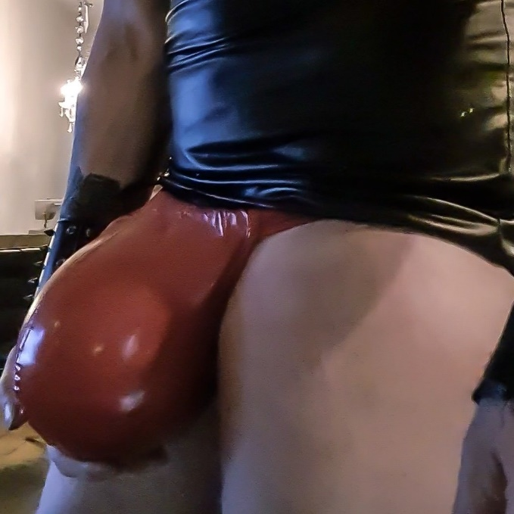
“Yes,” he groaned as he continued to play with my nipples, aggressively milking them. My cock continued to harden and swell within my pouch, pointing outward towards the mirror as a wet stop appeared at the tip of my cock.
I reached for my groin - unable to control myself - but found that my muscular arms would not touch my cock. That they could not touch my cock. No matter how hard I pushed myself or attempted to stretch, they would not bend over my roid gut or twist beneath it. So I was forced to whimper at my coach’s mercy as he played with my nipples, milking a steady stream of liquid from me. I thrust my cock out towards the mirror, wishing that I could touch it. Wishing that I had something to rub against it.
His hands went in waves of aggressive and sensual touches. Some moments he would tug and pull on them as if he were attempting to hurt me while other times, he softly flicked his fingers over the tips of my nipples. It was the softest touches that sent intense vibrations across my body. The softer the touch, the more intense they soft.
“And this is only the beginning.” He said from behind me before he removed his hands. I cried out in desperation. I needed his touch. I was so close. The wet spot had grown so large that it darkened nearly the entire pouch and my upper body was slick with the thick liquid that he milked from my tits. I needed it. I had to have it. Before I was given the chance to beg, The Helmet was slipped onto my head. My eyes widened as fear erased the pleasure I felt, and the buzzing sound of bees filled my ears once more.

