TEARS OF THE AEGIS
COMMISSION STORY
BY CHALDEACHANGE
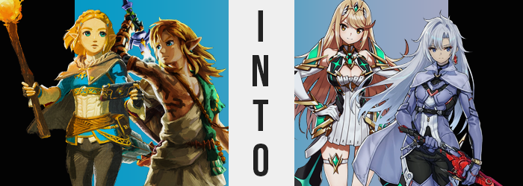

It had been a long time since she had last seen Link and last worn these clothes.

The thought crossed Princess Zelda’s name as she finished changing, putting on traveling clothes that she had worn back, well, in the future. Through circumstances she couldn’t have possible foreseen she had been launched into the distant past when Ganondorf had been reawakened in the future. A lot had happened in that time. She had become the Sage of Time and stood alongside the King and Queen of Hyrule in this era for some time, and after everything was said and done? The Ganondorf of the past had been sealed, paving the way for him to be defeated in the future.

And yet she still had to protect the Master Sword so that it might make its way back into the future. A monumental task that could not be accomplished with her current power. That was why she had changed into something more comfortable than the garments she wore as a Sage. The Zonai had powerful items known as Core Crystals that, when consumed, granted the consumer a great power. Zelda didn’t have any other options at this point.

It was a gamble that she needed to take.

“I hope this will work. It must… for Link’s sake.” She turned the bright green gem, that somewhat resembled a cross in shape, over and over in her hands as she sat upon the bed she had been given by Rauru and Sonia. If there had been any other option then she wouldn’t have considered this option, but considering the cost of Ganondorf’s sealing and the circumstances that had followed, what other choice did she have?
The future princess still hesitated though. While the tales spoke of the strength consuming a Core Crystal would bestow the wielder of, there was no indication of what form that power would take. King Rauru had never told her before his passing and she had no one else to ask now. It was completely a gamble and the risks, quite possibly, involved her own life.

Zelda sighed as she turned the stone over again. “How would I even go about swallowing this?” The size and shape of the crystal made it look as if the task might be difficult. Would it be possible to break it into smaller pieces? But for a crystal to survive in such a perfect cross shape for so long… It certainly wasn’t likely at all that such a task could be accomplished. “I suppose… I should simply just try.”

She steeled herself and closed her eyes, raising the Core Crystal above an open mouth before dropping it in. The base of the crystal hit the back of her throat, but that moment of impact was the most discomfort she felt. The gem had glowed and melted, and before she could react it had all drained down the back of her throat. “Grk!?” The princess had gagged briefly, but…

Its power could be felt immediately.

“Oh! Oh dear…” Not only felt but immediately seen as well. Because the quarters that she was occupying in the moment came to look larger and larger around her. She wasn’t so foolish as to think the room had grown bigger when the only factor that had been exposed to something unusual had been her own body. Besides, she could feel it in the fit of her clothing as well. Her body was getting smaller.

The princess was tall for a young woman of her age, towering over even her knight as she stood in the upper echelon of the five-foot range. But that was unraveling as her leather pants bunched up around her knees and her tunic top sunk down past her pelvis. When all was said and done the loss had been dramatic, with her height having fallen down to 5’2”. “W-Wasn’t I supposed to become more powerful!?”

In Zelda’s mind the process of gaining more strength didn’t involve getting smaller. If anything she had expected to grow larger to accommodate this supposed new power that she was supposed to gain. Yet she fumbled in her traveling clothes, fingerless gloves slipping off smaller fingers while her shorter arms were easily swallowed by sleeves meant for a taller body. But even though she was smaller, she could still feel it. A power unlike anything she had ever felt before.

My power.

For all her body had shrunk in terms of height, mind you? That loss of height was realistically the only loss she would experience as the Core Crystal’s power continued to surge throughout her body, reshaping her into the perfect container to both hold and wield it. Looking at the princess’ hair, for example, made it clear that the shoulder length cut she had decided on after Calamity Ganon’s defeat was not something that was meant to last. The braid atop her head unraveled and golden locks spilled out behind her, fanning out and curling in towards the curvature of her bum.

Meanwhile, her typically exposed forehead (a stylistic choice of the woman’s own) was promptly concealed by growing bangs that fell forward and curved up to the left. It was a rather ludicrous hairstyle that wasn’t helped in its unusual nature by the fact that the golden blonde of her hair was paling. Its core color remained, but this blonde had a more, subtle platinum feel to it – almost giving locks a metallic sheen. This gold was soon reflected elsewhere too, in Zelda’s eyes as it replaced their usual blues.

“No… I’m growing more powerful. I totally feel it. It feels awesome!” Those golden eyes closed briefly as the princess remarked upon her circumstances, casual words that weren’t typically part of her vernacular spilling out without her notice. The lashes of her closed eye grew fuller in the interim while the lips through which she spoke them became thicker in kind. All in all any semblance of Zelda’s identity was erased from her face, thick and bushy eyebrows thinning until they were no thicker than pencil lines and her nose becoming more petite as well. Even her face’s structure changed, become a touch rounder much like her ears.

Those Hylian points were rounded away entirely.

Something about Zelda’s posture seemed off as she rested her right hand on her hip of the same side. That body language was confident in a casual way that wasn’t at all customary of her usual demeanor. “Huh. So what was I…?” And what was with her voice? Why did it sound so flippant? Yet the woman herself didn’t seem to realize. In fact she couldn’t even remember what she had been doing or even her own name. The Core Crystal was affecting more than just her body and had even reappeared – embedded in her body just above her chest.

And speaking of… She hadn’t even acknowledged the fact that the chest in question was growing. Not just slightly either. Zelda’s bosom had always been rather lackluster compared to some of her peers, but the blue cloth of her tunic was struggling to contain the heft of swelling tits that were doubling and tripling in size. “Mph!?” The most acknowledgment that they ultimately received was a discomforted groan before the tunic’s integrity could no longer contain them and her neckline tore right down the center – displaying a valley of cleavage from her hefty new FF-cups. They certainly stood out now that she was shorter.

But then again her tits weren’t the only things that stood out more now. Those leather pants of hers were struggling to contain a widening load in the rear, and that was saying a lot because she’d always had a big and perky ass. Yet her cheeks swelled bigger still, eventually splitting the seams of the leather down her ass crack and prompting hips to widen several inches more in the process. What couldn’t be contained by her bodacious booty bled into her thighs, which thickened to the point that seams split around her upper legs there as well.

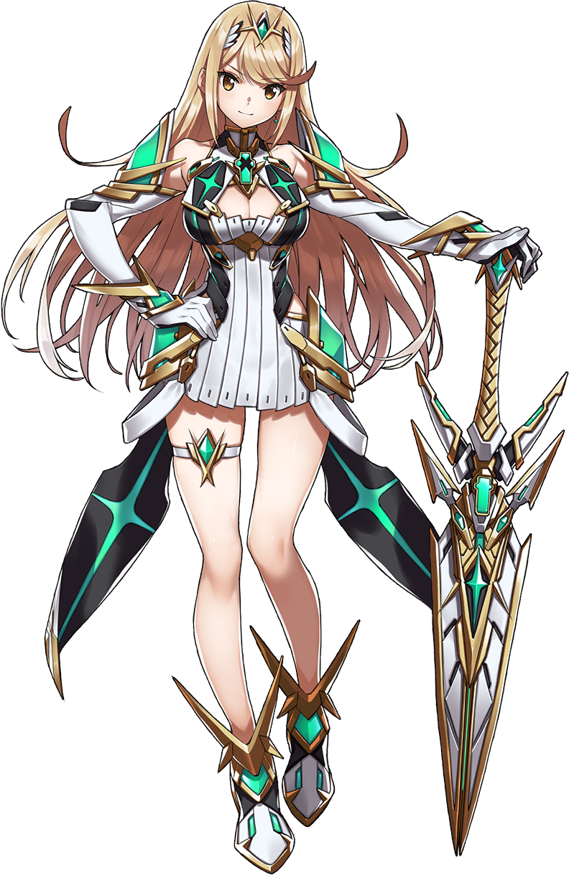
“What the hell’s up with these clothes? They don’t fit and they totally aren’t my style.” By the time the Blade had noticed her clothing malfunction she couldn’t quite understand why she had chosen to put on an outfit that didn’t fit. Thankfully all it took was a snap of her fingers to eviscerate the cloth by releasing an overwhelming heat within her before a short, white, futuristic dress hugged her instead. Ample thighs and cleavage were exposed, the green from the now exposed Core Crystal found about gauntlets, metal shoes, and the accessories that decorated her dress. Even upon a futuristic circlet that ran through her hair.

“Ooookay, so now what?” Completely reborn as a Blade, Mythra could only recall the purpose that she had been given from her past life. To protect the Master Sword that was sheathed nearby. “I’m supposed to just sit here and protect this thing for, what? Forever? Why can’t I remember how long it was supposed to be?” The beautiful woman’s flippant attitude certainly wasn’t doing her assigned task any favors.

From her perspective this sounded like the most boring job imaginable. She couldn’t even recall who had given the task to her, yet deep down Mythra knew that she couldn’t refuse the purpose that had been bestowed upon her. She picked up the sword and gave it a twirl, evidently an expert with a blade considering how effortless her movements were. Perhaps expected of a Blade herself.

“Huh? There’s a voice in there? Fi, huh?” She could clearly hear someone communicating with her. Someone who wasn’t happy with the fact that Mythra was spinning the Master Sword around so carelessly. It comforted her a little, to know that there was a soul in the sword. “Well maybe this job won’t be so lonely. But hey, Fi? You ever been in a relationship before?”

Probably not.

In the distant future, in the time that the Sage of Time had hailed from, her knight Link? Well… he was up to some nonsense. Hyrule was in mortal danger once more and that meant a grand adventure with terrible repercussions if he was to fail. Yet he was sitting around a campfire by himself beneath a tree he was using as shelter while a thunderstorm raged on.

That in itself didn’t sound all that bizarre. He was just taking shelter from the rain with a heat source, right? Wrong. Link was cooking and it was what he was cooking that was questionable. It was a rock. A small, crimson-colored crystal that was shaped like a cross. Had his foodstuffs run in short supply that he had taken to eating rocks instead of apples? Perhaps in a way, but that wasn’t really why.

It was a gut feeling. Something about the crystal spoke to him that he didn’t understand. He’d thought back to the words of his dear friend Daruk, that even Hylians could consume stones if they first cooked them properly. …Not that he had ever tried. But whatever was up with the red gemstone, deep down he recognized that it had to be consumed.

He eventually took it from the pot of water it had been boiling in and let it cool down enough to stick it in his mouth. Strangely, while it had retained its hard shape even after cooking? It was almost as if it had melted in its mouth. Why was he doing this again?

“Hah!?” Just seconds after consuming the crystal a strange feeling washed over him. It was almost as if his body was vibrating very subtly with a soft tingling sensation. “Yah!?” But a sharp pain in his left ear eventually stole his attention away as he stood up. Fingers reached to the point of pain where he not only found his usual piercing gone, but instead there was a larger hole with a big earring hanging from it. He couldn’t pull it forward enough to see, but it was the very same crystal that the knight had just swallowed.

And things only got stranger from there. The points of Link’s ears were soon obscured by his hair. Dirty blonde locks were always long, but they were growing longer and thicker (disguising the fact that pointed Hylian ears both shortened and rounded in the process) as it all cascaded down his back, past even his rear end. “My hair?” A strangely coherent thought was spoken by the boy after taking notice of its length as strands were twirled between the fingertips of his Zonai arm. But the length was only the beginning, for a splash of silver ran through this hair from roots to tips, dyeing even body hair and hair hidden by the light clothing he was wearing.

The blue of the boy’s eyes dulled in the meantime, taking on a steelier shade while silver bangs hung down over the rightmost optic. Yet his eyes, and his facial features as a whole, were becoming increasingly androgynous. Lengthier lashes upon those eyes for one, but their shapes also grew and rounded but displayed an uncanny indifference in their resting expression. Link’s nose likewise became smaller and his lips a touch fuller. With cheeks rounder he was left even more effeminate facially than he’d been before, and that was saying a lot for a boy who could already blend in with the Gerudo if he was wearing the right outfit.

But concerningly? With his Adam’s apple smoothed away, from the neck up he looked like a different person altogether. One that was much more convincingly a woman or at least designed to strongly resemble one. It was something that really wasn’t helped by the young man’s body becoming narrower. The bulkier muscle of his torso was just melting away, leaving him leaner overall but his waistline very narrow. Hips appeared larger as a result, but it wasn’t just an optical illusion.

“Huh? Seriously, what’s happening to me?” While chattier than usual, it didn’t seem like Link was losing sight of the fact that something was wrong with him like Zelda had in the distant past. But he didn’t sound or act troubled by it. All he felt was an acceptance even as his hips widening several inches prompted him to stumble.

Their widening was not a side effect of anything but instead a necessity for what was to come. No sooner than they had widened did his upper legs begin to appear enticingly full. Any hair was shaved away from skin that glistened as it was pulled taut, both thighs bloating so that they were nearly as thick as his narrower waistline by this juncture. There was no denying this gave him a very feminine gait, something that was surely helped by the extra padding that was bestowed upon his rear. Thankfully he was wearing clothing so loose that there wasn’t any discomfort.

Not even as his dick shrunk away into naught.

“That… felt strange.” And yet it didn’t shock her, seemingly. She didn’t question why her sex had changed, nor why her form as becoming more and more like a young woman. Her hardened expression seemed to suggest that she didn’t really care and that this was hardly worth something trifling with in the grand scheme of things. And this indifference continued even after her chest rose, one bare breast visible with her current outfit. They didn’t grow particularly large in the end, but those perky A-cups still suited her new build better than the absence of a bosom altogether.

Link could feel it. A surge of that energy that she had felt after consuming that crimson crystal in the first place. It passed through her body from within, and as it was vented through her skin the garments she was wearing were eviscerated only to be replaced a moment later. A silver-blue bodysuit that was notably armored clad her body, hugging the curves of her hips. Boots and gloves made sure nothing but her face was exposed, and a cloak was wrapped around her shoulders.

She observed the change in clothing quietly. While this was her first time seeing it she couldn’t deny that it all seemed familiar somehow. Like she had worn it in the past. There was certainly no denying the comfort, and the protection it offered was much greater than the robes she had been adorned with moments before. Practicality had never been Link’s strong suit much less something she considered. But now? She couldn’t imagine trying to be too unpredictable.

Which honestly was how she had saved Hyrule the first time.

The feelings of A were complicated in the aftermath of her transformation. Unlike the princess in the distant past she retained awareness of her past life – perhaps a welcome side effect of her having boiled it before consuming? Well, her memories had been retained for the most part. She could recall the general gist of things, but her previous name and a clear image of what she had one looked like were recollections that now escaped her.
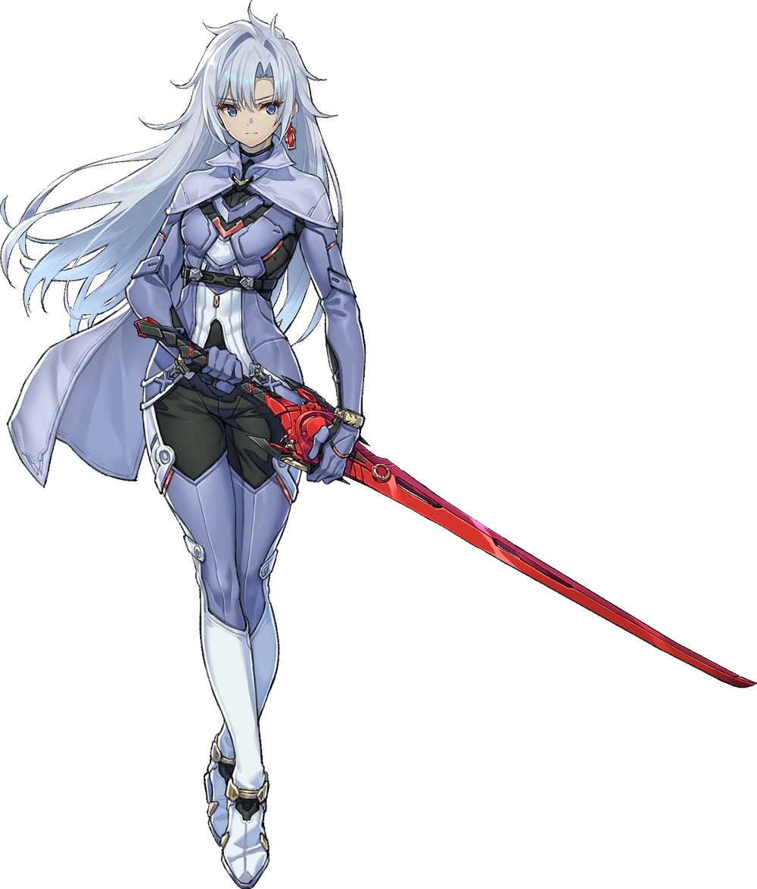
“But has my mission changed? I still need to save this world.” She was already chattier than her old self even if her words came across rather dryly. Saving Hyrule was of the utmost importance. That was something she still agreed with even with her changed personality. Holding out her hand, a sword eventually appeared. A crimson blade that didn’t look like anything belonging to this world.

It was a powerful blade, but A still knew that it wasn’t the blade she needed. “I need to seek out the Master Sword. It is the only blade capable of driving back the darkness.” The issue was that she no longer knew where it resided after it had been ‘returned’ to the princess, wherever that was. Of course she also didn’t know of the individual that was guarding it. A woman whose nature wasn’t all that different from the sword she was currently wielding.

“Well, I’d best set out.”

Didn’t she care about the rain?

