Fan
A Short Story
By Maryanne Peters

You have probably never heard of the rock band Wagon Bandwagon. They were big in my home state, and my girlfriend was crazy about them. And I mean crazy. She was the one who put the fan in fanatic.

I suppose I felt insecure. I mean, she desired him, the lead singer Rafe Kinnock, so what does that say about me? Am I insecure? Probably.

Maybe it was that insecurity that made me agree to join her in the mosh pit as a screaming fan. She dressed me up for the occasion. We all dressed up. It was supposed to be some kind of goth or punk thing, I thought. I had my hair (which was quite long) spiked up with gel and I wore dark makeup around my eyes and lips, and I had on black vinyl shorts with fishnet stockings. It was not supposed to be drag or anything like that. The right guy would have been able to pull off the look, but on me I just looked like a chick. I did not realize that until it was too late.

What made it even more difficult was that the entire mosh pit was made up of girls. It seems like every fan of WBW is a girl – probably because of Rafe Kinnock. Some of the girls were taller than me. A lot, actually. I just looked like one of them.

The music was good. I mean, I was not a huge fan of WBW but I knew the songs. We were all singing along, if you can call it that. Shouting the words more like it. Most of us had shouted ourselves hoarse by the end of the gig. I could barely croak a word.

We were near the front and putting on a real show of adoration. I just got caught up in it. It is crowd behavior, I guess. You just do what everybody around you is doing.

At the end of the concert one of the roadies approached the security guys who were at the barrier in front of the stage to select a few fans for back stage passes. My girlfriend and I were both included. She was delirious with joy. I mean she was crazy happy. I was happy that she was, so that made me as excited at the other girls, I guess.

I never even thought of myself as one of the other girls until we got together with the band and all the roadies. They were all boys, all looking to hook up with girls.

There is a priority to this. The band members get first call, starting with Rafe Kinnock as heartthrob-in-chief. After the band came the entourage – managers and close associates of band members. Then the production guys – in charge of sound and lighting, and lastly the riggers – manual laborers. My girlfriend made straight for Rafe. It was demoralizing. I was standing right there.

I was upset. I admit it. Even mad. I wanted to show her how it felt.

The party was held in what I guess was the green room behind the stage, although it was painted dark-blue. There was a table with food, and alcohol and drugs. I drank some alcohol. I avoided the drugs not because I don’t use, but because I did not want to get wasted, especially dressed as I was.

There were plenty of girls there – more than the guys involved in the band – but the were only there for the band and all the associated men. Of course, I wasn’t interested in men. Perhaps that was why Tip became interested in me.  I saw him being almost attacked by two girls maybe before he even saw me. I recognized him as the bass player, even though he was not standing forward on the stage. He told me later: “Bass players don’t”.  There was some expensive sound gear in the corner of the room and I was checking that out. Then he was behind me, saying the two girls trying to grab him: “Hey, I need to talk shop with Mindy over here.” | 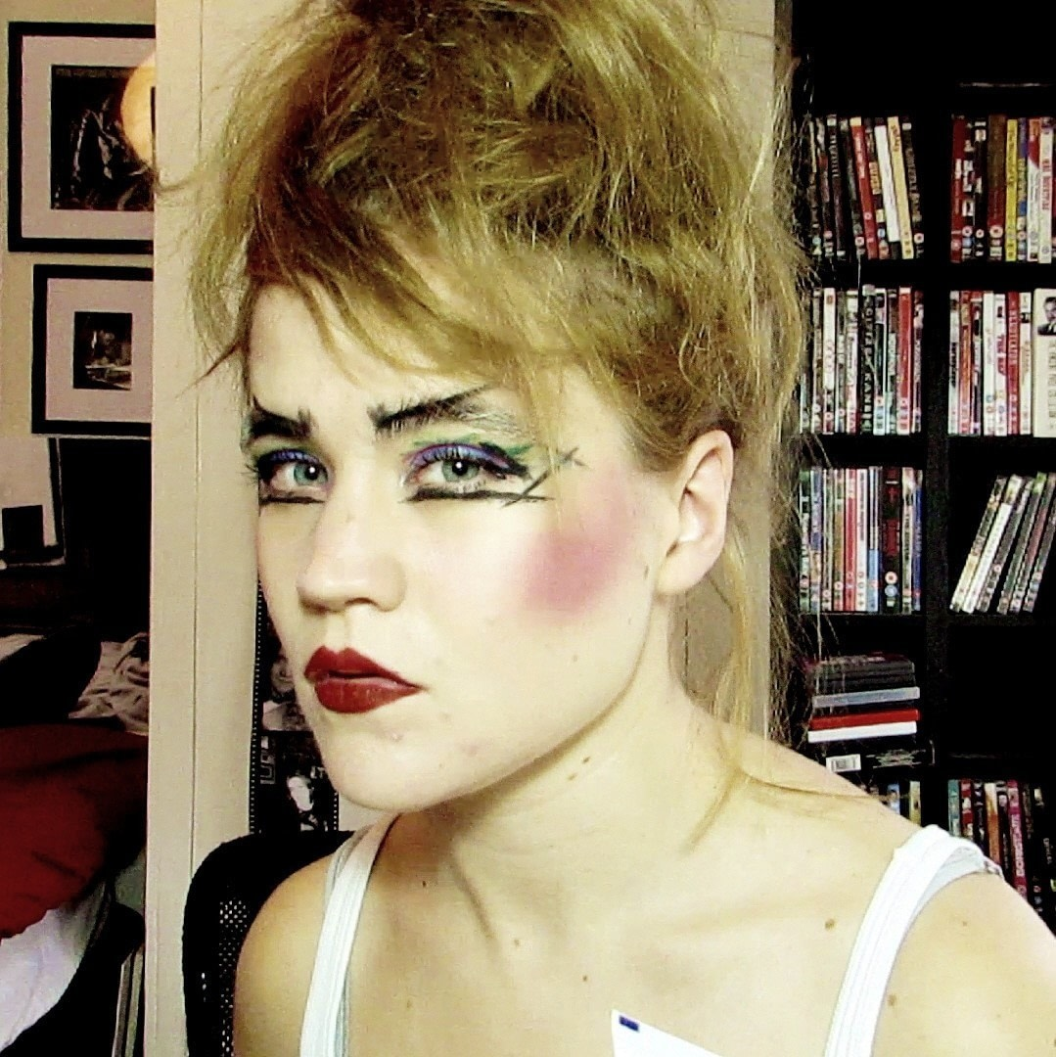

I was about to look behind me for Mindy, but I realized that he was referring to me. That seemed crazy. A guy called Mindy? He thought I was a chick. It figured. I nodded at him to come over. His two assailants looked disappointed.

“Thanks,” he said. “I had to get away.”

“No problem,” I croaked. I thought that my voice would give me away and that he would walk in that direction, but I realized that I sounded like half of the girls there, gravelly voiced from over-doing it.

“Do you know this kit?” he asked.

“Direct Injection box?” I was pretty sure, but not sure enough to make it a statement.

“A passive direct injection box for my bass guitar,” he confirmed. “The sound guy likes an active box, but I prefer this. It has better sound.”

“You should call the shots,” I said. “You are in the band. It’s your instrument.”

“I play the bass,” he said, as if that was an answer. He could see I was puzzled so he continued: “Look at those guys. This is like every rock out there. The lead singer is a performer. The lead guitarist is an artist. The drummer is fascinatingly crazy. The bass guitarist is the quiet guy at the back.”

“Holding it all together.” This was a statement. He liked it. He looked at me.

“What’s your name?”

“Mindy. Remember?” That made him smile. I knew his name. He was called JJ.

“You’re right, Mindy. It is the bass that is the beating heart of rock music. Not the kick drum. When the bass starts you know you are rocking. By the way, you have great legs.”

My girlfriend had said the same thing. She said that fishnets can reveal the harsh lines of a man’s leg, even if devoid of hair like mine now were, but that I had a soft shape to my legs. Like women’s legs, so she said.

“Thanks,” I said. What else could I say?

But it made me glance around for my girlfriend. I saw her across the room. She had given up on Rafe. She was moving in on the lighting guy. How far down the pecking order was that? I was being chatted up by the bass player.

“Are you looking for somebody? Don’t tell me you came here with a guy. They are not allowed at band after-parties.” He was smiling as if it was a joke, but I guessed that it was an accurate statement.

I saw her glance in my direction, so I grabbed his arm and hugged it, and I looked into his eyes. I said: “No. I’m here with you. JJ.”

What would my girlfriend make of that? I was going to look, but I was somehow caught in his gaze. I never even noticed her walk away, much less the fact that she barely gave a thought to abandoning me.

“Are you musical?” he asked.

“I play guitar, but not well. I trained on the violin. Not much call for that in rock and roll.” It spoke more of my protected childhood and the expectations of my older parents, than anything else. I liked rock as much as the next. I was just not the kind of fan that my girlfriend was.

“All music is written on the strings of the violin,” he said.

“That’s what they say.” That is what I think I said.

“I saw you in the pit when I was onstage,” he said. “I saw you singing as loudly as the others, but I somehow knew that you don’t go for our music.”

“That’s not true,” I lied. “But I came with a friend who is a bigger fan than me. She is in here somewhere.” I now realized that she was not. I was standing very close to this guy to show her something?), and now she was not there. What was I trying to show her? Was I trying to make her jealous? Was I trying to show her that anybody could pick up a rocker, even somebody who was not really a girl?

“I am not one to take advantage of fans,” he said. “They have no true affection. They are crazed by the image of us. There is nothing there, beyond their deluded dream.”

He was looking at me, his hand on my arm. It was strange, but I felt drawn to him, or perhaps I felt that he was drawn to me. Is it the same thing? He was telling me that he did not want somebody who wanted to be fucked by a member of the band. That would describe me.

I am not sure if I said anything. I think I just cleared my croaky throat and looked back.

Then he kissed me. A man kissed me on the lips. And I let him.

“I’m deluding you” I said. I had to say something. I had to stop this now, before it went any further. But more importantly, here was a guy who was talking about true affection, whatever that might be. I did not want to do this man wrong.

“How so?” he asked, still gazing into my eyes.

“I am not a girl.” Keep it blunt. Wait for him to go crazy. His hand on my arm relaxed for a minute, and a new look came into his eyes. Isn’t it strange how you can see such a change only in the eyes? But it was not hate. It was not disgust.

“Interesting,” he said.

I thought the room had been quite noisy before, but somehow when there is nothing to say, all noise stops, or cease to be aware of it. He was looking into my eyes again, as if to try and fund the inner me.

“Do you want to go somewhere quiet?” He should have said that. But it was me. It was as if I was no longer in control of my own actions, or not even my own thoughts.

He took me by the hand and led me away.

There was an internal loading bay beside the stage door and there was black van parked there. I suppose that I was expecting a limo, but this made sense. Non-descript with blacked out window, is was fitted out inside in opulent maroon velvet and brass. He held the door open.

“You are not entirely alone with me,” he said. “The driver is seated up front. We don’t have to go anywhere.”

I stepped inside. There was plenty of room, but we sat together on the plush sofa seat.

“I have nothing that you want,” I said. “No tits to fondle. No pussy to ram into.” It sounded almost sad as the words came. Like regret.

“That stuff is everywhere,” he said. “We even see it from the stage. All of it. Perhaps I am looking for something different?” He put his arm around me and drew me close. Was he going to kiss me again? I found myself hoping that he would. In fact, I couldn’t wait. I kissed him.

“I don’t suck cock or anything,” I said. “At least, I never have before.”

“Use your mouth for talking,” he said. “And kissing. I want to look at your face, not the top of your head.”

“You don’t want to get involved with somebody like me,” I said. “You can have anyone you want. Anything, if you like.” Somehow I was starting to tremble. He looked at me quizzically, as if to ask what was going on in my head. I had no idea. My head was not in charge. More powerful forces were at work.

“I am a virgin,” I said. “I mean I am an anal virgin.”

“Would you rather stay that way,” he asked. It seemed a genuine question. The answer was obvious. No heterosexual man could say anything other than yes.

“No,” I said. “If it’s you.”

It was like the red button had been pressed, or two keys turned, so that the two atomic masses are forced together to become one ferocious ball of energy. That is how an atomic bomb is detonated. That is how we were set off. We were a mass of bodies tearing at one another all the way to the hotel and all the way up the elevator and into his room.

It was not supposed to be this way.

Only hours before I had been a regular guy with a girlfriend moshing in an all-girl pit. Now I was lying in the arms of a man, exhausted, with my asshole tingling, and happy.

“How was that, Mindy?” he asked. “How was I?”

“I am a fan,” I replied

The End

Maryanne Peters 2020

