**CHAPTER 3**

**LEAVING HER MARK**

Allison wanted to die! Her entire body felt like it was about to collapse from pure exhaustion combined with the sickening feeling of dried feces coating her insides! Her face, lips, and cheeks were completely coated in shit, it had dried now and began to crack like the hard rock surface of a desert ground. The sun was directly above, shining down with its full heat and assaulting the island below.

Allison pushed herself forward, taking one step after the other, praying to herself that this would end soon, if she just pushed on, she would live and be home! Slowly she looked up, glancing forward, Katniss’ sweaty fat ass cheeks were less than a foot from her face, wobbling back and forth in her tight leggings as she pushed forward. There was a deep line of sweat down her ass crack that disappeared between the cheeks! Allison took a sniff and began gagging lightly, the odor wafting from her ass was so foul, so sour, or was that smell coming from her own face? She could not tell.

“God, it’s so hot out here! My tits are dripping with sweat!” Katniss complained…

“Can we take a break?” Allison groaned from behind her as they pushed onward through the jungle.

**“WAS I TALKING TO YOU SHIT LIPS?**” Katniss screamed as she turned around and stopped dead in her tracks. Allison stood there like a statue, completely silent.

“Oh my god!” Katniss exclaimed as she began fanning her nose!

**“YOU STINK!** I didn’t realize how bad it was until we stopped moving!!” Katniss said while stepping back and gagging!

“I… I… If I co…” Allison tried to speak but was quickly cut off…

**“STAY FIVE FEET BEHIND ME**, at least!!! Ugh, I’m about to puke!” Katniss groaned as she continued moving forward through the brush.

Allison wanted to cry! She had begun crying for a moment, but the salty tears were quickly absorbed by the dried shit on her face! Staying five feet behind Katniss, they moved on, it was less than ten minutes until they reached a beach on the east side of the island. Allison’s heart was racing as she heard the waves from a distance. As soon as the water was within view, she began to run! Sprinting towards the shore with desperation! She could practically feel the cool water on her face, washing off the feces! She had just about reached the water when she felt Katniss grab the back of her shirt, pulling her away and back towards the jungle and trees!



“**NO! PLEASE!”** Allison screamed and begged, reaching for the ocean water as Katniss pulled her back, dragging her across the sand and throwing her back into the thick jungle brush! Allison landed on her back with a thud, all of the air left her lungs as she started to gasp!

Katniss leaned down over her and put her finger to her lips, motioning to be quiet, before taking out her bow and arrow and then squatting. Allison watched in horror as Katniss squatted down, **RIGHT ON TOP OF HER FACE.** One knee was beside her head, her sneaker on the other, and right above her, Katniss’s sweaty crotch and shit-stained ass crack!

Allison took a light sniff, breathing in just a tiny bit, she knew it would be foul but the odor was far worse than she could have imagined! Even with her face covered in dried shit, Allison could feel her nose quivering, her throat closing, Katniss’s pussy smelled so bad! It had a sour fishy odor that made Allison’s eyes water! She started to gag slightly, unable to stay quiet, Katniss responded by dropping her weight and letting her crotch and ass smother the poor girl.

Allison’s eyes went wide as Katniss’s pussy lips engulfed her nose! She felt her hot sweaty ass cheeks come down over her mouth, jiggling on the sides of her face before settling down over her. The entire back and bottom fabric of her pants were damp with pussy and ass sweat, Allison could feel it burning her eyes!

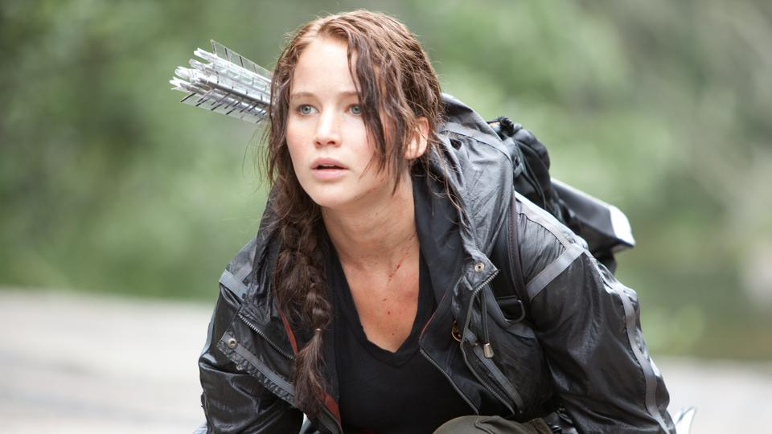

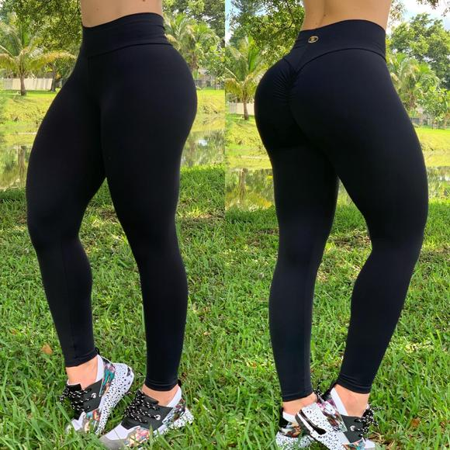

“Shhhhhhhh!” Katniss said quietly as Allison let out a muffled cry into her sweaty ass and pussy!

“I swear, I heard someone screaming and it came from here!” Some girl exclaimed as she ran down the beach looking around.

“You’re hearing things!” another girl replied…

Allison’s heart began to beat rapidly as she heard the other competitors close by! She had no idea who they were, or what weapons they had, all she could see was Katniss’ crotch over her nose and eyes! It was so sweaty and sour-smelling, she could feel her pussy lips through her leggings clenching on her nose.

“I can’t take this heat!” One of the women exclaimed as Katniss took an arrow from her back and slowly brought it to the bowstring. She began pulling back, tightening the hold and aiming. After the initial hit, she would have seconds to take the next shot.

Allison watched from below past Katniss’ crotch as she readied the bow, aiming carefully. Her nose was crammed between her pussy lips, slowly inhaling the fresh sour odor. She felt her body tense up slightly and then relax as a warm blast of methane washed across her lips and cheeks!

**Bbbbbbbbbbbfrrrrrrrrrrrttptptptptptptptptptptptptptptptptptptptptptptptptptppttppttptptpt**

Allison froze in horror! The gas was so wet and dense, she could taste it! Her entire throat began to flex and close as she had a brisk flashback to the diarrhea she had inhaled in the tree! Katniss sunk down, her ass smothering Allison’s mouth. Her nose was so deep between her pussy lips now that there was no chance for any air!

The arrow cut through the air like a knife, there was a split second of silence before Allison could hear screaming! It was a blood-curdling screech of terror as Katniss quickly readied another arrow! From below, Allison watched her fire, the arrow made contact with its target as the scream went silent. All that could be hard now was the wind as Allison lay there, the taste of Katniss’ gas still brewing in her mouth.

**BBBBFRPSPPPspppprpptptptp bfrtttt**

Katniss relaxed and let loose a wet fart that splattered between her sweaty ass cheeks! Allison could feel the hot gas pushing through the fabric of the leggings and into her mouth. It was foul beyond belief! She reached up, grabbing Katniss’ sides and trying to lift her but from the lying position, it was next to impossible.

“I was holding that one in forever!” Katniss exclaimed as she got up and began walking to the beach where she had hit her targets.

Allison lay there for a moment, choking on the hot gas that had been released into her throat. She could taste the cheesy flavor still but was unsure if it was from the fart or the dried shit in her mouth and throat. Slowly she got to her hands and knees, peeking out to the beach. She could see Katniss, her captor, going through the bodies of the victims. Allison saw her take a gun from one of the women, she checked it for bullets and then loaded it before putting it on her side. She quickly checked the other and but apparently, they had no weapon or nothing of use.

Slowly Allison crawled across the sand on the beach, inching towards the water. She wanted to wash her face so badly! Every breath she took was assaulted with the flavor of the feces inside of her mouth! She had just about reached the water when Katniss shot her a look of anger. Allison froze and began to shake…

“Can... can I… wash my face off? Please?” Allison begged Katniss, she was so close to the water she could feel the spray and mist from the waves.

Katniss walked up to her, she had her bow and arrow, and now also a handgun. She looked down on Allison for a moment, contemplating with her thumb and forefinger to her chin.

“Hmmmmmm, I don’t think there is time!” let’s go” Katniss smirked and began walking.

Allison stayed on her hands and knees, the water just inches from her face. She was so angry, so filled with rage! The water was so close, they had time!!! why could she not wash the shit off of her face!!!! Katniss was just being cruel, just being a bitch! Allison, still on her hands and knees began to cry as she shouted out!

**“NO, THIS ISN’T FAIR! WHY ARE YOU DOING THIS TO ME!”** Allison scried as she began crawling towards the water! Her palms touched the cool liquid as she heard a click come from behind her. Allison looked over her shoulder to see Katniss, pointing the gun at her. She was frozen in fear...

There was a minute of silence as they both stayed frozen like statues. Allison could feel the water crashing on her hands and knees as she looked back at Katniss. The threat was real.

“I’ll do it!” Katniss warned.

“I… I… I just… want to… wash my face off…” Allison stuttered and cried.

“I don’t give **A FUCK** what **YOU** want! If that water even **TOUCHES** your face, I will end your life right here!” Katniss said with soft and deliberate anger.

Allison could feel the spray of the salty seawater on her face, she was so close, why was Katniss so adamant about having her smothered in feces!? With shaking arms and legs, Allison slowly got to her feet and walked up to Katniss who still had the gun aimed at her.





“Lay down!” Katniss said with a grin as she dropped her pants and turned around, grabbing each cheek and spreading them wide. Allison watched as her stomach began to churn.

Allison had a surge of adrenalin as she turned and began to run! Her legs felt like soft noodles as her feet hit the soft sand, trying to propel herself forward with as much speed as possible. She looked back for a split moment and saw Katniss had pulled up her pants and was chasing her! She kept moving, running, her feet hitting the sand. Allison’s feet slid out from under her as she hit the sand, quickly scampering to her feet and running again. She had barely been moving a second before Katniss grabbed her and threw her to the sand! Allison hit the ground hard as all of the air left her lungs!

Katniss threw her knee onto Allison’s chest keeping her pressed to the sand with her weight. She wanted to scream at her but that could give away their whereabouts. Allison was writhing under her knee, she looked so pathetic.

Allison watched as Katniss stood and turned around, her big ass looming overhead as she slowly pulled down the sweat stained leggings. Her ass cheeks were covered in sweat with smears of dirt, her inner crack smeared with shiny sweat and bits of shit. Katniss reached back, grabbing her cheeks and spreading them, giving Allison a clear view of what lay in-between. Her anus was caked with shit, the leaves from earlier had done little to clean her. Allison’s eyes were watering from a distance just looking at the dirty hole. It began to tighten and pucker as a high pitched blast of gas escaped.

**VVVVVFRRTTPPPPPVPVPBBVVRRTTTT**

It was sharp and messy, ending with a wet splatter that made Katniss cry and Allison gag. Allison began crawling backward as Katniss crab-walked back towards her, trying to get over her face. Suddenly her hands touched the cool water, the goal she had been trying to reach to clean her face!

Allison watched as Katniss’s big ass came back towards her face! She dropped back with all her weight, her cheeks crashing into her nose while forcing her head back into the sand and inch of seawater. Her fat sweaty ass cheeks spread wide, completely engulfing Allison’s head within seconds. She could feel her greasy shit covered asshole slide down her nose to her mouth, wiggling back and forth. Allison did everything she could to keep her mouth closed, but it was forced open with Katniss’s weight.

Allison gasped, sucking in a gust of air through her nose, inhaling the odor straight from Katniss’ ass crack before gagging profusely, the odor was so sharp, so cheesy and bitter, she could still smell the fresh shit!

Katniss wiggled back and forth, Allison cried as her weight forced her head back even more into the wet sand and water. She was almost going to drown as the waves hit the top of her head. She could feel Katniss’ big greasy asshole in her mouth, spreading and quivering. Little bursts of hot gas rushed over her tongue, it was so spicy, almost burning hot. She cried and tried to pull her tongue back as far as she could get it into her throat.

**BBBBbbbbfrttttttt**

**bbfrrtsppSPppps sppprppttttttttt**

A very messy wet fart was unleashed into her mouth, the force of the gas puffed out Allison’s cheeks as she cried! The fart was so bitter and cheesy, ending with a wet splatter that leaked gooey bile like fluid onto the tip of her tongue! Katniss moaned loud above her, ignoring her gagging and muffled cries for help.

Allison could feel Katniss’ asshole beginning to spread, it moved and opened up wide as she grunted and pushed, her weight bearing down as she forced Allisons’ head even deeper into the sand. Allison was in shock, the shit that was coming out of her asshole was enormous, a monster! It was rocky and hard, easily a few inches in diameter. The monster came slow, crackling out with a wet splatter as it filled the space within her mouth. It was so wide and thick that it forced her tongue down. The thick mass squeezed down to the top of her throat, struggling to get inside her esophagus.

Allison reached up, grabbing at Katniss’ sides and trying to lift her, there was no way she could eat this! She would die! Katniss reached back, grabbing her wrists and throwing them down into the water, she held on tight and began pushing, Allison screaming under her!

Allison felt the monster pushing, the wet crackle in her mouth getting louder as more was pushed out, the pressure increasing like a cork in a wine bottle. She felt like her eyes were about to pop from her skull when finally her throat opened up to accommodate the mass of feces! All at once, it slid inside of her, like a massive snake it coiled down, reaching her stomach in one solid piece as Katniss groaned above her! Allison was in total shock, her stomach being pumped full of shit as it worked down her throat in one single piece. It was like her mouth was an extension of her digestive system.

**BBBBBFRppppfbbrrtttttttt**

An airy fart exploded around the turd, slowly turning to a wet splatter as the massive shit continued to push out! It had to be over three feet long, Allison could feel it in her stomach, it was so hot and heavy! Suddenly the shit broke off, the weight of the bottom pulled the top half down her throat quickly, it slithered down, leaving trails of wet feces behind in her mouth and throat as she cried! Katniss gave her no time to adjust as her anus ripped open, spraying loose a wave of wet shit that the massive turd had been holding back.

Allison reached up, her hand shaking, she could feel the burning feces forcing its way down her throat! Her gag reflex was hard at work trying to eject the foul waste, but there was nowhere for it to go! Her lungs began filling as she choked, feces sprayed from her nose filling Katniss’s ass crack, but she never stopped! The assault never ended!

Katniss looked up towards the sky, feeling the cool breeze on her face as the rancid shit sprayed from her asshole. Her stomach had been in so much pain since the beginning of this endeavor and now, for the first time since it began, she finally felt empty. The massive turd had been holding back dams worth of thick hot sludge-like feces that she deposited into Allison’s mouth. She could feel her jaw quivering under her as she pushed and forced it all out. She knew that what she was doing was wrong, but Allison would be dead without her! Katniss would help her survive, the two of them would walk out of here, and in the end, Allison would thank her.

Katniss grunted, letting loose a bit more, her shit had become completely liquid now, not a single bit of physical solid matter in it. Her asshole sprayed, slapping open and closed in Allison’s mouth as the fart echoed down her throat.

“Oh god, that’s foul” Katniss fanned her nose.

She rubbed her stomach as a wave crashed into her back, the water moved over her legs, the cooling feeling was very refreshing. She looked down at Allison’s motionless body and laughed, she must be in shock. Katniss got up and took a few steps into the water, letting the ocean water clean off her ass. She held her cheeks apart in the water, letting the crack self-clean as she smiled. Allison was still laying there though…

Katniss walked back to the shore, pulling up her wet leggings and dragging Allison to the sand by her ankles. She was very small and light so the task was easy!

“Hey! Let’s go! Wake up!” Allison clapped her hands a few times trying to get her attention.

“Hello? You finally got that water you had been begging for? Don’t you have anything to say?” Katniss asked as she kicked her in the side lightly!

Allison’s head fell sideways as her mouth dropped open. A combination of diarrhea mixed with seawater began pouring out onto the sand as Katniss stepped back choking and gagging. The odor was the worst thing she had ever smelled! She had to take a good ten steps back before she could breathe normally and catch some air.

“My God, the smell!” Katniss fanned her nose.

“Did I really do that?” she asked herself while plugging her nose and approaching the body.

Katniss knelt down and checked Allison’s neck for a pulse. There was none. Her eyes were rolled back and glazed over as a runny stream of shit leaked from her mouth. Katniss could only stand to be near her for a few seconds. Even with her nose plugged, the odor was too much. She quickly took a few steps back before fanning her nose again and taking a deep breath.

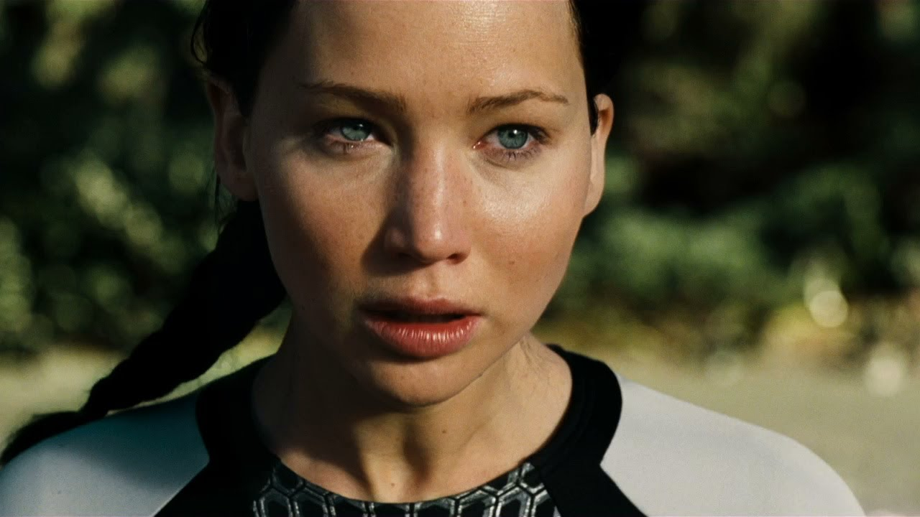

Katniss walked along the beach for an hour, feeling a hint of regret for what she had done. She used the situation to take advantage of a helpless young woman, and in the end, she had pushed it way too far. She had planned to save Allison, bring her back home for everything she had put her through. That chance was gone now…

The sun had just begun to set when a helicopter appeared in the distance, quickly approaching and setting down in front of her! The sand from the beach was whipped up in an air current as the blades came to a stop, slowly dying down. Katniss kept one hand raised to block the sand from reaching her eyes.

Two armed guards got out followed by a very nicely dressed woman in all red! She had long blonde hair and red high heels that caused her to stumble and walk very unsteadily in the sand. Katniss watched as she approached with help from one of the guards.

“Congratulations Katniss,” she said with a big smile, Katniss had no idea what to say…

“You are the last survivor!” the woman exclaimed while clapping with her palms.

“I'm the only one?” Katniss asked…

“All the other competitors have died, there is supposed to be two winners, but it’s all the same with just one! Are you ready?” she asked while reaching out for Katniss’s hand.

Katniss looked back down the beach, Allison’s body was not even buried, it was just lying there in the sun, shit spilling from her mouth, she felt guilty. Katniss wanted to go, she wanted to change things, she still would have used her mouth as a toilet, but she would have been a bit kinder. While she was mourning, the woman took her hand and began pulling her towards the helicopter. Everyone got in and Katniss watched as the island disappeared into the distance. No one would know what she did to Allison, no one would question what happened to her. The only thing anyone would care about. Was that Katniss was the winner. A smile crossed her face as he sat back in her seat.

**THE END**

