COSPLAYHEM
MARCH 2022 BIG STORY
BY CHALDEACHANGE
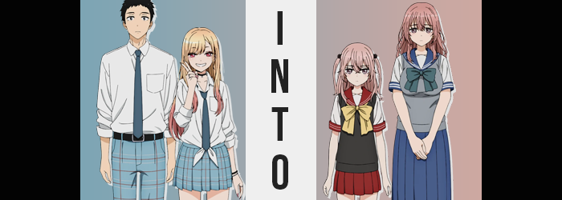

A lot had happened as of late, and as far as Wakana Gojo was concerned, it was all good. He had become friends with the girl that was who he considered to be the most beautiful girl in the class, Marin Kitagawa. Despite seeming like they were from different worlds entirely, they had bonded over their own eccentricities.

Marin had only approached him at first because he could sew, and she needed some help with making the perfect cosplays. And for Wakana? Not only did he enjoy being able to spend time with and help her, but she also accepted his love for Hina dolls. It really was a win-win, especially because he had gone so long feeling like he might be better off alone because he didn’t believe anyone would ever accept him for his hobbies.

The first cosplay endeavor for the two had gone exceptionally well, and Marin was already planning her next one when the two had been approached by another cosplayer – one who was renowned for her childish beauty… despite being older than either Wakana or Marin. It had been quite the shock for the two of them to learn that the Juju, real name Sajuna Inui, was not the child they had expected her to be.

And don’t get started on her sister, who was in middle school yet taller and bustier than Marin by a long shot.

But the two had to admit. Despite their eccentricities, the Inui siblings were much more experienced when it came to cosplay than the two of them were. “Okay! We’re now totally enacting the ‘get to know the Inui siblings quickly’ plan!” And so, after dinner at the Gojo home that night, Marin made her bold declaration once they had returned to Wakana’s bedroom to discuss their game plan going forward.

“The… huh?” Of course, as usual, the teenaged boy hadn’t even known that this was running through the girl’s head until she had said it aloud. He had been thinking this in part on his own too, of course. That they could learn something from Sajuna and Shinju by talking with them over lunch or something. They were renting the same studio in a week, so there would have been plenty of time for discussion then, too. “Well, I guess we could…?”

But before he could agree with the gyaru, she had pulled something strange out of her bag. A pair of what looked to be paper charms with the surname ‘Inui’ scrawled hastily on them. That was obviously Marin’s handwriting. “And so! Go to sleep tonight with this under your pillow! I’ve heard that if you do that, this charms will help you learn all you need to about the person whose surname is on it!”

Wakana felt his own eye twitch. Even if that did work, which he was more than certain it wouldn’t, how would the charm know which person with that surname to target? But because the doll clothing maker was so certain this plan would be a dud, he also didn’t exactly see an issue with entertaining her. “Er… alright.”

After all, what harm could come from sticking a piece of paper under his pillow?

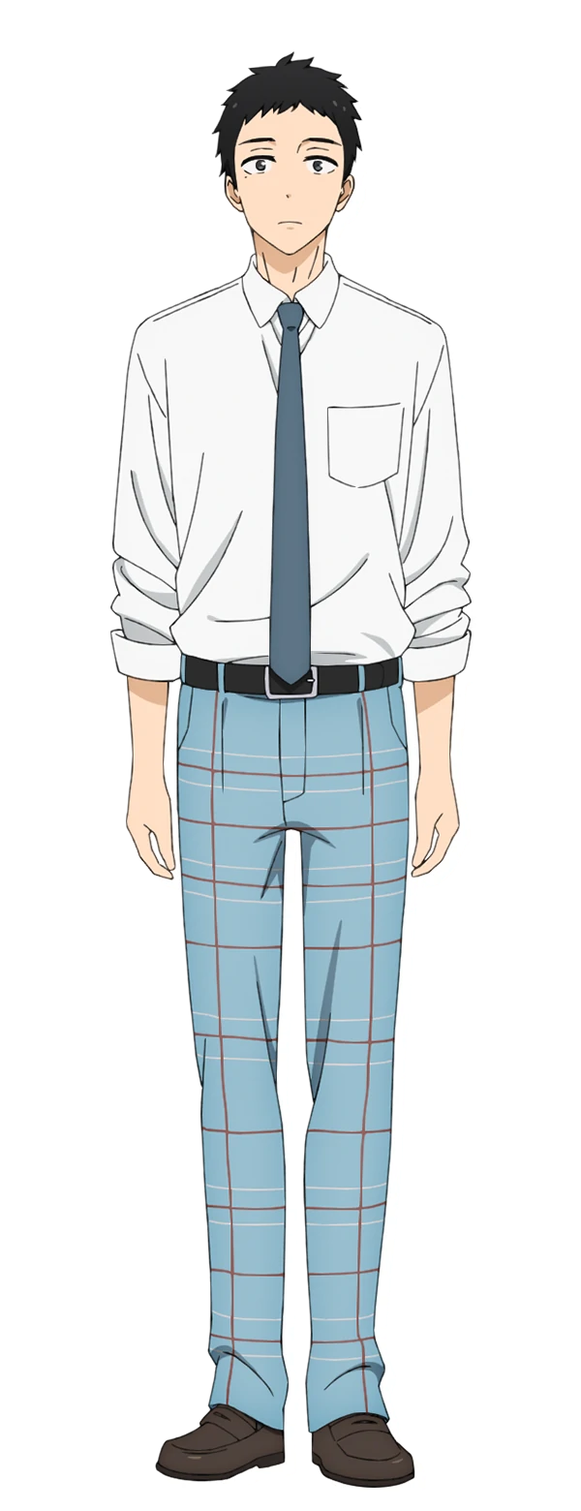
At 6:45am the next morning, Wakana was awoken by the sound of an unfamiliar alarm clock buzzing in his ear. That wasn’t the noise that his was programmed to make. Had there been a power outage that had reset the settings without him knowing? Groaning, he rolled over and slapped the off button without even opening his eyes. It seemed strangely bright in his room even with his eyes shut. And it smelled very… floral? Had Marin’s scent lingered the whole night?

Groggily, those eyes finally opened and… “HUH!?” The boy immediately sprung from the bedsheets in his white tee and boxers. Not only was this not his room – based on how big and open it was – but it was unmistakably a girls room. Pink was everywhere, with a cute little computer in the corner and what looked like an ample closet in the background. “How did I…? Oh no!”

He was in some unfamiliar girl’s room? There was also the worse possibility, that this was somehow Marin’s room and he’d done something strange while sleepy the night before. Very fortunately for him, that wasn’t quite what was happening. What was happening was, well… Marin’s charm had been successful. But not in the way that she had ultimately intended.

“I need to get out of here. But what if someone sees me? They’re going to think I’m a home invader!” Wakana had ruled out the possibility that this was somehow Marin’s place. It didn’t quite feel like hers, though he would be pressed to explain what that meant if asked. Based on Marin’s overall personality… No, it was one-hundred percent the uniform dangling on the back of the door. It was not only not the uniform of their school, but it was much too small for her. Almost child-sized, which… “…This isn’t Sajuna’s room, is it?”

If so, that was bad. He’d already seen far more of her than she was comfortable with, and understandably so. Now he was in her room without permission? Huh? What’s wrong with being in my own room? Wait! This isn’t my room though? What? Mentally, something just wasn’t lining up properly here. He felt strangely… confused. And as if to build upon that, something about his overall appearance began to appear chaotic to say the least, although Gojo himself didn’t easily notice it.

After all, it was largely featured amongst aspects of his appearance that were not easily perceivable without a mirror, and while there was one in the corner of the room, the teen had yet to find a reason to walk over to and gaze into it. Had he done so, however? He would have found himself staring at his own reflection with eyes that were significantly bigger, rounder, softer, and pinker. Like eyes that were not his own. Eyes that were so effeminately designed, lashes and all, that they better resembled those of a girl.

On the subject of pink, however, it wasn’t only his eyes where this color began to shine. Looking at the tips of his short, dark hair, the very same shade had arisen to almost give his mane what looked to be highlights initially. Only initially, mind you, because it quickly spread throughout the rest of his hair until the pink was not only dominant, but absolute. “This isn’t my room, right? Of course it isn’t! But…” Meanwhile, the boy himself just couldn’t seem to shake that he wasn’t in the wrong place after all.

Which was fine from the point of view of the charm beneath the nearby pillow because it kept Wakana suitably distracted from everything that was transpiring when it came to himself. Obviously there were some physical changes ensuing, but it was clearly mental as well – and the stronger those mental changed became, the less likely he was to realize what was happening before it was too late. He had even already brushed off the face that his hair was tickling the back of his neck, for the length of its new pink was growing longer and longer, stopping just short of past his shoulders while taking on criss-crossing bangs and a silkier aesthetic.

Continued change had seen to it that his face was reconstructed to the point that it was no longer recognizable as himself, as well. With its shape growing shorter came an inadvertent rounding of his cheeks, making his feminine looking eyes seem even bigger – especially with his nose shrinking as well. There was something almost childlike about it all by the time it had reconstructed, like the face of a young girl had been plastered onto the body of a six-foot tall man. Even the mole under his left eye seemed to have smoothed away.

That was, of course, before that height of his was targeted.

“Huh!?” The exclamation of surprise that escaped smaller, yet puffier lips was one exclaimed with a voice far higher than normal. Again like a maiden’s and triggered by the sudden sensation of rapidly falling. This couldn’t actually be the cause of the feeling, what with his feet still planted firmly on the ground, but it was absolutely true that his point of view rapidly fell towards the ground. Over a foot of height was ultimately lost, making it so that he most definitely could fit into the tiny uniform hanging on the back door, with arms, legs, and torso alike all shrinking down to this much meagerer stature.

Not to claim that Gojo was overtly muscular, but any muscle mass he did have was quick to melt away in the process, leaving arms and legs thinner. That said, there were several areas of inconsistency when it came to that weight distribution – at least if you were going to make the argument that he was still a young man. Even then, while he looked more youthful he had technically grown a year older.

The unusual weight distribution appeared to be focused in three key areas. Three key areas that would have made a lot more sense if Wakana was the girl he very much resembled, and it was a girl he would have recognized had he looked into the mirror at that moment. Then again, he would have only recognized his reflection as myself with how much his mental state had been adjusted behind the scenes.

Of the three key areas, the first was the boy’s chest. Gone were his abs, but in their place was soft, fatty tissue that also appeared to have seen his nipples to grow slightly in size. While petite, these were very clearly the beginnings of a pair of breasts. Which lined up well with the second key area, for his butt appeared to be perkier and a little more swollen than it probably should have been. This also bled into his thighs, which seemed a little more engorged, but not substantially so. All contributing to an aesthetic that suggested, beyond a doubt, that he was a teenaged girl.

And so too did her sex adjust, not that she paid it much mind with how her mind had already been assimilated. If anything, the sensation simply triggered a shudder from her while the oversized pajamas were wholly rearranged into a pink nightgown to better match the girl’s appearance and fit, for her old boys pajamas were practically pooling around her form by this point in time.

Until suddenly? She was overwhelmed with clarity.

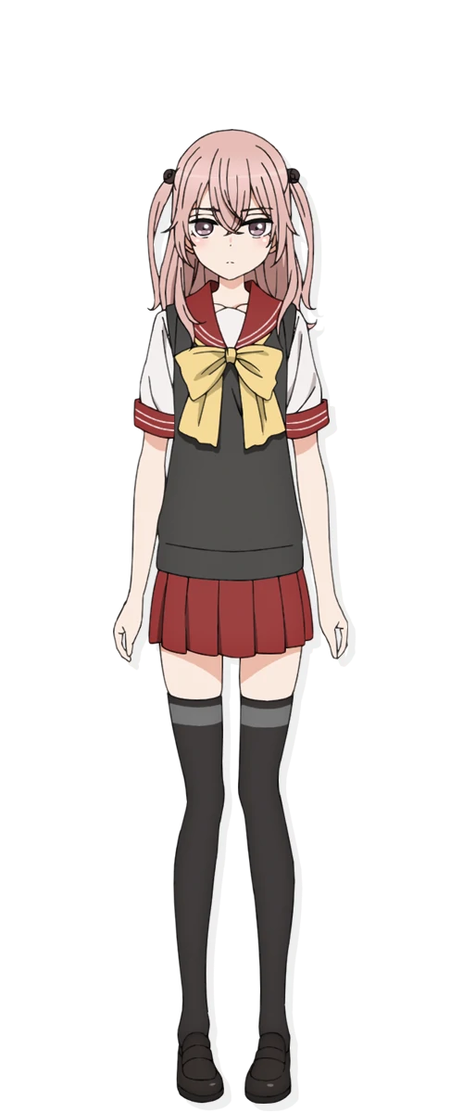
“Huh? Why was I so panicked? It’s Sunday, isn’t it? I don’t need to go to class…” Her breaths finally stilling, dressed in her pink nightgown, the seventeen year old Sajuna Inui finally managed to calm the anxiety she had supposedly felt ever since she had woken up. She couldn’t quite recall why she had gotten up with such a start and had begun to fret over her own circumstances, but the more she thought about it, the stranger it seemed.

Maybe I’m staying up too late working on this cosplay with Shinju… The thought crossed her mind. They had been working very hard so that quality would be consistent with Marin’s, even though Wakana was handling so much of the work for her. But why did that feel strange? Thinking about Wakana as another person snagged her thoughts a moment. Of course he was a different person!

And a different person that had seen her naked, to boot!

Reminiscing about this (now from the opposite perspective), Sajuna’s cheeks burned a bright red. Whatever! It was whatever! She was able to get what she had wanted out of him because of that, so it had been for the best! As a cosplayer of her renown, sometimes some sacrifices needed to be made! And one’s own shame was absolutely among them!

Wandering over to her closet, she yanked it open to reveal an assortment of outfits – some cosplays, some not – in an attempt to decide what to set out for that day. “Shinju and I are going to Gojo-kun’s place, so I guess I’ll pick out something fashionable… I want to one-up Marin-chan so bad!” She was kind of saying the evil part out loud, there.

“Eh?” As it had turned out, Shinju Inui used the exact same alarm clock that Marin did to wake herself up in the morning. So in the end? Hearing it buzz and hitting the off button hadn’t really struck her as all that strange when she had first stirred to consciousness. However, no sooner than she had sat up and opened her eyes did she realize that something was very wrong. “EEEEEEEH?”
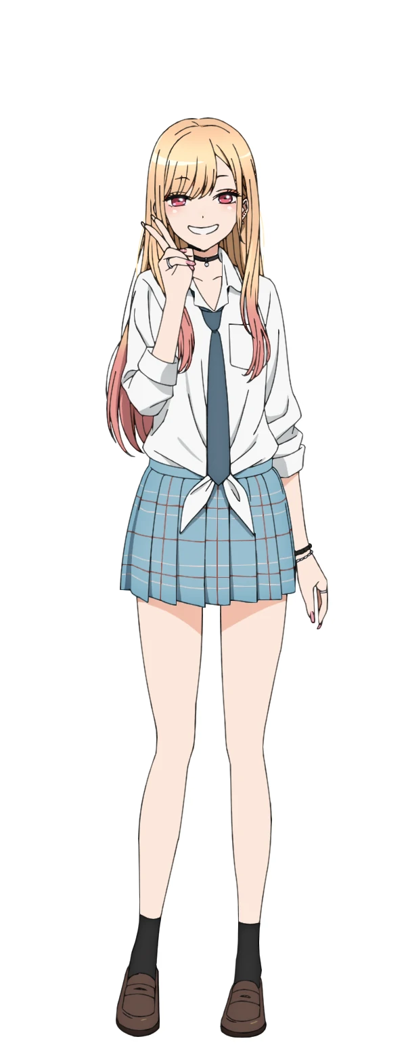
Being a girl herself, she wasn’t all that concerned about waking up in the room of another girl, even though she had most certainly gone to bed in her own bedroom the night before. But why was she here? How was she here? If she had been moved in her sleep, shouldn’t she have noticed? And she’d eaten at Gojo’s, so there most definitely hadn’t been anything strange in her food!

“Wait, is this Shinju-chan’s room?” Perceptive as Marin was, though, it didn’t take her long to put two and two together. After all, there was a huge middle school girl uniform hanging from the back of the bedroom door and sprawled across the nearby desk was a series of cameras and related supplies. Being Sajuna’s photographer, it only made sense that she would have them. “Did the charm work? No way!”

Did it though? This didn’t exactly help her learn all about Shinju, not without going through all of her things. And besides, she had been more interested in learning about Sajuna! Since she was the much more experienced cosplayer, she didn’t doubt that there was so much that could be learned from her in the end! But wait… if this was Shinju’s room, then this must have been Juju’s house, right? She just had to go find her!

…Was she really sweeping suddenly finding herself in someone else’s home under the rug? Evidently so. Such was the wild and chaotic mind of Marin Kitagawa. But that would gradually become overwritten in the following moments with something much calmer, more subdued, and overall shier. The mental effects simply hadn’t settled in just yet. But the physical on the other hand?
“Whoa!?” Marin had been so excited to find herself in this unfamiliar place that she had been ignorant to a strange warmth that had been spreading throughout her body. It was focused on two areas in particular, which had made it even stranger still. After all, why were her breasts and butt so warm? It wasn’t at all an arousing feeling, and she had more or less just chalked it up to sleeping in an unfamiliar bed. But her assessment of the situation was quickly forced to change, seeing as the mental changes had yet to see her perception adjusted.

The cause of her explanation had most certainly been something of a doozy, because before her very eyes? She was watching the size of her breasts practically explode. It felt good, but how it felt wasn’t really the issue! The nightgown that she wore was absolutely not adjusted for her breasts to be any bigger than they already were, and it was honestly safe to say that they were swelling to triple their original size. And Marin had thought her bust size was pretty impressive before!

Manicured fingertips were quick to grip her tits as they continued to fill her palms, ultimately overwhelming them, and pushing them forward – all while the base of her nightgown’s skirt was lifted higher and higher off her thighs while the top attempted to accommodate the mass of breasts that almost seemed to be the size of her head… each. “There’s totes no way, right!? Tits this big!?” It was certainly hard to believe. She was groping them now, but for some reason her nails were no longer digging into them. That was because her manicured fingernails now were short and looked like they were sometimes bitten nervously.

Wh-Why am I groping myself? I hate that they’re this huge…

Before she could take things too far though, the thought that this might have been unusual behavior for her struck her. Where was all of this insecurity coming from? For Marin, she was never insecure about her body. And she should have had even less of a reason with breasts like those. But it was there, lingering. And soon it was applied not only to the size of her breasts, but the shape of her figure overall.

After all, the warmth had been around her lower half just as much as it had been her chest, and with the latter having lifted the skirt of her bedwear up so high, it was clear to see that similar boons had been applied to that region in turn. Her thighs were thickening greatly for one, and through their growth her already impressively wide hips were forced even farther apart as knees buckled inward more as a direct result.

“I-I’m… why do I feel so weird…?” At some point, Marin’s voice had become much softer. The force it normally possessed just wasn’t there, and even her body language became more withdrawn with time. She was left perplexed as a swelling in the cheeks of her ass lifted up the back of her skirt so that the white panties beneath were exposed, and even then they were tightening around her engorged rump as well… all while the hair within her panties appeared to take on a familiar pink.

Now, with this bombastic figure at this height? Marin almost looked the part of a shortstack. But that was quickly corrected, once again at the cost of her nightgown’s fit. “O-Oh!” It was enough to get her to cry out, but the gyaru didn’t understand why she was crying out after the fact. Her clothes felt a little tight, she supposed?

Forget tight, because a change in height was quick to make it so that the nightgown didn’t fit at all. It was fortunate her panties still remaining fastened, for everything below her navel was left utterly exposed as she suddenly sprung up like a plant. Arms and legs both lengthened, while hands and feet ultimately came off as a little clunkier as a result of it. Before long she stood at an imposing 5’10”. A full six inches taller than Marin was supposed to be.

With everything that had transpired, it would be easy to assume that the teen had somehow grown older, and yet… Looking at her face would cast some doubts regarding that assumption. Her cheeks were rounder and her eyes bigger, and while her lips were quite pronounced? They lacked the volume that suggested she had properly matured. Rather, her face looked more like it belonged to a girl around the age of fourteen – younger than she had been before. Which made sense considering the uniform on the door.

“I’m… Uhm… What was I…?” If the girl sounded confused, that was because she was. Something felt off and she had been rendered incapable of figuring out just what was off. Even though it should have been absolutely obvious. Nonetheless, a pink swept through both her eyes and her hair. In the latter case, strands grew wavier and frayed. It lost the lustrous, well-kept appeal that Marin’s hair normally head. Instead it came off as a little more immaturely styled. Mostly because she had just woken up.

And, of course, her nightgown changed as well. Baby blue bled into the material, a material that stretched and fell so that her much ampler height was properly concealed. Much to the maiden’s own relief.

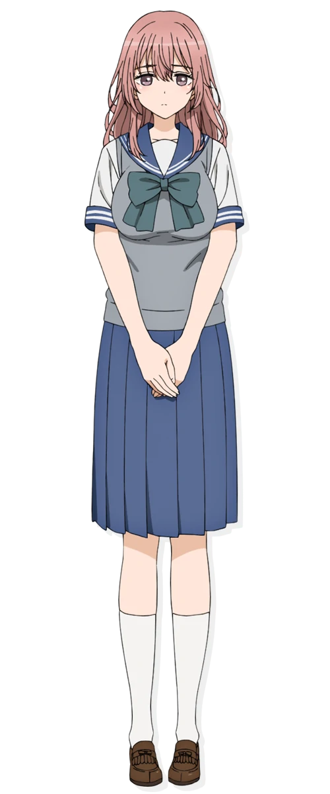
“Mm… Maybe its time to get a new nightgown. I’ve already grown out of this one…?” Her voice soft and shy, Shinju Inui tugged at the fit of the baby blue dress she had supposedly worn to bed the night before. She was actually so fixated on her outfit because she could vaguely recall everything feeling too tight from her body swelling beneath her old pajamas, but that didn’t change that this one was just a smidge too small as well. It was a curse being fourteen yet already being this tall and well-endowed, really.

Other than the feeling of her clothes not fitting properly, however, Shinju could recall nothing of being Marin. Her passions were all her own, from the enjoyment she felt working with her sister, to the passion for photography that burned so brightly within. In fact, even though it was Sunday, she didn’t mind getting up early because she was planning on showing off her cameras to Wakana and Marin when they went to visit them.

Their shared photoshoot was just a week away now. It had been a lot of work, but the young teen was excited. She loved seeing Sajuna happy and getting to use her photography skills made her happy as well. But thinking of Marin a moment, something else crossed her mind.

“I wonder if Kitagawa-san would give me some fashion tips?”

