FASHION GUIDES
COMMISSION STORY
BY CHALDEACHANGE
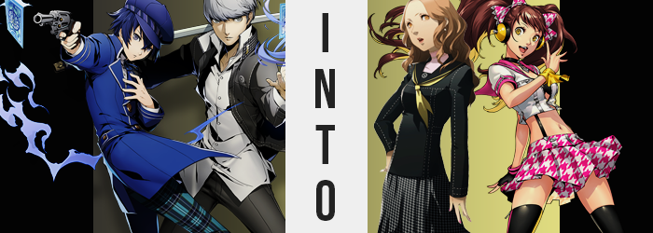

Toky0. Big and bright, with buildings towering high above the people below. It was certainly a much different experience from walking through the streets of the small town of Inaba, something the students of Yasogami High School immediately took notice of the moment they stepped off the bus.

As if out of nowhere, a field trip had been arranged for the entire school to come out to the city. Well, of course it wasn’t literally out of nowhere. Despite Risette’s hiatus, Rise Kujikawa had decided to participate in a charity concert in the big city, and her agent had arranged to buy tickets for everyone in the school as part of a big PR push for when she eventually came back to the stage full time.

There certainly weren’t any complaints from the student body. They’d all been brought up to Tokyo in lavish buses on that Friday night after class, with the concert not until the following night. That meant that they got to skip Saturday classes, and since the itinerary was so open, there was plenty of free time for exploration once they’d checked into whatever lodgings they’d been assigned.

Inaba was a small town, but plenty of students still attended the school. On short notice, it was more or less impossible to cram them all into the same hotels. So, as a result, the Investigation Team ended up more or less split into fragments with the intention of meeting up in the morning since it was so late. But in the meantime? Nothing was stopping them from exploring nearby shops so long as they returned by 10pm.

The only two members staying at this particular inn ended up being Yu Narukami and Naoto Shirogane. Maybe it was an odd pair to find hanging out with each other randomly – the exchange student and the Detective Prince, but they certainly didn’t mind one another’s company at all considering the things they had been through together. “It kind of sucks that we all got separated, but at least we weren’t completely alone.”

It was in Yu’s nature to be reassuring at times like this, not that he believed Naoto really needed that reassurance. She was strong, maybe even stronger than him. He didn’t want to create the impression that maybe he was looking down on her. “True. Should we grab dinner then? I saw a Big Bang Burger down the street.” Fortunately, it didn’t seem to be the case that she felt at all like she was being seen that way.

“Sounds good.” Yu shoved his hands in his pockets, and the two began to walk towards where the detective had seen the restaurant from the inn entrance. They only got a few shops down however, before an elderly woman grabbed them rather roughly and tugged them into what was clearly a salon?

Both were clearly stunned – both by the shock of the suddenness and the woman’s physical strength. “Sorry to startle you two, but we have a special on today in honor of Risette’s charity concert! Now, right this way!” Before either of the pair could react, a second elderly woman had appeared behind Naoto and grabbed her, while the first took Yu by the arm and pulled him in an opposing direction until each had been placed into a different private room.

“H-Hey! It’s alright, we aren’t in any need of a makeover!” Naoto was plenty frazzled by the time the old lady had dragged her into what looked to be a privatized salon space. She was trained to deal with the elderly in a kind and understanding fashion, but she was certainly having a difficult go of it by the time the woman slammed the door in her face, and she could hear the lock CLINK shut. “Er…?”

Had she just been abducted?

A fist immediately came down on the door. “Excuse me! I believe there’s been some kind of mistake? Let me out!” Always prepared for threats in the TV world, somehow this encounter made her hairs stand on end like whenever they had a dangerous Shadow encounter in that other realm. Was there some sort of danger here?

HISSSSSSSSSSSSSSSSSSSSSSSSSSSS

As if to see her truest fears realized, the sound of air or gas being pushed around suddenly filled the tiny salon space. It didn’t take long for the detective to note the cause: a pink gas was slowly filling the room, and despite covering her face with her sleeve, she was completely incapable of filtering it enough to not breathe any in. “Crap!” Was it going to knock her out? Kill her? Neither actually. Instead? Her body just felt like it was tingling.

But, unusually, it wasn’t her body that demonstrated any meaningful ill effects. Not right away, anyways. That honor? It went to something that shouldn’t have plausibly been affected by gas at all. But this also wasn’t your regular gas. As if their troubles from Inaba had followed them, it was a special concoction forged in the TV world, one arranged by an unknown partner of Adachi Tohru.

And so, it was Naoto’s clothing that showed immediate signs of altercation as she pounded on the door for a few moments, still trying to avoid breathing in this substance. As much as she could. It was in vain though, and her detective’s jacket (as she wasn’t required to wear her standard uniform on this trip) was proving just why, as the fibers darkened from blue to black, and the stitching entirely reconstructed itself. Reach across her torso, the open coat very quickly resettled into a familiar form: it was your typical Yasogami uniform top, equipped with even the same yellow ascot.

Except, even when dressing in her uniform, Naoto always wore a men’s top and pants, but this was clearly the tighter fitting girl’s top.

“Hm!?” Looking down, she could see that her top had changed – alerted by just how tightly it was hugging her body. But if the top had a restrictive effect, what happened to her lower half had the opposite one. Pants of a blue and black plaid unfurled from her ankles, both legs opening quickly in tandem with one another as the phenomenon moved up past her knees.

The cloth opened and fluttered, revealing more of her legs until, suddenly, the length was yanked up to her knees and the plaid pattern began to change into a black and white micro-plaid that was typical of the Yasogami skirts. And a skirt it certain was, for once it opened around her groin, both sides connected perfectly, much to Naoto’s alarm.

She reached down and tugged at it with her free hand, abandoning covering her mouth altogether. “What!? This isn’t… this can’t be possible!?” Naoto might have expected to endure a phenomenon such as this in the television world, but in the real one? Even now, socks had stretched into white tights that captured her legs, and black mary-janes were made of her more masculine shoe choice. Being dressed like this really made her feel insecure – and that was without realization that her hat was missing.

Rather, unbeknownst to her, she was simply becoming less observant overall. She hadn’t simply forgotten to cover her mouth, but something in Naoto’s brain had merely made her ignorant to its existence. The gas, laced with TV world-born nanomachines, was effective in changing pretty much anything as long as their creator willed it.

Case in point? The tips of Naoto’s hair had begun to lighten almost like she’d been given a terrible dye job. They reached a peak color that was a sandier, citrus-blonde before the color grew more consistent, but it soon seeped as deep as her roots. Perhaps it was for the best that her hat had already disappeared into obscurity as well, for the length began to slither outward as if each individual strand were a snake, finally stopped just a few inches past her shoulders.

Naoto shuddered, and a strangely well-manicured hand reached back to fan the hair out. “Since when was my hair so…?” The girl felt uncertain about it. It was certainly wrong, right? She liked her hair short? Yet, what she blurted out next completely contradicted the thoughts that were going through her mind, and it was conveyed in a completely different voice. “Ugh, I really need to give it all a good wash tonight!” From the impatient and snooty tone to the recognition of beauty techniques Naoto had no recollection of in her mind suddenly, this didn’t sound like her at all.

But neither was she looking much like Naoto in the first place any longer. Hair aside, if one’s face was the most obvious gauge towards their identity then her ‘old’ self was more or less screwed. The next she blinked for example, it revealed that her steel blue eyes were awash with a bright orange not too different from the color of her hair. When her eyes fluttered next, lashes would find additional length, and an uncharacteristically girly gloss painted her lips.

Not that this gloss was the only thing awry with those lips, either. It wasn’t subtle in how they felt nor looked fuller, helped by a jawline that had crunched narrower than what Naoto normally sported. On the whole her face just looked more mature, with raised by fairer cheek bones, and with orange bangs parted in the middle she looked even more so. Throw in the tinier nose, which in turn made every other aspect of her face look bigger, and you certainly wouldn’t recognize her as Naoto Shirogane.

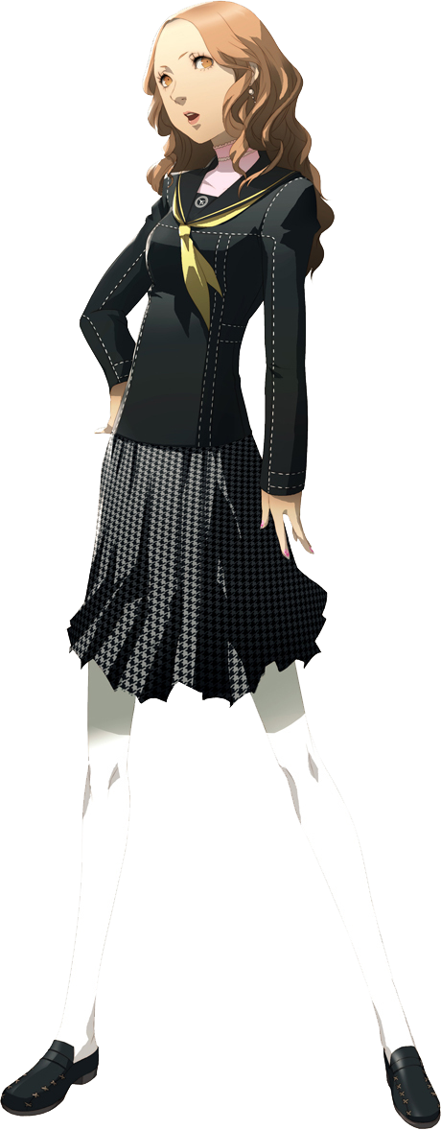
“Why’s my outfit feel so tight? For crying out loud, this is why I hate these ugly school uniforms!” Thoughts now more in line with what she was saying, she tugged at the chest of her top and the hem of her skirt as an undeniable tightness settled into place. This was because adjustments were being made to her figure, albeit minor ones. The cups of the bra she was wearing found themselves fuller, an additional cup size added to Naoto’s arsenal. And her hips? They’d widened a little to make room for the fat that filled her tights, seeing ass and thighs stretch and jiggle just a little wider. Add a few more centimeters to her height, and this girl could no longer be called Naoto Shirogane at all.

That went for her mental state as well. It was buzzing. Not as astute nor alert, her mind kept wandering to silly things like material goods or how she might catch the eye of the next man or woman that she came across. She very much thought, and would act like, a queen bee of sorts.

“Ugh, I feel like I just got hit by a bullet train.” Holding her head in agony, Ai Ebihara was having some difficulty making sense of her surroundings. Why the heck was she in a salon in Tokyo? Why had she felt so uncomfortable? Only bits and pieces made sense – why did she have the Detective Prince on her mind?

That made the least sense of all! But with the gas almost completely cleared out now, different details began to settle back into place. “Oh, right. The field trip? Risette’s concert? Yeah, I kind of remember now. I need to wait for her in the lobby though.”

Who was she waiting for, exactly?

Meanwhile, Yu was in a remarkably similar situation. He likely could have overpowered the old lady if he felt he’d really needed to, but at the same time the last thing he wanted was to find his face plastered all over Tokyo’s news stations because he wasn’t careful enough. Not as paranoid as Naoto had been right out of the gate, even after he’d heard the door of his room lock, he wasn’t immediately put on guard. At least, until…

HISSSSSSSSSSSSSSSSSSSSSSSSSSSS

“What!?” The boy’s mind began to race the moment the sound of gas filling the air could be heard, and as a result he was a little too late on the uptake to cover his breathing options before taking a big inhale of this pink substance – one that had made Naoto unrecognizable in both body and mind in the next room. He stumbled back towards the door and used the arm not covering his mouth to bang on it. “HEEEY! Let me out! What are you doing to us!?”

He could only assume that a similar fate was befalling his companion. What was up with these old ladies!? Perhaps this was the issue with making too many assumptions based on appearances alone? All Yu knew was that as time wore on, he was beginning to feel weaker and weaker. It eventually reached the point that he couldn’t muster the strength to bang the door any longer, and the idea was given up on altogether.

But this? It wasn’t without a reason. In fact, it wasn’t simply a feeling of weakness. Quick to work on re-sculpting the young man’s body, it had attacked his raw, physical strength first. Not that he was particularly built or anything, but he was among the physically strongest of the Investigation Team members – at least until his muscles had begun to deflate.

Whether it was his arms, his legs, his chest, or his tummy, it all became softer to varying degrees. While you could hardly make out a trace of strength in his arms and chest any longer, his legs and belly? They remained toned at the very least, almost as if his body needed to remain tight and agile.

But he hadn’t really noticed. Yu was more confused by his circumstances and overwhelmed by how fatigued he was suddenly to think about an impossible circumstance like his muscles thinning out. “I can’t seriously be trapped in here! I’m going to be late for the show!” A hand immediately clasped itself across his mouth, provoked by the shock he felt in response to speaking such a thing. Had his voice been higher there, too? “Testing…?” No? Maybe he was hearing things?

Risette’s show was tomorrow, right?

As he grappled with this odd incident though, more of his body had been in the process of changing. Not content with merely stealing away his bulk, the nanomachines had targeted his height next. Subtly, his point of view had been dropping as limbs and spine alike narrowed from their usual peaks. It wasn’t a subtle drop either and even in his confusion he took eventual notice thanks to how his clothes had begun to hang off of him. “What!?” After all, ten inches were shaved from his frame before it finished. “Wait, why am I so tiny— My voice!? It’s back!?” Yu could definitely hear it now. He sounded like a she?

No, he knew this voice personally…

“I sound like Rise!?” It took him a minute to realize, and even then it had proved to be a puzzle since you don’t sound the same to yourself as you do to others. It sure was a trick to move around with how baggy his clothes had become – and even then? His pants had fallen to his ankles, and he shed the oversized jacket for comfort reasons since it kept sliding down his arms. The only thing the leader was wearing was his dress shirt now, which while big at his old height, now fell as far as his knees.

Shoulders narrowed next, and farther south his hips parted wider, forcing his posture to see knees pointed slightly inward. “This can’t be happening? This is the real world, things like this can’t happen… I can’t just become… become… Huh? What was I thinking about again?” What? Why was it so hard to think all of a sudden? He’d been thinking about something important, hadn’t he? Something…

“Eep!?” The most feminine of squeals called from his lips thanks to the sensation of nipples suddenly hardening and pressing up against the inside of his shirt. Sure there was all of this gas (which he’d now completely accepted as ‘normal’), but it wasn’t cold? Why were they getting erect!? But more than that, the flesh beneath them began to push outfit, a fatty jiggle seeing an otherwise flat chest round expand into a pair of orbs. They didn’t grow to substantially large sizes, but the pair of breasts was evident as they pushed out the dress shirt’s front.

Looking down at them, though? It wasn’t the fact that he’d grown breasts that struck Yu as odd at all. Instead? “H-Huh!? Why am I wearing senpai’s shirt!?” He was incredibly flustered for a moment, but then confusion struck his facial features again. Wasn’t this his shirt?

The face contorted by confusion was softening now, cheeks growing plump, and lips swollen to a perky, kissable shaping. Silver eyes duller in color to a more mundane brown, as lashes lengthened, and shapes became more circular and naturally expressive. A tiny nose and miniature jawline brought it all together – the fact that his face now resembled Rise’s entirely, that is.

It was a phenomenon that likewise tackled his hair, a cherrywood brown stealing away the silver and seeing its length dramatically increase as a natural perm found its way among the styling. Before long, he sported a luscious head of hair that hung halfway down his back, extremely voluminous and fluffy thanks to all of the hair care products he could suddenly recall using that morning.

Or she could recall using, for a sudden tugging sensation at her groin forced another girlish cry to her lips, swelling thighs forced to rub against one another uncomfortably in direct response. “What was that!?” Her dick and balls had been replaced by a pussy with a trimmed bush of brown above it, of course. But from Yu’s perspective? There’d been momentary arousal, which heightened her embarrassment.

Not only was she in senpai’s shirt, but she was feeling weird? No, her feelings for him weren’t even there anymore! She’d gotten over him!

“Are these thoughts and memories mine?” Crimson staining her cheeks, a hand with fingers decorated in pink, acrylic nails came to stabilize a wobbling head via contact to her forehead. She felt like she was going to fall over from confusion, not at all helped by swollen thighs, or by the fact that she was becoming a little more back heavy. Her tight butt cheeks had suddenly found themselves in excess, as fat bubbled up to see them expand and round, pushing out the back of her shirt up in slight as cheeks peaked out a little underneath.

She eventually stabilized herself on shrunken feet with cute, painted nails, almost tripping over the men’s clothing that was laying on the ground beneath her for some reason. Her change was complete, and she was left speechless a moment as she attempt to piece everything back together mentally and emotionally.

Just as Ai had been in the other room, Rise Kujikawa was left in a disorienting daze by her transformation’s end. “Last I checked, getting my hair and makeup done doesn’t normally feel like this…?” She could string pieces of ‘memories’ together. She knew she was in a local Tokyo salon getting work done for her rehearsal show since her usual hair and makeup specialist was out sick. Was she sick too? No… it didn’t really feel like a cold or anything.

Still embarrassed that she was wearing Yu’s shirt, she quickly unbuttoned it and threw it into the corner. She couldn’t remember how or why she was wearing it, but she was quick to toss it aside. She had to get changed! And by the time the day ended, she’d forget about having worn it altogether anyways. Being the younger of the two as she was, it would probably be an idol and school scandal if anyone found out about this!

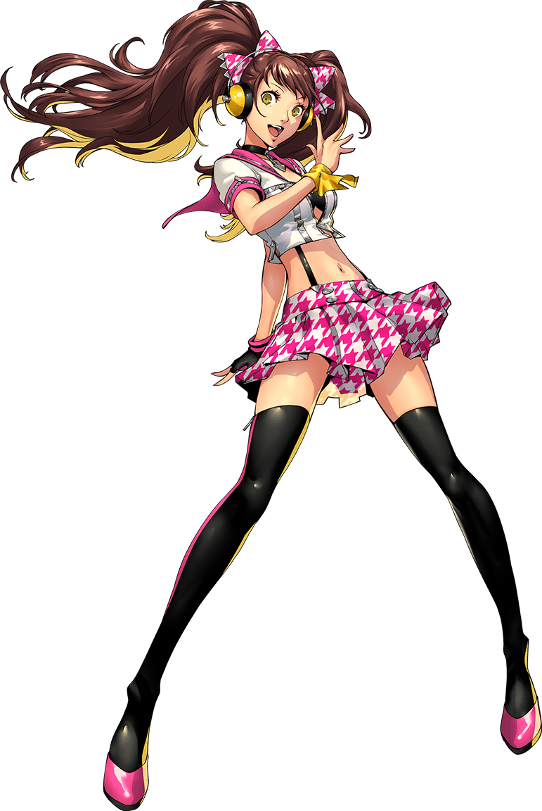
At least her costume hanging on the wall looked cute! As long as she was adorable, that was all that mattered aesthetically as an idol! Something was off though, and with manicured fingers planted upon her vaguely exposed hips, Rise leaned in to look at herself in the mirror. “Wait, my makeup isn’t finished!? Crud, she’s gonna be mad…” She? Who was…?

“Now, now. Take a seat and I’ll finish. I told you I was just fetching a glass of water, didn’t I?” The salon owner, an elderly woman, entered the room not long after. With these words, more recollections clicked back into place. That was… that was what had happened, wasn’t it?

“O-Oh! Right! Sorry…”

With her makeup now finished completely, Rise Kujikawa emerged from the private salon room to find Ai Ebihara, Yasogami’s sports team manager, waiting for her. “Are you finally ready?” Dramatically, the older of the two girls flipped her hair over her shoulder. Rise physically cringed at the comment, but her disorganized memories were falling back into place. She’d invited Ai to her rehearsal show tonight, right?

She wasn’t sure what right Ai had to complain about waiting, then.

There was something else though. Another reason. Despite Ai’s prickly nature, the two of them had become rather close as of late. Right… They were together now, because… “Hey, you invited me on this date before my show, right? You knew the risks of dating an idol!” They were going on a date after the show, and this was just the pre-date. Still, trying to be cute and mischievous, Rise gave a cute wink with her comment.

It was enough to make Ai bashful, and she looked to the side almost immediately. “Yeah, yeah… You look pretty, I guess.” Oh, how flattering! Honestly, this girl! But that was part of her charm in a way. Rise didn’t feel like she was constantly being sucked up to or being given special treatment just because of her idol career. It was nice.

Rise simply giggled before taking Ai’s hand thoughtfully.

“Thanks! ❤”

