SHE BREASTED BOOBILY
JULY 2022 FIRST PERSON STORY
BY CHALDEACHANGE
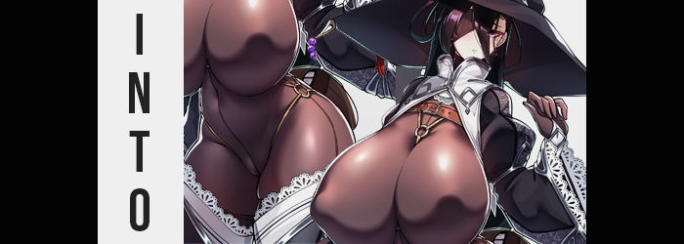

How is one supposed to keep up with all of the new game releases?

It was a question that had been plaguing me for several years now, as game after game came out without any pause. It didn’t matter what genres they were, because I was open to playing pretty much anything – and so naturally I purchased pretty much anything against my better judgment. As someone who didn’t spend money on other bad habits, you could say that this bad habit was my crux.

But it was beginning to take a toll. My Steam library, relatably, had filled to a ridiculous extent with games I kept telling myself I would one day play, only to never do so (or maybe just start up once and never again). Did I want to play games, or was I just hooked on the idea of owning them? The truth was the former but being an adult and working a full-time job meant that I didn’t have an endless supply of free time, as much as I really wished I did.

Of all the games I owned, it was RPGs and JRPGs that were the worst offenders. Stylistically they were my favorite types of games, and often the most appealing to look at in my opinion. When it came to JRPGs in particular? They were brightly colored and visually interesting – much more so than their Western counterparts. You couldn’t really argue that they had better character models, either. Well, if you like huge tits and big bums on your female leads, anyways.

Bemoaning my lack of free time for all of these games, I was flummoxed to one day find an unusual pop-up on my computer while looking for more games to purchase. EXPERIENCE THE WORLD OF FANTASALIA ONLINE WITHOUT INTERRUPTING YOUR WORK WEEK! Or so the ad read, but that alone was enough to make me skeptical. For one, I’d never once heard of a game called Fantasalia Online. That was a pretty dumb name in the first place, wasn’t it?

On the other hand, the experience it was promising was basically impossible, right? A game that wouldn’t interfere with work of all things? There was no plausibility to that claim whatsoever, and of course I was quick to write it off as a scam. Knowing how the internet worked these days, clicking that link would likely lead me to a crypto or NFT space.

And so I clicked it!

…Not intentionally. “Shit,” I hissed as a website began to boot up. If my clumsy hands somehow accidentally had opened a site that would give me a virus, then I would berate myself harshly. There was just as much of a chance that it was opening a porn website though, which definitely had some complications of its own. But in the end? I didn’t get to see what sort of website it opened. Because the screen turned bright white, and when the light faded? I was no longer standing in my office.

“…?” I was standing in a completely different place altogether. A room with walls, floor, and a ceiling of wood. Furnished with flimsy, basic furniture made with the same wood and featuring a bed that looked extremely itchy to lay upon. If I didn’t know better, it looked like the kind of cheap inn you might find in the beginning of any classical JRPG game. “How the hell did I get here?”

I was naturally concerned by my sudden displacement. Teleportation? Warping? Regardless of what had happened, it shouldn’t have been possible. And it felt more like a scene out of a badly written isekai series more than anything. Except it wasn’t like I had been reincarnated, or had any special powers, nor was any of that possib—

“OW!?”

The cry that had escaped my lips was clearly audible, and it hadn’t been prompted without a good reason, either. A sharp pain had radiated from my groin suddenly, almost like I had been kicked super hard without actually having been kicked. The feeling forced me to buckle over and paw at my groin, but… Wasn’t it a little flat? “…Huh?” The shock and pain gradually faded, but I was left perplexed by the absence of a bulge in my clothing. So perplexed that I, fearfully, placed a hand down the front of my pants.

A shudder ran up my spin as fingers didn’t grasp a dick, but instead probed into a warm, moist crevice of some fashion. Well, there was really no debate as to what that was, but I didn’t want to believe it for obvious reasons. “Is that…? Do I have…? A pussy…?” I probed one more time, and unfamiliar with the sensation? I moaned. In a voice that was a little more effeminate than it was usually.

Then again, ‘a little more effeminate’ was becoming a good way to describe my form as a whole. Because no sooner than my sex had changed so that I became a woman did my body begin to soften and take on a womanlier shape. My hair grew a little in length to my shoulders while my lashes grew longer, the overall shape of my face transitioning from something more masculine to a more feminine counterpart.

Really, it wasn’t all that dramatic. It was more like someone had taken me as a man and repurposed me into a woman. My hips had grown a little bigger, my ass a little plumper, my waistline a little narrower, and my chest a little fuller. My clothes didn’t fit quite as well as a result, but neither did my plumpness originally. I still had a notable belly, and a lot of my new breasts were simply weight I’d had before. My womanly cup size was very lacking.

“This is crazy… Why am I a woman!? How am I a woman?” There was no doubt that my voice was shriller and better matched the body of the somewhat unhealthy woman I resembled. Still dressed in an oversized tee and pajama pants, I was glad I had at least worn looser clothes. …At first. But they were then quick to become looser, and looser, and looser…

Simply because there was less of me! “Urp!? Wait!” I stifled a burp, but one that was only provoked by a sudden gargling discomfort in my tummy. Looking down, my tummy bulge was slowly dissipating – and reaching a hand to pat it down confirmed what it looked like. I was losing weight at an alarming rate, my belly becoming flat while all of the excess mass across my body went along with it. This just exposed how lackluster my womanly figure was, not that I was really concerned about that.

“I’m thin… I can’t… Pfft… believe it… Pfft!” I’d always wanted to be thinner, but the road to losing weight wasn’t all that easy. Wasn’t it kind of cheating to just lose it all like this? The thought had briefly crossed my mind, but I suddenly found myself blowing away strands of long, black hair with air from my mouth. Wait. “Huh? Since when was my hair this length… or color?”

It was true. My hair had grown slightly longer when my sex changed, but it hadn’t been this dramatic. Nor was my hair ever this dark. But my fingers, slenderer in shape themselves unbeknownst to me, tugged a few forward before I grabbed a whole handful. I could see my hair, now undeniably black, growing longer and longer before my very eyes. There was so much of it that it felt heavy to boot, and before long it spilled all the way down past my rear end. “How am I going to wash all of this?”

Distracted by my hair, I had been forced to ignore a vague tingling sensation in my facial features. One that removed any doubt of my femininity – as well as any signs of my old appearance, to boot. My face grew longer as a whole, its beauty dial turned up to eleven as eyes both narrowed and changed in color to a bright pink. On the other hand my lips swelled plumper and my brows thinned, inheriting the same color as the plumage upon my head.

What came next wasn’t exactly a change that fell in line with everything that had been happening thus far, though. Because all at once? My clothes suddenly tightened around my body. “Ngh!?” It was uncomfortable, but I couldn’t help but watch how my shirt and pants clung to my body, mending together as a blackish-brown color settled within changing material. Before long it was clear that both halves were latex, and they had formed into a body-sock that ran from my shrunken tootsies to my neck, covering my arms and fingers as well.

“What… am I wearing?” I had plenty of concerns about this outfit if it could even be called that. My breasts were small, and my hips were lacking, but you could fully make out their shapes while dressed like this – even the protruding shapes of my nipples. Which also highlighted that, well… “When did they get so big?” Fearing how sensitive they might be, I didn’t touch them, but I did marvel at how my nipples appeared to be almost bigger than my eyes, pushing the latex forward off my tiny chest.

Though wasn’t my chest feeling a little warm to begin with? With all that had been happening, I hadn’t thought much of it initially, and yet… Once I saw the body-sock begin to stretch, my pink eyes immediately went wide. “W-Wait!” I cried out in a voice that was much more naturally sultry than it had been a moment before, but no amount of words could stop what was to come.

That is, the growth of my chest. It wasn’t a little bit nor a lot, but it did explain why the later had seemed a little bunched up above my tummy. Because my tits grew, and jiggled, and grew and jiggled, pushing forward in increments that saw them develop from lackluster A-cups to D-cups, to F-cups, to… “Oh…” It took all of my strength just to prevent myself from falling forward with how big and bouncy my bosom became. The latex tightened around them, shaping them to perfection as a belt appeared around my chest with a strap that pulled the latex down in my cleavage, leaving these breasts full shaped even when dressed.

I almost fell forward again as one final surge of weigh saw an additional three cup sizes applied to my hefty tits, not that I could see the floor past them in the process. But something mentally flipped, and I suddenly found myself able to balance despite the fact that each tit was bigger than two of my own heads. They were so big that they practically fell down to my belly button. They were freakishly large. Yet I could recall how to walk with and care for them, somehow.

“Something isn’t… right…?” Plenty wasn’t right, I knew that. But I was referring more to my own mental state at this juncture. I felt like I knew more about this world than I had before, and even my own personality was now taking what was happening in greater stride despite how alarming it all was. My bombastic upper half was shocking, but a part of my felt comfortable with these huge tits like I’d lived with them my whole life. Even though my height nor my age had really changed.

As that calm settled in, though? My lower half found expansion in a manner similar to my heaving bosom. Hips pulled wider, and so too did my meager thighs begin to engorge. Little by little they blossomed, pulling the later tight and rubbing up against each other between my legs. Their masses were highlighted even more once thigh-high boots seemingly appeared as if from no where, their white lace trim hugging my thick thighs until their meat bulged up around them.

And this was to speak nothing of my ass, which protruded with the very same vigor and exploded in size to make good use of the latex shell that now contained it. The rise and fall of these cheeks as I walked in my new heeled boots would certainly be a sight to see. Them quaking as I was fucked would most certainly be another.

“…?” The uncertain calm I felt clouded any major reaction to my right eye suddenly being obscured, but I felt like I knew the answer. I was wearing my usual outfit, so of course my right eye would be covered. It was an outfit that included a black eyepatch, a big, black witch’s hate, and an open jacket that went over my body-sock with big, open sleeves that matched my boots. There was no denying the appeal of this outfit, because it was clearly meant to highlight my ridiculous figure.

In the end, short of my personality becoming much demurer… Well, I guess you could say my memories hadn’t changed all that much? I had a new identity, a new name, and in support of these things I had also inherited the bare minimum amount of knowledge of my new life. I was a fledgling adventurer, a witch by the name of Gravia who only had a basic understanding of magic. One with a tall and voluptuous body that I had apparently decided to dress up like this as a coping mechanism for my own insecurities. The eyepatch was part of that too since it made me appear mysterious.
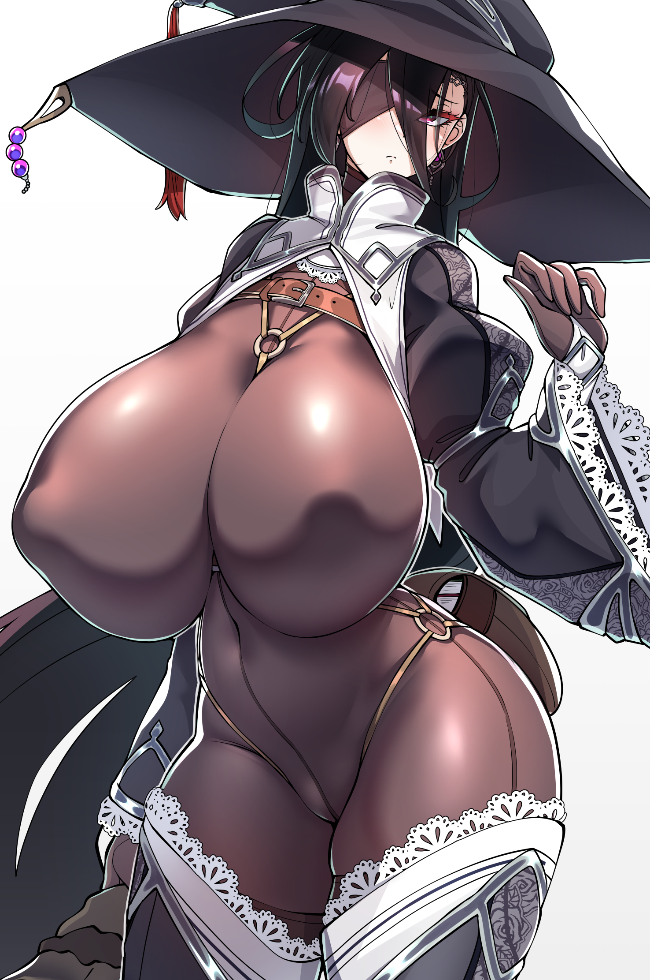
Well, those insecurities were isolated to my talents. Somewhere, deep down, I believed if I dressed in a way that showed off my bombastic body, then that could compensate for my lack of skill and have me scouted into parties anyways. While I didn’t have any memories of how that worked out, though? I couldn’t help but wonder if this would lead to me getting fucked more than anything. “My… What am I to do now…?”

I could also recall that I was an adventurer presently without a party. Which meant my income was low. Which meant I could barely pay for this inn room and feed myself. Which was not good. Experience Fantasalia without interrupting my work? This world had become my work! Because if I didn’t work, I would die.

Anxious, I sighed and set out the door, heading for the stairs down to the inn’s foyer. And since there was so much to my figure?

I breasted boobily down those stairs.

“…This is very uncomfortable.”

