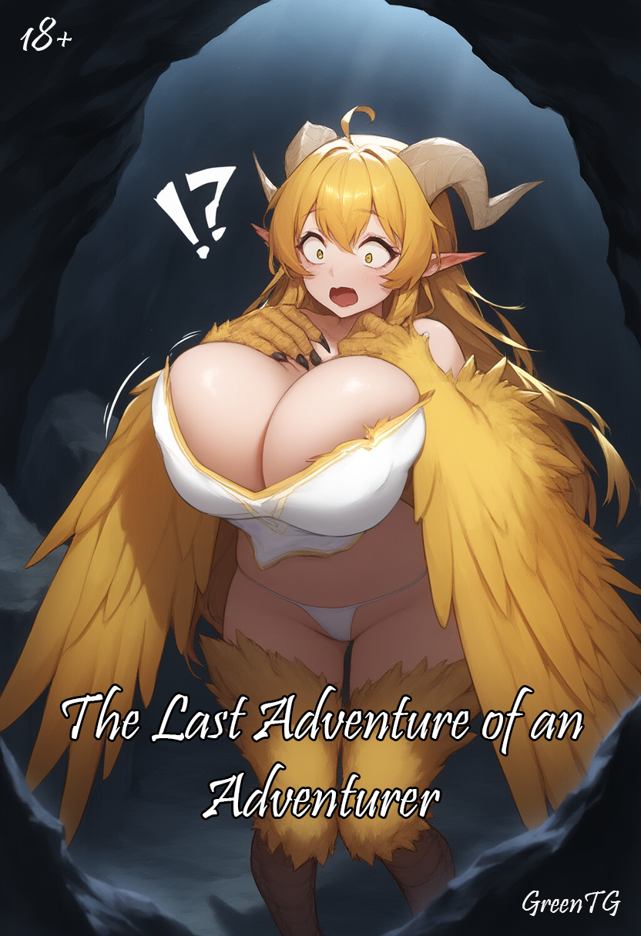

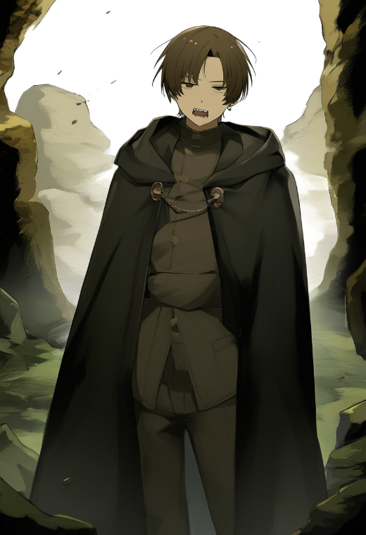
The cave loomed ahead, a black maw resembling a giant mouth ready to swallow anyone daring to step inside. In the thick twilight of pre-dawn shadows, it looked ominous, as if nature itself was warning: this was no place for the living.
Four travelers stood at the entrance, immersed in a brief silence broken only by the wailing wind. Jagged peaks surrounded them, along with dead, cold stillness.
— Another hole in the rock, — Crane snorted, brushing his bangs out of his eyes while eyeing the grim passage. His voice was lazy and mocking, as always when he wanted to show indifference.
Crane looked as if he wanted to be anywhere but here. Lean, with perpetually unkempt hair he never bothered to tame and brown eyes that sparkled with sly mischief. His face appeared both sullen and cunning, inspiring distrust from strangers at first glance.
— Nothing special, — he added with a shrug.
— Maybe stop whining? — retorted Amara, the red-haired warrior with a hint of irritation in her voice. She planted a hand on her hip, while a heavy two-handed sword swayed lazily on her other shoulder. They didn’t call her "Red Thunder" for nothing — her hair, as fiery as flames, and her temper, as explosive as a storm, made her a formidable opponent and no less dangerous an ally.
— We're here because of your lead, so at least pretend you're interested, — she added, narrowing her eyes angrily.
— I only passed along what I heard from my source, — Crane drawled, shrugging again. — But I’m not expecting anything worthwhile here. Still, you’re paying me, so I’m with you.
— Well, I am expecting something, — the eldest of the group, Gilbert, chimed in. His silver hair, neatly combed back, glinted faintly in the dim light filtering through the clouds, while the heavy, ornately carved staff adorned with a bright crystal added to his imposing presence.
The mage’s voice was steady, yet tinged with a weariness, as if years of searching and battling had become a heavy burden.
— Perhaps the rumors about treasure are exaggerated, but the cave feels strangely empty for a place like this. That’s suspicious.
Martan, the towering figure with a warhammer, stood nearby, gently shifting the massive weapon as if testing its weight. His muscles rolled under his leather armor, his expression focused.
— If there’s nothing valuable, we’ll just finish quickly and leave, — he rumbled, his deep voice echoing like distant thunder.
Crane only smirked to himself, glancing back at the black maw of the cave.
"Foolish simpletons," he thought, inhaling the damp, stale air thick with the scent of mold. "To them, this is just another stupid job. To me—it's a potential goldmine."
As the group stepped inside, the cold struck them as if they had crossed an invisible boundary between the world of the living and a dark void. Stone walls loomed high, draped with thin strands of moss and trickling droplets of water, their soft, eerie melody echoing in the silence.
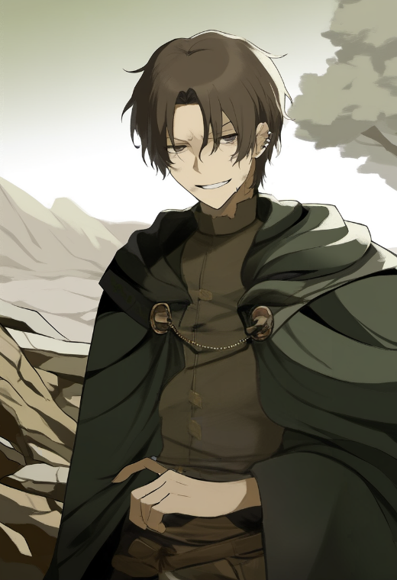
With every step, the air grew heavier. The sound of their footsteps felt too loud, and the distant rustling from somewhere deep within made them tense.
— The faster we search this place, the less time we spend here, — said Gilbert in a steady voice.
Crane walked at the rear, silent, as if lost in thought. Yet his eyes shifted constantly, scanning the walls, the ceiling, every uneven surface in their path.
When they entered a large chamber, Crane noticed what the others had missed. On the far wall, partially hidden behind collapsed stones, was the outline of a concealed door. Only a faint glimmer of light, reflected off polished stone, revealed its presence.
Crane paused, narrowing his eyes, the corner of his lips curling into a barely visible smirk.
"This is what my source was talking about," he realized, a surge of excitement rushing through him.
The door was nearly impossible to spot without a trained eye. A soft shimmer of magical markings, worn nearly to nothing with age, betrayed its secret. No one else in the group had noticed — Martan was busy examining another tunnel, Amara idly played with her daggers, and Gilbert watched the ceiling with tense suspicion, as if expecting danger.
Crane quickly looked away, pretending to study the stonework.
"If I tell them about the door, I'll have to split the loot," he mused. "But if I get inside alone… all the treasure will be mine."
He stood there, as if admiring the patterns in the stone, but determination burned in his eyes. "I just need to pull this off quietly."
…
Crane rose quietly, careful not to make a sound. Amara, keeping watch with her usual calm, had already relaxed, her eyes half-closed. Her strong fingers, once tightly gripping her sword’s hilt, had loosened, and her breathing had grown steady. The others slept nearby—Martan snored softly, while Gilbert occasionally stirred, as if replaying spells in his dreams.
"Good, just how it should be," Crane noted. "No one will notice a thing."
He carefully pulled his cloak around himself and moved toward one of the side tunnels. After a few steps, he froze, listening. Only the drip of water and a faint rustle, like something small scurrying over the stones.
— Toilet, — he muttered under his breath, just in case someone woke up and wondered where he was sneaking off to.
But his mind was on a completely different plan. He needed to check if he had truly seen a hidden door behind the far wall—or if it had just been a trick of the light and his imagination.
In the cave's darkness, everything looked different. The shadows deepened, turning the rocky outcroppings into shapes like snarling beasts. The uneven stone floor made Crane stumble more than once, though he quickly regained balance each time.
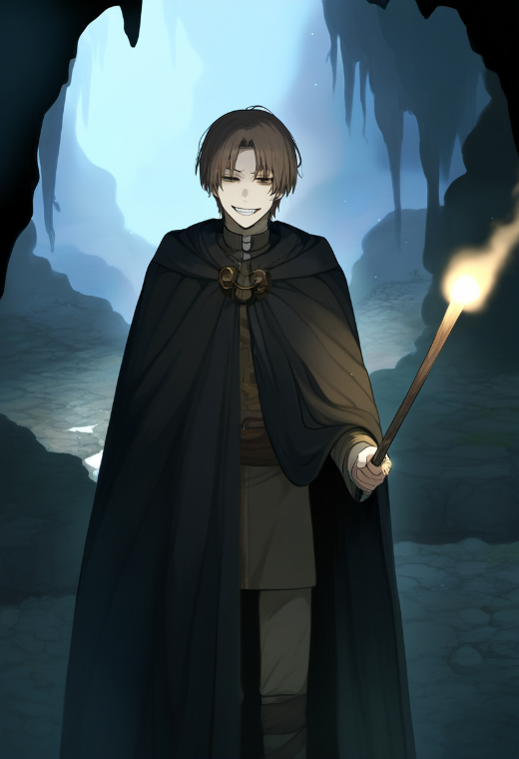
At last, he reached the same chamber. Now, silence ruled here, broken only by the soft plinking of water droplets echoing as they struck a small puddle nearby. Crane halted halfway to where the hidden door should be and froze, catching a flicker of movement from the corner of his eye.
Something shifted on the far side of the hall. Barely visible. Like a shadow passing where no shadow should be.
Crane tensed, drawing a small knife from beneath his cloak.
— Who's there? — he asked quietly.
No answer. Only the soft sound of something scraping far off in the dark.
"Someone else?" he wondered, narrowing his eyes.
For a brief moment, he regretted coming alone. But the thought of the treasure behind that door quickly drowned out his unease. If it really was another adventurer, they'd only complicate things. Crane decided to follow the sound.
Moving deeper into the tunnel, Crane scanned the dark corners carefully. No sign of anything unusual—just old stalactites, slimy moss clinging to the walls, and endless dampness seeping into his bones. Everything felt abandoned and lifeless.
Then he heard it. Closer this time. Movement. Footsteps—or more like a dragging sound over stone.
Crane cautiously peeked around a rocky outcrop, keeping to the shadows.
In the faint torchlight, he spotted a figure sitting against the wall, as if resting. A heavy cloak draped over their shoulders, concealing most of their body. Crane noted how the folds of the fabric seemed to billow strangely, as though the person had clumsily wrapped themselves in too large a garment.
"Idiot. Came here alone," Crane thought, and in that moment, an idea struck him. What seemed like a brilliant idea.
His hand slipped to his belt, where a pouch of "trinkets and junk" hung—what he called his collection of odd trophies and tools. Fingers brushed against old coins, amulets, dried herbs… until they found smooth metal.
The ring.
The one he never told anyone about.
Crane slid it onto his finger, savoring the moment as his grin widened even further.
— Ha, your big moment has finally come, buddy, — he thought, wagging his finger and admiring the recently "honestly" stolen ring. Just a couple of weeks ago, he had swiped it from a drunk mage in a shabby tavern, where the man had been bragging about the ancient artifact. "It's not just a trinket, it swaps bodies! Poof — and you're someone else!" the mage had babbled, nearly falling off his chair. Crane had waited until the mage fully passed out, then deftly pulled the ring from the pocket of his stained cloak. The mage snored softly, barely stirring, completely unaware of the theft.
Crane hadn’t tested the artifact back then, deciding to save that moment in case the ring ever came in handy. Now, as he watched the weary traveler by the wall, he felt a surge of excitement. "Poof — and you're someone else," he mentally repeated the mage’s words, hoping the man hadn’t been lying. After all, risking it for treasure was worth it.
His gaze and thoughts shifted back to the stranger, who seemed preoccupied. The figure by the wall wasn’t just sitting idly — the cloak shifted slightly, as if the person was examining something or holding an object underneath. Long fingers occasionally flickered in the dim light, adjusting the fabric.
"Is he hiding something? I wonder what," Crane thought, narrowing his eyes. His excitement was reaching its peak. If this traveler had something valuable, the body-swap plan would be even better than expected. But he didn’t want to waste any more precious time — he would swap bodies with the stranger, take everything from the treasure stash, hide it somewhere safe, then return here and switch back. After some time passed, he’d return to the hiding spot and claim the loot.
The plan seemed flawless. Even if his crew woke up, they’d just see Crane sleeping while he was actually elsewhere. And when the time came to switch back, he’d sneak up on his own body and reverse the swap.
He felt for the tiny vial of sleeping potion on his belt. "For emergencies," the alchemist had called it when Crane bought it. No emergencies had occurred yet, but now the potion felt like the perfect addition to his plan. Carefully, he unscrewed the lid and took a small sip, feeling the bitter liquid burn faintly down his throat.
"I'll return to my body and just say I fell asleep or stepped on a sleep mushroom," he thought, focusing on the silhouette as he carefully lowered himself onto the cold cave floor, leaning back against the wall.
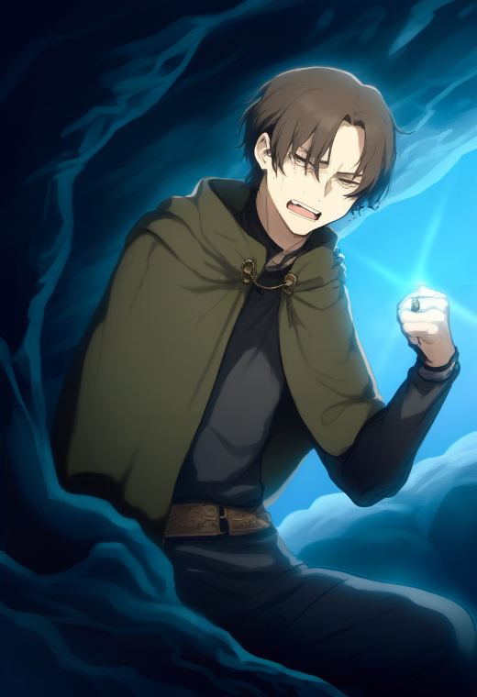
Crane felt the world begin to blur. His vision swam, his fingers tingled, losing their sensitivity, but the ring on his hand still glowed faintly. He squinted, trying to focus on the figure ahead.
— Come on... — he muttered, feeling his body weaken, refusing to obey.
But nothing happened. His limbs grew heavier. The sleeping potion worked faster than he’d expected.
— No, no, not now, — Crane whispered, straining to stay conscious. He clutched the ring tighter, nearly panicked. — Come on... activation... magic, poof, work, you damned thing!
But again, nothing. Gritting his teeth, Crane barely held back his frustration.
— Fine, if that's how it is... Swap! Swap bodies!
He focused all his willpower on a single thought: replace, exchange, switch.
Suddenly, the world spun violently. The ring flared with a bright blue light, and Crane felt his very soul being forcefully ejected from his body in a powerful surge.
Crane felt his consciousness plunge into emptiness. He seemed to be falling, yet there was no body, only the sensation of rapid movement. His head spun, and all that remained was the strange, rushing sensation.
...
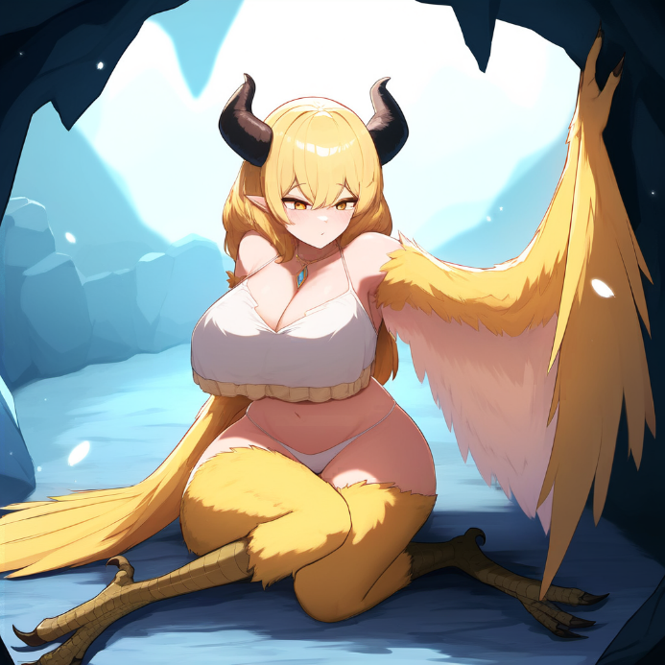
Then everything suddenly stopped. The heaviness returned, but it felt completely different. Crane came to his senses, feeling the cold stone pressing against his back. His body felt foreign, and he noticed it right away. "Did it work?" flashed through his mind, but he was immediately distracted by his chest, awkwardly pulling him downward, unusually heavy, as if bags of sand had been tied to his chest.
— What the... — a hoarse, yet still high-pitched voice escaped his throat. He blinked, listening to his own voice, and his eyes widened. That squeaky sound made him wince at the unexpectedly high pitch.
— God, did I just say that? — he swallowed hard, bringing his hand to his throat but immediately froze, feeling something massive and full beneath his chest, which now seemed to have a life of its own. His breath caught. He felt something soft brush against the smooth skin of his chest, creating a strange contrast of sensations, as if his hand was wrapped in a furry glove. When his fingertips slid further, he felt a slight prick of something sharp, as if the edges of his fingers were no longer blunt but had become pointed.
"Is this... my chest?! It's bigger than my head!" flashed through his mind before he threw his gaze toward the light coming from around the corner, where he had been just before the body swap.
He tried to get up, but the movement felt difficult. The weight of his chest seemed to pull him toward the ground, dragging him down with every awkward motion. The large breasts weighed on his body — the heaviness was overwhelming, swaying uncomfortably with every attempt to shift. He barely managed to get to his feet when a strange sensation hit his hips and buttocks: they, too, felt foreign, noticeably shifting with each step, as if they had become much larger.
— What the hell... — escaped his lips again, his voice still too high and raspy.
When he took his first step, his new legs clumsily scraped against the stone floor. Crane lost his balance but reflexively threw his arms forward to steady himself… and immediately felt something wide and soft brush against his back and sides. These strange extensions from his arms moved on their own, touching his skin as if they had a life of their own.
"Is this some weird chick dressed in a ridiculous costume?" he thought, struggling to process what was happening. Yet something was clearly wrong.
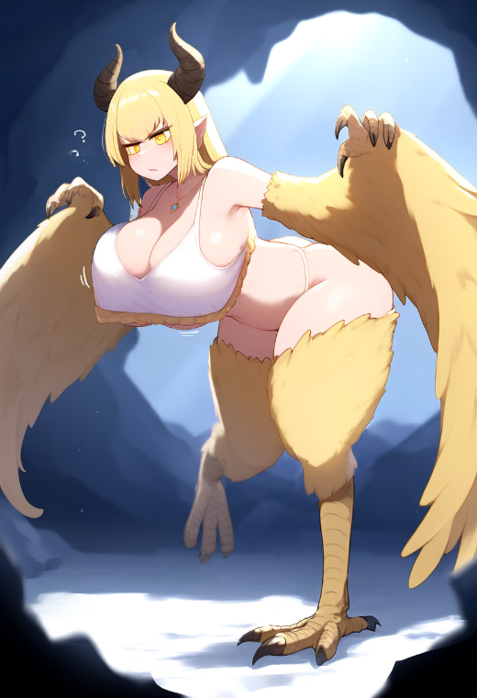
Every step echoed with the weight in his chest, which swayed as if it had its own mind. "God, how the hell do you even move with these…" he muttered, feeling the soft heaviness threatening to pull him forward. His hips and butt — far larger than he was remotely comfortable with — shifted unpleasantly, dragging his center of gravity and making him sway awkwardly with each motion.
— What the hell is wrong with my legs? — he whispered, lowering his gaze. But the darkness made it hard to make out the sharp claws where his feet should have been, resembling bird talons. They scraped the stone with a harsh, unpleasant sound each time he moved. Their shape felt entirely unsuited for a human body. He tried to stand upright, but his center of gravity had shifted to his lower belly and hips. He had to bend slightly forward just to avoid toppling over.
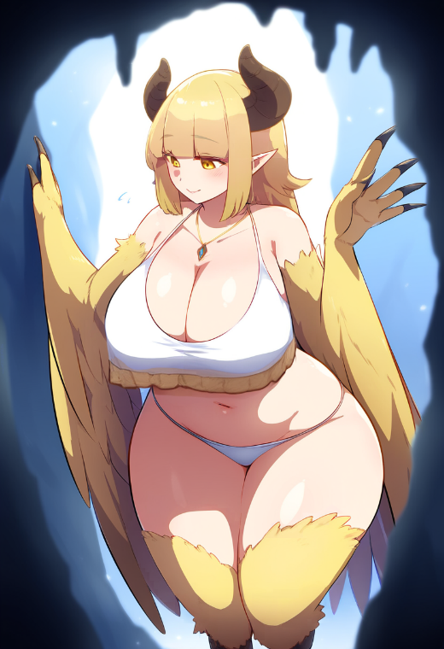
At last, shuffling forward and making strange noises as his claws scratched the stone, he stumbled ahead, hunched in an awkward posture. The heavy wings of this "costume," as he still thought, hindered his movement, brushing against the walls and creating a constant, unpleasant rustling. He had to lift them slightly with his hands to keep them from dragging, but that only added to his clumsiness. The weight of his chest kept pulling his body off balance, and his now uncomfortably large, rounded buttocks swayed noticeably with each step, throwing him further off rhythm.
"This is the worst thing that could've happened!" he cursed inwardly, trying not to think about how ridiculous he must look right now.
Finally, a dim torchlight flickered ahead, and Crane felt a tight breath escape his chest. He quickened his pace, stumbling but desperate to move faster.
As he drew closer, he finally saw himself — and the thought flashed through his mind how strange it was to see his own body from the outside. His old body still lay slumped against the wall, motionless, faint shadows lingering under his eyes from exhaustion. Its face was relaxed, as if it were enjoying the best sleep of its life.
— There you are, — he exhaled, feeling the tension in his chest ease slightly as a smile appeared on his face.
However, his smile quickly faded when he looked down. His legs—or rather, talons—were now clearly visible in the torchlight. Their grotesque appearance made his stomach tighten. The legs, or more precisely, the talons, were now distinct in the dim light of the torch burning beside Crane's sleeping body. These talons, covered in rough, scaly skin, resembled the feet of a predatory bird. They looked so unnatural that his stomach twisted in disgust.
— What a ridiculous costume... — he muttered, averting his gaze, as if unwilling to keep looking at himself.
He stopped and lowered his gaze further to inspect his new body. Massive breasts, barely contained by a top, swayed heavily with each movement. They looked absurd, as if they had a life of their own, their weight making itself known with every step. Crane couldn't tear his eyes away, both astonished and disgustingly embarrassed.
— They're enormous, — he forced out, his voice sounding almost like a pitiful whimper, too high and soft to be taken seriously.
He raised his hands, trying to calm himself, but instead of his usual fingers, he saw strange talons resembling a mix of bird claws and human hands, covered in golden feathers. His palms felt soft to the touch but were marked by small, sharp bone growths. Attached to them were enormous wings, trembling gently with every movement. The feathers, thick and golden, seemed both soft and alien. Crane felt them shift on their own, as if responding to his emotions.
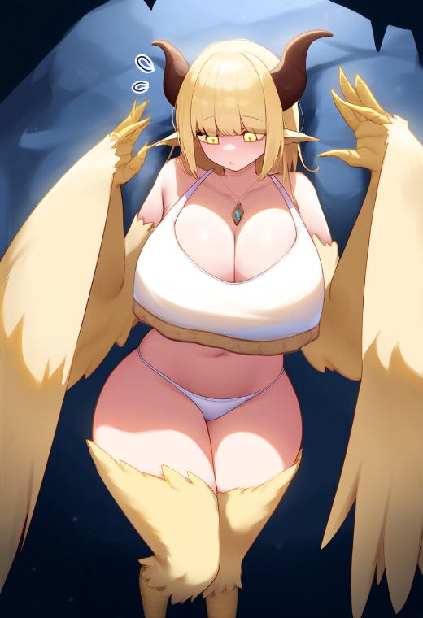
When he tried to raise his hands higher, the wings flared out behind him, striking the cave wall with a loud thud. And then it all clicked!
— What... the hell is this?! — he choked, staring at his new limbs. — I... — his voice caught in his throat, nearly making him cough before he managed to force out the words. — I'm in the body of a disgusting harpy?! — he shouted, his voice echoing against the stone walls.
He immediately clamped his wing-hand over his mouth, realizing he might have just woken his team.
— No-no-no! This can't be true! — He swallowed nervously and stepped back, stumbling over a stone. — A harpy?! What the hell is she doing in this damned cave? They’re supposed to live in the mountains, not here!
Crane pressed himself against the wall, his new claws quietly scratching the stone as he tried to catch his breath. His thoughts fluttered in his head like birds trapped in a cage.
"Damn it, fucking harpy. Going back to my body now is not an option," he thought, clutching his breasts with his claws as if trying to hold it in place. "If that beast wakes up in her body again, my sleeping self will be a perfect target. She’ll kill me without blinking. And if my team finds me like this… It's over. They won't bother figuring out why I look like a monster."
Suddenly, a faint rustle sounded behind him. Crane tensed, turning around. Footsteps? Or just some noise? There was no time to figure it out.
"Shit! Are they waking up?!"
He imagined Amara or, even worse, Marten with his damn hammer, walking into this tunnel and finding him. Even if he tried to explain… How could he? His body was right there against the wall, peacefully asleep. And now he looked like a grotesque creature with a chest bigger than he'd ever seen.
"I can't let them see me!"
Crane backed away frantically, pressing himself against the wall. His claws scraped the stone nervously, producing an unpleasant sound. Panic pounded in his head like a war drum. His new body barely obeyed him, awkward and unfamiliar. Struggling to keep his balance, he braced his winged hand against the wall, but it suddenly gave way slightly under his weight. A dull click echoed in the cave's silence.
— What?.. — Crane barely whispered, but before he could grasp what was happening, the wall began to turn, like a hidden panel. The cave around him froze, and then everything suddenly shifted.
— Hey! — he shouted, unable to jump aside in time. The rotating panel caught his body, like a giant playing with a rag doll, and literally flung him outside.
— Damn it, — he muttered, looking around. The stars shimmered high above, but the sight brought no comfort. Stone cliffs stretched upward, and somewhere in the distance, the wind howled, sounding almost like a moan. Crane swallowed, feeling the cold creep under the strange outfit—if it could even be called that. Smooth skin with a light layer of feathers barely shielded him from the chill, and the heavy wings only added to the discomfort.
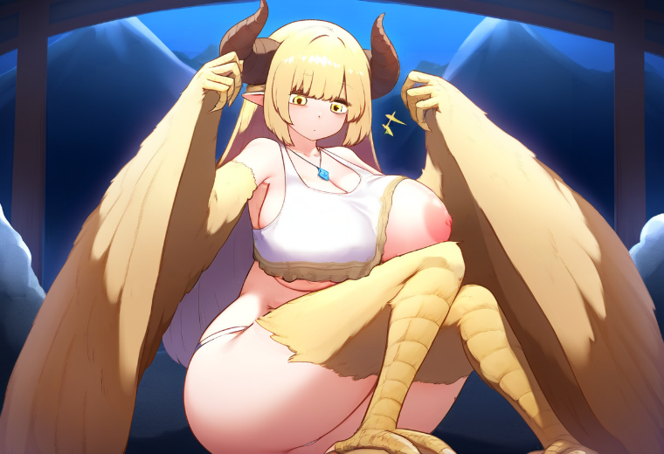
— Alright, screw it, I’ll figure this out. — He ran his wing-hand over his forehead but stopped abruptly when he felt the strange claws. — I need to get back.
Crane lay on the grass covering the rocky ledge at the mouth of the cave, breathing heavily and trying to recover from the sudden ejection from the wall. Slowly, he propped himself up on his elbows, feeling a new, unfamiliar heaviness pulling his chest downward. The movement made his body sway slightly, and a grimace of disgust crossed his face.
— If this is a dream, it’s a stupid one, — Crane muttered, struggling to stand. His new legs—clawed and alien—clumsily pressed into the grass, slightly scratching it with their sharp tips.
Looking around, he saw he was on a high ledge. Below stretched a valley, shrouded in nighttime darkness. The chance of anyone wandering here by accident was close to zero, yet the thought of possibly encountering people only intensified his anxiety.
“If anyone sees me like this, it’s over,” he thought, absentmindedly adjusting his ridiculous "clothing," which looked more like scraps. “Monster hunters don’t check IDs. They’ll see claws, feathers, and a boobs the size of two heads, and it'll be pitchforks on sight.”
He snorted, raising his wing-hand to scratch his head—then noticed one of his massive boobs had popped out of the narrow top. Crane froze, quickly glanced around, even though he knew perfectly well there was no one there, and hastily adjusted his "clothing."
— Oh gods, — he whispered under his breath, feeling a strange heat flood his face. — Of all things, I didn’t expect to... get embarrassed by my... these... huge things! — He squirmed, trying to tug the top back into place and muttered, — Who the hell even wears something like this? How many times did I tell myself: "Stay out of magic stuff!" But nooo, had to get clever. And now where am I? Half-naked, with chicken legs and these... damn pillows for a chest!
Running through all the options in his mind, he turned again to the spot where he’d been ejected from. The panel that had spat him out was completely invisible now, as if it had been part of the mountain all along. Taking a step forward, he felt his clawed foot catch on something in the grass. He tried to keep his balance, but the unfamiliar center of gravity played a cruel trick on him.
The next moment, Crane toppled forward, landing with a loud smack on his chest.
— Ow-ow-ow! — he yelped as his chest painfully hit the ground, his rear end sticking up in a comically awkward pose. His feathers were slightly ruffled, and hissing from the pain, Crane froze, feeling his strength drain for a moment.
Crane was breathing heavily, lying face down on the grass, struggling to catch his breath after the humiliating fall. His chest ached from the impact, and every attempt to move only brought a bitter smirk at his own clumsy state.
— Well then, — he muttered under his breath, carefully trying to rise on his clawed feet. — Feather-boobs, huh. The important thing is not to forget to mention my brilliance in overcoming all obstacles… if I even make it out of here.
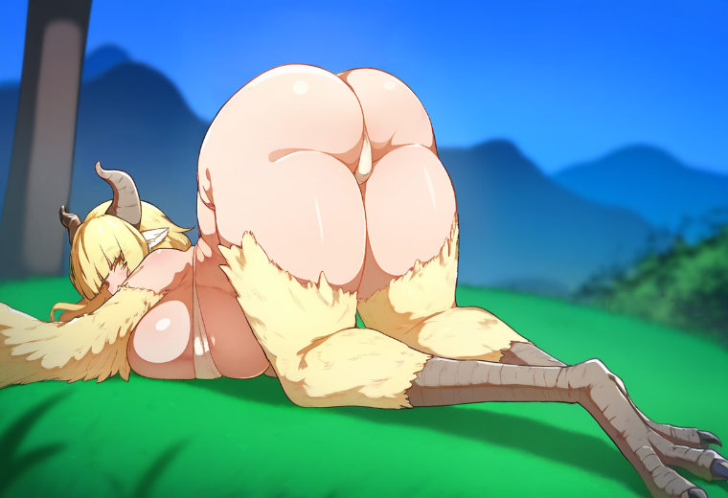
Before he could recover, a dull thud sounded behind him. Heavy wings sliced through the air with a sharp whoosh, and something massive, graceful like a predator, landed smoothly on the rocks at his back. Crane felt his heart drop somewhere deep — to his new bird-like heels.
— So, I've found you. — A calm, arrogant, and at the same time melodic yet mocking female voice rang out. The voice belonged to another harpy, but its threat was unmistakable.
"Alright, stay calm," Crane thought. "If it’s another harpy, I need to… What? Play along? Run? Pretend I’m one of them? Oh, sure. Just try to play along… Yeah, right. I’m just a harpy, with huge… those… Uh-huh. Brilliant plan, Crane."
He took a deep breath and, still lying in the ridiculous pose, slowly turned his head to see who was in front of him.
On the rock, narrowing her golden eyes slightly, stood a harpy. Her tall, imposing figure, crowned with large horns, shimmered in the moonlight. Black wings with a metallic sheen were folded predatorily behind her back, long talons tapping the stone nervously, while her sharp, almost sculpted features showed a mix of irritation and amusement.
— So, — he began, forcing a strained smile. — You’ve found me, good job. Now… my turn to seek?
The harpy tilted her head slowly, as if surprised by his words. Her golden eyes gleamed, and a predatory smirk curled at the corner of her lips. Then she let out a soft huff, folding her wings and crossing her clawed arms under her rather impressive chest. Her piercing gaze studied Crane with obvious doubt.
— Are you kidding me? — she asked, arching her brow mockingly. — Not only did you run away, but you also took the sacred amulet of the Mother of the Nest. Do you think this is some kind of game?
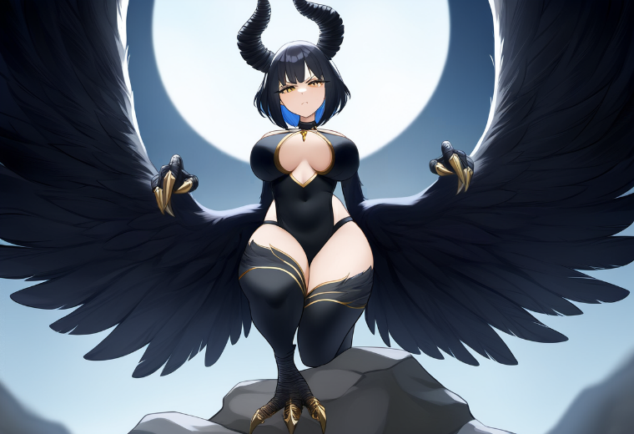
Crane blinked, trying to process what he had just heard. "Amulet? What mother?!" — the thought raced feverishly through his mind. He lowered his gaze to his chest and immediately realized the reason for her anger was hanging right there. A small yet clearly magical pendant dangled from a thin chain.
— Uh… This one? — Crane lifted the amulet with an awkward smile, trying to appear as casual as possible, as if he couldn’t care less. His new wing-arm twitched, and the feathers trembled, betraying his tension. — You can have it. I don't need it.
The harpy froze, staring at him intently. Her predatory smile slowly faded, giving way to an expression of irritated confusion.
— You think you can get away that easily? — the harpy hissed, her golden eyes flashing like lightning against a stormy sky. — Every nest is looking for you, Zephalina!
"Zephalina? What a name! Heh, now I know what this body's called," Crane thought with sarcasm, raising the amulet slightly higher so the harpy could see it better.
— Look, this is all a misunderstanding, — he started with a strained smile, like an old friend trying to explain why he hadn't paid back a debt. — If you want this… this thing, you can take it. I don't need it at all. Honestly, I don't even know how it ended up around my neck. I probably just found it… uh… lying around? — He felt his new face twist into something between a pathetic smile and an awkward grimace.
He began fumbling clumsily with his wing, trying to grab the chain. His claws, curved and long, kept slipping, making the task impossible.
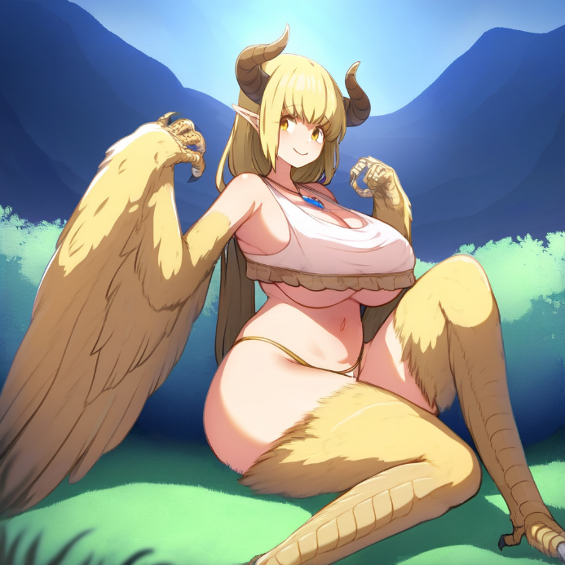
— Maybe you could help… — he muttered, still struggling to remove the chain. — These… new fingers… Damn… How do you even manage to do anything with them? — Crane finally tangled himself in his own wings, which twitched awkwardly, ruffling feathers and scratching the amulet. — This feels more like torture than hands!
The harpy standing opposite snorted, her eyes flashing with obvious disdain. She stepped closer, folding her black wings behind her back.
— Shut up, — she snapped, her wings twitching nervously. — I'm sick of your whining. You're flying ahead to the castle. I'll be right behind you. — She pointed a claw toward the cliff's edge, where darkness shimmered beyond.
"Castle? What the hell is she talking about? Since when do dumb harpies have castles? All they do is sit in nests, hatching chicks," Crane thought sarcastically but tried to keep his face a blend of submission and innocent confusion.
— Oh, right… a castle. Maybe we can grab a couple of crowns and a golden throne while we're at it? — Crane chuckled, shifting his weight from one taloned foot to the other, trying to look as relaxed as possible. — What’s next? A library and a wine cellar too?
The harpy tensed, her golden eyes narrowing. She took another step forward, her wings flaring threateningly.
— Enough nonsense, — the black-feathered harpy cut him off, snapping her wings with such force that the gust ruffled Crane's feathers. — Stop acting like a fool, Zephalina. Fly to the castle. Now.
Crane gritted his teeth, trying to hide his irritation. "I need to stay here until this harpy in my body wakes up without me and messes everything up!"
— Fine, fine! You win. You're so terrifying and serious, I'm scared just thinking of defying you, — Crane muttered, aiming for a mix of submission and exhaustion. He lifted his wings slightly, as if in surrender, and after a deep breath added, — I swear, I'll catch up later. Just give me a moment. I need to… you know, pull myself together. Breathe in, breathe out. I can’t show up at the castle all ruffled like this. It's a disgrace to all harpies.
— I'm done with your nonsense! — the harpy roared, her wings snapping open with such force that the wind nearly knocked Crane off his feet.
— Hey, hey, calm down! I’m just joking! — Crane stammered, backing away. — You know me, I always do this to, uh… break the tension!
But the harpy wasn’t listening. She stepped forward and grabbed his shoulders with her taloned hands.
— No! I've had enough of this! — she hissed, and before Crane could respond, her wings flapped powerfully, lifting them both into the air.
— A-A-A-AH! Let me go! — Crane screamed, his new voice sharp like a whistle. He thrashed, struggling to break free, but the harpy held him in an iron grip. — A-A-A-AH! Too high, damn it! God, I'm scared of heights!
— What?! — the harpy shouted sharply, still flapping her powerful wings, rising higher and higher. Her face twisted with a mix of anger and disbelief. — You're afraid of heights? You're a harpy! What kind of nonsense is this?!
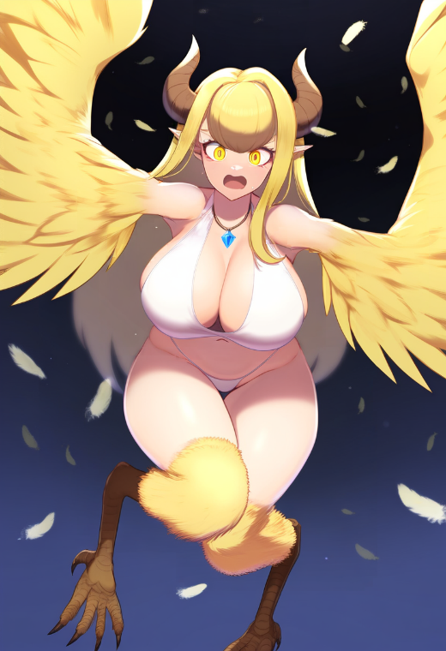
— A-A-A-AH! Damn, damn, damn! — Crane kept screaming hysterically in his shrill voice, not hearing her, his talons flailing wildly in the air. The wind whipped against his face, and he felt his new wings flutter helplessly in the gusts.
— Shut up already! — the harpy barked, her patience wearing thin. She struggled to keep hold of him, but his shrieks echoed across the night sky, filling her with indescribable rage. — Zephalina, I'm warning you! If you don't shut your mouth right now, I’ll drop you!
— Then just do it! You're not gon—A-A-A-AH! — Crane started, but his voice broke into a fresh wave of panic as the harpy loosened her grip.
— As you wish, — she muttered coldly and let go, tossing him like a sack of rocks.
Crane felt his body plunge downward. The wind roared around him, and the ground rushed closer with terrifying speed.
— Oh no, no, no! — he screamed, flapping his wings frantically. But his movements were so chaotic he looked more like a ragdoll in freefall. His wings kept folding and flapping out of sync, offering no control whatsoever.
— So now you’ve forgotten how to fly too?! — the harpy called out from above, watching as Crane struggled desperately to stabilize. — Perfect, Zephalina! Just perfect!
Crane wasn’t listening anymore. The wind howled in his ears, the cliffs and trees spinning wildly, growing closer with every heartbeat. He tried once more to flap his wings, but instead, his body spiraled into a clumsy tailspin.
— This is it! I’m dead! — he thought, panic flooding his mind as his strength faded.
A second. Another. Then everything crashed.
His body slammed into the rocky mountainside with a dull thud, pain exploding from his back to the tips of his talons. His wings twisted at unnatural angles as the ground seemed to vanish beneath him. He tumbled violently down the steep slope, smashing against rocks and branches. Lightning bolts of pain shot through his skull, blinding white stars bursting before his eyes.
The world spun faster—then suddenly stopped.
For a heartbeat, he could hear nothing but the pounding of his heart in his ears. Then even that sound faded, swallowed by silence.
Darkness closed in, and Crane lost all sense of reality.
…
Crane groaned, half-opening his eyes. The gentle touch of soft grass against his back was soothing, yet his head still rang with the hum of the fall. The world before his eyes slowly came into focus: a slice of blue sky with a rising sun, sparse clouds, and tall walls cutting into the horizon with sharp battlements. The air was fresh, carrying a faint scent of damp earth and feathers.
— What the hell kind of dream is this, — he muttered, covering his eyes with his hand and twisting his lips into a crooked smile. — Swapped bodies with some busty... — He fell silent, suddenly realizing the weight on his chest. His hand instinctively slid down from his face, fingers awkwardly brushing against something soft and firm.
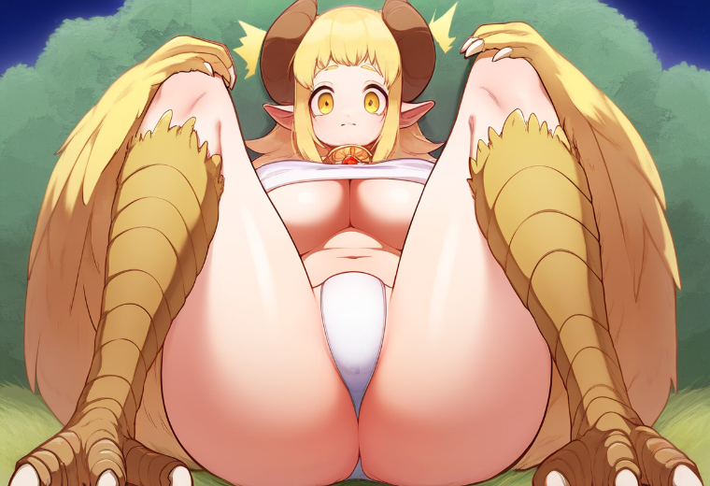
— ...harpy, — he finished the sentence. His hand remained in place, exploring by touch what definitely shouldn't be there. — No, no, no... — His voice trembled as he lifted his head slightly to look down. — Is that... a breast? — he whispered, as if fearing that speaking the words aloud would make them real and not just a trick of his imagination.
The heavy breasts left no doubt. It faintly shifted with every breath he took. Crane shook his head, only to immediately hit something hard against the ground. Sharp pain echoed through his skull, and sparks danced before his eyes.
— Damn it, what now? — he groaned, rubbing his forehead. But as his fingers touched something long, hard, and smooth, he froze. — These... horns?! — Crane shook his head again, but once more felt the strange protrusions scrape the ground, tugging uncomfortably at the skin on his scalp. — I have horns?
— So it’s all real?! — Crane hissed, feeling his tits tremble again with a deep breath. His face twisted with horror, slowly melting into anger and panic. His gaze, filled with worry and barely concealed hope, dropped downward. At that moment, he quickly reached down with a clawed hand to where his manhood should be.
— Oh no... — he groaned, discovering nothing where the most important part was supposed to be. His clawed hand froze in terror over the flat space between his legs. Crane swallowed hard, barely daring to breathe.
He lifted his eyes, chest heaving, feeling cold sweat roll down his spine. Right in front of him, like a predatory shadow, stood a harpy with black wings. She looked down at him, her golden eyes gleaming and a cruel, mocking smirk playing on her lips.
— Well, well, Zephalina, — her voice was melodic, yet every word dripped with hidden venom. — Is this really how proper harpies spend their mornings?
Crane froze, not understanding what she was talking about, but feeling his face flush hot. He jerked his hand away from his breasts, trying not to betray his embarrassment.
— What do you want from me? — he grumbled, struggling to maintain some semblance of composure. His new voice, high and raspy, sounded pitiful, more like a lost lamb than a fearsome harpy.
The harpy narrowed her eyes, her clawed hand making a slow gesture toward a door leading into the mountain fortress.
— Nothing special, sister, — she purred with false sweetness. — We're just taking you to your chambers. It's time you remembered your duties. After all, the new mother of the nest carries great responsibility.
Crane tensed, trying to catch anything in her words that might help him understand what she was talking about. "Mother of the nest? Chambers? What other duties?" he frantically wondered, feeling his heart pounding faster.
The harpy continued without waiting for his answer:
— And don't worry, you'll have plenty of time and... pleasures. Though, of course, it's better to enjoy that in private, not here on the grass for everyone to see. — Her lips curled into a predatory smile.
Crane blinked rapidly, struggling to grasp what she meant. "Pleasures? Is she hinting at some kind of rest? Or... what does she mean? Ugh, enough of this harpy nonsense. I wonder how far this place is from my body? Will I get back before that creature wakes up in it? Or... no. There's no way she's already awake. I'm sure she's just as shocked as I am. If harpies can even feel shock. Their brains are the size of a walnut, right?"
— Will I be able to stay alone in the chambers? — he asked quickly, trying to hide his true intentions.
The harpy let out a quiet chuckle, her gaze turning more disdainful.
— Of course, sweetheart, — she replied, stepping closer and grabbing Crane by his wing-arm. Her clawed fingers coldly gripped his forearm, helping him to his feet.
Crane flinched at the touch. The harpy's cold claws squeezed his new forearm, thinly skinned and covered with feathers, making him wince involuntarily. Every movement of this unfamiliar body felt awkward, as if he were wearing a poorly tailored costume that pinched in all the wrong places.
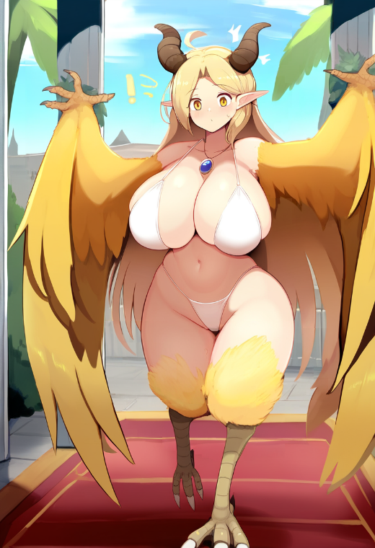
— Come on, get up, Zephalina, — the harpy mocked, giving him a slight push. — You've been unconscious for too long, though you finally shutting up back there was just perfect.
Crane tried to stand. His new clawed legs slipped on the grass, forcing him to balance on his toes like a tightrope walker on a strained wire. Every step took effort, and the heavy wings, which felt like useless weights, threatened to pull him backward. He shrugged his shoulders, trying to shake off the tension, and heard his feathers rustle with an irritating sound.
— Lucky me, — he muttered under his breath, finally standing upright and trying not to stumble too much. Each step sent waves of discomfort through his body. The heaviness in his chest shifted with every movement, as if it had a life of its own. Every step came with a strange sway—unnatural, as if his body deliberately exaggerated each motion. His hips felt massive, unusually wide, which irritated him as much as the swaying breasts.
"Damn it," he thought, struggling to adjust his stride. "Why is everything so... huge?! Too much extra! Hips like a farm cow, boobs like it’s stuffed with the whole harvest. And the backside—ugh, I won't even start. It all... moves on its own, doesn't it?"
The harpy walked ahead, her movements fluid, almost graceful. She barely seemed to touch the ground, her black wings shifting only slightly, as if they were just part of her natural charisma. Crane grimaced, watching her.
"And why is she so confident and smug?" he thought as he stepped inside, barely keeping a mask of indifference on his face, though everything boiled inside him. The massive hall beyond the door was nothing like a primitive bird's lair filled with feathers and bones. It was a grand structure that instantly shattered Crane's expectations of harpies.
Towering columns wrapped in something like glowing vines stretched upward, where instead of a ceiling, a vast glass surface revealed the stars and the slowly brightening sky. The floor, made of polished stone so smooth it reflected the light, looked icy cold. The walls were adorned with gold and silver plates depicting scenes of harpies flying, fighting, and carrying something—or someone—in their talons. In the center of the hall, a massive mosaic shimmered brightly, depicting a giant wing folded in a noble gesture. Along the walls stood heavy wooden chests reinforced with metal bands, and in the distance, doors leading to other parts of the castle could be seen.
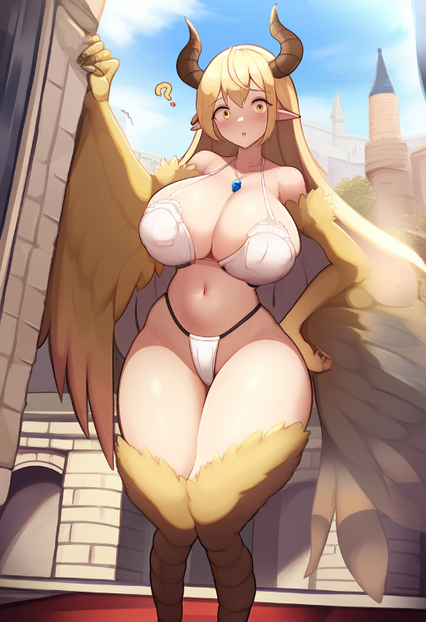
Crane came to an abrupt stop, nearly losing his balance, and froze for a moment. "This is... a palace!" flashed through his mind, immediately followed by another thought: "What the hell are these brainless chickens doing with a place like this?!" He scanned the hall, trying not to betray his shock, and took a deep breath. He could swear the air carried the scent of incense and something sweet, like a blend of honey and flowers.
— Why did you stop?! — the harpy snapped, turning around and glaring at him. — Move faster, I'm sick of dealing with you!
Crane jerked, struggling with the urge to snap back. "Patience, Crane. Patience like a monk. You'll get out of here as soon as you figure out what the hell is going on."
— I'm coming, — he muttered, trying to conceal his irritation. He clumsily shifted from one taloned foot to the other, following the harpy down the long corridor.
When they reached massive doors inlaid with pure gold feathers, she shoved them open with surprising ease. The doors groaned loudly as they swung back, and Crane stumbled inside with a yelp, nearly losing his balance. Behind him echoed loud laughter.
— You're so pathetic! — sneered the black-winged harpy, her laughter echoing through the vast hall, sounding more like harsh cawing. — I still can't believe someone like you is supposed to be our 'Mother of the Nest.' You disgrace our entire kind. Pathetic, pathetic girl, unworthy of royal blood.
Crane opened his mouth to respond, but the black harpy, slamming the door loudly, had already left, finally leaving him alone.
— Stupid hen. What is she even talking about, — Crane muttered, casting an angry glance at the closed doors. He listened closely, but the black-winged harpy seemed to have already left, leaving him alone in the vast room. The sound of her talons scraping against the stone floor had faded, and silence fell, broken only by his ragged breathing.
"Mother of the nest? Royal blood? I don't give a damn about your nests and blood! Put me back in my body, and I'll forget this nightmare ever happened!" he snarled mentally, cursing his fate while also marveling at the luxurious surroundings.
The room was stunning. High ceilings with intricately carved arches, massive columns adorned with delicate bas-reliefs depicting harpies, and wide windows that revealed an endless blue sky. At the center stood a huge mirror framed in golden spirals, as if sculpted by nature itself. Crane recoiled from it, trying to avoid looking at his reflection.
"No, thanks," he thought, turning away. "One glance at this body was enough. I've had it with these 'wings,' 'tits... breasts,' and that ridiculous ass that moves like it has a mind of its own."
He slowly paced the room, scowling as he examined everything around him. His attention was caught by stained glass panels on the walls, behind which a soft sunlight shimmered, casting a golden glow on the smooth stone floor. One of the panels depicted a majestic harpy with wings spread wide, a symbol of freedom, standing atop a mountain peak. Crane smirked.
— Why the hell does everything here feel so... like a real royal palace, — he muttered. His gaze settled on a large chest.
— Well, well... — Crane drawled, stepping closer as a spark of hope ignited in his mind.
The chest looked impressive: massive, reinforced with metal plates, with elaborate carvings along its edges. Strange symbols, possibly ancient harpy runes, were etched into its lid, which seemed to emit a faint, mysterious glow. This was way too fancy for ordinary monsters.
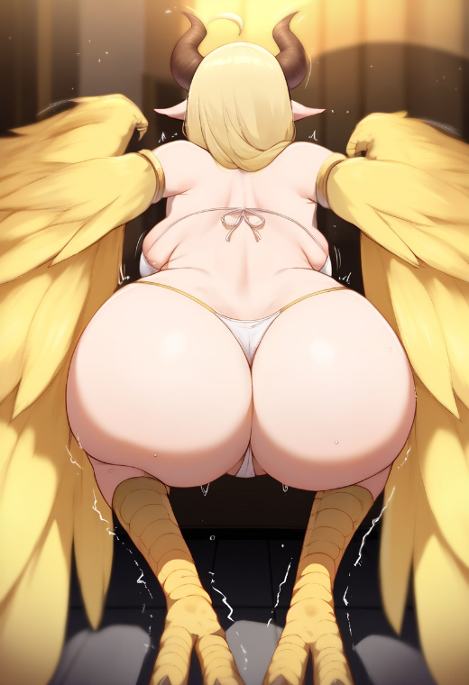
— Alright, old buddy, maybe this isn't such a bad deal after all, — he muttered. — A little gold, a few jewels... I'll leave this place richer than ever! Even if I have to haul around this... this body.
He leaned toward the chest. Tried to pull. Nothing. All that happened was his massive rear sticking out while his clawed legs bent slightly, starting to tremble from the effort. The lid didn't budge.
— Fine, no problem. Just a bit more effort... — he grunted, straining again, only to feel his muscles go limp. Its weight was unbelievable, and his new body was far weaker than he was used to. His wing-biceps trembled as if they were about to snap. He felt the awkward pull of his chest weighing him down, while his taloned feet slid on the floor, struggling for proper footing.
— Are you kidding me? — Crane hissed, brushing damp strands of hair from his forehead. — Why is this harpy such a weakling? Couldn't you have been just a little stronger?!
In the end, Crane twisted and let out a victorious wheeze, struggling to pry the lid halfway open, revealing the gleam of gold and precious stones inside. For a moment, Crane froze, staring at his "reward." Golden bracelets, necklaces with large gemstones, intricately carved crowns, and rolled fabric scrolls adorned with rubies.
— Well, would you look at that... — he whispered, gazing at the treasure. His face lit up with a broad grin. — These torments are finally starting to pay off. Just a bit more, and I'll be able to...
A sharp voice behind him interrupted his thoughts:
— What a magnificent sight, truly worthy of admiration! — a deep, velvety voice echoed from behind Crane, making him nearly jump. — Even from afar, I was already... stirred by the view of your royal... backside.
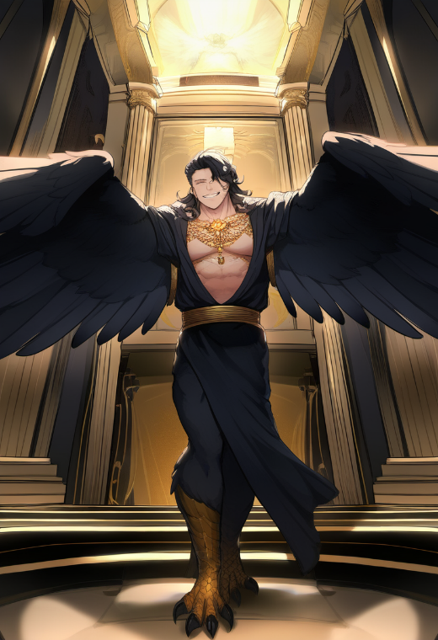
Startled, Crane released the chest lid, and it slammed shut with a loud bang, the echo sending a tremor through the entire room. He spun around sharply, his eyes darting toward the source of the voice.
A few steps away stood a tall harpy man. His figure was massive and muscular, with broad shoulders and powerful arms ending in clawed fingers. His wings, black with silvery streaks, spread out behind him, nearly brushing the walls. His face was angular, with a strong jawline. He was smiling, revealing perfectly white teeth — though the smile looked more like a smirk, carrying a certain hidden menace.
Crane stepped back, but the chest was behind him, leaving no room to retreat. His brain kicked into overdrive.
"This guy looks like he could crush me with a single claw," he thought, trying to stay calm. "Okay, stay cool, Crane. He's just another chicken with wings. A very... large chicken."
— Who the hell are you? — Crane snapped, trying to make his high-pitched, feminine voice sound as confident as possible. — And what do you want?
The harpy took a few steps forward, his taloned feet scraping dully against the stone floor. He leaned in closer, fixing Crane with his predatory gaze.
— What kind of stupid question is that, Zephalina? — the harpy man drawled with a smirk, moving even closer. His sharp eyes glinted with obvious anticipation, and his broad chest seemed to puff out deliberately, emphasizing his strength while blocking Crane's entire view. He was nearly a head taller than Crane now. — You know perfectly well why I'm here.
Crane tensed. A growing sense of unease tightened in his chest, but he kept his face straight. This massive "rooster" looked like he could smear him across the floor with a single swipe of his winged paw. But his usual cunning was already forming a plan: if this situation spiraled out of control, he'd need to act — and fast.
— Look, I was just... — Crane faltered, watching as the harpy man drew even closer. He loomed large, filling the entire space, his predatory grin widening as his golden eyes shimmered with a dangerous glow. Crane could feel his chest almost heaving under the man's heavy stare.
— You have no idea... how long I've waited for this, — the harpy man leaned in closer, his voice dropping lower, filled with a sensual menace. His eyes sparkled with predatory delight, and his broad grin revealed sharp teeth. — A royal body, a true mother of the nest... and all of it... mine.
19
Crane tensed, his mind frantically searching for a way out. His chest, massive and heavy, pulled forward uncomfortably, making it hard to focus, while the predatory man kept advancing, clearly not intending to back off.
"Calm down, Crane. You're an adventurer. A master of wriggling out of trouble," he tried to steady his panicked breathing. "This damn rooster thinks he's already won? Ha! He doesn't know who he's messing with yet!"
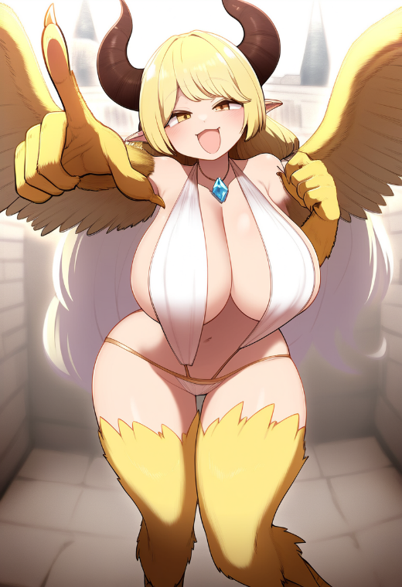
Crane smirked, trying to appear carefree, though inside he was boiling.
— If you want this body so badly... — he began, his voice trembling before he quickly pulled himself together. — Then it's yours!
His clawed hand shot forward, aiming at the man, grinning at the thought that struck him at that moment. He imagined the magical glow surrounding their bodies, their forms shifting — that pompous peacock trapped in Zephalina's body while Crane, now in the strong male harpy form, escaped to reclaim his freedom.
But nothing happened.
— What the... — Crane muttered, staring in shock at his outstretched clawed hand. Empty. No ring.
A flash of realization hit him — the image of his real body, still asleep somewhere in a cave, the ring still snugly on his finger.
"Damn it! The ring! It's on my real body!"
His smirk vanished instantly, eyes widening in shock. The harpy man grinned, noticing his confusion, and suddenly lunged forward, shoving Crane back against the massive chest. His clawed hands easily seized Crane's wings, pinning them up against the chest, completely immobilizing him.
— Oho, so you do want the same thing I do, Zephalina, — the man murmured with a smug grin. — Perfect. I like how... cooperative you are.
— Wait! You're getting this all wrong! — Crane squirmed, struggling to break free, but his new weak arms were no match for the harpy's iron grip. — Listen, I... Hey!
But the man wasn't listening. His taloned fingers abruptly yanked Zephalina's thin top upward, exposing her massive breasts, which bounced heavily, reminding Crane even more painfully of their presence. Crane froze, heat rushing to his face in burning humiliation. Those breasts, his new breasts, felt not just foreign but disgustingly degrading.
— Stop! — he shrieked, but his voice was swallowed as the harpy suddenly crashed his lips against his own.
A foreign tongue forced its way into his mouth, exploring aggressively while Crane let out a muffled, furious whimper. His eyes widened in shock as the harpy kissed him hard, possessively. Crane tried to push him away, but his feeble attempts were laughably ineffective. The harpy held his wings firmly, his massive body pressing Crane completely against the chest, leaving him no space to escape.
"This is the most disgusting moment of my entire life!"
Spluttering, Crane jerked his head away, coughing and spitting as if he'd just swallowed sour ale.
— Blegh! — he gagged, retching dramatically. — What the hell are you doing, you stupid chicken?! I've got news for you, big news! I'm not— Aaagh!
He didn't have time to finish — the massive, clawed hands of the male harpy easily grabbed him like a feather and, with a smooth motion, caught him by the hips, lifting his clawed legs upward, pressing them against his massive chest and carrying him somewhere. He felt his chest tighten under the pressure of his hips but couldn't even break free from that grip. His face flushed crimson with a mix of shame and anger.
— Listen, this is a misunderstanding! I'm not Zephalina at all! I'm... I'm a man! Got it? A man! — he shouted, writhing, but his newly weak muscles couldn't do anything against the harpy's strength.
The man smirked, holding Crane as if he weighed less than a feather.
— A man? — repeated the harpy, his brow arching in mocking disbelief. He stopped in front of a massive mirror, the one Crane hadn't even wanted to glance at when he entered, but now there was nowhere else for his gaze to go. A feminine figure with stunning wings, now hanging limply. His clawed legs firmly held by the man's hands at the hips, while his massive rear was now pushed forward.
— You must have fallen from a great height. Probably hit your head. That's why you're talking such nonsense. But don't worry, I'll help you come to your senses.
— Why did you lift me like that? You're not going to... — Crane, barely able to speak, tried to say something, but suddenly felt the hot and hard touch of the harpy's male dick slide between his legs.
— Zephylina, I want you to remember this moment. It's an honor to be your first, — said the harpy, his voice sounding both gentle and commanding.
— No! No-no-no! — Crane screamed, feeling the panic completely overwhelm him. He tried to break free, but every movement only emphasized his weakness in this body. — I'm telling you! I'm not Zephylina! I'm not... Aaaaa!
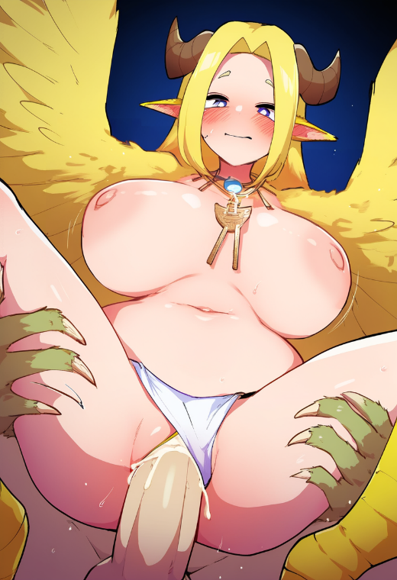
The harpy-man thrust into him sharply, and Crane felt something he was never supposed to experience in his life. His body seemed to respond to the intrusion on its own, triggering entirely new sensations he could not control. Shame and humiliation mixed with confusion, as if his body had become foreign, betraying him in the most disgusting way.
— Look, — the harpy whispered, moving his cock more and more frequently, forcing Crane to look into the mirror. — Look how beautiful you are. I want you to see this. It's not just an honor but our destiny. You will be a mother, Zephalina. You will give life to an entire new generation and will bear children until the end of your life, as befits the royal bloodline.
"Until the end of my life!?" — Crane's eyes widened, and his breath caught, but he was immediately overwhelmed by entirely different sensations, spreading in waves through his body. He tried to turn away from the mirror, but the harpy's massive hands held his hips firmly, not allowing him to move an inch. His heavy breasts swayed with each thrust of the harpy, and he felt how the member completely filled his newly formed female organ, meant for this purpose.
Crane felt his unfamiliar body betraying him, responding to every thrust with an unbearable mix of humiliation, pain, and a strange, uncontrollable pleasure. His new female body seemed to work against him, and there was nothing he could do to stop it. The final thrust, and he felt something hot and sticky fill him from within. The harpy let out a low, satisfied growl, holding Crane even tighter.
— Good, — he whispered, slowly pulling back and leaving him trembling and humiliated on the floor. — Now you will begin to bear your legacy.
...
In the dark, damp cave, Crane's body stirred faintly. Zephalina, inhabiting this body, slowly opened her eyes. The first thing she felt was an unusual lightness. There was no familiar heaviness of wings on her arms, no massive chest that always hindered her movements, and no sensation of long hair brushing against her skin. Her whole body felt... straight and compact.
She slowly raised her hand and froze, seeing long, sinewy fingers with short nails. Instead of soft, feather-covered skin, her fingers were rough, calloused, like someone who had often held a weapon or climbed rocks.
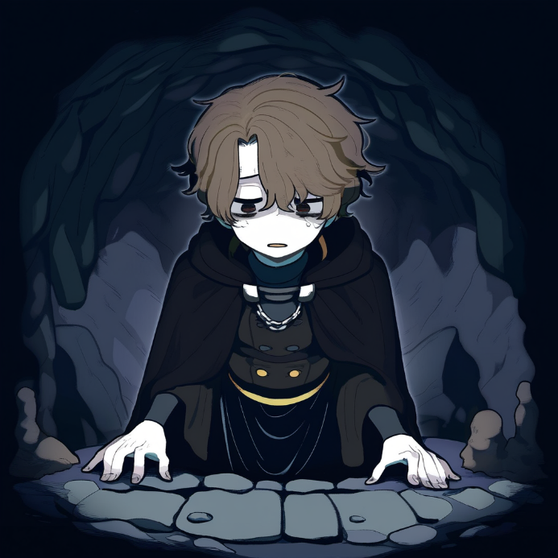
— What... is this? — she whispered. Her voice was low, husky, and completely unfamiliar. She sat up abruptly, feeling how her body no longer moved the way it once did. Her hips didn't sway, her chest didn't pull her forward, and even the lightness in her shoulders felt strange, almost magical.
She licked her lips, still not understanding what had happened. Images flashed before her eyes: how she had fled the castle, desperate to escape the unbearable "legacy and duties" that had so suddenly fallen upon her after the unexpected death of her beloved mother. How, clutching her mother's amulet, she had tried to hide in this cave, trembling with fear, remembering the cold stone floor beneath her... and then darkness. But now...
Zephalina rose, but on taking her first step, she nearly fell, unaccustomed to the weight of this new body. Yet instead of frustration, a faint smile lit her face.
— I'm... human? — she touched her face, tracing the strong jawline, the short hair, and the rough skin. Then, realizing, her hand shot down between her legs, feeling the unfamiliar organ there. — I'm a man? — she added, surprised.
The realization unsettled her for a brief moment, but it quickly faded. She still felt a trace of unease, yet it was drowned out by overwhelming relief and joy.
— Could it be? Have my prayers been answered? Though not... as I expected, but God, thank you for this! — she exclaimed, and her deep male voice echoed through the cave.
She didn't understand how or why, but she felt that her duty, that terrifying bond to the nest, was left behind. She had feared this moment her whole life — the day she would become the "mother of the nest." Since childhood, she had been told it was an honor, a great responsibility, but it had always felt like a gilded cage. To become the mother of an entire generation? No way! And now, she could be anyone. Live her life. Find freedom.
She laughed softly, nervously, but sincerely.
— Thank you for what, Crane? — came the clear, feminine voice of Amara, making Zephalina swallow hard.
She spun around sharply at Amara's voice, her new masculine forehead dampening with sweat. Reflexively, she wiped it, feeling the rough skin and short hair again.
'Crane? She's talking to me? So I am... him, and they're my new companions!' she thought.
— Uh... Thank you for... uh... being... Crane, yes, I'm Crane, — she blurted out with a strained smile. — And thank you for... all this! — She spread her arms as if gesturing at the cave and her companions. — For us being a team. And for... adventures! Who doesn't love adventures, right? I... love them!
Amara raised an eyebrow, eyeing her with mild confusion.
— Crane, are you sure you're okay? You're usually... well, sorry, but you're usually more cocky and never thank us. Especially not like this.
— Oh, that? — Zephalina tried to appear as relaxed as possible. — I just realized life is short. We should appreciate the moments more, you know? Here we are, traveling together, searching for treasures, facing dangers... Isn't that amazing?
Gilbert, standing slightly aside, watched her closely. His old eyes sparkled with curiosity.
— Hmm, you know, he's right, — he said, thoughtfully stroking his beard. — I like this attitude. Your optimism seems... genuine. And, I must admit, unexpected.
Marten smirked, crossing his arms over his chest.
— Oh, come on, — he huffed, his deep voice carrying a note of irritation, though something like approval flickered in his eyes. — Maybe our "friend" has finally grown up? Or just took a good hit to the head. Either way, I like this "new" Crane. Maybe he'll even be useful now.
Amara shook her head, still not entirely convinced but already softened.
— Alright, philosopher, — she said, squinting. — We thought you were ditching us when you disappeared last night, but it looks like you just hit your thick skull pretty hard, — Amara finished with a slight smirk. — Anyway, let's go eat. Marten nearly burned breakfast, but surprisingly, it smells decent.
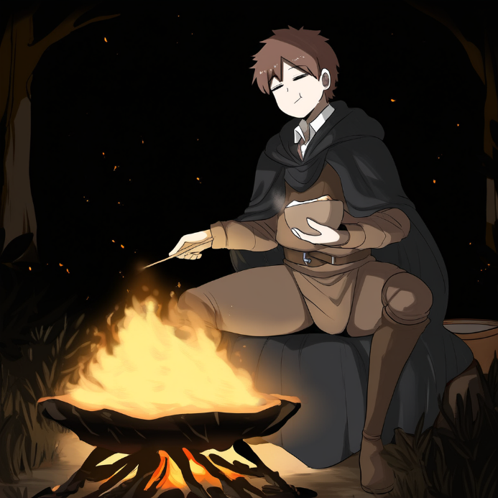
Zephalina froze for a moment, eyes wide open. Her stomach suddenly betrayed her with a loud growl. She had never eaten regular human food, sustaining herself either with magical energy or special grains from the nest that strengthened her bond with her kin.
— Gods, human food! I wonder what it tastes like? — Zephalina exclaimed with genuine excitement, not even realizing how strange it sounded.
Amara stopped and glanced back, narrowing her eyes.
— What? — she asked, clearly suspecting something was off.
— Oh, I mean... I... uhh... — she stammered, but was interrupted by Marten's loud laughter echoing through the cave, slightly deafening everyone.
— Oh, Crane, I don't know what's going on, but I like it! Alright, enough crowding here. Crane's back. Let's eat before I finish it all myself.
Amara, shaking her head, was the first to head toward their makeshift table. Gilbert gave a casual wave of his staff, nudging the sluggish Marten along.
— Hey, don't push! — he grumbled but followed her anyway.
Zephalina lingered for a moment, taking a deep breath as the tension within her slightly eased. "Human food... Well, let's see what I've been missing all my life," she thought with a faint smile, hurrying after the others.
…
Upon reaching the city, Zephalina felt relieved when the team finally scattered around town, tending to their own affairs. Amara had dragged Marten off to the blacksmith, insisting that his hammer needed urgent repairs, while Gilbert headed to the herbalist for ingredients for his potions. Zephalina was left alone, savoring the rare moment of quiet.
She strolled leisurely through the narrow streets, taking in the bustling life of the city. Bright shop signs, the aromas of food, the loud voices of merchants calling out to customers — all of it captivated her. She struggled to hold back a smile, feeling almost free.
However, as she glanced at the shop windows, Zephalina quickly realized that to buy anything, one needed "money." She had heard that word from the team while they were on their way to the city. Amara and Marten had nearly burst with laughter as they explained to "Crane," a man practically consumed by the idea of wealth, that money could buy almost anything. Zephalina had pretended to understand back then, but now, left on her own, she felt completely lost.
At last, her attention was drawn to a weapons stall. Small knives and daggers gleamed, swords hung heavily on the racks, and nearby sat a dusty chest filled with various trinkets. "I'm human now... and a man too. I've seen in pictures that human men all have... these? Is it some kind of special mark? I wonder why they need them? But it seems I need one too now," she thought, standing by the stall.
The merchant, a large man with thick arms, wiped sweat from his forehead, glanced at the potential customer, and smirked.
— Come closer, come closer! What are you looking for? — he said, brushing dust off one of the daggers. — Best prices in town! Something for protection? Or maybe just for style?
Zephalina picked up a small dagger with a carved hilt. It felt pleasantly cool against her skin, and she immediately liked it.
— This needs... "money," yes? How much? — she asked, turning the dagger in her hands.
— Money, yes! — the merchant chuckled, slightly surprised by her phrasing. — Just three silver coins, — he added, squinting at her.
Zephalina pretended she understood but quickly returned the dagger to its place.
— I don't have money, — she admitted quietly, lowering her gaze.
The merchant laughed, looking her up and down.
— Then why are you hanging around here, friend? Move along if you can't pay.
Zephalina felt heat rising to her face. She was about to turn and leave when she noticed the merchant's gaze fixated on her hand. On her finger glinted a ring — the very one she wore without ever giving it much thought.
— What's that you've got there? — he asked, nodding toward the ring.
Zephalina raised her hand, examining it with confusion.
— A ring? It's nothing special, — she said, feeling a twinge of unease. — Just... ordinary, I think.
The merchant leaned in closer, his eyes narrowing with interest.
— Hmm, it doesn't look ordinary at all, — he muttered, thoughtfully stroking his chin. — Magical work, isn't it? An interesting piece. If you want, I could buy it from you.
Zephalina froze, then glanced at the ring.
"It doesn't matter to me anyway. If I sell it, I'll get money and finally live like a human," she thought, shrugging.
— How much? — she asked, trying to sound indifferent.
The merchant squinted, studying her closely.
— Five gold coins. A fair price for such a ring.
Zephalina had no idea what it was truly worth, but five gold sounded impressive. She nodded.
— Deal, — she said, slipping the ring off and handing it to him.
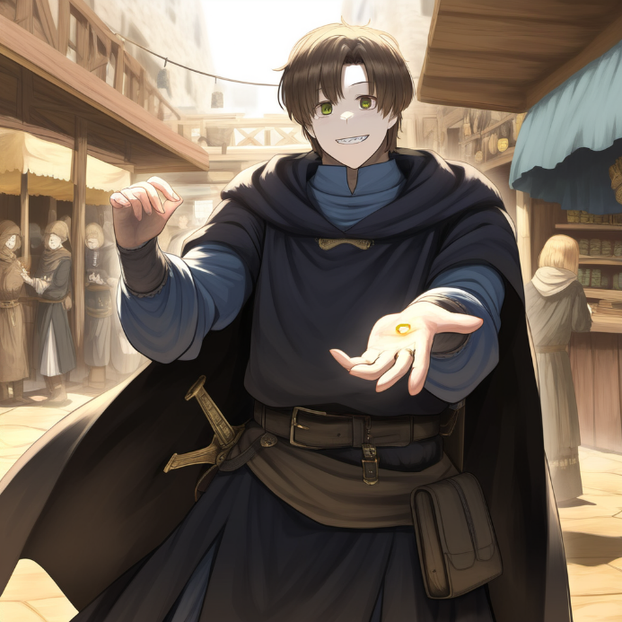
The merchant quickly grabbed the ring, examined it closely, then tucked it into his pocket. From his other hand, he pulled out a leather pouch and handed it to her.
— Here you go. Five gold, as promised.
Zephalina carefully accepted the pouch, feeling the unfamiliar weight of the coins. She tucked it into her pocket and gave a small nod.
— Thank you, — she murmured before hurrying away, a strange sense of relief spreading through her. Her gaze drifted upward to the sky, a soft smile appearing on her face.
— This feels... so good, — she whispered under her breath, breathing in the sweet scent of freedom.
…
Epilogue
Crane sat on a soft, lavishly decorated nest that looked more like a throne of feathers and silks than anything a bird would use. His body barely fit on the cushion, and his enormous belly, stretched to absurd proportions, pressed against his internal organs, forcing him to breathe heavily. With each passing second, the weight grew more unbearable.
— What the hell! — he groaned, gasping for air. His clawed fingers gripped the edges of the nest, while his wings twitched awkwardly behind him. — I... I'm just sitting here, laying eggs like some damned chicken!
His new body, which had already humiliated him more times than he could count, continued to betray him. He let out a loud moan, feeling another painful jolt deep in his lower abdomen. The sensation was strange — a mix of discomfort and some primitive, animal reflex.
— Oh no, no, no... again? — he rasped, pressing into the soft cushion beneath him. His chest heaved with every breath, large drops of sweat rolling down his face. — I just... There are already five! Why another?!
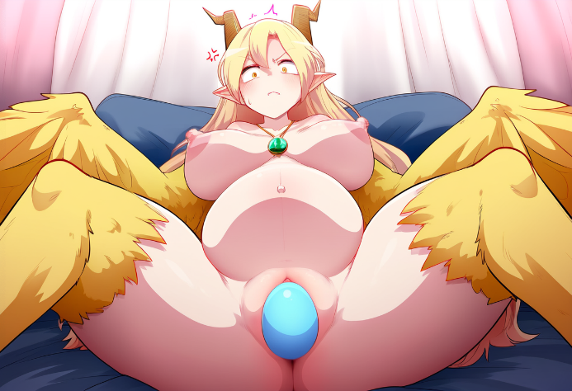
Suddenly, a sharp, piercing cry escaped him — high-pitched, almost like a furious scream. The pain was intense but oddly bearable. With a loud, wet sound, another egg emerged, coated in a thin, shimmering layer of magical energy, and rolled onto the cushion before him. It was perfectly smooth, glistening with golden and turquoise hues.
Crane stared at it, panting heavily, his face contorted in a mixture of disgust and exhaustion.
— Wonderful, — he muttered, barely able to catch his breath. — Another one. When will this end?!
He carefully nudged the egg with a clawed hand, examining it. It was warm, almost hot, and seemed to pulse faintly, filled with magical energy. Crane swallowed nervously.
— Well, hello there, you little parasite, — he muttered, slumping back into the nest. His belly still felt heavy, though slightly less than before. — I wonder how many more of you are in there? Ten? Fifteen? A hundred? Or maybe... this will never stop?
Crane threw his head back, breathing raggedly. One thought throbbed relentlessly in his mind: I have to go back. I need to get my body back. Fix this. And, damn it, I will make that cursed chicken pay for dragging me into this nightmare!
He slowly ran his winged hand across his damp face, feeling the feathers stick to his sweaty skin. His gaze fell on the massive egg that had just left his body. It pulsed with a soft glow, almost mockingly.
— Four days straight! — he suddenly shouted, louder than he expected, squinting as he glared down at the freshly laid egg. — Four damned days since I started laying these, and now six eggs. Six!
He shook his head, desperately trying to erase the humiliating memories of the process from his mind. His stomach still felt unbearably heavy, a clear sign this was far from over.
Crane looked at his massive wings, which lay uselessly at his sides. Flying was completely foreign to him, and with his swollen belly, it felt downright impossible. He could barely stand without gasping for breath after just a few steps.
— So how the hell am I supposed to manage this? — he muttered, bracing himself against the nest, breathing heavily. — How did... Zephalina handle it? Did she have an army of servants carrying her around on pillows or something?
The thought made his head spin. His new body demanded food — that strange magical porridge or those cursed seeds. He grimaced at the memory of their taste. The grain, a mixture of grass and magical energy, had made him nauseous, yet it oddly satisfied his hunger.
Reaching for the bowl with the remaining seeds, he grabbed a handful. The sticky food clung to his fingers, and its bitter smell made his stomach churn.
— Ugh, disgusting. But it's either this or starving to death, — he muttered sarcastically before shoving the seeds into his mouth. The taste was even worse than he remembered, but his body seemed to absorb the energy greedily.
His eyes drifted to the mirror across from the nest. Reflected there was an incredibly beautiful harpy woman with a massive, swollen belly, her clawed hand resting on it. Her eyes stared back at him with exhaustion and quiet despair.
— You're revolting, — he hissed at his reflection. — I’ll find you, Zephalina. I’ll get my body back. And you...
A sharp, stabbing pain cut through his stomach. Crane let out a cry, his claws digging into the edge of the nest.
— No! Again?! I just—! — he pleaded, but his body was already preparing for yet another "miracle."
Doubling over, clutching his belly, he screamed in pain.
— How many of these damn things are there? — he whispered, pressing his wings tightly to his stomach. — This... this can't go on forever...
His gaze shifted back to the nest, now filled with shimmering eggs, just as another was about to join them.
