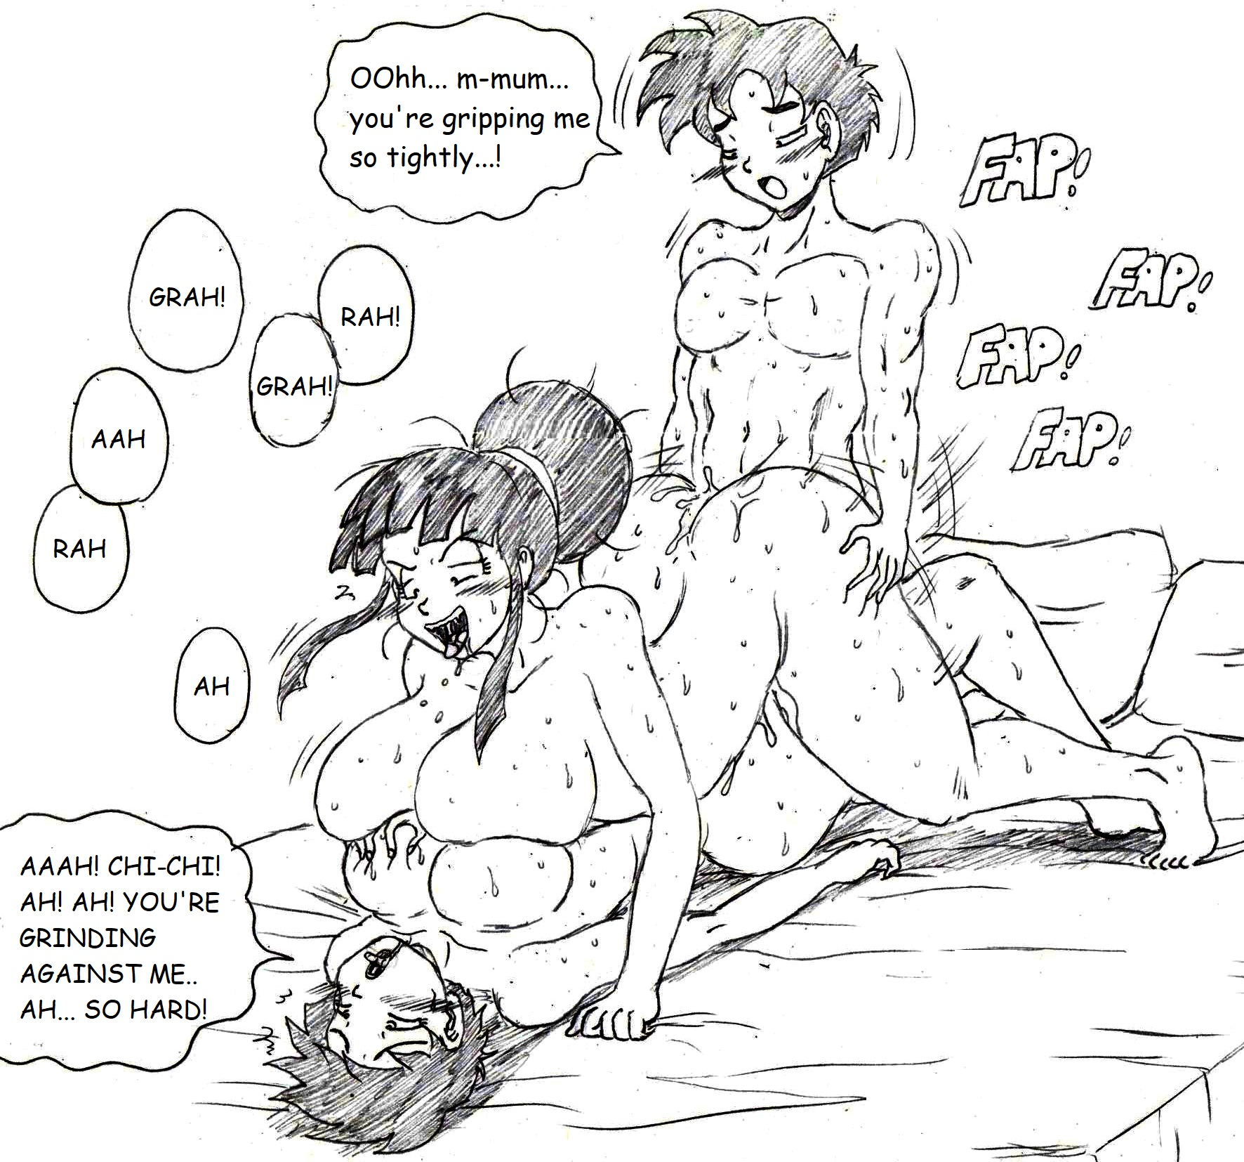

(For the record, this was one of the most awkward requests I’ve received, since the characters don’t come from the same timeline. I probably won’t be doing anymore of these)