SWORD ART ONLINE:
CROSSOVER CONSUMPTION
CHAPTER 8+FINAL: THE REMAINING
BY CHALDEACHANGE
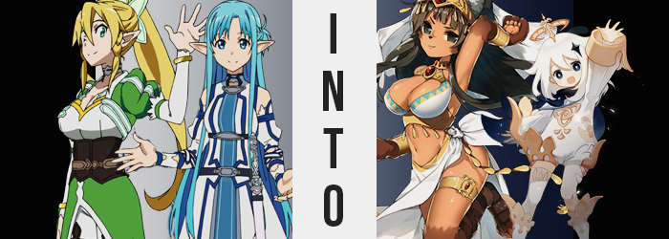

“Onii-chan and Alice went to visit The Underworld, right? I wish they’d invited us as well.” The sylph, Leafa, pouted as she laid herself down on the couch set up in the cabin that had been purchased by Kirito and Asuna within SAO’s tower, replicated in ALfheim Online. It was an incredibly significant home for the couple apparently, but it had become something of a hangout spot for everyone over the past year.

Because it was such a popular spot for their friend group now though, it was weird that only Leafa and Asuna were there at present. At least Kirito and Asuna had an excuse, but what about the others? They’d all been planning on meeting to watch a new ALO announcement later that evening.

In the kitchen, Asuna chuckled. “Kirito knew how much you wanted to see the announcement, but he also had to go at the same time. He didn’t invite you because he thought you’d be bored and regret going. Besides, at least he ran the event stuff with us beforehand?” That was true. The admins had been marketing the collaboration event as one that absolutely shouldn’t be missed, and thankfully everyone in their part at the time had gotten a drop.

She could hear Leafa groan about this even though she was still in the living room. “Yeaaah, but! It would be nice to at least get invited, you know!? We played a part in what happened with The Underworld too, so!” The sylph knew she was just being pouty, but she didn’t like it when her big brother left her out of things. Consider it a part of her lingering possessiveness, more or less. She’d made great strides in improving with that ever since the Fairy Dance incident, at any rate!

“Well, I need to fetch some more ingredients from the storage shed out back if we’re going to bake a cake for the stream, so I’ll be right back Leafa-chan!” Smiling all the while, Asuna gave her boyfriend’s little sister a wave as she disappeared out the back door, barely hearing Leafa’s “’Kay!” of confirmation that had followed after.

This left Leafa all alone, and she’d taken to flicking through her inventory on a whim to pass the time. She thought about sending Kirito a message but shied away from it, and instead attended to the gear she’d recently accumulated. “Bracelet of the Bastet, huh? Isn’t a Bastet some kind of Egyptian thingy?” She was looking at her haul from their collaboration run, and idly equipped the accessory without thinking too much about it.

It ended up removing her entire sleeve to put the thick, golden bracelet one. Wait…

ERROR! ERROR! ERROR!

IT HAD STRIPPED HER ENTIRELY!? “H-Huh!? What the!?” The girl was quick to sit up in her seat, bare breasts bouncing with a realism and displaying a likeness to her own that she wasn’t quite comfortable with. “Why am I naked!? Since when did they add this feature!? No… It’s an error, right? So why are these proportions…?” It was funny, because among their group Leafa’s avatar was the one most different from her IRL appearance. But in this case? Her breasts had been perfectly replicated somehow.

Distressed by her sudden nudity however, she was left oblivious to the fact that she was at least wearing the bracelet, and the fact that the skin around the bracelet was looking rather funny. Something was sticking out of it, something of a chocolate brown color in an inconsistent peppering. Fur. Tiny follicles of fur. And while they had been scattered at first? Within a matter of moments they had popped up all of the way to her elbow, painting her forearms in a fluffy and warm coating.

However, this fur was also climbing the sylph’s hands. It coated the backs of them completely, but her palms? They remained fleshy. Fleshy, but they likewise appeared to be a little swollen, particularly in their centers as the fur decorated around then. It climbed every bloating finger, but her thumbs ended up disappearing into their fuzzy masses while the pads of the remaining for rose on the underside. It was clear what they resembled as her fingernails buried themselves into her fingertips and became thick, sharp, and black.

They were the paws of an animal.

Her feet and legs, meanwhile, were facing a remarkably similar transition. A fur of the same color had spread from her ankles to just above her knees, while below the ankle her feet had begun to bloat as the fur wrapped around them. Each toe became rounder, although her pinkie toes were removed outright, with black claws hooking from them. Paw pads ended up appearing on the underside of either foot as well, creating a pair that were a match for, if not a little bigger, than those that were now her hands.

It wasn’t until Leafa placed a hand paw onto the side of the couch to push herself up that she even noticed, although she had been getting warmer and warmer as her limbs had been coated by its fluffy invaders. But the way her new paws interacted with the couch? It just felt weird. Her eyes wandered down to look at her hand, and in the end, she was left to shoot off a yelp of surprise in response to the fuzzy appendage she saw. Needless to say, the girl didn’t get out of her seat as intended.

“Paws!? Why is my character model changing!?” Right. Realistic looking breasts or not, this was still in-game. There was no reason to get too panicked! However, further changes seemed intent on making it so she might have to, particularly with how her pointed sylph ears were eerily crawling up the sides of her head. They didn’t turn or anything, they just appeared to be navigating upwards, though…

Had that layer of brown fuzz been there before? It was a darker brown than even her paws had taken on and was spreading both behind the ears and down their centers once the ears had reached her scalp. Within, the fur was softer and longer, and grew like tufts while the wrinkles in their cartilage smoothed out. Before long, her ears were fluffy and exceedingly catlike, their dark brown soon finding itself into Leafa’s golden mane.

The color conversion was quick, too. The dark brown swept through her hair like a fire catching against dry kindling, its full length quickly dark chocolate in tone, fanning out behind her as her hair tie going missing had seen her ponytail undone previously anyways. Leafa’s hair’s length became lesser though, cutting itself just past her shoulders – but where had the excess gone?

Her face, strangely enough. Or, well… Considering her paws and ears, perhaps it wasn’t all that strange. A tanned fuzz that was darker than her regular skin tone appeared beneath her chin and upon her cheeks and forehead, within moments covering the sylph’s face in its entirety – eyes aside. The issue? This wasn’t even the most dramatic change that occurred to her face, and Leafa couldn’t help but yip as it felt like something had punched her nose and yanked it forward. “EEP!?” There was a quality to her voice that sounded off, just a little deeper somehow, but the girl didn’t really have time to dwell on it.

After all, she could see her nose. Okay, so technically speaking that wasn’t all that strange, but it was more like she could see too much of it. From her perspective, she didn’t even need to cross her eyes to see it anymore, as if it had been pulled out farther. Not to mention it was black, and a little cold. No… was it wet? “What happened to my face!?” She was averse to doing so, but she brought one of her paws up to pat her nose. It was like her face had been tugged out into an animal’s snout, but just a little bit. Sharpened canine teeth ached as the grew within her mouth, and when Leafa withdrew that paw?

She was confused. “Hmm? Why am I confused about my snout? Bastets have snouts! …Bastet? That was… the bracelet?” Why had she been so certain her identity had been tied to the Bastet just now? It didn’t make sense, but it also, somehow, did. And the more things made sense, the darker her green eyes turned until they would eventually become brown.

In the meantime, the remnants of her body that weren’t covered in fur had begun to darken in color, skin taking on the very same tanned hue that the fur upon her face sported. It was like she was reaping the benefits of a tanning booth in real time, except the tan was completely natural – and tanning booths didn’t typically turn one’s nipples dark brown.

On the topic of Leafa’s nipples though, they looked more engorged, color aside. Rather, her breasts in their entirety just looked that much fuller; astounding, since she already had the most impressive rack of any girl she knew. They were bloating more and more, their heft forcing her to lean a little more forward in her seat, but the girl herself? She was feeling more and more at home with herself. Everything felt natural, there was no need to panic. Not even as her ass bloated beneath her, bringing her seat to rise while fat and muscle alike likewise brought volume to her thighs.

Her already impressive figure had been bolstered further, making her a real treat for the eyes. Well, if you were a furry. Adding to her overall bestial appeal, a dark brown tail slipped out from the base of her tailbone, swishing wildly as the woman finally found it in herself to stand. She stood because, well, she was confused. “Huh!? Where am I!? This doesn’t look like darling’s room?” She remembered someone important, a man that was taking care of her. A man whose wife she one day wanted to be.

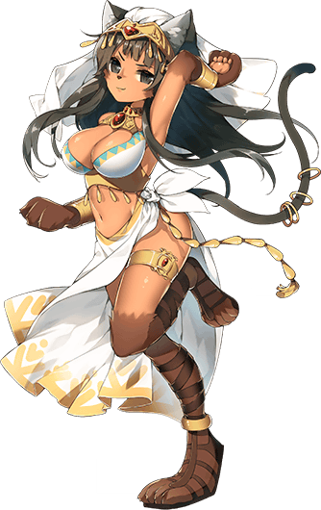
And as those memories bled in? Her naked body found itself wrapped up all neat and tidy – if ‘tidy’ was synonymous with ‘check out all of this exposed skin’, anyways. Her ample bosom was cupper by what appeared to be a decorative bra, crafted in white with a gold and blue triangular hem. This was the only thing on her torso aside from the golden jewelry that hung from the bra though, and her midriff was left completely exposed along with her bouncy cleavage. A white cloth skirt, open to reveal most of both of her legs, thighs, and all, shaped around her lower half, while leather sandals strapped themselves around her lower paws.

In terms of accessories, the Bastet maiden was given a golden headpiece with a white veil attached, along with a matching golden bracelet for her opposite arm. Likewise, a pair of golden anklets, golden bands that wrapped around her thighs, and a set of four rings that hung loosely from her tail.

Her ears twitched, and Rudi’s sensitive nose caught scent of everything both in and outside of the house. “There’s someone else here? Maybe they can tell me what’s going on!”

But even if she found Asuna, by the time she reached her? It would be too late to extract any useful information from her.

Asuna had planned on only taking a minute at most out in the back storage shed, but when a crisis froze her in her tracks, she had no choice but to linger. Because of course…

ERROR. ERROR. ERROR.

She was in the exact same situation Leafa had found herself in within the cabin’s living room. It hadn’t been triggered by fooling around with her inventory however and had rather the error had been activated seemingly without reason. It was only by coincidence that Leafa’s had taken affect while trying her bracelet on, after all.

The primary difference between the two incidents was that the piece of collaboration gear Asuna had received was completely different from that of her sylph companion, and once the undine had been stripped down into her birthday suit, she was adorned with only the ‘Fairy’s Halo’ she’d received, a tiny head accessory of gold that floated just inches above her head.

Naturally, it didn’t provide any coverage considering the rest of her body was now bare. “Wh-Wh-What!?” Asuna was plenty strong as a woman, but even something like this could take her off guard. How could the devs allow a glitch like this to happen!? Why was her naked form so… authentic!? As a survivor of the Sword Art Online incident, this just set off a number of red flags that brought a hand to quickly navigate to the logout menu.

“It isn’t there!? Asuna is concerned! …!?” A hand shot up to cover her mouth as she’d suddenly referred to herself in the third person, which was something she’d literally never done, yet had occurred nonetheless without even meaning to.

All the while, something was swirling among her eyes. It brought the bright blue of her irises down towards a much more navy blue tone, but more miraculously? Her pupils seemed to glow as they flickered from a black that could hardly be seen against the navy blue, to a pure white that stood out immediately. Needless to say, it wasn’t even a trait one could apply to their ALO avatar. It was something else entirely.

On the sides of Asuna’s head, even more strangeness was afoot as the tips of her ears rounded, lengths pulling inwards so that they were more akin to a normal human’s as opposed to the long fairy ears she’d sported prior. All in all, something about Asuna’s head was rapidly looking… youthful. She was eighteen, and so of course she still had a little way to go before reaching full maturity, but it was as if her face specifically had gone in reverse.

Cheeks grew chubby, already altered eyes wide, and her lips? They didn’t seem anywhere near as engorged as they should have been, regressing to a simplicity more akin to a girl of a much younger age. It was difficult though, because despite the initial panic that had taken her regarding this situation, the corners of these lips couldn’t help but curve into a smile. “Asuna needs to figure out what’s going on! Ah!? I did it again! But Asuna isn’t trying to!?”

Even her mannerisms were growing much more expressive, hands waving around. Although, those hands? They looked just the slightest bit smaller, with her nails trimmed despite her ALO avatar having a neat manicure normally. Distracted by how she was speaking, Asuna didn’t even notice that the weight upon her chest was lightening. Her breasts had regressed in size by half, and even the curves of her lower body had diminished in a similar fashion. She didn’t have much of an ass anymore, much to Kirito’s supposed disappointment.

It wasn’t really Asuna’s fault that she hadn’t taken notice though as just like in every other instance, powers were at work to make sure the transition into their new life was as seamless and void of confusion as possible. So even as her blue locks shortened and were bleached an irrefutably snow white, granting her a messy, shoulder length bob, she was otherwise oblivious.

“Hmm! Asumon isn’t sure, but isn’t something weird here?” With her arms now crossed beneath her essentially flat chest, the pitch of Asuna’s voice had begun to rapidly rise… all while her height rapidly fell. Her point of view did not change though, because some passive abilities had suddenly taken to her existence. More blatantly, she was floating?

The once-undine was just hovering in place as her limbs withdrew towards her body, an almost childlike daintiness applied to how short and thin they were. But it wasn’t as if the rest of her body had been left out of the equation either. Her torso crunched inwards, becoming a little chubby as her leaner height was squished away. This left her frame looking a little round, and more excessively childish. Naturally, the size of her head was required to shrink to match (else her appearance would have been somewhat nightmare fuel-esque).

And with a smaller head came a smaller mind, at least in this case. The girl’s head spun as her ability to take much of anything seriously faded away. Her stomach – no, stomachs – gargled as an overwhelming hunger distracted her, and before long ‘Asumon’, as she’d referred to herself prior, could only think about food.

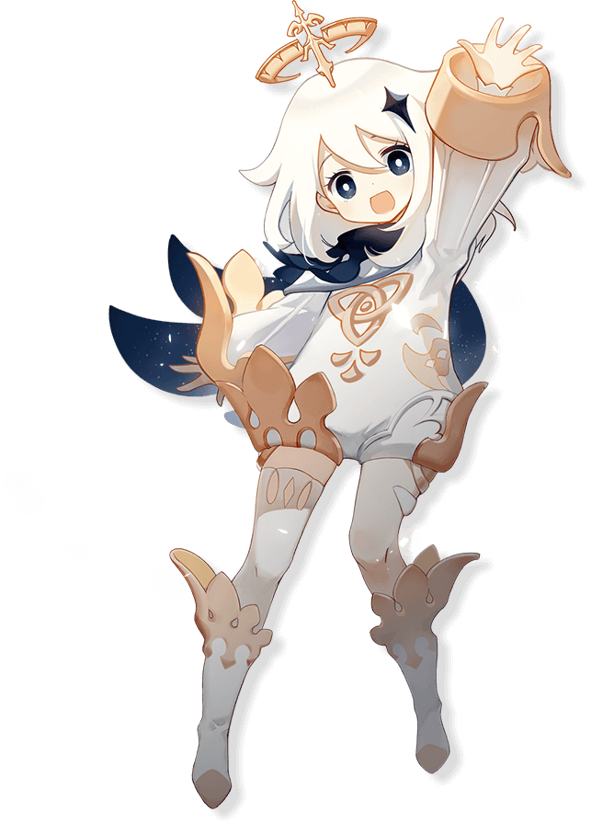
At least the growls of her tummy found means of protection, for a fluffy, one-piece bodysuit done up in white covered her torso, arms, and legs alike. It had a golden emblem embroidered in the front, with golden sleeves that were folded outward and matching booties tied to short leggings. Otherwise, a four-pointed, navy blue star decoration found its way into the left side of her hair, and a matching mantle fluttered out behind her like a pair of wings. Fascinatingly, the mantle’s underside seemed to reflect a starry sky, adding to the supernatural aesthetic of a tiny being that looked more like a fairy than any ALO player ever had.

“Paimon is hungry! Who trapped Paimon in here!?” And, with her transformation completed, the bubbly Paimon finally sprung to life. She fluttered here and there, looking for any potential exit from the storage room (while also keeping an eye out for any expensive looking treasures). She didn’t know where she was, but she also didn’t really care. Filling her belly with tasty food was waaaaaay more important than anything else! “Why! Won’t! This! Doorknob! Move!? Is Paimon too weak!?” Once she’d settled on the door being the only exit, she’d set herself to trying to open it. But her tiny hands, paired with her weakened strength? She kept sliding off!

Struggle as she may, Paimon just couldn’t get the doorknob to budge even minutes later because she was too small. “This is unfair! Make smaller doors for Paimon to go through! Even the windows are closed, I’ll be trapped here forever!” Still gripping the knob, the tiny space fairy pouted cutely as she tried to wriggle it more and more. Until finally… “WAH!?” The doorknob turned quickly with Paimon still clinging for dear life, and she was knocked back in a twirling fashion. Somehow had opened it from the other side? Who was it!?

She steadied her flight and tried her best to look at her savior, but that savior? “AAAAH! Paimon’s run into some naked monster!” It was Rudi, and she appeared to be just as shocked as Paimon was. She immediately looked down at herself upon being called naked though, and she grew a little flustered as a result.

“I-I’m not naked! Everything import is covered! Who even are you? Do you know where we are?” She’d come here in search of someone that could give her information but based on the reaction she’d received from this ‘Paimon’, she wasn’t so sure that she’d found someone of that nature.

“Nope! And Paimon isn’t gonna tell a pervert like you even if she did know! You call that clothing? PFFT!” Before their transformation they had practically been sisters-in-law. But now?

This was going to be annoying.

Yet again, another VRMMO tragedy had plagued its player base. Unlike the SAO incident lives weren’t lost, at least not in the traditional sense, but the fact that the players had taken the forms and souls of the characters they’d been transformed into the game in the real world meant that they would never be the same again. They didn’t hold any remaining memories of their old lives, and in many cases these players were no longer human. Thousands of players had been affected, and the company in charge of ALO’s development naturally went under due to lawsuit after lawsuit.

At the very least, Kirito and Asuna still recognized each other in their new forms.

After all, Mona and Paimon were from the same world!

