MISS FURINA’S SHOWTIME
COMMISSION STORY
BY CHALDEACHANGE
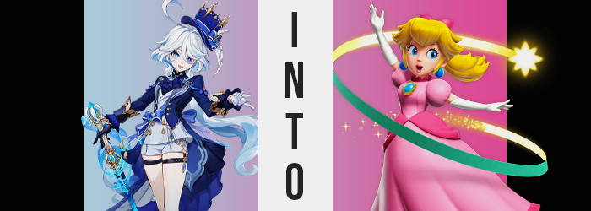

It had taken a while for her to get into the swing of things again but Furina de Fontaine was finally finding her footing in this brave new world. Honestly though, she wasn’t sure if it was all that appropriate to call it a ‘new’ world. Had anything realistically changed? The world was by and far the same even after everything that had happened to Fontaine. This was the type of mentality that the woman fell into when she was being hard on herself.

Which was something that was unsurprisingly easy for her to do. It had all been for the sake of Fontaine and the people that had lived there, but even with a fuller picture of what had transpired Furina was still burdened by the weight of guilt. While necessary, she has misled the people of her nation for 500 long years about her identity. She had tricked them into believing that she was the true Hydro Archon and while she was technically a piece of her, that didn’t change that she was still a human. She’d simply been cursed to live for a terribly long time.

Everything had been done for the sake of preventing a terrible prophecy from coming to pass. Although she had barely been a newborn human herself at the time, the true Hydro Archon had asked her to shoulder a great responsibility. She had asked Furina to carry that lie until the bitter end so that the prophecy could be avoided, and Furina managed to do that. But it had been painful. So incredibly painful that her heart had broken long ago.

Her efforts fortunately hadn’t been in vain. In the end the great flood that the prophecy foretold hadn’t been prevented, but the deaths of the Fontainians had been. So in ways Furina wasn’t considering this was a new world. It was a world where the people of Fontaine didn’t need to live in fear of a prophecy washing them all away. For the first time in the history of the nation they were free, and it was all thanks to Focalors, Neuvillette, and Furina herself.


“Hm? Were the costumes not supposed to be coming in with the props this evening?” Regardless, the false Archon had finally managed to pick herself up to some extent after everything was said and done. Her reputation among Fontaine’s people was being rebuilt little by little and she was getting more comfortable being in public. She had even been making an effort to help with arts projects around the city.

It was a chain of events that began when the Traveler had been seeking someone to help with a stage production. Out of the goodness of her heart Furina had reluctantly agreed, and through that adventure her love of the stage had been rekindled. She may not have wanted to perform on the stage any longer, but with 500 years of skill at her disposal? She could at least support those that did. She still loved the performing arts.

From that point on she had been picking up odd jobs in similar productions, barring the movie stint she’d had courtesy of visitors from Inazuma several months prior. The small home she was within at the moment as burly men funneled in boxes and equipment was the base of operations for one of them. She was helping backstage with a new shown known by the name of ‘The Mushroom Princess’. A touching tale about a pink princess from another world that is rescued by a humble man in red.

Aside form the men moving the supplies in Furina was the only person present. The day was getting late and she had volunteered to remain behind while everyone else got dinner. Socialization wasn’t her strong suit and, honestly? She preferred to be alone a lot of the time these days anyways. “Ah, there they are! Was that the last of everything then?” The small woman perked up after seeing a rack of hanging clothes wheeled into the room’s corner.

She handed the money to the deliverymen and saw them to the door, locking it behind them. “Phew. Everything seems to be here. We’re ready for rehearsal in costume, at least.” It took her a little bit to double check the stock, but her attention eventually shifted back to the rack of costumes. “Right. Elise wanted me to try on her costume, didn’t she?” Elise was the one who would be playing the main lead – the princess, Peach.

It also just so happened that the two of them had very similar builds and Elise was worried about her costume’s fit. But she was away with a light cold and didn’t want to spread germs onto the costume. And so she had requested that Furina try on the costume for her. Knowing she had the privacy to do so, it didn’t take her long at all to strip and put on the dress. It was a process that, by the time she had finished, made it clear to her that something had gone very wrong.

“This… doesn’t fit at all? The waist is too thin and everything else is too big!” Whose proportions had they even used!? Elise and herself were the only two women even involved with the production! The dress must have been tailored for a woman who was six feet tall! The gloves were supposed to reach just past her elbows, but almost reached her shoulders!

Furina had been wary of the company providing the costumes in the first place. She had never heard of them before and couldn’t find any reviews, but the rest of the members seemed keen to try them because their prices were low for what they offered. “Well if this is the sort of service they provide then I guess I understand why the costs were so low…” She was already creating the complaint letter she would be sending in the back of her mind. While trying to stop the ill fitted white gloves from slipping off her arms and hands, however.

Now, despite the extremely long length of the dress, suggesting it was made for a significantly taller woman, the waistline of the hem really was too tight. She had barely gotten it around herself and even then it was digging into her, but… “GASP!?” Seemingly out of nowhere it became even tighter. She felt a crunch as the very waistline that it was wrapped around was narrowed until it properly fit the dress’ narrow gait. It temporarily winded her, leaving her gasping for air.

And once she managed to compose herself again, gloved hands grabbed at the sides of her stomach. “H-How!? It fits now, but not because the hemming was changed… My own body changed to fit it!?” But that should have been impossible, right? Unless the dress had some sort of magic on it, but ‘magic’ wasn’t even real. Sure, visions and Archons existed. But those couldn’t alter the bodies of humans.

Unfortunately for Furina she was on the right track about what was happening to her. It was unfortunate because it wasn’t going to stop merely with making her core smaller. But simultaneously? That didn’t mean that all of the changes it would provoke would be negative. Well, depending on personal opinion at least.

A brassiere had naturally been included as part of the costume, and Furina had worn it just to make sure everything was in order. The cup size was much too big for her relatively flat chest, perhaps fitted for a bosom that featured a pair of C-cups at least. And well… “Wh-What now!?” She could feel a great deal of suction pulling on her small breasts. The bra was pushing the dress out to suggest a bosom size that the small woman didn’t possess.

Or, well… didn’t possess yet. She could feel her nipples growing erect under the sensation of her breasts being pulled upon by an invisible force. They were pulled closer and closer to the cups of the bra, simultaneously pulling her breasts themselves closer in the meantime. They filled to accommodate this pull, soft and perky tissue building mass as her cup size burgeon forward. “Eep!?” Until finally? Her nipples pressed into the bra, her body tilting forward from the added weight.

“My chest is bigger…? But…” Furina couldn’t help but try to squeeze them through her bra. Those were definitely her boobs. For the first time in 500 years she had a bigger bust? “Is that really a bad thing?” Was there anything wrong with becoming more attractive? It was a question she had to ask herself as the fit of the panties and bloomers that likewise came with the costume began to tighten around her body next. Beginning with a pulling sensation that parted her hips a little wider than they’d ever been. “Wait, is it happening to my lower body as well?”

Why did she sound so excited by the idea?

The woman was clearly lost in her own sauce; a side effect of living for hundreds of years in a body that had stagnated in age and build. Bigger breasts were an exciting addition for her, but that excitement now spread to her lower body. She couldn’t really see it with how big and puffy the skirt was, but she could definitely feel her thighs bloating so that the bloomers weren’t at risk of slipping. For a dress fitted for a character named ‘Princess Peach’, maybe it was fitting that her panties were filled with cheeks that evoked the image of a large, full, and beautiful peach. Each cheek would certainly bounce with each step.

Furina squee’d with delight. It was a little difficult to move with so much meat on her bones, but this had been something of a dream of hers. And that dream was only being granted further because her point of view grew… taller? “And now I’m getting taller as well? Hehehe! The others won’t even recognize me after this! I can’t wait to see Paimon’s face!” She placed her hands on her hips and puffed out her enlarged chest, the dress fitting her much more snuggly as she finally grew to the appropriate height. She shot up from five feet to a full six feet, allowing her hands to fit into gloves that now only reached her elbow, or feet to swell into her pink heels without sliding off.

But oddly? “Hm? Why does my head feel so… swollen? E-Eh!? And my voice sounds a little too high, doesn’t it!?” Panic set in because Furina had clued in to several changes that she didn’t understand. Touching her head with her hands… didn’t it seem much too big for her body? It wasn’t just that, of course. Her lips were fuller and pinker, her nose was pointier, and her eyes had grown to take up nearly 33% of her face. She couldn’t see this, but teardrop irises confirmed into normal, black irises and the mismatched blues of her irises in kind evened out at the same sky blue in either rounder eye. Each one complete with long and luscious lashes.

She didn’t look like Furina at all in her face, which was probably why her voice sounded so different too. But she wasn’t near a mirror to see that her face was now smoother and longer on top of the individual changes to her features. And it wasn’t until her blonde hair fell into view that— “Blonde hair!?” Golden locks had hung down from where white and blue strands had existed previously. It was the change that made the woman realize that what was happening to her was more than her body becoming sexier and completely reframed her opinion of what was happening.

“This might be bad, right? Didn’t the character have blonde hair…? She was also tall in the story draft but we went with a shorter actress…” All reasoned with a sickeningly sweet voice while blonde strands finally reached the center of her back. “Wait. I’m not wearing the crown, right? Maybe putting on the crown will fix it? Maybe it's just because I wasn’t wearing the full thing!”

Heels clacked against the wooden floor as the spitting image of the character she had been dressed as fumbled over to the clothing rack again. She took the crown with gloved hands and stuck it on her head wondering if, perhaps, it would fix things. And in a way? It did. If Furina wanted her identity and body to match then that was exactly what happened. “I… I… I was?”

The woman’s brain hitched and she had problems focusing. A great fog had beset her mind that made it difficult to think. But this fog disguised something that should have been alarming. Her memories were being funneled out while new ones were funneled in. It affected the perception of her life, of her identity, and by the time to fog cleared she would understand herself to be another person entirely. But just as concerning?

Her surroundings had been shifting in kind.

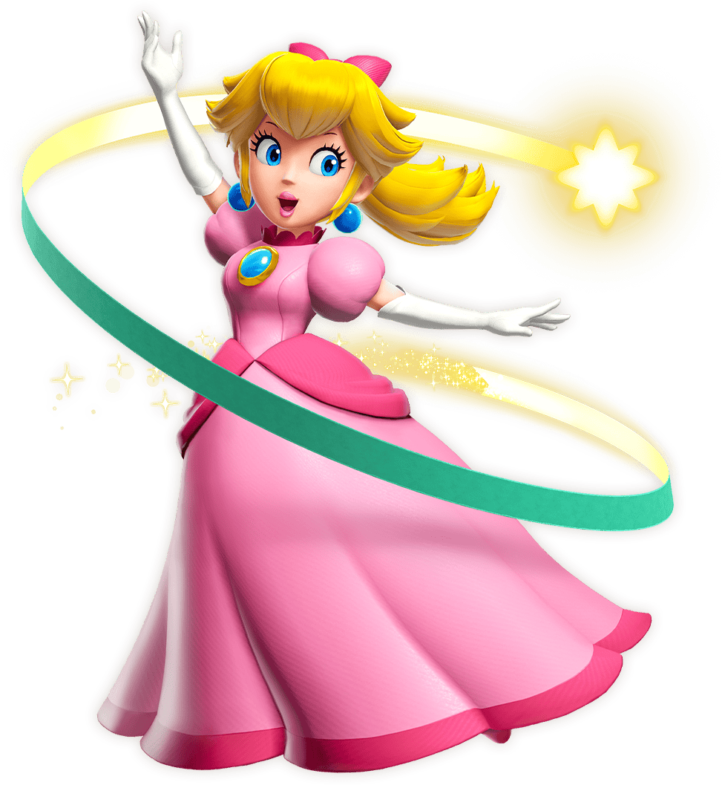
“Oh? Oh dear…” From Princess Peach’s perspective the whole world around her seemed to shift not even moments after her ‘mental readjustments’ had been made. She was all of a sudden stranding in a grandiose theater, one that had an air of mystery to it that she couldn’t quite place. But this shift in environment was just another symptom of everything that had happened to her. Something prompted her to check on the crown that had stimulated her mental changes, instead finding that a pink ribbon had tied her hair into a ponytail. “My crown is gone? Oh my…”

Her memories slowly but surely began to fill in the blanks. For a moment she had envisioned herself as someone else. As a diva from a Nation of Waters. But that was incorrect, wasn’t it? As much as she was a princess, Peach was also an accomplished actress. That role, the role of Furina de Fontaine, was one she had planned on occupying during a performance in this very theater – the Sparkle Theater.

When she managed to file that truth away everything else fell into place. The confusion about her identity dried up and she could remember just what it was that was going on. “The theater was besieged by the Sour Bunch, and then Stella… Ah! That’s right! I was attempting to free the theater from its captors!” All of a sudden that sense of responsibility that she had felt made perfect sense!

“I suppose I need to get moving then! Everyone is counting on me!”

Meanwhile, back in Fontaine… “Erm? Princess Peach? Ah, well… Of course! That’s who this costume belongs to, is it not!?” ‘Furina’ was confused about why she was wearing the Princess Peach costume their production had ordered. It fit her perfectly, which meant that it would fit Elise in kind. That meant that there was absolutely nothing to worry about in the costume department!

This Furina had as little context as the real one. She had actually swapped places with the ‘real’ Furina, the one who had become the Peach that now existed within the Sparkle Theater. This Furina was the real Princess Peach. The two had switched lives and memories, both of them now believing to be each other. “It’s getting late though. I suppose it's time to return to my apartment to make some macaroni!”

And so the two lives continued for the women as if nothing had even changed in the first place.

