SCOUTED II.
JULY 2021 REQUEST STORY
BY CHALDEACHANGE
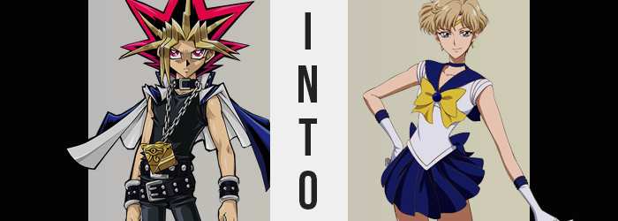

“Yugi? You can’t hear me? Hm… Something is strange here.”

The Pharaoh Atem, otherwise known by the name ‘Yami Yugi’, was confused about his current circumstances. He wasn’t sure what had awakened him or why, but his surroundings? They resembled a Japanese high school, or least the changing rooms of one. The room was vacant except for himself, but strewn about the benches and hanging from open lockers? Were clothes that undoubtedly belonged to girls.

“This likely isn’t good. I should take my leave.” Extrapolating based on what he could see, this was likely a school of some sort? What had Yugi been doing here? Considering he’d been dormant, he couldn’t recount his closest friend’s actions leading up to this moment at all. So he couldn’t have known the truth.

That Yugi had been sucked into a phone game. Not on purpose, but because Seto Kaiba had suffered a similar fate. Yugi and Kaiba’s fates were so irreversibly intertwined that one could not suffer a fate without the other being forced to go along against his will. It truly was a curse. The threads of destiny could be among the cruelest things in the universe. History had proven that time and time again.

Just as he was about to leave though, the door of a locker directly in his path swung open, seemingly on its own. Was he being beckoned? He didn’t sense the presence of any spirits about. Perhaps it had just been a breeze? “Hm…” Against his better judgment, however, he peeked inside. There was a bag with a name embroidered on it dangling there.

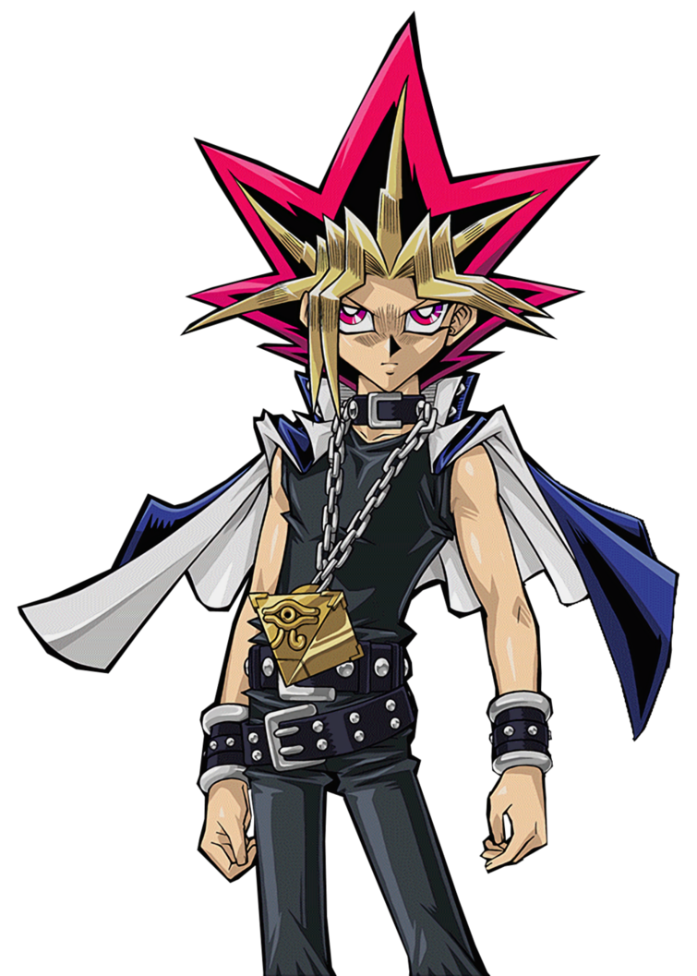
“Tenou Haruka?” It must have belonged to one of the girls, so it was best not to touch it. Even so, why did the name sound so familiar? Yami Yugi couldn’t possibly be aware of the fact that he was already falling under the influence of this world’s power – power that would gradually make him a permanent resident of this world and reunite him with Kaiba in the most bizarre manner imaginable.

And once those powers finally came into play, it didn’t take the young man very long to notice them. “Hm? That’s strange. It almost feels as if something is amiss with my…” It was a very strange statement to begin with a voice as deep and commanding as Yami Yugi’s. But he trailed off before her finished it, for it would have been an inappropriate thing to say. That it felt like something was awry with the package within his very skinny pants.

It was an uncomfortable situation that he wouldn’t really describe as uncomfortable as much as he would describe it as ‘wrong’. Without eyes on the area he couldn’t do much other than assume, and he wasn’t about to drop his pants in a girls’ changing room. But when all was said and done? She was fairly certain that she would have been more at home changing in here. “My…!?” Try as she might without reaching a hand down there, she couldn’t feel anything by trying to give it a little wiggle. It being her dick, of course.

May it rest in peace.

So of course Yami Yugi could only assume that a girl’s alternative now sat between her thighs – which had all sorts of implications. How was she supposed to explain this to Yugi when he was returned control of his body? Or could he not feel his consciousness because that was a possibility that could already be accounted for? Either way, it appeared that there was more going on here than a mere loss of groin.

Subtle in some areas, while being a little less than subtle in others, the shape of Yami Yugi’s body was gradually growing more and more feminine. Whether it was how her waistline tucked in to give her frame a slender arch, or how her hips protruded wider to stretch both her pants and the oversized belts holding them into place, femininity was undeniably on Atem’s horizon.

She raised a hand in front of her gaze, watching digits retract in length only to be adorned by longer nails – callouses and cuts Yugi had collected from interacting with Duel Monsters cards fading before her very eyes around the same time her muscular arms turned slender. A similar sensation could be felt from within her boots, what with the soles of her feet shrinking so that the footwear was several sizes too large. …At least for a moment.

Both Yugi’s boots and the bracelets around her wrists began to glow, and when that light cleared? She was wearing a pair of elbow-length white gloves with navy blue trim and a small pair of navy, heeled boots that raised the girl upwards with some confusion. “What’s happening here, now? My clothes!?” Accompanying the fact that her Adam’s apple had faded was a rise in the pitch of her voice that was evidently feminine, but still had an almost boyish undertone to it.

Marveling at her gloves and boots, she remained oblivious to the concept of her height diminishing – although to be fair it was only an inch and a half or so that simply allowed her new clothing pieces to fit much more comfortably along lessened limbs. There was also the small matter that something – or a pair of somethings – had begun to poke out from under her sleeveless, black shirt. Nipples were harder and stronger, but in terms of mass beneath them? At best, A-cup breasts had shaped themselves with such obscurity that it was difficult to tell she had a bosom at all.

Clothing once again glowed, but in this case it was Yugi’s top, mantle, collar, and even the Millennium Puzzle. “No!” Her panic was at its peak when she noticed the Millennium Item glowing, but before she could grasp at it, it was already too late. Instead she grabbed hold of a big, yellow ribbon that dangled from a dark blue choker upon a white, sleeveless sailor fuku top. The chain that had held up the Puzzle was now simply a blue collar as well. “This can’t be! I can’t be gone! It… It… What’s missing!?”

She just couldn’t remember, and this was the first case of her realizing that something was awry with her memories. Perhaps ‘realizing’ wasn’t the right word, though. It wasn’t that it occurred to Yami Yugi that her memories were being altered, and had been slowly suffering this effect all along. Instead it was merely registered as her having forgotten something – or perhaps she’d simply imagined something that hadn’t existed in the first place?

The process of her assimilation into this world cared little for her confusion evidently, for the upper legs of her pants were feeling rather tight. Becoming a better match for her widened hips, thighs had expunged additional weight to make them appear a little thicker, which in turn forced strain on her pants and undergarments. Things weren’t helped any further by a rear end that engorged itself ever so slightly, that’s for sure.

As the trend continued, her pants and belt shone next. When the light cleared, a pleated blue skirt rested against her hips, and white panties had replaced her boxer briefs underneath. As for her old belt? It had become a big, blue bow tied at the back of the skirt.

“This is all… I’m…?” Where in the beginning she had been confused about where she was, now? Her location was the only thing Yami Yugi was certain about. This was the changing room at Mugan Academy, the school she attended. But why did her head feel so heavy? Why did she feel so uncertain about herself? For a girl that typically projected such self-confidence, it truly was jarring.

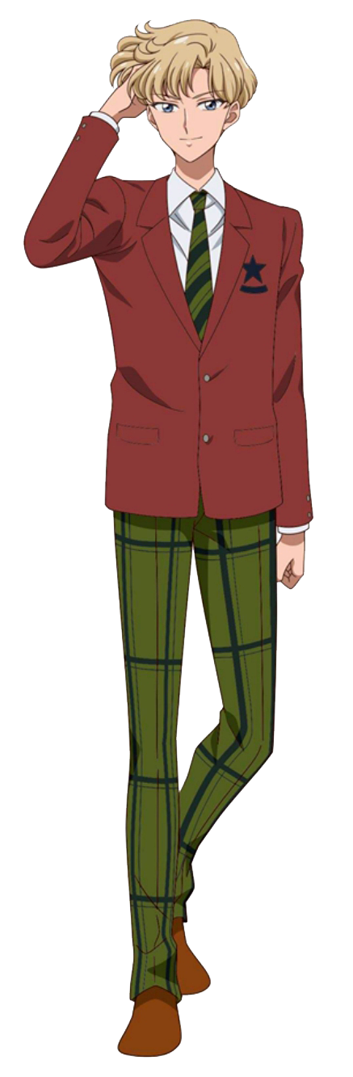
At the very least, the weight upon her head appeared to lessen. Because her vibrant and colorful 90s anime hair? It’s abundant shape and size was lost along with its layers of color. Rapidly it flattened, signature spikes drooping upon her scalp all while the length withdrew to something more manageable on the tops and sides. At no point did it fall past the peak of her neck, leaving it a boyish bob of sandy blonde rather than… Whatever style Yugi Mutou kept his hair in.

Her bangs were a little longer than the sides and back and were parted in the center-left, leaving much of her face exposed. Just in time for her jaw to narrow and her cheekbones to slender – while eyes narrowed and turned grayish blue as far as her irises were concerned. There was no longer a single piece of resemblance to Yami Yugi nor Yugi Mutou, appearance, personality, and memories all included.

“Why was I transformed? And at school, no less.” Sailor Uranus ran a hand through her short, sandy blonde hair with a sigh after glancing down at her person. If any of her classmates had walked in at that moment, she certainly would have had some explaining to do. And so her Sailor Scout uniform dispersed into particles of light, revealing small, plain undergarments beneath them. She must have transformed while getting change after track practice? Not that she could remember why.

Now Haruka Tenou in dress as well, she was quick to grab her school uniform from the bag in her locker. It didn’t take long for her to adorn it, from her dress shirt to her red jacket, to her plaid pants – and it certainly wasn’t a typical girls’ uniform. Instead she was dressed more like a boy, but there was a reason she was considered the prince of Mugen Academy.

And every good prince had her princess. “I’m going to be late if I don’t hurry.” While adjusting her collar, Haruka mused about her plans for the evening. She was picking up her girlfriend Michiru for a special date, but she also needed to slip home and change into something fancier as well.

If only she still had the awareness of Yami Yugi and the ability to learn that Michiru had once been Kaiba.

