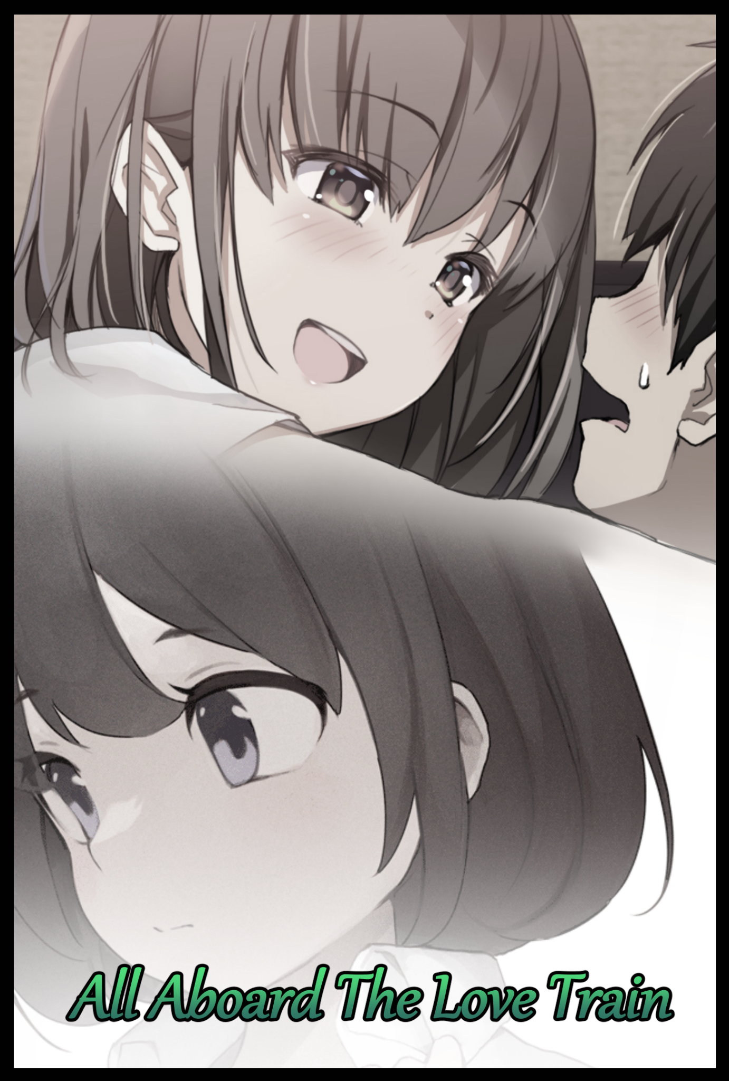

**"Simon! C'mon…I told you already, we shouldn't be…*you* shouldn't be doing this…we can't go down this road!"**

**"And why can't 'I' do this? Why can't *we* do it? Because of who I was? Because I had a *dick* a month ago? What's wrong with me the way I am now?!"**

Masking the sound of their argument in the midst of a busy karaoke studio filled to the brim with people looking to soak in as much of the last few days of 2022 as they could. Making happy memories and experiences they could all look back on come the following year…except the young couple didn't seem too eager to do the same, clashing in argument as the irate girl holds her ground against the young man seated in the couch before her with his back leaning forward. A sign of how serious he was, intending to stand by his words despite how one sided they were; directing the blame for the dilemma they currently faced…and whatever it was had the girl furious. Yet, her rage was not enough to overcome the sadness weighing heavy in her heart, unable to match the determined gaze before her eyes as she did her best to keep her trembling lips from curling while containing the searing heat at the back of her eyes from pouring through.

Distracted by the degrading situation and the muffled voices of the many oblivious partygoers filling their ears, the pair wouldn't notice the hidden ears listening in from behind the door to their booth as a young lady dressed in the karaoke establishment's uniform leans comfortably against the wall with a lackadaisical look on her face, arms in her pockets as she awaits further development in the young couple's ongoing argument, sighing upon the sound of a microphone being slammed against the floor as the frustrated girl tosses it against the carpet…not something she had expected to witness between a budding couple…one she had a direct hand in nurturing.

For quite a while now, the two had been the subject of interest to the strange lady for over a year now. Time long enough for her to get a good idea of the relationship they shared. And so she had decided to play a prank on them, just to see how far this friendship of theirs would go if one of them were to experience a spontaneous change…a change drastic enough to alter their dynamic.

But why was she doing this? Why for no other reason than to study humans of course. In truth, the lady was an extraterrestrial being incognito, all for the grand purpose of publishing a study on the biology and behavior of the mammalian bipeds that were the dominant species of this little blue sphere, sequestered in some random solar system out in the middle of nowhere on the galactic map.

Foreign to the human's concept of love and friendship, the offworlder had decided to latch on to two Earthling students that had caught her eyes after masquerading among their number for a good period of time, taking on different appearances to blend in amongst the crowd as another human, allowing her to go wherever she wanted thanks to her species' shapeshifting and perception altering powers, just a select few of the abilities her kind boasted, tailor suited to espionage in comparison to other, more drastic ones that involved the alteration of reality itself. From office buildings to government facilities, as long as she had the DNA and the looks down, no one batted an eye, never thinking for even a second that the man or woman they passed by on the street or through a corridor could've been the fabled E.T that scholars and freethinkers had argued the existence of for decades.

She had grown bored of Earth's industrial facilities, of their many rigid governments and militaries, the confuddling number of religions in practice the world over…the major components of her paper were already assembled, leaving just the minor stuff left to study, analyze and record before refining her conclusions to fit with the sizeable tone she had already amassed. And so her eyes fell upon the western continent's education system. More importantly, how human younglings were taught the knowledge of their forebears.

Over the course of her study, she would learn many things about the two young, adult humans she had decided to tag along with for the highschool section of her paper without their approval or notice. For one, the headstrong of the two went by the name of ***Simon*** while his friend, a more calculating individual went by ***Jared***. A duo who seemed just right for each other, complimenting what the other was lacking perfectly. Polar opposites in constant attraction, reminding her of how perfect couples back on her homeworld behaved when in the presence of each other…but to her knowledge, humans could not procreate with a random member of their population.

There had to be a male and female if they hoped to pass on their genetic material to the next generation. But Simon and Jared were both men, the best of friends, a term the humans called 'being on the same wavelength', hampered by the fact that the two were men and the resulting neutrality from each other as a result, it seemed the farthest they could go in their relationship was as best friends. Something the alien saw as a waste as she remained on the sidelines, watching things play out respectfully.

That is of course, until she would follow the two into an amusement park on a fine weekend evening. Where they would eventually stumble upon a love tunnel after escaping from their own families instead of being tied down at the kid oriented staples of the park their younger siblings enjoyed. Although a slow, casual ride on an artificial river or railway that would take the occupants through a romantic scene didn't sound like much fun. It was an attraction meant for heartfelt lovers to spend a quiet moment together without prying eyes or bothersome noise getting in the way. Without a partner of her own, she had simply stood by and watched as the two men eagerly board one of the empty saucer shaped boats, vanishing not long after as they set off into the inky depths of the tunnel while she remained behind, looking on under the guise of inconspicuous staff manning the ride as Simon and Jared traded jokes the whole way through as they played mock couple with each other.

That was when the idea for a devilish prank would come to mind, giving the alien a good idea for an additional segment to add to her paper while working out the necessary kinks in a bid to make their joke a reality, focusing hard until the job was done as she simply waits for the pair to exit out from the other side of the winding love tunnel as a growing commo

Given the titanic portions of energy being expended to fulfill her demands, the human's inferior technology was bound to go on the fritz. Temporarily shorting out the electronics nearby as the alien's manipulation of reality's intricate weaves begin to take effect on the unsuspecting 'couple' inside the tunnel, oblivious to one amongst their number experiencing a physical metamorphosis that goes unnoticed in the cover of darkness, only noticing something was off when the nasally voice of Simon cracks for a moment before giving way to a sing-song voice with a chirping aftertone to its pleasant vocals after a rapid series of changes including the vanishing of a bulge in a thin neck had gone by in the blink of an eye.

While his shirt would remain mostly unchanged save for a reduced size going from L to S and a change in coloration from black to white, baggy pants would shrivel away to become a pleated skirt decorated with floral patterns. Beneath which muscular legs would shed their thick coat of wiry hair, leaving unblemished skin to accommodate the formation of supple thighs and curved calves that ended off in dainty feet clad in polished sneakers. Between which sits an untouched flower protected by comfortable sky blue satin panties once the last bits of a male's pecker slips up and into tight, clean shaven lips. Repurposed by new abdominal muscles lining a warm passageway leading into an incubator beneath a tummy that had exchanged the beginnings of a six pack for feminine allure. Soft, pert and with just the right amount of flab to form a natural cushion for one to rest their head upon, flanked on both sides by subtly curved hips that had yet to hit their full potential and marked down the middle with a cute belly button.

**"Damn, you alright? Sounded like you choked on something for a sec…"**

**"Y-Yeah, I'm…wait…something's wrong…I..t-theres something…something inside of me!"**

**"Nice try dude, you tried that whole ghost shtick already…the only thing 'going inside' of you will be my shoe when I…w-what the fuck?!"**

Startled by the sudden insertion of a tampon as it slots itself into place within moist folds to elicit a jolt that brings notice to a pair of plump, globular masses set atop the front of 'his' chest and the squishing of cushioned cheeks against the seat, the realization of what had occurred would come too late by the time their ride nears the exit of the love tunnel just as the power comes back on, illuminating a bob cut head of silky brunette framing the wide eyed innocence of a young lady's visage in place of the mischievous prankster it had subsumed. Beneath which sits a petite neck and an ample bosom that tents the front of Simon's top despite the best of efforts of what must've been a C cup bra struggling to hold back the hefty heifers. Stunned to silence at the sight of them while Jared looked like he was about to fall overboard, rising to full height with hands glued tight to the sides of the saucer, eyes just as wide, mouth on the floor, slack jawed and at a loss for words…a sight that puts a wry smile on the hidden perpetrator watching on in silence from the stands.

The next few minutes would be spent with pointless bickering that drew the eyes and ears as Simon struggles with her newfound femininity, with Jared doing his darndest to try and find a logical explanation for how his friend could have experienced such a drastic change that, after a hesitant check, included an entire wardrobe change. With the phone in her skirt becoming equally as girlish, not to mention the new 'equipment' down below as well. It was almost as if the transformation had intended for Simon to look like she had always been a girl, a creeping dread that would only be confirmed after the two had sought to return to their parents in an attempt to get help, only to be greeted by happy looks from both families and inquiries as to what the 'two lovebirds' had been up to if they came back looking all flustered with no mention made to the Simon of old.

In fact, it seemed her parents no longer remembered having Simon for a son. In his place, Sophia had been brought into the world instead as their energetic and tomboyish daughter whose life had remained more or less intact to her male counterpart. Including the long-standing relationship with Jared that had been seeded ever since the two met as kids living in the same neighborhood. Memories that would begin to float to mind within both the changed and her companion, wafting alongside their original memories of the old world. A world with Simon in it that no one else but Sophia and Jared seemed to remember anymore…all thanks to the hidden spectator continuing her observation in the background, tuckered out from the massive expenditure of energy but overall pleased by the results. Excited to see what the future held for the two humans in front of her now that their dynamic as brothers from different mothers had been forever changed. Something she hadn't expected to turn out the way it did right now as she crumples to the floor right outside the door as Sophia and Jared's voices go quiet.

She still remembered the events soon after their repeated attempts to ride the attraction they assumed had been responsible for the change to enact a reversal ended in failure. The ride home would be an awkward one, with neither side being able to say anything the whole way through; with Sophia being too shocked to talk to anyone and Jared, being the socially awkward youth he was, couldn't quite find the courage to speak so casually with his friend now that he was a she…and a pretty one at that…left with an awkward stutter and an inability to look directly into her eyes.

As the days went by, Simon, now forced to live as Sophia, would try to adapt to her new circumstances; Returning to an unfamiliar room with new additions tailored to her new self. Living the life of a girl and all the hardships that came attached to it. Such as training her mind to enter the girl's toilet, hooking the clasps of a bra behind her back while ensuring her breasts remained comfortable and right in the cups, maintaining her hair and even more complicated issues that include the alien process of ensuring her menstruation cycles were as 'clean' as possible; putting on and removing tampons, wiping up her second lips in the uncomfortable void between smooth, rotund thighs whenever she was done going to the toilet. Dealing with muscle cramps in her tummy. Abstaining from certain foods. Etcetera etcetera…it was all so foreign, so new. And she despised it all despite having the memory of it all to aid her, with every moment only serving to remind her of that stupid ride and the loss of her manhood. Trying times during which she would have only one shoulder to lean on…

Jared on the other hand, would do everything in his power to try and find ways to revert the changes his friend had undergone. From looking up internet forums on the topic of spontaneous gender inversion to even more unorthodox methods like spiritual healers and priests, both of which were useless when they had claimed there was nothing wrong to be found in Sophia, both spiritually and physically, a totally healthy and functional girl in her final year of highschool. Whether or not they were scammed or not, Jared didn't let it bog him down, continuing to find something, anything he could use to try and get his friend out of her predicament.

In the meantime, their daily routine would continue as it usually was with some minor changes here and there. For one, they no longer horsed around as much seeing as how Sophia being a girl meant that Jared couldn't be as 'physical' with her like he used to be with Simon. Turning shared toilet break banters into silent conversations over SMS while the trip home after school would become exceptionally lengthened after Sophia's new preference to chat and de-stress with Jared at a casual pace, a fact lost to the oblivious young man who had simply assumed Sophia needed someone to talk to about her woes. Unaware of how her attitude was beginning to change over the course of her time as a girl, with special attention to the new light she saw her friend in.

Stuck in the form of a female with pre-existing memories of her own experiences separate from those of her old self, Sophia would be the first to succumb to her new life, especially the urges and feelings she would start to harbor after about a month of living her altered existence had passed.

Jared in the meantime, was too busy trying to find ways to undo the changes done to his friend in addition to the memories of his alternate self, thinking of them as mere fantasy in comparison to Sophia, who had even take to adopting her new name as the tendrils of womanhood continued to take root in her mind and soul, making her do things she never would have done before, stuff that would have made her think she was gay in the past…like masturbating with a dildo she now kept in the first drawer of her nightstand instead of adulterous magazines under the bed, making shameless sounds every time the plastic thing would brush past her feminine folds, never going deep enough to penetrate her hymen, necessitating the use of her dainty digits to tease and flick away at her clitoris with a hand held on the phone with which she had plenty of reference images to envision herself in a myriad scenarios that included Jared…

She was disgusted with the idea that she now had a boyfriend when the memory weakened within her, much less 'getting off' with female parts, but after a lucid wet dream within which her best friend had pushed her into bed as her old self before massaging and kneading her masculine form into her soft and tender self, she could no longer deny her lust when she would awake with a choked cry, curvaceous form covered in sweat, glistening skin red from euphoric bliss…and a pulsating throb emanating from between her legs, prying off her pajamas with slick strings of a girl's juices trailing all the way from her sopping wet folds…she couldn't resist then, not when the combined memories of Simon making fun of Jared's weiner had just so happened to come together with Sophia's many heartfelt exchanges with him, forming a perfect recreation of her friend standing over her in the room as naked as the day he was born. Flag at full mast, turned on by the sight of her naked body just like she now felt itchy all over just staring at the phantom's dick…

But with Sophia now inching closer towards acceptance of her new role in life, Jared would only become more desperate to find a solution. Believing the magic or whatever damned being had forced them into this life was still affecting them, influencing his friend to act against her will, to accept the life of a girl using the mask of affection and desire to goad her into it when she had asked him to stop calling her by her old name.

**"Besides, it doesn't fit me anymore does it? Huh? Why shouldn't I? Mom and Dad keep calling me Sophia so much that it's…just stuck y'know? Now c'mon, we're gonna be late for school!"**

She understood why one might be hesitant to accept a sudden lifestyle change, but the alien onlooker just couldn't get why Jared seemed to hesitant to just accept things as they were now; he had a girlfriend now, one the male student body seemed to accept in the top three ranked prettiest girls in the school. But yet he would rather prefer they go back to the way things were? Sophia had more or less settled in nicely to life as a girl, keeping her love for Jared on the back burner after realizing he was still trying to find a way to cure her, unable to just say outright that she wanted him to just drop it and be with her, like the Jared in Sophia…no, *her* memories that was always at her side, talking about the future they could have together, not about some weird online spell or whatever bullshit she knew would ultimately go nowhere. Falling in line with the alien's shared thoughts about why Jared seemed to keep running despite how futile it was to do so…

Having had enough and taking advantage of the winter holiday period, Sophia had asked Jared out with her, hoping to get him softened up and ready to talk to at a karaoke lounge the two frequented a lot in the intertwined past. And while she looked peppy and ready to do, Jared looked haggard and out of breath, as if he'd been spending the last few *weeks* not sleeping properly and pulling late night binges nonstop…it left Sophia worried for her friend despite the jovial intent behind this evening jaunt of hers.

Settled in the karaoke booth nicely, Sophia wouldn't begin with a song, but rather, a confession. One that wouldn't be finished once Jared's assuming nature cuts in, believing his friend to be under some sort of sway, unable to see her earnest confession for what it was as her desperation turns to anger and sadness, not knowing what to do as the room goes quiet…leading into the current situation where their friendship seemed to be teetering on a precarious edge all of a sudden, an unexpected development that had the extraterrestrial perp confused and ridden by guilt, contemplating the restoration of Simon if that really was what the stubborn man wanted.

**"W-Wait! Simon! What're you…doing! G-Get off of me!"**

Intrigued by Jared's sudden yell and a flurry of movement and banging as furniture and miscellaneous objects fall to the floor, the alien shifts her attention back toward the booth, peeking over the glass rim of the door to check in on what her subjects were up to, only to be greeted with the sight of Sophia straddling Jared in a dangerously promiscuous position; slender arms coiled around her boyfriend's neck while her thighs kept him locked down to the seat lest he risk sending her crashing backward and onto the table. Giving him no choice as his once strict posture becomes tense and submissive before Sophia, looking to the side with a fierce blush on his face, refusing to meet her equally uncertain gaze directly. Not when he could potentially end up motorboating his friend's bosom in doing so, a chest that he could almost swear had gotten bigger since he last saw them up close. 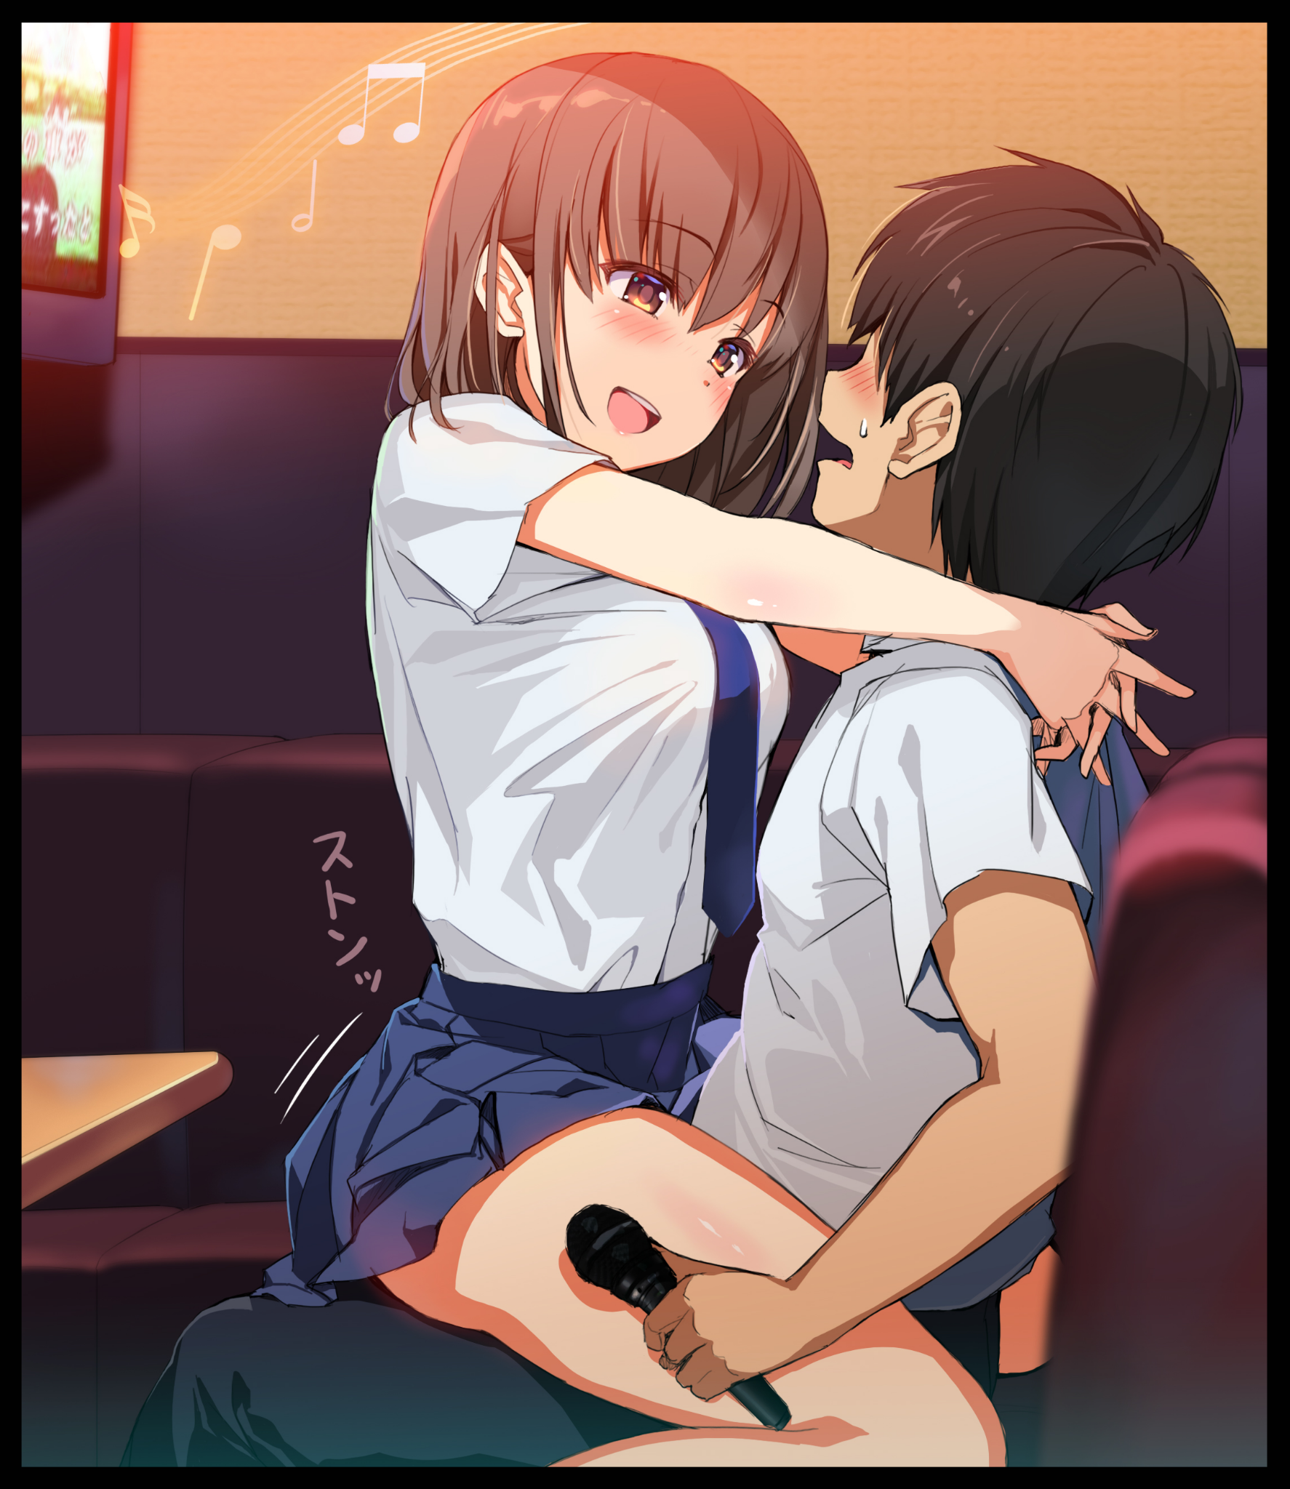

**"Y-You're not doing anything to get me off of you…"**

**"That's because there's…there's a table behind you, you idiot! If you fell…you'd hit your head! Now just, please…get off…"**

**"Not until you promise me you'll stop looking for a way to turn me back! We both know that's not happening so quit it…don't you think I wanted to be a man again?"**

**"So why aren't you fighting this? You're acting like…like a gir*-rmpf!*"**

Taking advantage of his delirium, Sophia moves in for the killing blow. Stifling his protests until his rabid movements calm, breathing at a regular pace as he falls into the warm embrace of the girl seated on his lap, feeling her body's natural warmth wrap around him like an ethereal blanket that threatens to send him to the realm of unconscious sleep as his weary body comes to realize the state it was in after all the toil and time spent chasing useless leads he had clung to out of hope and desperation to right what he saw as an error of his own making. He had been the one to suggest they take the ride that night, and so the blame could only be placed on him.

A train of thought that had blinded him to Sophia as a person, treating her like a figment of his imagination. Refusing to until he saw Simon again, oblivious to how his friend felt about him in return with vehement denials tossed her way until now as his mind struggles to process the feeling of his friends moist lips wrapped around his own, producing soft sighs and gentle grunts as her tongue easily slips by his teeth, coiling around his own while strong hips gyrate and grind, pressing her lower bits against his crotch in a titillating fashion that had Sophia breaking her kiss with a salacious grin on her face, wiping drool away from her cheeks before running a hand over her belly to press down her flipped up skirt, concealing the sight of Jared's hard on poking against the cameltoe pressed up against the blue panties slung around her hips…

**"I'm not…I'm not acting stupid…I've been honest with you so far…but you on the other hand…you've been awfully stubborn Jared…but at least your body's honest about how it feels with me!"**

**"H-How…where'd you learn to do that? What about-"**

**"You're smart aren't you? So you tell me~ Besides…you would've known if you were actually listening to me whenever we spoke…I'll say it again 'dude'...I like things the way they are now…it just took me awhile to get it. Whatever did this is permanent and there's no changing that…and these feelings I have…I know you've felt them too…what Mom and Dad called us…don't you wanna try and live that? Just put away this nonsense…what's wrong with me being a girl? Sophia or Simon…I'm still your friend, aren't I?"**

**"I…I don't know…what if you're being controlled? What if this 'force' *wants* you to act like a-"**

**"It's not your fault alright? None of this is your fault…things just happened the way they did, no blame to be thrown around…okay? So…please…take care of yourself…you've done enough Jared…"**

Allowing himself to be taken into another hug that ends with his face snuggled up all warm and cozy in Sophia's bosom, Jared's weary eyes slide shut from the heavenly warmth of the angel's embrace, allowing for his girlfriend to gently take his microphone away, turning as best she can in her position to interface with the TV and speakers, switching over to a fitting song to sing before dimming the lights, running her hand over Jared's head as if she was coaxing a kid to sleep as the gentle chimes and soothing jangles of a Christmas lullaby begins to play, drowning out the ongoing festive raucous until all Jared could hear was Sophia's singing voice, carrying loud and clear in the enclosed space as all strength leaves his taxed body.

*'How very interesting…'*

Pulling away from the doorway before she could be discovered and ruin the moment, the alien smiles to herself as she begins to move, strolling out of the karaoke establishment and down the street, turning the corner and into a deserted alleyway before shedding her human disguise, revealing her true self as an ethereal creature of animate light forming a vaguely feminine figure that looked like a blend between a cephalopod and a butterfly, loitering for a moment before vanishing just as abruptly as she'd appeared, drowning the enclosed alleyway in darkness without the ghostly glow of cyan green light to illuminate the surroundings.

Her findings were more than adequate for a detailed paper, her experiences worthwhile and enlightening in more ways than one. And despite her purposes here on Earth being strictly academic, she couldn't help but leave well wishes for Sophia and Jared in a future she had no doubt the two would cherish together from this moment onward, feeling slightly better now that she hasn't inadvertently caused the two friends to break off their relationship because of her interference, making sure to put special mention of their names to immortalize them amongst her people when the scripts were compiled and the layout finalized for publishing.

Until then, the peppy alien still had much to do as she prepared her ship for departure, speeding into the depths of space as a streak of light in the evening sky, leaving the rekindled lovebirds to their own devices as Sophia continues to sing her song, happy with the way things were, her mind free to plan out what she and Jared would do from now on…

THE END

*Image Sources*

Image 1 by Abarerumidori : <https://www.pixiv.net/en/users/55432668>

Image 2 by Hiroki : <https://www.pixiv.net/en/users/27631291>