Equality: Genesis – Art Edition

Version 1.0

by MagnusMagneto

(Author's note: I put a good deal of research into writing this story. In a sense, it is the most realistic FMG story I know of that features a woman this strong. It is based on real world conditions, and experimental research that is actually occurring today. What occurs during and after the recovery phase of this story is entirely conjecture, as there is no real world precedent. Please know that I intend zero disrespect to anyone suffering from muscular dystrophy, nor their loved ones. I genuinely hope that a treatment is found someday.)

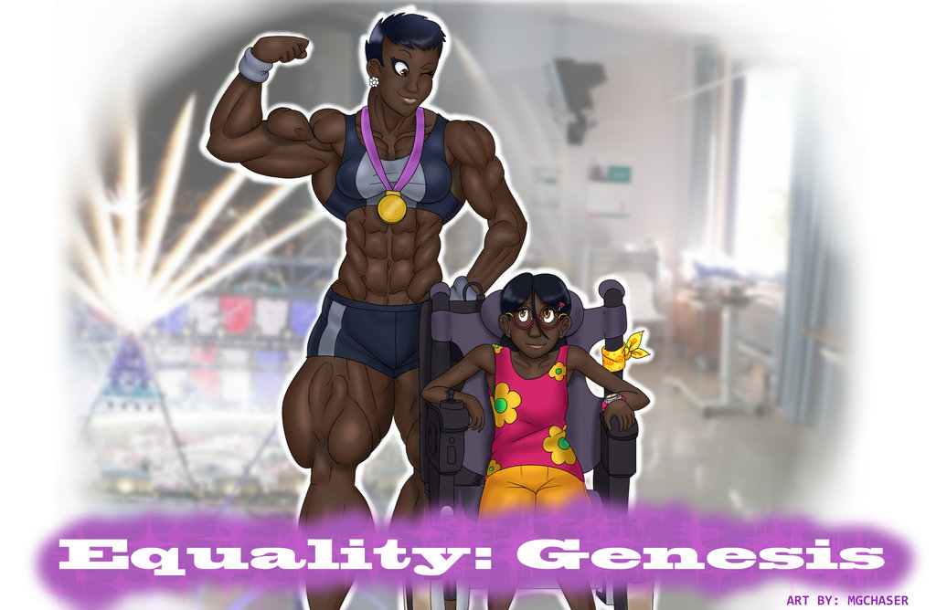

In the year 203X

1.) An introduction, and my school years.

My name is Genesis, and I'm the fastest human being in the history of the world. I'm also the strongest; at least my lower body is. That's not to say my upper half is shabby, I can give all but the biggest of men a run for their money. If you had known me five years ago, that would come off as some kind of sick joke. It still feels like yesterday sometimes, when I was confined to a wheelchair.

I remember the day it happened so distinctly: the evening my parents sat down on my bed and told me I was “special”. It was an adjective I came to hate, for a long time at least. The real truth was I was suffering from muscular dystrophy, but my parents didn't have the courage to tell me that. How could they anyway? Their 10 year old daughter, sister to the high school quarterback all-star, and two equally athletic sisters; it seemed encoded in my DNA that I would also be a superstar, but reality was the opposite. Instead of growing into a healthy, able-bodied woman during puberty, I was going to literally waste away.

The truth was, while my siblings inherited traits that gave them strong, agile bodies, my genetic makeup was missing vital sequences of DNA to naturally develop my muscles. Three years after that talk on my bed, I was in a wheelchair.

Life became a living hell for me. While none of my classmates had the audacity to pick on me or bully me, their stares alone pierced my heart. The way they looked with a mixture of pity of disgust – it drove me to tears when I came home. I was sectioned off to “special” classes, given a “special” caretaker, and refined to the “special” lunch table. As much as I understood the plight of the other “special” students, my mind wasn't like theirs'. I had no friends, which obviously led me to feel alone and isolated.

When I became older, I was allowed to integrate into the “normal” classes. I didn't really understand the point. I was always accompanied by my “special” aide, who had to wheel me everywhere, help me eat, and even assist me in using the bathroom. It was humiliating. In hindsight I appreciate everything she did for me, but at the time I actually resented her. I feel awful for ever harboring those emotions, but she was the biggest reminder that I was “special”; that I needed help because I was broken.

The worst day of my life was when I used my cell phone to do some research on my condition. Within a matter of moments from opening a few articles, I learned that there was no hope. Every muscle in my body would continue to waste away, eventually including my heart. I would not live past 30 except by some divine miracle. I would likely die a few years before that. Even if I did make it that long, it would be a life completely dependent on others, yet fully isolated from life's pleasures – a paradox whose wicked irony was lost on me until I became older.

I was 14 at the time I performed the research, and could not believe that I was effectively middle aged. Cruelly, the bottom of that web page had a related article predicting that my peers would be the first generation to have a life expectancy over 100.

I missed the following week of classes simply because I could not stop crying. Secretly, I wanted nothing more than to die. The thought of my already deformed arms becoming more pathetic, my face growing more lopsided; the fact that I'd soon be unable to feed myself at all unless my limbs were cut off and my family bought extremely expensive prosthetic replacements… Replacements that weren't covered by health insurance, and would require them to go into debt… Limbs that would be wasted when my heart gave out in a decade anyways... It was too much to bare.

Only out of respect for my family was I able to soldier through the next few years of my life. Things became progressively worse. I relied on my parents more and more for everything. Bathing, clothing, even eating; there was seemingly nothing I could do anymore. Nothing except to watch television and think; and my mind was too addled for the latter to do me much good.

I don't really remember much of a single school lecture, as all I could think about was the kids around me. Internally, I was seething with jealousy. Not a single one of them would ever dare be my friend. I felt like a disgusting monster, a mistake of nature.

While the grade-school years presented my classmates with myriad first experiences: sports, fights, dances, love, hugs, kisses (and what those lead into), hopes, dreams, fears… I was left with what felt like a hollow shell of an existence. Nobody would ever feel romantically for me, and I couldn't even blame them.

I think what startled me the most in my experience during school was the way nobody would look me in the eyes. The further my condition progressed, the worse it became. When the condition first started, kids would stare at me, then hide their faces when I looked back. Then it got worse, and they stared for a shorter length of time, their gazes hiding more quickly. More time passed, and they only snuck peeks, never lingering for long. By the time puberty had begun to transform them, they rarely ever looked me in the eyes. At best, some of the nicest, most outgoing girls would sputter out an awkward and forced “Hi there” before quickly growing nervous and leaving.

If this were a Hollywood movie, this would be the part where some popular jock has a fall-from-grace, and seeks my companionship, eventually resulting in our love. If it were a story on the internet, some nerdy, out of shape guy would give up on normal girls and try his luck with me. If it were a newspaper article, then I'd find love with someone else who was “special”. I wish I had story like that to add here. The truth is: I don't. I never, ever made a single friend throughout the course of my grade school career. (Except for my caretakers, but I didn't realize they were friends until much later.)

A few years later I graduated high school. The truth is, I don't think I deserved to. I barely completed any of my work, and the work 'I' did was almost entirely done by either my state-appointed “special” aide, or a family member.

I had to desperately beg my parents to not send me to college. They wouldn't listen to my reasoning that if I was going to die in a decade, there was no point in spending four years of that time and their money on education. I became paranoid, taking their gesture of kindness for some kind of trick to get rid of me. To not have to clothe me, bathe me, feed me. To not have to hear my distorted voice. To not have to watch their daughter literally and metaphorically waste away while their other three children became stronger, smarter, and more successful. Fortunately, I managed to convince them to let me stay home.

2.) In which I was given a chance at life.

The next few months were agonizing. I had no friends. No real hobbies. Nothing I could do productively with the short amount time I held in life (In truth, there were things I could've done, but I wasn't given the emotional tools to understand that). There were zero possible jobs I could realistically perform, and frankly, the prospect of spending any of those remaining 8-12 years working seemed absurd. So… I just watched television.

Then one day, everything changed. That day caused me the second most anxiety of any single date (the first being when I discovered my life expectancy). A pair of pleasant looking people wearing business casual attire, a man and a woman, arrived at the front door. They explained they were with a bio-tech research firm called Equality who were seeking a willing participant for an experimental treatment for muscular dystrophy. Equality's mission statement was simple, if not a bit morally high-horsed: they wanted to use medical research to bring physical equality to all human beings. Treating diseases like my own was one of the more obvious targets.

My parents were skeptical, but I begged (more like screamed, cussed, swore, and threatened as loud as my diminished lungs possibly could) to let them run any experiment they wanted on me. At best I would be cured. At worst, I'd be freed from this existence, and my death could possibly help save others with this ailment. Reluctantly, my parents agreed to let me at least meet the science team and hear their proposal.

The researchers were extremely nice. I could tell they were desperate for someone to accept their deal. There would be no compensation beyond the free treatment and physical therapy if it was a success, plus there was a very real possibility I'd die.

There was one other thing; something that they seemed concerned about my reaction to. They showed me a picture of an x-ray of a mouse's legs. The left side had small deposits of white, indicating the limb's muscularity was underdeveloped. On the right frame was a tremendous white mass, multiple times larger than the left's. I was told that this was the same mouse, before and after the treatment. The mouse originally had muscular dystrophy that was analogous to my own. They then produced a third image, which shows what a regular mouse's legs looked like – it seemed to have half the mass of the after picture.

The scientists then explained that they simply did not know any other way to cure the mice from muscular dystrophy. They had successfully replicated the experiment a few times, but it only worked by changing the genetic sequence in such a way that the body overcompensated how much muscle was produced—always creating roughly twice as much as there should normally be. Every time they tried to alter the sequence to prevent this overcompensation, the treatment failed in numerous ways.

In other words: if the therapy was a success, the baseline mass of my muscles would swell to approximately twice of what they were 'supposed' to be if they never had muscular dystrophy. I was warned that any strenuous exercise would make those muscles even larger.

It was surprising to me how the scientists thought this was some kind of huge disadvantage that would dissuade me from undergoing the treatment; that becoming jacked without effort (and even more jacked with) was a drawback.

Today, in reflection, I can understand why they thought this way. The vast majority of women do not want to be big. They fear being larger than their man; possessing muscles that only a bodybuilder could surpass would be a huge disadvantage, lowering the potential pool of mates by a huge margin.

To an 18 year old with arms so shriveled that she couldn't bring a fork to her mouth, that was the least of my concerns. If anything, I dreamed of becoming The Hulk; that in a bout of rage I would turn into a giant green monster bursting with muscle. I wanted to throw cars around and leap hundreds of feet into the air. I wanted to never sit in a chair again for the rest of my life. I wanted to never stop moving.

My parents on the other hand wanted me to 'sleep on' the decision. I refused. They tried to forcefully take me back home (which wasn't much of a struggle at all since I entirely relied on them to go anywhere), but I relented. I screamed as loud as my weak vocal chords allowed me to. I begged the scientists who watched with mixed expressions, petrified with doubts of their own on how to react. Desperate, my mind quickly came up with a solution – I yelled with as much clarity as I could muster: “Call the police! I am 18 years old and am being kidnapped! This is illegal! I am an adult with free will and I demand to remain here!”

To this day I'm not actually entirely certain how technically accurate that claim was, but regardless my voice was heard. The scientists quickly sprung into action, and my parents stopped, frozen in motion. How could they possibly deny me this? One scientist produced her phone, began a recording, and asked me if I was giving verbal consent to relocate me away from my parents, to which I hastily agreed.

That was the last time I saw them for the next few months.

3.) In which hope was poured into the hollow shell of my existence.

I don't remember much of the treatment itself. Before the operation, the staff all thanked me personally. Thus was particularly memorable because it was the first time in over a decade someone had earnestly done so. The last before that must have been when I was very young, six years old or so, and did some small task for my parents.

It was a transcendental moment: meeting these potential saviors. Their faces had the same emotion as my own. Everyone in the room, including myself, wanted nothing more than for this treatment to work. For the first time, people staring at me was a positive thing.

After signing a tremendous number of forms (I'm unsure if they were even legally binding since this treatment was clearly not sanctioned for human testing yet) I was prepped for surgery. They offered to let me think it over, to give me a night of eating hand-fed cookies, cake and ice-cream; a night of pampering and decadence – a last hurrah in case something went wrong (though they never admitted that). I vehemently declined the offer, begging for them to not let me spend another day in my dying body.

They must have been impressed by my gusto, because the operation was performed that very night.

The surgery's recovery was initially very slow. I was bedridden for a long time, so long that I lost track. It could have been a few days, or a few weeks – I really couldn't tell. When you're confined to one place like that, time becomes something of a tunnel you phase through in alternating spurts of extreme haste and sluggishness.

Despite this, I was alive. Not only was I alive, but for the first time in a decade, I felt as if I was getting… stronger. At some point it became easier to breathe. I could control the passage of air, holding my breath for a short while. A nearby mirror revealed that my face was no longer lopsided, as the flesh had regained its proper tautness. Over time, the heart-rate monitor to my side became more stable, less erratic. Soon, I could move my head more freely. Eventually, one day, I moved my legs. Not just slightly and jerkily, but moved them with a smooth, controlled motion. This in turn caused my heart-rate to skyrocket so quickly from excitement that two nurses burst into my room.

It was around this point that things started picking up. I could now feed myself with relative ease, and my appetite was skyrocketing. The doctors assured me this was a good thing, and constantly provided optimally nutrient balanced food whenever my hunger pangs flared. I treated eating like it was my job; not a morsel was ever left on my plate. I knew that my body needed sustenance to repair itself, to reverse the damage caused by years of genetic defect.

The doctors brought in a strange machine that massaged my legs. At the time I didn't understand what it was for, but later I would learn that it was a device used to stimulate muscle growth in bedridden patients. It was official: I was becoming stronger every day.

I wanted to help this process along, so I would intentionally move my arms and legs around, performing a makeshift kind of exercise. I couldn't believe it, I was actually intentionally working out in my own way.

From this point on, I started looking at life in a new way. Everything became more vibrant and full of life. When I watched television, I was no longer depressed at how I would never do any of those things; instead I was filled with hope. Hope that I would have a working body that could explore the world and live life.

Another week or so passed (I really wish I had kept better track of time during my recovery, but as I said, my perception of things was distorted.) and eventually it was time for me to try and walk. It was rough, and as much as I wish I could report success at my first attempt, it was actually a failure. Despite this, I actually stood on my own two feet, without the help of machinery or someone else, something that had been impossible for years. That night I was filled with determination. I ate more than ever, and performed my makeshift exercises.

A few days later, I finally walked. It was a moment so exciting that I burst into tears, as did many of the people around me. I only wish my parents and siblings could see what happened. Despite the overwhelming triumph welling within me, I felt both guilty and angry that they weren't there. Part of me was still furious that they would've prevented me from getting this treatment; another part missed them, and knew that ultimately they loved me.

Despite my misgivings about my family, my life became a true upward spiral from this point on. Each day I became a little more independent. Soon I was dressing myself, going for walks, and as embarrassing as it is to admit: finally using the restroom and bathing without any assistance.

My body was slowly filling out. It seemed like each day my thin, twig-like limbs increased in size. A week later, I was walking around the facility, greeting people, and watching on as they performed research. My mind was stimulated, and I realized that I was no longer going to die at 30; instead, I was going to be one of the kids from my generation projected to live until 120.

It was at that revelation I made my decision: I was going to make the most of my life. As soon as I was healthy enough, I was going to go to college. I was going to nourish my mind, and learn how to contribute towards the same research that saved my life. I was going to cherish my body, nurture it, and make it stronger. I was finally given a chance at life, and I was going to make the most of it. I was going to become as intelligent and fit as I possibly could!

4.) Making up for lost time

I confided my latest thoughts to some of my nurses. They were all happy for me, but generally unsure if it was safe for me to push myself like that yet. I told them it didn’t matter, and I would accept any risk. Inspired by my determination, they yielded slightly, and –

There was a new roadblock in my path to recovery: my growth had been almost entirely stinted due to my condition. I never underwent puberty, and despite finally being a functional –even healthy- young woman, I had the body of a 10 year old, instead of my biological age of 18.

After thorough review by the team of scientists, they offered to induce a quasi-artificial puberty through manipulation of my current hormones, along with new ones pumped into my system. I had come too far to stop here. I questioned them about how safe it was, and I was assured that it would simply let me grow into the body that I was supposed to have; though I might end up a little bit bigger due to the genetic therapy I underwent. Once again the medical team seemed worried that I would be averse to becoming a large, muscular, healthy individual. Once again I was all for the idea.

The team wasted no time, and spared no expense in the hormone therapy. From everything I’ve read, puberty is typically a lengthy and somewhat uncomfortable process, spanning over years of awkward changes. For me however, it was going to be a bit different. First I was going to undergo a rapid ‘catch up’ period, which would induce the majority of my growth over the course of a year. After this period, I would likely continue growing, though at a much slower and more ‘natural’ rate.

Of course, I agreed to the idea.

This year in particular felt as if it passed by simultaneously quickly and slowly. When I was in the moment, time seemed to crawl along at a snail’s pace, yet in hindsight, it flew by. There wasn’t very much to do. I simply needed to live. As long as I continued to exist, and continued to eat enough food, I was making progress.

My appetite, which was already quite high in comparison to before the therapy, increased even further. I’ve read about how teenagers going through puberty tend to eat a tremendous amount of food, but due to the artificially induced and controlled nature of my adolescence, I required even more sustenance. In hindsight, I was eating something close to 4000 calories a day during this time period.

In order to meet my nutritional needs, the scientists often provided heavily artificially modified food. These treated meals tasted good enough, and generally had far greater amounts of the vitamins, minerals, and proteins I needed, making each bite more calorie dense than it normally would have been. A lot of people are wary and skeptical of food treated in this manner, but looking back at this period of time, it likely saved my life; I’m not sure if I physically could have able to eat enough untreated food to meet the daily requirements to sustain this rapid growth.

A month later, I had grown an inch taller, and I was starting to fill out – in a good way. Since Equality wanted to make sure I recovered properly, I still had to remain on the institute’s premises at all times. I started becoming restless. During the day, I took long walks around the building, visiting the various rooms. I took interest in the daily going-ons of the research firm, and while some of the scientists wanted me to leave them alone, others would actually go out of their way to try and explain what they were doing in very simple terms. This would go on to further spark my developing interest in science, in particular biology and genetics.

With all of this extra energy pent up, I began performing various bodyweight exercises. In my bed I would perform lateral leg raises to work my abs, and out of bed I would do squats. Those two exercises in particular were fairly surreal for me to perform at first. The thought of being able to manually move up and down with my legs at length like that was a complete impossibility a mere few months ago. I tried performing push-ups as well, but doing those properly proved to be too difficult. As a result, I would often get down on my knees, and perform ‘girl pushups’, which was enough to challenge my frail upper body; still, even doing this was a far cry from being unable to feed myself before the therapy.

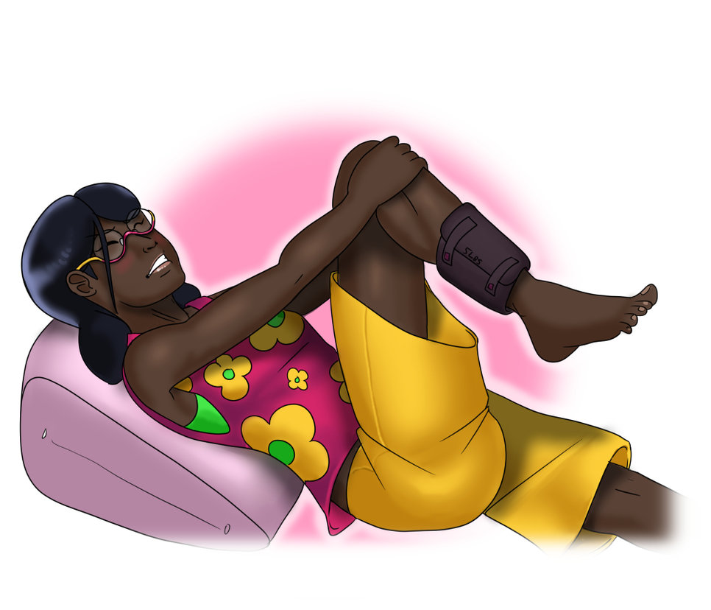

A few weeks later, I had grown yet another inch, and was looking more like a preteen than a child. I managed to convince the overseers that I was ‘stable’, and as a result was given the go ahead to use parts of the facility’s gymnasium. While I wasn’t allowed to lift weights, there was no restriction on running or bodyweight exercises.

It was during this time period that I first came in love with running. In hindsight, I was more jogging than anything else, but it was still enough to get my blood pumping, and cause that pleasurable burn in my legs. Every day I would go for as long as I could before reaching exhaustion. Running had become something of a form of self-expression for me, it was a full reversal on the seemingly insurmountable disability that plagued me mere months ago.

Whenever I ran, I felt as if I could go just a little bit further; as if I could move just a little bit faster. This feeling of progress, coupled with the fabled “runner’s high” made exercise almost addictive for me.

-

Another month passed, and I grew yet another inch. It was during this time that I truly entered puberty, and… without getting into the embarrassing details, I finally started getting a period. My breasts began to develop, and I was looking more and more like a young woman. It was almost startling how quickly all of this occurred. The long, gradual process of puberty (which, from what I’ve read, some feel is already fairly abrupt) had been condensed to such a degree that I could see changes in myself every few weeks.

As expected, the next month yielded another inch to my frame. Equality’s control over my quasi-artificially induced puberty was so absolute, that they could predict with 95% certainty what I would look like in a year. I was hesitant to find out, as part of the joy of ‘naturally’ growing to what I should have been came from the mystery behind just how much potential I had. Still, I reasoned it was better to know fully well what I had in store.

What I discovered shocked me considerably. I was, barring some kind of freak accident, going to grow to a very proud height of 6 feet flat. This already came as a shock to me, but I was told that it was possible that more growth awaited me, as that six feet only accounted for what I should have had, if muscular dystrophy never interfered with my genetic coding. In other words, there was a possibility that the treatment would cause me to grow further afterward. They sounded concerned, as if I would be upset about this. Once again, I assured them that I wanted to be tall, I wanted to be big!

Reaching a height of six feet seemed incomprehensible to me at the time. That would put me above my mother and sister –both tall women- in height, while also placing me at the same height as my father, and just a couple of inches beneath my brother.

4.5)

Another month, yet another inch. Honestly, after going on to study genetics myself in college (woops, spoiler? Oh well.) I think I’m more impressed with the Equality institute’s ability to perfectly control my induced puberty than the initial gene therapy.

At this time I was around 5’4”, and my body had begun to truly take on the distinctly feminine shape that comes with age. I also realized that I was getting… strong. Relatively strong at least. At the indoor track, when I wasn’t running, I was doing bodyweight exercises. By this time I had finally graduated to real push-ups, and regular squats were becoming trivially easy for me. I could crank out 100 repetitions of unweighted squats with little difficulty. My frustration that I wasn’t allowed to lifts weights grew, but my caretakers insisted that it was dangerous to introduce elements that could potentially interfere with my growth patterns (smoking for instance was obviously prohibited, not that I wanted to do that).

A few weeks later I researched more complex bodyweight exercises and started to use those to further my training. Tricep dips, pistol squats, chin ups, burpees, hip raises, various planks, and different types of push-ups such as diamonds were just a few among the myriad movements I implemented. New parts of my body felt sore after each workout, and it was thrilling to slowly improve in these new motions.

I was getting really good a running. My endurance had increased to the point where I could go for multiple miles at once. Sometimes I would go for a run twice a day, both in the morning and in the evening.

Homesickness had begun to set in. My parents tried to initiate a visit with me, but I declined it. I had a message letting them know that the therapy was a success and I was doing well relayed. The truth was, I wanted to wait until I had ‘grown up’ fully before I faced them. Whenever I felt pangs of guilt for putting off our reunion, I would work harder to improve myself, as I wanted to be as impressive as possible for when the day came.

-

By the six-month mark, I looked like an extremely healthy, young, adult woman. I stood at a respectable 5’6”, and enjoyed a figure that most women would be proud to sport. All of the exercise I had done over the past few months was starting to really pay off. Ridges of muscle bulged from my frame at all times, and I looked very much like an athlete who trained a lot. In particular, my legs were quite impressive.

Around this time I started incorporating stretching in my daily routine. To an extent, it was an excuse to get up close and personal with my own legs. Having been bound to a wheelchair for the greater part of a decade, actually possessing a pair of gams – not just any, but strong, muscular ones – was extremely thrilling. During my stretching regimen, I would tactically run my fingers along the smooth, bulging calves, and feel the crevices of my thick quadriceps.

For my nineteenth birthday, I was given the option to request a small gift or two. Many of the Equality staff had taken it upon themselves to give me something else, usually some kind of stuffed animal, food delicacy, or book. I requested lotion for my skin. The request seemed to be somewhat baffling to the men, but the female staff understood. From here on out, one of the staffers, usually a female nurse, would consistently keep my lotion supply stocked.

This may seem like a minor detail, but rubbing that cream on my legs, feeling the contours of my developing muscles; knowing that I was taking an active role to make my skin softer – it was a distinctly feminine ritual. For so long I felt like a little girl, and taking this extra step of care for my body played a large role in helping me feel like a woman.

5.) A glimpse of my future

It was during a routine check-up roughly a month later that I began to truly understand just how fit I was, and just what kind of potential I now possessed. My doctor was a thin, attractive, healthy woman in her thirties named Claudia. She had been my personal practitioner since the start of my time at the Equality institute, and she was someone I both admired and looked up to.

Well… on that day I actually physically looked down on her slightly. At the height of 5’7”, I had actually outgrown her. Still, I metaphorically always did, and always will, gaze upward in her direction.

By this time, my body truly looked like someone of my age. As such, I’ll feel no guilt in describing it in greater detail. I was wearing a poorly fitting tank-top, and athletic shorts that were a bit too short. The Equality Institute did a good job of providing me with new clothing, but there were often periods in between sets of new clothing where my current clothes were a bit small, and my upcoming ones were too big; in these situations, I opted to wear less.

My whole form had filled out considerably with taut muscles. The thin strands of the tank-top looked even smaller next to my round, capped shoulders; my breasts (it was still bizarre to me that I HAD real breasts at all) sat on top of visible pecs; small lats peaked out from underneath my arms, giving my body a small V-taper; the bottom inch of my sharply toned stomach peaked out; and last, but not least: my pride and joy, my thick, dense legs effortlessly stood at attention, and could have easily been mistaken for a male athlete’s my age if the skin on them wasn’t so soft and they didn’t have a distinctly feminine shape.

I practically exuded warmth and energy, a complete reversal from my almost lifeless appearance a mere year ago.

I remember some of our conversation went like so:

“I have to say Genesis… you’re the healthiest 19 year old girl I’ve ever seen in my life. In fact, you’re one of, if not the healthiest young woman I’ve examined, full stop. And believe me, I’ve performed check-ups on a LOT of ladies your age.”

“R-really?” I replied. Despite my glowing health, muscular body, and tremendous prospects, I still hadn’t mentally acclimated to my changes. A part of my psyche still felt like a small, weak child.

“Haven’t you looked at yourself in a mirror?” she asked with a warm laugh, “Go on, flex that arm and you’ll see what I mean.”

I complied, tensing the limb, causing a sizable and supremely defined muscle to pop up. Claudia reached over and squeezed it, “What you have here Genesis, is one of the densest and most genetically perfect biceps on the planet.”

I blushed slightly.

Claudia released her grip and continued speaking: “So, I guess here’s the part where we let you make a choice. As you know, you’re slated to grow to six feet from the induced puberty – after that, it’s possible a bit more growth could occur. Of course, as you’re well aware, six feet is already quite tall for a woman, let alone something above that. I understand that you might desire a more… normal life. To not be in a situation where you’re taller than most men, let alone the vast majority of women. Your muscles will likely also continue to grow, especially if you keep exercising them like this.

What I’m getting at, is… if you’d like, we can cease the artificial stimulation and production of growth hormone in your body so you stop growing. Well – you’d likely still gain a couple more inches, but you almost certainly wouldn’t hit six feet.”

“Uhh… w-why would I want that?” I sputtered.

Claudia shrugged. “Like I said, on your currently predicted course, you will end up quite large. Not in a bad way of course. Most girls don’t really want that.”

“Please Claudia, don’t say stuff like that. Offers to stop growing. I want to reach my full potential. The potential that was stolen from me when I was a kid.”

Claudia was moved. “Say no more.” She smiled, placing her hand on my rounded shoulder. “Now let’s finish the examination.”

5.5)

I continued growing at a consistent rate of an inch a month. My muscles further filled out, and my general fitness progressed. Towards the end of my controlled puberty, I was becoming extremely strong for a girl my age. Few bodyweight exercises could properly challenge me anymore.

One day, after showering, I observed bare body in the mirror. I hope I don’t sound narcissistic, but I looked really good. There wasn’t an ounce of fat on my frame, aside from my ample bosom. Muscles rippled without any provocation, and, to be totally frank, they looked even more defined thanks to my naturally dark skin. Playfully, I flexed my arms, causing a pair of golf-ball sized biceps to rise on command. They were just as ripped as the rest of my form, and it felt great to know those belonged to me. Those muscles were crafted through my willpower, and they were a visual representation of my strength.

My abs had transformed into a steely six-pack, complete with details of definition on the sides. I twisted my torso around, watching with bemusement as the muscles danced in accordance. At the bottom of my abdomen was a deep-seated Adonis belt.

I distinctly remember thinking to myself: “This is my body, and it’s already one of the most awesome bodies I’ve ever seen; yet I’m going to go further. I’m going to bring it to its full potential. That’s the least I can do with this opportunity I’ve been given.”

-

Surprisingly, my last few months at the institute weren’t particularly noteworthy. I came to outgrow many of the people around me, especially towards the end, when I was closing in on six feet of height. I was undoubtably more muscular than the vast majority of the staff, regardless of their gender, though I didn’t truly realize this until later in recollection.

I was accepted to enter college, a timeframe that conveniently lined up so a mere few weeks after finishing my induced puberty the first semester would start. The news made me nervous as I realized that I had been effectively mentally absent during my time at high school. I confided this fear in one of the nurses, and he took it upon himself to teach me study habits that worked for him. I took his advice to heart, and during the last few months in the cocoon of Equality’s campus, I spent at least two hours every night reading various textbooks.

-

Before I knew it, my time at the Equality Institute came to its end. I had finished my period of induced puberty, and stood at the full, proud six feet of height I would have reached had I never been plagued with muscular dystrophy. I was proud of my body, and my mind had been honed slightly from hours of studying the textbooks I never opened in high school. It was agreed that I would spend the remaining few weeks at home before taking off for a new life at the college dorms.

My farewell from the institute was full of tears. I can only imagine what it was like for the staff like Claudia who had witnessed my transformation every step of the way. I presume that to them I was something of a child figure, and they were now watching their bird fly from the nest.

I suppose that anyone who is reading this expects me to go into detail about the reunion with my family. The truth is, that wasn’t nearly as emotional for me as when I left the institute. It was strange – as much as I loved my family, I felt closer to the folk at Equality. My transformation, both of body and mind, was so vast, so sweeping, and so complete, that I was essentially an entirely new person. The weak, frail, apathetic and suicidal girl that had left them was no more. I was strong, full of life, and I wanted to make the most of things.

As a result, the few weeks I spent at home were strangely uneventful. I maintained my routine from the institute, spending a few hours each day running and doing bodyweight exercises, before studying in the evening. My parents didn’t really understand, and being around my siblings was extremely awkward. I was no longer a helpless thing they had to occasionally help; I was now a being more capable than most of them.

Those restless weeks soon came to pass, and eventually I went off to college. Despite feeling uncomfortable about my family, I was still determined to press forward.

6.) College

I’ve read about how college can be a huge shock for most people. Living on your own (kind of – living in the dorms feels like an extended adolescence honestly) for the first time, making your own choices, all of that – it can be overwhelming for most. For me however, the transition was even more pronounced. I had gone from being unable to go to the bathroom alone, to having complete freedom over my actions and my own body. Even at the Equality Institute, I was restricted significantly in what I could do, as to prevent any potential compromises to the therapy.

In hindsight, I realize that it would have made sense for me to want to experience all of the pleasures of life that had been locked off to me. Fortunately, a burning desire to position myself for the best possible future overtook that, delaying the instant gratification that would be offered by extensive parties and loveless flings.

For the first time in my life, I was getting attention from men; romantic attention that is. It was hard to truly understand what was happening at first, and I probably put myself in a few compromising positions. Fortunately, my muscular 6’ body deterred anyone from trying anything bad.

It was during this time that I was able to go to the gym and use the free weights as much as I wanted to. I distinctly remember the first time I stepped into the campus gym. About half of the people in the room were fairly out of shape, and the other half were all sweaty glistening bodies of muscular, moving statues. I was immediately invigorated to start my journey continuing to look like the latter, and push myself even further.

To my surprise, I was actually quite strong right from the start. I had done a lot of research on various lifts beforehand, and remembered the techniques used during my guided training, so I was already utilizing better form than most of the other students.

Picking up a pair of 25 pound dumbbells and curling them was one of the most empowering moments of my life. Feeling the network of neurons and muscles required to complete the motion, knowing that they were actually working; not just working, but that they would be torn, and rebuilt even stronger. It was a complete reversal from the complete helplessness I experienced a mere few years ago.

This moment of empowerment was superseded immediately by the next: I realized that I needed to lift heavier weights, prompting me to move up to the 30 pounders, then the 35’s.

Using the squat rack for the first time was a particularly memorable experience. I wanted to do things safely, so I initially just put a single 20 pound plate on each side of the 45 pound bar, totaling 85 pounds. I quickly found that this was trivially easy for me to squat. I added on another 40 pounds, and found the same thing again; another 20 pounds, still too easy.

After adding yet another 20 onto the squat rack, I felt somewhat worried; could I really handle 165 pounds my first time at the gym? 145 had been so light that I had to be able to. I got underneath the weight, pushed it up with my shoulders, and squatted. I could definitely feel it, but I wasn't incredibly challenged. I did a few more repetitions, looking down at my legs. At that moment, I saw a pair of thick, bulging quadriceps staring back at me. A chord of muscle ran through the center, displaying an excellent amount of definition. I could barely believe it; those were MY quads! Those were MY muscles! Two years ago I was in a wheelchair, and today I was easily squatting 165 pounds with a pair of beautiful, vigorous legs.

I soon concluded that this wasn't enough weight. I added another 20 pounds and repeated the process. My ebony stems bulged outward even more as blood rushed to them for the task at hand. With 185 pounds on my back, the squatting motion was finally becoming somewhat challenging. I completed a few repetitions, but still felt like I could do more. It seemed kind of crazy: the concept of going up to 200 pounds on the squats during my first day actually working out… but I was too excited to forgo the opportunity.

With 205 pounds on my shoulders, I prepared myself to lift the hefty weight. It was a difficult task, but I managed to perform multiple reps with proper form. Knowing that my legs, that a little over a year ago couldn’t even walk, were now capable of lifting this much weight… well, it was a feeling of indescribable euphoria.

6.5)

A couple of months into college, I got my first boyfriend. Without sounding too haughty, with the sheer amount of attention I was receiving, it was inevitable. His name was Paul, and he was actually about an inch shorter than me when we were barefoot. He was in great shape, as he was an athlete. I had virtually no experiences with romances like this, but fortunately I did my homework on how to safely and responsibly have a sexual relationship.

Paul seemed amazed by my boundless energy. Generally, things worked out well between us despite my general awkwardness. Paul didn’t know my past, and I didn’t really feel like telling him. In hindsight, he was likely confused why a tall, ripped Amazonian girl would randomly act so meek and self-unassured.

There were a few issues however. Primarily, he would note the sheer amount of time I spent bettering my body, and often make remarks about it. Little notes like “You know Genesis… if you keep this up, you might get buffer than me…” I find it funny how he never noticed that my legs were always much larger and stronger than his.

His concern was legitimate. My body initially reacted extremely well to weight training. It seemed like every week I was upping the weight on the larger compound lifts. I was eating a nearly inhuman amount of food – fortunately my meal plan allowed me to consume as much as I want at each meal. I became quite adept at sneaking food out for mid-meal snacks as well. I was eating thousands upon thousands of calories, always mindful to get as much lean protein as possible; in fact, when we ate together, my meals would outright dwarf Paul’s.

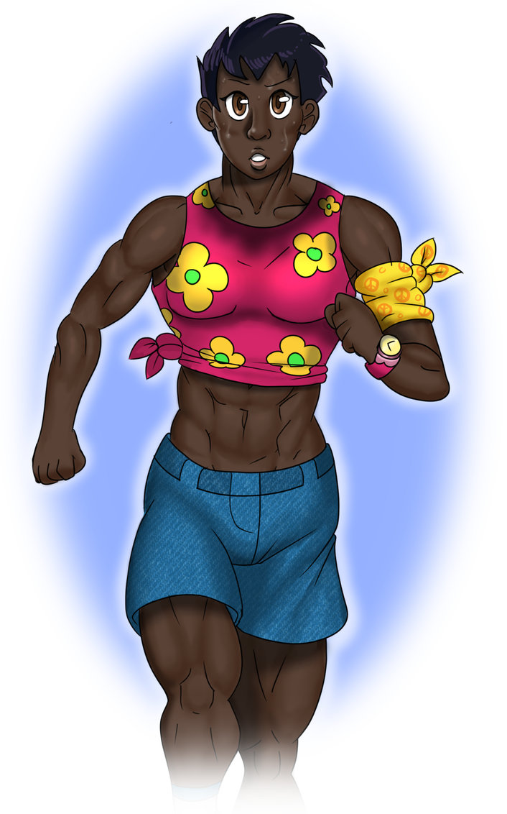

By mid-November, I had unmistakenly eclipsed him in upper body muscle mass and strength; in particular, his lower body paled in comparison to mine. I had also grown another inch taller, and stood higher than him, even when he was wearing boots next to my flats.

Funnily enough, Paul was afraid that I would be upset that he was weaker than me. This was such a strange concept to me. I remember pressing him for more details, asking why that would be a problem for a girl. His explanation was that most women wanted to feel like they were protected by their men. I had difficulty understanding this sentiment. Why would anyone want to have to rely on someone else to protect them? That’s not to say I wanted to necessarily date someone who was weak, just that my partner’s ability to protect me didn’t even register in my mind.

-

In hindsight, I think the routine I developed at the Equality Institute has led to my successes more than anything else. Every day I worked my body. This was accomplished with a daily run, and weight training four times a week. Every evening I spent at least two hours doing homework or general studying; usually I spent even more if an assignment was particularly involved.

Initially, I was terrified that I wouldn’t be able to keep up scholastically. After all, I was merely handed a high-school diploma, and these courses presumed over twelve years of proper study in grade school. To my surprise, and delight, this was never really a problem for me. Even the classes that my classmates thought were particularly difficult, like pre-calculus, were manageable. Sure, at first I had no idea what was going on, but with diligent note-taking, and my nightly study sessions, along with meeting up with some of the university’s tutors, I managed to understand things perfectly.

I closed out the first semester with straight A’s. If anything, I was flabbergasted at how… simple it seemed. The truth, which I didn’t realize at the time, was that I worked far harder than anyone else – to my knowledge at least. A lot of students will claim they spend time every day studying, but in reality, they’re often distracted. My two-plus hours of pure study daily meant I was putting in multiple times more work than most everyone else.

7.) A Confrontation

One aspect of college life I haven’t touched on is my roommate, Sharon. For the most part we got along well. Sharon was a very average girl in pretty much every way. By the time our spring semester, I stood well over a full head taller than her, and possessed at least 100 more pounds of muscle on my frame.

For the most part we simply got along. I hate to say it, but I think my stature instilled some kind of primal obedience in Sharon. This was, of course, something I hadn’t really noticed until I did extensive cross-studies between biology and sociology. What I’m getting at, is because I was so much larger and stronger than Sharon, and due to (what I perceive) her natural inclinations, she simply

She put her hands on my back, the size and width of which were greater than any of the guys I had seen her hook up with. My computer screen had my most recent grades displayed. I had scored a 97 on my Biochem class’s midterm which was then scaled up to a 100 – the highest grade.

“It’s just not fair Gen.” She started.

“Hmm?”

She continued, “Your grades are so good. Like, you’re so damn smart. And your body…” she dug her fingers, kneading the hard flesh, “You’re like a Greek statue. There’s barely any guys on the campus who can compare to you, let alone girls. You keep getting bigger too. I wish I could be like you.”

I wasn’t used to discussions like this. Most people were intimidated by me, or simply showered me with compliments and left it at that. Here Sharon was insinuating I had some kind of advantage over her. Sure, my genetic therapy let me build muscle more quickly than I naturally would have; sure, my height was thanks to my genes and the therapy… But my grades? That was sheer hard work. So was this body. If I didn’t put in the time, I wouldn’t look anything like this.

“Well, tell me Sharon, how many hours did you study for the biochem exam?”

“Uhh…”

I continued, “How many hours have you spent in the gym this semester?”

“Well…”

“Well?” I didn’t want to be a jerk, but I needed to prove my point.

Sharon let out a sigh. “I think I studied about, uh, you know, like ten hours for the exam?”

“Sharon. I’m your roomie. You can’t fool me.”

She sighed yet again. “Aright, fine. It was like two hours the night before.”

“And the gym?”

A sigh once more. “I went like, a couple of times…”

It was time to deliver my verbal riposte: “And how many hours do you think I spent on those things?”

“Gee, I dunno Gen…”

“Well, let’s start with my body. You know fully well that every day I run for at least an hour, sometimes two. Let’s be conservative with the estimate, and say it’s ten hours a week. I weight train four days a week. The sessions usually run longer, but for the sake of keeping things easy, we’ll say I spend an hour each time. That’s fourteen hours a week honing my body. Worth mentioning I kept up this routine during Winter Break.

We’ve been roommates since September; it’s now the first week of April. For the sake of keeping the math easy, let’s just count the time between the beginning of September and the end of March. That’s 7 months, so times 4, gives us roughly 28 weeks, add or subtract a couple of days. 28 times 14 is…” I did some quick calculations, my head quickly whirring through the math, “three hundred and ninety-two. That’s right Sharon, 392 hours were spent building and maintaining that back since this year started. In reality, the number is likely quite a bit higher as I was lowballing the estimates.

As for the books… well, funnily enough, I section off at least two hours a day for studying and homework. Usually I go over this time, but once again, let’s be conservative so I don’t overshoot the numbers. As you probably already realized, that would also be fourteen hours a week studying, the same amount of time I spent exercising. So 392 hours working out, 392 hours studying, add them together and we get… 784 hours bettering myself. That’s a low estimate, not counting time spent in class, and I have perfect attendance.

Now honestly, really, Sharon – how many hours have you REALLY put into yourself so far this year?”

Sharon was trembling. I felt bad – maybe I went overboard. Still, I needed to say my peace, and illustrate the truth behind my success. Sure, Equality had given me greater muscle building potential than I naturally would have had, but that didn’t change the immense amount of time and effort I put into building and maintaining myself. Plus, Equality didn’t do anything to enhance my success as a student – that was all me.

She finally replied: “I… gosh. Well, I guess I may as well be truthful, huh? Well…” she remained silent for a few moments as she likely ran her own mental calculations for comparison, “I guess not counting class, it was something like 20 or 30. Plus, I kinda use Facebook and stuff while I study…” A few more moments passed. “Oh god Genesis. I… I guess I never realized just how much time you put into all of this stuff.”

-

While Sharon never did adapt a lifestyle as traditionally productive as mine, she did make some positive changes. She spent more time in the gym, and actually joined me a few times, where I introduced her to proper weight lifting. She increased her amount of time studying, going from next to none to at least a few hours each week.

It was fun to watch her body firm up, and for small muscles to sprout on her frame. To notice her becoming happier, and her grades increasing; it was great to know I had a positive impact. This in turn inspired me to improve even further, so I could further inspire others.

8.) First Summer and Second Year of College

I was determined to make my first summer break as productive as possible. I took up two jobs: personal training (I didn’t have any certification, but my body was so impressive that finding clients was easy), and landscaping. Between these, I was easily working 50 hours a week – sometimes a few more if I had enough clients, or a landscaping job went on particularly long. On top of this, I continued training my body even further. Admittedly, I slacked on studying, as in I did none at all, but I still consider that summer to be highly productive.

I didn’t see Paul at all that summer, and in hindsight, this was likely a good thing. A mixture of the heat, my determination, and the general isolation I felt (I made no friends in high school, and I still felt like a stranger around my family) led me to pass the time with two separate daily weight lifting sessions, (morning and night), a daily run, and all of the aforementioned work.

I effectively had no real ‘days off’. The few stretches of idle time were spent filled with me revisiting old challenges, like bodyweight exercises – of which I had become immensely proficient at.

-

The result of this work was me returning to college with over 5 grand saved in the bank, and more than 20 pounds of additional muscle on my body. I had also grown another inch, putting me at 6’2”.

This… didn’t go over so well with Paul. At first things seemed good enough. We relieved some pent up sexual frustration, and went on a few dates. Unfortunately, a few weeks into September I knew something was wrong.

With some careful prodding, Paul opened up completely to me. He went on about how I had become so much bigger and stronger than him. It was true. I held easily 30 or even 40 pounds more muscle on my frame. I was undoubtedly taller than him.

He told me that he didn’t want to be with someone that made him feel inferior. I retorted that at least 90% of women, probably more, worldwide must feel this way in their relationships – that their partner is bigger and stronger than them. He said that’s how things were ‘supposed’ to be. I told him that was, by definition, sexist.

Paul sighed, and eventually declared that while he mostly loved me, he couldn’t stay with me if I kept getting bigger. I told him that it was my intention to go as far as I could, and if I’m going to be in a relationship with somebody, then they need to accept this. A few more words were exchanged, and we agreed it would be for the best to end things.

-

I cried a bit… but honestly? It didn’t take much for me to get over the relationship. I just hit the gym and the books a bit harder than usual, and let the endorphins of self-improvement wash away whatever grief there was.

8.5)

My sophomore year was similar in productivity to freshmen year – perhaps even more so since I knew precisely what worked, and what didn’t. I was becoming something of a legend on campus, and frankly, it made sense; after all, how often do you see a 6’2” African-American (any race really) girl with over 230 pounds of sheer muscle on her frame running at full speed as she wears skimpy, athletic clothing? Yeah, not very often (or ever for that matter).

I started partaking in a few romantic flings here and there. This wasn’t to say I was constantly hooking up or anything, but with so many men throwing themselves at me (though many did it… discretely, as if they were afraid of being seen publicly hitting on a girl like me) I had a wide variety of choice.

-

Life was good. My muscles kept growing, though not quite at the same breakneck pace.

9.) A Change of Course

In fact, my Sophomore and Junior years were both rather uneventful. I continued to get A’s across the board. I never really entered another extended relationship, and my ‘flings’ became far less frequent. The truth was, I was too focused on myself – in a constructive way, not a narcissistic one. I would enter these periods of feverlike fervor in which I would spend the entire day eating, working out, going to class, and studying – doing literally nothing else.

I had become an extremely promising student, and my name was known by professors I had never even met. By my Junior year college had become essentially free for me due to a tremendous plethora of scholarships. It seemed all but assured that I was going to go on to graduate school, and probably even my PHD. If I kept up with my current rate, I would be able to specialize into any niche of science I wanted, and work for nearly any company. I had a pretty good idea of what I wanted to do: I wanted to return to the Equality Institute, or another firm like it, and make sure that more stories like mine came to pass.

There’s a catch to this though: I haven’t obtained even a bachelor’s degree… Yet.

To paint the picture, let’s fast forward to the end of my Junior year. I was still maintaining a perfect 4.0 GPA, and my body looked something like so:

I was 6’4”, and I weighed around 260 pounds of sheer muscle. My upper half was shaped in a tremendous V-taper – thick, wide lats and cannonball-like shoulders formed the foundation of a rippling triangle of sheer power. A tangle of traps sat opposite my pecs – a pair of huge armor-like slabs of muscle sitting guard beneath my pert breasts.

My massive 22 inch arms had healthy veins running across, and a deep, serrated split down the middle of their high peak. A washboard of eight clearly defined abs sat in the center of the expanse that was my abdomen.

And my legs… they were quite possibly the most muscular any woman’s had ever been. Pound upon pound of steely flesh were collected in each gam, split, striated and separated to perfection. My hams were comparable to most people’s quads, and my calves were like upside-down hearts the size of bowling balls.

In the gym, I was lifting a tremendous amount of weight. I suppose this is something I should have touched upon earlier, the progression of my weight training – but yeah, I could squat over 650 pounds. That’s not a typo, a mistake, or an exaggeration.

There’s something… strange about my legs. As you might recall from earlier in the story, before I underwent the therapy, the Equality scientists showed me various images of mice and their muscle mass; in brief, the therapied mouse had essentially double the muscle mass of what it normally would have.

That was pretty much me – my legs grew to be far larger than they ever would have, except, there’s one critical aspect that separates me from that mouse: I was actively training my legs, intentionally inducing hypertrophy, while that mouse likely lived in a cage and led a relatively inactive life.

-

With that out of the way, let’s establish what detoured my seemingly unstoppable scholastic train. One day, in the gym, after reaching a new personal best on the squat rack, fit, male student on the small-ish side introduced himself to me. He tried to appear as brave and self-assured as possible, but I could easily tell he was extremely nervous. I was used to this kind of reaction. With this guy in particular, I estimate I must have stood a head taller than him with over 100 pounds more muscle on my frame.

I know that for many girls it’s aggravating to have a guy approach them when they’re trying to work out, but it was rare for anyone to approach me in the gym, and he was pretty good looking. I eased him into the conversation, making it clear I shared some of his interest, and soon enough he offered to take me to dinner at a buffet off-campus – a proposition I found difficult to refuse.

During dinner, my date started asking me various questions – questions that nobody had never really bothered to before. Questions like: What was my motivation? What was my end goal? What did I want to do with my body?

I gave my usual answers, which mostly amounted to me reiterating that I wanted to make the most of life, and be the best that I could. He seemed dissatisfied, and continued pressing the issue. I got the impression that he wanted me to have greater aspirations. I’m not sure if it was derived from his sexual interests, or a genuine concern for my well-being, but it was a refreshing attitude either way.

At one point he mentioned the Olympics. He explained that the Summer Games would take place again in two years, and, if I was indeed natural, then there was no reason why I shouldn’t take place in them. With a body like mine, coupled with my work ethic, it made sense that I should be able to win a gold medal.

9.5)

While that guy was sweet, and we had some very… intense… moments together, a true relationship never formed. Despite this, the idea of competing in the Olympics was seeded into my mind. That had become my new goal – to compete in the Summer Games and win a medal – or at the very least, do my best.

I had never really considered what sport I wanted to do. Without sounding too arrogant, I likely could’ve done, well, almost any sport that permits a large, muscular frame.

Eventually I found a generalist coach and agent to give some direction.

I was told that I was ‘too bulky’ for running; told that if I wanted to win the event, I’d need to cut down considerably. This wasn’t an option for me. Even if I had only been given the opportunity thanks to Equality, I still earned these muscles through days, months, and years of sweat and hard work.

The coach told me to simply go for the heaviest weight division of women’s weight lifting; that there was no way I could possibly lose. It was a guaranteed gold medal – that sort of thing is extremely rare. Deep down I knew she was right, but that wasn’t what interested me. Running was my passion. Running was the impossible task that haunted my thoughts when I was in the wheelchair. Running was how I expressed myself. Running was how I reminded myself of where I came from. I was going to run, and it didn’t matter if my build was ‘too big’.

For the next two years, I put myself through what would be considered a living hell to most.

10.) Training

Angry at the agent, I decided I was going to take things into my own hands. I was going to run, and I was going to make myself as strong as possible beforehand.

There was one person I trusted with helping me train and reach my full potential: Claudia, my general practitioner back at the Equality Institute. My hopes were rewarded. She was thoroughly impressed with (and possibly secretly attracted to) my physique, and seemed genuinely interested in helping me take it as far as I could – both for scientific curiosity, and personal interest.

Claudia provided me with a place to stay, and used her position to bring me the nutrient-dense food that helped me survive artificially induced puberty. To say my training regimen was intense would be an understatement. I was pushing my body hours upon hours each day; I would run for miles at a length, perform interval sprints and other specialized speed training, and partake in two separate weight training sessions.

This was how I spent nearly every single day. Only on occasion I would take a holiday off (during which I would usually still perform some form of physical activity), and these days only came upon Claudia’s insistence so my body could recover.

Fortunately, one of the many benefits of the therapy was my body was highly effective at restoring itself. As a result, I rarely became injured, and whenever I did, I would heal rapidly. Other than my heightened potential to build muscle, and the quality of said muscle, this was the other major advantage I had over any of the other competitors – I was frankly able to train far longer and far harder than any other person.

Of course, I still had to put in the effort. Even if someone had the ability to train most waking hours of the day, would they actually do it? I like to think not, and that it was only through my dedication and willpower that I was able to accomplish what I did.

My efforts were rewarded. While I didn’t gain too much more weight, my strength skyrocketed.

-

Claudia became more and more involved in the training process. She utilized some of the instruments from Equality to optimize my progression. In particular, after each strength training session, she would scan my body and find precisely what parts of my muscles had micro-tears in them (which would indicate they were properly challenged by the workout). Using this data, she would then find any small muscles or areas in my muscles that weren’t properly trained, then give me the optimal motions, weight, and repetitions to induce tearing; after which, I would go and perform those exercises.

As a result, I was, in a sense, performing the most scientifically perfect workouts I could in order to strengthen my body.

-

Over the course of this two years, my strength practically doubled; I reached a (final, to my knowledge) height of 6’5”, and was on the cusp of 300 pounds of muscle. My neuromuscular efficiency was through the roof, as I was capable of squatting over four times my bodyweight, an unheard feat.

Despite this, I still wanted to run, and run I did.

11.) The End

In theory, an entire story of this length, or longer, could be written about my time at the Olympics. The sights, the sounds, the smells; the emotions… it was a whirlwind of sensation. These things aren’t the real point of this tale however. What really matters in terms of my development of a person was the race.

-

As I stood next to the other competitors at the starting point, it was clear that I was the odd-one out. This happened at all of the qualifier events too, but now the collective gaze of millions worldwide was upon me. By this I mean that I was far, far larger than all of the other girls. I got a lot of strange looks, and I’m sure the commentators were giving some interesting words about my appearance.

After a countdown, the race started and we were off. My tremendous trunks exploded with power, and I quickly snatched an early lead. My conditioning was perfect, and despite moving so much mass, I was able to maintain blistering speed without any drops in my endurance.

The excitement, anxiety, and resulting adrenaline had become too much. I closed my eyes, allowing my feet to guide themselves solely off of intuition. My legs continued to propel me; the wind smashed against my face.

A few moments later, I opened my eyes. There it was: the finish line ribbon. Was I really going to be the first to breach it? I didn't dare turn my gaze to check on the competition. Filled with even greater determination, my legs dug even deeper into my reserves of strength, and my speed increased further.

The next few moments felt as if they were moving in slow motion as the ribbon came closer yet. I was going to win the event. Genesis, the girl who was bound to a wheelchair, destined to die an early death in her late 20s, was going to be an Olympic gold medalist. Tears welled in the corners of my eyes.

Suddenly, in a flash, I was directly in front of the ribbon. I threw my arms up in celebration, and destroyed the thin strand, proving I was the first to cross.

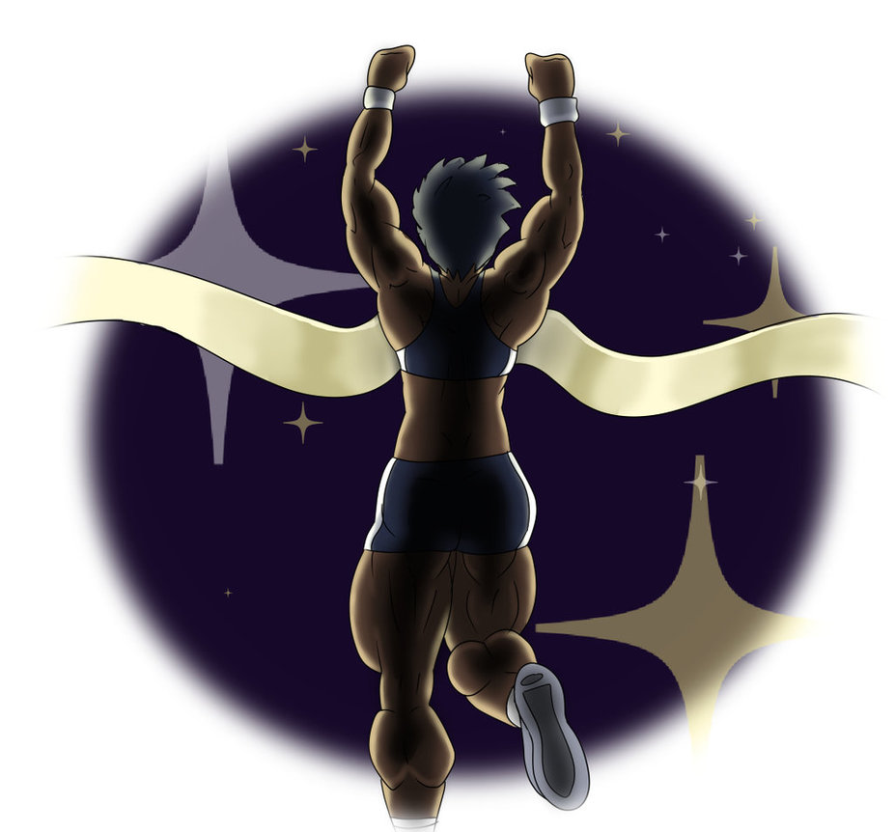

-

That was the greatest moment of my life – so far at least.

I hope that someday everyone who suffered the way that I did are able to have their fates returned to them. I hope that someday, in yet another way, we’re able to achieve a little more Equality.

- The End