BLONDE AMBITION
PART 2

Leah arrived at my house at 7 pm on Friday. I greeted her at the door, opening it and taking her purse and overnight bag. She has such an alluring addictive smile! It stretches so wide across her face. She brushed her blonde hair aside, knocking some snow from her head before taking off her jacket and handing it to me!

“I’m sorry I’m late!” she said while panting a bit, slightly out of breath.

“You don’t ever need to apologize to me, Princess!” I replied!

“Well, in that case, I’m not sorry!” she laughed a little!

“Are you hungry? I can order some food!?” I asked with a smile!

“That’s why I’m a bit late! My mom made butter chicken! It always gives me the worst gas! So I figured you wouldn’t mind the delay!” she smiled and I almost melted right there! She is so cute and beautiful all at once!

“Get me a beer!” she demanded as I hung up her jacket and hurried to the kitchen to get a drink for her.

Leah had come prepared to stay for the entire weekend. Her overnight bag was full to the brim, I had no idea what was indie but it was heavy in my arms. Carrying her beer and bag I followed her to the stairs and up to my bedroom! She had on a grey sweater with a pair of very thick fuzzy sweatpants. Her feet were covered by thick high top winter socks. I walked behind her, watching her thick ass bob back and forth as her soles hit each step. Suddenly she stopped and bent forward, her ass bubbled out so large and wide in my face! I didn’t need any instructions!

I leaned in, driving my nose deep between her cheeks and taking a deep whiff! Even through the thick sweats, I could smell the foul stench of anus! It was deep and wet, almost unwashed! I could feel her anus flex under the fabric as a foul wind squeezed through! It was so spicy! So warm and aggressive! It had a deep odor of Indian food as she laughed and hooked her thumbs under the waistband of her pants.

“Sorry, I forgot how thick these are, you probably can’t smell a thing!” she said while ripping the pants down to her thighs! My nose popped from her cheeks as I looked up, greeted by the sight of her bare ass! She had no panties on!!!

The odor got so much worse but I had never been so aroused! I grabbed each ass cheek and spread them, pressing my nose right to her asshole! I noticed as I was moving my nose inwards that she had a bit of shit stuck to the rim! It was light brown, almost yellow. I sniffed over and over, taking in the odor as she laughed!

“God, you're so gross! Stop it” she said with a giggle while pulling up her pants and running up the stairs to my bedroom. I followed behind her the thick lingering scent of her shit, stained to the tip of my nose.

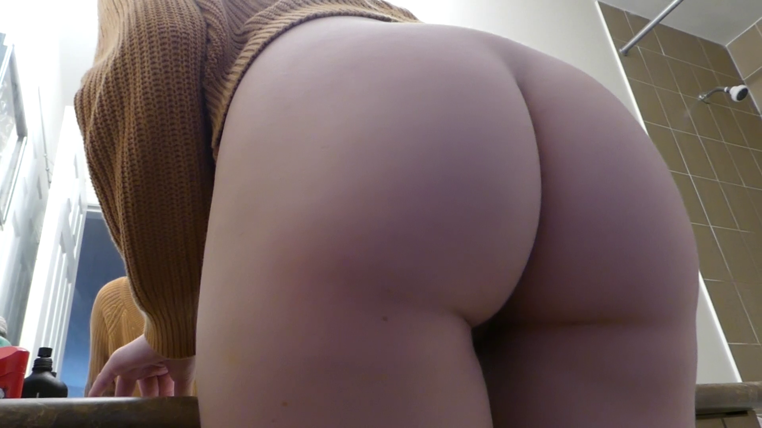

She took her purse and began unpacking some of her things, getting my room set up for herself without even paying me the slightest bit of attention. I was like a statue standing there as she went about herself going through my possessions, making room on my desk for her things, setting up her bong and weed. She walked into the bathroom and laughed, acknowledging me for the first time in over 2 minutes.

“HAHAHA is this your bed?!?!?!” She asked with a laugh.

“Yes, Princess!” I answered as I entered the bathroom.

“It’s perfect for filth like you! Lay down!” she demanded with a tiny giggle

“I got down onto my back, laying down underneath the toilet seat, my would-be bed for the next 72 hours! She looked down at me, a huge smile on her face and a glimmer in the corner of her eyes! I could tell she was enjoying this, the power, the humiliation, having complete and utter control over another life!
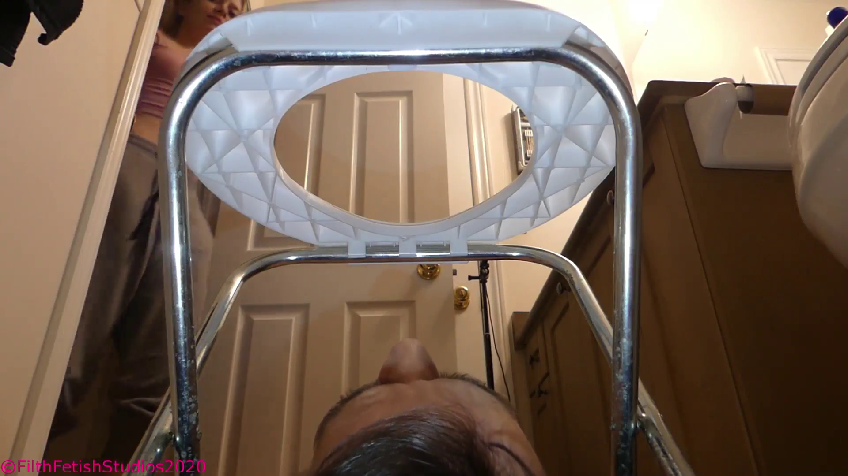

She walked over to me and put her foot onto my chest, pushing down and smiling. I could feel the heat of her sole through my shirt, I wanted to sniff her feet so badly and enjoy the stench!

“So, this weekend, we are going to play a little bit of a game, I took some time out of my VERY IMPORTANT schedule to think of this, so you should be grateful!” she spoke with a hint of disdain.

“You’re paying me $1000 to stay the entire weekend correct?” she asked while putting more pressure on my chest!

“Yes, Princess” I answered…

“Well, since I am SO BEAUTIFUL… I think we should rework things into a game!” she smiled and bent down a bit. Before I could speak, she continued to explain.

“EVERY time that I take a pee! If you don’t finish EVERY DROP, then I am gonna charge you an extra $50, also! I want you to start eating my toilet paper! I don’t think that’s too much to ask considering what else is going in your mouth! Also, EVERY time I shit! You will finish EVERYTHING! If you don’t or you spill, then the money is DOUBLE! Understand?” she asked while pressing her foot down even harder on my chest, it was a bit difficult to breathe.

“I might not be able to afford that much Princess!” I said with worry…

“Then you better do a good fucking job, I don’t know how you can even stand this, my god, the smell! If I am gonna sacrifice my nose for you, the least you can do is make an effort to make it more comfortable for me! Either that or you pay up! Understand?” she said with a grin.

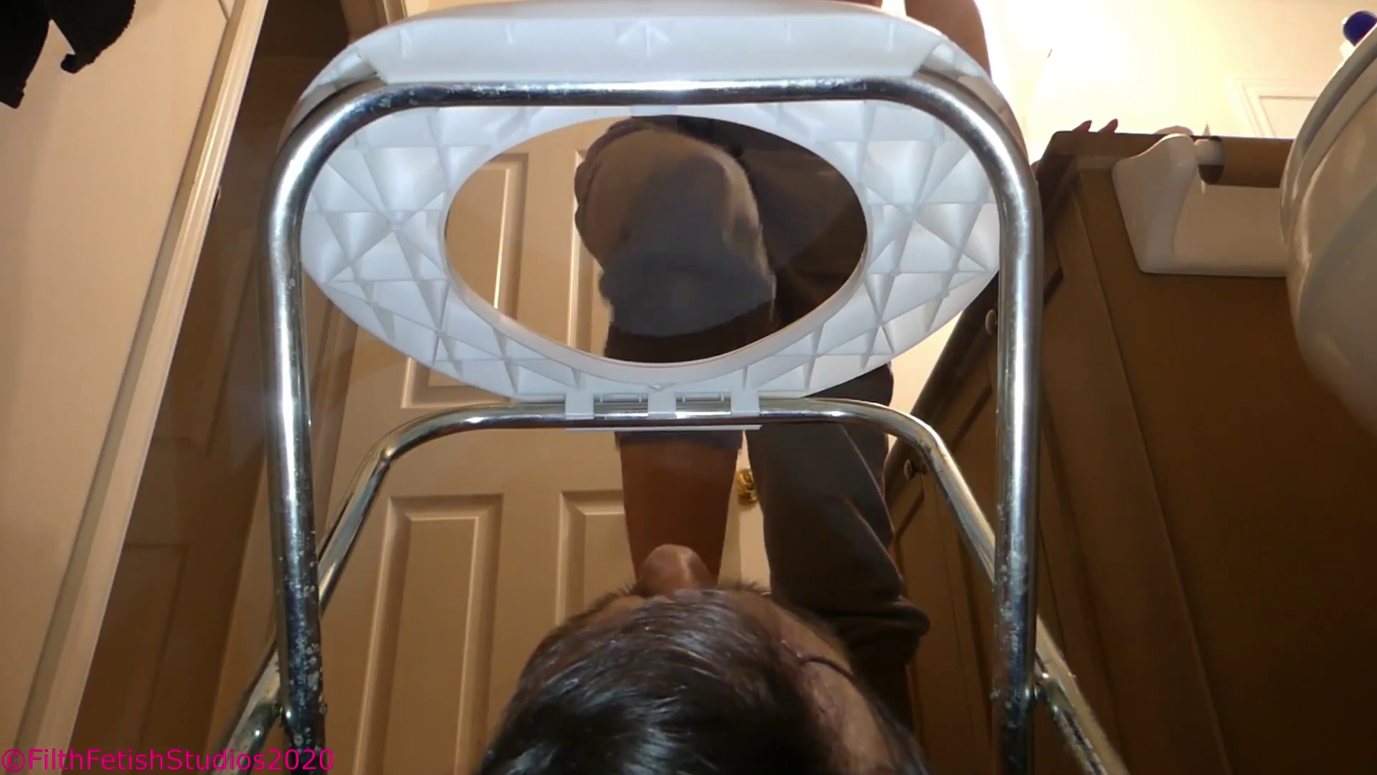

“Yes Princess, I understand” I replied.

“Good, now here’s a little treat for being a quick learner!” she smiled and spun around in a circle, pulling down her pants and plopping her ass down right above my face! Her asshole was inches from my nose, spread wide, puckering! I could see the inside of her rectum as it spread wide and pulled inwards! Suddenly she hit me full force with a spicy rancid fart! My eyes watered from how hot it was. I was still choking when she pulled up her pants and walked out, leaving me alone on the floor.

I got undressed down to my boxers and lay there, knowing it would be a very short time until Leah returned! I could hear that she had already opened a second beer can and had begun streaming some horror movie on Netflix. I have no idea which one, but I could hear the screaming sounds coupled with the horror sound effects.

I have never been so happy or content laying on a cold tile bathroom floor! Just the thought of knowing that only a few feet away in the next room, a beautiful young blonde princess was drinking and eating, relaxing and enjoying herself, all with the intent of using me as her toilet! I have heard a few times from different sources that generally people who are into horror are more open in the bedroom, especially with s/m. Well, Leah was laughing, LAUGHING, at the horror movie she had chosen.

“I had two different types of funnels designed to keep the odor away from Leah, the first was just the top third of a coke bottle cut off so I could let it sit on my mouth. This would allow me to catch any piss easily and not spill all over! The second funnel/contraption was just the center part of the bob bottle with the bottom removed. I was going to use the cylinder to squeeze around my face skin tight while also allowing the viewers (you) a clear view of what was coming out from above!

“I HAVE TO PEE!” Leah yelled from the other room, my heart began to race!

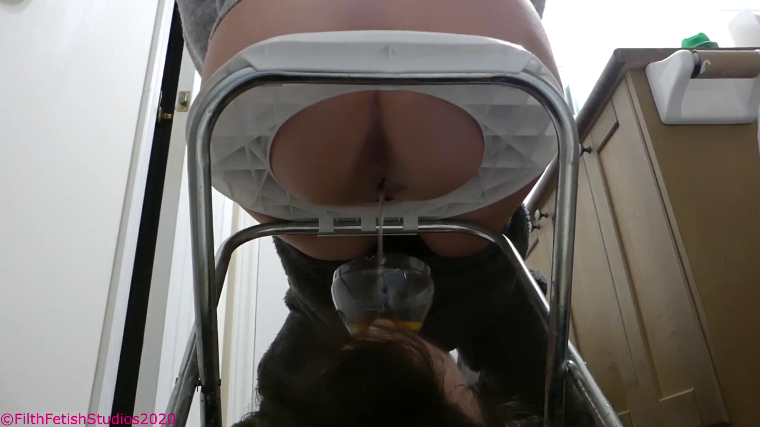

She walked in and plopped her bare ass down above me, the funnel was already waiting for her! The thick stream began instantly, FILLING my mouth with her salty tangy piss! The urine was BURNING hot and steaming from how long it had been sitting inside of her! I started to drink, chugging, gulping, again and again, remembering her words, not to spill or miss a drop! I kept drinking, sucking down her piss, but the flow was too strong, I just couldn’t keep up!

The urine was so strong that it was almost impossible to swallow without flinching! It had a sour almost vinegary flavor that was stained with the flavor of unwashed pussy! My heart was racing but not from excitement, I felt like I may puke! Her anus was just above my nose as I breathed in and out, inhaling the stench! It was so thick making the piss so much harder to drink!

She looked down and I could hear her giggling, she could see I wasn’t able to keep up! The funnel in my mouth was halfway full! My cheeks to their limit! I was crying as the hot piss ran down my throat, filling my stomach!
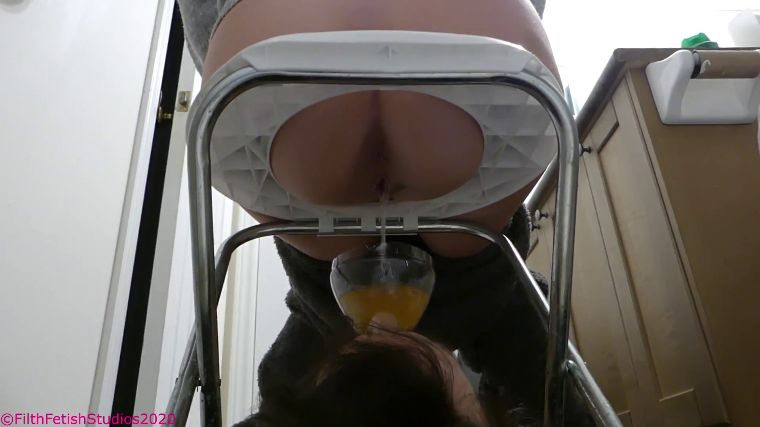

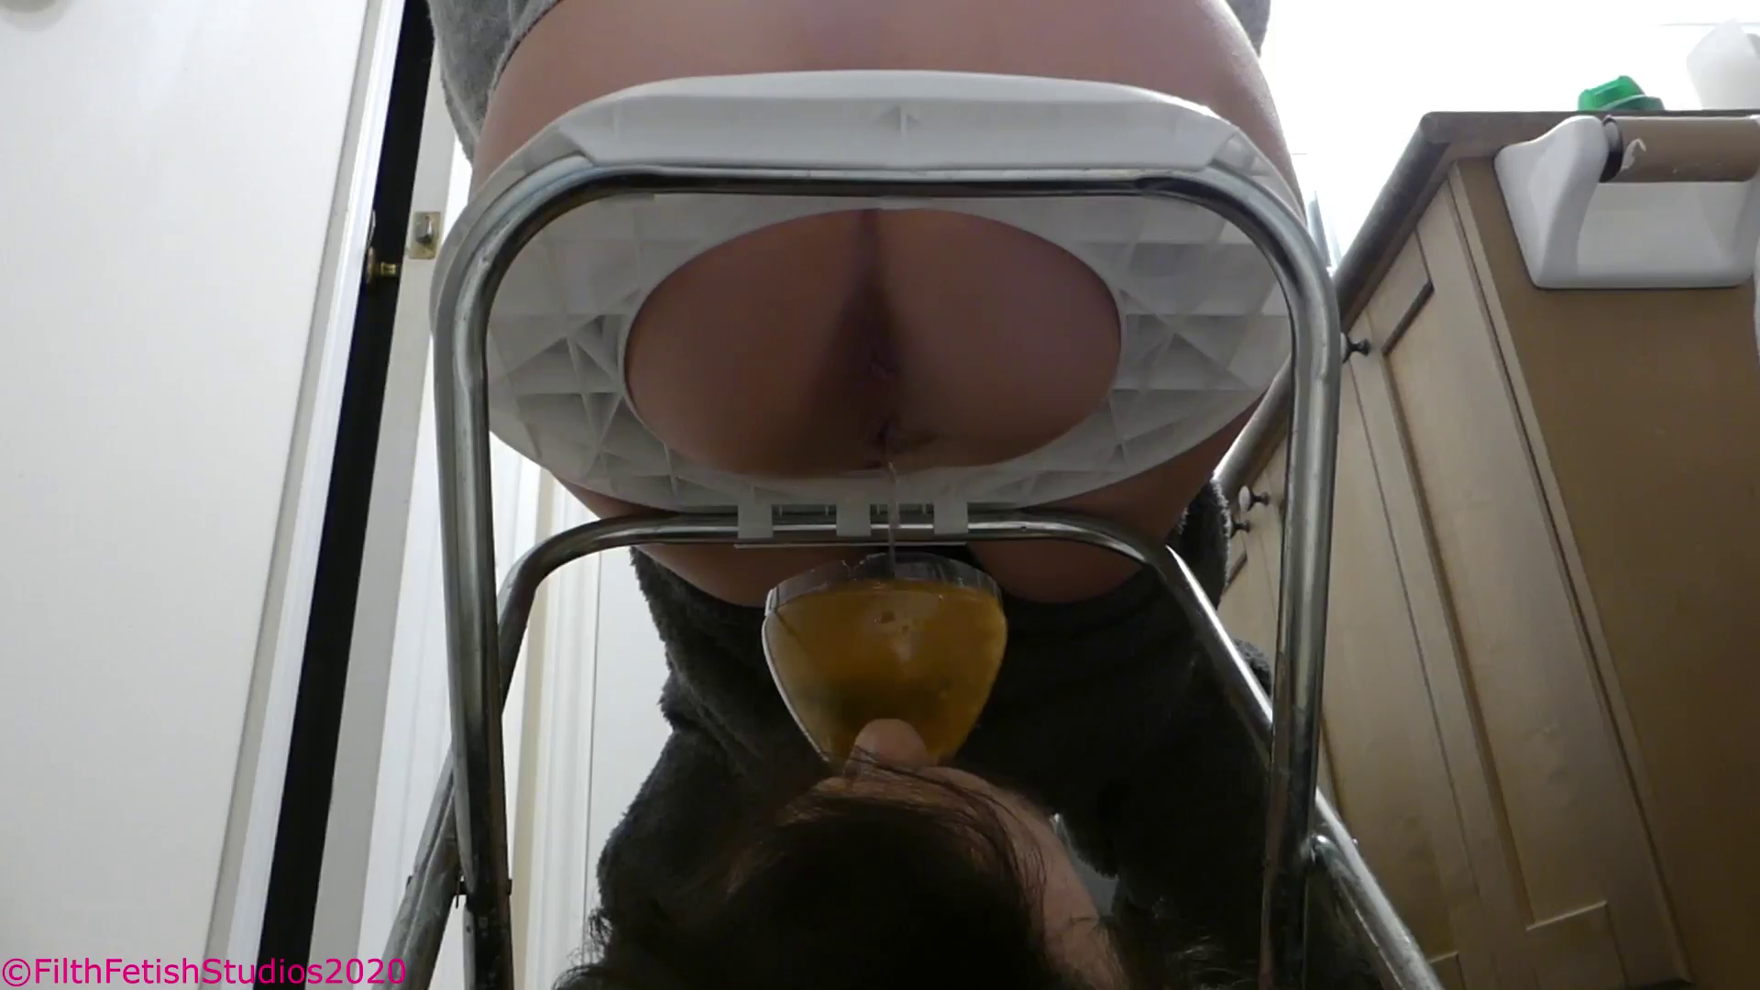

She completely topped off the funnel, I was barely able to hold it upright with my mouth from the weight! My cheeks were still full of her piss but I couldn’t drink another drop! It was running down my throat, trickling into my stomach! The taste was so bad, I was praying for her to get up and leave so I could gag and choke! Deep down I knew I was going to throw up!

“God, you're disgusting,” she said while standing up to wipe her pussy! She dropped the toilet paper over my face before walking out leaving me alone in my humiliation! I choked and lifted the funnel, her piss rained down on my face, smothering me as I gagged and inhaled a bunch into my lungs! That was not my intention but I had no idea how to get the thing out of my mouth without spilling! I heard laughter coming from the bedroom as she called out to me…

“It’s like you don’t even want your money, that’s another $50” she giggled as I gagged on her piss, it was dripping down my entire head!

I leaned over beside the shower and let warm water run over my head, cleaning her urine off before drying off and laying back down. I gladly would have slept covered in her piss but she hates the smell, the one thing she asks of me always is to keep things smelling as clean and fresh as possible for her!

She came walking back into the bathroom and I grabbed the funnel in a hurry making her giggle and laugh.

“Not yet, but I like your attitude! I want Taco Bell” she said while holding out my phone, it was locked and she needed the password.

“1,2,3,4” I answered as she laughed…

“I should have guessed” she walked out but I could see she was opening the uber eats app.

“ARE THERE MORE BEERS DOWNSTAIRS?” she yelled…

“YES, PRINCESS!” I answered as I heard her footsteps heading down the stairs.

I could hear the cupboards downstairs opening and closing as she looked for snacks. A minute later her footsteps came back up the stairs followed by the sounds of a chip bag crinkling and a beer can fizzing as the top was pulled open.

She came back in without saying a word and pissed over my mouth again, I barely had time to get the funnel in place as she FILLED it to the brim again! Her bladder is so big, she is like a fucking camel! She slammed her bare feet down on my chest making me gag and choke, spilling her piss all over my face.

“I thought you said you were good at this?” she asked…

I was still choking on her piss and unable to respond.

“Don’t worry, I’ll make a toilet out of you soon enough! I used to train dogs you know!” she said while cleaning her pussy and dropping the paper over my face.

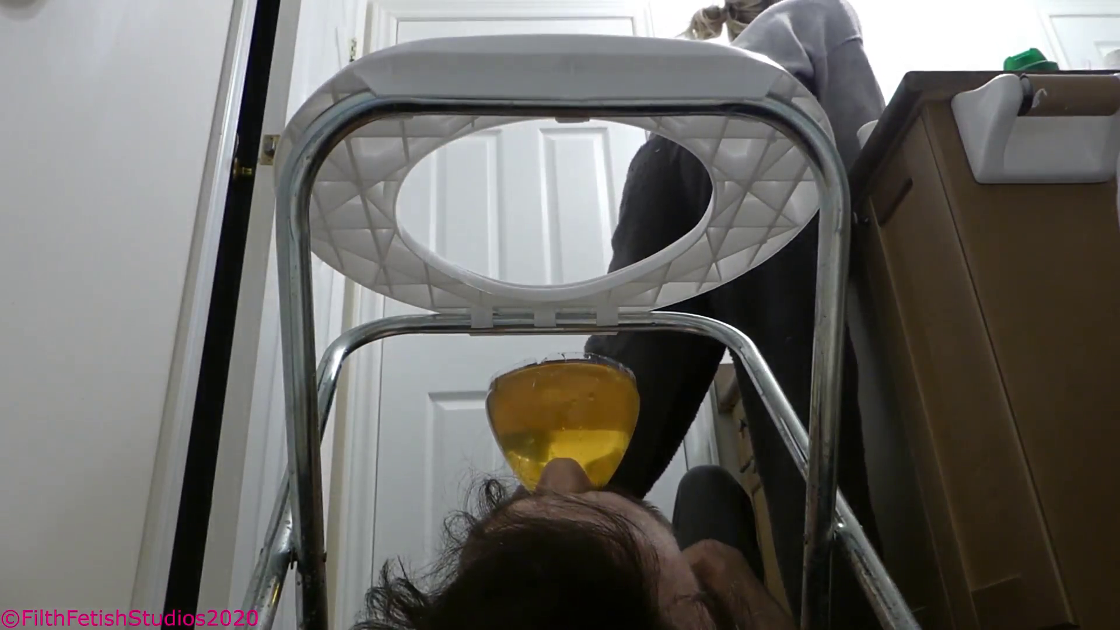

She finished her movie and started another one just as the Taco Bell arrived! I could hear her unwrapping all the food, I was not serving as a toilet the last time she had ordered and she got some sort of combo box with two tacos, a burrito, and chili cheese fries! I am assuming she ordered something similar along those lines.

I didn’t need to wait long, barely ten minutes after she had begun eating before she called out.

“TOILET, I'M COMING TO SHIT! GET READY!!! FAST!!” by the tone of her voice, it sounded urgent!

I grabbed the clear plastic cylinder I had made from the midsection of the 2L pop bottle and squeezed it around my face skin tight making a nice bowl for her feces to land! I had no idea what I was about to endure!

Leah came rushing in, pulling down her pants and slamming her ass down on the seat just above me! I could already see a hint of wet shiny brown in the center of her rectum, the odor was ripe and very wet! My eyes were already watering! Her anus squeezed tight as some short but VERY wet and pungent gas leaked out! I could feel the heat on the tip of my nose! The smell was stained with the stench of beans and cheese, I never really liked Taco Bell.

Leah grunted, it was high pitched and painful sounding as she pushed and a bit of very milky liquid shit landed on my nose! I was assaulted with the odor and flavor as it dripped my upper lip and into my mouth! The cheese smell was so thick, it had a beefy undertone that combined with the spices from her butter chicken made a deadly combo!

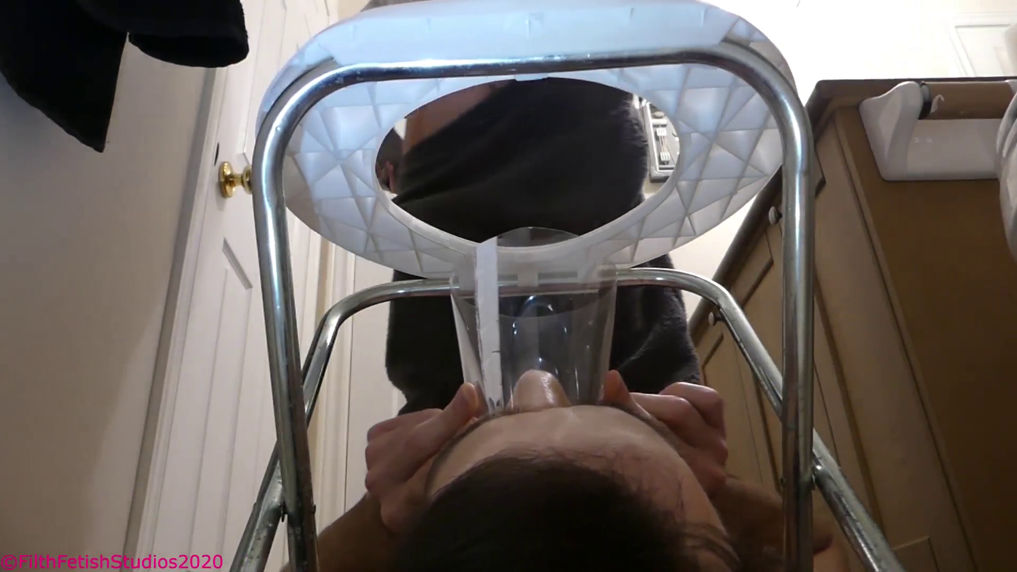

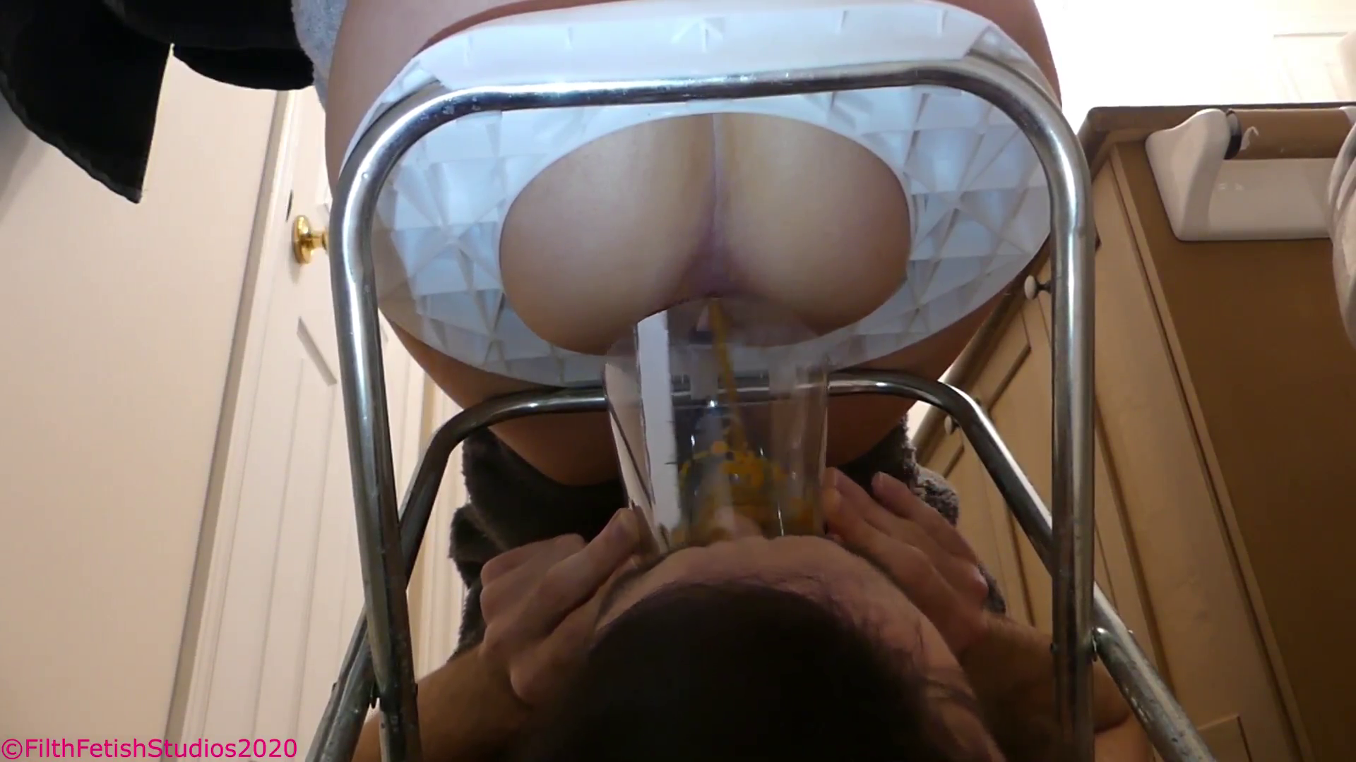

Less than 5 seconds had passed since she sat down, it all happened so fast! Her anus ERUPTED! BLASTING FECES OUT!!! It rained down on my mouth and nose before filling up like a pool over my face! I could hear her moan in pleasure as the hot shit left her colon and pooled up over my unsuspecting face! I was not ready for this, not at all prepared! I should have used the funnel but it was too late for that now! She began pushing as more liquid shit blew out, piling up and making a reservoir of feces above me! It was in my eyes, my nose, my mouth! I couldn’t breathe!! She grunted and pushed as more rained down, I could feel the weight on my face and wanted to cry! The shit was leaking down my throat, running down my nose! I opened my eye for a moment and that was a mistake, it burned worse than anything I had ever experienced!

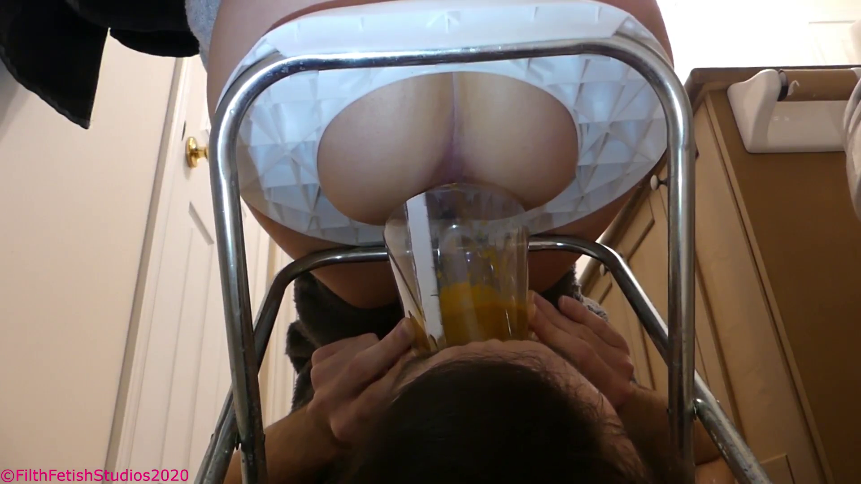

The diarrhea was two inches thick above my face, a literal POOL OF FECES! I was dying underneath this liquid poison! She gagged a little and began wiping her ass, dropping the discarded and dirty paper all around my face. I had not taken a breath in over a minute and needed air! I opened my lips just a bit and her feces PILED IN! It was so wet and slid between my lips so easily! I could feel her hot sticky shit covering my tongue, hitting the back of my throat! it took everything inside of me to hold back choking and gagging until she was gone!

As soon as I heard the door close I lifted the plastic funnel and let the shit POUR OUT BELOW ME! It was like breaking a dam as it flowed out making a mess on the floor. I turned around, my face was covered! I couldn’t even see the camera! I have been a toilet for a lot of women, but my god, nothing had compared to this! Her shit was not edible, not that shit was meant to be ingested, but this stuff was foul beyond belief! It’s hard to imagine someone so hot, so spoiled and pretty, could produce something so horrifying!

The smell was all around me, staining the floor and filling the room with fumes! I could hear Leah laughing and choking in the adjoining room as she called out.

“THAT STINKS, CLEAN IT UP NOW SLAVE!!”

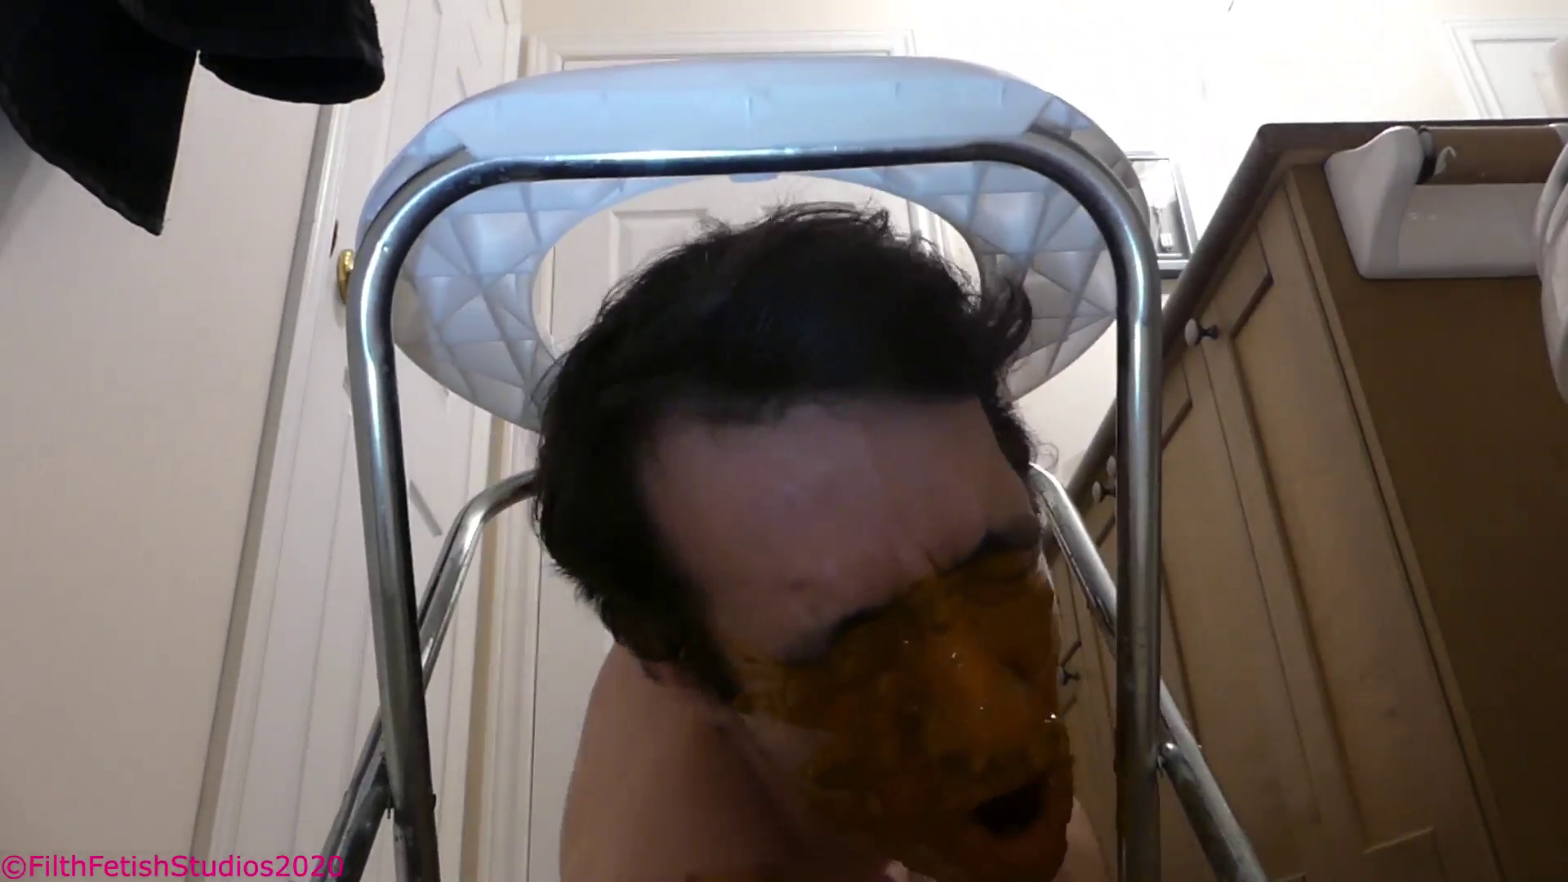

I was in NO CONDITION to clean! First I had to take care of my ruined face!

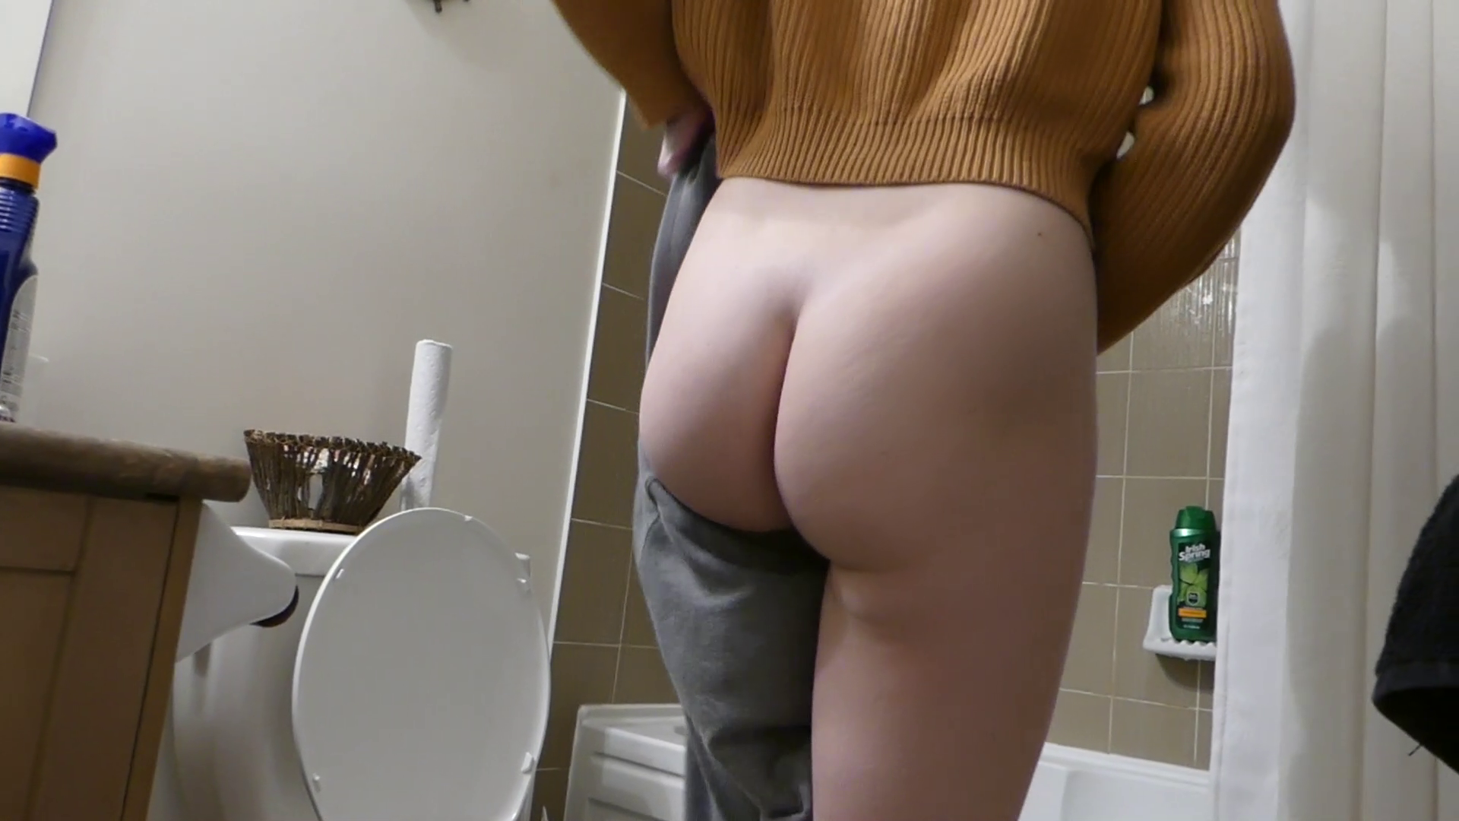

After a very, very, very, very, very, very, VERY thorough shower, I got to work on the floor. There was a puddle of diarrhea that was still fuming! I focused on some bits of rice in the mess and began gagging uncontrollably. It was so foul! I used a paper towel and bleach to clean the floor as she continued to eat and enjoy her movies in the other room. I had such a huge erection, literally scrubbing a spoiled young woman’s feces from the floor as she enjoyed a nice meal! I was scraping her shit from the floor in small piles and plopping it into the toilet when the bathroom door opened behind me.

“You better get your act together, or you are gonna owe me more than you can even imagine... by the time Sunday comes around!” Leah said with a giggle as I turned back to see her looking down at me.

“Ugh, gawd, it stinks in here! I’m heading to sleep, but that doesn’t mean you get to rest! I may be back for a mid-night poop, so be ready!” she smiled and closed the door locking me in with the odor!

The night was long and I was incredibly uncomfortable laying on the bathroom floor, naked with no blanket! Not to mention that Leah had opened the window in the bedroom causing the temperature to drop dramatically! I was shivering and cold! My teeth were chattering and I could still smell the foul odor of her diarrhea all around me! The stink was so thick that no matter how much I cleaned it just wouldn’t go away!

It must have been around 3 or 4 in the morning when I heard Leah getting out of bed! I could hear a lighter clicking as she began pulling on a bong and smoking some weed! My heart began to race! Knew from previous experience that she always smoked in the night before going to the bathroom! I grabbed the funnel (The smaller one, I had learned from last time) and shoved it in my mouth getting ready for her! Less than thirty seconds later she came in!

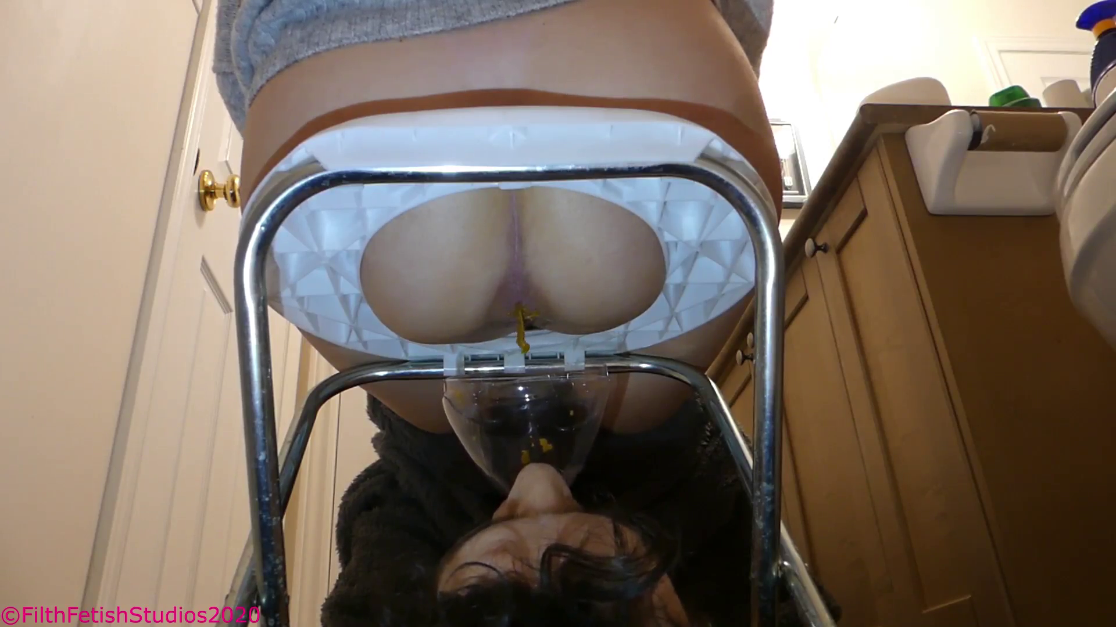

She sleepily sat down, resting her plump thick ass cheeks above my face! Wet raspy farts began ringing out, spraying down from above me and covering me in the stench of fast food and taco meat. One of the farts let a small wet blob of shit to spray loose, it hit the funnel sticking to the side as she moaned! The odor was identical to earlier, if not denser! I could feel my nose twitching as my throat began to close a bit.

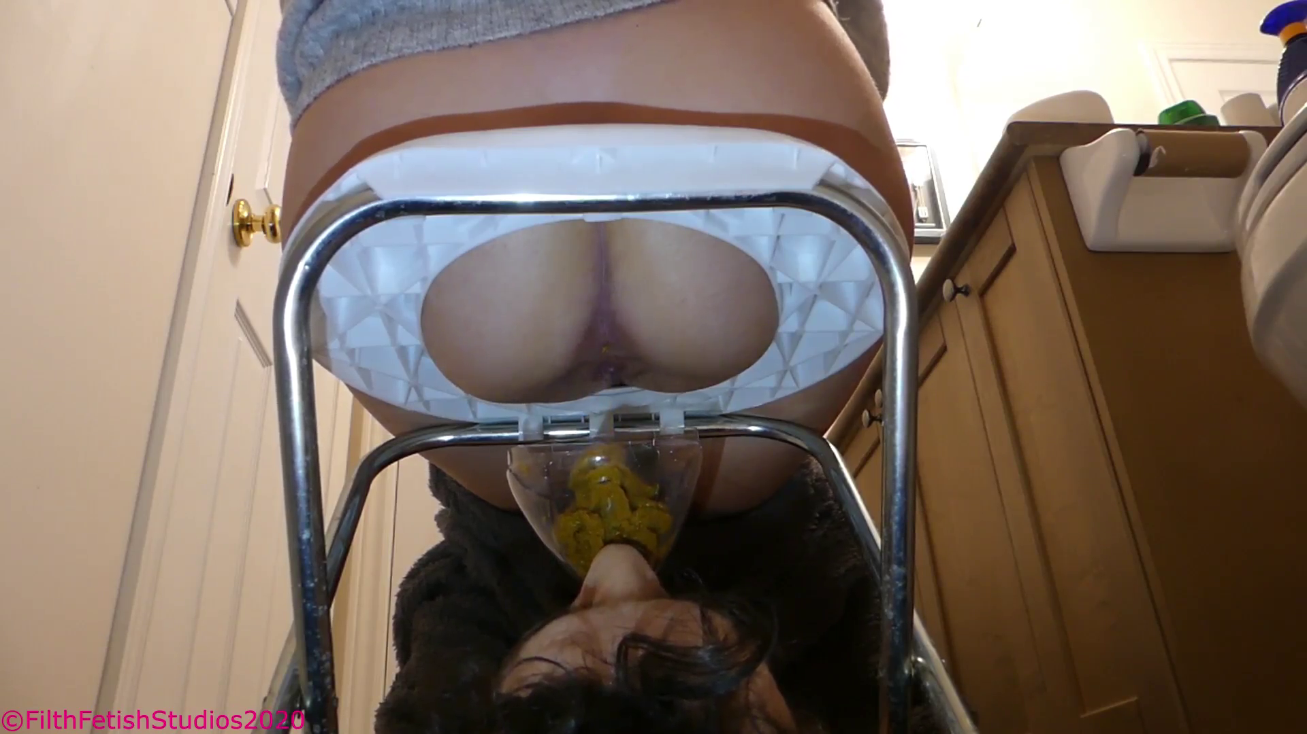

Leah pushed and her anus opened letting out a soft string of shit that coiled down into the funnel! I had to move my head back and forth a bit to catch it all as her farts blew into my eyes! The feces began leaking down and into my mouth, the taste was so bitter and cheesy! I couldn’t hold back gagging! If you have never eaten shit before, having a hot rancid piece on your tongue is like having someone pull on your gag reflex, it takes so much muscle and will power not to puke!

Leah grunted and pushed, more shit dropped down, filling the funnel! It was leaking onto my tongue, dripping down my throat as she stood above me and cleaned her ass! The dirty paper rained down around me with one hunk rolling right down my forehead! I had such a large erection with her soft shit sitting in my mouth, all while she washed her hands above me! On her way out she stepped on the shaft of my dick causing me to flinch in pain, but she didn’t react at all. Either she was too sleepy to notice or she just couldn’t have cared!

The smell that filled the bathroom was terrible! It brought tears to my eyes! I couldn’t hold back from reaching down and grabbing my dick! I could see her in my mind, her eyes closed peacefully as she slept on a comfy pillow, meanwhile, I was laying on my back on a cold floor, my mouth filled with her hot shit! It’s a dream come true!
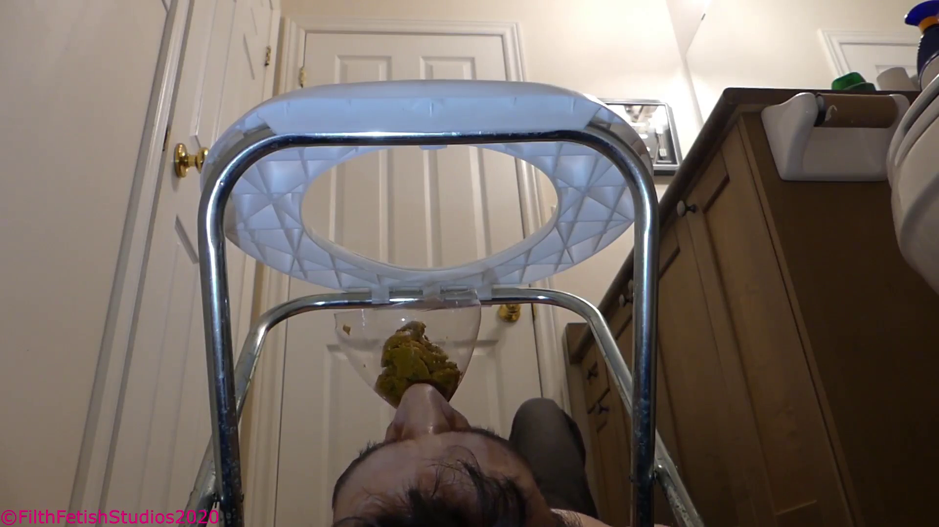

This ENTIRE experience is available in VIDEO format through the discord folders in the BLONDE AMBITION FOLDER! It will be for the $20 and $30 tier and I ask PLEASE keep this private! I would like to continue sharing private stuff like this but can’t if it keeps leaking online!

Part 3 is coming in a few days! It gets WAY DIRTIER no Saturday and Sunday! And Leah has promised to bring her best friend to stay next weekend! so December is gonna be MESSY!

