IN THE YAKUZA’S BED
COMMISSION STORY
BY CHALDEACHANGE
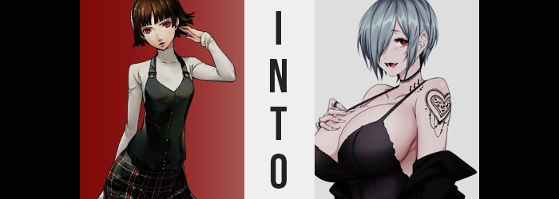

Makoto Nijima’s older sister had been busy as of late, but what else was new?

The younger sibling could hardly fault the elder, because she knew just how much work it was to be a Public Prosecutor as Sae was. If anything, she was thankful that her time as a Phantom Thief had more or less come to a close. She didn’t need to try to keep that secret any longer. Well… not until they went on their planned road trip that summer, that is. At the very least for now they had been offered some reprieve.

While Makoto now had plenty of opportunity to relax some, that wasn’t the case for Sae. The Phantom Thieves case wasn’t one that was really open any longer, at least for the time being, and with all of the shakeups on the law enforcement side of things in Tokyo she had been busier than ever. The past week or so had been one primarily occupied by one specific case: the disappearance of a number of women and the relation the yakuza had to those disappearances.

Sae had amassed no shortage of evidence, and some of it had ended up in the shared Nijima apartment as the prosecutor traveled between her home, office, and crime scenes. So it was becoming something of a common occurrence for Makoto to walk by Sae’s room and see things like baggies with guns in them sitting on the desk of her older sister.

“I’m assuming this isn’t supposed to be out here…” Because her sister was always so well put together and was keen on making sure Makoto didn’t see more than necessary, it was certainly a surprise to the younger sibling that, after waking up and getting ready for school that morning, she found a piece of clearly marked evidence sitting on their kitchen counter.
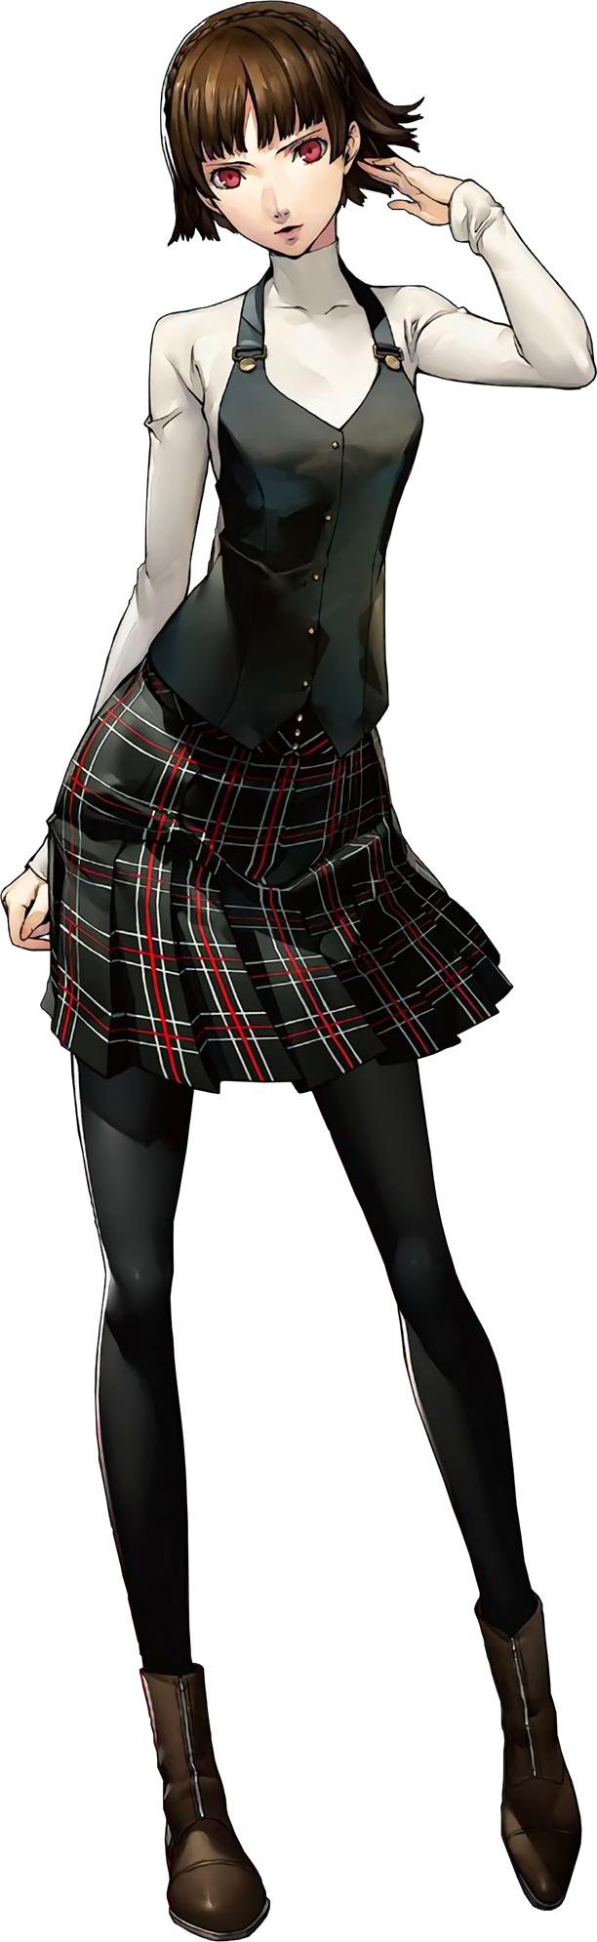
Within a plastic baggy with an evidence code on it was a black ring. There was nothing particularly stylish about it. It was just black steel. “I wonder if this belonged to one of the victims? Women have gone missing, right?” This assumption was certainly a sound one, but unfortunately for Makoto it was also incorrect.

These rings popped up at the scene of every disappearance, and there was no record of them belonging to any of the women that had disappeared. In fact, the police were trying to figure out where they even came from. Some believed that the rings were mementos meant to tie the disappearances to a specific organization, and in the case of every missing person there had been witness reports of yakuza activity in the area at the exact same time.

Even if Makoto had known this, it wouldn’t have changed the actions the followed on her part. “Strange for Sae to leave evidence out like this. Maybe she was called in suddenly?” Thinking that she would do her sister a favor, she picked up the baggy and moved it into her sister’s office. When she finally put the bag down, however? Something caught her eye.

Or maybe it was more like the lack of something had caught her eye.

“Oh no. Don’t tell me it fell out? Is there a hole?” The bag was empty. Had the ring fallen out while she’d transported it that short distance? But there didn’t appear to be any holes in the plastic, and the bag wasn’t open. She was pretty sure it was a crime to take things out of evidence bags without express permission, too. Crap.

Makoto scrambled. She scanned every inch of the floor in her sister’s room and eventually ended back in the hall between her kitchen and the office. It wasn’t until she placed hands on the floor to get an even closer look that she realized where the ring had actually ended up. It was on her leftmost ring finger. “How did it…!?” She absolutely had not taken it out of the bag and put it on, and when she stood back up to pull it off? She found it wouldn’t budge a single inch.

“Stupid ring! Get… off… my… finger!” Even mustering all of her strength ended in failure, but to be fair it wasn’t exactly a simple process to remove a ring that was much too tight. Makoto was quick to bolt to the kitchen, remembering thinking that she might be able to remove it by adding a little bit of soap to the equation. She wasted absolutely no time in turning on the tap in preparation for what was to come, but upon doing so?

She noticed something appeared off about the finger the ring was stuck to.

Makoto didn’t exactly let her fingernails grow too long. It was a personal preference so that they didn’t get in her way. Yet the nail upon that finger extended a full inch past the fingertip. No… It wasn’t just the nail on that finger! One by one, she could see the nails on the other fingers doing the very same thing… and the fingers themselves… “This is impossible!” Each finger grew a little longer and bonier. The girl held them closer to her face in hopes that perhaps she was simply seeing things from a distance. But rather than deconfirm her assumption? She was greeted with the scents of cigarette smoke and alcohol wafting from her own hands.

“They stink!” The girl recoiled away from her own hands, nose twitching as she fought the urge to sneeze from the mixture of foul scents. Why did her hands smell like that? This just pushed her to apply the soap to them faster, the girl meticulously scrubbing them beneath the water and pulling them out again to dry. Even after scrubbing so obsessively, that scent persisted. “Ugh, why is this happening to me?”

While she was understandably panicked, it wasn’t much like Makoto to act in a way that could be perceived as so snobbish – which was exactly how her words had begun to come off. Rather than the ring being stuck to her for the time being, she was much more fixated on the state of her hands: both their designs and their scents.

But the more she inhaled of the cigarette scent, the more restless she became. It was like something within was crying out for something. Being a straight laced teenager, she didn’t exactly know what it felt like to have an addiction, much less could she place a need to that building desire. Instead it just made her shaky and agitated.

“Damn it! What’s up with my clothes!?” Case in point? Even the slightest inconvenience to her comfort was enough to provoke her into lashing out. To be fair to Makoto in this specific case though, the cause that had brought on said discomfort was certainly one worth freaking out about. Maybe not in the way she had, but it was alarming and nigh impossible.

Because the girl? She was growing. The reach of her spine had begun to steadily grow longer, and in the process her limbs were given no choice but to follow suit if the girl weren’t to look like some sort of unevenly designed mess in the aftermath. What resulted was a four inch burst of height that left the maiden’s school uniform sitting against her frame unevenly. Her tummy was left slightly exposed with her turtleneck and vest pulled higher, and her tights had been pulled slightly down her bum and pelvis with more leg to her than they could possibly sustain.

While this was already a very substantial and unbelievable change, things only worsened from thereon out. “Urp!? Damnit!” To Makoto, it almost felt as if someone had gripped both sides of her waist and pushed inwards with such force that they had cracked, collapsed, and stayed that way. It was certainly true that the gait of her tummy was left thinner as a result, but another grasping sensation soon saw her hips torn asunder soon after – giving the band of her skirt no choice but to tear at the sides. As did her panties, but rather than fall to the ground they simply got caught up in the tights that had slid even further down.

“Just what the hell is happening here!? I need a damn smo— HUH!?” She had finally gone and done it, blurting out the thing that she had struggled to identify thus far. She was craving a cigarette? It was a prospect that should have been disgusting, and yet she quickly dashed to a table in the front hall of the apartment. Sae left a pack of cigarettes there in case they ever had company that smoked, and as if it was the most natural thing in the world she had taken one from the pack and lit it.

Brought to her lips, she inhaled deeply. All of the stress she had been feeling melted just as quickly as the smoke touched her lungs. But Makoto, at first, was not used to smoking. She coughed incessantly briefly but eventually adjusted. Because the state of her lungs had, greying some to indicate that she had possibly been smoking for a much longer period. Maybe even a decade. Which, at Makoto’s current age, would have put her at around seven when she had started?

Needless to say, that wasn’t possible.

Nor was it an unchangeable fact. Looking at Makoto’s expression as she exhaled a ring of smoke from her lips, it soon became obvious that the matter of her age was something that would soon become hotly debated. After all, the lips through which she had blown that ring looked to be more pronounced than when she’d inhaled from that cigarette held masterfully between her fingers in the first place.

Thicker, poutier, plumper; all adjectives that went far in describing the shapes of these lips. They certainly gave the taller girl a more mature look, but that was quick to spread into every facet of her face. Skin grew more worn, and her eyes drooped ever so slightly. All in all, it became restructured so that she didn’t really resemble Makoto at all. She looked like an older woman that was pushing thirty. Not even her eyes retained their color, turning red as silver dye washed through her brown locks – which flattened and hung across her right eye.

“That’s the good shit…” She felt much better with a smoke in her hand, and she didn’t seem to give a rat’s ass about flicking ashes onto the floor of an apartment that was looking increasingly unfamiliar. Her uncaring attitude was gradually becoming supplemented by a changing sense of fashion, for pitch black colors had begun to erode any sense of vibrancy from the outfit she normally wore. Fabric was thinning and loosening too, almost as if to make room for something. At the same time, tattoos painted themselves upon her. An elaborate heart across her left shoulder, and what looked like a lace collar of ink around her neck.

The purpose of her loosening clothes was quick to rear its head. Its mounds? Wording aside, it was a matter of observing the maiden’s bosom, for it was swelling with a grotesque amount of vigor. “What the hell!?” It was enough to even take her off guard, and lengthened fingers reached up to fondle what was clearly swelling beneath their grasp. Breasts burned hot as they filled with mighty need, stretching the thinning cloth of upper wear that had gradually merged into a single layer.

As breast swelled, her neckline grew deeper and deeper so that her cleavage was ultimately revealed. Sleeves unraveled, and in turn this rendered the integrity of her top held up by only a pair of thin looking spaghetti straps. Creamy tits largely exposed by this juncture, manicured nails dug into their peaks with reckless abandon. She’d never felt so full! So sexy! So powerful! “Hehe~!” And yet all that called forth from her lips once boobs bounced into their final, G-cupped forms was a vapid, uncaring giggle.

Her mind was filling with raunchier and raunchier things the more she touched herself. Never a sexually minded student, all she wanted at this juncture was a huge dick jammed into her aching pussy. To reflect this it deepened some, all while the flesh around it began to bulge with the same eagerness that her tits had. Whether it was a full ass pushing out the back of a microskirt that had been fashioned from her uniform, or thighs stretching with enough mass that the tights she had once worn tore into intentionally ripped thigh highs beneath thick, leather boots, she looked just as lustful as she felt.

“Hehehe~! Look at all of this key evidence just laying around? I bet my darling will spoil me silly when I come back with this haul!” No sooner than the woman’s transformation had completed did she skip (boobily, I might add) into the open maw of Sae’s office, where a bunch of evidence was just piled up around the desk. The woman could not recall how she had ended up here nor where this even was, but she recognized the things stored here.

One of the guns packed up, for example. It belonged to her boyfriend, the leader of the local yakuza gang. She only knew this because the gun’s holster still had markings from where she had given it a good luck kiss. Seems that it turned out to not be all that lucky considering it had wound up confiscated by the police.

What she did not realize that these memories were fabricated. She was now one of many women that had been transformed into idealized women for the yakuza to take under their wing. They would treat these women right… in exchange for their bodies, of course. But it didn’t really matter, for as far as they now knew they were madly in love in the strong yakuza men that they could recall dating.

Even now, she had taken a plastic bag from the kitchen to begin stuffing the baggies inside of it. No one seemed to be in this apartment except for her, so why not take them? Who was going to find out? The hidden camera in the bookshelf across the way, perhaps? But there would be no records of the woman’s identity even with pictures of her.

“I’m totally gonna get fucked raw tonight for this! And I’m gonna enjoy every second of it!” With the bag full, Makoto began to skip towards the exit with a twisted expression of lust upon her features. Vapid and sex-crazed, it was clear that she would be as submissive as was expected of her by her ‘boyfriend’. And any of the other guys too, if they were interested. She didn’t really mind!

“Now, how the hell am I gonna get back without getting caught?”

Sounded like a problem for the future Makoto Ito.

She hadn’t even realized that the black ring had fallen from her fingers and had remained on Sae’s desk…

