ALL THAT GLIMMERS
FIRST PERSON STORY
BY CHALDEACHANGE
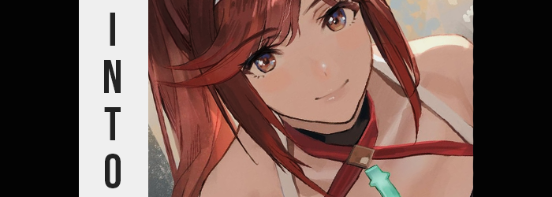

It felt like, after years of the pandemic impacting game releases, that things had finally begun to go back to normal. Or maybe it was more like that all of the games that had begun development before and during that era had finally reached a point where they could be released – because in 2023 it felt like there was far too much to play. Up until the summer began there was big game release after big game release; to the point that I yearned for my younger days when I had time to play a million things at once.

As you got older, however, you were saddled with more responsibility. I could only watch as I bought more and more games. My backlog continued to grow bigger and bigger, and my time was more and more limited. It seemed like I was stuck now in a never ending cycle of buying new things just to not have time.

“Xenoblade Chronicles 3 released a new story DLC too? God…” I still hadn’t even managed to make time to beat the base game because of everything else going on! As much as I had wanted to dedicate the time to it, there just wasn’t the time. The base game had come out almost a year ago now and I was still only about halfway through it. But hey if anything? Xenoblade character designs were always bangers. I could at least admire… the new… “Is that Pyra’s daughter!?”

It was pretty much undeniable, wasn’t it? That flaming red hair and matching eyes, that Core Crystal embedded above her breasts… not to mention the size of those breasts themselves. She looked like Pyra from Xenoblade Chronicles 2, but she clearly wasn’t. Even her name was different. “Glimmer…” Okay, I wouldn’t comment on how silly of a name that was. Would Rex give his child a stripper name?

…Probably.

Admittedly I had a big soft spot for Pyra and Mythra from the second game, and so the sight of Glimmer alone was enough to get me to want to play the DLC. “But I still haven’t beaten the base game…” I didn’t know how relevant the main game was to the DLC, but it probably was somehow, right? That was how the Torna expansion was compared to the second game after all. But could I make the tens of hours to complete it when I had other things I was trying to play at the same time? Probably not.

“I wish I could get to know her another way…” Of course, I was thinking about things like watching playthroughs on YouTube. The DLC had been out for a while by this point, so I could definitely find one. But the Nintendo Switch I was holding in my hands at the time appeared to have different plans based on what I had said. Because it began to glow. Not just the screen, but the whole console. “…Huh?”

The weight of the console disappeared from my grasp as the light turned a bright green before piercing my chest. Or that’s what it had felt like, but it didn’t hurt. My chest felt a little heavy after, and I could see the light still glowing from beneath my shirt… in the shape of a Core Crystal. “There’s no way!” Pressing fingers against the light through my shirt, it was hard. Like a stone. And it was embedded into my skin!

Seeing as I was at home alone, I immediately pulled my top up and over my head to get a look at it. There really was a Core Crystal embedded in my chest. Knocking on it? I could feel the vibrations wracking through that chubbier form of mine. Or well, it had at first. But the crystal began to glow once more, prompting me to worry about what a glowing rock stuck into your body could do. In this case, however?

“Wait, am I getting thinner?” I stood there gawking at not only just my chest but the exposed tummy beneath it. Inch by inch my gut retreated until it was flat as could be, stretchmarks fading away while the depth of my navel was highlighted by… toned abs? “Shit, not just thinner!” It wasn’t just my tummy! My chest, arms, and legs were all toned as well. Not muscular but toned; still a far cry from what I had just been moments prior.

But evidently that had come with a cost. “Hey!?” I didn’t really know who or what I was hey-ing at (the Core Crystal on my chest, evidently) but it was the shock of my point of view beginning to drop that had prompted it. I was a fairly tall guy, at least taller than average, but that rapidly wasn’t the case whatsoever. My limbs shortened and as a result my torso did in kind. Which was for the best else I might have looked proportionally bizarre. I was already shirtless, but the trackpants I was wearing had definitely bunched up around my knees because I’d dropped all the way down to 5’3”.

“I guess I was always wondering what it might be like to be shorter, but not like this!?” A weird voice crack left me confused. Or perhaps it was the opposite. Hearing that voice gave me a realization because I recognized it. From a game. And considering the Core Crystal in my chest and the fact that my body had gotten smaller, could it have been…? “Am I becoming Pyra!?”

Wrong. But it would take me a bit longer to realize that.

To be fair, most of what occurred from that point on seemed to suggest I was correct. My face was gradually changing towards the feminine, features softening while my thinned face became narrower by design. I pursed my lips, feeling that they felt fuller than they ever had, and a wriggle of my nose vaguely relayed to me that it was smaller. Even my eyes felt heavier – largely because my lashes were longer and thicker, but the shapes of those eyes were different too. They were bigger, rounder, and irises had shifted to a crimson that would have supported my earliest theory.

But I also looked younger. Like twenty at latest.

“Ngh!? I guess that wouldn’t feel pleasant, would it?” Still believing I was becoming Pyra, I didn’t question the sound of my voice any longer. It sounded identical to her voice actress’ voice though the delivery was a touch harsher. I was forgetting that Pyra wasn’t the only character that she voiced, but it also wasn’t Mythra nor Pneuma. Regardless, I was speaking about the new vacancy between my legs. I keenly pulled them down along with my boxers, shorter and slenderer legs kicking off my legwear so that I was completely naked. My dick was notably absent, instead a smooth curve covered in red hair ran down to my new pussy. I was a little coy about touching it just yet though.

If I seemed dismissive about the fact that I was transforming into a woman, perhaps that was because it was something I had always wondered about at least a little. Had I been born to be a woman in actuality? However this was happening, it had reminded me of that curiosity. No, it was more than a curiosity. I’d always seen myself as a woman deep down.

And so I wasn’t at all bothered by a dramatic widening of my hips that irreversibly altered my silhouette towards the feminine. Nor was I at all concerned by the fact that my thighs were thickening to a plush girth. It was the sort of padding that would be nice to lay one’s head upon… If they weren’t my own thighs, that is! “Wow, I really am becoming hot.” But Pyra was hot after all. Figuratively and literally. I could feel my ass cheeks jiggling as they became rounder and bouncier, and I arched my back to get a good look.

If there was a mirror in my room I might have realized my assumptions were incorrect by this point now. I did bear a striking resemblance to the Aegis Blade, Pyra, but I wasn’t identical to her. I was a little shorter, my thighs and butt were a touch more compact than hers, and even my face was a little off. The best way to probably word it was that I looked cuter than Pyra. A little younger and less experienced.

“Mmmn…” This was further demonstrated by my bosom, which began to swell in a similar manner to my ass and thighs. I bit my plump lower lip while resisting the temptation to grope myself as I watched nipples expand into puffier, pinker versions of themselves. They led the charge for what expanded beneath them, skin stretching around soft fat that rounded out my pecs and ultimately formed a pair of tits that grew… and grew… and grew until they were roughly E-cups. Every breath I made prompted them to jiggle, every movement provoked some sort of bounce.

While they were massive and their weight surprisingly hefty, a strange thought crossed my mind. “Aren’t these too small? Hmph. Not like it matters, I guess.” I felt like Pyra’s were bigger than mine. And what was with that feigned indifference? That wasn’t part of my own personality or Pyra’s. “Wait…” The truth ultimately did strike me just in time for the hair atop my head to turn a pale crimson and grow. Pyra had a short haircut, but my hair elongated well past that. It fell farther and farther down my back, all the way to the backs of my shins while lengthened bangs were swept to the right. It was all soft and silky, but the length and even the color…

It wasn’t Pyra’s hair.

It was Glimmer’s.

I blinked more than a few times, utterly stunned by this realization. But it made sense, didn’t it? I’d been pining about the Xenoblade Chronicles 3 DLC just before this had all happened because of Glimmer specifically. If my desires had been granted somehow because of that, then I wouldn’t have become Pyra. But still…

“Uh… Did I just turn into Glimmer? I mean, of course my name is Glimmer! But… Ugh! I didn’t mean to say that!” The sight of me getting snippy with myself might have been unusual, but could you really blame me? I’d just been turned into the spitting image of a video game character, and a woman at that! Something I had desired, but that desire was poorly expressed by my new attitude. It wasn’t even just surface level! This feistier personality I was demonstrating wasn’t my own! I was usually way more reserved! I just… couldn’t help myself! “I can’t even refer to myself with a name other than ‘Glimmer’? Is that how it’s really going to be?”
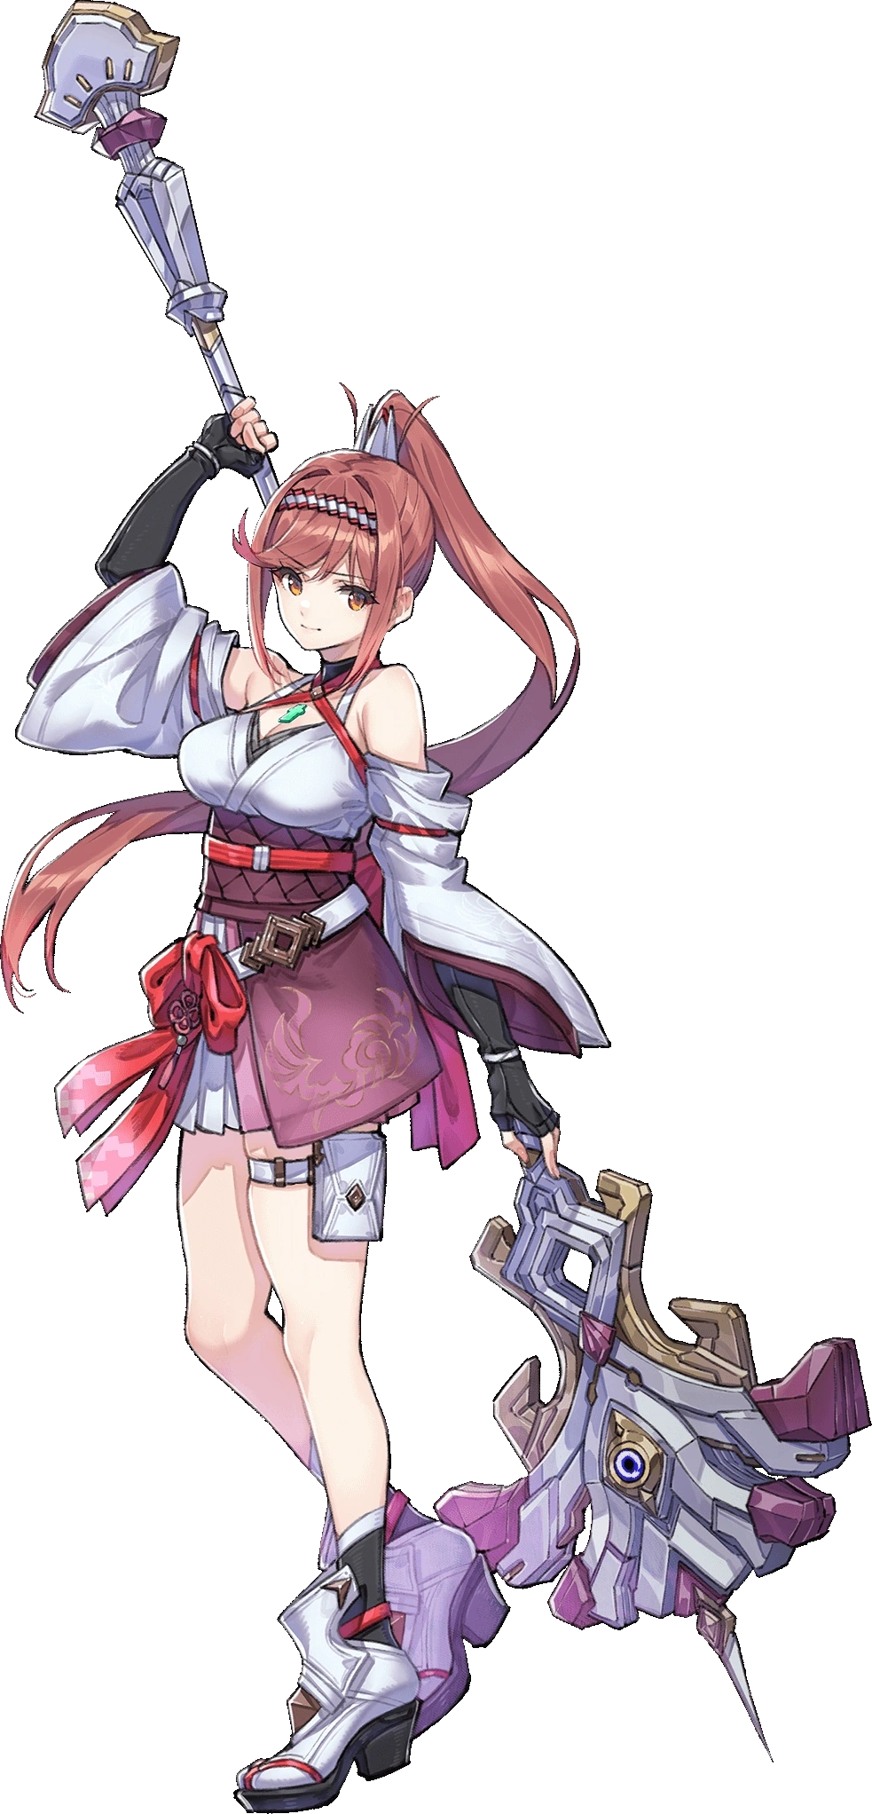
An agitated sigh escaped my lips. I was Glimmer now. On the bright side I was definitely younger now, and I was pretty. Sexy, even? So I had plenty to be confident about. My new attitude definitely needed some work though, not that I could force it to change. “What about my life though? It’s not like…” It wasn’t like my past had changed? I had been about to say that, at least up until I reflected back on my memories. I was still a denizen of the real world, but I could remember growing up here as a woman, as Glimmer. These was reflected by changes in my room and wardrobe, making things more feminine and replacing my clothes with far trendier outfits – though for the time being I was still nude.

How had I lived here for so long without people asking about my Core Crystal? “People just assume it’s an accessory, so it’s whatever.” I had the answer already, apparently. Still, this was strange. Could I keep living on like this? Did I have a choice? Wasn’t there actually something more concerning I should have been worrying about? I’d lost something important during all this, and it wasn’t my previous body’s dick I was thinking of.

“Damnit, I’m going to need to buy a new Switch!”

