HEART OF AN ASSASSIN
COMMISSION STORY
BY CHALDEACHANGE
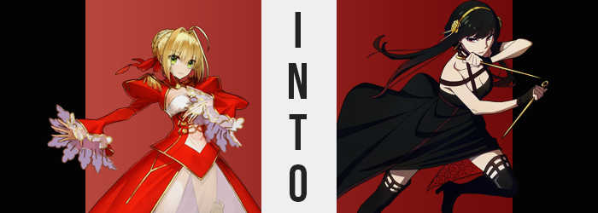

“Let me gooooo!”

“Now, now. Be a good girl and eat all of your dinner for your mother!”

Things had been a little livelier than normal within the Chaldea Security Organization. Not that they weren’t usually lively in some capacity, but there had been new faces springing up here and there among the Servants that had some questionable origins. As in no one could really seem to recall summoning them in the first place. Did records of summoning them exist in the summoning system? They did, but it was still strange. There wasn’t any camera footage of it happening, and no one could really remember the times listed in the logs.

One of these Servants was Kurumu Kurono, the one screaming almost like her life was at risk in Chaldea’s cafeteria. She wasn’t necessarily a very noisy Servant on her own, but Minamoto no Raikou had taken a liking to her. Wherever Kurumu was, Raikou wasn’t far behind her. Whether it was eating in the cafeteria, using the baths, or even going on quests. The two were inseparable… and not because Kurumu wanted her there. She had been involuntarily adopted by the worst Servant imaginable to do so.

Very few envied this arrangement between the two of them, but that didn’t mean that no one envied them. The Assassin-class Servant, Jack the Ripper, was perhaps the only Servant in all of the building that would look at Kurumu’s fate with any semblance of desire. After all, she was a child – and one who yearned for the comfort of a mother. “We wish we could have someone like that…”

Around the same time, Nero Claudius was moving through Chaldea’s halls, seemingly without much purpose. She had spent a morning at the gym, and then after finishing she had moved to the baths. When she had walked past the cafeteria it had sounded like there was some sort of ruckus, but the Saber gleefully hummed to herself and skipped past. She was having a great day, and she wasn’t going to ruin that by engaging in what sounded like an annoyance.

“Hm hm hm~! Rome is the best! Hm hm hm~! Rome will clear the test!” What had begun as a mere hummed tune evolved into a full song with lyrics before long. Not that the singing was particularly good, however. There was more than one reason as to why many saw her and Elizabeth Bathory as rivals. And her inability to hit the right notes was certainly among them.

After wandering aimlessly for a while longer, Nero eventually found herself outside of the door to her quarters. With a quick touch of her palm to a censor in front of it, it slide open, and she danced inside. “Umu! Perhaps after a quick rest I’ll resume my very important activities!” But they were hardly all that important. It was more likely that she’d end up intentionally being a nuisance to some for her own amusement.

And so, a nap had been on the menu, but before she could make it as far as her bed, something glimmering in the corner of her eye caught the Servant’s attention. “Hm!? What’s that? I do not recall leaving something over there!” It was hanging off of the hangar on the back of her door. A golden headband with golden roses decorating the sides. It appeared to be rather fancy. “What a pretty headpiece! It would fail to stand out within locks of hair that are even more gold, but hmm…”

“Perhaps I should consider who delivered this gift to me before I cast it aside?” Selfish as she could be, Nero didn’t want to insult whoever had delivered this gift to her. Especially when she factored in that the people who could have gifted it to her in the first place were limited. Realistically, it could only have been her Master and Nero would not squander any gifts given to her by them. Not even if they clashed with the rest of her outfit! …Within reason, anyways.

Nero’s confused expression turned into a beaming smile once she had come to that (incorrect) conclusion. “Well, I am their favorite! It only makes sense that they would lavish me with gifts, and it’s only fair that I adorn myself with them to show off to the other Servants how favored I am!” Of course, her giant ego would be what would ultimately convince her to wear the tiara-like headband.

Something that would be her own undoing, even if it was inevitable in the end. Regardless of her will, the powers that had created numerous other strange Servants in Chaldea thus far would find a way to enact their will over the Saber too. All according to the wishes of one child. Or a bunch of souls of dead children compounded into a single child.

It took Nero a moment to affix the decoration onto her head, but upon looking in the mirror frowned at her reflection. “As I thought, it doesn’t stand out very much, does it?” Gold on gold really didn’t work, but since it was a precious gift from her Master who had just recently summoned her… “Umu?” That was wrong, wasn’t it? Hadn’t she being summoned years ago? She’d been with Chaldea since the struggles back in the Rome Singularity. Rome? Which country is that?

The emerald coloring of the Servant’s eyes turned dark as memories began to clash with one another. A dark green at first, they took on a reddish hue before long – granting her a crimson gaze that stood out even with her bright red dress adorned. These matters became more bizarre, in fact, because her gaze sharpened courtesy of a narrowing gaze. Not one sharp enough to alter the short woman’s perceived race or anything of that nature, but it began a departure from what could be considered the ‘essence of Nero’.

“E-Erm! Of course I know of Roma! Sweet Roma! How could I ever – COUGH – forget about – COUGH – Roma!?” Had a coughing fit beset the emperor’s speech? It had, and each cough seemed to accompany a downward shift in her tone of voice. Before long it was far less shrill that it had been, even featuring a softer quality to the sound of it all. She was holding on tightly to the memories of her homeland, too. Nero was naturally confused, but instinctively she recognized that she had to hold onto her memories for dear life.

During this disorienting process, the shorter woman had moved away from her mirror as anxiety forced her to pace. This had been a detriment to her understanding of things, because if she’d been looking at her reflection then she would have easily noticed the changes to her face. Especially since they went beyond just her eyes, stretching her face’s length a touch and swelling her lips and nose until she didn’t look an iota like the woman she was supposed to be. She appeared more mature and reserved, even though there was a clear anxiety to her movements and the furrowing of thinned, darkened brows.

Those brows weren’t even alone, as it turned out. The roots of her golden blonde hair were quick to take the same charcoal black, and that color swept through all of her tied up hair. Hair that grew, albeit not substantially in the back. It was the sides that framed her face that reached longer in turn, stretching down to her breasts and even past them while bangs were tussled into a messier, right-swept style. Unfortunately, her signature ahoge was lost in translation.

But her hairpiece now stood out! So there was a single positive!

“Rome… That name holds a certain nostalgia to it. I can recall growing up there, but…” A separate set of memories had begun to overlap them. Memories of growing up in dire circumstances in a world where the names of the nations were unlike anything she had ever heard before. It wasn’t enough to make her forget her life as Nero, but the waters within her ego were definitely getting muddier as her transformation continued to ramp up.

The direction of ‘up’ incidentally became a relevant one shortly after. “Hm?” It applied itself in a way that left the woman bewildered, for it seemed like her eye level was lifting upward? That and there was a strange feeling of tension present consistently across her skin. “Am I getting taller?” There was hardly a point in dancing around it: the old Nero would have given a much more dramatic reaction to such a realization, yet her new personality had left her a little too calm about it.

Her assessment had certain been on the nose, though. Inch after inch her height climbed. The emperor had always been short, but that was something she showed pride in (even if it had bothered her deep down). She’d been a meager 4’11” prior, but eight inches prompted her limbs to lengthen and her torso to stretch. The lower portion of her dress, the leotard like segment beneath her skirt, tore after being forced into the crevices of her pussy and ass for a few moments which brought her to squeak and blush.

Now 5’7”, she blinked her crimson gaze down at herself. “This is unbelievable.” In part because she wasn’t sure how to feel about it. This height was different, right? But there was a part of her that felt the opposite, like this new height of hers was just right. If anything it had done a good job of making her perky bum and large bust not seem as dramatic as it had on her tinier form. At least for a brief few moments. “Oh!?”

The feelings of tightening clothes and stretching skin returned with the vengeance, although it wasn’t as widespread as it had been during her vertical growth spurt. It target certain key areas and was accompanied by a weightiness that hadn’t been present with her previous growth. Looking down? She could see her bust forcing the material of her dress’ cups being forced forward, mass giggling to attention to apply an added two cup sizes to her bust. “They’re bigger…”

And it wasn’t just her tits. Her ass and thighs found a thickness that hadn’t been present prior too. Nero’s rump swelled further into a pleasant peach shape, flossing clinging white undergarments further into her crack. But what likewise pushed her butt and legs thicker was muscle. Not only her legs became more physically powerful but her arms, stomach, chest, and butt to boot. This toned strength was vaguely veiled by the added softness of her new figure.

It almost clashed with the calm and polite demeanor she was exhibiting. Like she might use her body for something far more nefarious than you would expect. Violence. Recorded within changing memories were methods for committing unspeakable violence upon others. But not out of cruelty; out of necessity.

It certainly wasn’t the body of an ordinary woman. She must have exercised a lot and, in fact, she could recall having lived that lifestyle before becoming a Servant. “Everything feels so hazy. Who… am I?” Nero’s old ego had held on and wasn’t yet lost, but she was having problems navigating her memories as the new ones were becoming stronger and stronger. This dissonance was very distracting, so distracting that the discomfort her clothing provided with her current body shape fading away went unaddressed.

But there was a reason for it. Her clothing had finally stretched to suit the changed flesh. Reds and white mended together and darkened, forming a sleeveless, black dress with a short skirt beneath a longer one that sported a crimson, flowery underlayer. Leather boots rose up to her thighs and half-gloves wrapped around her palms to match bands beneath her shoulders.

“Hm? Was I about to do something?” Now dressed as she was, it would have been easy to assume that the woman Nero had become was an elegant, proper, and wealthy lady based on the regal black dress that she wore along with the golden headpiece that stood out much better against her head of raven black hair. Yor Forger also looked more or less like a regular, human woman. But she had a Saint Graph embedded within her.

She was a Servant of the Assassin class.

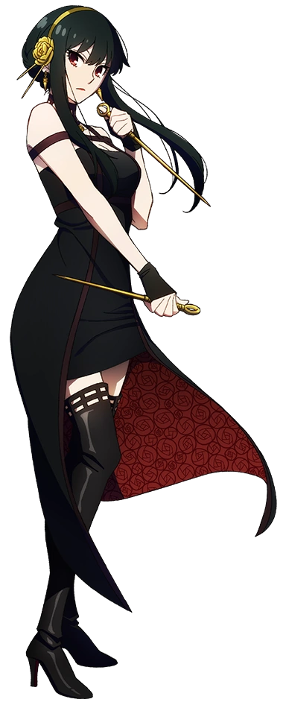
A textbook case of ‘looks could be deceiving’, even now she conducted herself in a vaguely clumsy way as she tidied up her hair and smoothed out her dress with a pure smile upon her lips. “I wonder if Miss Jack is looking for me? She’s always fussing…” It had been plain from the start, but Nero had been forced to take this form because of Jack the Ripper’s desires. Much like the other Servants that had strangely appeared under mysterious circumstances, she had actually been ‘summoned’ due to the strong wishes and desires of another.

And this was what finally broke her, any recollections of her past life sealed away forever after Jack came to mind.

Not that Yor herself saw it that way. Her own memories spoke to the idea that she had been in Chaldea for a full month by this point, and in that time, she had met Jack the Ripper, a small child who had desperately needed a mother. Yor still believed she was inexperienced with such matters, but she was trying her best as a mother figure! “Okay! I think I’m good to go! Has she eaten yet today? I suppose I should ask…”

Despite how much she appeared to look the part of a young mother, she hadn’t been summoned into the Assassin class for any random reasoning. In life she had killed and killed plenty of people as a professional assassin. It was something that had been necessary for the survival of herself, her brother, and eventually her new family – and so she had never felt any regret for living that life. In plenty of ways the presence of Jack had reminded her of that. But she also wanted to use that strength of hers to protect her new Master.

KNOCK, KNOCK!

Before Yor could head out on her own, a small knock had rung from her door. The mother hurried over and opened it but found no one on the other side. At least at first. But then her gaze moved downward, and she saw a tiny, white haired figure. “Oh! Miss Jack! I was just on my way to find you! Are you hungry?”

The tinier Assassin’s face lit up the moment that she was addressed. “Yay! Mother!” She ran into the arms of a crouching Yor to give her an excited hug. “We’re really hungry! When we went to the cafeteria, we got sad seeing Kurumu with her mother, so we came to get you! So, we don’t feel lonely!” Yor stroked her hair to comfort her.

“Okay! Let’s go then, Miss Jack!”

And so they left the room, hand in tiny, bandaged hand.

