***The Prototype V2.0 - Henderson’s Tale***

***“We hope for your understanding in this Mr Henderson…Ms Beatrice’s sacrifice will not be in vain rest assured. Her participation in this project, voluntary or otherwise, has been most useful in gathering the data needed for the third generation armored suits that will give all pilots an edge unlike anything we’ve had before.”***

***“We’ve transferred her to the ICU under Doctor Sam Akers, in light of your medical background, we will grant you access to the very best services we have in our possession if you feel Ms Beatrice is worth salvaging. That is all we can offer you..”***

Within an air conditioned chamber lined from floor to ceiling with titanium plates, a lone man lies hunched over one of the many consoles that dotted the aisles around the room, a bright holographic readout displaying a full three-dimensional scan of an unnamed subject with a big red marker placed over the cranium. A sign of something seriously wrong being detected in the body of the subject.

From the heavy eyebags under the man’s eyes as he remained hunched over with his arms lying splayed out over the smooth tabletop, he had most likely blacked out after working himself to the bone. Not budging an inch even as the doors behind him slide open with a metallic chirp, followed by steady footsteps as the new arrival makes their way towards him, planting a firm hand over the shoulder of the sleeping man, inciting a reaction as his weary eyes flutter open.

"You shouldn't be pushing yourself like this y’know? Go get some rest…"

Groaning in frustration, the man shoves his comrades arms away from his shoulder, thumping an elbow against the console behind him as a result, jumping in shock at the stinging pain shooting up his arms, cussing angrily at no one in particular.

But that spike of pain seemed to have calmed the man down somewhat, sighing as he settled back down in his seat while gazing at the bio readouts with a despondent look, as if he'd been hoping to wake up without that big red warning staring him in the eyes again.

"So…it's still a no go?"

"No…it isn't…and it ain't looking any better than it did yesterday."

Reaching toward the console, the exhausted man thumbs a button, beginning a startup sequence as neon blue lights behind the imposing bulkheads flicker on, bathing the room in light as a dormant one way mirror displays the interior of the room directly opposite the observation room: a pristine chamber with no visible entrances and a single pod in the middle, with the unmoving figure of a young woman lying on top of it. Draped in a medical gown with her head wrapped up in bandages, a deathly pale face locked in peaceful slumber with a bevy of wires and plugs feeding into her body.

“No matter what I do, her vitals aren’t budging. And the longer she stays this way…goddamnit!”

“I understand how you feel Henderson, but you can’t keep pushing yourself like this. If you kick the bucket before you find a solution, you know what the stooges in command will do…they’ll cut her life support off.”

Spitting in anger as he tears his hand free from his colleague's grip, Henderson slumps back over the chair in exhaustion, cradling his head as a sudden fit of drowsiness washes over him. Biting his lip in bitter regret, thinking back to the moment when it all started to go downhill, and the person lying in a medical stasis unit had once been his upbeat yet annoying partner, just doing their best to give mankind a tomorrow.

Before Henderson’s colleague takes a seat in the chair facing him, clearing his throat with an uncertain look on his face. "Y’know…you never did tell me much about how you met the kid…"

"What? You want some kinda bedtime story or something?"

"Sure…I mean, it could help ease whatever it is you're going through right now Henderson. You never know…”

"Seriously…where do I even start…ah hell…strap in for a long one…i’m startin’ from the beginning with this one."

Leaning back into the chair after letting out a deep sigh, the weathered man begins to recount his experiences from before he'd gotten himself involved in this mess…

**HENDERSON’S TALE I**

In a world where the surface was all but overrun by enormous creatures from outer space, mankind had been driven well below the surface with scant few installations and outposts left outside that were barely clinging on to life, with more going dark each passing day. An unexpected precedent for a civilization that enjoyed the benefits of renewable energy sources and medicinal cures for ailments like cancer; the stuff of dreams once thought impossible by their predecessors

It all happened so fast. One moment the people of this idyllic society were rushing on with their daily lives and the next, the sky was on fire with buildings coming down in major cities and communications worldwide becoming scrambled. The incident had been dubbed the Collapse by those who survived the coming months, and their enemies; the Hybrids, fittingly named after their twisted forms resembling amalgamations of different animals fused together into one gigantic nightmare.

But between the short time between the start of the Collapse and mankind’s utter devastation at the hands of this new foe, the remnants of the world’s leaders had come together to face a common enemy; pooling their resources and manpower to throw at a solution towards the aliens as they laid waste to armies worldwide. Finding their ace in the hole through the completion of a mechanized suit of armor akin to a bipedal tank that would serve as an extension of the human body; working in tandem with AI cores and a neural link to basically make it possible for anyone to become a pilot for these imposing steel puppets. Monitored by a group of specialists lovingly called Handlers.

It worked for a time, felling their titanic foes without much trouble and retaking cities lost at the start of the Collapse, things were looking up for the humans.

Until their enemies evolved to tackle the humans' innovation, unleashing new breeds of monster never before seen capable of widespread devastation and intriguing command capabilities, directing their lesser brethren in coordinated strikes much like a general would do with their troops. Rending claws and sharpened maws joined with biochemical fiery breath, electromagnetic pulses and pustules filled with acid. In a single day, whatever foothold the humans had gained had been knocked down to rubble, pushing the survivors back into hiding with hope falling rapidly across all fronts.

But there were those higher up the chain of command who didn’t believe in this anticlimactic fate for humanity; intelligent beings beaten down and hunted to extinction by mere animals. Plotting in secrecy to give an edge to whatever remained, even if they had to cross the moral gray lines between good and evil to do it.

Enter into the lives of Henderson and Ben; a Handler-Pilot duo with a long lasting service record together in their quest to protect their bunker from falling apart, running daily ops outside the safety of the underground in order to scour for what little resources remained in addition to whatever else the leadership wanted of them; gathering spare parts or uncovering old world technology.

Although the Handler was a known grump and irrational drunk to most people, the pilot he was responsible for saw the thirty something year old man as something of a father figure to him, never pushing him away like he did everyone else and being the only one he could open up to. But it hadn’t always been this way.

Before Ben was Maria, Henderson’s spouse and then pilot after the two had gotten romantically involved after many runs in the field together, being the only Handler insane enough to actually join his pilot on missions by tagging along in the rear seat. And with a child on the way, it seemed the indomitable couple was going to lead a successful life together.

That was before the second wave of Hybrids had made their appearance known to the world…and just like that, Henderson had lost Maria and their future son after they were attacked by one of the evolved Hybrids, knocking their mech out with an electromagnetic pulse before sawing away the entire front portion in one swift bite.

Henderson had crawled back to the base embittered and numbed by the loss of his family, becoming a drunkard who drank away his worries in the bunks while reports came in worldwide of the havoc wrought by the new Hybrids, losing the will to be a Handler ever again while struggling with the loss of Maria.

But when mandatory drafts were put in place to keep up the futile struggle years into the conflict, Henderson had been forced back into his role as Handler, put in charge of a spindly young pilot that looked like a fresh out of college rookie with barely any experience under his belt. He didn’t know who he was, but apparently, the spritely young man knew almost everything there was to know about him. Henderson Cole, renowned Handler from the first generation of soldiers who deployed alongside his pilot Maria. Scoffing to himself as he listened to the glorified tales the drill instructors and trainers had fed to the energetic pilot.

“W-Well, I hope you don’t mind me saying this but…I hope we get along just fine Mr Henderson, sir! Oh, and my name’s Ben by the way!”

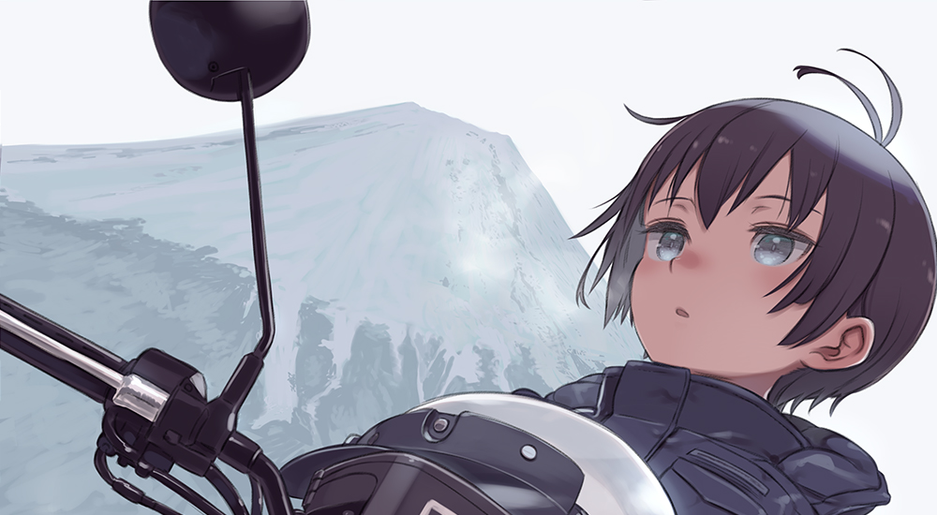

He wasn’t sure if it was his overly enthusiastic energy or his over confident face, but something about Ben had struck a chord with the grizzled Handler that day, finding himself shaking hands with him as the two got to work immediately…but *‘work’* was abit of an understatement considering how lax Henderson was as he drilled Ben from the sidelines, reclined over a chair in front of a monitor as he watched the clumsy pilot stagger around in his cumbersome mech.

*‘Kid’s gonna get himself killed out there…’*

The pair did more than simple practice drills however, owed moestly towards Ben’s insistence with getting to know Henderson more as he followed him around everywhere he went. Getting on his nerves as he remembers the fateful beginning to their friendship together in the present, groaning with a solemn look in his eyes, gazing back toward the unconscious girl behind the mirror.

"I never knew she was an orphan back then y’know? Yelled at her about following some retired fart like she wasn't getting enough attention from mummy and daddy…"

Chuckling, his colleague adjusted his glasses before remarking at his mistake. "I'm guessing you made her cry before…getting back together after apologising?"

"Hah…hardly did any apologising…the kid took it calmly…maybe a bit too calm…the look in her eyes back then…should've seen it yourself; brave and dignified, like she wasn't afraid to say she lost her entire family…"

But deep inside, he knew it had been the spark from their similar backgrounds that drew him towards Ben, like a father would to comfort his son who was acting tough after being bullied at school. If Maria was still alive, their kid would most likely be a tad bit younger than Ben was.

That has led to the two growing somewhat closer despite Henderson’s insistence on maintaining a cold mentor figure to his pilot, overseeing Ben's training during the day before engaging with the energetic young man in simple banter, recounting his experiences against the Hybrids with Maria at his side among other heroic tales from his glory days.

"She sounds amazing sir…d'you think I can be like her someday?"

"Pheh! Dream on kid…now get going…it's almost lights out and we've got another day of training ahead of us before deployment. So get some rest alright?"

Interrupting the tale, Henderson's colleague slaps him over the shoulder as he chuckles at the idea. "Bet you're eating those words right now aren't you? She's got a record to put Maria to shame now, no offence intended of course."

"That's cuz of what those monsters up top did to her…"

"So the rumours about illegal experimentation and the incident from last month being a cover up…"

"...are true, more or less, but I'll get to that…"

**HENDERSON’S TALE II**

He wasn't quite sure when it happened, but tracing the events of the days leading up to Ben's first deployment on the field. Henderson was certain it had been on the night before when the ruling body's stooges had made their move, implanting a so-called *‘upgraded AI core'* under the guise of regular maintenance with the duo none the wiser to the actual contents contained within the modified core.

Right until the moment Ben had plugged into the suit after a lengthy pep talk from Henderson not to overdo it on the field and to stick to what he had taught him over the last week or so. Hearing a pained cry over the comms from his pilot as his bodysuit bonds with the mech.

"Kid, you alright there? Your vitals just spiked…maybe we should call this off, if you aren't fit for duty then-"

"I-It's alright sir…I can do this! *'Run if things start to get hairy'* right? I can’t give this chance up! Don’t worry about me…"

“You know withdrawal from deployment isn’t even possible right? I bet even she knew there wasn’t any choice but to go forward.”

Ruffling his head with a look that suggested he was deep in thought, Henderson shakes off whatever was plaguing him at the moment as he sighs in a regretful manner, as if wishing he could’ve done something different that day to stop Ben from embarking on that ill-fated deployment run that triggered this downward spiral of events. All because the eggheads up top had decided upon the rookie as their latest lab rat.

But he knew his colleague was right; no matter what he did and even if Ben didn’t want to go, refusal wasn’t an option, with so few left in reserves, the management would rather lose an entire squad now rather than later if it meant even a small chance of success in retrieving more supplies for the ensured survival of the inhabitants in the subterranean base.

“Yeah…you’re right…but that still doesn't change the fact that I couldn’t do anything but watch…watch as they turned my pilot into their lab rat for some twisted experiment…”

“How can you be so sure though? Was it something they put in her rations?”

“No rookie pilot ends up decimating an entire nest of those things on their first day on the surface, Sam…not even Maria had the balls to take on one of em herself until a few missions into her career. Fact is; they slipped their prototype tech in under our noses…and now she’s paying the price for it…”

**HENDERSON’S TALE III**

He still remembered how fast the squad had fallen apart the moment they reached the surface, picked off one by one by the Hybrids as they split off in panic, flailing and firing in blind fear as they lost unit cohesion. With Henderson all but ready to accept his pilot’s fate with his headset laid down on the monitor, arms held in silent prayer.

But after a few minutes of hearing numerous voices be silenced one by one, an excited cry remains buzzing over the headphone, looking up slowly in disbelief at the monitor with all but one of the icons representing the squad showing flatlines and a crimson hue representing a KIA status. Scrambling for the headset after realizing who was the last man standing.

“Kid?! Are you there? W-What’s your status?”

“Mr Henderson sir, I hear you! I’m alright so far, but I think…I think I'm the last one left!”

“I see that…just hang in there kid, you’re doing real good so far, just follow my lead and you’ll get out of there just fine, you hear me?”

“G-Got it sir!”

From there, the ace Handler within Henderson would resurface, hands becoming a blur as he swipes over the on-screen reports and real-time environmental scans, shouting constant sitreps to his pilot as he keeps an eye on the green dot symbolizing Ben, surrounded by a never ending swarm of red triangles emerging from the nearby mountainside, fearing for the young man’s life over the sounds of deafening gunfire and screeching metal as the rookie makes his way through the horde, cutting down each incoming Hybrid with a cold finesse he hadn't noticed in the last week or so training him in the hangar.

Where he once struggled to even get a running start when testing motor functions in the legs, Ben was scaling up the cliffside at a rapid well maintained pace, all while cutting down incoming Hybrids with precise cuts and jabs to their vital points. And in place of the panicky youngster who jumped at every surprise, Ben exuded the air of a veteran soldier, his heart rate barely exceeding the norm, only ever rising when a lucky Hybrid managed to get a hit in. Rocking the mech and filling the cockpit with the screech of protesting metal as it holds against the barrage of claw and bone.

With how fast he was taking down Hybrids while working in tandem with Henderson's quick relaying of information on their positions to ensure his back was covered, the flood of red triangles had dwindled away to a small trickle, with Ben having made his way into the abandoned mine that served as their nest and the destination his squad was supposed to reach where a cache of supplies and materials had been detected. Clearing the way for another team to safely extract the goods.

And with the last Hybrid signature vanishing off the tac map, Henderson leans back into his seat whooping as the voice of Ben joins in on the celebration.

"I can't believe it…we did it! We actually did it!"

"That was all you kid…can't believe you've been holding out on me like that!"

"I-I swear I wasn't hiding anything sir! That stuff back there…it's like-"

"Alright, that's enough, when you're done hyperventilating down there, come on back. There's nothing hostile left out there for miles so you and the rear team should be alright on the way back…you did good Ben.”

“T-Thank you sir!”

Sighing wistfully, Henderson gazes back toward the screen once more, eyes on the terrible conditions of the patient relayed back at him. “I should’ve noticed the signs when he came out of that thing…i thought; maybe it was my mind playing tricks on me…but looking back on it now, the pieces all click together."

Reminiscing on the jovial celebration that had taken place in the hangar after Ben had exited the cockpit before flying into his arms in a bear hug. Henderson could clearly remember how much more softer his body felt through the skinsuit as he held him in his arms

Perplexed by one word, Sam leans back incredulous at the implication of something disturbing. "Wait…'he'? You mean Beatrice was-"

"-A man…I'm not surprised you didn't know considering how secretive those bastards are…you only know about her condition but not how she developed it…about the young man she was before all this went down."

"Damn…yeah, the neural degradation? So you're saying; whatever they did to Beatrice's mech…not only affected her mentally but also altered her body? That's impossible…"

"Remember the AI control system? Replace that with a computer core derived from a Hybrid's brain mixed with autonomous nanomachines, and you've got a shitstorm ready to blow…"

"But…Hybrid neural systems aren't meant to be linked to, way too dangerous and unpredictable…and if those nanomachines had their safety locks released…I think I know what happened that made Beatrice the way she is now…"

“If it’s the same answer I'm thinking of, hold on to that thought for a moment Sam, think you'll do just fine for the next Q&A…"

**HENDERSON’S TALE IV**

After that astounding victory against the Hybrids, the higher ups had begun to make use of their new up-and-coming ace pilot, sending him and his Handler on many more missions that reached out further and further into uncharted territory not seen by human eyes in over 10 years since the second wave had swept mankind back underground. Each time, Ben would return victorious. And everytime he did, Henderson would be there to welcome him home with a warm hug and a smile on his face. The pair were beginning to grow closer than ever before, with many bystanders mistaking the two for a father-son duo working as Handler and Pilot. Of course, Henderson’s colleagues were happy for the man, considering how they’d seen him slip away into a depressive hole for the past decade or so.

*“I swear, the man’s treating him like he’s his own son or something.”*

*“He probably is…didn’t you hear? Henderson used to have a wife once, she was his pilot back before the second wave, lost her and his unborn son in one go when they were out on a simple supply run that day…never stood a chance…”*

*“Fuck me…that’s no way to go man…”*

But the two didn’t focus on all the gossip around them, spending most of their free time much like a regular family. Since Henderson had no one to talk to and Ben was the last of a squad he barely even got to know, it was only natural that things went on this way. They were a team, and they only had each other to rely on.

“So when are you actually gonna come with me on missions like you did back then?”

“Hah! I’m getting a little too old to be out there on the field kid! Plus from the way you pilot that beat up old clunker, i might end up breaking a few bones or two…”

That was when Henderson began to notice subtle changes spreading over Ben with each successive mission completed. It started with his hair gaining a radiant complexion while growing out in longer, silkier tufts that were beginning to turn a pale silver at the tips, similar in appearance to aging but without the detrimental effects as his face begins to turn unusually effeminate. With his eyes slanting upward at the edges and his skin mellowing out into a warm peachy coloration. A man his age should already have begun to sport a stubble, but Ben’s linear chin remained smooth and hairless. *‘Probably takes after his mother more…’*

“H-Hey! What was that for?”

“N-Nothing…your cheeks were lookin’...weirdly swollen for a second there…you gettin’ ACNE kid?”

“Ohh that…it’s nothing really, i noticed it a few days ago but it hasn't bled or anything, looks pretty cool though right? Like those eye-drop tattoos people used to wear on their shoulders all those years ago!”

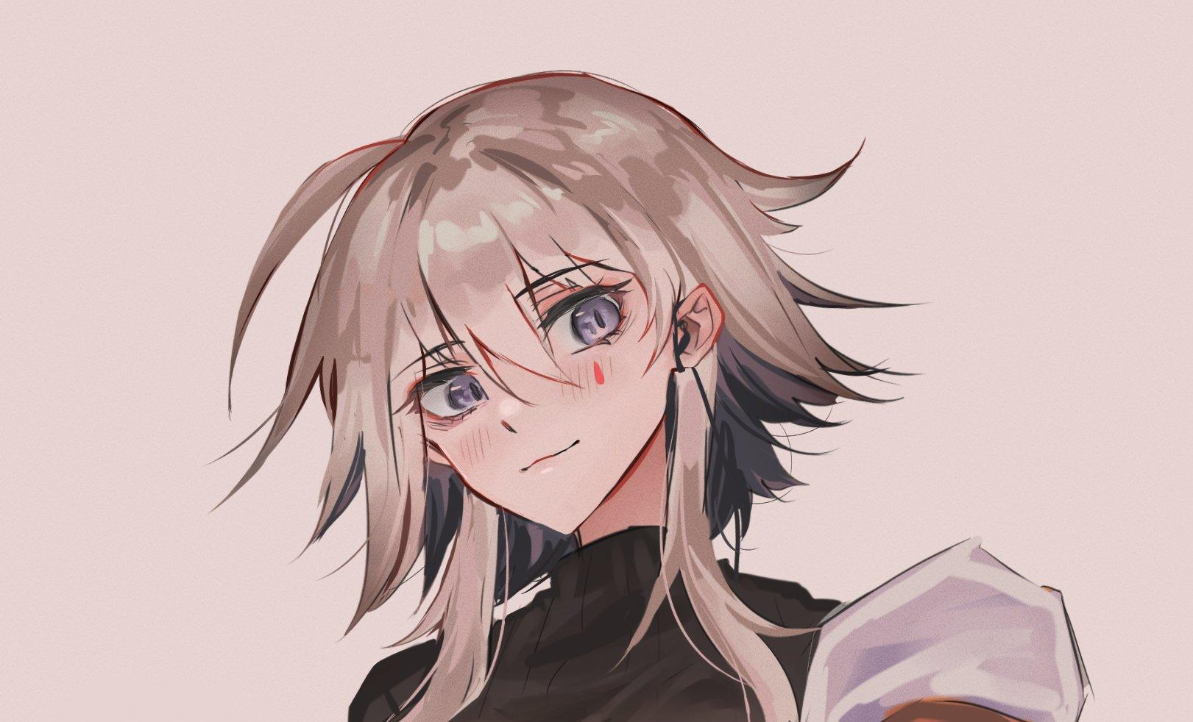

Then came his body; rapidly gaining in height and mass as his limbs begin to take on a noticeably slender appearance, his well trained torso plumping up with soft tender fat that didn’t seem to go away no matter what the duo tried, only growing more abundant and alluring after each mission until Ben was beginning to grow concerned over the two soft lumps he now sported on his chest, where chiselled muscle once sat a few days ago. Afraid to say anything, the nervous pilot had hidden that fact away from Henderson, who was already more or less aware of the physical changes with how long Ben’s hair had become, reaching his shoulders with barely any rogue tufts sticking out to the sides because of how smooth each individual strand was.

Until it became impossible to conceal altogether, with Ben exiting the cockpit after a mission looking uncomfortably to the side with a flushed look of embarrassment on his face, slowly stepping down the ramp towards a confused Henderson who was wondering why he had his arms clasped around his chest like a girl not wanting her breasts to be seen.

“Umm…sir? C-Could we go somewhere private? I…I’ve been meaning to tell you something…”

And so the pair would return to Henderson’s private quarters, locking the doors behind them as Ben undoes the seal of his pilot suit in a rather nervous fit, fidgeting with his slender legs rubbing together before turning to face Henderson, whose eyes widened at the sight of the jiggling masses wobbling on Ben’s chest covered in smooth hairless skin, bright pink arrows tipping the pert mounds aimed right at him.

“Jesus Ben…you’re barely lookin’ like a man and now you’ve got…tits?!…how long have you been hiding this?”

“I…I’m not sure when this all started! I only noticed it cuz it felt…strange…when I put on my suit for deployment two weeks ago, I didn’t know it’d keep growing so I didn’t say anything…aren’t these things boobies?!”

Henderson had brought Ben to the clinic immediately afterward, bringing him in for emergency treatment as he sat outside the lobby, waiting with bated breath for what felt like hours until the doors slid open with the doctor stepping outside, hurrying to meet Henderson with a concerned look on his face.

While the situation wasn't life threatening, Ben's body was beginning to produce a massive amount of estrogen, partly explaining why he was beginning to turn more and more effeminate with each passing day.

"B-But…he's not really gonna become a…a girl now is he? There's gotta be a way to reverse all this."

*"Well that's where things get complicated Mr Henderson…according to our scans of Ben's body…he already has a functioning pair of ovaries…and they're working overtime alongside another unidentified viral load to trigger the changes. I don't know if it's something he caught from out in the field but we can't keep him from duty, the higher ups don't want to lose the momentum they've been building with their ace in the hole…I'm sorry, but the best we can do, is to help Ben along with the transition. The viral load inside his body is playing havoc with his other organs vital functions so he might experience some strange side effects every now and then. As his Handler, I'm sure you know what to do…"*

“We played right into their hands back then…should've just kept the whole thing a hush hush secret…"

"That's impossible…from the looks of it, they already had eyes monitoring Ben's progress if the doctor had the *'medicine'* all prepped and ready to go…but if the Prototype core was already turning Ben…what was the medicine for?"

"Remember what you said about neural linking with Hybrid brains being a dangerous thing no human should ever attempt? The medicine was to weaken Ben’s mind, let that thing worm its way in easier."

"That explains why the brain damage was so severe…it's like dropping a firewall and letting a virus wreck a computer…it didn't take any longer after that now did it?"

"Yeah…it happened ver a few weeks, he started acting differently…behaving differently…they even prepared some new techsuit to *'accommodate'* him for future deployments. I mean, he did seem to warm up to the idea of becoming a girl…but it still feels weird when I think about how fast he got over it all; changing his name, getting used to going to the girls side, not having anything between his legs anymore…”

"But your pilot wasn't even a he at that point right? From the way you're talking…it sounds like Beatrice was already calling the shots…and the headaches you mentioned plaguing her were only getting worse right?”

Tapping at the console, Henderson mouses to a folder, clicking it to reveal one single data file; a video. Nodding at the screen for Sam to pay attention to as he opens it up.

Coming out through muffled speakers, Henderson can be heard speaking in a hushed flustered tone as the feed rises up from darkness to reveal a bunk room, and the young woman lying inside the medical pod strutting across the room in her new techsuit, examining herself in the mirror while fidgeting with the hem of a mini skirt, cocking her head to the side with a slight hint of doubt in her eyes.

But to Hendersen who had been recounting the past year to Sam, it was like rewinding a tape through time and watching Ben’s development from a spunky young man into an elegant young lady burdened with the role of being mankind’s best hope in reclaiming the surface.

"Are you sure dad? I still feel like somethings a bit off. I feel so…*exposed*."

"I'm telling you Bea, you're perfect! You're gonna knock it out of the park with the press later…can't be the **Shining Star** of mankind with a frown on your face now can you? Make sure you take your medicine before the interview alright?"

**HENDERSON’S TALE V**

And then the video cuts off, freezing on a demure look of pleasant surprise painted on Beatrice’s face right as she turns toward the camera.

“*’Dad’* eh? And you get up close seats with the Shining Star everyday? I should’ve known her face looked familiar when I patched her up that night.”

“It’s nothing like that you nut…at some point we just dropped the honorifics, she called me Dad back when she was still Ben so it stuck I guess…but when Beatrice came into play…it made me feel like a real father y’know? I saw her like my own baby girl, even had her agreeing to move in once the files for adoption were processed…even started going out into the field with her just like I did with Maria all those years ago…God, she’d kill me now if she were here…”

“I’ll bet on that…but if the accident happened the day after the news article on Beatrice went live…then that video was your last time together right?”

At the mention of the incident, Henderson’s head pounds at the memory of how it all culminated into tragedy with his newfound daughter convulsing in seizure right after shooting him a bright smile, interrupted midway as she spoke about how excited she was to meet with someone she had gotten to know yesterday, screaming in pain the instant her suit plugs in for yet another mission just one day after their first year anniversary together.

Before the sight of the AI core by Beatrice’s head explodes, releasing a flurry of Hybrid gore that begins to swarm her head as Sam’s worried voice snaps him back to reality, pulling him out of the nightmarish image of her grizzly fate,realizing he was sweating profusely as he clutches a hand over his beating heart, gazing wearily towards his colleague’s concerned face.

“You alright there Henderson? I think I know where the rest leads to after that…must’ve taken a lot to tell me about it though…Henderson?”

“O-Oh…yeah…that's where it ends off mostly…the higher ups just discarded her after that, even had the balls to remove that prototype AI core right in front of us but that’s enough about them…I think i’m gonna take you up on your offer and…”

“And go to sleep?”

“Sam? Do a check on Beatrice’s vitals, now.”

Rising off his seat and dashing down the aisle towards the well hidden door by the side of the observation chamber, Henderson thumbs the password for the lock before slipping inside as Sam complies without a word, taking Henderson’s place on the console while running a new scan on Beatrice, a look of excitement and disbelief on his face as he taps his shoes impatiently on the floor while waiting for the decontamination process to end before dashing into the medical chamber.

“Bea? Bea, can you hear me baby girl?”

Walking up towards the stasis pod before taking a knee, Henderson cradles the bandaged head of his daughter in his arms, shedding a tear at the sight of her open eyes staring dimly into his own. They were still swollen, but clearly open and staring right at him. He wasn’t sure how long she had been watching him but glancing towards Sam earlier had him catching sight of her head tilted down toward him where it wasn’t facing before as his colleague’s scratchy voice comes through the PA system.

“I don’t believe it…she’s recovering? It’s slow but the signs are there…if you keep up the treatment you’ve been providing for her…she should be back up on her own feet within the next year or so! Bar some temporary memory loss, but she’ll live.”

“Hear that Bea? You’re gonna be alright now…just wait a bit longer alright? We’ll get you up and running again.”

Hearing that the medicine he had been synthesizing in the hopes of healing the damage done had worked was great news. But there was still a long way to go with healing the facial scars caused by the surgical removal of the Hybrid mass that had fused itself with Beatrice’s face, but he had faith in Sam for that.

With renewed vigor in his heart, the weary father takes one last look at his daughter as her heavy eyelids slowly shut before turning to leave the medical chamber, eager to get back to work again if it meant he could have his daughter back by his side again. But there was still the lingering issue of the people in charge and their cronies to deal with.

*‘One problem at a time…for now though Bea, sit tight…Dad’s got everything under control…’*

***THE END***