DERE TO DREAM
MARCH 2021 REQUEST STORY
BY CHALDEACHANGE
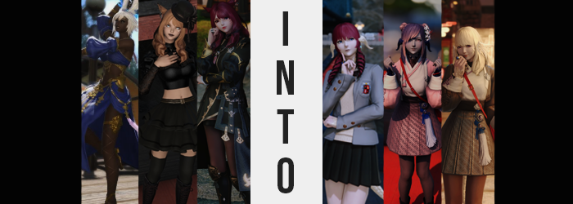

The three adventurers had never been to a school festival before. Each of them had their own circumstances, but their backgrounds didn’t exactly lend themselves to academy stays nor lives of normalcy. Were those that could privileged? Perhaps, but the Source was a place where people came from all walks of life. You didn’t need to be extremely well educated to be successful, nor were you guaranteed to be just because you were admitted into a well off academy at a young age.

At least in Eorzea, most of the city states didn’t even have such a thing. But at least in the Eastern seas, they seemed to be more common. Such as this one, Kugane Academy, naturally located in the bustling seabound city of Kugane. The event truly was fascinating, with plenty of events and foods available all in the interest of spreading awareness about the school’s amenities.

The trio had even had their fortunes told! Although each of them reacted differently to what the fortune teller had informed them of. For the ruby-haired, Miqo’te scholar Silvia, her fortune had come out as ‘you will find yourself ending up in many accidents’, something she dismissed as a bunch of nonsense. For the dancing Viera of dark skin and pale hair, Nadja, her fortune was ‘money is on the horizon’, something she was surprisingly hopefully about. And for the third? The Miqo’te woman with brown hair, done up in goth makeup and attire, ‘you will become popular with the ladies’. She highly doubted that.

No member of this trio could have possibly realized at the time that they had fallen into a trap, however. A trap created to create new students for this academy, for a lack of applicants had put it into economical jeopardy that threatened to have the entire school closed. The school, after this festival, would mysteriously have a record high number of students, saving its bacon. But at what cost exactly?

After having their fortunes told, the trio had split up into various directions to explore the rest of the festival at their own pace. Silvia wanted to rush through for example, knowing that she had an important meeting once the sun went down – and it was already evening. Her fortune had placed her in a fowl mood to boot, but she didn’t want to overlook any potential artifacts that might be stored on school grounds either.

So, she’d ended up sneaking around inside the wooden school building, beyond the many booths and classrooms that were set up. “There must be an item or two of note in a building this old…” Those who weren’t faculty or student couldn’t normally come inside the school, at least not normally, so this was more or less her big chance. As she slid into what looked to be the school’s awards room however, she didn’t realize that she was being tailed.

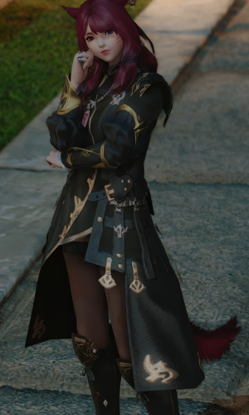
They weren’t there to do anything to her, but they were there to observe. Observe, and then guide once it became appropriate to do so. Because while Silvia had yet to notice just what it was that was going on, the warning signs should have been coming into view right about… now.

Naturally, they wouldn’t take place in a spot that was immediately noticeable. This entire plan hinged on the victims not realizing they were victims in the first place, and so the beginnings were simple enough. Tufts of ruby red hair had begun to peel from Silvia’s tail, beginning at the tip and slowly working its way down towards her body with clump after clump trailing behind her as she observed the trophies and various other awards littered about.

“Hm… Nothing stands out particularly. Maybe deeper in?” The awards room seemed to be quite large – she supposed it wasn’t unusual for academic institutions to motivate their student body with shiny awards, but whether or not they fashioned any of them with rare and unique items?

Meanwhile, her tail was completely bald now. Although the peeling clumps hadn’t exactly revealed a bald appendage. White scales had wrapped themselves neatly around it, with the tail’s general shape engorged at the base while narrowing towards a tip that was slightly pointed. Sleek and spiny, there was no doubt that this tail was reptilian in nature, different from the cat’s tail she should have possessed. It best resembled the tail of a Raen Au Ra, through and through.

“Whoa!? That was disorienting…” Silvia hadn’t taken any notice of it though. Rather, she was offput by a strange feeling that she was hearing double, at least for a brief moment. The sound of students walking down the hall outside of this room sounded layered and she couldn’t quite place why, but there was reason enough had she just managed to perceive it.

After all, a pair of somethings had sprouted on the sides of her head. Tiny nubs of white that matched her tail in color and texture. They looked, and were, incredibly hard, but as they continued to protrude, and eventually took thin, horizontal, cone-like shapes that were bridged by the initial growths, it was clear that these horns were completely hollow, allowing her to hear were she in the absence of a pair of ears.

Which she now was. Her head was complete vacant, without a single Miqo’te ear to its name. Rather, the horns on either side of the new Raen’s head flattened backwards in slight, giving them a thin, fin-like aesthetic that encroached itself upon her cheeks, scale plating stopping just below her eyes. But those scales began to pop up elsewhere too, largely around her wrists and down the sides of the bottom of her legs, with some scattered beneath her neckline.

Silv could no longer be considered a Miqo’te by any stretch of the imagination, and yet she still largely looked like herself otherwise. “…Why’d I come in here again?” Raising a finger to her lips, she couldn’t help but tilt her head to the side a little as she looked around. She felt a little like she had been looking for something, but it was honestly becoming a little difficult to think. Rather, she was growing increasing restless, and her verbiage was becoming much laxer as she occasionally bounced on her heels without realizing. “It was something important, right? Huh!” She gave a casual shrug, pushing it aside for the time being.

As she bounced over to the next trophy, the pigmentation of various aspects of her body began to waver. When it came to her pale skin, there was a slightly pinkish-purple undertone that came in, so subtle that it only minutely altered its tint, and each eye reflected a pink that was almost bubbly in its vibrancy.

What suffered the most dramatic change in color, however, was her hair. Typically a bright and fiery red, strands of a platinum blonde had mixed themselves in. Almost as if there was a direct correlation between how much of her hair color remained and how intelligent she was, as the blonde became more prominent, the scholar intellect became less honed. Memories of tirelessly learning throughout her life, investigating ruins, studying relics; it all emptied out. In its place much humbler things found root, including recollections of attending this very school.

The blonde was almost completely dominant now, and Silvia’s interests had even been affected. The life of an intellectual was not for her, she was much more of the sports type! She was the star of the track and basketball teams after all! Was that right? It sounded right! Additional volume made its way into her platinum blonde mane, seeing it become fluffier and forcing her bangs into a hime-style meanwhile.

“WAH!?” Thinking she’d examine the basketball rewards, wondering if hers were still there, she ended up tripping over nothing on her way, almost eating the floor if not for catching herself. Or, well, it had seemed like she had tripped over nothing from her point of view, but what actually happened was that her feet had fallen free of her boots. The size of her body was diminishing, and rapidly.

Arms and legs alike collapsed as several inches were shaved from her appearance, hands and feet naturally collapsing as well. The porcelain tone of her skin was freed of scars and blemishes while a youthful glow saw her completely rejuvenated, all while the clothes around her became loose. Because Silvia typically wore a big jacket, she wasn’t at any risk of losing that, but with everything shorter the sleeves ended up swallowing her hands, and her tights drooped just the slightest bit.

Silvia’s breasts faded several cup sizes, but on the other hand? Her thighs somehow looked plumper. Perhaps it was because of her shorter stature as she now drooped down to roughly 5’1”, but there was a meatiness to her butt and thighs that was rather pronounced, born both from good genetics and her sports activities. In fact, she now felt more energetic than she ever had.

“Aha! There’s my award! Best b-ball player!” The girl beamed, seeing her trophy in its case. Even as she smiled, last minute adjustments settled into her facial features. Her lips became swollen and glossy, and her eyes narrowed to take a shape that was far more Eastern like all natives of Kugane. She rocked back and forth on her bare feet, reading the name aloud. “Miyoshi Suki! Sixteen years old!”

A boundless energy preventing her from sitting still, Suki Miyoshi was rocking back and forth on her heels as she admired the many trophies and awards set up in the room. Even though common sense would suggest not touching them, the shininess of one particular trophy had caught her eye, but in reaching up to grab it she tripped over her now-oversized leggings and fell face first into its stand with a “GAH!?”

“Why me…? Actually, what am I wearing!?” Someone brighter, or at least someone more perceptive, would have noticed the oversized jacket and leggings much sooner, but Suki’s mind was such a one-track ordeal that the shininess of everything in the room had caught her attention first and foremost.

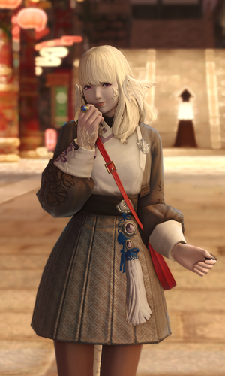
Still laying on the ground, her platinum blonde hair a mess as her white Raen tail wriggled behind her, she was surprised to hear another voice behind her. “Suki-chan? Don’t you usually walk back to the dorms with Koko-chan at this time?” Looking up, the source was another Raen Au Ra with dark hair tied into two buns. Suki had never seen her before, but she automatically identified her as her ‘senpai’ as the other’s hands helped her up and onto her feet. “And why are you dressed like that? You should have a spare uniform in the classroom, maybe you should go put that on?”

All of that made sense! Kind of! Suki nodded vigorously in response to the suggestion. “Oh, r-right! Thanks senpai, I almost forgot about Koko-chan!” …Had she? Who was that? She couldn’t be entirely sure, but that name felt especially important somehow. Actually, dumb as she was, thinking about that girl also made her a little flustered?

Even so, cheeks a little pink, she sped off to where she knew her classroom to be. Bumping into people and tripping over herself several times over the duration of the trip, of course. Well, bakaderes always had the worst of luck.

‘You will find yourself ending up in many accidents’ indeed.

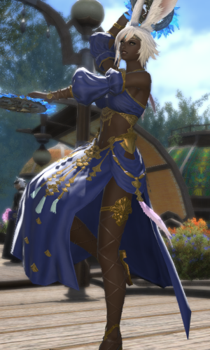
Elsewhere, the Viera woman Nadja was observing different booths on her own, keeping a subtle distance from each while taking joy in what was offered. Curious, perhaps to a fault, she had been the one most gung-ho about coming to this school festival in the first place. It had also been her idea to get their fortunes read. Little did she know how much damage she’d unintentionally caused by making that suggestion.

Curious as she was, socializing also wasn’t her forte. She didn’t like interacting with strangers all that much, so she’d been a little bummed when the others strayed off on their own. Still, she’d managed to get some good food and had learned a lot of interesting things about Kugane culture, so she couldn’t complain that much!

Intent on moving to the next stall, her plans were suddenly thwarted when she noticed a teenaged girl beckoning to her. A Raen Au Ra, as most of the girls here seemed to be, she looked troubled. Nadja put her anxiety aside, at least briefly, to see if she needed something. “Are you alright…?”

“You’re an adventurer, right!? I think a monster just ran into this tent! Could you deal with it?” The girl’s plight seemed authentic (it wasn’t), and the Viera wasn’t one to turn down a request for help when she was capable of providing it, so she merely nodded and stepped inside, casting the tent door behind her. But there was no monster inside. The girl had merely needed Nadja out of the public’s eye, considering the timing.

Nadja blinked once she had entered. It seemed like a costume tent of sorts, and she was certain she’d heard word of there being a show of some kind, yet… “I don’t even hear a monster. Are you sure you— Huh?” She’d turned back to the tent entrance, assuming the Raen had followed her in. But she hadn’t.

Not sure if she should let her guard down though, the dancer moved a little more into the large tent with caution. A monster still could be here, and she didn’t have the foggiest idea why a student might mislead her. That said, such a reason was already affecting her, adding context that she was otherwise missing, and would not catch.

To begin with, there was the matter of the young woman’s skin. Splotches of an off-tone were forming without consistency here and there. It wasn’t a matter of them darkening or lightening in even the slightest of ways, but instead these spots were practically bleach white when compared to her usual, melanin-rich skin tone. At first, they were like tiny, white freckles – yet, before long they had multiples and grown, dyeing entire patches of her flesh with a tone so pale that it might make a snowman jealous.

It didn’t help that the woman’s hair was also white, but it wasn’t longed to retain that tone just as her skin didn’t. For, curiously, a red not too unlike that she knew from Silvia’s own head showed signs of popping up. At first it was only in the bangs and tips, giving her short mane a multi-color aesthetic that wouldn’t be seen as too unusual to anyone who’d ever had their hair styled by a certain someone. Yet, it eventually moved inward both from there and Nadja’s roots simultaneously, sweeping away the white and leaving red in its wake.

Almost like it wasn’t content with that alone, the Viera’s disheveled but short hairstyle soon creeped and crawled downward in length, bringing with it a greater volume that was cleaner than Nadja usually kept it. And yet, as the length continued to grow out behind her, it began to spiral into a trio of natural curls – which was completely out of place since Viera hair tended to be at least 80% straight. These curls were dramatic though, spiraling on either side of the back of her head with the third directly behind her, all while the hair atop her head remained soft and unbound.

Not only did her eyelashes reflect the same cherry color as they thinned, but beneath her robes, the color of her pubes did shift to match. Typically thick and bushy, a proper trim was applied to them, matching her brows in the sense that they now seemed to receive proper attention and care more befitting of someone who wasn’t always on the road like the Viera was.

“I came in here for some reason, did I not? How strange…” Her right eye twitched as she spoke, bright blue creeping into her irises, all while the shapes of her eyes readjusted to better match her new locale. Those eyes, lashes long and pretty, better resembled those of Eastern descent with a narrower design; but the blue of her irises was much more striking than their original gold tone. Just as she hadn’t noticed much else, the fact that her manner of speech was growing more proper, and that she was speaking much more confidently, was not a new feature she caught realization of.

Rather, still looking around the costume tent - and for what reason? She did not know – her face twitched here and there, seeing her features soften. Whether it was the flat tip of her nose rounding, or her chapped lips becoming both more tender and just the slightest bit softer, it was evident that her pale flesh was being molded away from the typical designs one saw on a Viera.

But then again, her rabbit ears, which had still retained their white fur, could hardly be called such at this point. They had already halved in length, and now that they were shorter, they were folding forward, fusing with her head. A temporary deafness occurred, but just as had happened with Silv, so too did horns of white protrude from the sides of her skull, their hollow shells allowing her to hear just as well as she had before.

These horns were of a different shape though, still bridged, though funneling nearly directly backwards in a set of pointed funnels that were rounded, as opposed to being flat like Suki’s. White Raen scales encroached upon her cheeks narrowly, although they were hidden by her red bangs, which were longer on the sides. These scales likewise encased her neck, the backs of her hands, the sides of her legs, and erupted from behind her… on a brand new tail. Viera may have been modeled after rabbits, but they were tailless. Not that this scaled appendage, less decorative than Suki’s, looked at all like it belonged to a mammal.

As if to solidify the racial changes that had turned her into a (very tall) Au Ra, her toes ultimately cracked within her heeled slippers as well. Toes, by nature, had become much daintier – and the callouses earned from her life of combat through dancing? They faded entirely away one her heel softened.

Not that she could recall dancing at all. “What was I… I feel as if I was just working up a sweat?” Well, she could recall some dancing, but not for combat purposes. She was light on her feet and had taken some classes as a child because her daddy had wanted her to, but it wasn’t until this play that— “Play? Was I working on something like that…?”

As Suki’s had been prior to her transformation completing, this Au Ra’s memories had next to no consistency. Her life of adventure had been slipping away bit by bit, and in its place much more mundane recollections had sharpened. Memories of growing up in Eorzea the daughter of a wealthy family, of having everything in the world, yet feeling like she had nothing. But then she’d come to Kugane on an exchange and become student council president.

The last legs of her existential shift followed along with twisting memories, and all of the muscle earned from fighting bled from her frame, giving her porcelain flesh a soft glow. And then she began to fall. Slowly at first, but limbs then regressed at a heightened pace, quickly dipping her below six feet but still stopping at a height that was tall for a girl of her age.

That age? Seventeen. Her face had softened as she’d shrunk, mellowing out at around 5’5”, and she certainly looked as if she were on the cusp of maturity, not quite there but close to arriving. The height loss was enough that the golden bangles upon her arms and legs slid right off along with her detached Dancer’s sleeves – and her feet had slid right out of her shoes. The only thing holding the Raen teen’s top and bottom on were thin threads that clung to her hips and shoulders, for even her curves were now lacking in comparison.

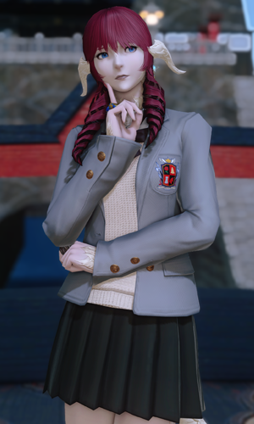
While her hips and ass had suffered the greatest deflation, her breasts were still quite hefty though. In a way they complimented the fact that Suki was all butt and no boob, but the young himedere saw it as a weapon in her arsenal.

And then, it came. Bubbling up from deep within. An impulse she couldn’t bury, for it was just too true to her own character. It was both terrifying, but familiar. A staple of the person she now was. “Oh… Oh… Ohh…”

“Ohoho~! Even though my clothing is disheveled, of course even I could pull off something as ghastly as this!” Unable to resist the laugh that had been bubbling up from within her for so long, Hana Morikawa drew the back of her right hand to the left side of her lips and bellowed out this pretentious statement and laughter. Her clothes as they were looked like they belonged on some kind of exotic dancer, and they certainly struggled to cling to her flesh. Were they crafted for a taller race? Even if she were an adult, she couldn’t imagine that these would fit her properly!

“But the question remains: how did I end up dressed this way? And why do I feel as if I’m forgetting something? Of course that latter statement is impossible, for I am a genius! OHOHO~!” Evidently, this laughter was something of a staple of her new personality. Hana was too confident to consider even a passing moment of negligence on her part, and as for her costume? If she was wearing it, then she must have chosen to!

Questions would find answers as another girl entered the tent she was housed in; the very same girl that had led Nadja there in the first place. “Student council president? Why are you still in your stage costume? You said you were going to meet your kouhai, didn’t you?” These statements were carefully crafted to jog Hana’s memories in a sense.

“Oh, of course! We were performing A Tale of Dancing Maidens for our booth! I remembered that, of course!” She puffed her chest out as her drill-styled hair bounced. And naturally, the kouhai she was meant to meet… “Koko-chan would be so lost without me! As student council president, I must make sure that poor little sheep finds her way home, as inconvenient as it is!”

…Or so she claimed, but the red-headed student council president’s true feelings were different. This wealthy himedere, a transfer student from Eorzea, had become quite smitten with her underclassman, and these justifications were merely excuses.

Money certainly had been on the horizon.

“You honestly think you’re worthy to walk Koko-chan back to the dorm house? Don’t make me laugh, you blonde-haired buffoon! I, Morikawa Hana, as student council president, will make sure she gets home safely!”

“B-Buffoon!? I’m Koko-chan’s best friend! Geez, you rich types are so mean! She probably hates you now that she can hear you talking like that to me through the door!”

“HAH!? I-I suppose she can hear me, can’t she!? I apologize, Koko-chan!”

“I KEEP TELLING YOU TWO THAT I DON’T KNOW WHO THIS KOKO PERSON IS!” The festival had come to an end as the lights of the stars found themselves scattered among the darkening sky above, and the moment the goth Miqo’te S’aiya had chosen to head back to the inn she and her companions were staying at, she’d found herself cornered by a pair of Raen girls that had begun to spout a bunch of nonsense at her.

They seemed like they were familiar with S’aiya herself but continued to call her ‘Koko-chan’ while acting like she should have known who they were. Of course, she had no idea! She wasn’t the kind of woman that typically hung out with teenagers, particularly not in Kugane. Not especially social, she’d dipped into the nearest bathroom… not that it changed anything. The two girls continued to argue outside the door, playing ignorant to any assertion on her part that she wasn’t who they said she was.

The one that called herself ‘Suki’ was dressed up in the uniform S’aiya knew to be the uniform of this school, sleeves, and skirt colored crimson. But the other one – ‘Hana’? Her blue jacket and skirt had a more Western appeal. Was it a uniform from across the ocean?

Even now they were arguing. It was loud, it was annoying, and yet… a thought crept into the back of her mind, one that didn’t belong at all. ‘I can’t believe those two are arguing again… I do so wish they’d get along…’

“Huh? What the…?” The goth shook her head from side to side, unsure of where such a thought could have possibly come from. She had never seen those rowdy girls in her life, she absolutely shouldn’t have had any familiarity with them, and certainly not enough to comment on their relationship with one another.

But this meeting was a key to stimulating the effects of the fortune that had been read to S’aiya. That she would become popular with the ladies – just, ladies in the 15-18 age range. She was being fashioned into something of a dating sim protagonist, and unlike with the others, the fact that her age was in danger was not something that would be toyed with.

It happened quickly instead.

She was hovering a few feet away from the doorway, the bathroom small. But all of a sudden it began to look much larger, almost like the world around her was growing. Of course it was the opposite, and the twenty-eight year old woman was backsliding through the years, peeling from her both her experience and her height.

Muscles honed on the street faded away, leaving limbs soft, but not completely free of strength. What settled in its place was not a strength born from swinging a weapon, but rather? A tool. Or many tools. S’aiya’s fingers remained calloused but those callouses redistributed themselves to better reflect what her hands were far more typically used for.

Tilling the fields, harvesting crops…

“…?” The Miqo’te tilted her head to the side, on the verge of realizing that she was shrinking, but never quite hitting the mark. Still, once her height settled at around 5’2”, her clothing was left a disheveled mess. The skin tight, black top that typically revealed her navel had slid down to cover that bellybutton, fingers vored by the shirt’s long sleeves. The former was made possible in no small part because the woman’s breasts, which had once been astoundingly large in their E-cups, had come down to a bouncy but unimposing set of high Bs. Bigger than Suki’s, smaller than Hana’s.

Her skirt, on the other hand? It hung loose, but not substantially so. Her butt was perkier in its youthfulness, and yet it was still quite well endowed for a girl of only sixteen. Hips were relatively wide as well, and much like with her bust, her ass and thighs were roughly in the middle of the scale of the other two. Her thigh highs hung loose, not that it mattered with her skirt now dangling down to her knees.

But S’aiya? She was just as oblivious to it as the others had been during their own transformations. She picked at her costume here and there to make sure that it didn’t fall, but there was nothing more significant than that. “Why do I feel like…? Mm! Something just isn’t right here, is it!?” The teen was confused, but something deep down told her things were going to be a-okay! In fact, her usual anti-social demeanor was melting at an astounding pace, and a blinding optimism was taking root.

The dark makeup that decorated the girl’s eyes and lips waned, and before long, her face was completely bare of any whatsoever – it was school code not to wear any on campus, after all! But more remarkable, her face’s general composition softened. Not in terms of age, her features had already rounded in that sense, but in a way that gave her face a longer design. Her jaw arched into a sharper chin, and somehow it seemed like she had more cheek than ever before, all while her lips were ripped of their sensual definition to leave something plainer in their place.

There was no doubt that she would look extremely pretty if she were done up in makeup, but it was a ‘plainness’ that persevered throughout it all. Plain, at least aside from her tanned skin tone, which was becoming less and less brown in color. That did not mean it was lightening, but the pigmentation that settled in its place was more of a blue or purple. These skin tones weren’t uncommon in this world, but it certainly wasn’t an attainable tone for S’aiya personally.

But it was widespread. Hands, feet, chest, face; all of it adopted this new hue. It led credence to the fact that she was becoming like Suki and Hana – yet she wasn’t becoming quite like them. For as tufts of brown fur peeled from her tail, they revealed dark blue scales in their wake. Raen like Suki and Hana had white scales, but this shade? They were more characteristic of the Xaela, which lived among the Azim Steppe.

Which made sense, at least to S’aiya. “Did I mail that charm to Cirina…? Cirina…? Who is…?” She tilted her head to the side again, this time confused by her own recollections. Cirina was a member of the Mol tribe, and her cousin, actually? Did she have a cousin? Why did she feel as if she didn’t know her own family? “Mol…? Am I a Mol?”

The cat ears upon her head flattened, and in their place the same hollow horns the other two had been gifted took shape from her skull’s sides. The were similar in shape to Hana’s, but did not hook on the top, and were just as dark blue as her new lizard tail. Scales of dark blue hardened around the usual places, but also claimed her forehead too, evident as low as just above her nose.

A darker purple than her skin found its way into S’aiya’s brown hair, stripping her of her natural curls and finding it all straightened. Much of it hung free to her shoulders at a shorter length, while a great deal was rounded up onto a pair of buns just above her horns. Cherry blossom pink soon graced her locks as well, both tickling her bangs and dyeing her buns in a pleasant, aesthetically pleasing way. This color was natural, the pink from Cirina’s side of the family!

“Oh, that’s right! I needed to send my report to the tribe!” Tiny hands clapped together, and as they did the lights of her eyes shifted. Her left eye took the same pink, and her right eye the same purple, of what was in her hair. Born with the heterochromia, she was often regarded as something of a good luck charm to her people.

And they’d been right! That was why she’d been sent to this school in the first place! She was attending this academy to pick up skills that would be useful for the Mol. Considering all they had done for her growing up, it was only fitting that she repaid the favor!

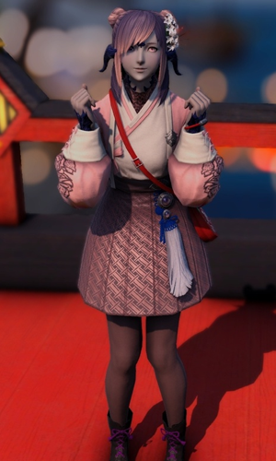
Still a little dazed, Koko Mol pushed her way out of the bathroom to find herself face to face with the two that had been making a ruckus. Both parties erased their scowls and beamed at her immediately, each taking one of her hands in their own. “Oh!?” Koko was a little dense, at least when it came to these two. She treasured both of them and harbored the beginning of what could be considered romantic feelings… but she was also oblivious to how they perceived her. She was just a farmer’s daughter from the Steppe, attending the academy thanks to winning a lottery.

She absolutely did not perceive herself as exceptional nor fun, but she did have a noticeably big heart. So she squeezed the hands she was given and smiled. “Are you two done arguing now? I wish you would get along; it would be nice to have a sleepover with all three of us!” Being the deredere she was, there was a skip to her step as she closed the gap between them and bumped shoulders with both Suki and Hana playfully.

The two girls blushed brightly, but once again… Koko didn’t really seem to notice, or at least comprehend the context. “Together, I’m sure the three of us can do anything! Hana-senpai is smart and confident! Suki-chan is bubbly and always ready for anything! And myself…? Well, I’m not sure if I have any redeeming qualities, but…!”

“YOU’RE CUTE!”

“AND KIND!”

…Or so the other two blurted out, before wrapping the Xaela girl in a hug. They were pretending to put their differences aside, if only for Koko’s sake. But in reality? Both of them had fixated on that. The invitation for a sleepover. “It’s the weekend now, soooooo how about I come over at ten or so for a sleepover! I just bought these really cute new pajamas…” Suki blurted out, still hugging.

Hana physically recoiled. “H-Hey! No fair! Naturally, I will be there at 9:59! Someone of my noble blood would never be late! OHOHOHO! Not to mention, the pajamas I recently purchased are so risqué, I’m sure they’ll get your heart thumping!”

Her own cheeks pink, Koko merely beamed innocently once more. “You two can come over whenever you’d like! I’m extremely excited to have you over! I wanted to show you my new pajamas as well!”

They were, of course, teddy bear print pajamas. The deredere curse.

“Actually, do you two know why I’m wearing these clothes? They seem a little… inappropriate…” She should have been wearing a uniform like Suki’s, right? Hers was done up in pink though, indicating that she was a special student from the Steppe.

“WE THINK THEY’RE FINE!”

Of course they did, with so much of the girl’s body on display.

