MOTHER OF ALL
FIRST PERSON STORY
BY CHALDEACHANGE
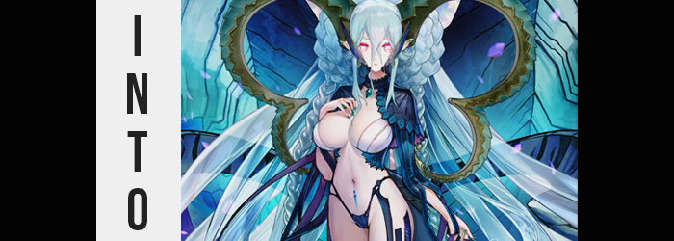

“I really think these holidays are pointless…”

Well, technically the days I was referring to weren’t real holidays anyways. Things like Mother’s Day and Father’s Day – ‘holidays’ meant to celebrate specific people that weren’t really recognized with things like public time off. Not that I had anything against these days specifically, but the relationship that I had with my parents could be strenuous at best.

It was a fairly common story, honestly. A man and a woman get married and have kids, but then things don’t work out as those kids get older and they eventually split. Those parents continue to care for their kids in their own ways, but it’s never the same as being a complete family. It was what it was, though. I was an adult now; it didn’t really bother me all that much.

But my parents still bickered and put me in the middle of their drama even now. I’d bought my mom something nice for Mother’s Day, but it was Father’s Day now. I’d purchased my dad something that was a little more expensive and she’d caught wind of it. Problems had ensured as a result. “It’s not like I did it intentionally. It’s so hard to understand how mom actually feels sometimes.”

I’d just gotten off the phone with her and had been pacing around my room in frustration. Who didn’t love a good old fashioned, phone-based guilt trip? I rubbed at the back of my head, not considering the fact that someone had been eavesdropping the whole time. Then again, when wasn’t she eavesdropping? She didn’t even need to manifest in front of me to keep tabs on me.

YOU REALLY SHOULD CARE MORE ABOUT WHAT YOUR MOM THINKS, YOU KNOW?

A disembodied voice prompted me to look up. It was mischievous in nature, no care for my situation whatsoever. “Hisa…” The nekomata that had plagued me ever since I had created her had a bad habit of toying with me for her own amusement. She likely agreed that my mom was being unreasonable, but it was more entertaining from her point of view to poke at me instead. “You don’t even have a mother, so do you really have an opinion about this kind of thing?”

Technically speaking I was her only parent, and I was a man. At best she could claim to have a father, but there was nothing akin to a mother in her life. I realized a moment too late that I had made a crucial mistake by reminding her of this, though. Hisa was a nekomata, yes, but she was far more powerful than even the ones of yore. She had complete control over the fabric of reality and something of a kink for altering the lives of others.

More than often mine.

OH~! I GUESS YOU’RE RIGHT, HUH? BUT MAYBE THAT COULD CHANGE? MAYBE YOU’RE THE ONE WHO NEEDS TO UNDERSTAND WHAT IT’S LIKE TO BE A MOTHER NOT GETTING THE TREATMENT SHE DESERVES~?

That tone… I immediately tensed up and backed away from my desk. She was about to do something to me, and yet her words were always a little misleading. I couldn’t be exactly sure what she was about to do to me if anything. Sometimes she just liked to fuck with me by threatening me this way. “Hisa, don’t…” But it was already much too late on that front. From the pocket dimension that she called her home, she had already started to cast a spell.

A spell of which the effects I immediately noticed thanks to a gurgling in my stomach that accompanied what could best be described as a feeling of weightlessness, even if that wasn’t exactly what it was. “Damnit…” I immediately slapped my own tummy with my shirt in the way – finding, as I expected, less resistance from my body. I wasn’t a thin guy, or I wasn’t supposed to be, but much of my excess body mass had already been sapped from my body.

This meant that my clothes, designed for a man of my previous size, were not at all fitted to my body now. My shirt might as well have been a tent hiding a tummy that was not only flat but also curved in on the sides in a pointedly feminine manner. It always bothered me that despite knowing I wanted to lose weight, she refused to use her powers to help me take it off. Instead she only made me thinner when she was planning on making me her plaything.

“Yeah, no way she’s turning mother into a… man…?” She seldom ever did unless they were exceptionally feminine. Someday I was going to get turned into an Astolfo or a Bridget depending on her mood. But I’d more pointedly noticed something that I had said. “Mother?” I’d referred to myself in the third person, but not with my name. With a title. And I clearly wasn’t technically a mom. Even though I knew a change of sex was inevitable.

In service of that, in fact? I found my posture momentarily instead. My knees bent in towards one another, prompted by a widening of my hips that managed to make it so that my pants, which were at jeopardy of falling if I made the wrong move, clung well enough to them. The opposite phenomenon saw my shoulders narrow around roughly the same time, just a few inches so that my build was no longer as broad above my chest.

“Testing… Testing… Aaah. AAAAAAA!?” A tingling in my face had alerted me to the fact that my facial features were changing, or by that point had changed. I could feel a weight to my lips that hadn’t been there before; they were definitely fuller. My eyes felt rounder and lashes heavier too, but neither of these assumptions could have prepared me for the color change. Not only had they turned a bright pink, but my irises had turned white and expanded into four-pointed stars that were turned on their sides. There was nothing human about them.

Those eyes had gone wide not because of this though, nor from the fact that my eyebrows were now thick, circular, and ocean blue or how my canine teeth had grown into razor sharp teeth beneath fair, feminine facial features. Rather, in opting to see if anything was wrong with my voice? Well, I’d found a problem. I’d practically sang part of it unintentionally. “Whaaaaat!?” My voice was softer and effeminate, but every time I went to make an ‘ah’ sound my brain extended it like a musical note.

I bit my fuller lower lip with sharpened teeth. The ‘mother’ thing, the ‘ah’ thing; both pointed to one outcome.

There was no mirror in my office, and I didn’t run to find one. I knew full well that whatever was happening was going to happen. I did extend my right hand to look at the back of it. My fingers were definitely smaller and more delicate, but what stood out more was how my fingernails, typically bitten short, were long and not painted a baby blue – but were biologically that color. Something similar had of course happened to shrunken feet, but in terms of things getting smaller.

“Whaaaaaaa!?” One of those manicured hands reached out to catch the side of my desk as my office became increasingly large. Pant legs bunched up around my knees and my shirt quickly better resembled a dress than a shirt, but all because my height had dropped significantly down to 5’3”. That said, my hips had remained just as wide as before and my shoulders just as narrow. Which made sense seeing as they were the foundation for everything else to come. “Shorter? Was she really this short?”

My voice had such an eerie, nurturing calm to it now.

If I was becoming who or what I thought I was, somehow I expected to be a little taller than this. Though even as I expressed shock at this realization the situation continued to worsen. Or get hairy. Literally. The dark locks atop my head were growing at a fantastical rate, growing like weeds as it all spilled out behind me and the same blue that had found my rounded eyebrows was splashed throughout. Bangs grew long and fluffy, settling between my pink gaze while hair pooled on the floor beneath me otherwise. I noticed and my hands did their best to lift it up, but clearly it would need to be cut or raised in braids to not drag across the floor. “Mother has so much haaaaaair!”

I’d referred to myself as ‘mother’ again, and the worst part? Well, I kind of liked the ring of it. It made me feel important and loved, and it filled me with so much more love for others than I’d ever had before. Of course I was still missing some key attributes for it to make biological sense, but looking at my shirt? It was clear that these were all now growing in.

Being shorter with wider hips, I’d already had some difficulties with balance. But a hefty weight upon my breast had me tilt forward involuntarily. Manicured fingers reached up as if to support this weight and push me back, fingers pressing into the soft flesh of sensitive, growing tits. My cheeks burned pink from the feeling, masking the sensation of my ears pulling into notable, monstrous points in the interim. But the G-cup breasts that pushed against my top weren’t to be underestimated in their soft perkiness. They felt very… pillowy.

“Aaaaaand I’m on my waaaaaay to becoming a womaaaaaan!” Every ‘ah’ sound continued to be sung like a long musical note, not that I could help it. And despite what I was saying I didn’t exactly sound distressed about it. My heart was beating rapidly in my chest with anticipation. If I was a woman than my level as a mother would increase. Was that what was exciting me? Considering the destined form I had already assumed to be my impending outcome, this likely made sense.

In terms of things being pillowy though? My thighs didn’t seem to want to be outdone. They thickened within my trackpants, pushing against their loose fabric until it was pulled as tight as it could be while slightly yanking up what had bunched around my knees. My boxers felt tighter around them too, but they felt tight everywhere. A bubbling of my ass cheeks forced them tighter still, pushing uncomfortably against a dick that was stiff from how sensual the changes felt otherwise.

Well, only briefly before it folded inside of my new, moist pussy.

“AAAAAA!” The feeling of my sex changing forced a sing-song moan from my lips. It hadn’t been painful. In fact, it had felt kind of nice? And no sooner than it had disappeared did a blue marking appear beneath the navel on my impossibly narrowed waist. Almost like an elongated arrow that pointed down past my shaved pelvis towards my new genitalia.

For but a brief moment it felt like I was finally out of the woods. How much more could my body, now entirely that of a woman’s, possibly changed? I had a big bosom, a big ass, thick thighs, wide and childbearing hips, and a woman’s pussy. If I had been becoming a normal, human woman then this definitely would have been the end. And yet… “AAAAAA!?”

I cried out one final note that was relevant to my transformation, responding to a sudden and excessive building of pressure behind my ears and above my ass that was soon relieved… as new extensions to my body erupted from these points. From behind my ears? Long horns curved back and in before fanning out and in again, growing thinner and thinner before reaching ornate points. They were dark blue and gold, featuring jagged edges.

On the other hand? A scaled tail jumped from my tailbone, lifting my shirt, and pushing down my trackpants slightly off my big ass so that the peaks of my pale cheeks could be seen beneath them. This tail was clearly reptilian – or draconic – and was about four feet long before its tip could be seen. I had full control over it, but not before knocking over my desk chair unintentionally.

“Ti-aaa-maaaat? Ti-a-mat… You turned mother into Tiamat?” It was lucky that my office was spacious, because my newly grown horns fanned out with their significant sizing to the sides. It would certainly be a wonder for me to fit through a door with them, but that wasn’t exactly what was on my mind in that moment. I understood my form. The form of a voluptuous yet monstrous woman. The form of the Beast from which all life had originated, Tiamat.

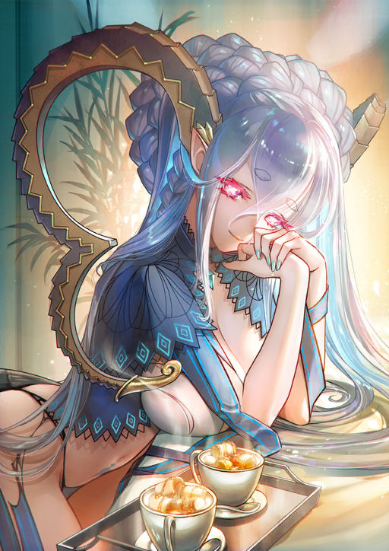
In many ways that made me the ultimate mother. Every living being on this planet was my child. Hisa was included, but even stranger? My own mother factored into this. I saw her as one of my children too. I was likewise unable to stop referring to myself as a mother, words spoken slowly as if the human tongue wasn’t wholly familiar to me. “Hisaaaa… Why did you do this to your mother?”

Everything from my flesh to my personality and mannerisms had changed into this Tiamat, an iteration ripped straight from Fate / Grand Order, but my memories were still my own. I could recognize how I’d ended up in this position and the nekomata who had put me there. Unluckily for me, the disembodied giggling I could hear was not suggestive of the idea that I’d be getting changed back anytime soon.

SEE? NOW YOU’RE THE UNDERAPPRECIATED MOM? I BET ONE OF YOUR CHILDREN NOT TREATING YOU RIGHT MAKES YOU FEEL REAL BAD, RIGHT?

She wasn’t wrong. I lowered my gaze as I considered the possibility. Even if I didn’t meet Hisa’s expectations, that thought left me feeling a little hollow and sad, like I would do my best to try and make it up to her! Because that was what a good mother would do! So not giving my mom a gift as expensive as my dad… Even though I knew deep down that it wasn’t a big deal, my nature as Tiamat felt guilty about disappointing my mom, about disappointing one of my children.

“But how can mother make it up to her looking like this…?”

Could I even change into clothes that would fit?

