# WALKTHROUGH & CHEATS for SPACE PAWS v0.75

**Cheat Codes:**

To activate the “codes console” you have to: go to your bedroom, click on the floor or any unclickable place, tap the spacebar and a blue rectangle with a button will appear. The cheats you can type are:

* **myprecious:** receive the bracelet
* **machoman:** strength 100
* **flowerpower:** strength 1
* **einstein2.0:** knowledge 100
* **dumbasarock:** knowledge 1
* **pantydropper:** charm 100
* **thatcreepyguy:** charm 1

**Attributes needed:**

* Strength: 50
* Knowledge: 25
* Charm: 50

There is also a time limit of 50 days.

# All interaction energy requirements:

* Talk:-10
* Ask:-10
* Give:0
* Date:-80 // 10 if you fail
* Girlfriend: -60 //10 if you fail

# ROSELYN'S ROUTE

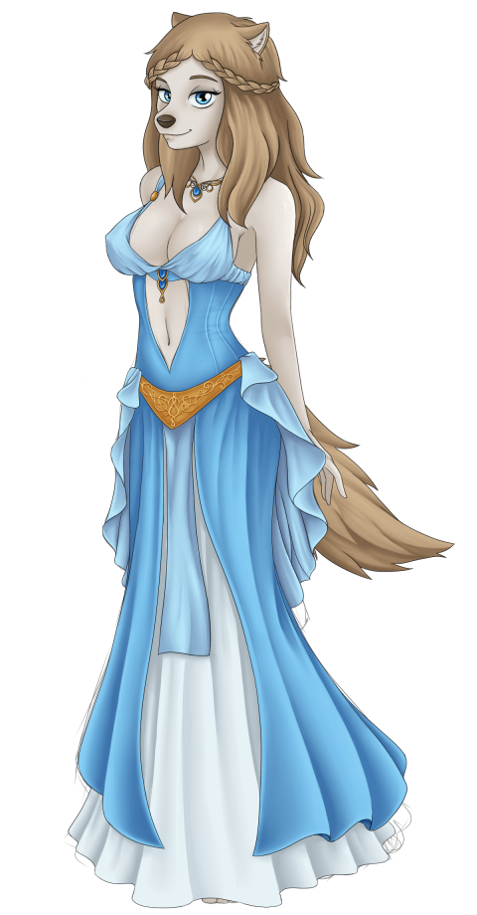

First of all, you have to go to the Market. You can interact with some characters (Max, the girl in red, and the Merchant). Talk to the merchant and do his riddle challenge (Requires knowledge 15+). The answers are:

1. A stick
2. D
3. What?
4. Your mother
5. Tomorrow

Once you answer all questions correctly, he will give you a **red ball**. You'll need this ball to distract the guard in front of the gates of the Roselyn's castle. Give him the ball. If you have strength 20+ you'll throw the ball far enough and the guard will completely disappear.

Inside the castle, you'll find Amber, Roselyn's counselor. She'll demand a "reference" in order to let you in to talk with Roselyn.

In the market, talk with Max. He'll ask you to babysit his hyperactive puppies (if you haven’t talked with him before, you'll need to talk to him a few times). Accept.

After that crazy night, you'll talk again with Max. The job is done and you have your reference. From this point you can visit Roselyn and you can also talk with Alison, who's in the spaceship's library.

Focusing on Roselyn's route, go to the castle, talk with her and you'll explain her your mission and your relationship status will become **Acquaintance**.

From this point, you have to talk with Max, he'll go with you to "the Dungeon where nobody dares to go in". To enter in the cave you'll need or Knowledge 25+ or Strength 40+. Once you're in, solve the puzzle and you'll obtain **Roselyn's bracelet**. (Alternatively, to skip this and just get the bracelet, go to your room on the spaceship. Click anywhere on the floor and press the spacebar. In the box that appears at the bottom of the screen, type “myprecious”. You should now have the bracelet in your inventory.)

**IMPORTANT: since the v0.69 if you want to do Roselyn and Nebet's route in a same game, you should complete Nebet's routes first. Eventually Pharaoh will give you the bracelet back so you will able to go forward with Roselyn's route.**

Go back to the castle, and give Roselyn her bracelet. In order to become **Friends** and be able to date your charm must be 20+.

If you successfully become friends, now you can date her. Here starts the "fun". :-P

You can obtain an H-scene with her in EVERY date. If you obtain at least 1 H-scene on the dates, you'll become **Fuck Buddies**.

To obtain the H-scenes, you'll need:

* Forest: Charm 30+
* Lake: Strength 40+
* Snowy Mountain: Charm 35+

Once you're fuck buddies you can Girlfriend her. That means that after the first date if you fuck with her, you can do directly the final challenge with Roselyn, BUT you'll be missing the other H-scenes (that's your choice!)

You can also date with her on the three places (without fucking her) and then do the challenge. The answers for this are:

1. Loryns
2. Manifus
3. Oranges
4. 912
5. I went once
6. (Pick any of the options, except for indifferent – that’s the worst thing you can say to a girl like Roselyn!)

If you did it well, you'll get Roselyn's ending. Congratulations! She’s crazy for you and I bet you're crazy for her too.

# ALISON'S ROUTE First of all, there's an Easter Egg with Alison. See the easter eggs below to see how to get it.

To interact with Alison, you need first to babysit Max's puppies. All that noise will make Alison go out of her room and you'll be able to find her on the library since the day after you babysit. Talk with her; she'll be impressed of all your efforts to make your mission. Your relationship will change to **Acquaintance**. If you go to sleep, you'll have a dream of her.

Now, you need to date with Roselyn or with Nebet and visit 3 different places (Forest, Lake and Snowy Mountain in Roselyn's case, or Oasis, Canyon and Badlands/cave in Nebet's case) in order to know good places to plant the sprouts. On the dates, you can do dirty things with the furry girls (or not, that's your choice) and it won't affect to your relationship with Alison. Note that if you choose to go on the Badlands date, you will need strength 50+.



Once you've visited the places, talk to Alison again. You two will become **Friends**, so now you can “date” with her with the excuse of measuring the ambient of every place. When you go on dates with her, you'll see her with different outfits and how your relationship is quite better than before. After the dates, Alison will want you to take the shovels that are in the Storage room (the one blocked from the beginning of the game).  
  
**NOTE: to unlock her ending on the 0.69 date her on the dog planet. Cat and Fox planet endings aren't available yet!**

There, you'll find the shovels in the closet. But, there's something more. On the left side near the floor, you'll find a mysterious book. That's Alison's diary. You can't open it yet, because it has a password. On the cover, you can see the word “CaNdYCaNe”. That's not the password, but it is the hint you need to open it. Remember the words with their capital letters and go to the library. There, look at the Periodic Table of the Elements. The password is made of the atomic number for each element:

Ca= 20

Nd=60

Y=39

Ca=20

Ne=10

Only a library rat like Alison would make a password with the Table of the Elements. Anyway, put the password in to unlock the book: 2060392010.

*Dramatic music...*

Ok. Now, you can keep reading her diary. Reading every chapter requires a lot of energy (60), so you are only able to read one chapter every day. After reading a chapter, go to sleep, and you'll dream about a labyrinth. Every chapter unlocks a different labyrinth (or lost memories in your head). In every labyrinth, you must find the key and the exit door to unlock the memory (H-scene) of the chapter you read.

How to solve the **first Labyrinth:**  How to solve the **second Labyrinth:**

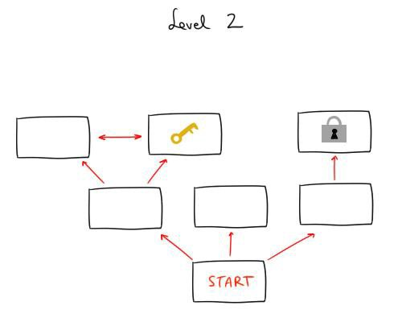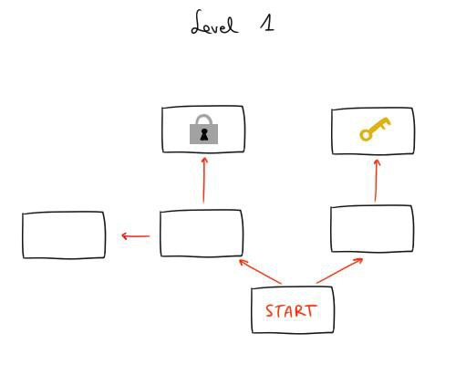

How to solve the **third Labyrinth:**

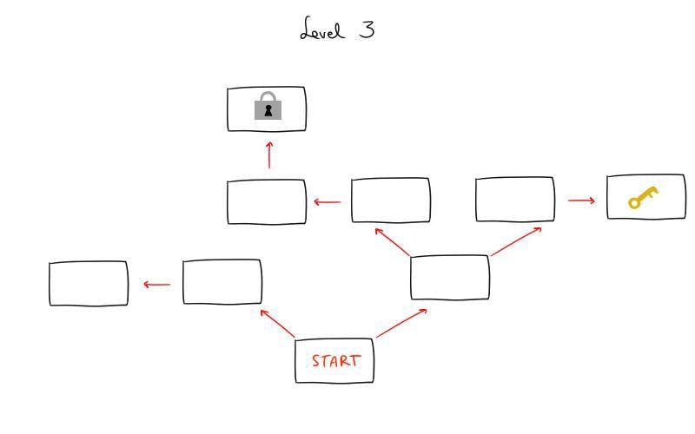

How to solve the **fourth Labyrinth** (2 KEYS):

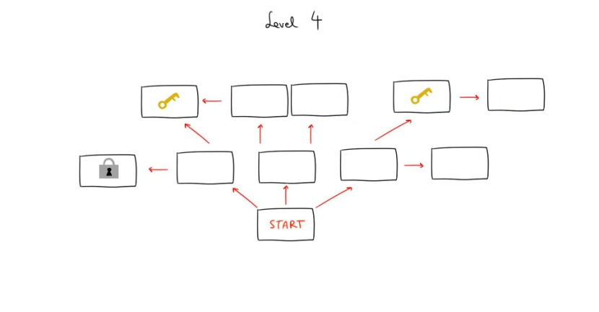

How to solve the **fifth Labyrinth** (3 KEYS):

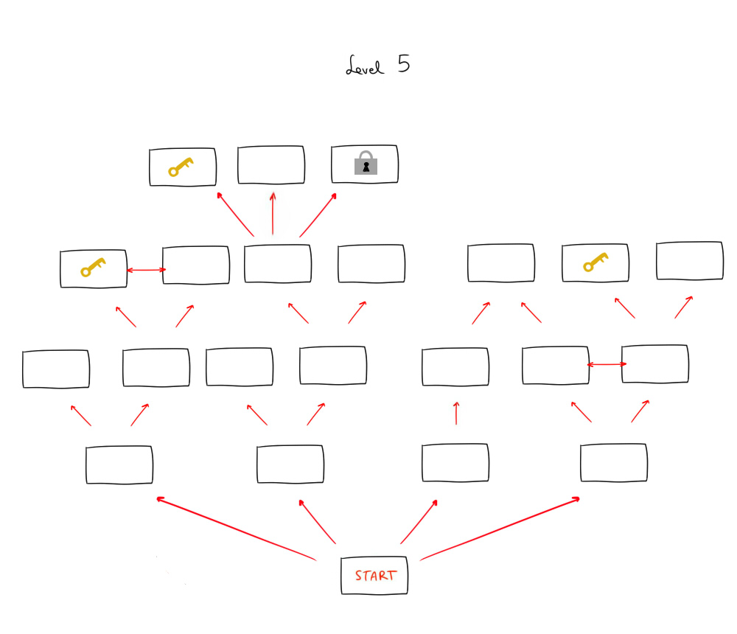

At this point, you'll be able to read the 5th and last chapter of the journal. After reading it, Alison will catch you. Oh man! She will get very angry for that and will shut the door with you inside the storage room. Dramatic music plays, the spaceship is moving... WTF is going on?

You hit your head when the Spaceship is moving violently and you pass out. After that, you get to get out of the storage room. You talk with E-Millio and he doesn’t know anything about what happened because Alison made sure he wouldn’t remember anything. So you need to explore the planet were you dated with her. There're 3 possible places where Alison could be on every planet. On v0.69 this is only available on Dog Planet, so you will need to explore the Lake, the Snowy Mountains and the Forest. Alison went to the Snowy Mountains so you can go there directly. You'll find her and carry her to the hut. There you ask for an explanation and she will tell you everything. (At least everything she knows, haha!)  
You will need to choose between forgiving her or not. And of course, if you want a happy ending you'll need to forgive her.

# NEBET'S ROUTE

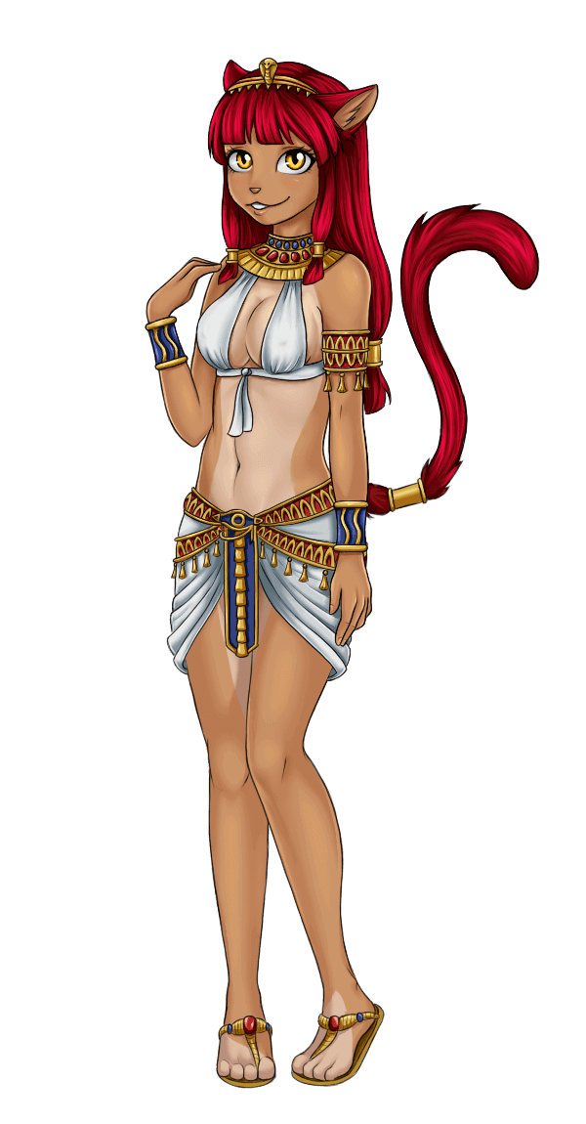You land on a desert planet with an Egyptian town. Go there, and you'll find two cat guards blocking the town's gates. You have to discuss with them and select the correct option to say in order to get in.

There's a hint available if you have knowledge 30+: you have to mess with them. So, you have to select the option that they will make the two catsconfront each other. The correct options are:

1. (To strong cat) so you're the boss, right?
2. (To skinny cat) but is he who always speaks?
3. (To skinny cat) I bet he's always who sees everything first...
4. The sight is not the problem dude. He instills more respect
5. Hey! Wait! The most important thing is...Why is his weapon bigger than yours?

Ok, the two cats are now fighting and the gate is no longer blocked. Get into the town, there you'll find some villagers. You can talk with them, but you'll need to talk with the old cat and with the mother cat at least once in order to make Nebetappear.

Talk with her. She'll think you're a messenger of their Gods and you go along with that. Now, you'll need to train your charm (40+) in order to get an audience with the Pharaoh. He's an untrusting old cat but thanks to your training in charm, you'll achieve to go along with all your sham.

Now, talk to Nebet and she'll tell you she wants to take you to their temple to..."take care of you" ;) Accept.

There'll be an H-scene with Nebet and their priestesses (click on the priestess to zoom in the CG) But it seems that after all this passion, Nebet has scratched your back. It wouldn't have affected you if you were a messenger of the Gods... but unfortunately you're a mortal being and you start bleeding a bit. Gotcha!

Don't worry, you explain Nebet everything about your mission and you convince her to help you. She accepts, and after a premonition, she tells you where you can find the jewel with the blue scarab that Pharaoh wants to see (surprise! Roselyn's bracelet!).

So, you'll have to do Roselyn route until you get the bracelet. (Alternatively, to skip this and just get the bracelet, go to your room on the spaceship. Click anywhere on the floor and press the spacebar. In the box that appears at the bottom of the screen, type “myprecious”. You should now have the bracelet in your inventory.)

Then, you'll have to choose: Nebet or Roselyn? One of these girls will receive the bracelet and the other won't, so what you gonna do? Your decision automatically blocks the route of the other girl, so it's a good idea to save after you get the bracelet! That's the reason why Nebet seems a bit worried about what you'll do with it.

When you show the bracelet to Nebet, she'll cheer up and you'll be able to visit the Pharaoh again. Go and after talking with him, now you and Nebet are Friends and you'll be able to date with her.

These are the dates and the order you should follow to obtain all the H-scenes:

**Oasis:** This date is not strictly needed to get Nebet's ending, but it's the most important to obtain 2 of the 3 H-scenes of the dates. Be sure you have trained your strength (you’ll need 40+ to do this date). A pairof bandits will appear and one of them will try to rape Nebet (CG). You must beat one of them (the biggest one!) in a minigame. Take into account that "Claws" is stronger than you and every hit he doeswill do to you double the damage you do to him. When it's your turn to attack, look carefully at where he's blocking, and attack him anywhere else. On your turnto defend, you'll have to look carefully where he's attacking you to block it successfully (be careful, an uppercut punch starts from below and finishes on your head, so protect it well!).

After beating him, the two bandits will escape, and... Nebet will offer to compensate you for saving her. If you accept, you will see an anal H-scene with her.

**Canyon:** You'll have to obtain a vine that you'll need for the Badlands' date. If you fought and won against the bandits on the Oasis, you'll notice that Nebet is a bit nervous, and she will keep reminding you that she is debt with you for what you did on the last date. So, yes, in order to unlock the Oasis' and the Canyon's H-scene you have to win the fight against "Claws".

**Badlands:** You'll need charm 50+ to unlock this H-scene. Nebet will pass out, you'll have the chance to be a gentleman... or not. If you have enough charm, you'll see the H-scene. In any case, after that Nebet will be naked (woohoo!).

Now you have to use the vine you obtained on the Canyon. After roping down, you'll find an immense cave with an awful lot of water. Oh, and a bunch of rocks blocking the water!You'll have to talk with the Pharaohagain.

Once the date have finished, you'll explain him what you've seen. Now you've figured out how to solve the drought problem. You become friends with the Pharaoh and you have his permission to live on his planet.

Now, you can "**Girlfriend"** Nebet. She will ask you to answer some questions before leaving her responsibilities as a priestess to be with you. The answers are:

1. There aretwo, one hidden and one visible
2. Your accent and suit
3. There's one of the biggestrivers
4. It's where the essence of the life is
5. Neftet
6. To be with you/ to bang you every day of my life / to know more about you

After answering, you'll get the final foreplay and H-scene withNebet. Enjoy! :)

# A:\Users\Txus\Desktop\siaren full.pngSIAREN'S ROUTE

Go to the third planet (the green one). After landing, go through the jungle (costs 20 energy). There you'll meet Siaren.

After some chatting, she we'll ask you to join FRY and you finally accept. She will take you to FRY's base and there you'll meet the rest of the members. Once you talk with Gunter and accept to become a new FRY's member your relation with Siaren will change to **Acquantaince**.

At this point you'll need to train your aim with Maya's minigame. You have to get a record of 50 hits in order to further the story. If it is too difficult for you for any reason (not using a mouse, using a bad mouse, actual bad aim skills...), there's another way. Talk with Zaphirus and Zirkon. They will give you the choice to do an intensive training with them in order to achieve 50 hits. If you finally choose this option, you'll spend 10 days with them and your skills will decrease 10 point each! So, it's a good idea to try Maya's minigame a few times before giving up.

Then, click on Gunther's aim button. He'll check if your aim is over 50 points, and he'll give you your first mission. After that, go to the landing zone. On the bottom right corner you'll find a teleport beacon. Click on it. You'll be taken to the floating city.

Talk with the citizens there. After that, a mysterious fox will take you to an alley and give you a paper. Your work is done! But after that you'll see in the city a very mysterious fox wearing a red tunic giving orders to the Vanguards. Keep reading to bring those little children with you.

After that, just go to the FRY's basement in order to give them the mysterious paper you got from the stranger fox. There you will find Siaren. Give her the paper and try to decipher the meaning together.

You’ll need **50 points of Knowledge** in order to solve it, and the correct options are:

1) The numbers and their position

2) The highest numbers

3) Join the points in Fibonacci's order

4) Think of the quote and the kite

It's done! The hint Da Winki gave was "Wind".

Since now, you and Siaren will be **Friends** and you'll be able to date with Siaren. There're 3 available places to go:

-Coast of Lovers

-Whistle Rocks

-Silent Fields

The Silent Fields is where you should go, but it's blocked until you go to the other 2 places. You can go to the Coast of Lovers and the Whistle Rocks in any order and you won't miss any H-scene for that.

Coast of Lovers

To get the H-scene just DON'T be charming. Siaren doesn't like charming guys. If you act like a confident playboy you'll be a mood killer to her. So "Fight against your instincts" and be sure to have Charm less than 20! You'll be rewarded with a nice Thighjob H-scene. :)

Whistle Rocks

As in the last date, the point is not to be charming enough and having your knowledge skill over 55.

If you do, keep talking and select the option **"Take off your clothes".**   
Has anybody asked for a Footjob? :)

Silent Fields

Well, you are in THE PLACE. Da winki’s lair is here but you'll have to find it. Once the chat ends, just put your mouse in the center of the screen. Then, slightly to the left there's a button **"Trees"** that should appear. Click on it. Da Winki's hideout is there, but the door is blocked by a password. Don't worry, it's easy if you followed the story (especially if you are reading this walkthrough lol). The password is "Wind", the hint of the paper. (doesn’t matter if you write “WIND”, “wind” or “Wind”)

If you click on the **"No idea"** button, Siaren will tell you the password, BUT you'll miss the H-scene. Maybe Siaren is crazy but she isn’t impressed by someone that doesn't remind what he deciphered some days ago :)

Once you are in the hideout and after the chatter, clicked on the **"Play detective"** button. This way you'll receive a blowjob. *(Creator's note: Mmm... should I get a job as a Detective?)*

After that you two go back to the bunker and...voila! Da Winki is there! It seems that the FRY members already knew where he could be and for some reason they decided to keep you busy... mm, that's suspicious. Da Winki reveals to the rest of the inhabitants of the planet that the members of the New System are... Lacertans! (the reptilian new race that you don’t know yet)  
After all this talk it is recommended to talk again with Gunter. He will explain you the reason why they kept you busy.  
Now with Siaren you can talk to her, repeat the H-scenes of the dates and Girlfriend her. There's a Quiz you'll need to answer correctly. The correct options are:

1) Tie up people

2) I was a fucking party pooper

3) Air has particles that acts like sex pheromones

4) The wind goes around the mountains

5) There was a white noise

6) A virgin

And this is it! You and the crazy fox girl Siaren are now together.

# 

# Easter Eggs

# Easter Egg [Dog Planet]

In this world,there's an Easter egg where you'll be able to see 2 H-scenes with Erin, the girl in red of the market. To unblock it, just talk with her before day 13th. Once you've talked with her, go back to the market on the day 13th. When you arrive to the market, you'll see a pair of old (and ugly) ladies in the market instead of Erin. They will bring you to the widow's forest and thereyou'll have to help Erin with a short minigame. The correct order for solving this minigame is:

Yellow, Green, Purple, Black, Red, Blue, White, Orange

# Easter Egg [Cat Planet]

To unlock this Easter egg, don't solve the Cat planet issue until the day 20. From this day on, visit the well that's near the cat city (click on the left side of the screen, where there're some palm trees). If it's day 20 or more, the drought problem will be quite severe and this will mean the well has less water. That makes possible to see a shining object at the bottom. Grab the lamp, rub it, wake up Ginny, the genie, and make your wish. The H-scene are the wishes " You have such amazing boobs" and " Threesome".   
**NOTE**: This easter egg can't be repeated in a same game, so save your game before finding Ginny's lamp if you want to try the other wishes.

# Easter Egg [Fox Planet]

# This is probably the most challenging easter egg so far. To unlock Maya's easter egg, you'll need to play the shooting drones minigame and reach at least 100 hits. However, there's a alternative way to unlock it. If you feel you're not good at this kind of games, you're using trackpad or anything, you can unlock it trying the shooting drones minigames 8 times. No matter your score, after spending energy and days in the minigame, the easter egg will auto unlock.

# Easter Egg [Alison Solo + Fantasy]

It won't affect to her route, but you'll get 2 nice H-scenes with her if you unlock it. You know there’s a peeping scene at the 3rd day where you wake up and see Alison naked in her room after having a shower, right? Well, the next day she’ll have some sexy fun on her own! But you’ll only get to see it if you have at least **40 points of knowledge by the day 4** and click on her door. (You’ll find the first H-scene).  
After that, you can spend the rest of the day as you please. Once you go to the bed, you'll feel unable to sleep and you will fantasize with her because what you saw that morning had turned you on (2nd Hscene).