Electric Potential Energy - Worksheet

13 Free-Response Questions

Organic Chemistry Tutor

1. A +50 μC point charge moves from point A to point B as shown in the diagram below. The magnitude of the electric field is 2 x 10⁶ N/C. Points A and B are 80 cm and 20 cm above the negatively charged plate respectively. (a) Calculate the electric potential energy of the 50 μC charge at points A and B. (b) How much work is done to move the charge from point A to point B? (c) What is the electric potential at points A and B? (Assign a potential of 0V to the negatively charged plate)

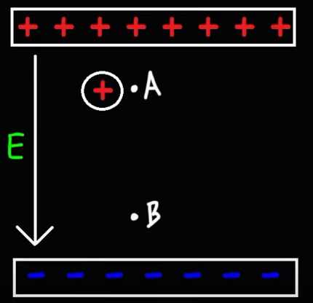

2. A +70 μC charge is located at a point where the electric potential is +300V. (a) What is the electric potential energy of this charged particle? (b) What is the electric potential energy of a -60 μC charge located at an electric potential of +500V?

3. A 100V battery is connected to two oppositely charged parallel plates that are separated by a distance of 10 mm. (a) Calculate the electric field. (b) What is the electric potential at a point 7 mm above the negatively charged plate? (Assume the negatively charged plate is assigned an electric potential of 0V) (c) What is the electric potential energy of a +400 μC charge placed 7 mm above the negatively charged plate?

4. A proton is released from rest in a uniform electric field with a magnitude of 500 V/m directed along the +x-axis. The proton travels a distance of 0.40m in the direction of the electric field. (a) Calculate the change in electric potential of the proton. (b) Calculate the change in electric potential energy of the proton. (c) Calculate the speed of the proton after moving through a displacement of 0.40m starting from rest.

5. A uniform electric field with a magnitude of
800 N/C is directed north. A -300 μC charge moves south by a distance of 30 cm. (a) How much work is done on the charge by the electric field? (b) How much work is done by the electric field on the -300 μC charge if it moves north by a distance of 50 cm due to its initial velocity?

6. An electric field of 500 N/C is directed east along the +x-axis. How much work is done by the electric field on a +50 μC charge as it moves north by a distance of 40 cm?

6b. An electric field has a magnitude of +600 N/C and is directed north. A +500 μC charge moves a distance of 8m at an angle of 330⁰ counterclockwise from the +x-axis. How much work is done by the electric force on this charge during its 8m displacement?

7. What is the change in electric potential energy of an electron that passes through a potential difference of +800V? (Provide the answer in electron volts)

9. A +400 μC charge is 5 mm away from a -300 μC charge. What is the electric potential energy of these two charges?

8. Which of the following expressions is correct regarding the electric potential of the points shown below?

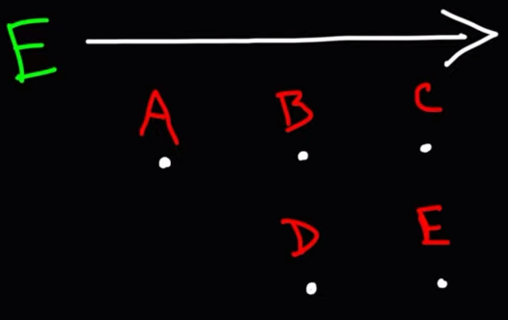

A. V_{A} > V_{B} > V_{C} > V_{D} > V_{E}
B. V_{C} = V_{E} > V_{B} = V_{D} > V_{A}
C. V_{A} > V_{B} = V_{D} > V_{C} = V_{E}
D. V_{E} > V_{D} > V_{C} > V_{B} > V_{A}

10. How much work is required by an external force to bring a +20 μC charge from a very large distance away to a point 40 cm from a +80 μC charge?

11. A +300 μC charge is fixed at the origin. A +40 μC charge with a mass of 1 Kg is released from rest 60 cm to the right of the +300 μC charge. What will be the final speed of the +40 μC charge when it is very far away from the 1st charge?

12. A +500 μC charge is fixed at the origin. A
+60 μC charge with a mass of 4 kg is released from rest 50 cm to the right of the +500 μC charge. What will be the final speed of the +60 μC charge when it is 2m away from the 1st charge?

13. Three point charges with magnitudes +30 μC, +20 μC, and -10 μC form an equilateral triangle with a side length of 1 cm. (a) What is the total electric potential energy of this system? (b) How much work is required by an external force to bring these 3 charges into this configuration if they were initially very far apart from each other?

Answers:

1a. U_{A} = 80 J, U_{B} = 20 J
1b. +60 J
1c. V_{A} = 1.6 x 10⁶ V or 1600 kV, V_{B} = 4 x 10⁵ V or 400 kV
2a. 0.021 J
2b. -0.03 J
3a. 10,000 V/m
3b. +70 V
3c. 0.028 J
4a. -200 V
4b. -3.2 x 10⁻¹⁷ J
4c. 1.96 x 10⁵ m/s
5a. +0.072 J
5b. -0.12 J
6. No work is done on the charge by the electric field as it moves parallel to the y-axis.
6b. -1.2 J of work is done on the charge in the y-direction. No work is done in the horizontal direction.
7. -800 eV
8. The correct answer is C.
9. -216,000 J
10. 36 J
11. 18.97 m/s
12. 14.23 m/s
13a. +90 J
13b. +90 J

