© 2016 Ziel
Art ©2016 Seraphiel
All rights reserved.
Big Changes
Jock and Awe
By Ziel.

Big Changes
Jock and Awe

“You want me to wear THIS!?” Troy squeaked in shock as he held up the small jock strap that his friends given him.
“Of course.” Mike replied.
“It’s the perfect color for you.” Ike added.
“The color’s not the issue! I mean… just look!” Troy stammered indignantly and gestured towards his cock. His dick was as massive as ever. It was so huge in fact that the head of it rested solidly on the tiled floor of the gym locker room, and that was even after it had draped over his huge nuts.

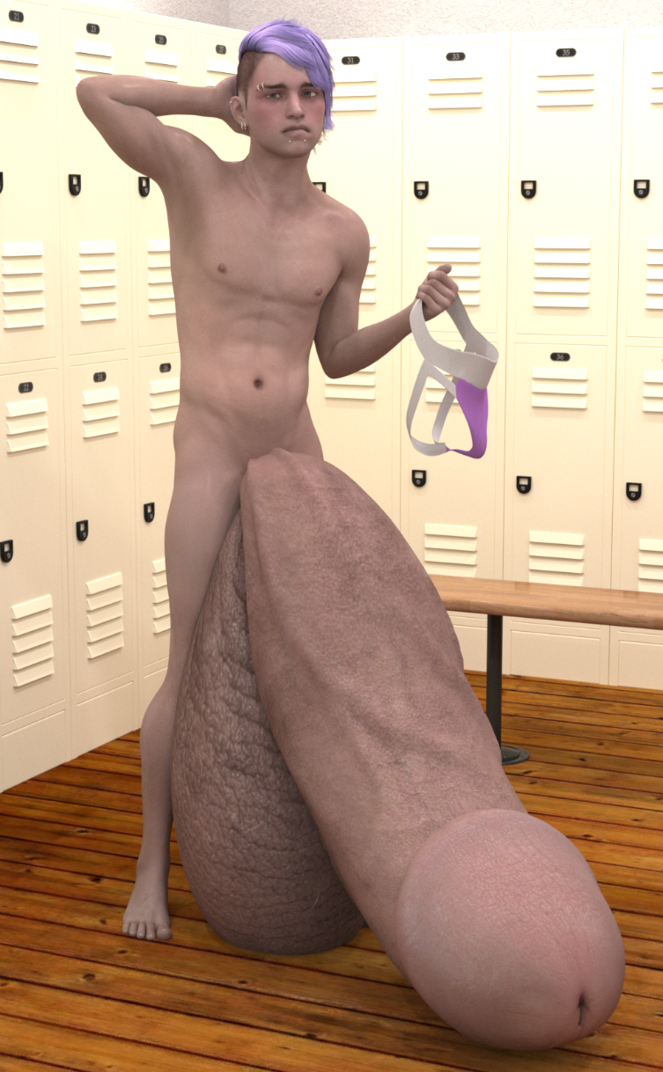

“Looks great to me.” Mike replied casually.
“Yeah. No problems here.” Ike agreed.
Troy was about to grumble something in reply, but the second the twins dropped their shorts, the words refused to form. Troy could only stand there and gawk at his two hot, buff buddies as they stood there clad in nothing but their tight, little underoos. The twins’ underwear left very little to the imagination. If anything the bright red color of their tight, little briefs drew Troy’s gaze like a flame draws a moth. Troy couldn’t help but stare at the way their huge, floppy foot longs strained against the front of their briefs.

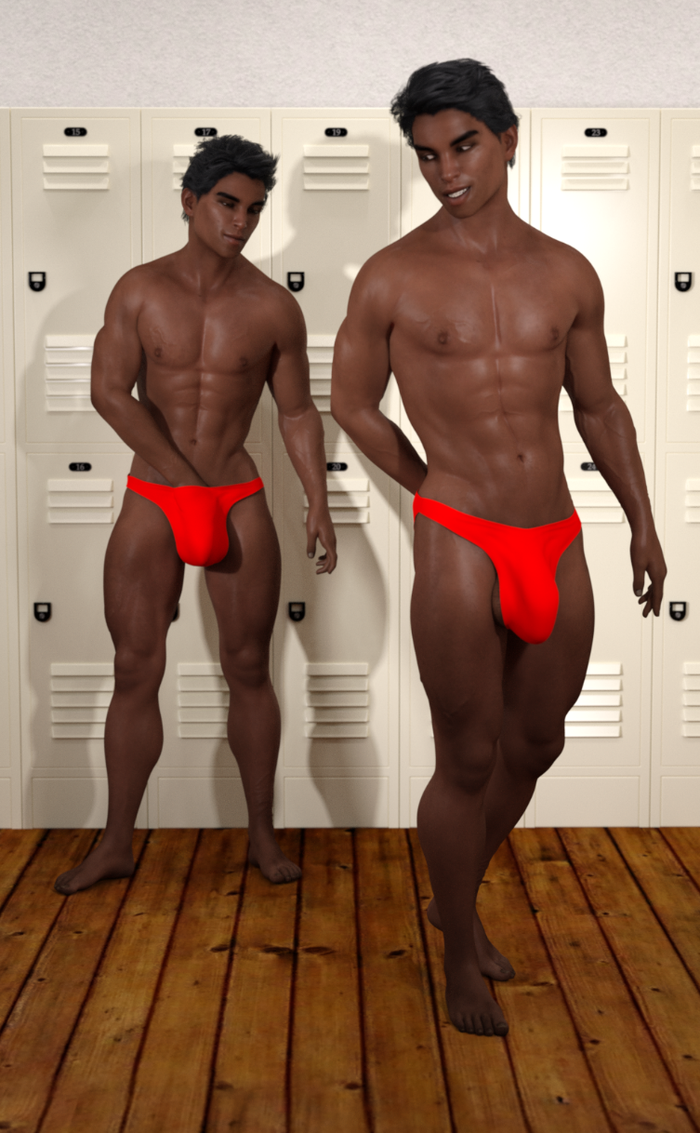

“No complaints?” Mike asked playfully.
Troy could only let out a soft, pitiful whine in reply.
“I knew you’d see it our way.” Ike replied with a chuckle.
Troy wanted to say something. He wanted to come up with a good counter, but no sooner had he cleared his head and begun to muster a comeback than the twins dropped their briefs too. Troy was once again rendered speechless as the twins’ huge cocks flopped into view. Their dicks were even more amazing now that they were exposed, and the way that their nude, tanned bodies seemed to glisten under the fluorescent lighting of the gym locker room lights was hypnotic.
The twins shot each other a knowing wink and took a moment to casually pose like models at the end of the runway. They turned this way and that. They effortlessly flexed their muscles as if they were just casually warming up for the gym set, but Troy new better. He knew that they were intentionally giving him a show. Troy could feel his cock stirring to life as he watched the twins pivot at the hips and flex as if stretching. Their toned lats and sculpted traps bulged for Troy’s viewing pleasure. Troy could feel his nuts getting heavier between his knees as the twins stretched as if yawning. Their arms raised up high and their bodies tensed causing their already immaculate eight pack abs to clench and flex making the defined grooves of their amazing abs even more fantastic. Troy could feel his already massive cock getting ever so slightly bigger, thicker, and harder with each passing second as the twins turned to rummage through their gym bags. They bent down giving Troy a clear view of their sculpted booties. The twins even went so far as to rhythmically flex their glutes for Troy’s viewing pleasure as they casually hummed a tune and rummaged meticulously through their gym bags.
Troy could barely contain himself. His hands drifted down towards his crotch as he stared. His fingertips traced a path down his smooth, flat belly and across his clean shaven crotch. His hands brushed against his impossibly huge cock. He found himself wishing he had bigger hands so that he could actually grip the shaft and stroke his cock as he watched the lewd display before him. It was a strange thought, but by this point he had completely given up on the thought of his dick shrinking down to a normal size. In fact he hardly ever even thought about it. By this point he was so used to being obscenely hung that he wouldn’t even know what to do with a normal sized dick, and he couldn’t imagine going through life with such an average cock.
Troy tried to clear his mind. He tried not to focus on the hot twins and their amazing bodies. At this rate he’d be fully boned in no time. He was already flying at half mast, and he hadn’t even gotten into the gym yet.
Mike looked up from his bag and smirked as he beheld his shorter, slimmer friend. Troy was blushing beet red and his dick was damn near fully boned. Mike couldn’t get over how cute Troy looked. He was half tempted to forego the gym and have a little fun right then and there, but they hadn’t had nearly enough time to tease Troy yet.
“You might want to take care of that before you get onto the floor.” Mike commented casually as he stepped into his jock strap.
“Yeah. You’ll put someone’s eye out with that thing if you go out there swinging that battering ram around.” Ike added as he adjusted his bulge in his own jock strap.
Troy merely nodded in reply. He knew they were right. The last thing he wanted to do was stagger around the gym with his semi-boned dick swinging around like some sort of foam-wrapped hazard in an episode of Wipe-Out. As it was he was liable knock someone off their feet every time he tried to turn around.
“We’ll be waiting for ya. Don’t take too long.” Mike said casually and turned to walk out of the gym locker room clad in nothing but a pair of sneakers and a small, red jock strap. The red fabric ball pouch contrasted with his dark, tanned skin perfectly, and the open back of the jock left Mike’s impeccable ass free for Troy to peruse.
“Yeah. The gym won’t be open much later, and I’d prefer it if we had the chance to ‘finish up’ before they closed.” Mike added and shot Troy a sly wink.
Troy silently cursed the twins for being so stupidly sexy, but his dick gave a quick lurch of approval at what he saw. Try as he might he just couldn’t deny how hot his friends were, and he had to admit they could be pretty fun to be around when they weren’t trying to get him to pop wood in public.
Troy waited around for a few moments for his dick to deflate enough for him to make an effort in putting his clothes on. He was originally just going to wear the shorts he had worn when he arrived, but the small, lavender garment was calling to him. He had to admit he loved the color, and the fabric was so amazingly soft.
Troy picked up the jockstrap and examined it closer. It was a remarkably well made piece of clothing, and it seemed a shame to let it go to waste. Troy couldn’t help but wonder what the twins would think if he came out wearing that. Surely they didn’t expect him to actually try it, did they?
Troy smirked as he imagined the look on his pal’s face as he strode out of the locker room clad in just an overstuffed jock strap. Surely it would be their turn to spring a board, and the thought of it just made Troy giggle. The thought of turning the twins’ own games on them was too perfect to resist.
Troy stepped into the jock easily enough. The leg holes were perfectly sized for him, and unlike with regular underwear, there was nothing going on between his legs to block his balls from dangling. That just left the matter of what to do with the front pouch. Troy experimented a bit to see just how much he could fit inside the pouch, and what the answer he found was “not much”. He could barely even get just the huge, puffy head of his cock into the pouch. In fact the jock pouch looked like little more than purple painted foreskin once Troy got his dick tip in. There was no way Troy could ever hope to get any of the shaft in, but that was fine enough. As long as it kept his dick off the floor he figured it would do.
Troy strode out of the locker room and up the stairs towards the weight room. He was not at all surprised when he found that the twins were already up there and having a grand old time. They were in the middle of the weight room. Either twin had huge, hefty dumbbells in hand and were doing bicep curls in perfect unison. Their skin glistened with sweat under the warm halogen lights.
“Look what the cat dragged in.” Mike commented playfully as he turned to look at Troy.
“I told you he’d wear the strap.” Ike said and nodded towards Troy’s choice in attire.
“As if he could resist.” Mike replied with a smirk.
Troy fidgeted awkwardly as he stood atop the steps. He felt ridiculously out of place, and it wasn’t just because of his skimpy clothing. His cock was pretty much entirely exposed. His dick was so huge that the entire shaft poked out over the waistband of his jock. His massive schlong was so huge that it was folded over like a slinky at rest and it still came close to bopping against his chin, and his balls were left to dangle between his legs completely free from any and all cloth confines.
Troy was suddenly having second thoughts. He had thought he’d have the upper hand for once, but it turns out he had once again played right into their hands. Troy wasn’t about to give up so soon though. He had come with a plan to put the heat on the twins, and he wasn’t about to back down after such a minor setback.
Troy clenched his fists. He swallowed the lump that had formed in his throat, and he strode out onto the gym floor. He tried to get a bit of a sway going with his hips, but his movements looked and felt stiff and awkward. He knew that would never work. He needed to really ramp up the charm if he wanted to have any chance of turning the twins’ game on its head, but what could he do against them? This was their game. This was their territory.

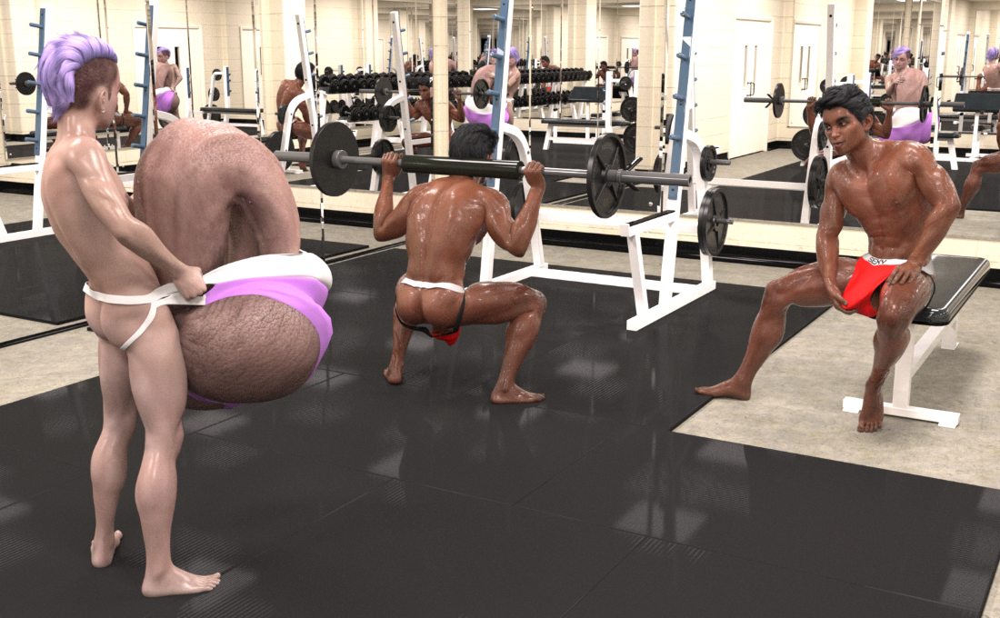

The twins had already begun the next stage of their fun. Mike had already grabbed a barbell and had it propped up on his shoulders. He slowly lowered himself down into a perfect squat. The pose caused his butt to stick out and his cheeks to spread giving Troy a great view of his pal’s hot ass and tight little hole. The way the light reflected off of Mike’s slightly sweaty booty made the spectacle even harder to ignore. Troy could feel the blood rushing to his cock. He could feel his dick straining harder against the overstuffed pouch of his strap. The twins knew exactly what they were doing, and the smug smirk on Ike’s face as he sat back and watched Troy’s swelling cock strain against his jock said as much.
Troy knew he was fighting a losing battle. He knew his cock would get the better of him before long. He knew that the twins could see his balls swell up from his arousal. They knew him too well. They knew everything that made him tick. Everything Troy did played right into their hands. There was nothing he could do to stop them… unless…
A slight smirk played at the corner of Troy’s lips. The twins knew exactly what made him tick, but the same could be said for him. He knew what they loved. He knew what parts of him really captivated their interest. He knew what attitude and angles got their goat. All Troy had to do was play to those traits and he’d have the twins right where he wanted them.
Troy’s mannerisms became less stiff. His pose became more relaxed. He managed to sway his hips seductively as he sauntered over towards the weight rack. The maneuver caused his huge package to bob and sway enticingly before him. It caused his bubbly booty to bounce and swish enticingly for the twins’ viewing pleasure.
Troy couldn’t help but smile as he watched the twins’ gazes drift towards him. He had to stifle a giggle as he noticed the normally smug smirks on the brothers’ faces steadily begin to falter. Neither of them had anticipated Troy stepping up to the plate like this. Neither of them had thought he had had it in him to try and one up them, but here they were, and there he was.
Troy’s newfound confidence was not without its limits though. There was a slight tremble to his body and a slight wobble to his step, but this worked in his favor. The twins were captivated by the clumsiness of his attempt. The blush of embarrassment across Troy’s otherwise pale face made him even more adorable. The slight quiver of his lip made him even more endearing. The slight stagger of his step made him even more enticing.
Troy tried his best to keep up the ruse as he squatted down before the weight racks. His huge balls rested solidly on the ground. His cute butt jutted out and wiggled for the twins’ perusal. His pose caused his cheeks to pull apart, giving the brothers a clear view of his cute, tight little hole.
It was now the twins’ turn to fidget and fight their arousal, but they were not doing near as well as Troy had. Already their cocks were well past half mast. Already their steadily hardening semis strained against the front of their straps. A small wet splotch was forming on the front of their red pouches, and this time the dampness was not from their sweat.
Troy grabbed a suitably light dumbbell and hoisted it up to his chest. The maneuver caused the slight bit of a bicep that he had managed to build over the last few months to bulge out. The thin layer of sweat that he had accrued glistened in the fluorescent light of the gym and caused his muscle to practically sparkle. Like a couple of crows, the twins’ gazes were drawn to the glimmer of Troy’s small muscles.
Troy sauntered over to one of the workout benches beside the large, mirrored wall and set his plan into motion. He squatted down beside the bench and propped himself up on his elbows so his arms rested on the bench and his booty jutted out behind him. He was all but lying atop the gargantuan mass of his enormous cock and his colossal balls. The pose gave the twins a clear view of Troy’s cute, bubbly booty; his puffy, little taint; and the enormous expanse of his exposed nut sack.
The pose was good for putting on a show, but unfortunately it was good for little else. Try as he might, Troy couldn’t even muster a simple rowing motion. His cock and balls did not provide a steady enough perch. All he was really doing was wiggling his cute butt for the twins’ viewing pleasure, but that was all Troy really had had in mind.
To say that the twins enjoyed the view would be an understatement. Their big dicks stirred to life within the confines of their red jock straps. The twins exchanged a silent fist bump and continued staring at their pal’s lithe build, cute booty, and of course his absolutely enormous, sexy cock and balls. It was an amazingly sexy view, but that wasn’t the main reason the twins enjoyed the show so much.
“Is he doing what I think he’s doing?” Ike asked his brother.
“I think he is.” Mike concurred.
“He trying to out-flirt the masters…” Ike added in answer to his own question.
“That’s adorable!” Mike replied giddily.
The twins took a moment to soak in the view. Troy was really trying to ham it up. His bubbly booty wiggled before the twins’ eager eyes. His puffy taint was clearly visible as were his enormous nuts. Troy’s balls had swollen considerably even during the few minutes he had been in the weight room. Either enlarged orb was now close to the size of a beach ball, and they were still swelling before the twins’ very eyes. It was clear how hot and bothered Troy was just from watching the steady inflation of his huge balls, but the look on his face made it even clearer.
The twins could see Troy’s cute face reflected in the mirrored walls which surrounded them on all sides. Troy’s face was bright red. He chewed nervously on his lower lips as he tried his best to act like he was completely in control of the situation, but he was not fooling anyone. If anything his awkward expression just made him look even cuter and made it even clearer to the twins that they should step in before something happens.
“As much as I love the view…” Mike lamented as he took another glance at Troy’s exposed booty.
“… we really should stop him before he hurts himself.” Ike concurred.
The twins worked in perfect unison. They sauntered across the gym over to their pal’s side.
“Your form is all wrong.” Mike chided softly and placed a hand gently on Troy’s shoulder.
“Here. Let me show you. We wouldn’t want you to get hurt.” Ike chimed in sweetly.
Troy wasn’t able to even try to argue with them. Mike’s soft touch and Ike’s sweet words absolutely demolished his already crumbling resolve. The hefty barbell slipped from Troy’s grasp and landed with a thud on the bench in front of him.
Ike wasted no time in grabbing the weight that Troy had just dropped and moved on to the next phase of his plan. “Ok. Your form is pretty good, but you need focus more on keeping your back straight… like this.” Ike explained as he got into position. He placed one hand against the weight rack and started to squat down nice and low as he detailed the motions he was doing. He even made sure to gesture towards his back so Troy could see the way that Ike was standing and learn from it, but it wasn’t Ike’s back that had Troy so captivated. It was Ike’s impeccably round and muscular ass. The pose Ike had struck caused his butt to wiggle mere inches in front of Troy’s face. Troy could actually feel the warmth emanating from his pal’s butt. It was so close he could almost taste it, and part of him wanted to do just that.
“Here. Now you try it.” Mike chimed in. He didn’t even give Troy a chance to respond. No sooner had he spoken than he placed his hand right between Troy’s shoulder blades and shoved down as if trying to help Troy straighten his back, but his maneuver had caused something very different to happen. The shove had caused Troy’s face to jerk forward a few inches which lead to Troy being suddenly face down right in Ike’s beefy buttocks.
Troy wasn’t about to complain though. The twins had impeccable hygiene so it wasn’t like there was anything gross there. It was just yet another part of the twins’ anatomy that Troy found amazingly sexy. In fact, he had daydreamed more than once about what it would be like to eat out one or both of his smokin’ hot besties.
Troy didn’t even try to fight it. As soon as his face made contact with Ike’s exceptional ass, Troy began to nuzzle against his pal’s sculpted cheeks. Troy’s nose bumped awkwardly against Ike’s twitching, tight pucker, but Troy quickly found a nice position which he could really explore the contours of his pal’s amazingly sexy ass.
Troy started low. He gave Ike’s puffy taint a small kiss and a soft lick and nuzzled against his pal’s ass once more. Troy quickly settled into a rhythm. He would give his pal a quick kiss and a sensual lick and then go back to burying his face in his pal’s butt. As Troy moved his way slowly up along his pal’s hot crevasse he started to get more and more into it. He kissed deeper. He licked longer. He drank in more and more of his pal’s raw sexuality with each passing second. Troy was so into it that he hardly even realized that Ike was slowly standing back up. Troy hardly even realized that he himself had begun to stand up to keep pace with his pal. Soon Ike had hopped up on the bench. Ike’s perch atop the weight bench put his beefy booty right at eye level to Troy so that Troy could really go at it without having to be hunched over at such an awkward angle.
Troy gasped as he suddenly felt something. It was so sudden and it felt so good. It made the hairs on the back of his neck stand on edge and made his bubbly booty break out in goosebumps. Troy felt it again. It was warm, and wet, and soft, and sensual. This time he knew exactly what it was though. It was Mike’s tongue tracing a path along the insides of his crack. Mike obviously had more experience in the matter than Troy did. His tongue felt amazing against the sensitive part of Troy’s backside. The way he playfully flicked his tongue against Troy’s hole felt amazing. The way he sensually licked along the sides of Troy’s crack sent shivers down Troy’s spine. The soft, sensual moans coming from behind him caused Troy’s dick to get even harder than before.

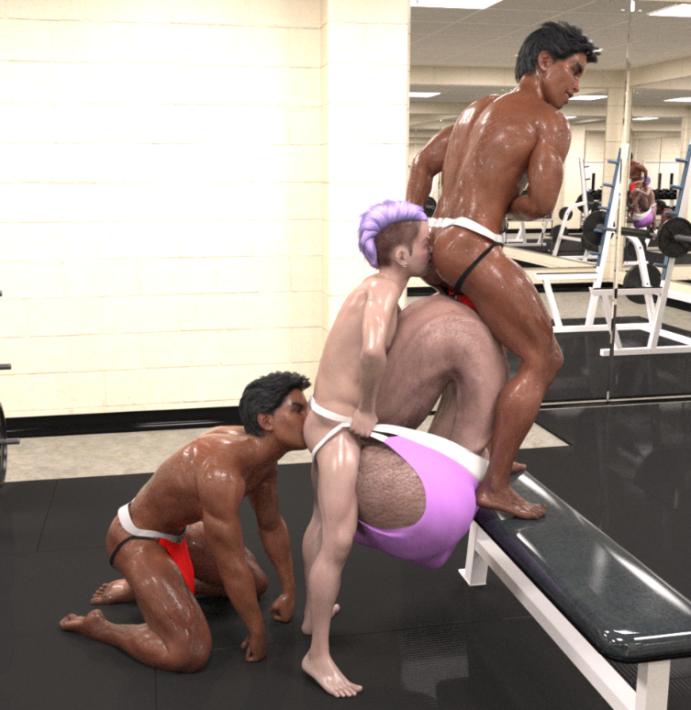

Troy’s cock had already been well past chubbed for a while now. He was so hot and bothered that his semi-boned cock was struggling to break free from the lavender clothed confines of his overstuffed jock strap. His dick was so hard that the way his strap caused his dick to fold over actually hurt quite a bit, and the discomfort kept growing as Troy’s cock grew harder and harder. Troy’s soft pleasurable moans gave way to groans and grunts of discomfort.
The twins were quick to act the second they heard the change in Troy’s voice. They knew him well enough to understand the difference in his tone, and the last thing they wanted to do was hurt their best buddy. They were just about to take some drastic measures to get Troy’s dick free from the confines of his jock pouch, but they didn’t even have the chance. A loud crack reverberated through the gym. The back strap of the pouch snapped like a rubber band. Troy’s cock swung up straight and tall and sent the broken jockstrap sailing through the air like a flying squirrel. The strap sailed halfway across the spacious weight room and would have gone even farther in fact had it not gotten caught on one of the squat racks across the room.
Troy breathed a sigh of relief. He was so glad to no longer be in pain that he didn’t even mind that he was now bare-assed naked in the middle of the gym. It wasn’t like his strap had really covered that much anyway, but even so his face burned bright red from embarrassment.
Troy’s cock had looked enormous while it was in the pouch, but now that it was flying free for all to see everyone could see how simply massive it truly was. The massive beast was every bit as wide as his shoulders and jutted out in front of him over four feet. For the time being at least his dick was still a good foot shorter than he was, but at the rate he was growing, there was a very real possibility that someday he’d have a cock bigger than his whole body!
As huge as Troy’s cock was though it paled in comparison to his nuts. Troy’s balls had been inflating steadily since he had arrived at the gym, but in the past few minutes his size had really ramped up. Either enlarged orb was now close to the size of a sofa, and they were still steadily swelling by the second!
“Looks like someone’s happy to see us.” Mike cooed softly as he stroked Troy’s dick and leaned in to give it a soft kiss on the tip.
“It wouldn’t be a party unless our little buddy’s little buddy decided to make an appearance.” Ike said sweetly as he too caressed Troy’s fully boned cock. Ike leaned in beside his brother and lapped at the pre that trickled from Troy’s slit. Troy was sure things were going to get very hot and heavy from there, but he was only partially correct.
Mike and Ike took a step back and exchanged a devious glance. A mischievous smirk was plastered on both of their faces as they eyed Troy’s fantastically huge cock. This was the moment they had been waiting for. Everything was in place. Now all that was left was to unveil their new toy.

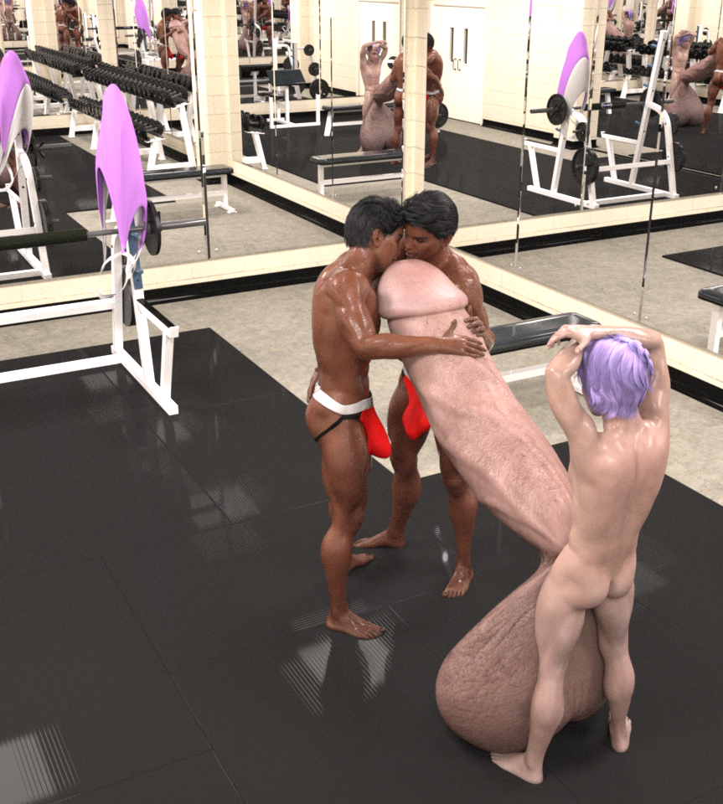

“We have a surprise for you.” Mike said playfully.
“Yeah. I just know you’re gonna love it.” Ike added. He was practically gushing at this point, but he was nowhere near as gushing as Troy’s cock was. Pre flowed freely from the tip of his enormous dick and poured out onto the matted floor of the gym’s weight room.
Troy wasn’t in any condition to be asking questions. He was now so horny that he could barely think straight. All he could do was shoot his pal’s a questioning glance, but even just that said it all. The twins wasted no time in getting to work. They knew that Troy would love every second of what they had in mind.
Mike and Ike dashed across the room to one of the weight racks against the wall. As the twins approached the rack, Troy began to notice something odd about it. For starters it didn’t have and dumbbells on it at all. Instead it had a bunch of shiny, chrome spheres. Each sphere was about the size of a soccer ball and was as reflective as the mirrors that surrounded the weight room, and when the twins began to scoop the large orbs up into their hands, Troy noticed something else that was odd about them. The balls were linked together by a thick rope. It was a string of beads, but these were way larger than any of the sets he had at home!
“You like them?” Mike asked with a devious smirk.
“We know your last set wasn’t nearly big enough to satisfy you anymore.” Ike added playfully.
Troy didn’t know what to say. He wasn’t one to turn down a gift, but he wasn’t even sure he could handle those beads. Even by his standards they were massive!
“You don’t look that excited.” Mike chided playfully.
“There’s no need to worry. I’m sure you’ll handle these just fine.” Ike said reassuringly.
The twins continued their steady approach with the beads in hand. As they got closer and closer Troy got more and more uncomfortable. On one hand, what they were suggesting sounded hot as hell. Troy had to admit he loved the feeling of having his dick filled with beads, and much to his chagrin his last set was starting to feel a tad on the small side, but this was more than just a simple step up. These were huge!
Soon the twins were standing directly in front of Troy’s huge cock with beads in hand. Seeing the beads up close did nothing to assuage Troy’s fears. If anything he was even more nervous now that they were so close that he could actually see his expression reflected on the silver spheres. He could see the look of uncertainty in his eyes, but he could also see the red flush of arousal that had spread over his otherwise pale cheeks.
“Uh… guys…?” Troy squeaked nervously.
“Just relax.” Mike said in a soft, soothing voice.
“We’ll be careful.” Ike assured just as softly as his brother had.
“You know we aren’t going to hurt you.” Mike said softly.
“If it ever starts to feel uncomfortable, let us know and we’ll stop.” Ike added soothingly.
“Ok… but just… I mean… Ok. Just be careful.” Troy whimpered softly.
“You know we will be.” Mike replied soothingly.
“We always are.” Ike added sweetly.
Troy was so nervous and excited that he was practically hyperventilating. He had to take long, steady breaths just to soothe his nerves and keep his excitement from getting the better of him. He was so hot and bothered that he was dangerously close to blowing his load, and the twins hadn’t even touched his dick yet. At the rate he was going, he was going to start cumming before the first sphere even slipped into his dick.
Troy gasped as he felt the cool surface of the first metallic ball make contact with the tip of his cock. A deep, throaty moan started to slip out of his mouth as he felt his slit being spread open to allow the enormous orb access to his cock, but his moan was cut short by yet another gasp of shock. Troy’s mind felt like it was exploding from all the sheer bliss that arced through his cock. The large ball filled his cock so spectacularly that he felt like he was in heaven. Synapses in his skull fired like a fireworks display on the Fourth of July. He wanted to moan. He wanted to writhe. He wanted to cry out and say how great it felt, but as it was he couldn’t even breathe properly. He felt so fantastic that all he could do was suck in short gasps of air as he struggled to keep his load down.
Troy felt so fantastic that he couldn’t even keep himself upright. His legs felt like jelly. He wobbled unsteadily for a second before collapsing to his knees. Troy found himself face down against his own enormous cock which was still pointed straight up towards the twins. Troy glanced up at his two identical pals and stared groggily as they smirked down at him and slowly slid in yet another sphere.
Troy whimpered and writhed as the second sphere slid into him. It felt just as fantastic as the first. It felt so amazing in fact that all Troy wanted to do was cum and cum again, but he quickly realized that he just could not do so. The beads were so huge that they blocked off his entire slit! They stopped him from being able to so much as spurt! His cock bucked and lurched. Troy moaned and writhed and wriggled, but still he just could not cum!
Troy groaned and moaned and panted and pleaded for release, but his two pals continued to smirk and slide more and more beads deep within his dick. The underside of Troy’s cock bulged out as the beads slid deeper into him. The normally puffy ridge along the underside of his dick was looking like a fat boa constrictor that had just swallowed entire rodents of unusual size, and the lumps slid further down the shaft as the twins loaded yet another sphere into his cock. By the time the twins had the sixth sphere deep inside Troy’s cock, the first one was all the way down at the base of his dick. He could actually feel it pressing against the root of his cock as if it was trying to slide into his body, but it was held at bay by the rising pressure of Troy’s growing backlog of spunk.
The twins marveled at their handiwork. Troy was so far gone by this point that he couldn’t even focus his eyes. A trail of drool trickled out the side of his mouth as he whined and whimpered for more, but there was no way that his cock could fit any more inside of it. Fortunately Troy had plenty other places that the twins could plug full.
The twins stepped out from behind Troy’s enormous cock and stood where Troy could see them. Troy tried as best as he could to focus on them, but even then his eyesight was a little blurry. He could make out what they were doing though. He could see the sly smirk on their faces as they hooked their thumbs into the waistband of their jock straps. He could see the way they slowly and seductively shook their hips as they shimmied the waistband lower and lower down their thighs. He could see their huge cocks as they slipped free from the red pouches of their jock straps and stood up at their full size.
The twins’ cocks were nowhere near as massive as Troy’s was, but their dicks were absolutely huge by all normal standards. Both brothers had a solid foot of fat cock. Their dicks were as long and as thick as their fit forearms. Their balls were every bit as big as baseballs and hung heavily in their sacks.
Troy whimpered pleadingly as he stared at the brother’s fat cocks. He was so horny that he couldn’t even form words, but the twins knew exactly what he wanted.
“Save your strength.” Mike said softly.
“Yeah. No need for words, anyway. I’ve got something better you can use your mouth for.” Ike chimed in.
The twins effortlessly hoisted Troy up and then draped him over his own enormous cock. Troy’s dick was so huge that Troy was able to lie face down atop it and his head didn’t even reach the puffy tip of his fully-boned cock! This gave Ike plenty of room to sit down atop of the soft, spongy head of Troy’s enormous cock and present his own thick dick for Troy’s sucking pleasure.
Troy wasted no time in wrapping his lips around his pal’s fantastic cock. It felt perfect in his mouth, and it wasn’t just the size of it. Ike’s cock was amazingly thick for sure, but it was more than that. It was the taste of it, the smell of it. Troy could taste the slight tinge of sweat of Ike’s flesh. He could taste the slight tang of pre oozing onto his tongue. It was all so wonderful that he didn’t want it to end.
While Troy was busy with Ike’s cock, Mike took his position around back. He had made a brief detour to grab a small bottle from his gym bag and had then squatted down right behind Troy’s cute, bubbly booty. Troy’s balls had grown so immense by this point that Ike was able to kick back and relax against the massive, sloshing balls as he lined his cock up with Troy’s cute little shuddering hole.
Troy was so far gone that he hardly even noticed the cool splash of lube against his ass, but he certainly wasn’t so far gone that he couldn’t feel his tight hole stretching wide to accept Mike’s fat cock. Troy stopped sucking on Ike’s cock long enough to let out a long, contented sigh as he felt Mike’s cock slide deeper and deeper into him. Troy was in heaven. He couldn’t believe it was possible to feel this good. His dick was more sensitive than he could ever remember it being, and his body was bristling with arousal. His skin felt warm and sensitive. Even the slightest touch made his skin tingle with pleasure. Even the softest nudge felt like a passionate embrace which of course meant that the intense, passionate gropes and grabs of the twins’ hands against Troy’s body felt outright orgasmic.

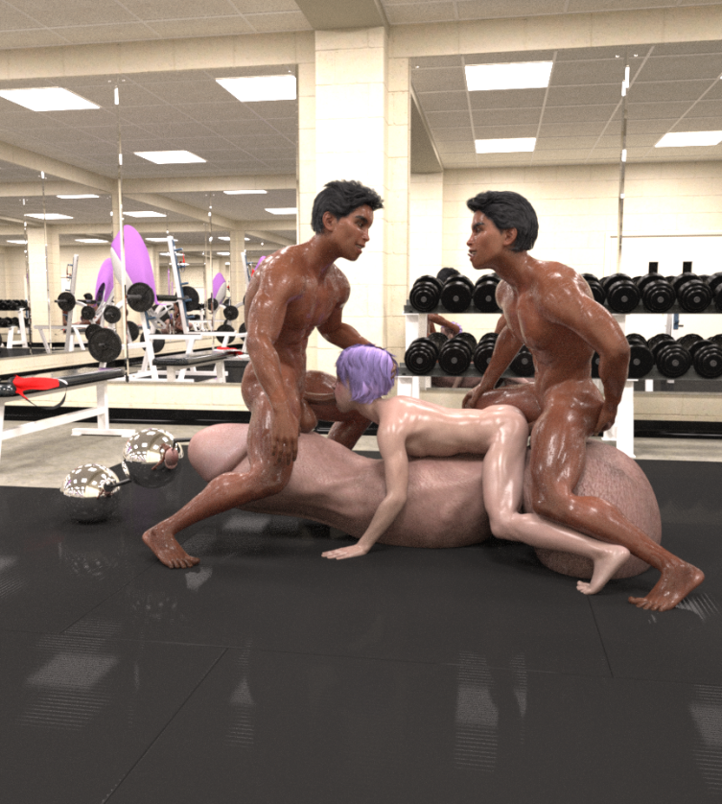

Mike and Ike couldn’t hold back anymore, and they could tell from the way Troy was wriggling that he was loving every second of it too. They stepped up their pace and settled into a nice rhythm. Ike would shove his cock deep down Troy’s throat while Mike pulled his huge dick back in Troy’s ass, and then they would reverse. Mike would slam his meaty cock deep into Troy’s hungry ass while Ike sensually pulled his dick out from deep down inside Troy’s throat. The constant motion caused Troy’s body to rock back and forth like waves on a beach. The steady rocking caused his cock to grind against the rubberized floor of the gym’s weight room. The grinding motion felt amazing in its own right, but it was made even more orgasmic by the enormous beads which were still embedded deep in Troy’s cock. With each rock forward Troy could feel the beads digging into the inner lining of his cock. With each roll backwards Troy could feel the beads rubbing against the sensitive flesh on the underside of his cock. It was all too much for Troy to take. He wanted to cum, and yet he simply could not. His cock was just too plugged full to let even a single droplet to escape. Troy got hornier and hornier by the moment, but he still just could not cum. The pressure built up more and more in the base of his cock, but still his jizz had nowhere to go. His balls steadily swelled more and more by the moment, but the twins continued to ram and ream Troy from both blissful ends.
Troy wasn’t the only one loving every second of it. The twins loved the sounds Troy made. They loved the little whimpers that escaped his lips during the brief, fleeting moments where Ike’s cock didn’t fill his entire mouth. They loved the soft moans that rattled deep in his throat while Ike’s cock plugged his mouth full to capacity. They loved the way he wriggled and writhed in ecstasy, and they especially loved the way he felt wrapped around their cocks. Troy’s warm and wet mouth felt fantastic around Ike’s cock, and the way Troy’s tongue lapped at Ike’s dick as the huge tool was buried down his throat just added to the wonderful sensation. Troy’s ass gripped Mike’s cock in such a wonderful way and yet despite how tight it was, Mike’s fat cock could still easily slide in and out of Troy’s lube-slicked, stretched-out hole.
“I… can’t…” Ike groaned.
“Hold… out…” Mike moaned.
“We’re gonna cum!” The twins cried in unison.
Mike slammed his dick in as deep as he could go. His huge, full nuts slapped against Troy’s puffy taint. At the same time Ike pulled back as far as he could so that only the spongy tip of his huge dick remained in Troy’s mouth. The two brothers moaned and panted in perfect unison. Their bodies tensed up. Their dicks shuddered and lurched, and then they let out one last, orgasmic moan as they pumped their loads right into Troy’s body.

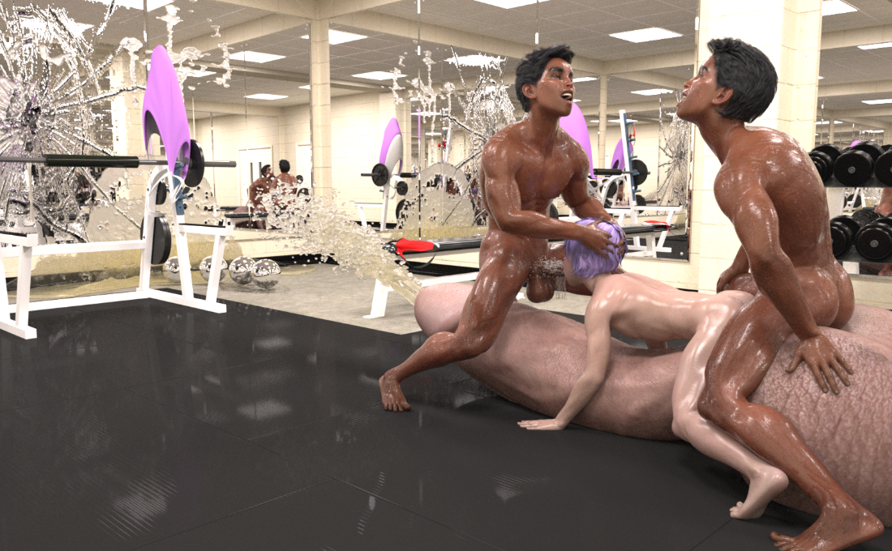
The exact second the twins finally lost their battle with their own arousal, the dam quite literally broke for Troy as well. The pressure building in the base of his cock became too great for even the blockage of the string of beads to hold out against. Cum erupted from Troy’s dick with enough force to send the string of beads soaring across the room. The beads slammed against the wall on the far side of the room. A loud crack split the air, but it was nowhere near as intense as the cracks which now spread through the mirrored panel like a spider web.

Troy came again and again and again. All the while he could feel and taste the twins’ loads pumping into him. He could feel the warm, wet rush of spunk flooding into his ass. He could taste the mellow flavor of Ike’s jizz as it washed over his tongue. There was just so much of it that Troy could never hope to swallow it all. He tried – he really did, but it was no use. No matter how much he swallowed, five times as much came flooding in in powerful spurts from Ike’s huge cock. Jizz oozed out the sides of Troy’s mouth and spilled out onto his enormous cock, but the cum seeping from his ass was nowhere near as much as the spooge pouring out of his ass. Troy couldn’t just swallow Mike’s load like he had done with Ike’s. Mike’s copious cum shots were left to keep flooding into Troy’s already overstuffed ass, and with nowhere left to go, the huge quantities of cum seeped out his hole despite Mike’s huge cock doing its best to completely seal the opening.

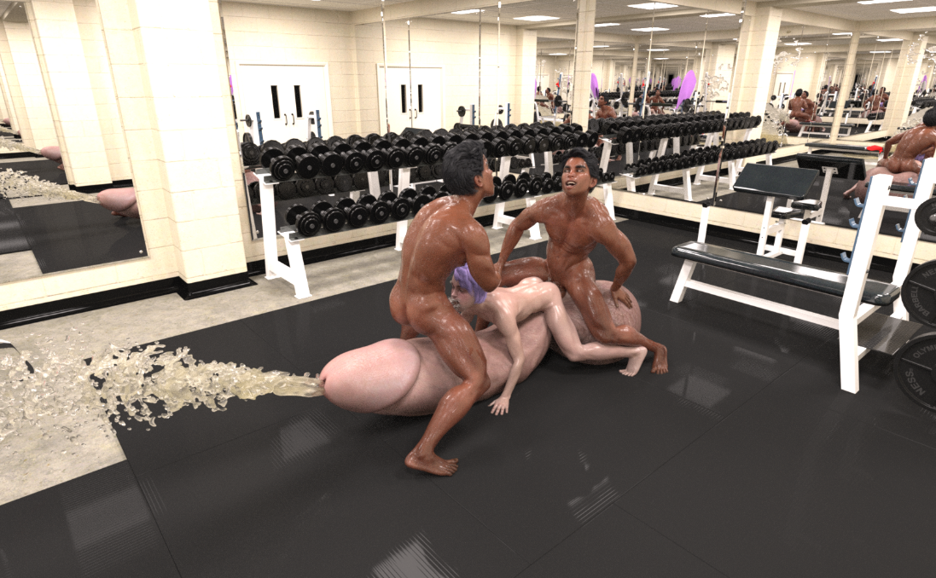

The twins came and came again, but in the end they were spent long before Troy was anywhere near unloading his gallons upon gallons of spunk. By the time Troy had finally busted his colossal nut, his balls had been the size of minivans, and they had only shrunken down to the size of dumpsters by the time the twins were completely spent. The gym was drenched in jizz. The equipment was coated in spunk, and the only reason the room wasn’t filled with a standing pool of spooge that was over six inches deep was because all the excess jizz had spilled out of the room and down the stairs into the lower floor of the gym.
Troy’s colossal cock continued spurting for several minutes after that. By the time he had finally finished cumming he was so exhausted that he was barely even coherent. All he could think about was how great he felt and how amazing that climax had been.
Troy could feel the twins nuzzle up against him and slowly prop him up onto his feet, but he was too addled and exhausted to be much help. Troy stared groggily around the room as the twins helped him walk back downstairs and towards the showers to get cleaned up. The place was a disaster, and it only got worse as they made their way downstairs. The stairs were soaked in spunk, and the lower floor was flooded. Troy was still feeling too giddy from the afterglow to be freaked out by the devastation though. All he could do was chuckle at the mess he had made.
The twins were quick to pick up on Troy’s titter. “Hehe. I’d say the new toy is a success.” Mike commented.
“Indeed it was, but our buddy is still a growing boy.” Ike concurred.
“Yeah. No doubt we’ll need to get an even bigger one before too long.” Mike agreed.
Troy heard the words, but they didn’t really resonate with him. Some part of him knew he should be freaked out by the prospect, but he was still so groggy and giddy that he couldn’t help but think that it would be kind of fun to get even bigger and try even larger toys. The doctors still had no idea what was causing his cock to grow so really it was only a matter of time before he outgrew even his newest and biggest toy…

