GO FIGURE
COMMISSION STORY
BY CHALDEACHANGE
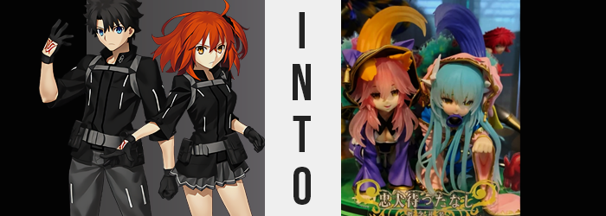

Both of the Fujimaru siblings were surprised to receive a gift that day.

And in the form of chocolate, no less. Valentine’s had long come and gone, and with Christmas on the horizon maybe it wasn’t that strange to get sweets. But not in such a mundane fashion, and certainly not from the Servant they had received them from. Medea wasn’t one to pay her Masters any favors, after all.

“Why are you two looking at me like that? It’s just some chocolate.” The witch in question had feigned being upset at any reluctance on the part of her two Masters, which were deemed ‘Gudao’ and ‘Gudako’ by everyone to avoid confusion… seeing as for some reason the two of them shared the exact same names. “I merely forgot to give you your gifts for Valentine’s Day, that is all!”

Medea explanation did make some sense, and neither of them could remember receiving a Valentine’s gift from her, but this was a Servant that had murdered her Master in another Holy Grail War – not that either of the siblings knew anything of this. Perhaps it was for the best that they had known in retrospect, because they might have been wary about accepting any gifts from this woman. Then again, to be fair, she didn’t exactly mean either of them any harm.

They really should have been more suspicious about receiving Valentine chocolates in November, though.

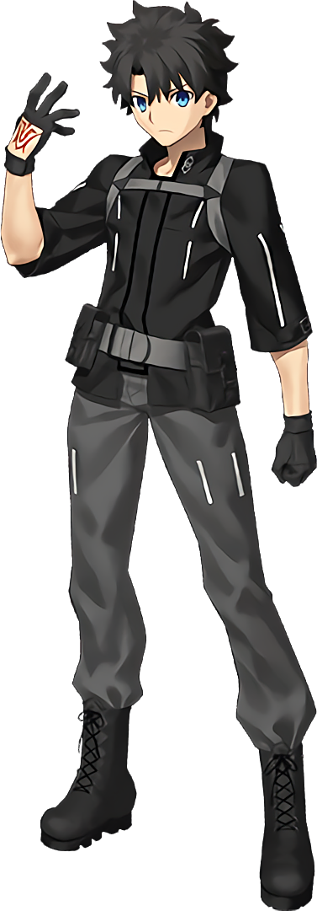
The pair had accepted the chocolates with no hesitance whatsoever, chalking up Medea’s comments as a precaution born from a past of distrust by others – an unfortunate side effect of her legacy and reputation as a witch, the be sure.

It had been so late at night that the Caster had approached them both, and the duo had already set off back to their individual rooms without taking a bite of the snack. The pair were housed on opposing sides of the Chaldea building after all, so that in the case of an emergency there would be equal coverage and one Master could respond wherever an issue arose.

The brother, the Ritsuka who was known more prominently as ‘Gudao’, didn’t even hesitate to scarf down his snack once he got back. “Wow, it’s actually really good!” Had he expected it to be bad? No, but it was certainly better than expected. Perhaps having sweets before bed wasn’t the best idea, especially since he hadn’t even gotten changed into his pajamas yet, but he wasn’t really thinking about that.

Five minutes passed, and in that time he washed up with the intention of getting changed and turning in. And yet? He was overcome by a very strange feeling the moment he stepped out of the adjoined bathroom. “That’s weird. Why does my head feel so heavy?” He didn’t mean this in that he felt groggy, no. It was a much more literal weight, physically leaving his head to hang down lower passively.

And so he stepped back into the bathroom and turned his gaze to his reflection in the mirror, and what he saw? It wasn’t right. “What the hell!?” His hair? It was much longer than normal and appeared to be growing longer still with each passing moment. It soon tickled his neck and spilled down his shoulder, the full length of it straightening so that not a single curl survived the change. But it wasn’t length alone that was afflicted.

Strands of a bright pink saw to that! If the color appeared familiar, it was undoubtedly because he’d seen it on plenty of Servants in Chaldea with all sorts of backgrounds. He had nothing to tie the color back to any one of them in particular at first, but that period didn’t last particularly long before the weight atop his head became more still, and from within tufts of pink something else began to emerge.

“Are… are those ears!?” It was an astute, if not blatantly obvious observation reaffirmed by the fact that he could hear through them, and much more clearly so than the ears upon his head’s side. Clad in brown fur, they pulled higher and pointier while white, puffy fluffs grew out of their inner canals. They looked like the ears of an animal. The ears of a fox. The ears of… “Crap.”

Gudao had a very bad feeling about this. It was all so reminiscent of a certain Servant, and a woman at that. His bad feeling only stood to worsen once a tingling ran through his facial features, and before his very eyes his face’s shape softened – including those eyes. Lashes fluttered longer as a bright gold possessed his irises and the same pink from his hair found his eyebrows. All in all they were much more expressive, and matched more keenly with rounder cheeks, fuller lips, and a daintier nose.

But it all made him look like a woman, and the very same woman he was fearful he had begun to resemble. Tamamo-no-Mae. Or, at least, one of them. Drilling this point home, the human ears on his head’s sides were stolen away, leaving the sides of his head bare and buried beneath pink locks. “There’s no way!? Ah!?” In his confusion, Gudao had cupped his softer cheeks to make sure this was all real. It was, and the familiar tone of his voice, brought about as his Adam’s apple smoothed out, only served to intensify his anxiety.

Whatever was going on here, it was traveling downwards – now at a much quicker pace than what had transpired with everything above his neck. His shoulders narrowed, leaving his jacket and undershirt to sit upon his frame a little more loosely than it had before. The muscle in his arms diminished as the phenomenon travelled down them, and when it reached his hands? Palms slimmed, and fingers stretched ever so slightly with grown nails.

“Is this really happening to me!? But why!?” The chocolate? Had Medea slipped them something weird? But even then it didn’t make a lick of sense considering the outcome. Why would she want to turn him into Tamamo? Questions persisted, and his situation only worsened despite them. The counter in his bathroom began to look taller for example, for his height was regressing as the transformation gnawed at his spine.

The looser fit of his clothes that resulted wasn’t permanent though, not once a tingling affirmed itself beneath the from of his clothes. Nipples grew plump and erect, and before long he could make them out pressing against the front of his outfit. “No! Damnit!” Crying out and pawing at his chest, he was powerless to prevent his once flat pecs from filling out in a softer, squishier form. A pair of ample breasts, so bulbous that he was forced to unfasten his jacket’s straps clumsily with changed fingers so that his ribcage wasn’t crushed by the mass suffocating within. DD-cup tits completely filled out the white of his undershirt, nipples on the verge of erupting cleanly through them. “I have tits!?”

He knew he shouldn’t touch them, but he did anyways. They just felt so good.

It was a momentary distraction that worked against him, for below his pants had already fallen down to his ankles and his boxers held on by the good graces of his hips. Hips that, soon after, had begun to widen several inches. This gait allowed both his rump and thighs to swell with the same vigor that his chest had, and the seat of his underwear was soon tightly bound around two full ass cheeks that looked to be on the verge of escaping their bindings. Even the shorts of the boxers were too tight, encasing taut thighs that bulged out from around the bottom hem.

Making matters worse, something soon erupted from above his pants in the back. It grew several feet long from his tailbone, thicker at the base than it was at the tip, before much like a Christmas tree being unbound, a plethora of fluffy, brown fur fanned open to decorate his new tail.

“Ngh!? Tight!?” The length of Ritsuka’s legs was lessening so that he neatly fell down to around 5’3”, but that was hardly as pressing as, well, the pressing feeling around his groin. His boxers were a little too tight, crushing his little guy. Looking at his reflection now though? Feeling his breasts? It was pretty obvious that it was no longer longed for this world. And with a sharp tug, she ceased to be a he altogether. But it felt good, and she let a sharp moan ring out as her feet and toes crunched within her socks.
“This is impossible! Why do I look like… like…” Like Tamamo-no-Mae!? Staring at her reflection in the mirror, there wasn’t a shadow of a doubt in the new woman’s mind that this was who she had become. From her pink hair to her fluffy ears and extra appendage, to even the sound of her voice – it was all identical to the foxy Caster. Of course she was still dressed in his regular clothes to the best of their ability, but her ass and breasts were doing their best to try and escape.

In a situation like this you might think she would get changed into something that fit better and try and find help, but that wasn’t the thought that possessed her as her eyes glossed over. It was something completely different, and she vocalized this task to no one in particular before heading off.

“I need to go see Medea…”

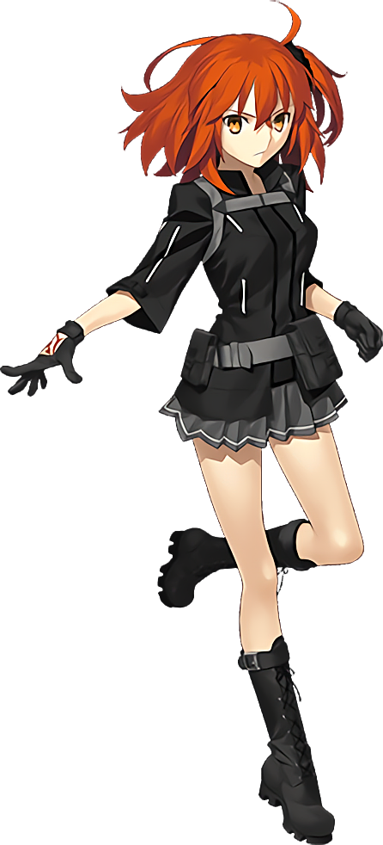
Meanwhile, the twin sister had been thrust into very similar, and yet surprisingly different circumstances. Much like her brother she had decided to indulge in her chocolates not long after arriving back in her room, but had instead decided to just lay down on her bed in her underwear after removing most of her outer layers. Unlike her brother, she was very much the type of person that liked to sleep as nakedly as possible.

“Today was a long day… At least it ended with an act of kindness, I guess!” She was, of course, referring to how she had received chocolates from Medea. She didn’t think much of it, and the sweet taste was still on the tip of her tongue as she began to nod off. But Gudako? She wasn’t able to fall completely asleep before a strange feeling washed over her only five minutes after she had collapsed in the first place.

She didn’t slide off of her bed, not at first. It jolted her awake, golden eyes wide to stare at her ceiling again, but it wasn’t enough to make her panic initially. “What’s… going on here?” She sensed an unusual weight atop her head, which was still firmly planted on her pillow. But when she sat up? That pillow was hoisted up with her. “…Huh?”

How was her pillow mounted atop her head? Both hands reached up to explore, and the pair of them discovered the same thing. The pillow? Two sharp, thick objects had impaled it on the sides, and those objects? They were bound to her head. A pair of horns. Or at least she assumed, because what else could they be?

“Oh no.” The Master didn’t know what was happening, but she didn’t need to know for sure to know it was bad. After struggling to pull the pillow free – something that she could feel through where the horns were mounted on her skull – she scrambled up and onto her feet, and over to the body-length mirror in the corner of her room.

In the time it took her to do that, though, things had escalated past the emergence of a pair of horns that she soon discovered were white, pronged three times, and erupting out of her head’s back. Every step she took saw the length of her ginger hair grow until it cascaded past her ass, and a pale, green-ish blue color saw its image utterly reinvented with newfound uniformity. Even that which decorated the sides of her face grew longer, framing them wonderfully.

Taking this all in before the mirror, Gudako’s bad feeling only worsened. She recognized that combination of hair and horns all too well. “I’m dreaming, right?” Or maybe it was more akin to a nightmare? She could see it all too well in her facial features – that they were softening beyond what was normal for her, almost becoming more youthful yet familiar.

Eyes widened, and among them a bright yellow shone around pupils that inversed so that they were white instead of black. She retained her Japanese appeal, and yet it all became more picturesque. A petite nose, thin yet perky lips, and a narrow chin highlighted a beauty that was more akin to a doll’s than a living person’s. But Gudako herself saw it as mirroring the face of another. “Oh god, I look like Kiyohime… Scratch that, I also sound like her.” It certainly didn’t take her very long to notice as much.

The youthful look of everything above the neck certainly mirrored Chaldea’s Berserker, who was a girl in her early to mid-teens physically. Squinting with her new, yellow eyes, she could even make out that her complexion was a little paler than it normally was. It wasn’t too pale for Kiyohime, however!

Much like with her brother’s transformation across the facility, changes continued to trend downward. The gait of her upper body narrowed, allowing her to present herself with a much thinner design overall – but one born only from the fact that she was growing younger and little else. At least her skin was softening? Wearing only her underwear, it was simple to see the pale complexion spread, actually.

“Ah… I don’t know what I was expecting, actually.” If Gudako sounded dejected all of a sudden, it was because she was. Looking down, she could both see and feel the cups of her bra emptying, straps already struggling to hang onto her narrower shoulders. Fitted as it was, looking down plainly revealed her nipples to her even with the bra still adorned, for two whole sizes had been shaved from their overall weight. “So Medea must have put something in that chocolate, then?” But why turn her into Kiyohime? That hardly made sense and didn’t at all fit Medea’s interests.

But she was also reminded of the fact that her brother had been given some too. That was probably a problem.

Gudako’s overall bodyweight had lessened, and that was no clearer than in her torso. Her ribcage had become more obvious beneath her skin for one, and her tummy was basically as flat as a washboard where at least some muscle had existed beforehand. It was borderline unhealthy, but stretched skin thankfully became less apparent once her hips narrowed to match her shoulders. She was very fortunate that they’d retained a size just barely big enough for her panties to dangle loosely without falling.

Still, a hand reached down to hold them up, nonetheless. “I feel so small…” Because she was small. Her torso had shortened as had her arms, and once change began to run rampant through her legs she dropped even more. It was only 5’2”, but it was still a significant, two inch drop.

What made her look even tinier was her figure, and when it came to her rump and thighs, that trend was continuous. Gudako’s cheeks had emptied and tightened, becoming firmer than ever at the cost of their peach shapes. Meanwhile, her thighs were still plump – but only in the sense that they were plump compared to the rest of her body. They were merely the most enticing trait of her body, and suddenly Gudako understood why it was the only but of skin that Kiyohime showed off.

“This can’t be happening! Why do I look like Kiyohime!?” It had been one thing to see it happening from her perspective, but it was a completely different feeling to see her own reflection. Because it wasn’t her, it was of one of her Servants dressed in her undergarments – undergarments that were hanging on by a thread because her lessened figure was hardly enough to properly support them.

Fortunately it was only her body and voice that had changed to completely mirror Kiyohime’s, because if even the smallest semblance of the Berserker’s personality had slipped in, then Gudako would certainly have been in a great deal of trouble. The last thing she wanted to be was obsessed with her own brother. “This isn’t good! What am I supposed to do now!?” Common sense suggested getting dressed and seeking out da Vinci-chan, but she was quickly compelled elsewhere.

Out her door, and down the hall.

Both siblings traversed the paths between their own rooms and the room of Medea, which was at roughly a midway point between the two rooms on Chaldea’s blueprints. Either way, it wasn’t a terribly long trip for either party – but something seemed intent on forcing it to take far longer than it should have.

“That’s strange…” mumbled the foxified Gudao, her movements gradually becoming more and more difficult to push out as she moved forward. It was a phenomenon that her serpentified sister was dealing with at the exact same time, a sensation that almost felt as if their bodies were growing stiffer and stiffer in the process. Each step felt more labored, and yet even when a step was accomplished? They didn’t feel as if they had gone as far as they had intended on initially.

This wasn’t unsurprising in the least with a little perspective. Because while the pair of them had been rendered oblivious to the fact, their bodies had begun to shrink. An inch or two was shaved off with each and every step, the walls swelling all around them and the floor below growing closer and closer still. Before long the two were smaller than children, and it wasn’t long until they fell even deeper – all while retaining their proportions, suggesting it wasn’t a loss of age.

The two, at tops, were only eight inches in height by the time their shrinking came to completion. Their clothes had shrunk along with them too, but they finally began to squirm about and cling to the bodies of the two women in a very unnatural way. It was more like the cloth bound itself to them before it hardened, forming a pair of hooded ensembles with dog ears – blue for Gudao, and cream-colored for Gudako. The outfits were form-fitting and cute, accentuating the feminine features of the pair excellently.

But gradually, little by little, they eventually made it to the point where the pair of them were almost directly in front of Medea’s door – fortune having favored them in that their height loss hadn’t fully kicked in until the both of them were so close. The two, now a meager eight inches, made eye contact with one another. But they didn’t say anything, mostly because they couldn’t. Their movements had grown so still that the pair had fallen onto their hands and knees. It was a struggle to even crawl, and any motion in their faces had more or less been erased.

They both turned towards the door nonetheless, both tiny women only an inch or two away from the other as their faces finally showed some movement. Their lips curled up into sensual smirks, expressions overall become rather seductive. Neither sibling was aware of the translucent stand that their hands and knees were resting on between them and the floor, and once Gudako lifted her left hand like a paw?

The two froze completely.

Stiff bodies hardened into an undeniable PVC, the very same substance that composed the matching outfits they were now wearing. Their heartbeats slowly stilled as flesh and hair alike took on a notably plastic sheen, and all of the orifices in their bodies filled in with the same material. That included their mouths, and the last thing they could ever taste was the very same, chemically plastic that their flesh and bones was now made of. There wasn’t even a speckle of life even to their eyes, which now amounted to little more than two sets of stickers.

And so, the door to Medea’s room slid open. “My, my! There you two are. You certainly took your time!” The woman was a giantess compared to the two on the floor – the two had that been transformed into a PVC figure of Tamamo and Kiyohime on a single stand. The Caster crouched down and was quick to pick it up, aware that the two were still conscious within their motionless, PVC prisons.

But neither ‘Tamamo’ nor ‘Kiyohime’ were upset with this fate. Rather, once they were raised to the Caster’s eye level something clicked in their minds. A desire. A longing. There was no longer any individuality between the two, for their consciousnesses united with a single intention when they were placed into a glass case within Medea’s room.

We certainly hope that we can impress our owner~!

