GENSHIN IMPACT: METEOR MASH
CH2: PRINCESS OF MOND
BY CHALDEACHANGE
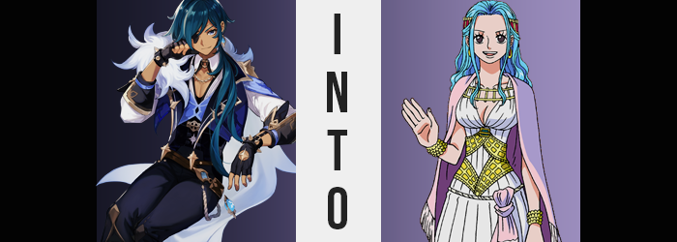

Even though he wasn’t typically one to pay attention to such things, the Calvary Captain of the Knights of Favonius, Kaeya Alberich, observed the sky full of shooting stars from his window. A man that was always on the go, he had ended up returning to his office in the Knights’ headquarters late that night to fill out some paperwork when the sight outside had caught his eye.

“Oh? This is quite the rare sight. I hope the Acting Grandmaster has a good view. She could use a moment of clarity like this.” The man chuckled to himself as his gaze flickered between the lights in the sky and the paperwork on his lap. Documents regarding issues and arrests that he had been part of solving throughout the day were piled up on his lap – the most loathsome but necessary part of his job.

As he scribbled away at some of the documents, eyes away from the sky for a few moments, a loud crash predated all of the paperwork being swept off his lap, for a bright blue stone had crashed through the window and flown right past his groin before landing beneath his desk just a few feet away. “Woah there! Almost got sacked by a rock.” But unfortunately his paperwork had been sacrificed and was now scattered across the floor.

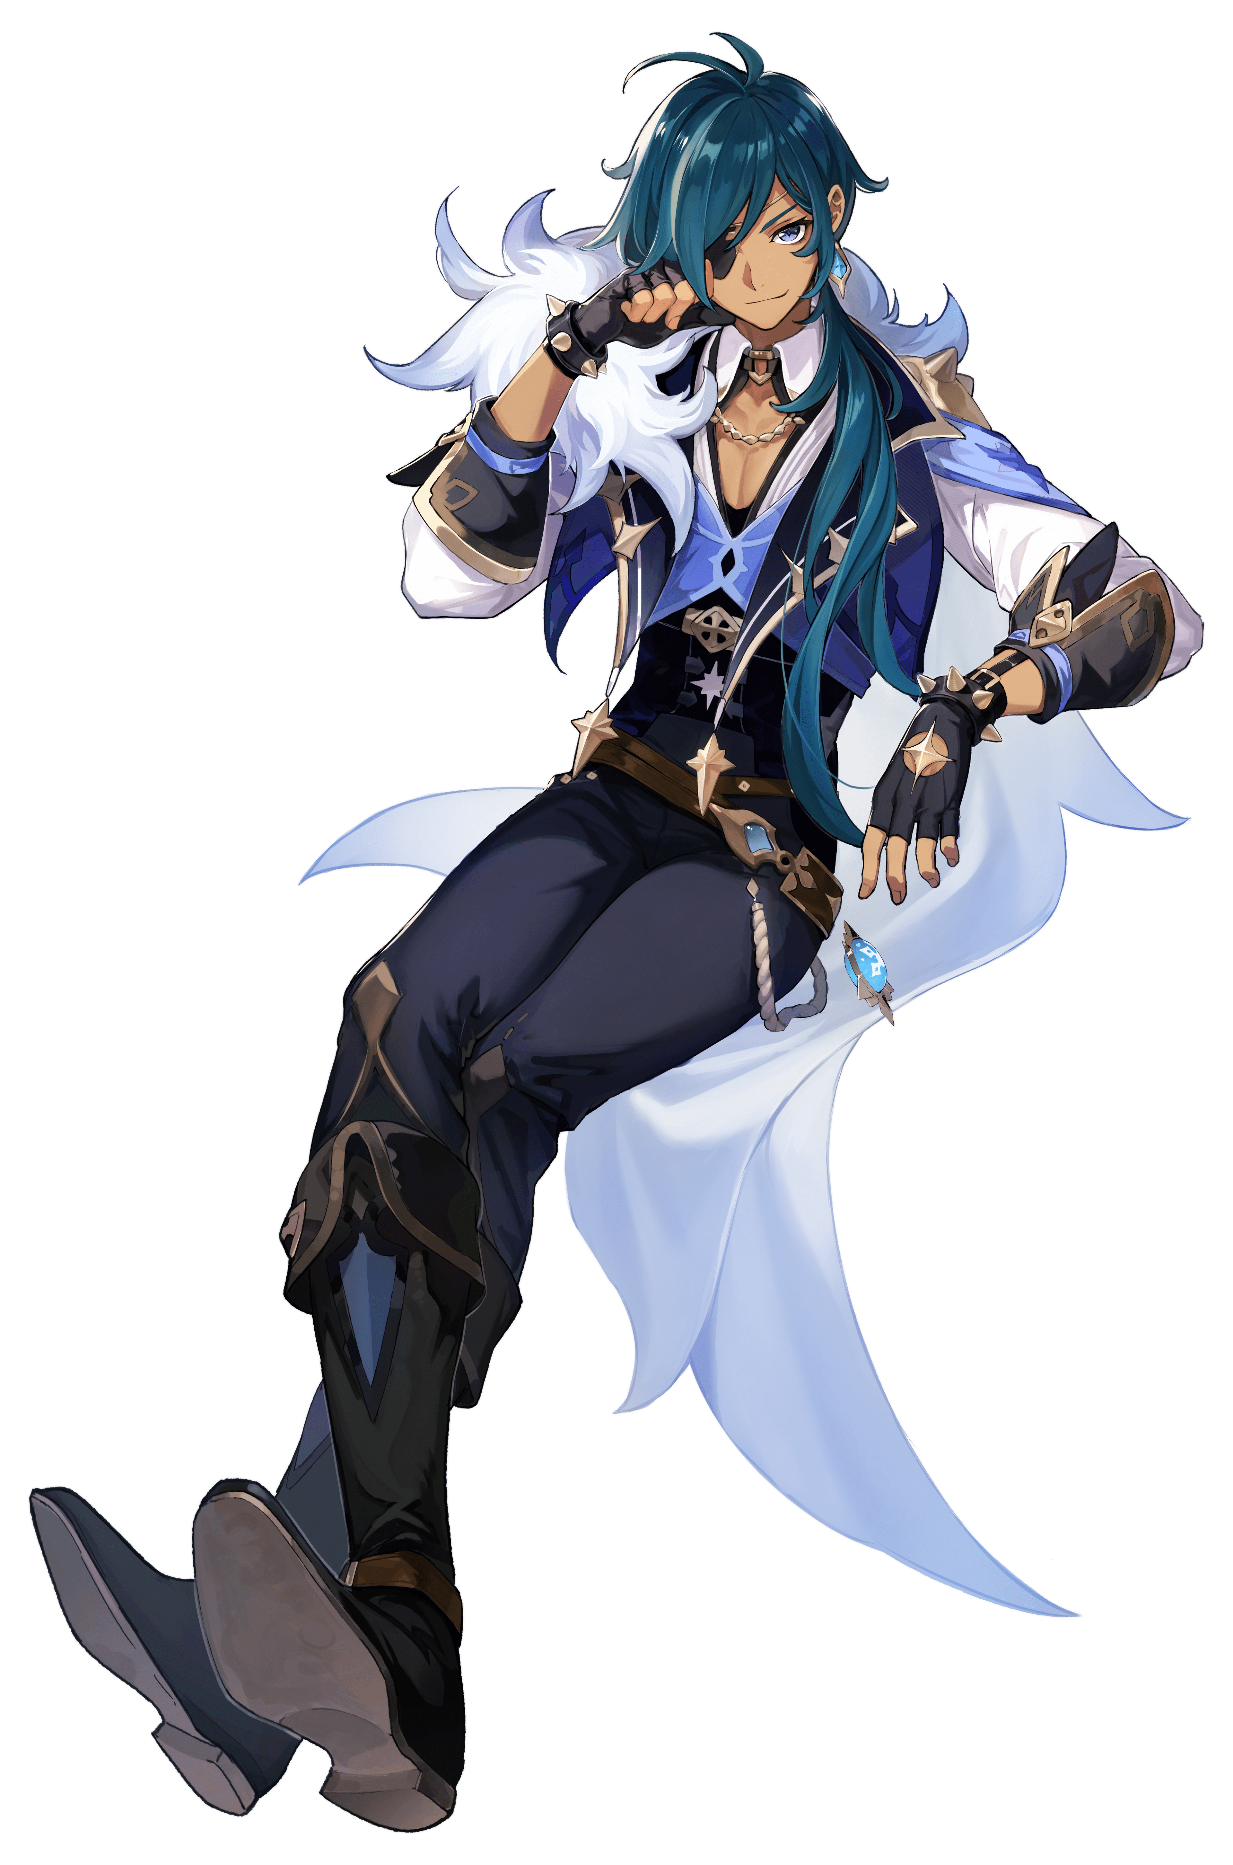
Kaeya pushed himself off the sill and bent forward to beginning picking up the scattered documents. But for some reason he couldn’t bring himself to stop looking at the stone that had crashed through the window and caused this mess in the first place. Was it one of the rocks that had fallen from the sky? Considering its unique properties, that was likely the case. Although Kaeya himself didn’t fully grasp just how unique it truly was. After all, no sooner than he’d turned his attention back to the paperwork did a peculiar thought cross his mind.

One of the knights must have dropped this? I guess I can do them a favor by cleaning it up.

“That’s not what happened. And why am I thinking of myself like another person? Maybe it isn’t the Acting Grandmaster that needs to get some rest?” With a sigh, the man snatched the stone off the floor and chucked it back out the broken window. He’d have to petition someone to fix that in the morning. But that isn’t my responsibility? That should fall on the shoulders of the Cavalry Captain since this is his office… “No, I am the Cavalry Captain. What is…? Hm?”

Something around Kaeya’s chest had suddenly tickled, forcing him to spare a glance down at it. With his top being a deep v-neck, you could make out the inner area of the pectoral muscles he’d developed. They were always so firm and appealing, but looking down now they appeared unusually puffy. “Maybe I need to add going to the gym to my list of things to do, too.”

Kaeya eyed his chest a little longer though. Did it look even more swollen? It almost felt like his top was a little tighter too. After a moment of deliberation, he reached up a hand to investigate. Just a light squeeze to make sure everything was up and running properly. But instead of it being a quick check without incident, the man ended up moaning much to his surprise. Because the flesh of his chest had been so soft and sensitive.

They’d also felt fuller than the man had expected, and on closer inspection? There appeared to be cleavage forming in the v-neck of his top. “Wait. Are these breasts? That’s impossible, but… Nn…” Another squeeze put things into perspective. They were certainly bigger, and a tanned valley had been forged upon his chest while his clothing struggled to contain the building bosom. Within a matter of moments it peaked at a pair of D-cups, leaving an exasperated expression upon the man’s facial features.

…Which were similarly swelling. His lips had grown thicker and his eyes wider, while the shape of his face was just on the whole incredibly more feminine. Even his hair had been afflicted, no bangs now obscuring his forehead while it was all thicker and wavier in the back. “Am I becoming a woman? Hey now, that’s a weird thing to ask even for me.” But why need I ask? Princesses are typically women. “A princess? That isn’t the kind of life for me.” Right? So then where was this uncertainty coming from?

Meanwhile, while the top of Kaeya’s shirt had tightened from his hefty new set of breasts, around his belly had begun to feel contrastingly loose. His tummy was tucking inward from the sides, presenting his body with a more dramatic arch at the side, though it was helped a little by narrowed shoulders. Just a strikingly was the fact that his tummy was now completely smooth where it had once been rippling with muscles.

In fact, this was a trend that had plagued the knight’s body much more generally than just his belly. Whether it was his arms or his legs, the muscle definition he’d accumulate for the sake of being a knight was entirely erased. His limbs were left stringy, and his breasts now rested upon a chest without any real muscle mass to them. But did all of that weight simply disappear?

Hardly. Some of it brought a softness to his arms, while some brought Kaeya’s breasts to appear even larger. The bulk of it, however? It moved below his belt. “Down there now, too?” Considering that he couldn’t deny he had a pair of fat tits on his chest now, the man wasn’t super surprised to feel a tightness in his pants. At first it was more prevalent around his upper legs, where thighs were bloating with glee to take up space that had once been occupied by his muscles. This left the material of his pantlegs frayed.

All while the back of his pants created a very uncomfortable situation for his loins. The man’s ass cheeks blossomed with no shortage of energy, forcing the waistband of his blue pants to tighten to no avail. Unfortunately, his butt swelled to a size that the paints were forced slightly down, and the cleavage of his new rear poked over the top. His boxers were directly affected, yanked back thanks to this huge ass – which of course caused complications for his dick.

The cloth of his undergarments was pulled so tightly that he thought his cock and balls were going to be crushed from the tension. But that tension eventually lessened… much to his dismay. “Wait, no! Not those, I need tho…se… What did I need again?” While pleading with the mysterious force changing him not to steal away his genitals, her voice jumped dramatically in pitch until she sounded the part of the princess she was more and more believing herself to be. By the time she was left with a woman’s pussy decorated with short, bright blue hairs, she could hardly remember having a dick at all.

And that was just it. Kaeya’s memories of old were growing farther and farther away from him. Rather than remembering being adopted, becoming a knight, and so on? There were now memories of being raised the daughter of Mondstadt’s royal family. It became hard to reject a reality that you no longer had any point of reference to deny.

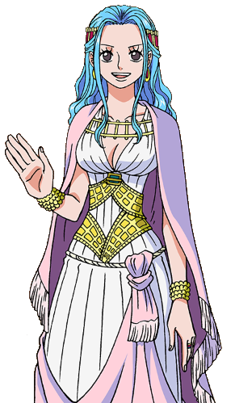
“I’m… I… who am I..?” The woman struggled with her own identity as she moved to the front of the desk (a struggle, considering her outfit’s current ill fit) because something deep down was saying I don’t belong behind a desk that isn’t mine. While she did so, dramatic change affected her body’s general aesthetic. Her natural tan brightened to a pale white that shone under the light of the moon that filtered through the broken window, and her mane adopted the same bright blue that her pubic hairs had. Both of his eyes now appeared silver as well, though one was still concealed beneath his eyepatch.

Although, not for long. With a flash of blue from the stone out in the yard, the one that Kaeya had a discarded, the woman’s clothing disappeared and reappeared in a completely different form. Gone was her neat, savvy costume that all of Mondstadt’s citizens easily recognized. In its place was a white gown with her cleavage still hanging out, though sitting much more comfortably. Gold decorated her wrists and torso, along with a matching headband in her hair that likewise drew attention to her gold, loop earring. A pink throw rested on her shoulders, complimenting the scarf wrapped around her waist.

Well, she looked like a princess in every sense of the word now.

Nefertari Vivi felt more certain about why she was in the Calvary Captain’s office now, even as she stacked the paperwork back on the desk. “Oh, right! I was about to let them know I was going on a journey. It’s a pain to have to go through the Knights every time I want to go somewhere, but it beats being locked up in the castle.” As she now recalled, she was Mondstadt’s princess. A princess that was known for her adventurous streak, one that caused the knights no shortage of headaches as a result.

The stone’s influence had been so great that, in order to fit this narrative, an entire castle has suddenly appeared on the water behind the church proper. The home of the Nefertari family that had ruled for the past one-hundred years. But the stuffy life of a princess wasn’t one that Vivi wished to subject herself to. Teyvat was a great, big world – and she wanted to see as much of it as she could!

“That’s strange, though? Sir Kaeya is usually in at this hour? I wonder if I should just leave my letter of absence on his desk?” So wrapped up in it all, she had no means of recognizing that Kaeya was in the room. Because she had been born of the Cavalry Captain’s own existence. “I’m setting out at morning’s first light, so I suppose that will have to do!” And so, Princess Vivi placed a handwritten note beside the stack of paperwork before turning to leave.

But she paused. What about this room struck her as so strangely nostalgic? It was hard to say. She merely shook her head and pressed out of the door. “Oh well! Tomorrow, it’s off to Liyue Harbor!”

