BEACH-I THE ROCK
CH3: BEING SHADY
BY CHALDEACHANGE
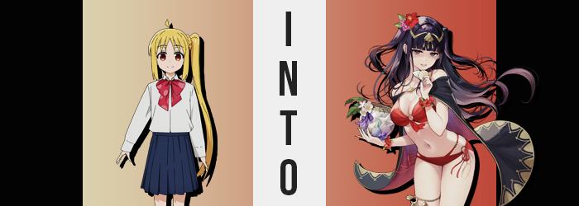

“I feel kind of bad for leaving Kita-chan there with Bocchi-chan…”

Nijika knew that she and Ryo had planned to run off and get snacks to avoid the inevitable changing room fiasco, and she certainly did feel guilty about that. But they couldn’t all wait around for Bocchi to finally work the courage up to leave, and their trip’s preparation did involve more than just settling down in the sand and jumping into the water. They were going to have a beachside picnic!

That was the primary reason that Nijika had wanted to go to the convenience store on the beach’s edge. Not only did they need to pick up things like sandwiches and drinks, but the picnic idea had been kind of last minute. They needed blankets to lay down on the beach so that they didn’t get all sandy too! To those ends Nijika had gone ahead of Ryo back to the spot they had chosen with blankets in hand, leaving her friend to handle carrying back the food.

She wasn’t completely confident Ryo wouldn’t just eat some on the way back, but the blonde haired girl was worried about Bocchi too. She might have run away to avoid the initial problems, but she still had to be a supportive senpai, right!? “Plus Bocchi-chan will want reassurance from everyone, right!?” Funnily she had mentally omitted Ryo from the ‘everyone’ part of that declaration. She couldn’t count on her to be supportive ever, at least not in a way that wasn’t extremely roundabout.

Nijika just didn’t understand Ryo’s dark and brooding personality at times!

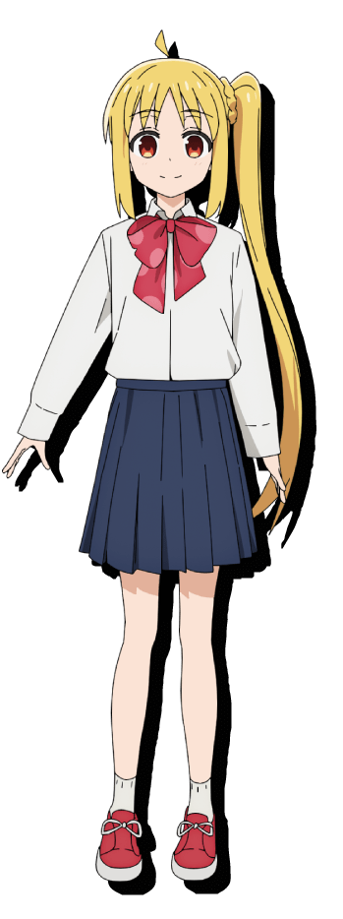
The teen didn’t plan on ruining Kessoku Band’s trip by lamenting such things though! She was already a few minutes out from the convenience store, walking a path on the outskirts of the beach that would eventually take her to the isolated section that they had chosen to go swimming at for Bocchi’s sake. Nijika didn’t really mind, it wasn’t like she had come to the beach to show off or anything. This was just a fun group activity for the band!

Walking the beach outskirts was kind of nice. It bordered a forest so there was some shade, which also meant that most other beachgoers avoided this side. That was why she was surprised to find a woman running past her towards the convenience store she had just come from. It was really hard to miss her, too. “Whoa…” Not even Nijika could stop herself from drinking in the swimsuit-clad beauty’s appearance for a moment. Fit with a big chest and big butt. Traits that were admirable, but also traits she had come to terms with the fact that she’d never grow them.

She squinted as the woman disappeared off into the horizon though. “Was there something glowing in her bag? It was all rainbowy!” Not only that but the girl felt like she had seen a bag like that somewhere before. Maybe it was nothing? It was probably just a coincidence if anything, and that glowing light was likely completely harmless! Just some funny little accessory!

It wasn’t though.

Instead of setting herself back on track to return to Kita and Bocchi, something prompted Nijika to remain still. She felt fatigued somehow, almost like a wave of exhaustion had just hit her. Considering the girl was typically so full of energy it surprised even her. “Huh! I’m pretty sure I got a full night of sleep last night! Hehehe…!?” The sound of her own voice shocked her into dropping the towels she’d been carrying.

The teen’s eyes went wide for a moment, making it easy to see that the colors of her irises were undergoing a fairly pronounced change. The reddish brown that she was known for was dulling, speckles of a cold purple settling in its place that almost better suited what was happening around her eyes. Dark circles had deepened underneath her gaze, a telltale sign of fatigue… or at least of being accustomed to darker spaces than out and under the sun.

As for why her eyes had gone wide in the first place, well… It had been that laugh. It was more of a giggle, but she hadn’t meant to giggle. Not to mention it had sounded a touch unhinged and creepy. Unbefitting of a peppy teenaged girl like herself! Yet if you could define ‘creepiness’ in a physical sense, her body continued to change past merely her eyes to suit that description. Just take her skin! Any semblance of color it had possessed was rapidly draining until she was pasty white and at very high risk of getting sunburnt.

“That laugh was weird… but I’m used to sounding suspicious…” Huh? Was she? And what was with that low energy remark? It almost sounded like she was hissing under her breath! And yet her face scrunched up while commenting in part because she felt sour, but in greater part because her face’s shape was changing.

Narrow Japanese eyes widened to take on a different racial profile and her lashes lengthened several inches. There was something more mature about her gaze like this and it was further assisted by the rest of the changes that altered her face. Fuller lips bore a sad pout beneath a sharper nose, and overall? Her face’s shape narrowed. Rather than a teenaged girl she certainly looked more like a young woman.

And that young woman she looked like appeared increasingly creepy. Her gaze was skittish now, jumping around the beach as she tried to remember what had been bothering her only moments before. In the meantime her vivid blonde hair darkened towards a purplish black and thickened. Since Nijika wore her long hair in a side ponytail it retained this style for the time being, but it was very clearly more ample than it had been before. On the other hand her bangs were now cut straight across her eyes like a set of curtains.

She shuddered. “Ugh… The sun is so annoying…” Her voice deeper but still as creepy sounding as it had been since the rainbow stone had begun to work its magic on her, she couldn’t seem to recall what had driven her to go to the beach of all places all of a sudden. She couldn’t fathom such a trip being her idea. I prefer being in the shadows after all.

With her pale complexion, dead looking eyes, and dark hair there was a strangely alluring quality to her that might have only really appealed to people that were into goth chicks. But there would soon be more to love about her appearance in general. The maturity upon her face had essentially foreshadowed what was in store for the rest of her body, and a subtle growth of two inches to her overall height laid the groundwork for the rest of it.

Having come to the beach in her uniform like the other girls had, the fit of that unform had been discreetly affected by that growth. Her blouse had come untucked from her skirt, but it was ultimately lifted even higher even though Nijika hadn’t grown taller. The cause? Well, it was fairly obvious. “Urp!?” She could feel it too. But she didn’t process it like she probably should have.

There was a lot of tension in her bra. The cups felt way too tight, and the band that wrapped around the back was struggling to hold on. But eventually the clip did snap and the front of her brassiere came loose beneath the blouse. And there was a rather sizable… bounce. Her chest had leaped forward like a pair of beasts that had just been unleashed. Clearly her tits had been swelling and the sight of them had been restrained by her underwear. But no longer. The DDs they had become could be seen pushing her top forward and out, the top two buttons having popped off to reveal the valley of her cleavage.

“Hm?” Had something just happened? “…White? Why in the name of Grima am I wearing white?” Was that truly an unusual color for her to wear? In no small part it certainly felt like it now. She would have preferred a darker color. And her wish was soon granted as the blouse and bra disappeared only to be replaced by a crimson bikini top.

Her skirt would soon disappear to reveal a matching bikini bottom, yet she was still growing down there. Narrow hips had been shoved apart by an accumulation of mass that bolstered the arsenals of her thighs and ass. Upper legs became soft and shapely – perfect for using as a pillow. While in tandem her ass swelled into a lovely peach shape that chewed at her underwear until it was replaced by that bikini bottom.

Accessories appeared in the final stage to compliment her swimsuit. Sandals and a golden band around her right thigh that was a little too tight (so you could see flesh bulging around it) dressed her legs. While above her waist? Red flowers were attached to wristbands with one in her hair above a golden headdress. Throwing it all together was a black cloak with golden trim and a red underside. Somehow the scent of that cloak excited her a little.

Without even thinking about it, Tharja had retreated fully into the shade provided by the nearby trees out of fear of her pale complexion burning. She wasn’t one who enjoyed being outside because of this, and doing something with friends? That was even more annoying. Her dark and gloomy personality did not mesh well with social situations whatsoever. “Urgh, why did I agree to even come out here in the first place…”

The dark mage bent over to pick up the blankets that had been dropped over the course of her transformation, of course not at all aware of the circumstances that had caused them to drop in the first place. Her perky ass was stuck up high as she did so. Had she been her old self, this new body of hers might have been one Nijika would have admired just as she had Musashi’s. But as far as she knew now, Tharja had always had a body like this.

Not that she cared if it drew attention. She only wanted one person’s attention. The attention of another woman in their group that had caught her eye some time ago. You could say that Tharja had become rather obsessed with her and that was why she had agreed to come along to the beach in the end. “This better all be worth it…”

Based on how she hissed it didn’t sound like she was confident it would be.

