CHANGE OF PLANS
COMMISSION STORY
BY CHALDEACHANGE
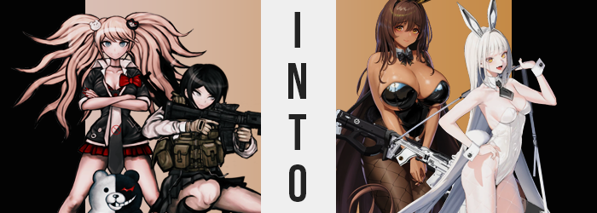

“Mukuro-chaaaan~ I’ll handle things on the technical side here if you want to go secure the perimeter as we planned!”

“Right.”

Despite being twin sisters, the differences between Junko Enoshima and Mukuro Ikusaba were really quite stark. The younger of the two, Junko, was more flamboyant both visually and personality wise (hiding her diabolical cruelty within), while the older Mukuro was more muted in both regards, appearing plainer and doing whatever her sister asked of her. She was extremely loyal and that loyalty had led her into following Junko into the factory of the TETRA Line company along with her little sister.

And they certainly weren’t there to have fun. The Killing Game of Hope’s Peak had yet to unfold. Junko was still in the preparation phase, having acquired the participants but not having completely set the stage. There were still some resources that she required, one of the most important being the Monokumas she had designed. She needed those silly looking android bears to have a presence in the school during the game and so she had commissioned their creation from the Towa robotics group under the pretense of them being robotic rescue workers.

“I’ll teach them…” Things had taken an unfortunate turn for Junko when TETRA Line had come out of nowhere and purchased all of Towa, setting aside her project even though she had already paid and it was close to completion. The fact that they’d found a completed product inside of the warehouse had been proof of that. So she was going to scrape their data, install a virus in their systems, and run off with whatever completed work they had.

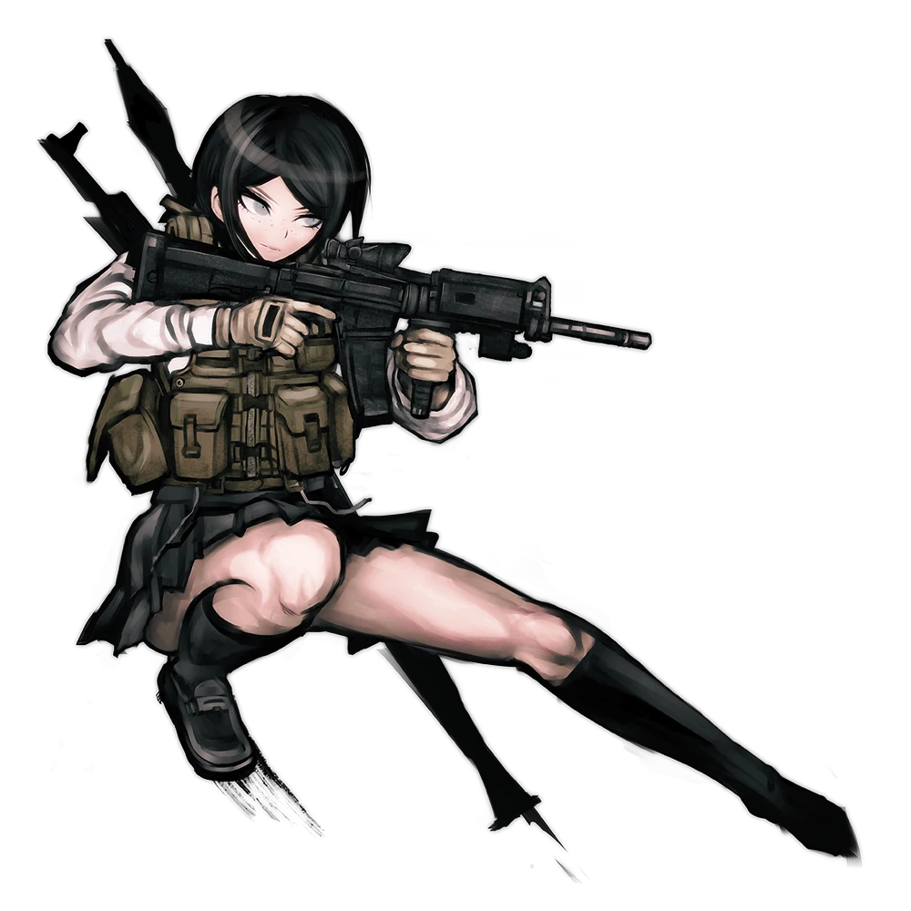
Mukuro was patrolling the surrounding hallways of the TETRA Line building as Junko did her work inside. Despite having the appearance of a high school girl she was a combat expert, and the military-grade rifle that she was carrying certainly help demonstrate that expertise. She had already created atrocities for her dear sister and understood that on a fundamental level that she was ‘broken’, wired to wish to spread despair.

But she was often left out of the loop of Junko’s plans and simply obediently followed whenever something was asked of her. She had no desire to go against Junko even if Mukuro knew that she was ‘evil’. She was still family. “This location has a surprising lack of security compared to the others I scouted first..." It had been through Mukuro’s snooping that the location that had the completed Monokuma had been found, and the other locations had cameras and mounted turrets.

They had gotten in a little too easily and that made her wary.

The truth of the matter was that there was a type of security feature installed that neither of them had considered to be on the lookout for. Something tiny and light. Something that they would have easily discovered had a simple test of the air been done. Nanites. They filled the air of the warehouse and had yet to be activated, yet as Junko accessed the computer inside… they soon sprung to life.

“Hm?” It took a second for Mukuro to notice it. The fact that the air was thick with something white. Smoke? Fog? She actually had the better part of her deal than her sister, who was presently taking a much more dangerous concentration of nanomachine interference. But what she had already inhaled, and what had begun to cling to her body, was already enough to raise questions and concerns. “Urk...!?”

She immediately clutched her chest through her military vest. Her heart was showing signs of palpitations. It felt like something was digging into her all across her body, yet there were no signs of puncture wounds or anything of the sort. On the other hand? She was treated to the uncanny sight of her uniform and military equipment melting away. Color was lost and the liquidated cloth tightened around her flesh, ultimately becoming…

A white bunny girl costume? A strapless leotard with fishnet tights covered most of her skin. She had shakily been lifted up by silver heels, and she had a collar with a black bow as well as cuffs. Atop her head there were also a pair of metallic bunny ears. Not to mention the fluffy bunny tail at the rear of the leotard “I’m dressed like I just came out of a casino!?” And it certainly didn’t help that the outfit didn’t really fit. Her breasts were too small for the cups of the leotard and so you could see them at first, nipples and all. And the tights were a touch too loose.

Not that she wanted this embarrassing outfit to fit.

“What is this stuff!?” Mukuro lashed out at the ‘fog’ while wondering if she should run back to Junko. But something was awry mentally. She was so typically a doormat that would always put her sister above herself, but in that moment? Her wants were very forward and selfish. She was much more concerned about herself than her sibling, and she certainly had plenty of good reason for that.

With so much of her muscular body exposed in this outfit, Mukuro could actually see things changing beyond just her clothes. Scars were mended and those muscles began to lean. “Wh-What…?” She almost didn’t believe her eyes, yet her arms and legs were certainly thinning as a softness possessed them, her athletic ability shot entirely out the window. She was rendered very slender as a result, even in her torso where pecs and abs faded away. But this loss was seemingly exchanged for gain.

As her pecs were absent, the bunny girl leotard was even looser around her chest. If her breasts had even seemed large in the first place it was only because her muscles made them stand out. But not for long as those cups appeared to tighten around her bosom. Or at least that was how she had seen it initially, until she realized that things were actually the other way around. The meager showing of meat she had for a pair of breasts was growing, inflating in roundness with a bounce and a jiggle to fill the cups. They were only B-cups at the end of the day, but as she was wearing so little, and because her body had grown so slender, they were still very eye-catching. Especially when you factored in just how perky they had become.

Mukuro blinked with awe, the weight of lengthier lashes going unnoticed… much less the fact that her vision seemed sharper than before. “What is happening to me? How is this… possible?” Her irises were glowing a golden color, relaying visual data to her ‘brain’ in a manner that was different from before. Her heart palpitations had come to cease too… All because she no longer possessed one. At least not a biological one. There was a pump beating in her breast but it was circulating a coolant that now replaced her blood around an iron frame. She was entirely synthetic.

She was an android.

But she hadn’t realized it yet. “This is SO weird!” There was an aggression to her voice that was atypical of her quiet personality. Her voice sounded shriller than before, and it was communicated through a mouth that was oddly shaped. Well, comparatively anyways. Her mouth was a touch longer in shape and her lips? They hadn’t been quite that puffy before. Nor had her nose been that sharp, or her golden eyes so round. Was that really even Mukuro Ikusaba standing there? In a sense. But she definitely looked more like a young adult than a teen now.

The curvature of her body continued to be enhanced in subtle ways much like her tits had. Her hips were pulled outward several inches which pushed her knees to buckle for a moment before she corrected her posture. This laid the foundation for a slight swell to the surrounding regions. Her ass cheeks perked up, pushing out behind her to help fill the fishnet stockings in all of their newfound shapeliness. You could see her whole ass with the outfit she was now wearing, and so their bulge was a visually welcome one. As was the excess, that plumped up her thighs a bit. Some muscle had been retained in her upper legs, but it certainly didn’t steal away any of their new appeal.

“Hmm…” The nanites in the air were thinning and the woman herself was slowly piecing together the recollected shards of a new life and identity. While she did? She didn’t so much as bat an eyelash as her short, dark hair spilled out behind her in excess. Silky strands fell as far as her ankles before curling in towards the backs of her knees, and like a wave of snow the white flowed from her roots all the way to their tips. It ultimately completed her brand new look. All she had to do was accept her all new memories as well!

“Ugh… My head is a mess!” Or was it more like her internal computer was a mess? While she resembled one, Blanc was not a human but instead a NIKKE produced by TETRA Line. Her body was an artificial one. An android. But while new personality data had been provided to her as a part of her repurposing, her memories still belonged to one Mukuro Ikusaba. “But like, I get it. We were here to screw the place up? But why would sis need to go that far?”

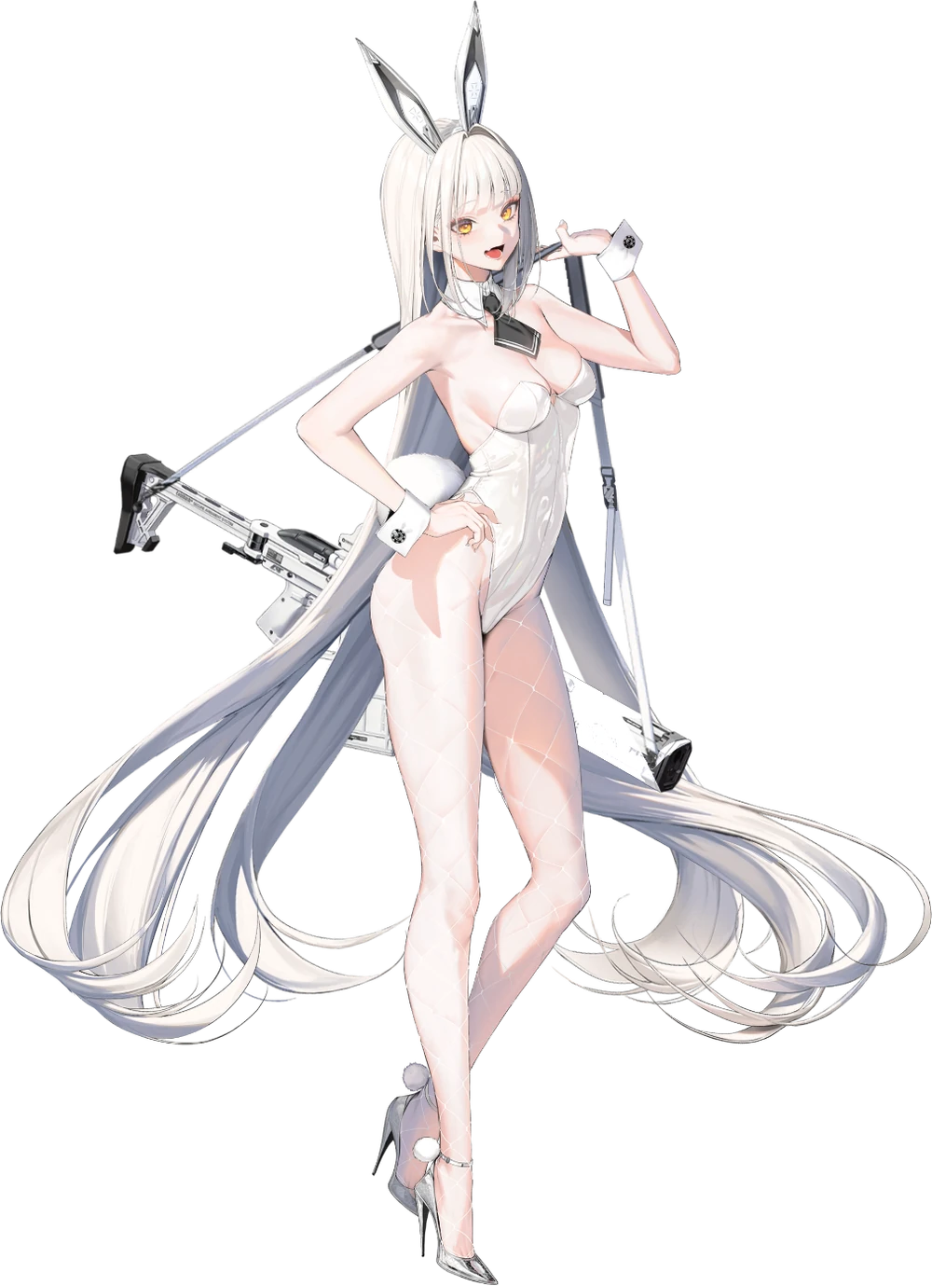
Therein existed the issue. Mukuro had basically been a doormat that never questioned Junko’s motives, but Blanc was a much more headstrong and independent young woman. She only had questions, and she also had a difference in priorities. She was a TETRA Line product now and so there was no will on her part to bring harm to her own company. “Guess I need to go pick her brain. Or give her a piece of my mind if I have to!” But she didn’t feel like she would have to go that far.

The mental image she had of her sister was… different somehow.

But what if she came off too harshly? There weren’t typically concerns she’d ever had about her sister because Mukuro never talked back to Junko. Their dynamic had shifted now though, and the only way to see in what way was to brave their reunion. Blanc wouldn’t back down no matter what the answer was though. It was her duty as the more willful of the two! …Even though moments before that would have been a descriptor best reserved for Junko instead.

Turning back the clock a few minutes, Junko had been typing furiously away at the computer as she put her hacking skills to the test. Not that it was much of a test. Even the extremely rigorous security systems of TETRA Line’s server system were no match for her, which worked out perfectly because she wanted to inflict as much pain as possible as revenge for inconveniencing her. “Upupupu… Let’s see how you like this!”

She slammed the ENTER key, unleashing the virus she had been prepared into the network. Or at least that was supposed to be how it went, but instead the screen began to flash bright red with barely legible text. “Activating security nanites? What…? SHIT!” Not only had the computer locked her out but the air around her had come to life with a vaguely visible amber glow.
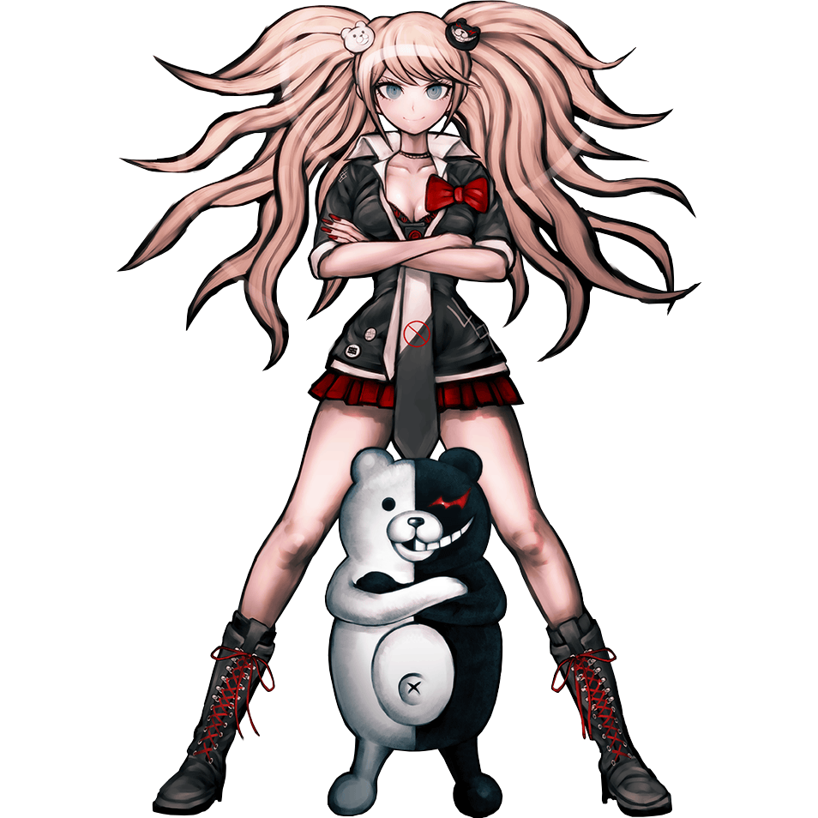
More than being panicked about what kind of circumstances she might have found herself in, Junko was pissed that she had been outplayed. But they weren’t going to get the best of her! Or at least that was what she was thinking. She had absolutely no control over her own fate by this juncture. Of course she understood what nanites were capable of. She could already feel them getting to work both internally and externally.

But as was the case with Mukuro in the nearby hallway it was her outfit that suffered first. Her trendy gyaru outfit practically evaporated into thin air, instead tightening and hardening in place into a black, strapless leotard and black mesh tights. Like Blanc she also had the cuffs and collar, but her heels and bunny ears were largely black. The leotard was way too big even around her already impressively large chest, and it seemed designed for a taller person. “What the heck is… this…? …!?” Junko looked confused after expressing her confusion at her attire, but her confusion wasn’t as aimed at her new, skimpy outfit as it was at what she’d just said.

She’d meant to shout it! Use expletives! But what had ultimately left her lips was a much more subdued version of it. It left her feeling a special kind of despair! …And that made her feel terrible. “No, no, no, no…!” She softly lamented this. Despair was supposed to make you feel terrible, right? That was what Junko had loved about it! And yet as her irises turned a yellowish brown, she… realized she didn’t like feeling that way. …Why would I want to feel despair? So long as I follow sis, I won’t have to feel that way!

Follow… Mukuro? No, was that her sister’s name? It didn’t sound right. She distracted by her new thoughts and feelings, the teen’s attention wasn’t where it probably should have been. It didn’t take much of a glance to notice that her skin color was changing, but it went completely over her head. And yet it was, melanin gradually increasing so that her complexion turned tan initially before turning into a rich mocha caramel.

Like Blanc, her internals had already shifted into something technological and inorganic, but despite having become a piece of technology herself? “Maybe I can do something with the computer… thing? If I just, um… B-But I could do all kinds of stuff before, couldn’t it?” Her tanned face showed a wide range of shocked and worried expressions as Junko came to terms with the fact that she didn’t know how computers worked anymore. At least not enough to even hope to help with the nanothingies.

While her once sharp intellect had been rapidly diminishing, it seemed that her body was now doing the opposite. A chocolate brown had found its way into her hair, seeing it all lengthen to her ankles where it curled in like Blanc’s. But this was actually a more dramatic change than you might have first believed… because Junko’s height had extended an extra four inches.

The young woman was completely lost by this juncture. It was like her brain, or the computer that now functioned as her brain, could only produce white noise while contradicting memories and personality traits fought amongst themselves. “I… Uh…?” The structure of her face changed, becoming fuller and more mature. Her lips were bee stung and stunningly glossy, while narrowed eyes had fuller lashes than she could even have accomplished with makeup before. She was still a natural beauty, but she didn’t look Japanese – and she looked older to boot.

But in terms of fullness there was a singular area where the word ‘full’ almost took on a new meaning. It wasn’t her ass and thighs, although these areas did inflate to stretch her mesh tights into their fuller, glossier glory. It was the sight of her already impressive tits swelling, DD’s inflating as if a pump had been fastened to them and was funneling fat directly into their packages. “O-Oh!”

Her squeak of surprise had been inspired by the sheer weight of her tanned breasts for they moved her center of gravity increasingly forward. Each new pound of fat that saw skin stretch around her mammaries called for a new adjustment of her posture and a tightening of her synthetic back muscles. Before long they at least filled the cups of the open leotard, but those cups were huge. Each tit surpassed her head in size and each nipple was bigger than an eye with areola spinning most of their tips.

These were an alarmingly big addition to her body, and yet as she blinked and gave one of them a squeeze? They didn’t feel unfamiliar to her.

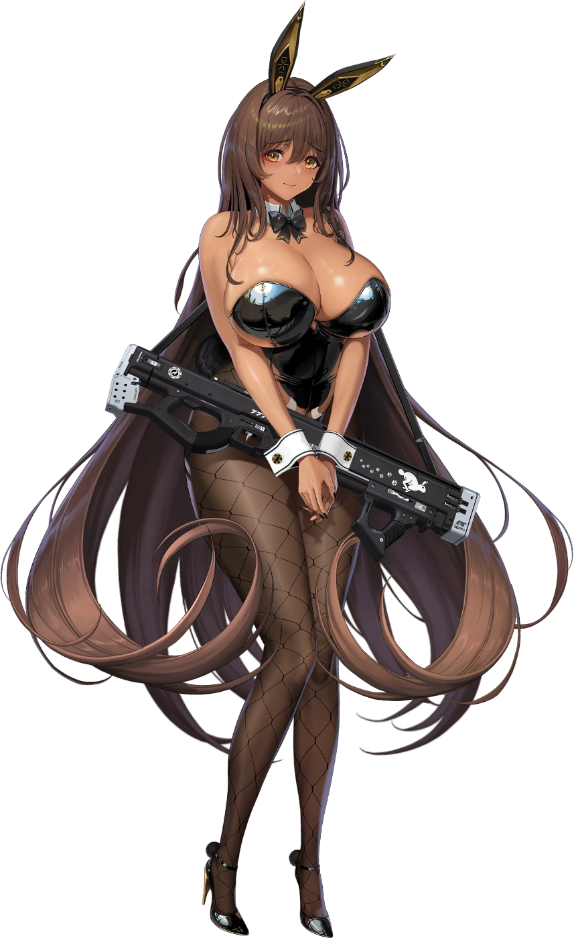
“I…” Once so forward and intimidating, the woman that Junko Enoshima now stood quietly alone within the room with the computer. A computer that she no longer knew how to use beyond basic functions, which was almost funny considering Noir’s own brain was stored on a computer within her thick NIKKE head. Junko’s memories had essentially been erased since she’d suffered a more potent nanomachine dosage than Mukuro had. Noir didn’t want to be that kind of person anyways. She just wanted to follow her sister, Blanc, and would do so without questioning her.

A true role reversal.

One that was on full display as the white-haired Blanc pushed back into the room, taking no issue with Noir’s appearance. Her expression was irate and confused, leaving Noir concerned that she had done something wrong. I don’t want to get yelled at! …A thought she wouldn’t dare state out loud. “Noir! So what’s with all of this Killing Game nonsense? I’ve been following your orders all this time, but enough! It’s a bad idea!” Or so she was saying, but her words were muffled by Noir’s bosom near the end. She had been moving so quickly that she had clumsily overshot her goal and flown face first into Noir’s tits, and Noir happily drew her sibling into a hug from that point on.

She didn’t know what to say at first though. Those plans… What plans? Had she ever had plans like that? Noir froze up as the two just enjoyed their sisterly hug. “…I-I don’t know what you’re talking about, promise!
” Noir was fine just staying with TETRA Line if that was what Blanc decided. Any thoughts of despair and disobedience were gone, and there was no longer any desire to pursue them so long as she had Blanc by her side telling her what to do. After all…

Family had to stick together, right?

