Too Convincing

A Short Story

By Maryanne Peters

Part of the problem was that my sister Dee, has incredible skills as a beautician. But more than half of the problem was me – her subject matter. With my big blue eyes and fine features, she said it would be easy to make me look like a girl, and she was right.

When dressing as a girl for a Halloween party, a guy is supposed to look like a guy. It is a joke. Okay, so put some effort in and shave your legs, wear a body stocking with shape in it, but use a bad wig and too much makeup. But be recognisable as you.

I did not look like me. Nobody recognised me. Maybe a couple of girls who saw me with Dee. None of the guys. When I revealed myself, they were dumfounded. It was hilarious initially, but as my friend Mike told me later: After that it was just weird. I was too good-looking and that made him feel uncomfortable.

I think a big part of the problem was that I ended up not wearing a wig at all. If I had I could have just taken it off. But Dee persuaded me that my hair was long enough for her to do something with. With a little wash out hair color and a curling wand, she was able to send me out with a girly hairstyle. One I could not take off.

So, it was kind of strange at the party. I sort of hung with the girls. Dee was showing me off as walking evidence of her skills. The guys sort of stared at me from a distance but found it difficult to treat me as me. When Dee suggested we take up an invitation to move to another party across town, I agreed to go with her and two other girls.

It was at that party that I met Nate.

Nate was a big guy and a real contradiction. I was told that he had a reputation for violence, but he was artistic, a sculptor in steel, and he was intelligent. He hung with a bunch of guys who clearly thought of him as a god. I could understand why. He had a real presence.

I suppose I fell under his spell just like those guys. It was not a sexual thing, at least not then. He was a man admired by men. He clearly loved women, just as I did. We were both heterosexual men, at least then we were.

The party was at his place. While he was only a little older than me he had his own place. It was a studio, I guess. It had a concrete floor in the front and then it had levels and “living spaces”, including rooms hanging from the ceiling. It was great for a party.

When I arrived, nobody knew I was a guy, and because I did not know anybody there apart from Dee and her friends, I did not tell anyone. I just waited to see if anyone would guess. I suppose I figured somebody would. If they did I would just laugh and explain that I was not a trannie or anything like that - it was just a Halloween costume. I was Danny, not Danni.

But nobody guessed. My costume did not seem to be a costume at all.

I was putting on a little bit of a girly voice, I suppose. It just seemed to fit with what I was wearing. If I had been dressed as Dracula I would have spoken with a Transylvanian accent – right? Maybe some gestures were feminine, but pushing back my curls, or straightening my dress – when you have curls and wear a dress you just do that – right? It did not seem a deliberate thing, as if I was trying to deceive anybody.

And maybe, just hanging with the girls rather than the guys, I picked up on what they were doing. I ended up drinking wine rather than beer. I confess that I was not used to wine and I tended to chug a little, rather than sipping it. I got a little too drunk. But I never lost my poise in that costume.

Anyway, I ended up talking to Nate. We had a big discussion about industrial art. I had a mechanical background, but I did not tell him that. I told him that I had a full-time job looking pretty. He loved that. I guess it was flirtatious, but I was just in character.

I ended up on his arm. I know that sounds strange but it was his party and he knew everybody, and I knew none of them. I like meeting people. The host is the best guy to hang with. He introduced me to people as “my new best friend, Danni.”

I was way too drunk when he kissed me. That’s right. He kissed me. I won’t say I kissed back, but didn’t push him away either. I really liked him, and he wanted to kiss me, so I let him. You can tell me now that no guy would let that happen, and maybe I was gay, or bisexual or something. It didn’t feel that way. But it was not like a joke either. It felt like intimacy between two people. It was at the end of a wonderful evening, but Cinderella’s spell would soon have to end.

But that wasn’t the end of the evening. I don’t remember how the evening ended. What I do remember is waking up in his arms.

The first thing I remember is the aftertaste of vomit in my mouth. I knew that I had gone too far. Then I felt movement under my head I became gradually aware of where I was. My hair with curls all over the place, was on one side of a man’s hairy chest, my arm across the other side of it. I became aware that I was fully clothed, my soft fake breasts still housed in the bra my sister had provided, my penis still tightly tucked in the heavy panties that were needed.

I didn’t move. His arm that was underneath me moved slightly to cup my shoulder. I couldn’t move. Not without waking him. It was Nate. It was morning with warm sunlight just coming through the curtains in the sleeping shelf of his studio.

I had time to try to think about what had happened. It was a blackout. Not good. It had only happened to me once before and I had sworn that I would never get that drunk again.

And then he woke. He gently moved my head to see that my eyes were open. They were, wide with fear. What was going to happen now? Surely he had not reached down into my panties. If he had done that then I would not be in this position. I would likely be a ditch somewhere – if not dead the seriously injured.

“Good morning, Gorgeous,” he said.

My secret was intact. It had to be. But suddenly it was all very complicated. But I was clear on what I needed to do. I needed to get home. I did not need a scene here. I needed to play it cool – be Danni for a few more minutes, until I got out of here.

“Hey there,” I said, smiling at him. I should be able to say that it was a pretend smile, but there was something in the moment that made it entirely genuine. The sun was coming in a window somewhere, the bed was soft, he was warm, and the hangover was not that bad.

“Shall I make some coffee?” he asked.

“Can I take a rain-check?” I responded. “I really have to go. I am already facing the walk of shame wearing evening clothing home in the morning.”

I searched for my shoes and found them. Even when I had them on he was taller than me. He took me in his arms and kissed me tenderly on the lips.

“I smell of puke,” I said.

“I did my best to clean you up,” he said.

I said: “Thank you,” coyly. I had a vague recollection of him holding me as I retched over the toilet.

“I’ll call you,” he said. He did not ask for my number. Could I get out of this that easily?

No. We must have swapped numbers. I had only been home an hour when my cell phone rang. It was him.

“Hey there Babe,” he said. “You haven’t forgotten our date, have you?”

I had. But it was not possible. He needed to know. He needed to know now.

“Nate,” I began. “I am so sorry, but I need to tell you something. Before I do, I think that it might make you very angry. I just want to explain to you that it was an accident. I really enjoyed myself too much last night. I should have told you before it …, I should have told you at the very beginning…”

I was getting flustered and he could hear it. He said: “Take it easy baby, just tell me.”

“I am a guy.” There. Said and done.

Silence. How do you respond to silence? I just waited.

“That is not possible,” he said.

“I’m sorry,” I said. “I didn’t mean to hurt you. I was just having so much fun last night. I …”

The phone clicked off. He had hung up on me. That is fair. My only concern now was whether he would be able to find me a tear my head off. But we moved in different circles, so it seemed safe. I felt relieved but also a little sad. He was a great guy and an interesting guy. In other circumstances, I would like to know him, and to be a friend to him.

I decided that I would just stay at home and take it easy for the rest of the day. The whole thing had been too heavy. But then, about an hour after the first call, Nate rang back.

“I’ll tell you the way it is going to work,” he said. He sounded angry, but collected. “If you are truly sorry for deceiving me the way you did, then you will do what I ask.”

“Okay,” I said. It was a meek reply. He was in charge.

“We have a barbeque this afternoon at Pete’s. You agreed to that. You told everybody. Everybody has met you. I cannot allow anybody to know that you are a guy. We can break it off then. I will tell you when. You pick a fight with me. It will be over then. Do you understand?”

“You are scaring me a little,” I said, timidly. “You are not going to hurt me, are you?”

“I like you,” he responded. “At least I did when I thought you were a girl. I accept your explanation, that it was not intended to go as far as it did. It is just that all my friends think that you are the new woman in my life. I can’t have you disappear as a one night stand who threw me off, or even worse as a trannie who tricked me. You owe me this.”

All right,” I said. “When is the barbeque?”

“I will pick you up at 4:00 pm. Where do you live?”

“You can pick me up from Starbucks Southside,” I said. I was not going to tell him where I lived. I had just agreed to walk into the lion’s den.

“Sis,” I called out. “I am going to need your help.”

I explained the problem to her. She started by laughing, but then she could see that I was worried. She said: “He is right. Give him the chance to ditch you and save face.”

“I passed as a girl at night, but can I pass in the daytime?” I asked.

“Hey, do you doubt me?” she exclaimed. “We need to find you the right outfit and be more subtle with the makeup, but let’s get to work.”

She selected a sundress and sandals. She washed my hair and put in some curls and used a scarf as a hairband. I stood outside Starbucks for only a few minutes in this outfit, with a pair of her sunglasses on and a bag of essential items over my shoulder.

His car was a brand-new pick up painted metallic blue. It was just right for him. He looked out the window at me. He was not happy. I paused for a bit so that we just stared at one another. Then I shrugged my shoulders and got in.

“I still can’t believe it,” he said, after he had driven in silence for a few minutes. “Nobody would guess. You had me completely fooled.”

“I wasn’t trying to fool you,” I said, apologetically. “I am just living my life.” The words came out, and I seemed to be saying that I lived in drag all the time. That was not true. At least not then.

“We were invited together, so we are going together,” he explained. “If you can, we will pick up where we left off last night. I suggest that after we have had a meal you have some kind of meltdown. Give me a reason to ditch you. Then I’ll get you a cab home, and we will never see one another again. Agreed?”

“Agreed,” I said. I felt a little sadness that I would never see him again. I told myself that it was not about attraction – he was just a good guy and I fooled myself that in other circumstances we could be good friends. I wondered if I would find him on Facebook and follow what he was doing. I wondered why I suddenly found this man to be so fascinating. It seemed weird.

When we arrived, I remembered immediately the host and his wife – Kevin and Dahlia. And there were other people there who I had met at the party the night before. Several asked with concern whether I had recovered. It was clear that I had been a hit, even though I had later embarrassed myself.

I started to have a really good time. I drank soda only – I was not going to let it happen again. But the company was good and the conversation stimulating. It was fun.

Also, in the absence of intoxication I became aware of just what kind of girl I was. That’s right, what kind of girl. I was bubbly and cheeky. It might be that my personality was a bit like that, but as a guy these things do not interest people. When you combine a playful nature with a pretty face it seems to make you the centre of attention.

My face was pretty too. It was a warm afternoon and I needed to check my face regularly, and freshen my lipstick. I thought that I had looked glamorous the night before, but in the daytime, I just looked pretty.

Nate was with me most of the time, but when he wasn’t I could see that he was looking at me. I smiled at him from a distance, or looked at him when he was near me. He was going to ditch me. I was going to be heartbroken. I would leave in tears. We both knew what had to be.

We all had a meal together and it was after that when I felt that the time was right and I needed to take the cue and create a scene.

I felt that I did not need a complicated back-story. I just pulled him over to one side of the garden. I whispered: “Here goes then.” And then I shouted: “You are a pig!” and I slapped him right across the face. Quite hard really. It left a red mark across his cheek that made me wince in sympathetic pain.

What was he going to do? Would he slap me back? Would he start an argument? Would he simply turn and walk away, and tell his friends that I was a crazy woman? I was ready for whatever followed. Ready for anything except what did actually follow.

He looked me in the eyes. The look in his eyes could have melted an iceberg. He took me by the shoulders and pulled me to him. He kissed me, passionately. Passion like that must be contagious, because I kissed him back. I found my arms around his neck and I kissed him back, and more besides. I could have sworn that my feet left the ground and that I hovered in the air for a while.

I did not seem that it was me at all, who was doing this. It was somebody else. Some silly girl, who has fallen for a guy on a first date. Or was it a second date?

When he finally broke away, he whispered in my ear: “Change of plan. I think I’m in love with you.”

I was just amazed – that is the word. Neither of us noticed that everybody else at the barbeque was watching us, smiling at the lovers’ tiff turned into passionate embrace.

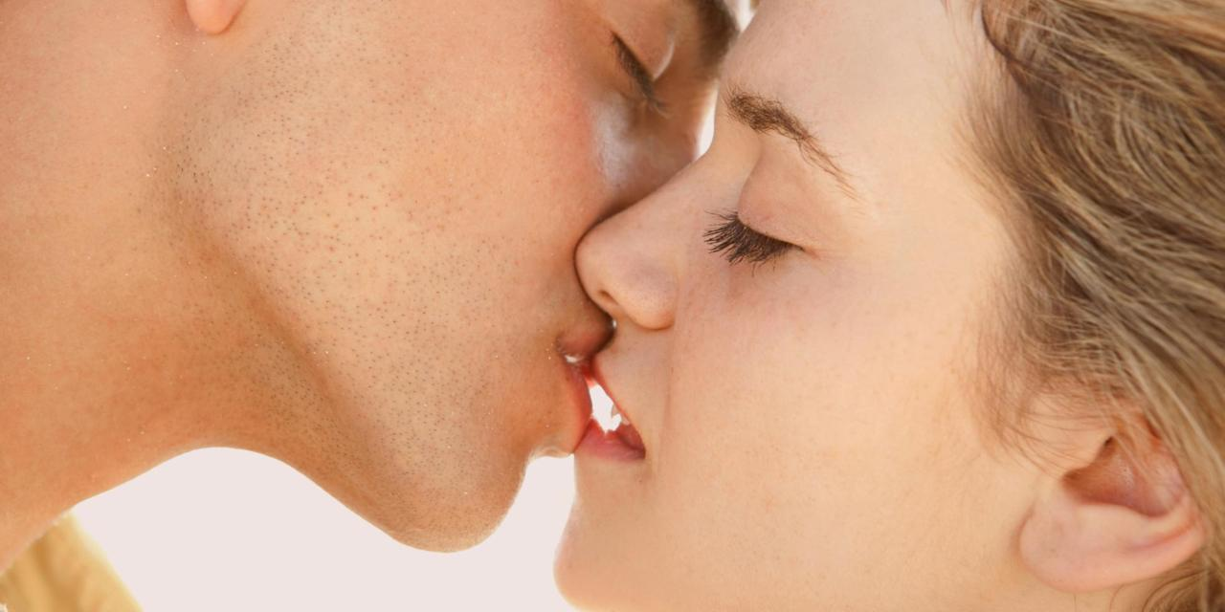

And that was how it happened. That was how I became the woman I am today.

Don’t ask me how this is possible. I don’t know. I know that love is between two people. Attraction is the beginning, but love is something else. He was attracted to me as a woman, so that is what I have become. I went through the hormones and the painful surgeries, to be a woman for him, and to become his wife. It was only a year later, on Halloween, that we got married. It will always be a special day for both of us.

The End

© Maryanne Peters 2018