Clothes
A Short Story
By Maryanne Peters

What woman feels comfortable about her boyfriend staring at other women? It is not just annoying, it is demoralizing. OK, so I might not be the best-looking woman, but I expect his eyes to be on me.

David told me that he wanted to be with me, and I believed him. But it seemed that it never took much to turn his head away from me – a wisp of blonde curls or the hem of a colorful skirt, and it was as if I had disappeared. It doesn’t help a woman’s confidence.

But I am a confident person. I am a professional and I work in a tough business. Publishing is tough, and I play tough. Fair enough, I may not bother too much with my wardrobe or hairstyle. It’s not that kind of profession. I’m not trying to impress anybody except with the quality of my work.

I favor sensible but smart office clothes - dark jackets and pants and pastel colored blouses, and my light brown hair in a tight bun, but I still consider my style of dress to be feminine. No guy would wear what I wear.

When we had sex, I would let my hair down. On days when I had planned for him to undress me, I would wear nice underwear – sexy-ish, but it still had to be comfortable. He liked to play with my hair when we had sex. He was a considerate lover and would usually let me go on top so that I could get him in as I like it. We had a lot of fun. We always had orgasms. Maybe not at the same time, but we both got what we wanted.

We seemed happy. But he was always looking at other women.

He said that he was not interested in anybody else. I mean, we talked about it. I believed him. So, what was the fascination? It took me ages to work it out. He had a thing about women’s clothes.

I said that we could work through it together. I wanted us to stay together so I was ready to do that. I mean, I am a practical person. This guy had everything going for him, and just one little flaw. We could fix it or find a way around it. We were both smart people. A publisher and a tax consultant. We were both intelligent, sensible and very-well paid.

We worked out that the problem had only really come forward when he became sexually active, which means when I came on the scene it all started for real. Before that he was, I think you might say “sexually repressed”. He kept it all bottled up. Sexual feelings are like a gas - now that the bottle was open it could not be put back inside.

We had to find a way to feed his desires; to satiate his appetites. It wasn’t enough for me to put on a colorful dress and prance around in front of him after work. That was not me anyway. Ultimately, the problem was his not mine. He had the fixation. I decided that he should be the one to dress up.

I know that there must be women out there who would find the idea of their boyfriend wearing women’s clothes disgusting or depraved. But I could not care less. As I say, I wanted him to be my boyfriend, so as long as his fetish was a private thing, he could do whatever worked for him.

In fact, I sort of enjoyed it all. I may even have enjoyed his discomfort a little too. It struck me that transvestitism is a little bit funny. I know for some it is very serious, but not for me. Not at the start anyway. As long as he looked like a guy in girl’s clothes it was funny. When that was no longer the case, things changed for me.

But that was a long way off. It was a slow progression. It started with him dressing when he got home in an outfit that we bought for the purpose – a pink dress with a long-sleeved bodice and a ruffled skirt. It was outrageously feminine and deliberately so. He wore it with white stocks and Maryjane shoes, and a blonde wig. It hid his body totally. He could walk around the house as if he was a woman. It worked for a while, and then it was not enough.

The problem is that if you wear sleeveless tops, or short skirts, or any pantyhose other than thick tights, you have to shave your arms and legs, or rather he did. For him, it simply did not do the job if your body did not look right. And going to bed with a shaved man was a difficult thing for me.

I am not a lesbian. I am not saying that I like being in bed with a hairy man, just a man. A shaved body just doesn’t seem right for me, somehow.

Then he decided that he would need to wear women’s underwear under his work-clothes. It got to the point that he felt that he could not function in his job if he wasn’t wearing an empty bra, panties, suspenders and stockings under his suit. It was ridiculous, but as long as he was not offending the rule that this must remain “a private thing”, I would not complain.

But then things got worse – much worse. He wanted to go out wearing women’s clothes. He said that it would be discrete. Just him and I, after dark, walk around, maybe drop into a bar, and have a quiet drink in the corner. I have to ask the question: Why? Why would he want to put our relationship and his reputation at risk for a momentary thrill? Was the compulsion really that strong?

Well, apparently it is.

He ordered some clothes over the internet. The wig was more realistic than the blonde one, and the dress was sleek and professional rather than flouncy and frilly. It showed off some cleavage, and for that he had a bustier garment with insets to push the flesh on his chest up to look like real breasts. He went home early to put the outfit on and then agreed to meet me around the corner from my office and go to a bar we had never been to.

Rather than apply his own makeup he had gone to a cosmetics store to have it done for him. They did a great job. Imagine going out to a bar and having your boyfriend looking better than you.

Unfortunately, this encouraged him to do more. It is one thing to sneak out after dark, but another thing entirely to see him dressed in the full daylight of a Saturday shopping together. Or rather, he was shopping, and I was following him around. He was the one interested in clothes. He selected some things for me, and I approved on one outfit.

I preferred pants. I think a trouser suit can be very smart and professional looking, and pants are just practical. But he would only wear dresses. The truth is that he had the legs for it – long slim legs with a bit of shape to them, and his feet were not large for a man. He had me wear a skirt, and the comparison was not flattering to me.

That weekend he spent every moment in women’s clothes, even wearing a nightie to bed.

In fact, if you do the numbers you will see the problem. Including commuting times David would spend 50 hours per week appearing as a man while being dressed as a woman at the skin, but if you assume that was the only time he dressed as a man, then 70% of the week he was dressed as a woman. 70%!

And what made matters worse was that when we were out together men were looking at him as the better looking one of us. I think that some people might have thought that we were a lesbian couple. I can live with that, but not if they think that he is the pretty one, so I must be the butch who wears the strap-on. He is the one with the penis. I am a woman and he is not.

It seemed to be worse than the situation that we started with. He was the one who had been embarrassing me by staring at women, and now he was embarrassing me by being the woman who men were staring at. What a mess!

I asked him to tone it down. I told him that the essence of femininity is not about dressing in colors and frills, it is the feeling inside, which can just as easily be achieved with more conservative clothes. To be honest, I am not quite sure if I believe that, but it didn’t matter because David was not having a bar of it.

“Men’s clothes are just so awful,” he said. “I can barely get through the day in a man’s suit, even with the very sexiest underwear underneath.” And summer was upon us so concealing that underwear would be a problem.

I had no idea where all this has come from and advanced so quickly. It seemed to me that only a few months before he had been a regular guy, and now when he wore a suit people looked at him strangely. It was embarrassing. Perhaps it was the longer hair or maybe the hint that his eyebrows had been shaped? They could not have known that under the suit his body was shaved, and he was wearing women’s panties and stockings.

Could things get any worse? Oh, yes.

One evening he came home with a prescription pack of hormones – female hormones.

“We need to talk about this,” I complained. “What have you been saying to your doctor? How could you just go a get this stuff without talking to me first? We are in a relationship, for God’s sake.”

“I am a wreck,” he said. “Maybe this will put me on the level again. There will not be drastic changes for ages. It is just a question of finding a balance that allows me to function.”

It seemed to me that he was balanced when we met. I could not understand what had happened to change things. Was it my fault? I had told him to dress because women’s clothing was his fascination. Did that get things started?

He told me that the hormones would not affect our sex life, but that was a bare-faced lie. He seemed to lose all potency. He acted as if it should not matter, and we could still cuddle, but it did matter to me. I wanted a man who could make love to me. Not this hairless droopy creature.

He started to buy more clothes – only women’s clothes. He would not even buy news socks or underpants, using female garments instead. His suits and shirts were becoming threadbare and so were his shoes. I could see that as a man, he did not care about his appearance as he had before. It was as if putting on men’s clothes was a huge burden. His whole demeanor became depressed, until the moment that he could get home and put a dress on. Then he lit up. To see him in that moment should have given me joy, but after a while I hated it.

When he told me that he would going to work as Diana the following week, I knew that our relationship was over. We did not have a wide group of friends, but my colleagues knew him, and his colleagues knew me, and our families knew one another. At a stroke he had branded me as a lesbian, and I was not one. I did not want to be one.

He had his hair done that weekend. He was as elated as I had ever seen him. Telling him that I did not want to live with him if he was to live as a woman, could not even bring his mood down. He tried to talk me into staying, but it was clear that he had made his choice. I would never see David again. Nobody would.
To rub it in, he became a part-time model. It seemed like his face and his new body was on every catalogue. As I said, he had great legs. He was tall and slim and did not have the hips that (I am told) make some garments unflattering. Apparently “the androgynous look” is a modeling thing. Anyway, my guess is that he must have been inexpensive, because he was everywhere.  I even saw him in a lingerie shoot the other day. It was not the kind of thing that I would buy, but I saw his face, so I accessed the catalogue on line. I don’t think it was photoshopped, so I guessed that the hormones had done there thing over the months since I left – he had breasts. Not big breasts, but something suited to his shape. And then he was wearing panties. How was it possible for him to have no apparent package in them?  Anyway, I don’t have to endure it. I don’t spend a lot of time looking at fashion catalogue. I am not really interested in clothes. He is.  The End  © Maryanne Peters 2019 | 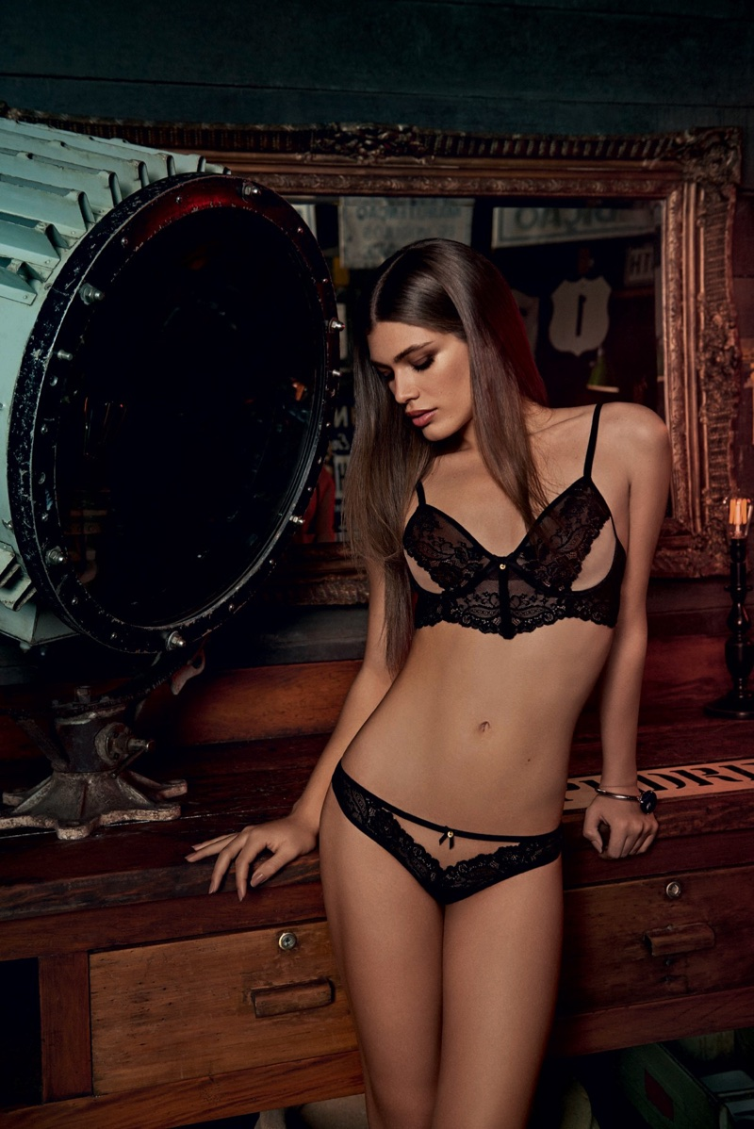
Author’s Note: This story was inspired by a suggestion from a guy called Dave, but I cannot remember when or how he posted the idea. I copied it and it reads: “A variation on the distracted boyfriend image? The girlfriend works out its not actually the girls who are distracting him; rather their clothes, and arranges for him to have a chance to wear them? Maybe, eventually the girlfriend and her feminised boyfriend do end up together, but it’s not an easy road. She has to ask herself if she can stay with a guy who spends more time in dresses and skirts (the fashion this starts with obviously grows legs) than guy stuff. But he’s just jealous that girls get to wear various different stuff whereas guy clothes are all rather samey.” So, wherever you are Dave (I could resist putting you in that outfit), thanks for that.
The image is of transgender model Valentina Sampaio.
.

