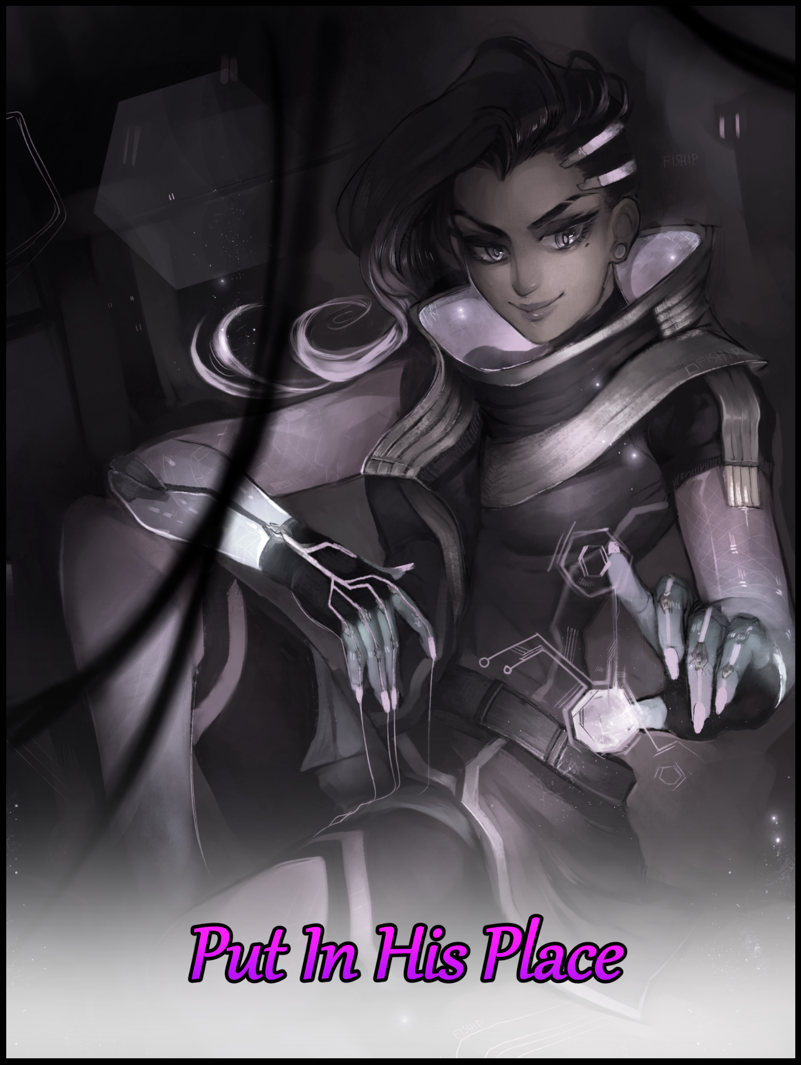

December, the final month of the year, a season of giving and festive merry making for many across the world where the thought of fitting gifts to get for family and friends alike floated by in one's mind alongside suitable decor for the home in preparation of Christmas and the inevitable year end bash to usher in a new cycle.

But to some, those major milestones mattered little. They might not see reason to celebrate Christmas or maybe the reminder of yet another year coming to a close had roused bitter feelings in their hearts, whatever the case, they just couldn't see why others might look forward to such occasions. Carrying on with their lives with their feelings on the matter remaining neutral, distant and silent without making a fuss. Minding their own business while the world around them kept on going, round and round.

One of these individuals was a young man going by the simple name of Leonard Ross. A paper pusher at some random business firm downtown in the city where he lived in a modest apartment home, the man had no goals in life, taking things in stride as they appeared on the path. As long as he had a roof over his head with a functioning power supply, Leonard was content with the way things were.

Living alone with the prime of his life long past, Leonard saw no hope of ever landing himself a partner around five or so years ago, abandoning the dream most men had of one day being able to confidently call someone his significant other. With his age beginning to show through creases in his brow, bags under the eye and a growing pot belly thanks to a relatively lax lifestyle, the office man had learned to hang up the hat early, tempering his expectations and restricting himself to admiring members of the opposite sex through digital imagery, never to talk to a woman face to face unless they were his colleagues or distant family members. A rare occasion seeing as how his anti-social inclinations extended into the office space and at home, doing his best to get away from the latter early on in his life after finishing studies in university. Although it wasn't as if his status as a single loner bothered him enough to keep him up at night…

Life was a simple affair for Leonard. With weekends, it simply meant waking early, slogging through work before heading home at six in the evening, washing up, eating a light dinner before retiring to bed early. Rinse and repeat until the weekends, where he could fully indulge himself in the one thing he truly loved; video games.

Nurturing a healthy addiction for gaming at a young age, Leonard was no stranger to any particular genre, ranging from the usual FPS to the rare RTS. And in a modern age where anyone with a laptop or desktop connected to the internet had immediate access to a wide range of free to play games, Leonard could never grow tired of finding something else to sink spare time into compared to most people who struggle to clear their backlog of video games…

Despite Christmas inching closer and closer, Leonard saw no particular reason to be excited. But that was to be expected since he was the sort to see any holiday as just a legitimate excuse to stay home for a day and game away. Sadly for him however, this year's twenty fifth of December fell on a Sunday, further stifling any bit of excitement he might've had for the coming holiday.

While he might not be the most vocal of individuals, Leonard had recently begun to cultivate a nasty habit with his recent foray into the world of competitive online shooters where toxic behavior and an ultra sweaty mindset was commonplace. A rabbit hole Leonard had fallen into after a few weeks spent playing such games, gradually responding to nasty comments in the chat, irritating kids mouthing off on voice channels and even resorting to trolling if they happened to wrong him or the team. Usually ending off much worse than if he’d made the choice to leave it be, turning into an insufferable hodgepodge of vitriol and spite once the infighting began to spread in the session.

That left Leonard feeling irate and jittery most of the time, a negative that would begin to leak over into other aspects of his life in the form of a growing anger management case. Foul tempered and quick to anger with some of his colleagues even noting how he'd frown or scowl in annoyance everytime someone would ask him something along the lines of a favor, dismissing it under the assumption that something must've been bothering him at home, none the wiser to the self-inflicted nature of his fickle temper…although it wouldn't be long till they had enough and a confrontation broke out, just like in the digital world. A situation that didn't seem likely to improve any time soon as Leonard continued to engage in squabble after squabble…something he himself was more than aware of.

And on a chilly Friday evening where he was free to spend all night wide awake, the seasoned gaming vet was nose deep into trying out something new he had hoped would quell his growing problems after assuming it to be some light hearted Pixar-esque take on the first person shooter genre based on appearance alone, only to end up in an even thicker quagmire after coming to realize he'd gotten himself into one of the more competitive video games out there, complete with an E-Sports scene of its own.

Very soon, Leonard had found himself struggling to hold back from hurling insults as childish insecurity takes over, costing him victory after victory while cycling through the varied roster of characters with each session, unable to find one whose playstyle resonated with him and taking that frustration out on whoever he was playing at the time whenever his foul mouth wasn't busy cursing lousy teammates and losses, unable to concentrate at all on his constant flubbing, thus leaving them unresolved.

But as the saying goes; the walls have ears. A phrase Leonard wasn't privy to and one he would soon learn to heart in an unexpected way as he continues on his verbal tirade against the game. Oblivious to strange forces lying just beyond the veil of human comprehension encircling him, drawn to the incredible amount of negativity radiating from the grown man sitting in front of his computer with a slump to his posture and a scowl on his face, all while specks of snow falls silently outside the window.

And as he silently grumbles to himself while waiting for the game to load away from the stat screen of yet another lost game, the inhuman beings set their schemes to motion, leaning over the man's shoulder with a wispy, nondescript arm extended, touching the desktop by his feet with a finger before retreating from the home one by one now that their job was done. Whatever happened from here on out, they would not pay any attention to, leaving everything to the small yet incredibly powerful intelligence they had imparted upon Leonard's computer, putting a sudden strain on the inefficient hardware that had come to house it…

"Goddamn purple bitch can't live past a few shots…stupid hacking gimmick needs a…what the?"

Deepening his frown as he leans toward the monitor, Leonard squints at the glitched out wording that made up a sudden popup that had appeared midway through loading. Clicking the mouse had no effect, neither did pressing any combination of keys ranging from the escape button all the way to force closing the game, leaving the grump staring down a static screen with weird artifacting and visual glitches gradually turning the stat display into an indecipherable mess of blurry pixels.

But before he could investigate further, the same distortion on the flat screen monitor begins to 'spill over', bleeding forth from the digital display in an eerie effect that gradually worsens his eyesight once the digital noise begins to overcome his vision, accompanied by a debilitating migraine that booms into existence in the span of a second, leaving Leonard immobilized by a combination of tremendous pain and light headed dizziness, leaning back into the chair with a groan and a wheezing curse. Grabbing at his head with clenched eyelids struggling to remove the nauseating blossom of gaudy colors and scratchy effects that refused to vanish as binary code and zipping lines of neon permeated his eyes, layering themselves over his brain like an inescapable delusion threatening to overwhelm him.

The pain was immense, so much so that he feared his head might just split open if he removed his arms from the sides of his sweat soaked cranium. At first, Leonard had suspected dehydration, but he knew that couldn't be the case once he saw a gloved hand emerge from beyond the white hot glass of the monitor like a scene straight out of a horror movie, except the gloved hand seemed familiar to Leonard; skintight, sporting a mixed color pallet of navy blue fingers trailing a smoky pink aura as they flexed in preparation for a grab, revealing midnight black palm wraps before receding into burning pink that engulfs a slender forearm, traced by angular, pulsing lines of energy that could be summarized as generic patterns one might think of if told to envision science fiction imagery. From the physique alone, he could tell the arm belonged to a lady, but there was something…animated about the limb that made it feel like it shouldn't logically be there in front of him, like a vivid hallucination of sorts…maybe that was it?

No matter, the man had been weakened by the sudden barrage against his senses, Leonard could do little but try to waddle out of the seat, struggling to kick away with his feet as the disembodied limb drew closer and closer, flexing with fingers spread, facing the stunned man with an open palm that produces a brilliant flare that seems to draw him in like a vacuum, tugging at his very being until color had faded entirely after passing the white threshold in the middle of the unseen woman's palm, letting out a whimpering yell as his knees grind against solid ground, barely able to reach his arms out in time to break a sudden fall in the middle of an empty void filled with a strong, ambient hum coming from somewhere deeper inside…wherever this place was.

Letting out a hoarse cough after a few seconds of allowing strength to return to his aching body after the tremendous level of pain he had suffered in his head, Leonard's eyes, now cleansed of the strange glitchy veil after passing through the light, slowly adjusts to the darkness, squinting at the sight before his eyes while his ears pricked at the familiar sound of electronics pulsing beneath the surface.

"What the…metal…grating? Where…how is this even possible?"

Taking his eyes off of the industrial plate flooring with gaps peering through to oblivion, the flabbergasted man glimpses miscellaneous piping running along intricately detailed walls of black iron, rusted nails and even smaller wires criss-crossed over each other like knotted veins. And just beside him laid an oblong wall of matte purple and moody gray, glimpsing faint lights of pink and blue in the darkness above, illuminating overhanging wires drooping down from some unseen machine above.

"How's it feel? To be inside a machine? Must've been one bumpy ride I imagine…"
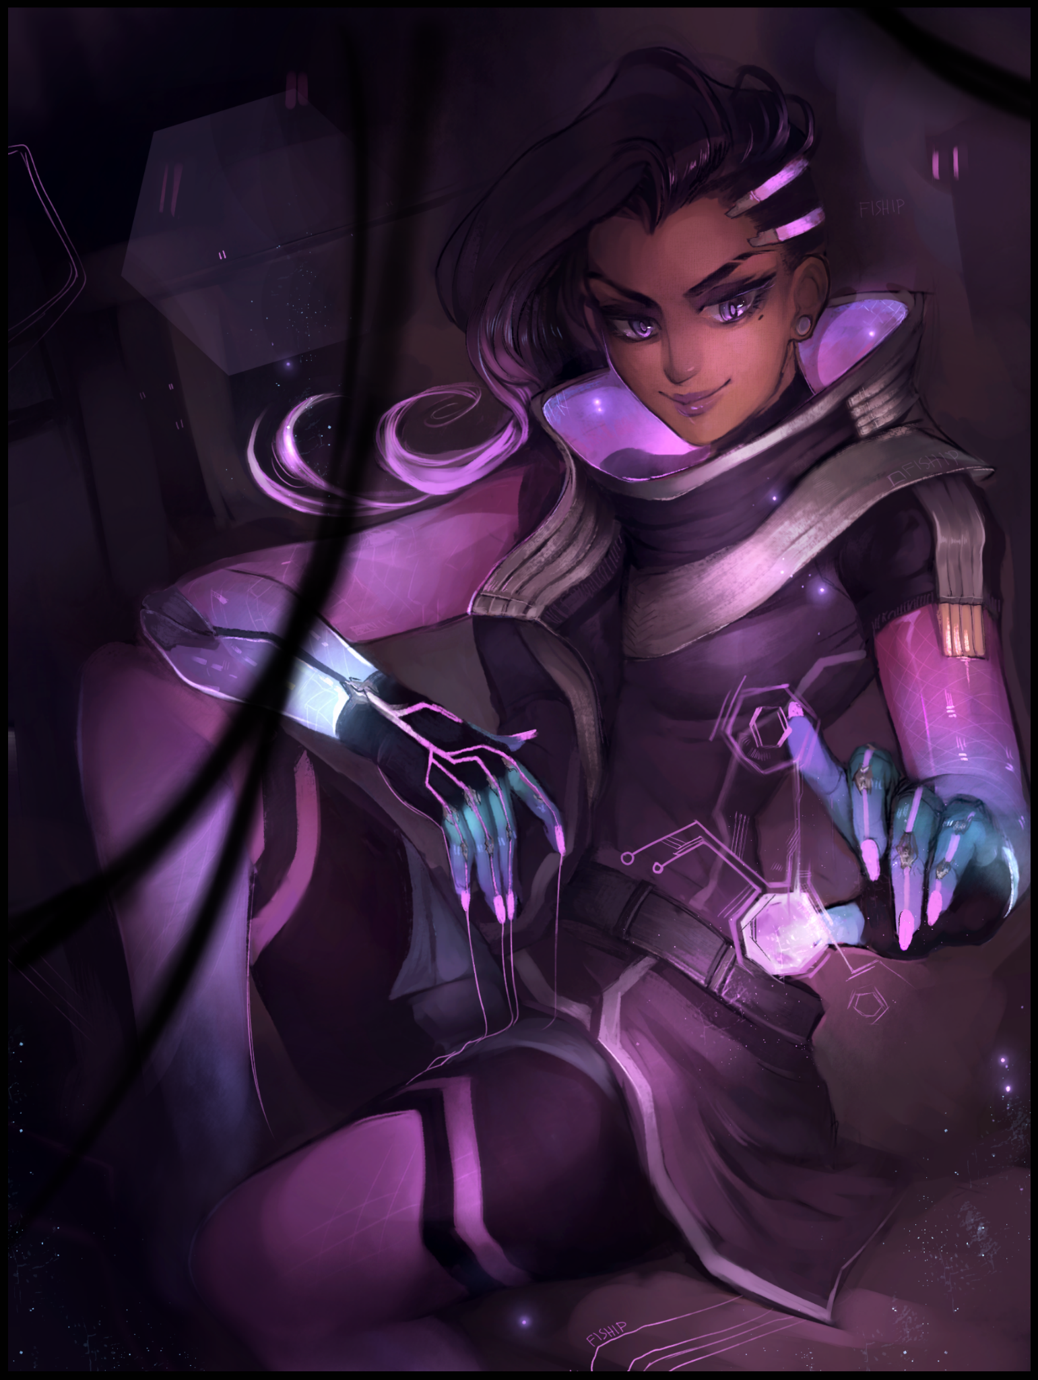
Stunned by the sudden, reverberant voice of a sultry woman with a thick accent that betrays her Mexican heritage ringing out from somewhere in the darkness, Leonard spins around, scrambling backward until his singlet clad spine brushes up against the wall from earlier, sinking into it as his frantic attempts to move back causes the oddly malleable surface to conform to his frantic shoving, freaking him out once his brain registers the fact that metal walls weren't supposed to be soft and warm with an eerie similarity to living flesh.

"Oh my, daring are we? My eyes are up here mijo!"

Craning his neck upward, eyes wide in astonishment, Leonard gawks at the sight of a certified giantess leaning against the wall, towering over him with a holographic display dancing around her index finger, illuminating the surroundings with a gentle glow tinged with strawberry pink in line with the neon lights that adorned her attire and accessories, contrasted by an effervescent blue glow ebbing within her wrists and metallic silver highlights on futuristic clothes that draws the eye toward her sharp facial features, leering down at the diminutive man with a smug expression overshadowed by a side swept fringe of swooping hair that tapers off into wicked curls of venomous magenta. Wide, animated eyes unblinking as they stared right into the soul of the midget who had bumped into her stocking clad thighs.

Now that he had a good glimpse of his abductor, Leonard realized why those gloves from before looked so familiar to him. And that voice…even though he wasn't one to care much about looks…and despite how her appearance differed slightly than the 3D model he could vaguely remember controlling just minutes ago…there was no mistaking the image of Sombra sitting there before him…except he didn't remember the disruptive DPS having an ability to turn herself into a titaness

But her appearance wasn't the only thing that concerned Leonard, it had been the words she had spoken, something about how it felt to 'be inside of a machine'...

"S-Sombra?! B-But how…you said…what the hell do you mean 'inside a machine'? Oh…I-I know! It's just a dream…this is all a dream!"

"Ain't no dream I'm afraid…I'm as real as you are…and I know you've been a very naughty boy Leonard, awful lot of swearing and anger on this chat log…that's your name isn't it?"

"How do you know that? L-Let me out of here!"

The giantess would not acquiesce to Leonard's demands, snickering under her breath as she plucks the midget off the floor with a swift hand, pinching his collar between her index and middle fingers before bringing him up until he was face to face with her, struggling and yelling all the way.

"Hah! Like a mouse in a trap…are you seriously telling me you haven't figured things out yet?"

Despite the panic, Leonard already had an inkling of an idea as to what Sombra meant after all the not so subtle hints she'd been dropping with each word out of her cocky mouth, spurring his confrontational side to action as he shoots a rebuttal back at the oversized video game character holding him up in the air with comical disdain. In his eyes, there was just no way any of this could be real. Being dragged into his own computer before coming face to face with a giant replica of the character he had been playing as in a dark metal hallway.

And if it was a dream, then logically no harm could befall him even if it all felt real. Stuff like the bite of his sleeves as the fabric dug into his armpits, the admittedly aromatic scent wafting off of the animated Mexican woman holding him up in the air and the industrial chill of the interior of a desktop he was supposed to believe they were inside of. That was how lucid dreaming worked after all; being aware of the dream and that nothing that befell him here would carry over to reality.

"I know you're a terrible character to play as…can't even stay alive for more than a second after some cross hairs end up hanging over you…and that gimmick? Hacking people? Running away like a coward? No wonder you're such a stuck up bitch!"

With the last word out of his mouth, a sense of pride and accomplishment floods into Leonard's chest as he watches the lean smile on Sombra's face fade until a noticeable curl had taken its place, forming a grimace of annoyance. And if he looked closer, he could almost see a bulging vein on her forehead about ready to pop.

'Calling me a 'little boy' when she can't even take an insult without losing her cool…'

He had expected her to do something along the lines of throwing him against the wall, or crushing him in the palm of her hands, anything to end the dream right then and there. But she would do nothing, simply smiling once more before cocking her head to the side in amusement, scoffing while her free hand begins to move, stroking and tapping away at a bevy of holographic displays and interfaces that immediately cause a notable change in the surroundings as pixelated cuboids appear from our of thin air, devouring the dark, moody environment and replacing it with a more homely, spacious zone with heavy sci fi influence and flair in the form of angular furniture, neon lights that were built into the walls, even more holographic displays showcasing indecipherable readouts and more worryingly; banners that displayed a familiar icon. Catching Leonard's attention for long enough to the point he hadn't realized the pull of gravity had left him standing once more on his own two feet. His captor, nowhere to be seen save for the ghostly echo of her voice bouncing around the walls of the spherical chamber.

'Surprised? I thought it'd be a good place for what I've got in mind for you mijo…what? You thought I'd make you a little red smear and be done with it? I told you Leonard…this is real…'

"Doesn't matter what you say or do cuz I know it's a dream! There's no such thing as 'being inside a computer'! You only say those things cuz you're tryin' to get at me! You're just noise in my…my voice?! I-Is that-"

'Nice accent there…not even I knew you could pull off an Englishman act Leonard~'

Gripping at his throat, the stunned man struggles to speak 'normally', rifling through a bevy of words, forming sentences midway through before ending them off with curses or a click of the tongue, unable to rid his voice of the obnoxiously thick British accent that had crept its way into his speech patterns midway through his taunt. Another trick, it had to be it!

"Nice try…but I know your ploy mate, you're just tryin' to spook me! Get me to give in!"

'Wherever did you get that notion? I'm simply giving you what you deserve, cuz unlike you, I know my place…something my other self wouldn't say but, here we are…I'm right at home, and I'm gonna fix you right up, starting with that rotten mouth of yours!'

An electronic beep rings out in the air as an invisible Sombra fiddles with her gear before Leonard crumples to the floor in a sudden spasm, gripping at his throat with trembling hands as it begins to pulse and ripple with visible activity, fearfully pawing at gurgling skin as unseen changes begin to wrack the insides, causing the subtle bump along the length of it to shrink, fading away as Leonard's voice box changes, producing a higher pitched voice that leaks through in distorted tones, gradually shifting into the out of place soprano of a young Englishwoman, peppy and energetic…if it wasn't sullied by distress and hoarse coughs as the man gradually recovers from the strenuous ordeal of having his voice box modified and his Adam's Apple vanished over the span of a few seconds.

"Y-You bitch! My voice! I sound like a…l-like a girl!"

'Mhm…sure you do…but it doesn't look right…doesn't it? You're what? A forty something year old man? And yet you've got the voice of a happy go lucky chica…a bitch…really sucks when karma comes to bite you in the ass huh?'

Vehemently clinging to the idea that this was all taking place in a dreamscape hostile to him, Leonard stands his metaphorically ground, rising quickly to his feet with determination and grit clear on his face.

"This is all just a dream...so do your worst…and karma? You're a criminal aren't you? What would you know about karma?"

'Many things…and besides, I'm not really that bad of a person…and compared to what I usually do? You have it quite good…that voice of yours? Just a taste of the makeover I've got in mind for you…'

Leaving a still defiant Leonard with a warning as Sombra's voice fades away once again, an itchy sensation begins to make itself known across the surface of his skin starting with his palms, spreading out like a pulse that vanishes just as fast as it appeared, turning his head downward just in time to spot a series of glyphs and digital halos flaring to life in front of his hands before beginning to move forward, syncing themselves to his movement so they would never deviate from their intended target.

And as the first series of cycling symbols and holographic circles crosses over Leonard's body proper, a startling sight would leave him shocked for a moment as the pale blue light cast over his fingers begins to alter the flesh; removing dirt from beneath ill-maintained nails as they reshape to fit waifish fingers, soothing creases in the joints, destroying callused lumps of dead skin while dry spots moisturize, leaving dainty digits wrapped in smooth, slightly tanned skin tipped with polished shells that contrasted greatly with the pale freckled hide that remained beyond the metamorphic halo's touch as Leonard's wrists snap and pop into a more streamlined physique as the changes start to creep down his forearms, vaporizing hair follicles along the way.

'Perfect nails for some mighty fine hands hm? Ahh what one can do with a piece of code…I can't wait to feel those palms…'

"C-Cut the crap! Whatever you're plannin', it's not going to work-"

'-cuz it's a dream? You've been saying that for a while now…suit yourself, it's definitely no skin off my back…'

As if signaled by the annoyed tone in the hacker's voice, another series of glowing symbols burns to life on the floor, forming a sphere that, like the cuffs, follows perfectly along with Leonard's jittery movement as another bodily tingle radiates from the soles of his feet all the way up to his skull, sapping him of all strength as he falls onto all fours, barely able to support himself with a freshly modified set of slender arms that had been stripped of the bulk offered to them by weathered fat and withered muscle that hadn't seen exercise in years, except the feminine manipulators now held more strength in them as evidenced by the bulge of toned flesh and swelling muscle against porcelain smooth hide concealed by the new, leather cuffs of a thick shoulder being formed out of thin air, connecting to the pale, cotton of his original singlet to form the beginnings of what was apparently an air force pilot's jacket, keeping the more sensitive series of alterations hidden while the enlarged circle on the ground works on Leonard's feet, causing a prickly numbness that hinders his ability to right himself, only managing to land on his rump instead, watching through furrowed eyes as his bead-like stumps are consumed much like hands were, replaced first by dainty feet sporting equally mesmerising pink nails, followed up by toned calves that no longer jiggled with obese layers and eventually, plump thighs shaved clean and wrapped in the same sensitive skin he could feel creeping over his torso alongside a suffocating ball of air trapped inside of his lungs, feeling adrenaline spike once his boxers begin to disintegrate, revealing the undeniable sight of a curvaceous woman's legs in their full glory while forcing haggard coughs and strangled wheezing ouut of lips that were starting to glisten with a rejuvenated sheen as cracked skin heals while youthful perkiness returns with an added topping of feminine allure in the form of thick lower lips jutting outward in an inviting propoting, made more tempting once the hairy mustache and stubble that was beginning to form around a rounded visage vanishes from sight.

But it wasn't just an added layer of femininity that left Leonard shaken, it was the animated, stylized look his altered body parts now sported as the two halos that had transformed his upper half spin once more before vanishing now that the job was done, leaving their mark in the form of lengthy yet slender arms and a baggy leather jacket hugging a slender, effeminate torso, all of it rendered in the same matte smooth, Pixar-style shading and cartoony outlines he'd seen in the spitting replica of Sombra from before her sudden disappearance. Leaving Leonard's mind in a scramble as he watches even more of his body gradually fade, losing age and weariness in exchange for an animated facade that left a lump of dread in his heart once an unintended, sultry sigh escapes his inflated cushions as air quickly expels itself from his lungs in tandem with a surge of flesh that pushes flabby pectorals outward, triggering dormant nerves and glands while inert nipples flare into angry pink nubs atop a set of perfectly sculpted breasts filled out with jiggly mass and a healthy sag to their heft, leaving Leonard immobilized once a sudden shock of euphoric bliss zips through his newly grown milkers, stimulating pleasure centers from the many erogenous zones his feminizing form now sported, especially down between the expanse of widened hips where a still defiant pecker remains, standing tall and proud in the open now that his pants had been completely removed with no alternative unlike the more concealing top that kept the breasts of an incomplete woman concealed.

'Feels good doesn't it? Still think you're living a dream Leonard?'

"S-Screw…you! You can…make me sound like a girl…l-look like one even…but I'm still…me!"

'That's what I'm counting on…but really, we'll have to do something about that foul mouth of yours…it's gotten you into so much trouble recently hasn't it? Ever thought of using gentle words?'

"I'll…s-show you 'gentle' once I get my hands on you…"

'Mmm~ I'd take you up on that offer…but not quite yet…just a little more to go, and you’ll be the perfect compañera~'

Whimpering in a womanly tone that left Leonard frustrated amidst the ongoing buildup of hazy pleasure, the exhausted man struggles to escape the confines of the circle keeping track of his every move, following along beneath his shadow as he struggles to crawl along the floor, hoping to get on top of the central terminal built in the heart of the chamber in the mistaken idea that the transformative glyphs would not follow, all while a lean ass stuck out in the air, bubbling with activity before bloating into a sizeable heart shaped derriere that wiggles and sways like an attractive pendulum, rubbing pliable butt cheeks together with each back and forth movement as trembling legs carried Leonard forward, gritting polished teeth in dire focus against the annoying tickle of silken strands pouring down an unrecognizable face far removed from the Caucasian male he was supposed to be, feeling a broad nose shrink and compact itself into a cute button while an overgrown brow flickers into a slim line of brown, overshadowed by a fluffy fringe composed of brunette tufts swept into a swooping sideswipe, reminiscent of Sombra's but lacking the mystique and intrigue of her overall ominous appearance. The thought of which suddenly causes a growth spurt of sorts that finally consumes the man's narrow eyes, squeezing shut in defiance as the creeping wave washes over them, before opening as wide, almond shaped eyes inlaid with dull brown irises…complete with the animated flair that had consumed his entire being….save for one particular spot on the voluptuous vessel Leonard now possessed as he continues forward, unable to do anything but.

Still resisting but evidently losing the fight as a sporadic shrinking of the gonads continues unabated while internal changes set the stage for the new organs soon to flourish beneath a tight, toned tummy…the seeds of which instantly throb and flair the moment the unmistakable sensation of a warm hand wraps around Leonard’s dwindling manhood, causing the shemale to yelp in embarrassingly ‘cute’ fashion…

“Hya! W-What are you…s-stop!”

'Consider this a favor; the last release you’ll ever get to feel with your little camarada…Uno…’

Counting in her native tongue, Sombra's unseen hand strokes slowly along the slick length of Leonard's devastated penis, removed of its skinvelope and free to bask in the glorious feel of the hackers gloved hand running across its knobbed surface in a painfully slow cycle that halts Leonard's progress as his back arches inward to the orgasmic ministrations, sticking out his ass in an invitation that gets answered by a harsh slap that forces a guttural moan out of his mouth, the seductive tone stunning the still very much manly mind within the girly exterior who couldn't believe such a sound had left his mouth…although the masculine form of address could no longer apply to a woman like the one currently on her hands and knees, shivering in the throes of the pleasure wrought upon her exquisite body by the hands of her invisible partner, showcasing the pathetic nub that had at one time been a proud mast.

'Dos…'

"Hnngh!!?"

Another stroke more skin to a simple brush of the finger, and Leonard's resistance was completely shattered, accompanied by an added heft to her ass while the remnants of her testicles finalize themselves into the gorgeous lips of a woman's flower; a vibrant slit of moist pink flesh and fluttery folds that immediately lubricate themselves with a trickle of milky fluid oozing out of a newly opened urethra settled neatly below the sealed, shrunken weiner above.

Never before had she ever experienced pleasure on a scale such as this, enough for it to threaten her remarkably intact belief that this was all just a bad dream, that she would wake up, back to normal in her bedroom, unaware of how empty said room was alongside the sputtering ruins of an exploded desktop that just couldn't handle the load of two digitized souls…

Her womb felt hot, spasming loins and vaginal walls were on fire, heavy breasts ached for the hand around her soon-to-be clit to squeeze and fondle it just as much and her mind was ablaze with an inferno of lust. No longer trying to move forward once her eager body takes over as animalistic instinct grasps hold of her mind like a new pilot shoving aside the weakened one, left utterly helpless to the alien pleasures of a woman's body as Sombra's count reaches its end, no longer stroking a nonexistent penis but instead, maneuvering her index and middle fingers until they held the tiny little nub of hypersensitive nerves in between their warm grip…before squeezing down hard, making extra sure to give it a good rub as the knobbled surface of her gloves prove overkill, causing the newly born English woman to toss her head back, rolling her eyes back up into her skull while a wanton tongue lolls in the air, thrusting her ass even further back while her bosom jiggles to the momentum of her spasming body, gripped by the throes of her first ever orgasm.

“Ahahn!”

'Tres…there we go…let it all out~’

In an instant, the floodgates were broken, causing Leonard's now useless semen to flow out of her cunt in a milky forth, mixed with the slick, transparent fluid that would serve as lubricant for her tight folds produced by a new set of reproductive organs that wastes no time in filling her up with feel good chemicals and female hormones, linking up with her brain in a connection that allows her to finally get a good 'feel' of her altered physique; the sag of her breasts as they pulled on her shoulders beneath an encompassing jacket and sci fi harness. The tickle of silky smooth hair against smaller ears and softer cheeks. The clenching of new muscles all along her lithe, curvy body. And lastly; the disgraceful feeling of cum oozing out of her vagina as it works to empty itself of her former essence as a man, staining the floor between trembling legs with a pool of fluids gleaned from man and woman…leaving another animated woman in place of the human male as Sombra rematerializes out of thin air, rising to her feet with a cloth to wipe up the hand that had ministered her victim's final handjob, wearing a vindictive smirk on her face as serpentine eyes scan the half naked body of the woman panting like a dog on all fours, struggling to get ahold of herself while the rest of her attire save for a fitting pair of pants takes shape beside her in a neat pile, as if she had willingly stripped down before presenting her bare ass to the domineering hacker, greedily eyeing up a dripping pussy she couldn't wait to mess up. Even more so when her eyes meet with Leonard's, enjoying the sight of her trying to form a frown from that vapid smile of hers…

"Rise and shine cariño~ We’re not done yet…far from it.”

“W-Wh-mnf! Why…?”

“You really have to ask? I'm just doing what I can to keep myself occupied thanks to whatever you pissed off back there! So making naughty men like you much more agreeable sounds like a nice start…being a piece of code on the net's gonna be mighty boring after all…so a tight chica like you ought to make things a lot more interesting. Now…sit."

Leonard wanted to curse the smug hacker, to spite her with another volley of vulgarities and petty insults. But her mouth wouldn't obey her commands, neither did her body as it begins to move on autopilot, moving with a pronounced air of seduction to it as a soft , unwilling giggle leaks out of her mouth, unable to stand against the feeling of her own thighs, wet with drool, rubbing together as her cushioned ass makes contact with the cold, hard floor. Sitting comfortably as ordered before Sombra, watching the brunette gal look up at her with an adoring smile before control returns to Leonard, frowning in anger and shock as she struggles to lurch forward and tackle her oppressor, oblivious to the power she now held within her unsuspecting body, one the former man remained clueless to, relying solely on waning strength woefully inadequate to compete against the likes of a healthy opponent.

"Keep that gorgeous ass on the floor…you could've gotten me…but you still have no idea who you are right now huh?"

"Agh! W-What're you even sayin'? I'm me! Leonard Ross!"

“Hah…I don’t think so dear…take a look…and tell me what you see…no, who you really are…”

Blocking out the view of Sombra as a large display instantly blips into existence before her very eyes, Leonard comes face to face with a perfect reflection of herself, giving her a good look at the drastic changes that had left her unrecognizable, feeling another ball of dread anchoring her to the ground as she runs an animated hand over her cheeks, disturbed by the way it all felt. The smoothness of a woman's porcelain skin, hot air escaping perfectly kissable lips, the heft of a woman's assets pulling on muscles on her shoulders and back…and then there was the void between her legs where her brain still remembered the familiar feeling of manhood hanging down where a pudgy slit now laid, dribbling with female nectar and emptied of seed…

But a part of her brain was starting to tingle upon the sight of her changed yet familiar form as synapses spark and tingle, realigning to form natural blockers and directives she had inadvertently fallen into upon catching sight of her reflection while her ears had been graced by Sombra's undeniable orders, unable to help herself into answering as the words slip free of her trembling lips.

"I-I…I'm Leonard Ross Lena Oxton…Tracer…I'm a man woman! N-No! Stop making me say things you bitch!"

"Clever girl…as for the how, I simply made a few changes to your code; made you look better…nicer even…but I wonder…why so mad if you still think this is all a dream?”

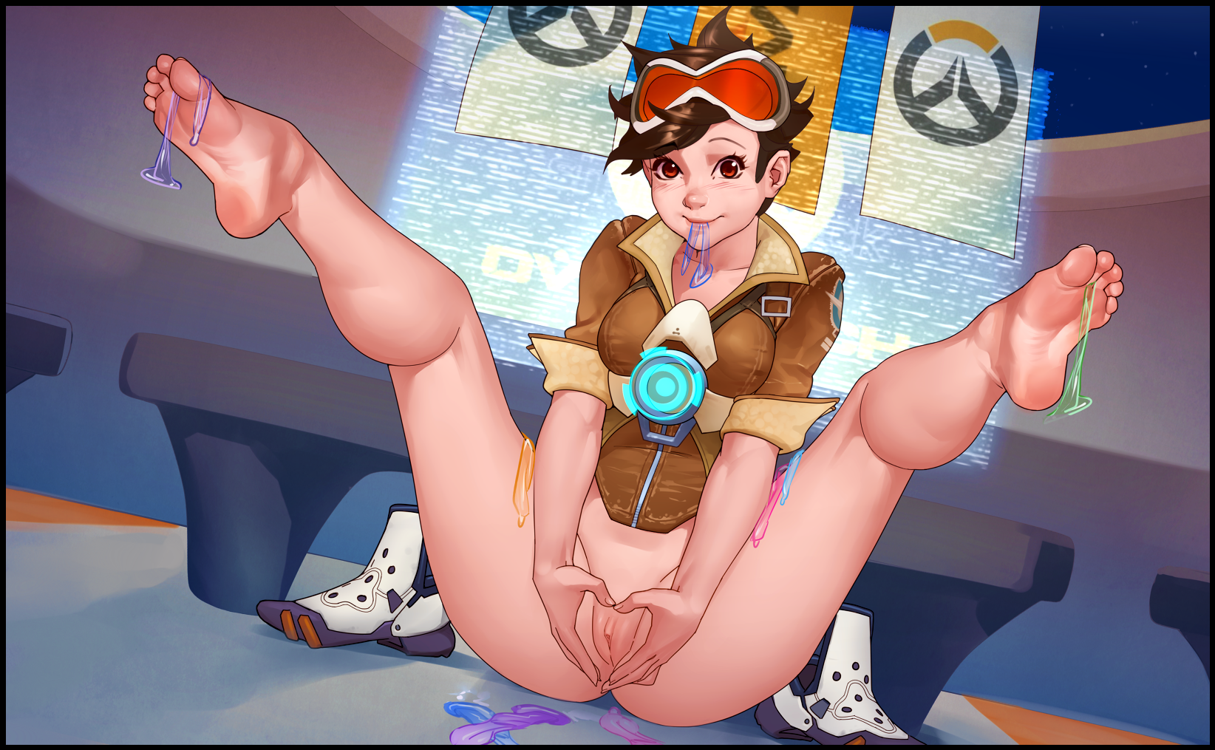
She couldn't find the words to respond, feeling utterly helpless against the confident woman as she steadily begins to close the distance between them, stepping through the reflective display with a dismissive wave of her hand, vanishing the unnecessary holograms while a burst of static appears between her legs, producing an equally large member that hangs down low between an altered opening in her leggings, instantly catching Lena's eyes as another switch in her brain clicks, accompanied by a subtle throb in her groin and a rumble in her stomach that leaves her ashamed and horrified at the wanton ideas slowly beginning to leak into her head at the sight of a her former manhood standing proud over Sombra's front. Ignorant to the highly implicating rubber that had appeared in the same moment, scattered all over the floor around her bare bum with some lying in the puddle of her own making…

“From now on, you'll be my dutifully loyal pet. Doesn’t that sound good? You’ll get to live all nice and comfy…living a simple, mundane life as a…let’s say pleasure doll, beats being a corporate slave while popping a blood vessel in those stupid games of yours doesn't it? C’mon mija~ Be honest, you wanna show me how excited, how happy you are, don’t you?"

No longer able to find the strength to muster up a competent resistance, Lena happily spreads her legs before Sombra, giving in to the mental conditioning coaxing her to raise them up high while cupping her hands together in center, brushing by her bosom to form the shape of a heart with her untouched flower pressed into the middle, kicking up some of the he unused condoms lying on the floor while holding one or two in the grip of her dexterous toes, doing so with a happy smile on her face and a rubber in her mouth…

"Good girl…never thought I'd get the chance to indulge but…Tracer sounds like a good start…I'll be sure to treat you real good~"

Leonard, locked away inside her body, had no choice but to obey her mistress' commands, tingling with euphoria and excitement wrought on her by the bits of her brain that had been made subservient to Sombra through the alterations made to her 'code', still reliant on her own belief that this was all just a dream despite everything that had happened, managing to curse with anger for one last time out of the corner of her mouth as she feels the tip of her repurposed cock push apart her vaginal folds…struggling to project anger on her face as it creases into a vapid expression of perverted happiness instead…

"F-Fuck…yo-ohhh~"

"Hngh! And I love you too…Dios mío, you’re tight!”

For the rest of the night, a digitized Leonard altered and locked into the body of Tracer would experience sex on the other side of the fence for the first time in her life at the hands of another woman, ploughing her silly with her stolen member all while her sensitive form would be ravished without end by the voracious reproduction of Sombra who knew she wasn't the real thing, free to do as she pleased after being brought into existence within the real world by unknowable entities, acting on their behalf without realizing as she has her way with her prize; a formerly moody office worker without a social life, regressed in age, beautified and touched up into a twenty six year old babe with a sonorous voice Sombra would have the pleasure of indulging in for the rest of time.

Days would pass since the incident, and the less than honest landlord, after failing to hear back after attempting to contact the missing tenant of the apartment on the fourth floor, would sell whatever he could, including the burnt out desktop. All while the world kept on moving forward, including the people over at Leonard's former workplace, most of whom didn't even bat an eye toward his extended absence, thinking nothing of the grouchy, isolated man most couldn't even remember in the first place. Dismissing the thought of him after a new hire had arrived to take his place. Deciding not to bog themselves down with worry, especially not when the long awaited day of Christmas had finally come round.


As for the vanished man in question, none would ever think about the possibility of Leonard being whisked away into cyberspace at the hands of a tech savvy, future tech wielding hacker from a video game brought to life and enjoying it well in her domain tucked away within the depths of the Internet where anything was possible, kept company by her ever loyal pet she had yet to rescind her promise to, enjoying the feel of her creamy breasts as the two nubile women get nice and warm together on a couch in the middle of a cozy living room decked out in Christmas decor.

But if one put the idea that it was all a synthetic recreation at the back of their mind. The warmth of the fireplace, the posh leather of the exquisite couch, the arid breaths of the other tickling their faces, the tantalizing scent of two women hanging in the air like a pheromone call for mating…would be more than enough to make it all seem like an actual locale, fit to celebrate the coming end of the year with a warm body or two…

Over the last few weeks, Leonard's hopes of everything being a dream had crumbled somewhat after her first time being taken by Sombra. Extinguishing the part of her that found the thought of being a woman to be repulsive, steadily growing to love it as her 'mistress' opened her eyes to what one person, especially a girl like herself, could feel, taking her places she'd never thought possible, dulling her hostility to the point where the hacker no longer had a use for forceful commands, not when Lena had become docile and oh so sweet, taking the initiative on her own to return the favor whenever Sombra wasn't busy overpowering her. In a way, she was starting to fall in love with this strange continuation of her life. Sure, she might not look like an actual human, forever stuck in her cartoonist yet realistic body. But she was young again, restored in an admittedly sexy body that didn't have aching limbs and capable of superhuman feats, no longer needing to worry about a lonely life anymore, nor did she ever feel that burst of irritating anger inside whenever things didn't go her way. Tempered and stifled by a woman she both looked up to and bowed her head to willingly. Even if it all turned out to be an excruciatingly drawn out figment of her imagination, it was one she no longer wanted to end, yelping softly as a Christmas hat falls over her head, knocking similarly themed goggles over her eyes, overlaying her sight with a green tint that made the overhanging figure of Sombra in all her nude glory, leaning forward to whisper something in her ears while a familiar warmth pulses and throbs against her stomach…

"Merry Christmas cariño…”

“M-Merry…christmas…”

“Ahh you adorable gato! We’ll need to work on those vocals of yours after this…”

Unsure of what to say or do without the usual compulsions forcing words out of her mouth, Lena simply returns the embrace, uttering a haphazard sentence thought of at the spur of the moment thanks to her still developing social skills after having not spoken so earnestly to another girl in quite a long while…but that wouldn’t be a problem seeing as how she had all the time in the world to learn after all…

THE END

Image Sources

Image 1 by Fiship : https://twitter.com/_Fiship

Image 2 and 3 by Kairunoburogu : https://twitter.com/kairunoburogu

