VOLATILER DYNAMIC
COMMISSION STORY
BY CHALDEACHANGE
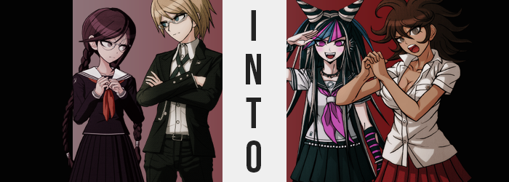

To say that there was a developing issue at Hope’s Peak Academy would have been an understatement. Two of the students that had been trapped inside the killing game, both Makoto Naegi and Kyoko Kirigiri, had both mysteriously gone missing. But were that not strange enough, two new students had popped up in their places. Two young women named Mikan Tsumiki and Hiyori Saionji.

Both young women were almost overwhelmingly eccentric, with the form being a nurse that was always falling over herself into extremely lewd poses, while the other, despite her short stature and claims of being a performer, was extremely rude – especially to Mikan. Neither of them had any answers to give the others about how they had arrived in the school, or where their friends might have gone.

And Monokuma, the bear that had captured them all, seemed to be more than content in withholding the truth despite the fact that he very clearly seemed to know what had happened. “Considering the nature of this school, it goes without saying that he’s the only one who could have made such a switch.” Such was the hypothesis that Byakuya Togami had put forward.

Now he wished he hadn’t. Because after pitching this theory he’d been met with a chorus of ‘Well maybe Togami should investigate where Makoto and Kyouko were last seen for clues about Monokuma’s involvement!’, which in turn? Brought him to a nurse’s office that was very clearly full of some kind of airborne issue. A translucent, white gas of a sort.

Was it dangerous? It was very probable that Monokuma had used it to knock their missing peers unconscious so that he could swap them with the two girls that had appeared in their place – that was the most logical situation he could think of. But it did pose a dilemma. How could he look for clues without ascertaining the risk the gas posed? Well, he did have one tool at his disposal. “You go in.”

He'd been tailed, as he was constantly being so, by Toko Fukawa. She had taken something of an interest in him, but perhaps it was better described as an obsession? He loathed it, but in this particular scenario he stood to benefit from the writer’s undying loyalty. “H-Huh!? But there’s… a gas in there…?” It seemed not even the sheepish maiden was so loyal as to jump into danger without reassurance.

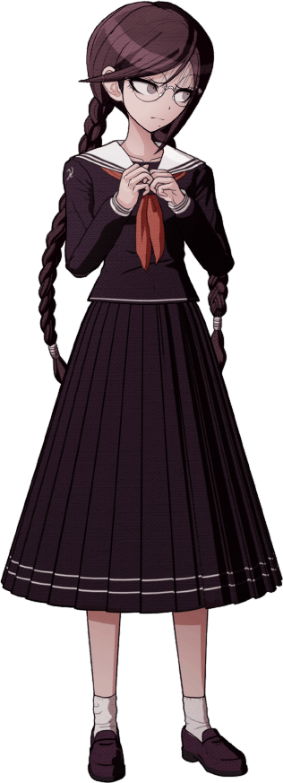
“It’s harmless, I’ve already confirmed as much. I just need you to go in and turn on the exhaust because I’m… allergic.” Togami’s disregard for others was fairly plain here. He took no issue with lying to Toko, who cautiously accepted his words as the truth (even though there was no way to back up his claims) and moved inside.

Following the instructions of the boy who had left such a firm impression on her, Toko pulled open the door enough to slip in and then closed it just as quickly so a minimal amount of gas could slip through. Despite Togami’s reassurance, she had expected to pass out the moment she stepped inside, but? She didn’t have any problems breathing, nor did she feel dizzy. Maybe it really was harmless?

“N-Now where’s the exhaust fan switch…?” Still buying into the man’s lie, she squinted even with glasses through the gas. It was thick enough that she couldn’t see more than a few feet in front of her, though. And since she was focusing so much on that singular task? It became a fool’s errand for her to notice that irregularities had begun to pop up on her own body.

Fukawa was an attentive young woman, but with her low self-esteem that attention was almost never pointed inward. This made it all the easier for changes to go unnoticed, especially in the beginning where they were in less than obvious places. For example? The girl’s nails. With her anxiety she was very prone to biting them, which naturally left them in disarray – yet their lengths not only grew to healthy sizes, but also took on pink and blue paint in rotation. Bright colors that she would never be caught dead wearing.

The overarching theme of her earliest tells might as well have been ‘vibrant colors’, because unexpected places lost their dull luster in favor of much more animated shades. Take her dull, almost gray eyes. Fumbling around in the gas, she briefly thought she had gotten something in those eyes… but this wasn’t the case. Instead, her lashes had grown just a bit longer and poked into them, and simultaneously their colors brightened to a very high-contrast pink.

A pink that, mind you, both matched her nails and made its way into the girl’s hair. Not the bulk of it, mind you, but it did find prominence among her bangs in streaks, but so did the blue that was also found on her nails. With pink on either sides, blue was crammed in the dead center. But these also weren’t the only irregularities to surface as far as the color of her hair was concerned.

“Mm… I can’t see anything in here!” Fukawa wasn’t one to speak unnecessarily, and yet for some reason she’d just felt the need to speak up there. Almost like she was borrowing some of the confidence from her other self. Still, it was indicative enough of her ignorance. Ignorance towards the streaks of white that weaved through her purple locks, as well as that purple darkening and taking a bluer undertone. It all left her head looking rather chaotic, the mix of color far too out of character for the writer under normal circumstances.

Even so, she was feeling more confident with each passing second. At times she felt like she could hear Syo’s voice, and yet it almost felt like it was echoing her own thoughts? Which was strange seeing as the two of them were polar opposites when it came to wants and disposition. It was, in a way, almost like her brain was a blender and someone had turned it on, allowing those two personalities to meld ever so slowly. Without questioning it, Fukawa could even feel a smile begin to pull at the corners of her lips.

Lips that were, by all definition, more defined. Not only did they seem plumper, but just below them on the right side of her face a tiny hole had formed – one that was similar in nature to the many that soon dug themselves into the cartilage of her ears, as well as one within her bellybutton. All unfilled piercings that the pristine Fukawa would never ever get if given a choice. Or would she? She had certainly begun to feel freer.

Evidently, though, the gas was not yet finished with changing her color palette. With eyes and hair dyed, next came her skin – although fortunately it wasn’t as dramatic as the previous two areas. Still, the richer pink of her flesh did wane some, becoming rather pale to the point where it almost became a ghostly white. “Eh!? What was I looking for again!?” No sooner than she blurted this out did she cover her mouth. Had she really just said that? No, it wasn’t quite what she had said as much as it was how she had said it. That much energy was more reminiscent of Syo, and come to think of it… Where had her other half’s presence gone?

Pink eyes were quivering from confusion, but unbeknownst to her, her situation was growing more dire. Well, suffice to say because of the influences being enforced upon her mind she wasn’t exactly in any position to question it past a certain point. The maiden’s height had lapsed, dropping her but a single inch – while by contrast her hair seemed to grow a few inches longer and earn a coarse, straight quality that made her braids begin to fray.

Her uniform had been left just a little loose with her body having shrunk so meagerly, but clothes became an even poorer fit – especially around her chest. For her tits shrunk a few centimeters, leaving her bra even emptier than they had been before. As if to make up for this though, there were areas that grew. Thighs swelled with fresh, firm weight that just as readily bled into her rear end. Panties tightened around swelling cheeks, ultimately creating a slight wedgie while her skirt rested higher on this new rump.
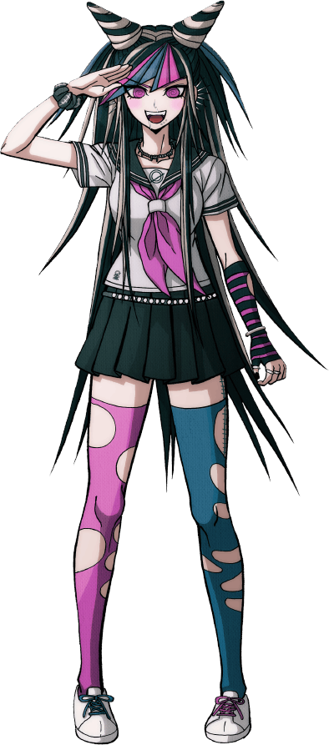
“WOAH!? IT’S FOGGY IN HERE!” Unable to repress the energy she felt any longer, words with a hyperactive ring burst out from lips that she had tried to hold tightly closed. She didn’t look much like herself anymore, and even her face had filled out a little so that paled skin complimented thick lips, big eyes, and an unusually pointy nose – from which her glasses fell, not that she needed them anymore. Aside from her clothes, which she now felt were ‘totally not her style’, there was no way to indicate that she was Toko Fukawa. Not even her memories reflected that.

“Hehehe~!” Ibuki Mioda, despite the fact that her clothes all felt two sizes too small for her, bounded about the nurse’s office without any proposed purpose. She could recall attending Hope’s Peak, and she could recall coming into the nurse’s office on her own after hearing from Mikan that there were some cool outfits inside! …But this one wasn’t really quite her style, though. It didn’t appeal to her rocker’s soul!

Even so, she was as energetic as a firecracker and as curious as could be, so since she was unsupervised in this foggy realm she was sticking her nose into everything. Picking up things she shouldn’t, pressing buttons she shouldn’t. Such as, for example, an exhaust fan switch?

In the meantime, Togami had absolutely no idea what had been happening while standing outside. It had been quiet once Toko left, but the sound of a girl yelling, and giggling had been growing more and more predominant from within – and the voice didn’t sound like that of the girl he’d sent in there. The gas was so thick that he couldn’t see inside, and he didn’t dare run in there himself, but…

HISSSSSSSSSSSSSSSSSS…

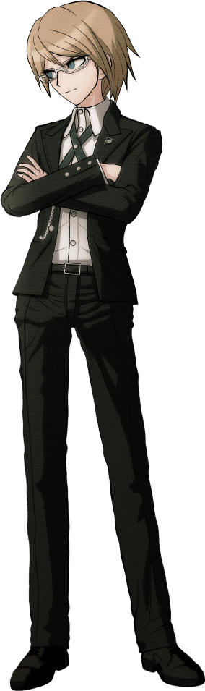
“…Hm?” A loud hissing sound filled the air and drew his attention upwards, where he saw white gas raining down upon him, filling the hallways. “What!? Why on Earth!?” He took a step back, but it was much too late already. “Don’t tell me she found the exhaust and it…” And it pulled the air out into the hallway!? What sort of backwards exhaust system was that!? He’d made an error though. There was no way a nurse’s office would need a complicated ventilation system. It wasn’t a science lab.

Did that mean it would be safer to go into the office? But what if there was still gas being pulled out? He was stuck between a rock and a hard place, practically paralyzed by the very idea that he might have inhaled some of the gas already – which he had.

“Damnit!” Togami directed his anger at Fukawa internally despite the fact that (for all he knew) she had merely done what he had asked of her in the first place. Agitation aside though, there were already signs that he was falling under the gas’ influence. His anger was manifesting in a desire to act out, while typically he would just bury it and make passing comments. He also felt unusually fidgety; a side-effect of his personality trying to suppress what was boiling up from within.

POP!

Through the thin dusting of gas that filled the air of the hall, it wasn’t very difficult for the young man to take notice of it. That is, it wasn’t hard for him to see the upper buttons of his dress shirt pop off while the green ribbon he draped around his neck was lifted higher and higher… by the design of his own chest. “Are these…!?” Their weight growing exponentially, the heir had little choice but to try and pull his balance backwards to accommodate what were clearly a pair of women’s breasts.

“What the heeeeell!?” There had definitely been a crack in Togami’s voice there for a moment, but it was hardly as big of a concern from his perspective as the growths that were still pushing out the sides of dress shirt as they swelled, revealing to him the depths of a cleavage unlike anything he had ever seen this close before. Were they comparable to Asahina’s? No, they were probably bigger, weren’t they!? “Why do I have these!?”

At the very least, his surprise provided the perfect opportunity for the incoming personality to take hold with as little resistance as possible. Fixated on his new tits, in fact, the young man hadn’t even spared a thought to the fact that a very similar phenomenon was reshaping his waist and below. Said waist in question underwent a bizarre narrowing, but everything else?

Perhaps if the changes there had made a sound, that sound would be ‘BYOM’? With nowhere else to go, his belt slipped around the peaks of his hips – for the hips themselves swung more than a few inches wider, in turn causing tears in the side of green fabric. Those tears were minor compared to the many that formed not long after though, with both his ass and legs filling out.

Boxers clenched around this building mass, tears eventually forming in them as well as swelling weight made good use of the space left between parted hips. “This is so damn uncomfortable!” She cried out, absolutely at the mercy of her transformation to the point that, if her cock and balls hadn’t retreated inside of her to form a moist pussy at that moment, they certainly would have been crushed. Togami’s uniform was beyond disheveled now, with pants split down the back directly along the line of her ass crack with cheeks much too big to be contained.

She would’ve flailed about if not for her clothing being so restrictive, but that was eased some as her height soon dipped down to 5’7” from 6’1”. This looseness was much more accommodative of her new curves as far as her uniform was concerned, but some of that space soon found itself occupied by raw strength. For all of the muscles in her body swelled, granting her the strength to support her heaving bosom… and kick the ass of anyone she wanted, really.

All of Togami’s keen intellect was being drained away, leaving her with a mind that defaulted to solving all of her problems with her feet and fists. It was a simple-minded way of thinking but one she soon found comfort in. It wasn’t bad not having to overthink everything, was it? In fact… “Why am I wearing these nerdy things?” With little care whatsoever, she swiped the spectacles from a nose that was smaller and rounder than it had been before. In fact, much like her body her face had become much more effeminate on the whole. Plump, luscious lips and softer cheeks sold that.

Her eyes were also bigger, sporting longer lashes. But the size of these eyes made it clear that the woman’s eye color was not what it had once been, and was now a dull grey. In terms of changing colors, this wasn’t even the most noticeable of changes though.

Togami had once had a preference for short hair, but blonde locks were now slithering out behind her in a chaotic, wavy style that better suited her new personality. What’s more? The blondes darkened, taking on a rich chocolate brown that definitely highlighted just how pale her complexion had been.

At least briefly. It didn’t take long for even the melanin level of her skin to bend, heightening and in turn kissing her flesh with a dark tan that was completely nature. She needn’t sit out in the sun to get her skin to be that rich of tone. After all, that was the color she had been born with. It gave her something of an Amazonian appeal when you also factored in her rippling bod and wild attitude.

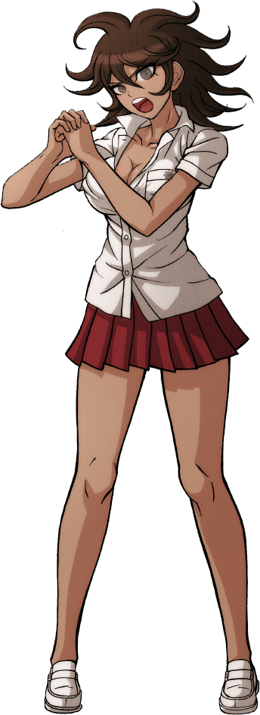
“HYAAAAAA!” With one final stretch, Akane Owari was able to finally get the last bit of stiffness out of her body at the cost of unintentionally undoing three more of the buttons on her current outfit, leaving her ample breasts all but uncovered. “That feels better! Why the heck am I wearing this though!?” In some capacity she felt as if she had just woken up from a very long nap. That would explain why she couldn’t remember putting on this clothes, at least.

But a different answer fell into her lap. “Huuuuh!? What do you mean, Owari-san? We put them on together, right? Yours totally didn’t fit because you’re so BIG though, BWAHAHA!” With the gas having escaped into the rest of the school, it was easy enough for Akane to see Ibuki as she stepped out of the nurse’s office.

She tilted her head to the side for the moment. Was that what had happened? It would’ve been pretty stupid for her to try and cram her bod into an outfit made for some lanky dude, but she supposed that was the best explanation she had. “Yeah? I dunno, I feel like I just woke up! I’m still so tense, too!” But then she had a good idea, or what she believed to be one.

“Wanna come back to my room and help me work those kinks out?”

